Software Requirements Specification (SRS)
Project: Student Club Event Ticketing & Budget Portal
Version | 1.0
Authors | Jayanth K (PES1UG24AM123)  Kishore V (PES1UG24AM139)  Leeladhar G Sairaju (PES1UG24AM148)  Mohammad Bilal A (PES1UG24AM162)
Date | 28-10-2026
Status | Draft
Course | Software Engineering - Mini Project (Section C)

Revision history
Version | Date | Author | Change summary | Approval
1.0 | 28-10-2026 | Project team | Initial version for review | Pending

Approvals
Role | Name | Signature / Email | Date
Course Coordinator
Team Lead

Table of Contents
1. Introduction
2. Overall description
3. External interface requirements
4. System features (detailed)
5. Non-functional requirements (detailed)
6. Quality attributes & Acceptance tests
7. System models and diagrams
8. Requirements Traceability Matrix (RTM)

1. Introduction

1.1 Purpose
This document is the Software Requirements Specification (SRS) for the Student Club Event Ticketing & Budget Portal. It defines the functional and non-functional requirements, interfaces and verification criteria the team will build and test during the two-sprint mini project.

1.2 Scope
The portal lets student clubs submit event proposals with budgets, routes them through a three-stage approval (Faculty Coordinator, Finance Officer, Dean), issues QR-code tickets to students for approved events, validates tickets at the venue and gives the Campus Admin a dashboard with reports. Online payments, SSO with the university system, a native mobile app, venue hardware, proposal document attachments and a user-management screen are out of scope. Email notifications, PDF export and rate limiting are stretch goals. Approved proposals are published automatically as events for student registration.

1.3 Audience
Project team (developers and testers), course instructor / evaluators, and club and administration staff who review the requirements.

1.4 Definitions
SCP - Student Club Portal; FR / NFR - Functional / Non-functional Requirement; RBAC - Role-Based Access Control; JWT - JSON Web Token; QR - Quick Response code; HMAC - Hash-based Message Authentication Code; MERN - MongoDB, Express, React, Node.js stack (this project uses MySQL in place of MongoDB); API - Application Programming Interface; TLS - Transport Layer Security; RTM - Requirements Traceability Matrix; UAT - User Acceptance Testing.

2. Overall description

2.1 Product perspective
A new, self-contained web application. A React single-page app talks to a Node.js / Express REST API, which stores data in a MySQL database. It replaces paper and email-based event approvals and manual entry lists at club events.

2.2 Major product functions
- Login and role-based access
- Submit, edit and track event proposals with budgets
- Three-stage approval workflow with comments and history
- In-app notifications on status changes
- Event registration and unique QR-code tickets
- Single-use ticket validation at venue check-in
- Dashboard with filters and CSV reports (PDF export optional)

2.3 User roles and characteristics
- Club Lead: creates and tracks proposals for their club, views the dashboard for their own club and scans tickets at their events.
- Faculty Coordinator / Finance Officer / Dean: review and approve or reject proposals at their stage.
- Campus Admin: views the dashboard for all clubs and exports reports. Users and roles are loaded by a seed script.
- Student: browses approved events, registers and shows the QR ticket at entry.

2.4 Operating environment
Modern web browsers (Chrome, Firefox, Edge, Android Chrome) on desktop and mobile. Server: Node.js 20 LTS with Express, MySQL 8.0 database, hosted on a college lab machine or a free cloud tier.

2.5 Constraints
- Must be built and tested within two one-week sprints by a team of four.
- Technology stack fixed to React, Node.js / Express and MySQL.
- No payment gateway: event registration is free.
- Users are identified by college email addresses.
- Users, clubs and roles are created by a seed script; there is no self-registration or user-management screen.

3. External interface requirements

3.1 User interfaces
Responsive web UI with a role-based navigation menu: proposal form, approval inbox, proposal status page, event list, My Tickets, check-in scanner page and admin dashboard. Clear error messages next to invalid form fields.

3.2 Hardware interfaces
No special hardware. The check-in page uses the device camera (phone or laptop webcam) through the browser to read QR codes, with manual ticket-code entry as a fallback. Browsers allow camera access only on HTTPS or localhost, so the manual entry path is the fallback on a plain-HTTP demo host.

3.3 Software interfaces
- MySQL 8.0 database accessed from Express through a parameterised query library.
- REST/JSON API between the React client and the Express server.
- Open-source libraries: jsonwebtoken (sessions), bcrypt (password hashing), qrcode (QR images), CSV export (PDF library optional).
- Optional SMTP mail service for email notifications (stretch goal).

3.4 Communications
HTTPS (TLS 1.2+) between browser and server in deployment; JSON request / response bodies; JWT sent in the Authorization header.

4. System features (detailed)
Each requirement includes acceptance criteria and a reference test case. IDs follow SCP-F-###. Total: 15 functional requirements.

4.1 User Authentication & Roles
Description: Users sign in with their college email and get access only to the screens and actions allowed for their role.
Req ID | Requirement (shall...) | Priority | Source | Acceptance criteria / Test case ref | Comments / Dependencies
SCP-F-001 | The system shall allow users to log in and log out using college email and password, issuing a JWT session token on success. | High | All users | Valid credentials open the role's home page and issue a JWT that expires after 8 hours; wrong password shows an error and no token is issued; logout discards the token. Test: TC-AUTH-01 | Passwords stored hashed (SCP-SR-001)
SCP-F-002 | The system shall enforce role-based access for Club Lead, Faculty Coordinator, Finance Officer, Dean, Campus Admin and Student. | High | Security | A user calling an API outside their role receives 403 and the UI hides the action. Test: TC-AUTH-02 | Users and roles loaded by a seed script

4.2 Event Proposal Management
Description: Club Leads create event proposals with a budget and can correct and resubmit them if rejected.
Req ID | Requirement (shall...) | Priority | Source | Acceptance criteria / Test case ref | Comments / Dependencies
SCP-F-003 | The system shall allow a Club Lead to submit an event proposal with event name, date, venue, expected attendance, budget amount and description. | High | Club Lead | Proposal is saved with status PENDING_FACULTY; submission fails with field errors if any mandatory field is missing or invalid. Test: TC-PROP-01 | Budget must be a positive number
SCP-F-004 | The system shall allow a Club Lead to edit and resubmit a proposal that is rejected, restarting the approval from the Faculty stage. | Medium | Club Lead | Rejected proposal can be edited; on resubmit status returns to PENDING_FACULTY and history is kept. Test: TC-PROP-02 | Approved proposals are read-only
SCP-F-005 | The system shall allow a Club Lead to view the current status and stage of each of their club's proposals. | Medium | Club Lead | Proposal list shows status (Pending Faculty / Finance / Dean, Approved, Rejected) for own club only. Test: TC-PROP-03 | -

4.3 Multi-stage Approval Workflow
Description: Each proposal moves through Faculty Coordinator, Finance Officer and Dean in a fixed order.
Req ID | Requirement (shall...) | Priority | Source | Acceptance criteria / Test case ref | Comments / Dependencies
SCP-F-006 | The system shall route every proposal sequentially through Faculty Coordinator, Finance Officer and Dean approval stages. | High | University policy | A proposal cannot reach Finance before Faculty approval, or the Dean before Finance approval. Test: TC-APPR-01 | Core business rule
SCP-F-007 | The system shall allow the approver of the current stage to approve or reject a proposal, with a mandatory comment on rejection. | High | Approvers | Proposals pending at the approver's stage appear in their inbox; approve moves the proposal to the next stage (or APPROVED after the Dean); reject without a comment is blocked. Test: TC-APPR-02 | Only the current-stage role may decide
SCP-F-008 | The system shall record an approval history entry (stage, approver, decision, comment, timestamp) for every decision. | Medium | Audit | History tab lists every decision in order with approver name and time. Test: TC-APPR-03 | Supports SCP-NF-005

4.4 Notifications
Description: Users are told when something needs their action or when their proposal changes status.
Req ID | Requirement (shall...) | Priority | Source | Acceptance criteria / Test case ref | Comments / Dependencies
SCP-F-009 | The system shall send an in-app notification to the next approver when a proposal reaches their stage, and to the Club Lead on every approval or rejection. | Medium | All users | Notification appears in the bell list within 1 minute of the status change. Test: TC-NOTI-01 | Email is optional (stretch)

4.5 Event Registration & QR Ticketing
Description: Students register for approved events and receive a unique QR-code ticket.
Req ID | Requirement (shall...) | Priority | Source | Acceptance criteria / Test case ref | Comments / Dependencies
SCP-F-010 | The system shall list approved upcoming events and allow a student to register once per event while seats are available. | High | Student | Registration succeeds only if seats are left and the student is not already registered. Test: TC-TKT-01 | Capacity = expected attendance; an approved proposal is published as an event automatically
SCP-F-011 | The system shall generate a unique, signed QR-code ticket containing event ID, student ID and ticket ID for each registration. | High | Club Lead | Every registration gets exactly one ticket; QR tokens are unique and verify against the server signature. Test: TC-TKT-02 | HMAC-signed token (SCP-SR-003)
SCP-F-012 | The system shall allow a student to view and download their QR tickets from the My Tickets page. | Medium | Student | My Tickets lists all tickets; QR downloads as a PNG image. Test: TC-TKT-03 | -

4.6 Venue Check-in
Description: Organisers scan tickets at the venue; each ticket can be used only once.
Req ID | Requirement (shall...) | Priority | Source | Acceptance criteria / Test case ref | Comments / Dependencies
SCP-F-013 | The system shall validate a scanned or typed QR ticket at check-in, mark it USED, and reject tickets that are already used, invalid or for another event. | High | Organiser | First scan shows 'Valid'; a second scan of the same ticket shows 'Already used'; a tampered code shows 'Invalid'; a ticket for another event shows 'Wrong event'. Test: TC-CHK-01, TC-CHK-02 | Webcam/phone camera or manual code entry

4.7 Dashboard & Reports
Description: Campus Admin and Club Leads get a summary of proposals, budgets and attendance.
Req ID | Requirement (shall...) | Priority | Source | Acceptance criteria / Test case ref | Comments / Dependencies
SCP-F-014 | The system shall provide a dashboard with the proposal pipeline (count per stage), a proposal table and filters by status, club and date range. | Medium | Campus Admin | Counts match the database; applying filters refreshes the table with only matching rows; Club Leads see only their club. Test: TC-DASH-01 | -
SCP-F-015 | The system shall export a budget allocation report and an event attendance report in CSV format, with PDF export as a stretch goal. | Medium | Campus Admin | Exported CSV opens correctly and totals match the dashboard; PDF is checked only if implemented. Test: TC-DASH-02 | -

5. Non-functional requirements (detailed)
NFRs below are measurable and tied to the test plan. IDs SCP-NF-###.
Req ID | Requirement | Category | Priority | Acceptance criteria / Measurement
SCP-NF-001 | Pages and API responses shall load within 2 seconds for 90% of requests with 50 concurrent users. | Performance | High | 90th percentile <= 2 s in a JMeter load test on the deployed host (not applicable if only run locally). Test: TC-PERF-01
SCP-NF-002 | QR ticket validation at check-in shall return a result within 1 second. | Performance | High | Average check-in response <= 1 s over 100 scans. Test: TC-PERF-02
SCP-NF-003 | The UI shall be responsive and usable on desktop and mobile browsers (Chrome, Firefox, Edge, Android Chrome). | Usability | Medium | All main pages render without layout breakage at 360 px and 1366 px widths. Test: TC-UX-01
SCP-NF-004 | The system shall remain available during event submission and check-in windows, with a target of 99% uptime in the demo week. | Reliability | Medium | /api/health is monitored during the demo week; target >= 99% (best effort on free hosting; not applicable if only run locally). Test: TC-REL-01
SCP-NF-005 | Approval and check-in actions shall be logged with user and timestamp in audit tables that the application never deletes. | Audit / Maintainability | Medium | Log entries with user and timestamp exist for every decision and check-in; the application has no delete function for audit tables. Test: TC-OPS-01

5.1 Security

5.1.1 Security Objectives
- Confidentiality: Personal data of students and staff (emails, registrations) and club budgets are visible only to authorised roles.
- Integrity: Approval decisions, budgets and tickets cannot be forged or altered; every ticket can be used only once.
- Accountability: Every approval decision and check-in can be traced to the user who performed it.

5.1.2 Security Requirements
Req ID | Requirement (shall...) | Type | Priority | Acceptance criteria / Test case ref
SCP-SR-001 | User passwords shall be stored only as salted bcrypt hashes; plaintext passwords shall never be stored or logged. | Security | High | Database contains only bcrypt hashes; log files contain no passwords. Test: TC-SEC-01
SCP-SR-002 | Every protected API endpoint (all except login and /api/health) shall verify the JWT and the user's role before processing the request. | Security | High | Requests without a token return 401; wrong role returns 403. Test: TC-SEC-02
SCP-SR-003 | QR ticket tokens shall be HMAC-signed by the server so that forged or modified tickets are rejected. | Security | High | Editing any character of a token causes 'Invalid'. Test: TC-SEC-03
SCP-SR-004 | All database access shall use parameterised queries and all inputs shall be validated on the server. | Security | High | SQL-injection payloads in form fields are rejected and do not alter data. Test: TC-SEC-04
SCP-SR-005 | All traffic between browser and server shall use HTTPS (TLS 1.2+) on the deployed demo host. | Security | High | On the deployed host, HTTP requests redirect to HTTPS and TLS version is >= 1.2; not applicable to localhost runs. Test: TC-SEC-05

6. Quality attributes & Acceptance tests
- Exit criteria for acceptance: all High-priority FRs implemented and verified, no critical NFR or security failures, and the RTM shows all planned test cases executed and all High-priority requirements passed.
- Acceptance test suites: Authentication, Proposals, Approval Workflow, Notifications, Ticketing, Check-in, Dashboard & Reports, Performance, Usability and Security.

7. System models and diagrams

7.1 UML Use-Case diagrams
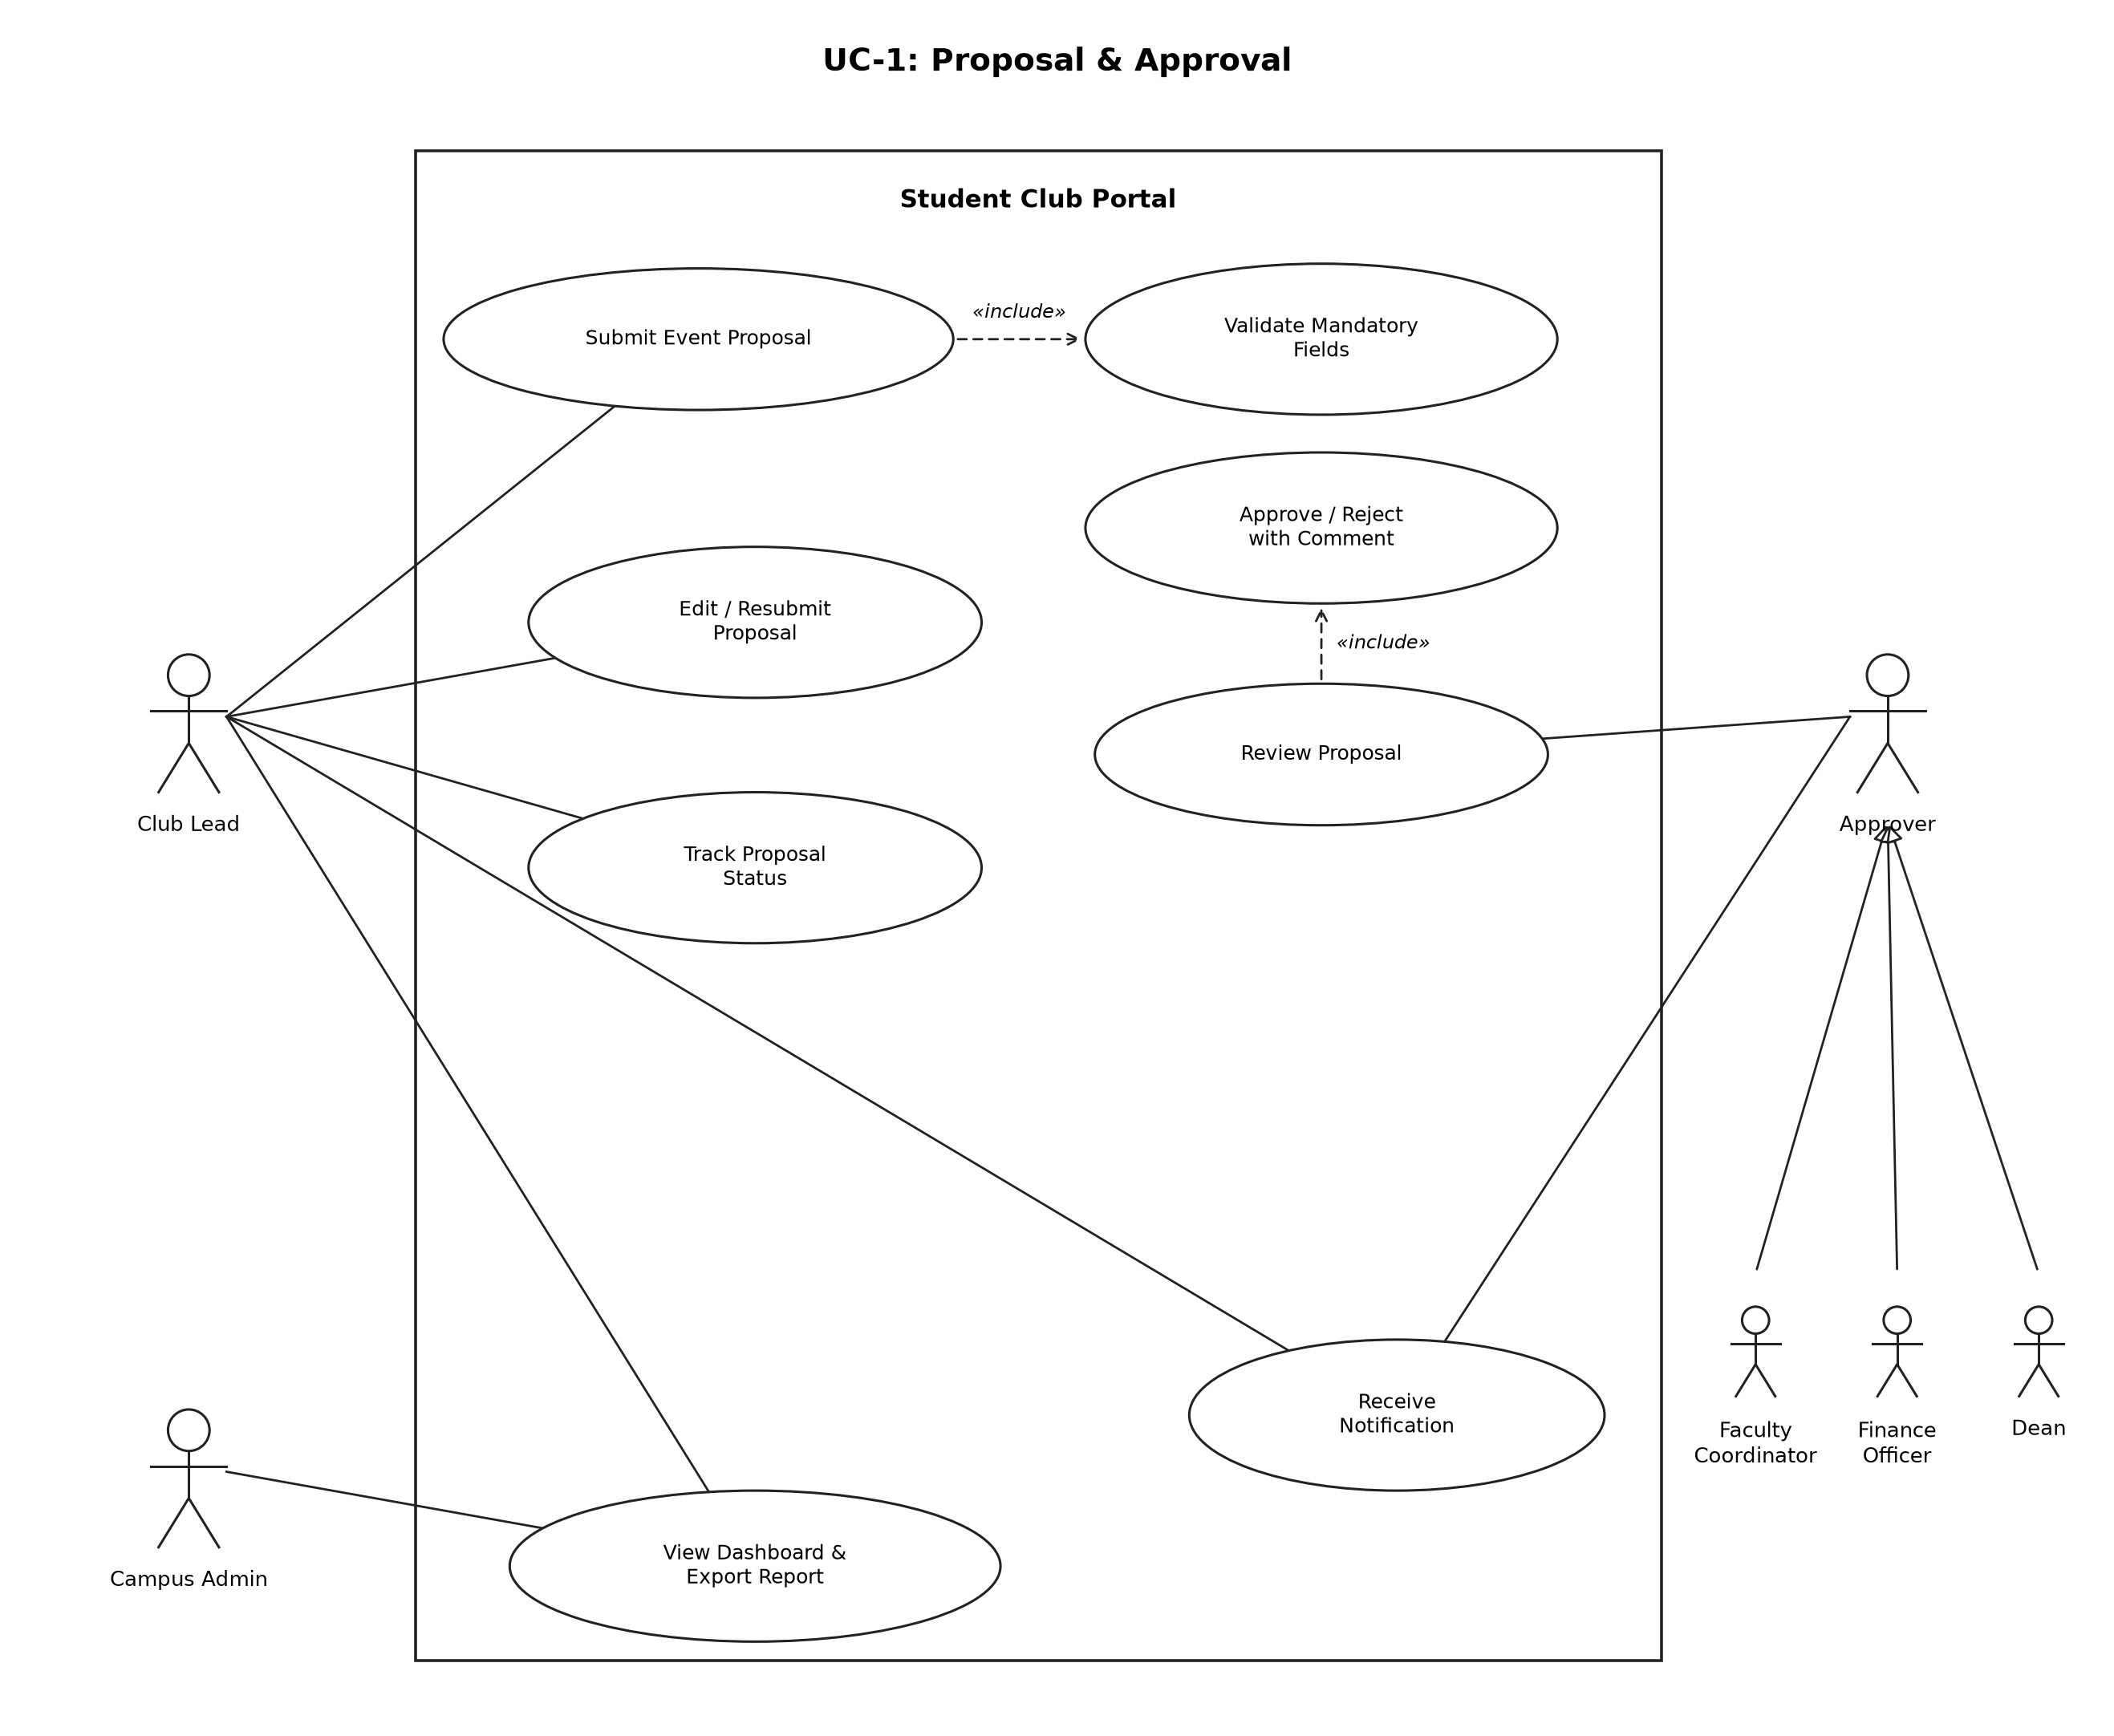
Figure 1: UC-1 Proposal & Approval
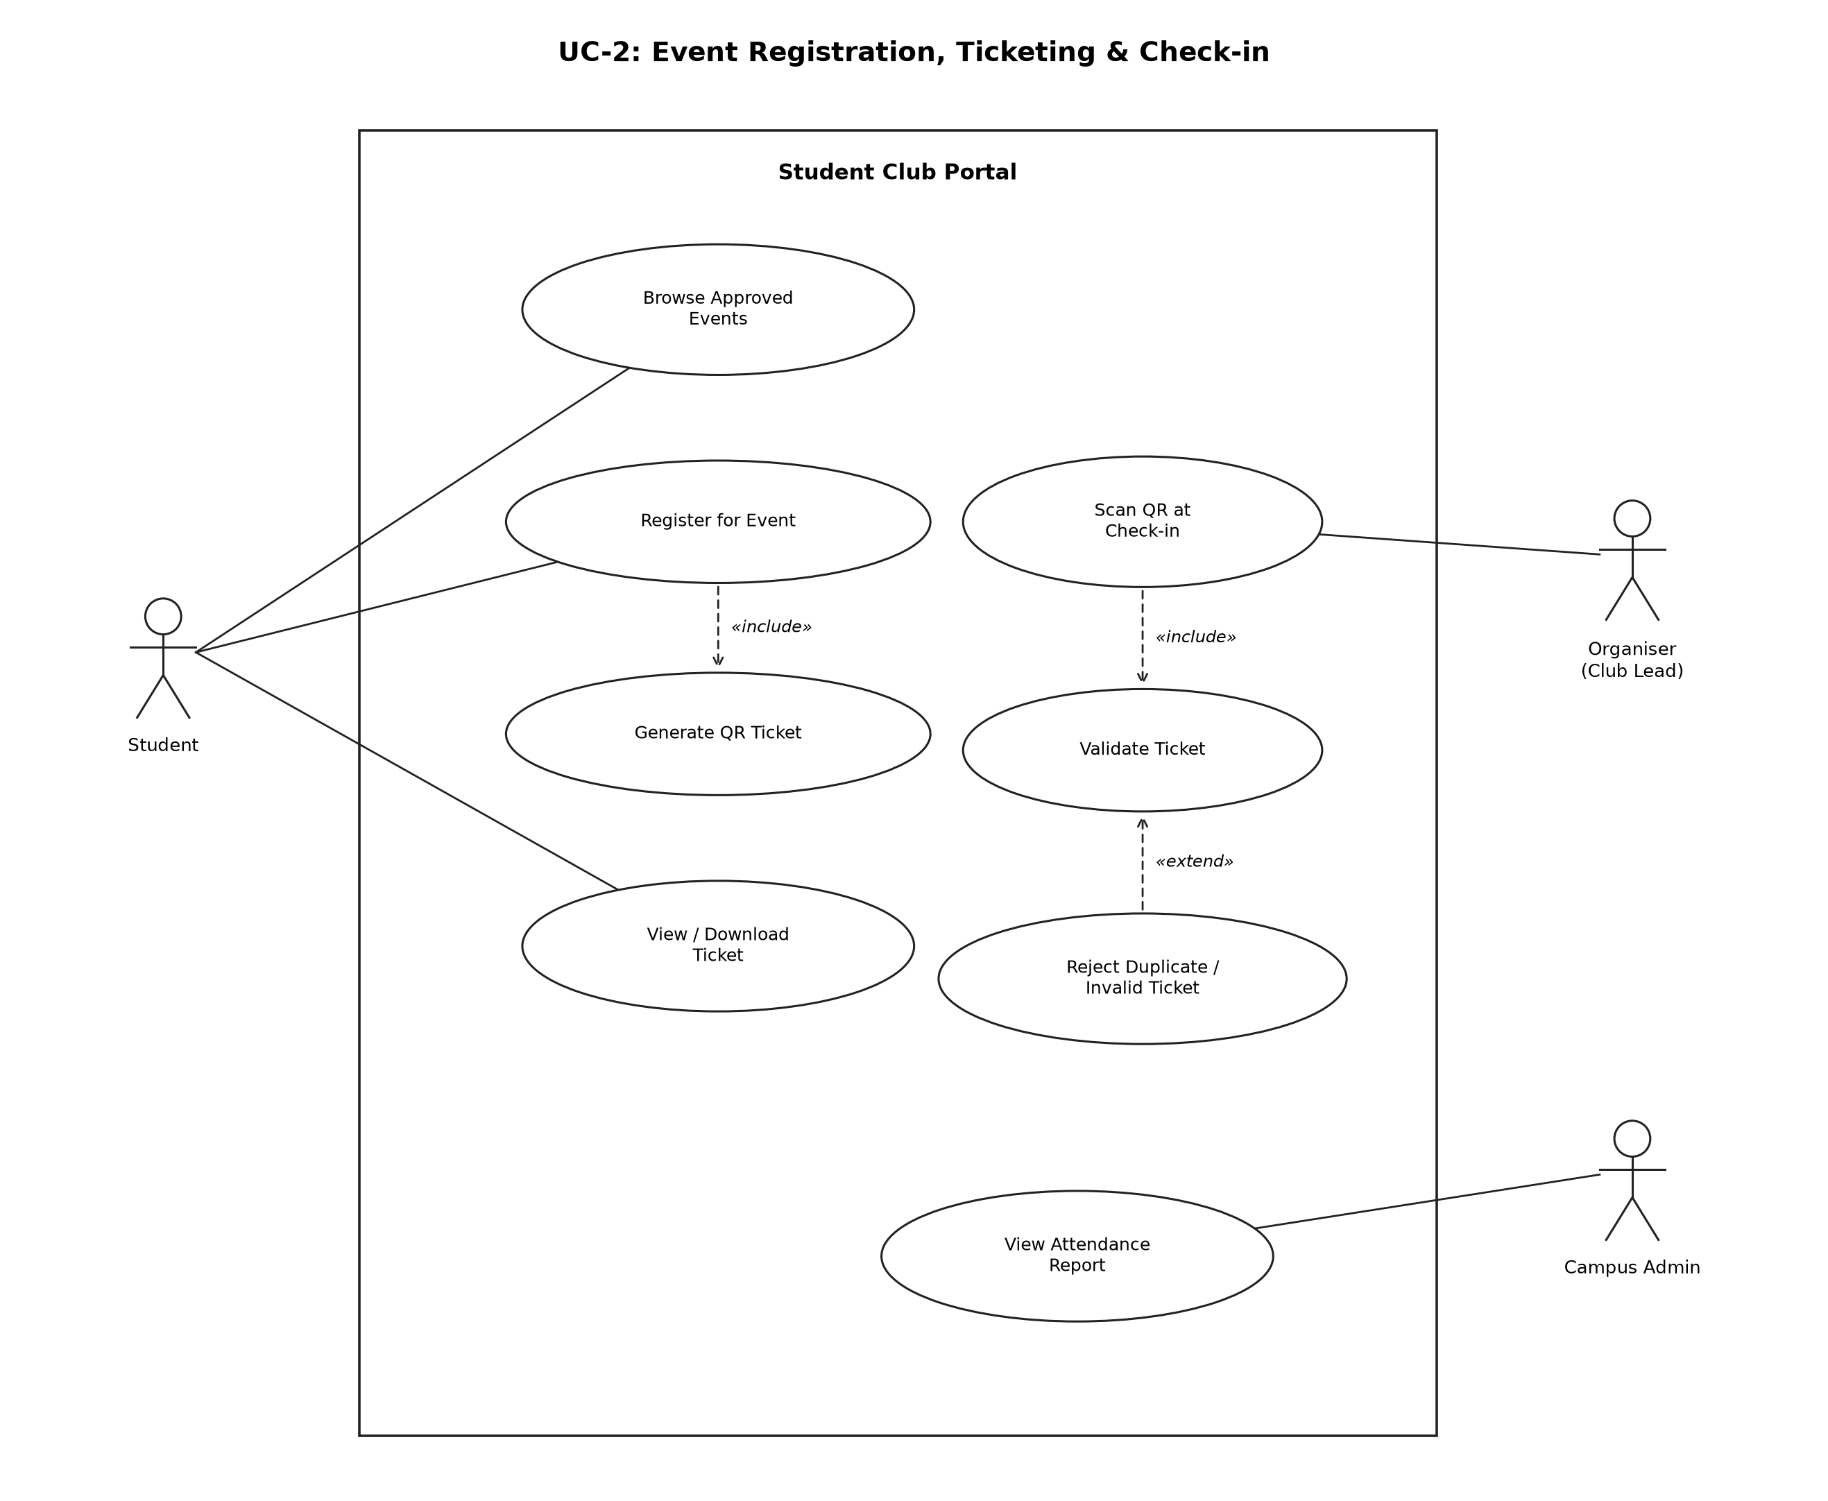
Figure 2: UC-2 Event Registration, Ticketing & Check-in

8. Requirements Traceability Matrix (RTM)
Status: N = Not started, P = In progress, A = Accepted (tested and passed).
Req ID | Requirement short | Section ref / Design spec | Module | Test case(s) | Status (N/P/A)
SCP-F-001 | Login / logout | 4.1 / DS-AUTH-01 | AuthManager | TC-AUTH-01 | N
SCP-F-002 | Role-based access | 4.1 / DS-AUTH-02 | AuthManager | TC-AUTH-02 | N
SCP-F-003 | Submit proposal | 4.2 / DS-PROP-01 | ProposalManager | TC-PROP-01 | N
SCP-F-004 | Edit & resubmit | 4.2 / DS-PROP-02 | ProposalManager | TC-PROP-02 | N
SCP-F-005 | Track status | 4.2 / DS-PROP-03 | ProposalManager | TC-PROP-03 | N
SCP-F-006 | Sequential stages | 4.3 / DS-APPR-01 | ApprovalWorkflow | TC-APPR-01 | N
SCP-F-007 | Approve / reject | 4.3 / DS-APPR-02 | ApprovalWorkflow | TC-APPR-02 | N
SCP-F-008 | Approval history | 4.3 / DS-APPR-03 | ApprovalWorkflow | TC-APPR-03 | N
SCP-F-009 | Notifications | 4.4 / DS-NOTI-01 | Notifier | TC-NOTI-01 | N
SCP-F-010 | Register for event | 4.5 / DS-TKT-01 | RegistrationMgr | TC-TKT-01 | N
SCP-F-011 | Generate QR ticket | 4.5 / DS-TKT-02 | QRGenerator | TC-TKT-02 | N
SCP-F-012 | View / download ticket | 4.5 / DS-TKT-03 | TicketStore | TC-TKT-03 | N
SCP-F-013 | Validate at check-in | 4.6 / DS-CHK-01 | CheckInValidator | TC-CHK-01, TC-CHK-02 | N
SCP-F-014 | Dashboard & filters | 4.7 / DS-DASH-01 | ReportGenerator | TC-DASH-01 | N
SCP-F-015 | Export reports | 4.7 / DS-DASH-02 | ReportGenerator, AttendanceLog | TC-DASH-02 | N
SCP-NF-001 | Response time | 5 / DS-PERF-01 | React UI / Express API | TC-PERF-01 | N
SCP-NF-002 | Check-in time | 5 / DS-CHK-01 | CheckInValidator | TC-PERF-02 | N
SCP-NF-003 | Responsive UI | 5 / DS-UX-01 | React UI | TC-UX-01 | N
SCP-NF-004 | Availability | 5 / DS-OPS-01 | Express API / MySQL | TC-REL-01 | N
SCP-NF-005 | Audit logging | 5 / DS-OPS-02 | ApprovalWorkflow / AttendanceLog | TC-OPS-01 | N
SCP-SR-001 | Password hashing | 5.1.2 / DS-AUTH-01 | AuthManager | TC-SEC-01 | N
SCP-SR-002 | Token & role check | 5.1.2 / DS-AUTH-02 | AuthManager | TC-SEC-02 | N
SCP-SR-003 | Signed QR | 5.1.2 / DS-TKT-02 | QRGenerator / CheckInValidator | TC-SEC-03 | N
SCP-SR-004 | Input validation | 5.1.2 / DS-OPS-03 | All services | TC-SEC-04 | N
SCP-SR-005 | HTTPS | 5.1.2 / DS-OPS-04 | Deployment | TC-SEC-05 | N

