Jayanthi M

Assignment 21/07

Configure a Linux system by modifying .bashrc to set permanent environment variables, aliases, and a custom prompt that loads automatically on every new session.

create a .env file with key-value pairs, load it into the session

Additionally, manage system services using systemctl (start, stop, enable, check status), check service logs using journalctl, and document each command and output in a report.

a)Configure a Linux system by modifying .bashrc to set permanent environment variables,

**Step1: Before setting environment variables if we type echo $variable name it will show blank**

**Step 2: To set environment variables we need to go to vi .bashrc**

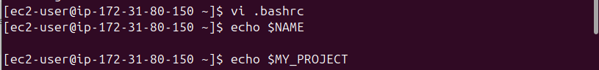**Setp3: Edit the bashrc file using vi.bashrc and add export MY_NAME=”Jayanthi”**

**export MY_PROJECT=”$HOME/project”**

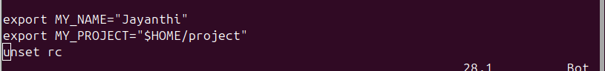**step 4: After setting environment variables in .bashrc file we need to run source ~/.bashrc to reload the configuration and applies our changes immediately without needing to logout or restart our terminal**

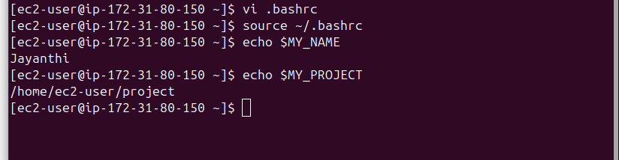**step5: we need to open other terminal and we need to check by giving echo $MY_NAME and echo $MY_PROJECT**

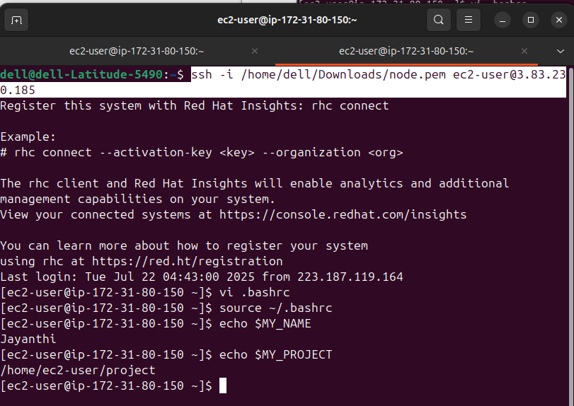

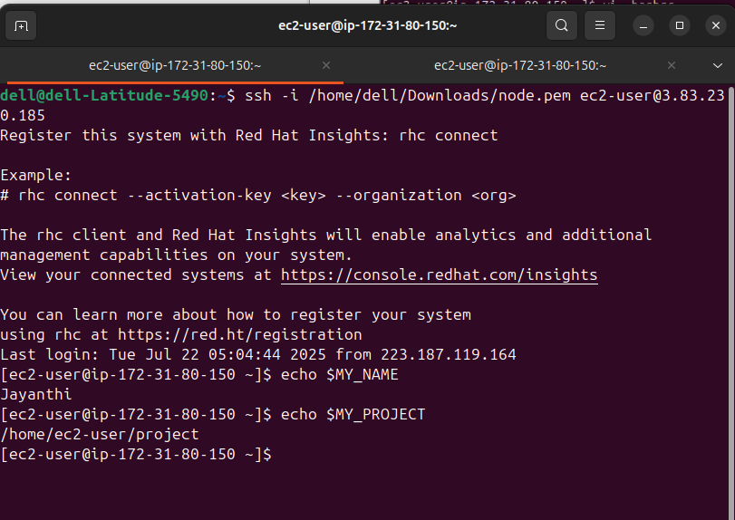

b)set permanent environment aliases.

Step1: Set the alias in .bashrc file using vi .bashrc

alias du=’du -sh’

alias df = ‘df -h’

alias c=’clear’

alias ports=’nestat -lntu’

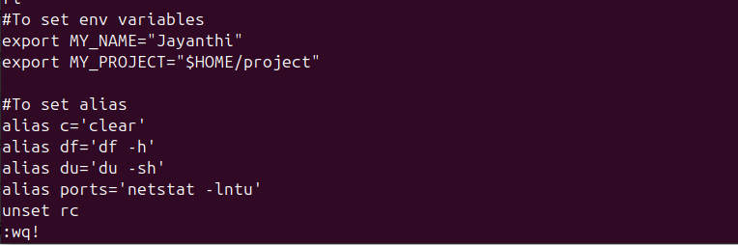Step2: After setting alias in .bashrc file run **source ~/.bashrc**

to check all Alias we use **alias** and to check individual alias we use **type df**

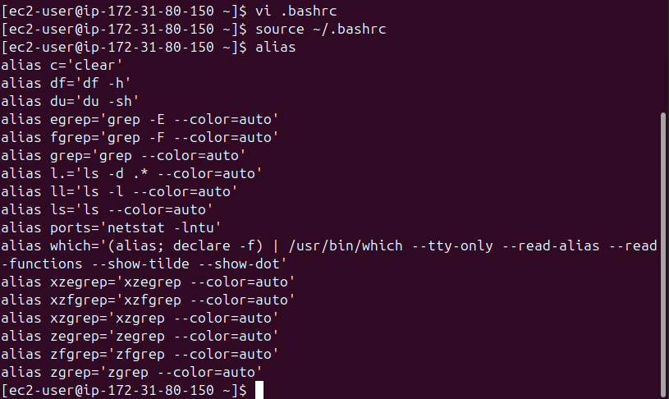

Step3: To check given alias is working or not we just type **du** = it should display disk usage

**df** it should display disk free space **c** It should clear screen

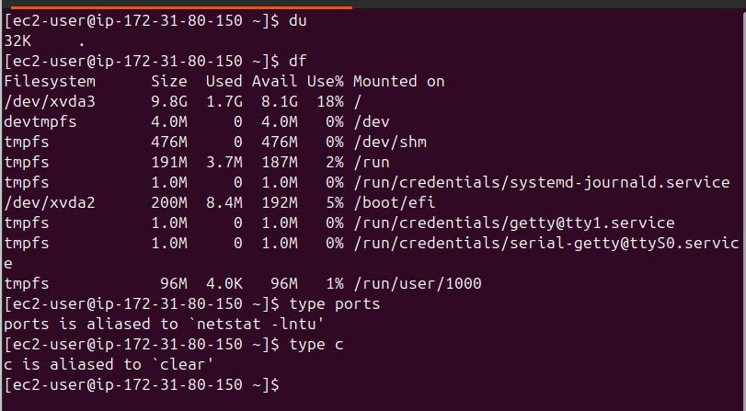

c)a custom prompt that loads automatically on every new session.

Step1: we need to add **echo -e "\e[1;33mWelcome to terminal, $USER!\e[0m"**

echo: Prints a message to the terminal.

* -e: Enables interpretation of backslash escapes like \e, \n, etc.
* \e[1;33m: ANSI escape code to start yellow bold text.
* Welcome to terminal, $USER!: The message itself.
  + $USER dynamically shows your current Linux username (ec2-user)
* \e[0m: Resets text formatting to default (white).

**export PS1="\[\e[1;32m\][\u@\h:\w]\$\[\e[0m\] "**

export PS1= Sets the primary shell prompt (PS1).

\[\e[1;32m\] ANSI escape for bold green text start.

[\u@\h:\w] The prompt body:

\u Current username (e.g., ec2-user)

\h Hostname (e.g., ip-172-31-80-150)

\W Current working directory (e.g., /home/ec2-user)

\$ Shows # for root user, $ for normal user.

\[\e[0m\] ANSI escape to reset text color.

**in vi .bashrc**

**Step 2: execute source ~/.bashrc**

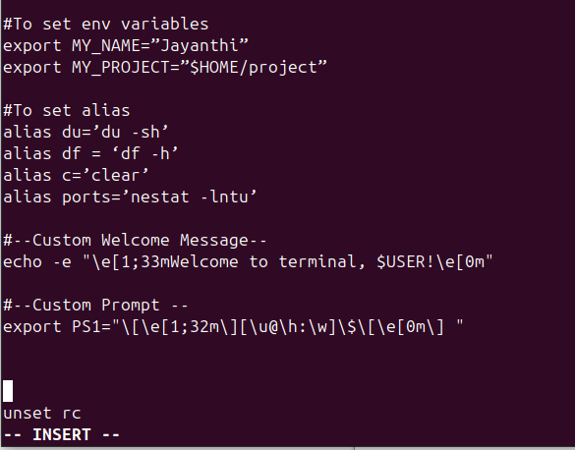

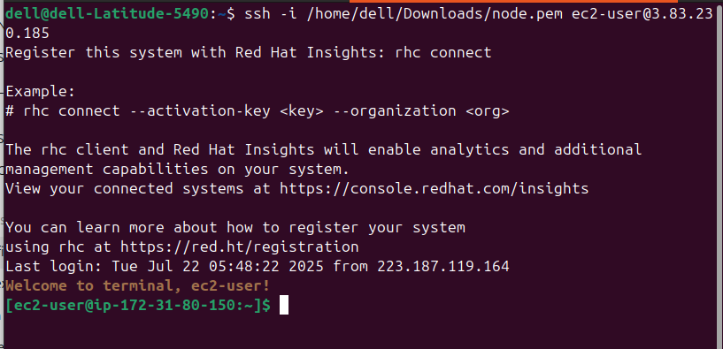

**d)create a .env file with key-value pairs, load it into the session**

To create .env file with key-value pairs we use

**vi ~/.env**

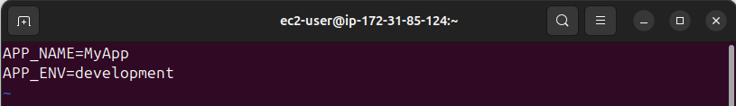

to load it into the session we username

**export $(cat ~/.env)**

To check this

**echo $APP_NAME**

**echo $APP_ENV**

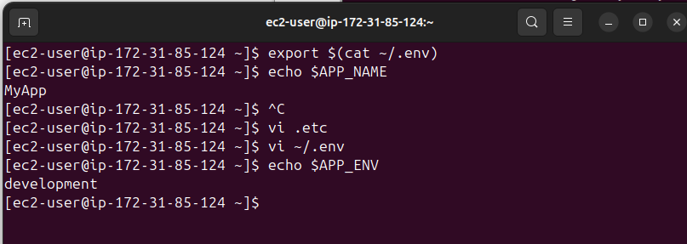

e)manage system services using systemctl (start, stop, enable, check status)

to manage system service using systemctl

**sudo systemctl start nginx**

**sudo systemctl enable nginx**

**sudo systemctl status nginx**

**sudo systemctl stop nginx**

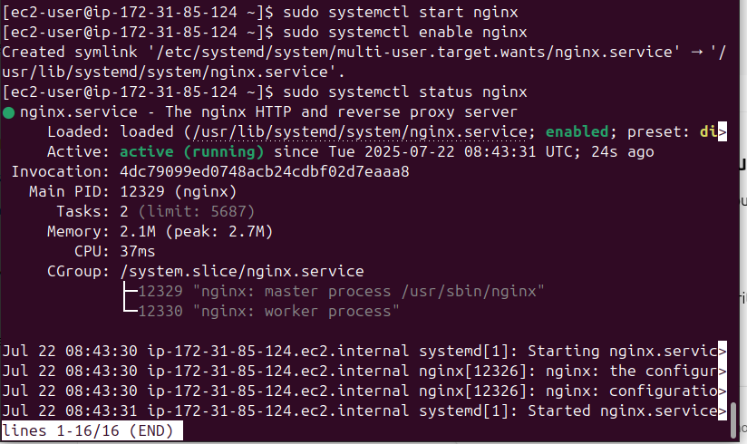

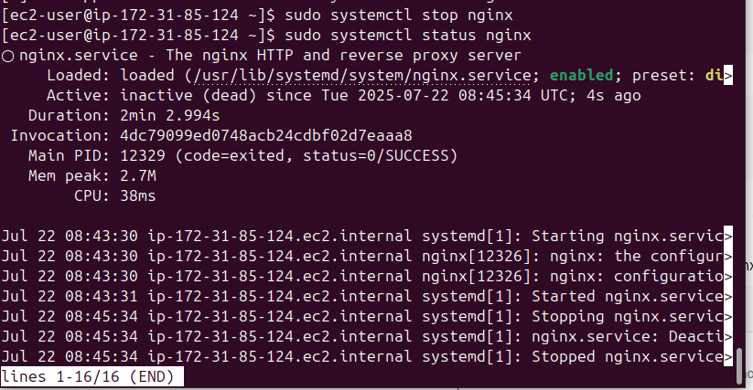

f)check service logs using journalctl,

to check service logs using journalctl

**sudo journalctl -u nginx**

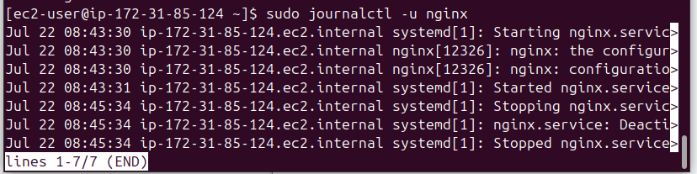

List of all the commands mentioned above

## A. Environment Variable Commands

### 1. echo $VARIABLE_NAME

Displays the value of an environment variable. If not set, it returns blank.

### 2. vi ~/.bashrc

Opens the .bashrc file in the vi text editor for editing user-specific shell settings.

### 3. export MY_NAME="Jayanthi"

Sets an environment variable MY_NAME to "Jayanthi" and makes it available to child processes.

### 4. export MY_PROJECT="$HOME/project"

Sets MY_PROJECT to the path of your project directory in your home folder.

### 5. source ~/.bashrc

Reloads the .bashrc file to apply changes immediately in the current shell session.

## B. Alias Commands

### 6. alias du='du -sh'

Creates an alias du to show disk usage in a human-readable format and summarize directories.

### 7. alias df='df -h'

Creates an alias df to show disk free space in a human-readable format.

### 8. alias c='clear'

Creates a shortcut c to clear the terminal screen.

### 9. alias ports='nestat -lntu'

Creates an alias ports to show listening network ports (note: should be netstat, not nestat).

### 10. alias

Lists all currently set aliases in the session.

### 11. type df

Shows the definition of df, including whether it's an alias, function, or binary.

## C. Custom Prompt Commands

### 12. echo -e "\e[1;33mWelcome to terminal, $USER!\e[0m"

Prints a yellow welcome message with the username. -e enables escape sequences for colored text.

### 13. export PS1="\[\e[1;32m\][\u@\h:\w]\$\[\e[0m\] "

Sets a custom shell prompt with green text showing [username@hostname:working-directory].

## D. .env File Commands

### 14. vi ~/.env

Creates or edits the .env file to store key-value pairs.

### 15. export $(cat ~/.env)

Loads all key-value pairs from .env into the current shell session as environment variables.

### 16. echo $APP_NAME

Displays the value of the APP_NAME environment variable.

### 17. echo $APP_ENV

Displays the value of the APP_ENV environment variable.

## E. systemctl Commands (Service Management)

### 18. sudo systemctl start nginx

Starts the nginx service immediately.

### 19. sudo systemctl enable nginx

Enables nginx to start automatically on boot.

### 20. sudo systemctl status nginx

Shows the current status (active, inactive, failed) of the nginx service.

### 21. sudo systemctl stop nginx

Stops the nginx service.

## F. journalctl Commands (Logs)

### 22. sudo journalctl -u nginx

Displays the full log history for the nginx service.