Jayanthi

Assignment:

**Assignment 1**: Create a directory structure for a project: Add a main directory called project, with subdirectories for documentation, source code, and logs. Create a file for documentation in the appropriate folder and another for source code in its respective folder. Write some sample text into each file. Modify permissions to ensure: The source code folder is accessible to all users with full permissions. The logs folder does not allow write access for others. Move and copy files: Copy the documentation file to the source code folder. Move the source code file to the logs folder. Display the contents of the main directory, sorted by the time of modification, and include detailed information.

a)Create a directory structure for a project: Add a main directory called project, with subdirectories for documentation, source code, and logs.

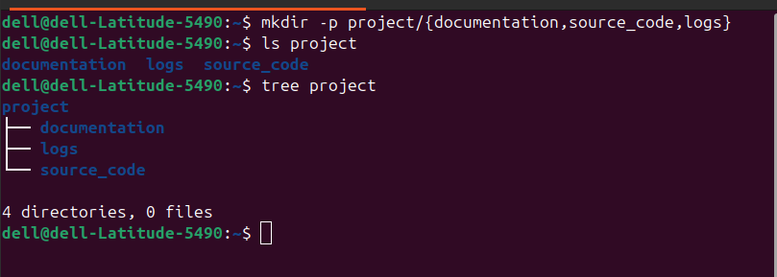

b)Create a file for documentation in the appropriate folder and another for source code in its respective folder. Write some sample text into each file.

**vi file1**



**vi file2**



c) Modify permissions to ensure: The source code folder is accessible to all users with full permissions.

**chmod 777 project/source = to give full permissions to all users**

**ls -ld project/source_code = to check permission of a source_code directory.**

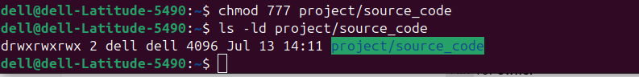

d)The logs folder does not allow write access for others.

**chmod o-w project/logs = doesnot allow write access for others.**

**ls -ld project/logs = to check permission of a logs directory.**

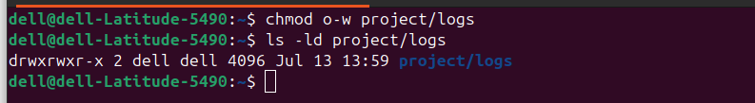

e) Move and copy files: Copy the documentation file to the source code folder.

**cp project/documentation/file1 project/source_code/ = Copy the documentation file to the source code folder.**

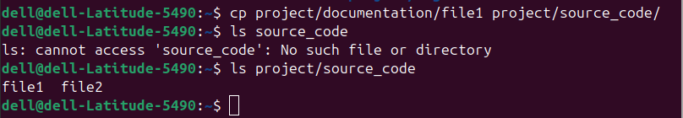

f)Move the source code file to the logs folder.

**mv project/source_code/file2 project/logs/ = to move the source_code file to the logs folder.**



g)Display the contents of the main directory, sorted by the time of modification, and include detailed information.

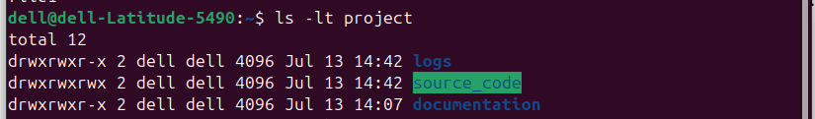

**Assignment 2:**

Create a text file containing at least 15 lines of random text.

Determine:

The total number of lines and words in the file.

The number of lines starting with the letter A.

The number of lines that do not contain the word error.

Extract specific sections of the file:

Display the first five lines.

Display the last five lines.

Use sorting and filtering:

Sort the first five lines of the file alphabetically.

Count the number of unique lines in the file.

a)Create a text file containing at least 15 lines of random text.

**vi file = is used to create a file and open in vi editor**

**cat = is used to display the content of a file without opening a file in editor**

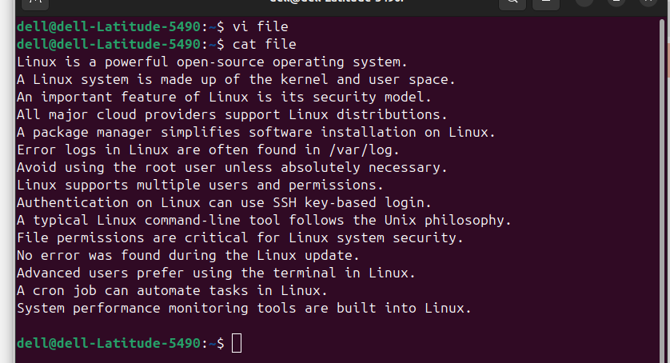

b)The total number of lines and words in the file.

**wc -lw file = this command is used to count lines and words in the file**



c)The number of lines starting with the letter A.

**grep -c “^A” file = used to count number of lines starting with letter A**



d)The number of lines that do not contain the word error.

**grep -v "error" file | wc -l = used to count number of lines that do not contain the word error.**



**e)**Extract specific sections of the file:

Display the first five lines.

**head -5 file = used to display the first five lines of the file**

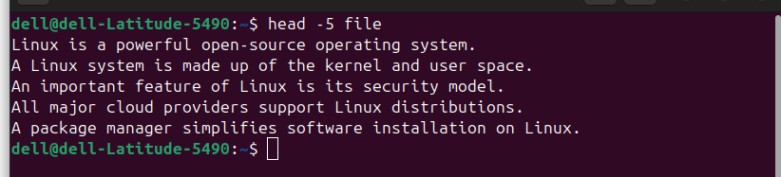

f)Display the last five lines.

**tail -5 file = used to display the last five lines from the file**

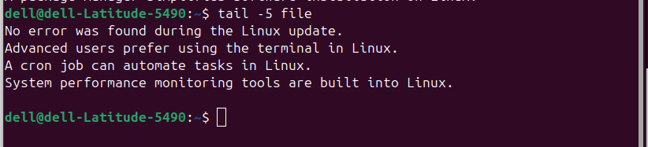

g)Use sorting and filtering:

Sort the first five lines of the file alphabetically.

**head -n 5 file | sort = used to sort the first five lines of the file alphabetically.**



**h)**Count the number of unique lines in the file.

**sort file | uniq | wc -l = used to count the number of unique lines in the file**

