Jayanthi.M

Assignments

Assignment 3:

Analyze the disk usage of the current directory and identify the available disk space.

Display a list of all currently running processes.

Identify a specific process by its name or ID and terminate it.

Search the current directory for:

All files with a specific extension.

Files modified within the last 90 days.

Directories that are empty.

Find all empty directories and delete them in one step.

Check the last 10 entries of a system log file.

a)Analyze the disk usage of the current directory and identify the available disk space.

**To check disk usage of the current directory we make use of** **du -sh .**

**To identify the available disk space we make use of df -h**

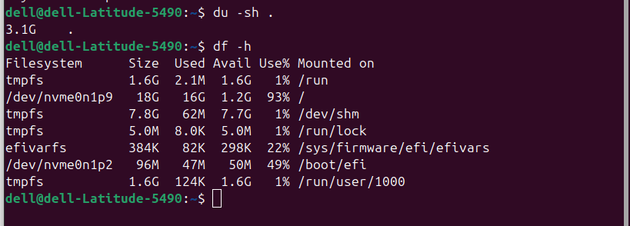

b)Display a list of all currently running processes.

**ps -ef id the command used to list all currently running processes.**

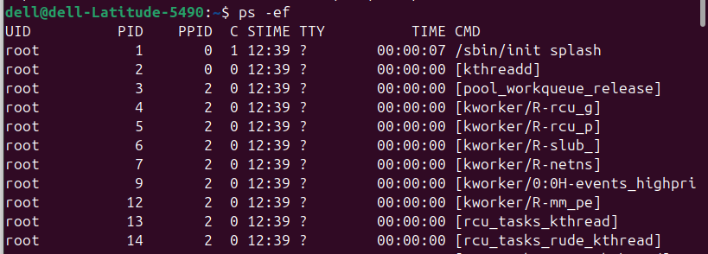

c)Identify a specific process by its name or ID and terminate it.

**To identify a specific process we make use of ps -ef**

**ps -ef | grep sleep it shows all running processes that contain the word sleep.**

**kill -9 1356 command used to terminate the process**

**to check the sleep process is terminated or not we use same ps -ef | grep sleep**

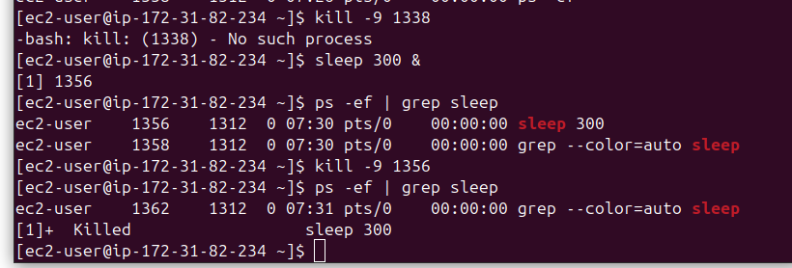

d)Search the current directory for:

All files with a specific extension.

To search the current directory for all files with a specific extension we make use of

**find . -type f -name “*.csv”**

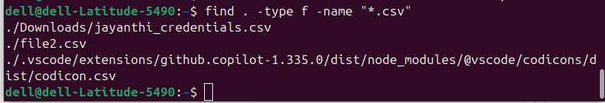

e) Files modified within the last 90 days.

To search files modified within the last 90 days we make use of

**find . -type f -mtime -90**



f)Directories that are empty.

Find all empty directories and delete them in one step.

**To find all empty directories and delete them in one step we make use of**

**find . -type d -empty -delete**

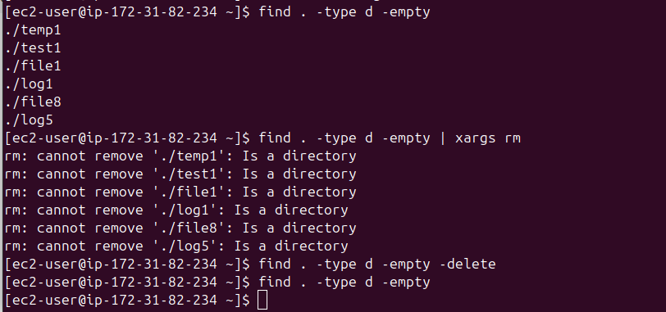

g)Check the last 10 entries of a system log file.

To check the last 10 entires of a system log file in redhat we make use of

**sudo tail -n 10 /var/log/messages**

