Jayanthi_assignment4

Assignment 4:

Create multiple files with different names and extensions in a folder.

Locate all files in the folder that match a specific pattern in their names.

Identify and list all files modified more than 90 days ago.

Create a hard link to one file and a soft link to another. Verify that the links have been created correctly.

Search for large files in the directory (e.g., larger than 1 MB) and delete them.

Verify the differences in behavior between hard and soft links by listing the inode numbers of the linked files.

a)Create multiple files with different names and extensions in a folder.

To create a multiple files with different names and extensions in a folder we make use of

**touch mulfile/file1.txt mulfile/file2.csv mulfile/file3.json mulfile/file4.html**

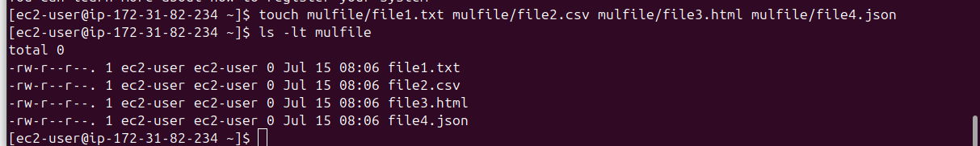

b)Locate all files in the folder that match a specific pattern in their names.

To locate all files in the folder that matches a specific pattern in their names we make use of

**find mulfile -type f -name “*.txt”**



c)Identify and list all files modified more than 90 days ago.

To identify and list all files modified more than 90 days age we make use of

find . -type f -mtime +90

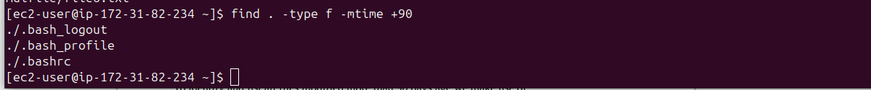

d)Create a hard link to one file and a soft link to another. Verify that the links have been created correctly.

To Create a hard link to one file and a soft link to another we make use of

**ln -s file6.txt softlink6.txt**  this is to create softlink

**ln file1.txt hardlink1.txt**  this is to create hardlink

command to verify that the links have been created correctly

**ls -l file1.txt hardlink1.txt file6.txt softlink6.txt**

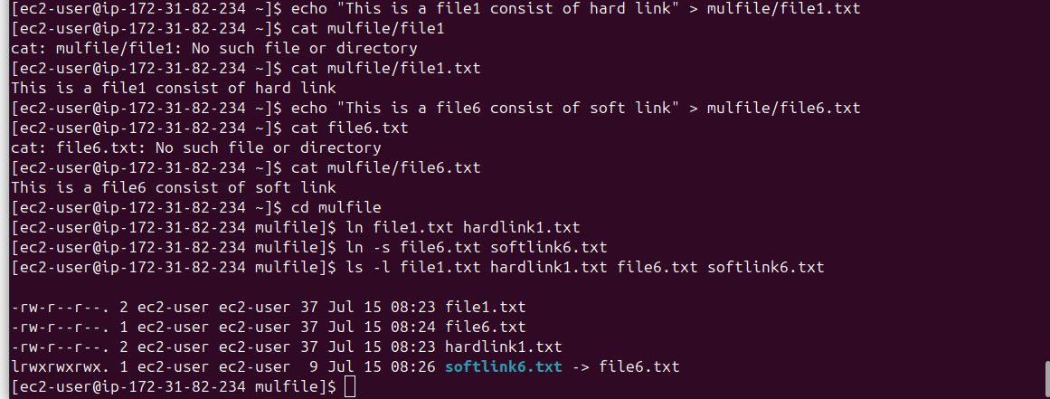

e)Search for large files in the directory (e.g., larger than 1 MB) and delete them.

To search for larger fies in the directory which is larger than 1 Mb and to delete them we make use

**find . -type f -size +1M -delete**

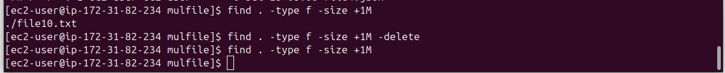

f)Verify the differences in behavior between hard and soft links by listing the inode numbers of the linked files.

To list inode numbers of the linked files we make use of

**ls -li file1.txt hardlink1.txt file6.txt softlink6.txt**

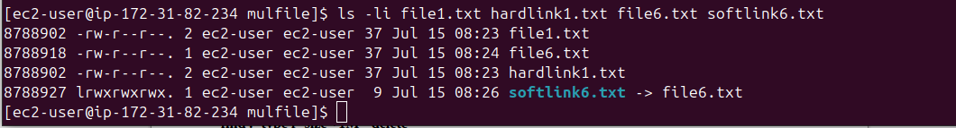

**The behavior difference in between hard link and soft links are**

|  |  |
| --- | --- |
| **hard link** | **Soft Link** |
| same inode number: 8788902 for hard link | same inode number: 8788902 for soft link |
| Same file permission 644 | Same file permission 644 |
| Link count is 2 | Link count is 1 |
| If we delete file1.txt it will still work because it points to the inode | If you delete file6.txt, softlink6.txt becomes broken and unusable. |
| Same inode, same data. | Different inode, just a path. |

**After deleting hard link that is file1.txt still its showing content inside a file**

**after deleting softlink that is file6.txt it is not showing the content so softlink is deleted**

