Jayanthi.M
Assignments:

1) How to check port?

We make use of

sudo ss -lntu

to check the ports
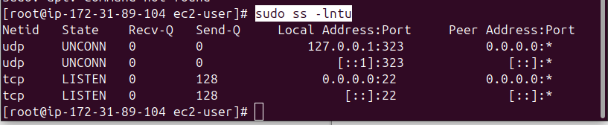

this will show:
- -l: Listening ports
- -n: Don't resolve names (show IPs/ports as numbers)
- -t: TCP
- -u: UDP

2)How to check all busy ports?

To check all busy ports we make use of

sudo ss -tunap | grep ESTAB

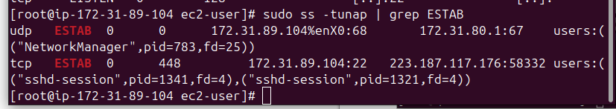

This will show

Part | Meaning
sudo | Run the command with root privileges (required to see all processes)
ss | Utility to dump socket statistics (faster and more modern than netstat)
-t | Show TCP connections only
-u | Show UDP connections only (included here to see both TCP/UDP)
-n | Show IP addresses and port numbers, not domain/service names
-a | Show all sockets (listening and non-listening)
-p | Show processes using each socket
` | grep ESTAB` (Connection is established and active)

Method 2: netstat -l

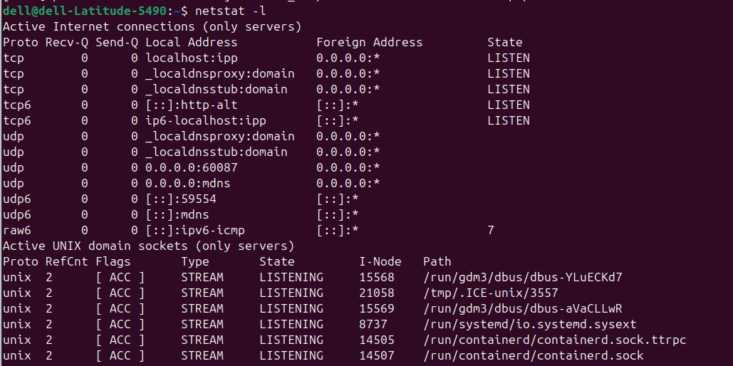

3) List all the used ports?

Command to list and print used ports

sudo ss -tuln | awk '{print $5}' | cut -d : -f2 | grep -E '^[0-9]+$' | sort -n | uniq

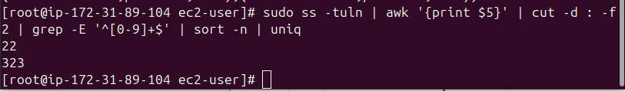
method 2: we can use

netstat -ano to list all the process

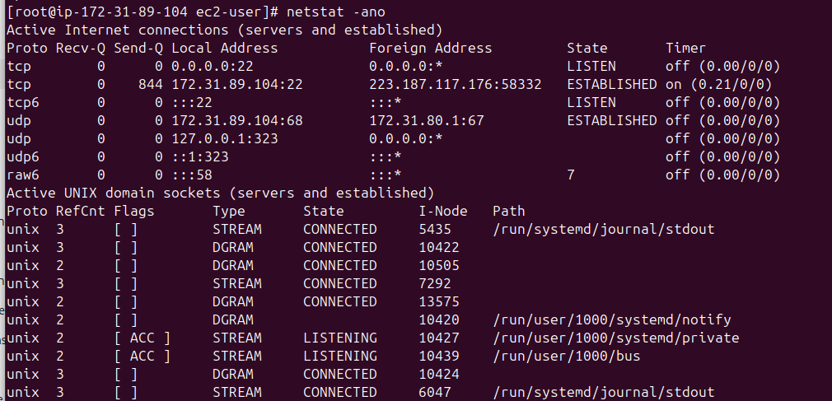

4) To check Which software using which port?

sudo netstat -tulpn

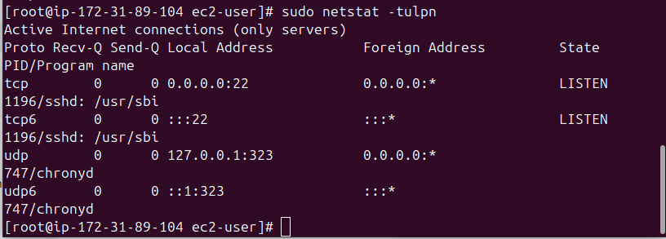

5)How to check how long system is up and running?

uptime

is the command used to check how long system is up and running

6)What is load average?

Load average is a measure of how busy your Linux/Unix system's CPU(s) are.
It shows the average number of processes that are:
- Running (actively using the CPU), or
- Waiting to run (queued for CPU time)
7) How to check available ports or free ports on the system?
Netstat -a
is used to check all the available ports
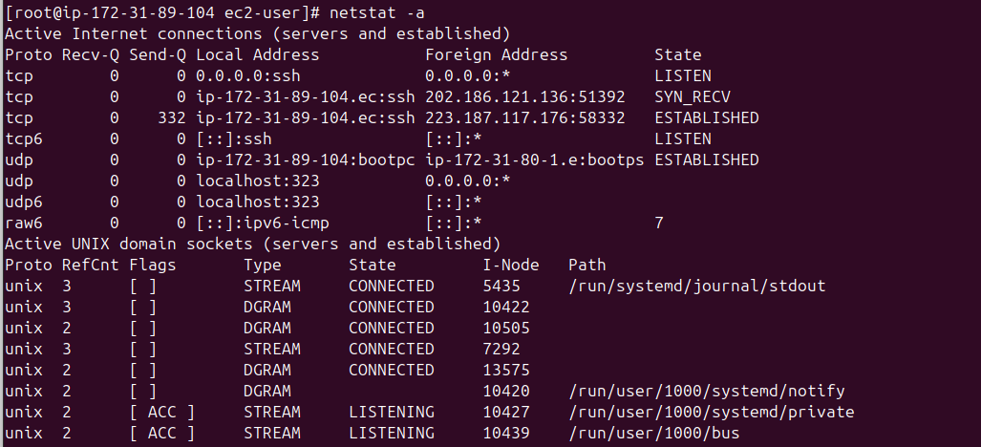

8)Setup a pass wordless connection between two servers?

Steps to setup a pass wordless connection between two servers are:

Let's assume:
- Server A = your local or source machine (where you initiate SSH)
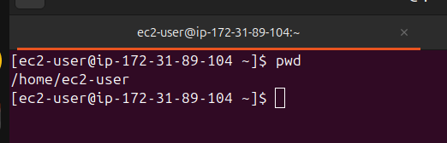
- Server B = remote or destination machine (you want to connect to without password)

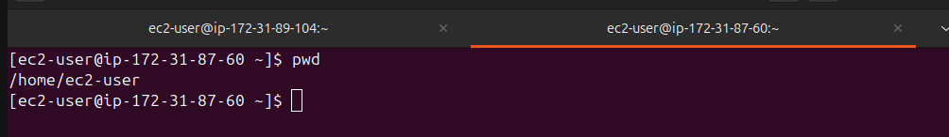

🔹 Step 1: Generate an SSH Key on Server A using the below command
ssh-keygen -t rsa
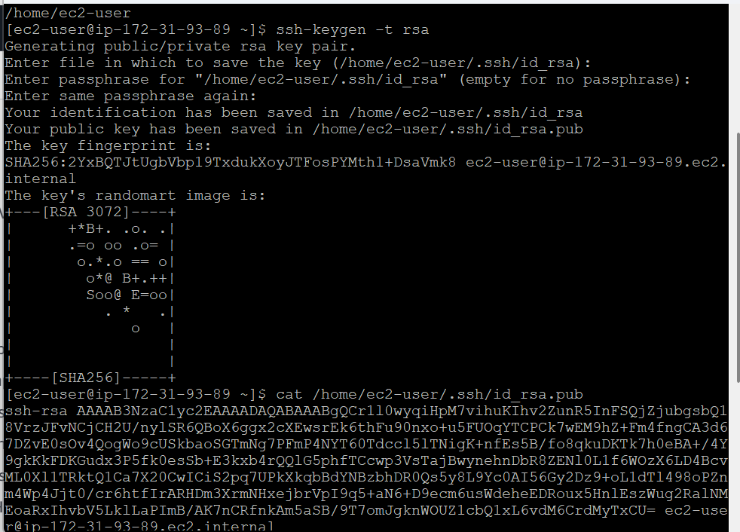
🔹 Step 2: Copy the Public Key to Server B
cat /home/ec2-user/.ssh/id_rsa.pub

🔹 Step 3: login to serverB using the below command
cd .ssh
vi authorized_keys
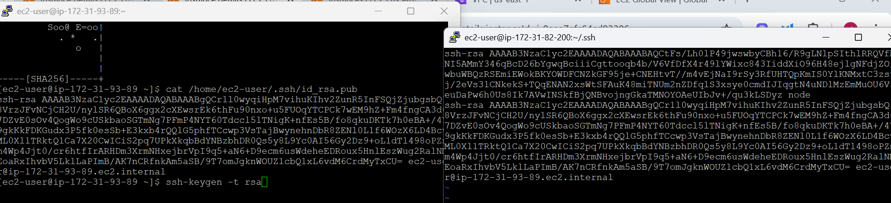
paste key at the end of a file without changing the existing key and save it.
🔹 Step 4: goto serverA and run the below command
ssh ec2-user@serverA

