Jayanthi M
Assignments : 5 and 6

Assignment 5:
Create a file with some sample content. Add additional lines of text to the file without overwriting the existing content.
Modify the file to replace occurrences of a specific word with another word.
Extract specific columns from the file if it contains tabular data. For instance, display only the second column.
Identify lines in the file that begin with a specific pattern, such as a number or letter.
Remove duplicate lines from the file and sort them alphabetically.
Identify the largest files in the directory and list the top five in descending order of size.
Combine multiple utilities to extract the names of files with a particular extension in a folder and display only their names.

a)Create a file with some sample content.

We create a file using touch sample.txt or vi sample.txt

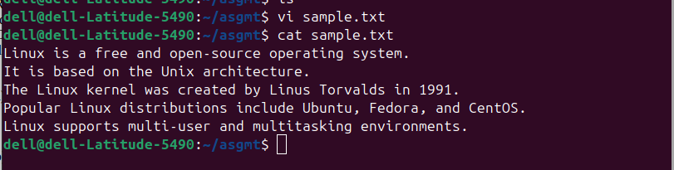

b)Add additional lines of text to the file without overwriting the existing content.

Using echo “Linux file permissions are managed using read, write, and execute flags.” >> sample.txt we can add additional lines of text to file without overwriting the existing content.

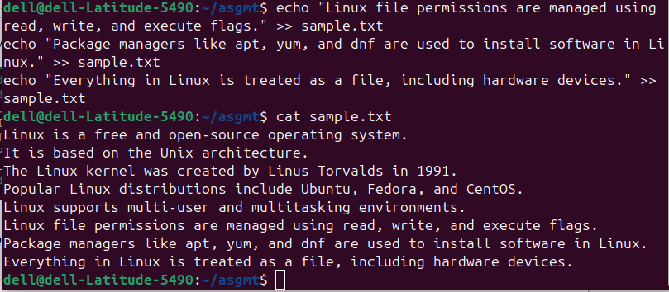

c)Modify the file to replace occurrences of a specific word with another word.

Using sed -i ‘s/fil/directory/g’ sample.txt we can Modify the file to replace occurrences of a specific word with another word.

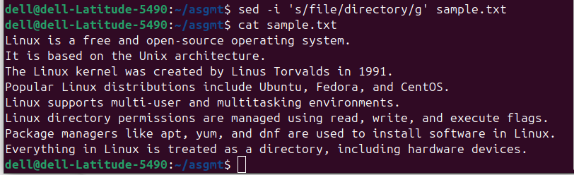

d)Extract specific columns from the file if it contains tabular data. For instance, display only the second column.

To Extract specific columns from the file if it contains tabular data we make use of
awk -F “ “ ‘{print $2}’ sample2.txt

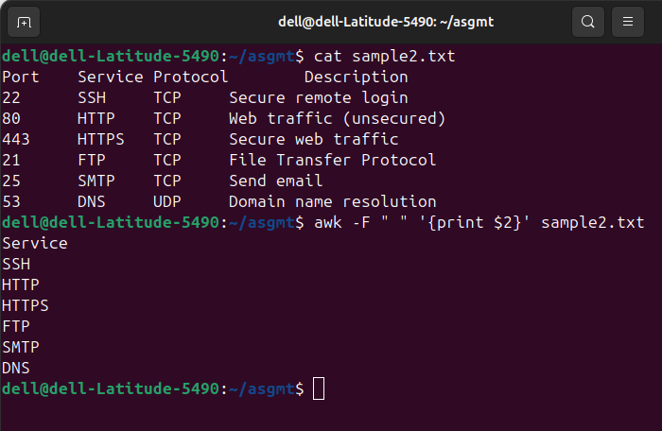

e)Identify lines in the file that begin with a specific pattern, such as a number or letter.

To identify lines in the file that begin with a specific pattern we make use of grep command
grep ‘^[0-9]’ sample.txt

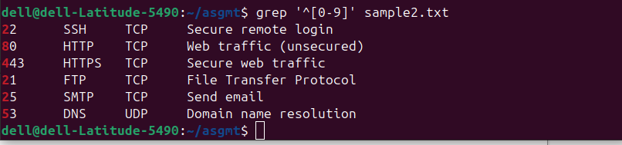
grep -i ‘^linux’ sample.txt

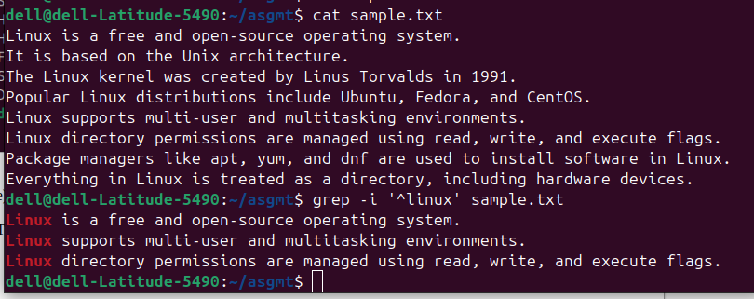

f)Remove duplicate lines from the file and sort them alphabetically.

To Remove duplicate lines from the file and sort them alphabetically we make use of

sort sample.txt | uniq

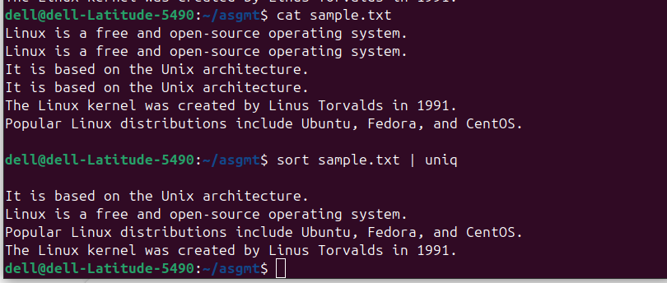
g)Identify the largest files in the directory and list the top five in descending order of size.

TO identify the largest files in the directory and list the top five in descending order of size we make use of ls -lhS | head -n 5

ls : list

-l: long listing
-h: human-readable sizes
-S: sort by size
head -n 5: show top 5

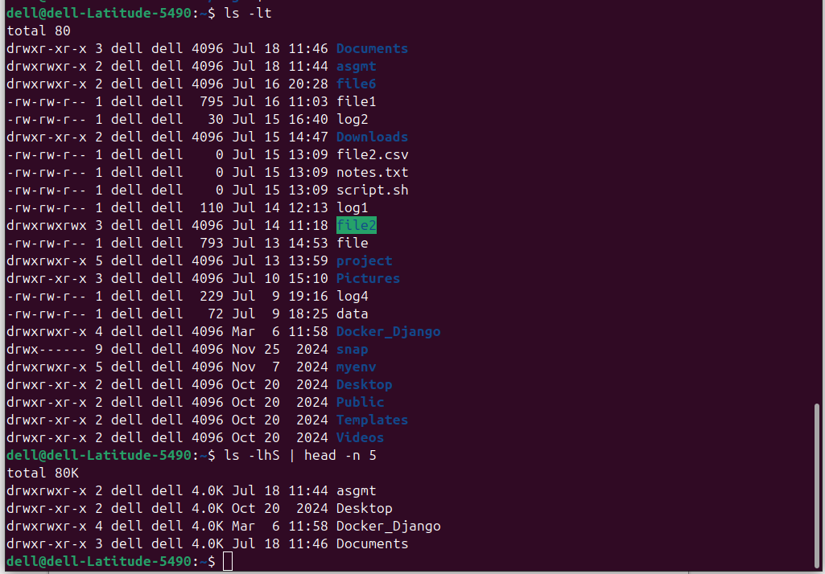

h)Combine multiple utilities to extract the names of files with a particular extension in a folder and display only their names.

To Combine multiple utilities to extract the names of files with a particular extension in a folder and to display only their names we make use of find . -maxdepth 1 -type f -name "*.txt" -exec basename {} \;

Assignment 6:

Create a structure with folders and files containing random data.
Search for all files within a specific folder structure that were modified in the last 90 days.
Modify file permissions:
Make a folder readable, writable, and executable by everyone.
Restrict a file to only be editable by the owner.
List the contents of the main folder sorted by modification time and display only specific columns of metadata (e.g., file owner and group).
Monitor active processes on the system and terminate one by identifying it based on its resource usage.

a)Create a structure with folders and files containing random data.

To create a structure with folders and files we make use of
mkdir -p project/data project/logs project/scripts

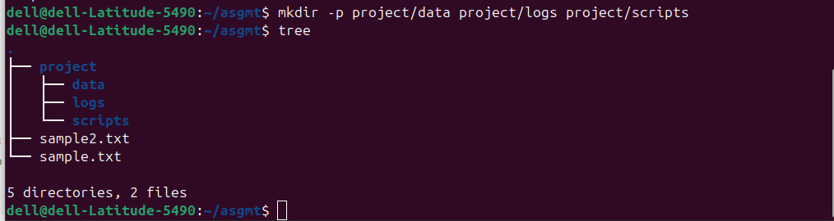
content inside the files


b)Search for all files within a specific folder structure that were modified in the last 90 days.
To search for all files within a specific folder structure that were modified in the last 90 days.

find project/ -type f -mtime -90



c)Modify file permissions:
Make a folder readable, writable, and executable by everyone.

chmod 777 project

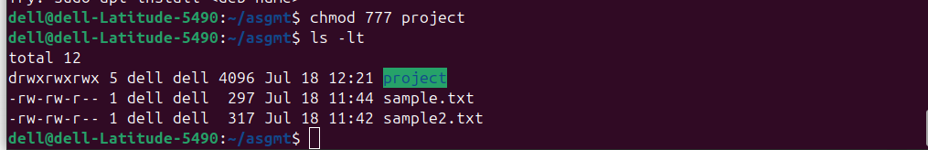

d)Restrict a file to only be editable by the owner.

chmod 600 project/logs/log1.txt

e)List the contents of the main folder sorted by modification time and display only specific columns of metadata (e.g., file owner and group).

ls -lt --time-style=long-iso | awk '{print $3, $4, $NF}'

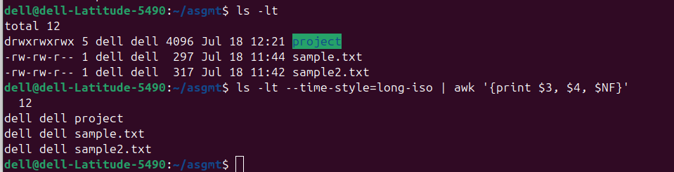

f)Monitor active processes on the system and terminate one by identifying it based on its resource usage.

Step 1: first we make use of top command to check real-time system resource usage.
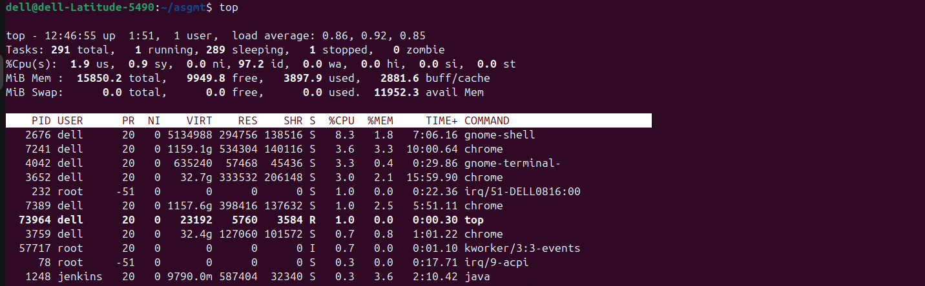
Step2: WE need to use ps command to sort by memory usage

ps aux --sort=-%mem | head

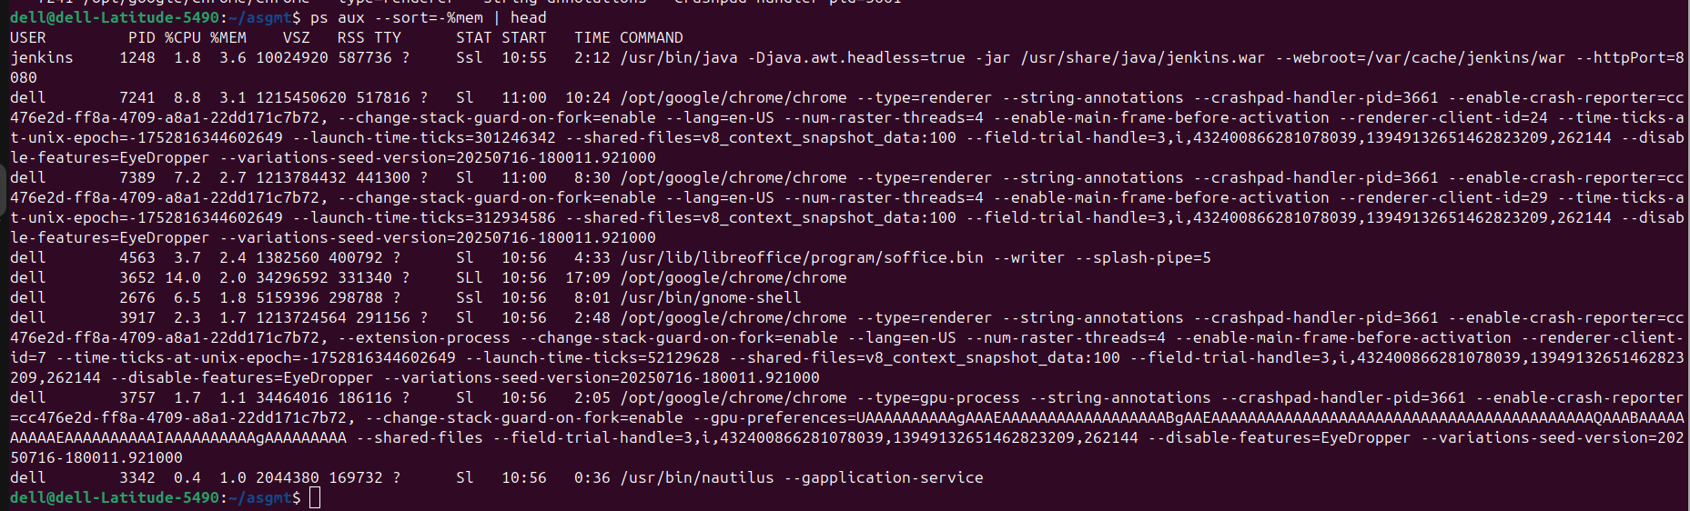

Step3: Before killing the process we need to double check the running process using particular PID which we wants to kill

ps -p 7241 -o pid,cmd

Step 4: Now we can kill the process using “kill -9 7241”

After we can confirm that process is killed or not by using “ps -p 7241”

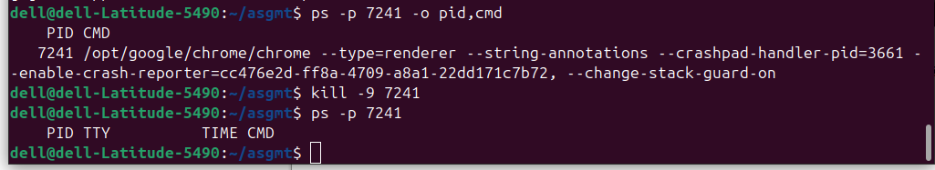

In my system Jenkins is taking more memory usage but due to some reason I am not killing the Jenkins so I killed the chrome that is 7241 which will not effect my systems other process

