Jayanthi
Assignment

Assignment 02/08
1.Write a Bash script that searches for all files with a specific extension (e.g., .txt)
- Copy then to a separate folder call backup with the file and directory name appended with backup
2.Create a Bash script that monitors the CPU and memory usage of a server and sends an alert if the usage exceeds a certain threshold.
The script should also log the usage details with timestamp.

1.Write a Bash script that searches for all files with a specific extension (e.g., .txt)
- Copy then to a separate folder call backup with the file and directory name appended with backup

#!/bin/bash
mkdir -p backup
find . -type f -name "*.txt" | while read -r file; do
dir=$(dirname "$file")
base=$(basename "$file" .txt)
mkdir -p "backup/$dir"
new_name="${base}_backup.txt"
cp "$file" "backup/$dir/$new_name"
done
echo "Backup complete. Files copied to ./backup"

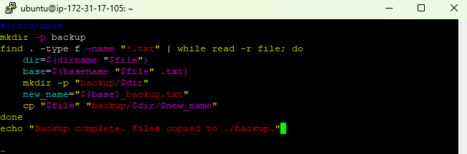
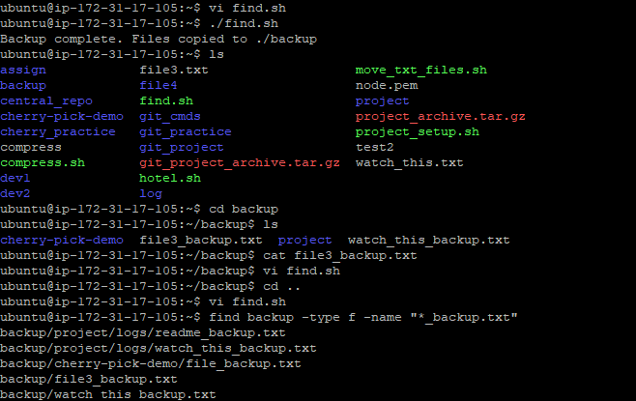

2.Create a Bash script that monitors the CPU and memory usage of a server and sends an alert if the usage exceeds a certain threshold.
The script should also log the usage details with timestamp.

#!/bin/bash
CPU_LIMIT=05
MEM_LIMIT=20
LOGFILE="usage.log"
while true; do
TIME=$(date '+%Y-%m-%d %H:%M:%S')
CPU_IDLE=$(top -bn1 | grep "Cpu(s)" | awk -F',' '{print $4}' | awk '{print int($1)}')
CPU_USED=$((100 - CPU_IDLE))
MEM_USED=$(free | awk '/Mem:/ {printf "%.0f", $3/$2 * 100}')
echo "$TIME CPU: $CPU_USED% MEM: $MEM_USED%" >> "$LOGFILE"
if [ "$CPU_USED" -gt "$CPU_LIMIT" ]; then
echo "ALERT: CPU usage is high at $CPU_USED% ($TIME)"
fi
if [ "$MEM_USED" -gt "$MEM_LIMIT" ]; then
echo "ALERT: Memory usage is high at $MEM_USED% ($TIME)"
fi
sleep 60
done

