Jayanthi.M
Assignment

Assignment 12/10
Write a Dockerfile using Ubuntu as the base image. Use the custom image to run a container, and ensure that the application is accessible from the outside world
Prerequisite is
Install java
Step 1: Create your project folder
- Open a terminal (Git Bash).
- Create a new folder for project:
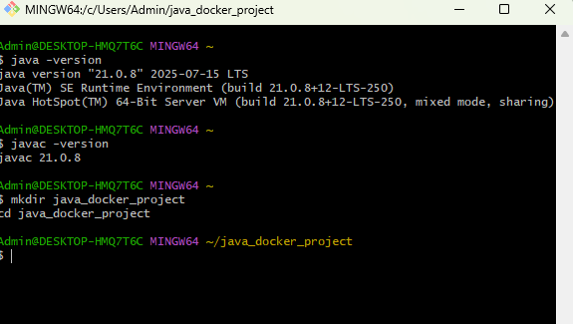

Step 2: Create a simple Java project
Inside java_docker_project, create a file called App.java:
Using touch App.java
Open it in a text editor and write minimal Java HTTP server code:
vi App.java
import java.io.IOException;
import java.io.OutputStream;
import com.sun.net.httpserver.HttpServer;
import com.sun.net.httpserver.HttpHandler;
import com.sun.net.httpserver.HttpExchange;
import java.net.InetSocketAddress;

public class App {
public static void main(String[] args) throws IOException {
HttpServer server = HttpServer.create(new InetSocketAddress(8080), 0);
server.createContext("/", new MyHandler());
server.setExecutor(null);
System.out.println("Server started on port 8080");
server.start();
}

static class MyHandler implements HttpHandler {
public void handle(HttpExchange exchange) throws IOException {
String response = "Hello from Java Docker container!";
exchange.sendResponseHeaders(200, response.length());
OutputStream os = exchange.getResponseBody();
os.write(response.getBytes());
os.close();
}
}
}

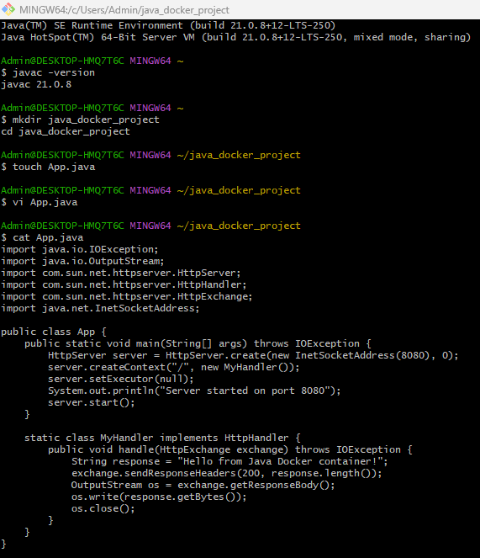

Step 3: Create the Dockerfile
In the same folder, create a file called Dockerfile.
# Use Ubuntu as the base image
FROM ubuntu:22.04

# Set environment variable to avoid prompts
ENV DEBIAN_FRONTEND=noninteractive

# Install OpenJDK 21
RUN apt-get update && \
apt-get install -y wget unzip openjdk-21-jdk && \
apt-get clean

# Set JAVA_HOME
ENV JAVA_HOME=/usr/lib/jvm/java-21-openjdk-amd64
ENV PATH=$JAVA_HOME/bin:$PATH

# Set working directory
WORKDIR /app

# Copy Java source code into container
COPY App.java /app/

# Compile Java code
RUN javac App.java

# Expose port
EXPOSE 8080

# Run the Java application
CMD ["java", "App"]

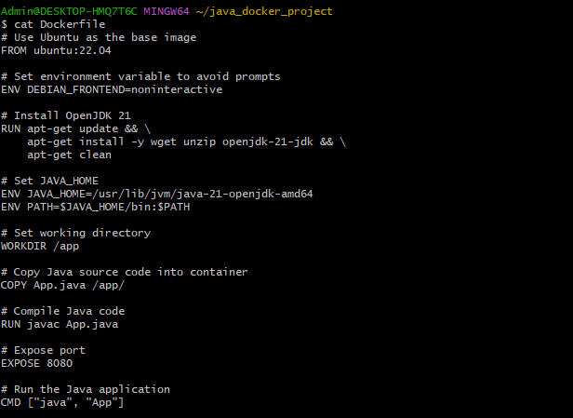

Step 4: we need to Test locally

To Make sure Docker is running.

Build the Docker image using below docker cmd:
docker build -t my-java-app .

we need run the container and expose port 8080:

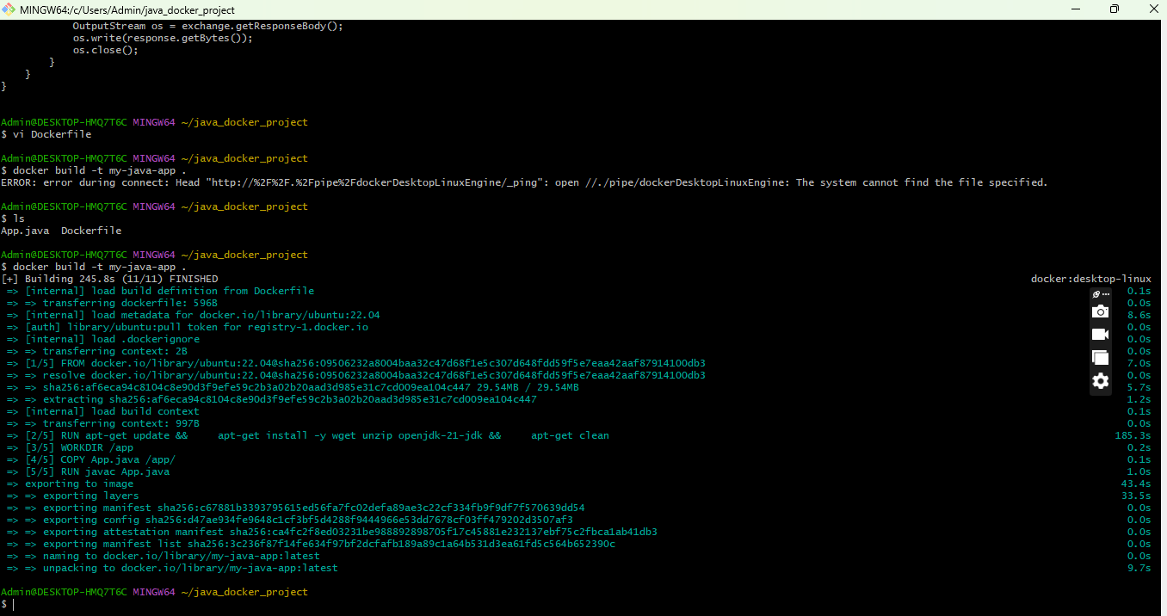

docker run -d -p 8080:8080 --name java_app_container my-java-app

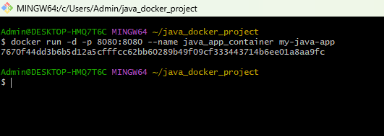

We need to test in your browser

http://localhost:8080

