Jayanthi M
Assignment 29/10
create a custom Docker network, launch 2 dummy containers, and make them communicate with each other
Step 1: Create a custom Docker network
docker network create my_custom_network
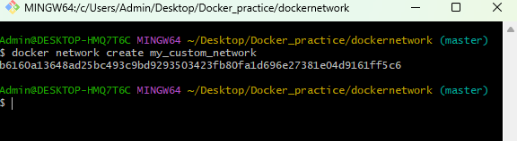
To Check network:
docker network ls
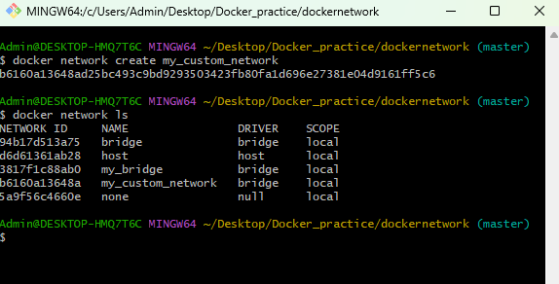
create 2 dummy containers using below command
docker run -itd --name container1 --network my_custom_network ubuntu
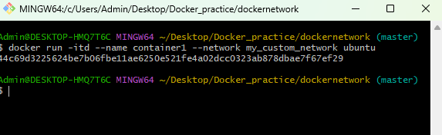
docker run -itd --name container2 --network my_custom_network ubuntu
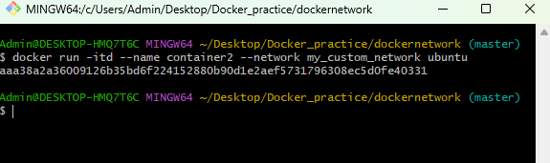
run the below command to check the running container
docker ps
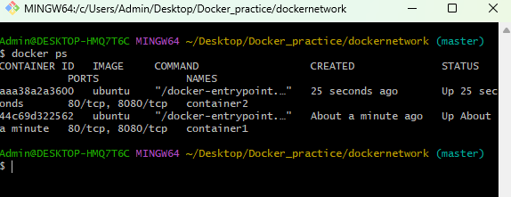
Step 3: Install ping inside containers
Container1
docker exec -it container1 bash
apt update && apt install -y iputils-ping
exit
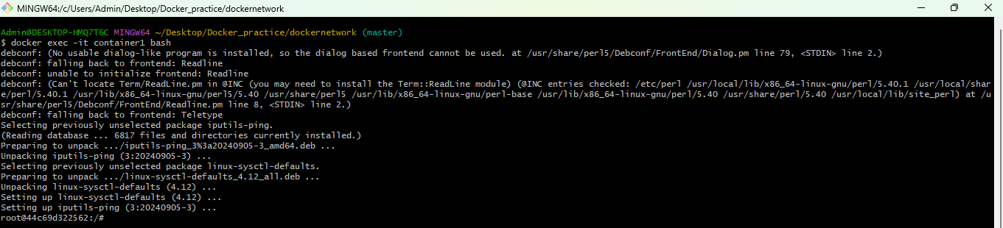
container2
docker exec -it container2 bash
apt update && apt install -y iputils-ping
exit
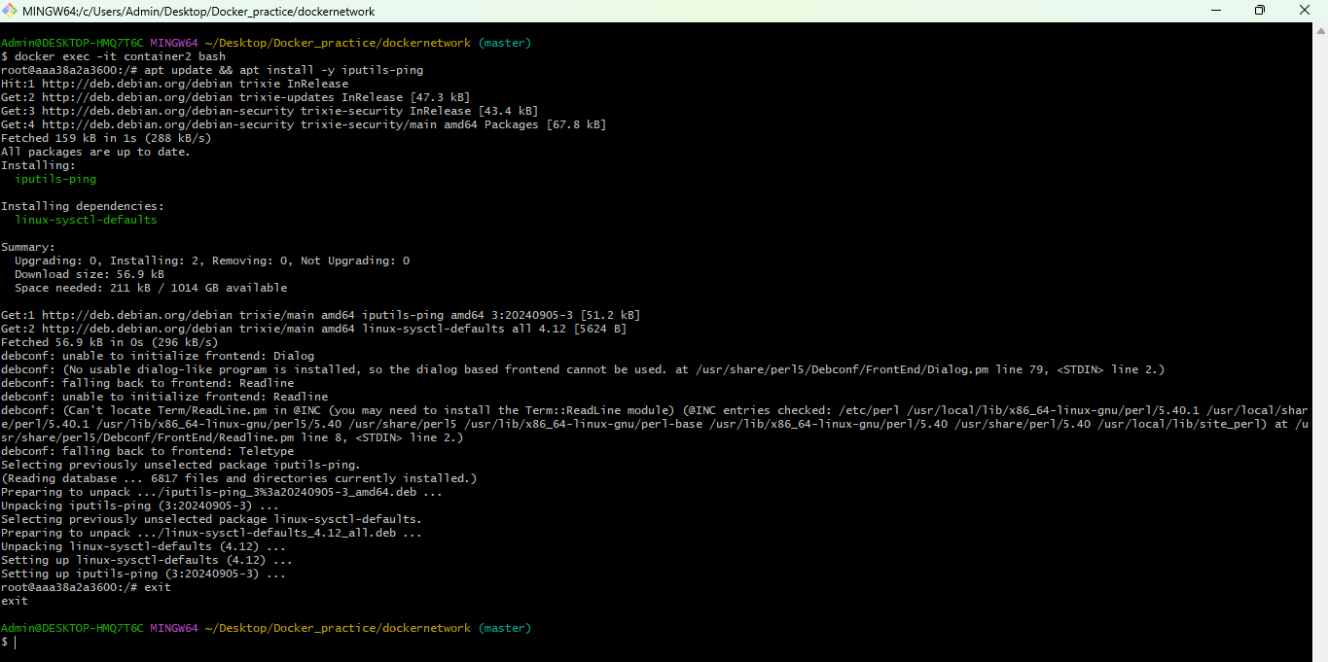
Step 4: Test communication
Command to Ping container2 from container1:
docker exec -it container1 bash
ping container2
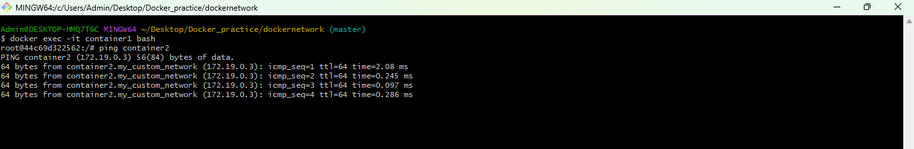
Ping container1 from container2:
docker exec -it container2 bash
ping container1
