Jayanthi M
Assignment
Assignment 09/08*
Task 1: Create a new branch, make some changes, commit them, and merge it back into
the main branch.

Task 2:- Task: Create a merge conflict intentionally by editing the same part of a file in two
branches and resolve it manually

Task 1: Create a new branch, make some changes, commit them, and merge it back into
the main branch.
We need to create a git repository and initializing git repository and creating a branch using below command
mkdir central_repo
git init
echo "Initial commit" > file.txt
git add file.txt
git commit -m "Initial commit"
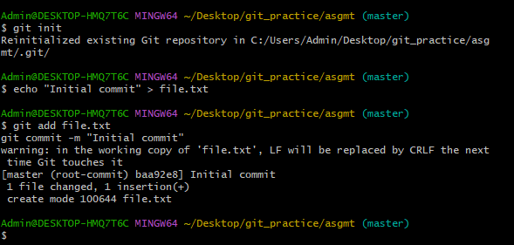

a.1) Create a new branch, make some changes, commit them, and merge it back into
the main branch.
To create a new branch we make use of
git branch <branch_name>
ex: git branch feature
make changes to feature branch
echo "This is a new feature" >> feature.txt
git add feature.txt
to commit the changes to new branch
git commit -m "Added feature.txt with new feature"
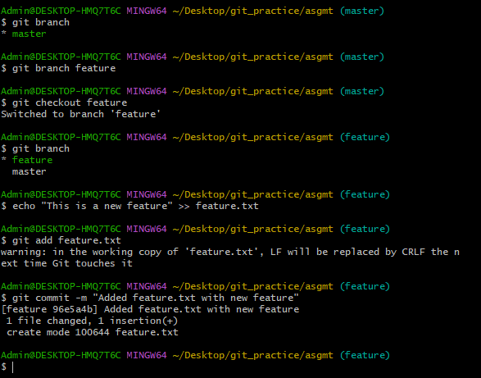

merge it back into the main branch.
git merge feature
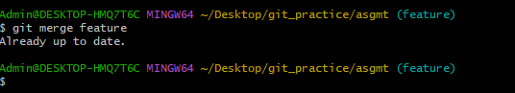

Task 2:- Task: Create a merge conflict intentionally by editing the same part of a file in two
branches and resolve it manually
For Task 2 (merge conflict)
We have three branches:
- master (main branch)
- feature
- conflict-branch

- we start editing a file in one branch (say feature).
- we then edit the same part of the same file in the other branch (conflict branch).
- When you try to merge them — Git sees both branches touched the same lines → conflict.
Step 1 — Switch to master – because I am in feature branch now so
git checkout master
Step 2 — Create branch named conflict-branch
git branch conflict-branch
Step 3 - switch to conflict-branch from main-branch
git checkout conflict-branch
Step 4 - Make changes in conflict-branch
Edit a file (or create one) — make sure to pick a file that also exists in master and will be edited there too.
echo "Edit from conflict-branch" > conflict.txt
git add conflict.txt
git commit -m "Edit from conflict-branch"
Step 5 — Switch to master and edit the same part
git checkout master
echo "Edit from master branch" > conflict.txt
git add conflict.txt
git commit -m "Edit from master branch"

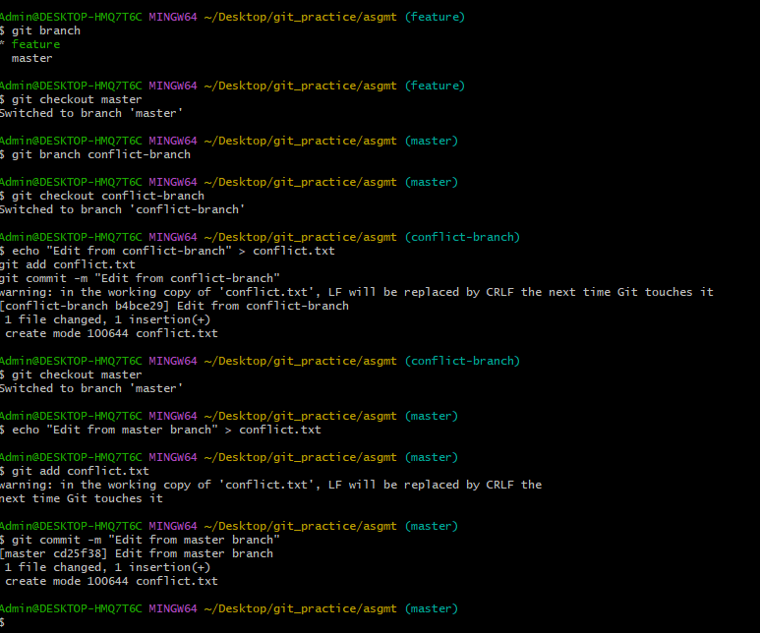

Step 5 — Merge and trigger conflict
git merge conflict-branch
Now Git will show a merge conflict.

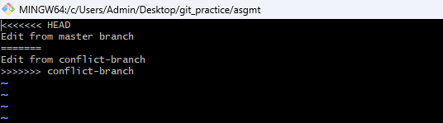

After editing manually, the merge conflict
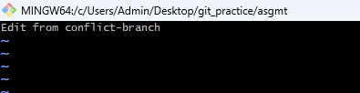

Adding files after solving merge conflict
git add conflict.txt
git commit -m "Resolved merge conflict"

