Jayanthi M
Assignment

Assignment 18/08
1) Create a free style job build deploy and test
2) Connect Jenkins to a GitHub repository and trigger a build when code is pushed.

- Create a free style job build deploy and test.

Steps to Create a Freestyle Job (Build → Deploy → Test)
- Login to Jenkins
We need to create a ec2instance from aws console and using publickey we need to connect to server.
Then we need to install Jenkins before that we need to install java.
Then to start Jenkins
sudo systemctl start Jenkins
sudo systemctl status Jenkins
default port for Jenkins is 8080

  - Open http://<jenkins-server>:8080
  - http://18.215.174.17:8080/
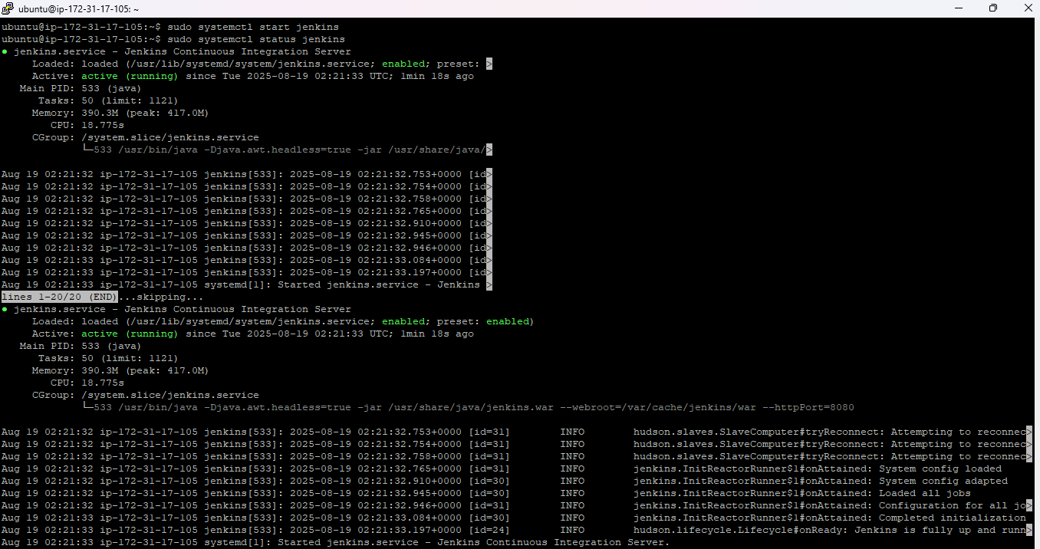
Then we need to login using username and password.

- To Create a new job
  - Click New Item
  - Enter a name (e.g., freestyle-demo)
  - Select Freestyle project
  - Click OK
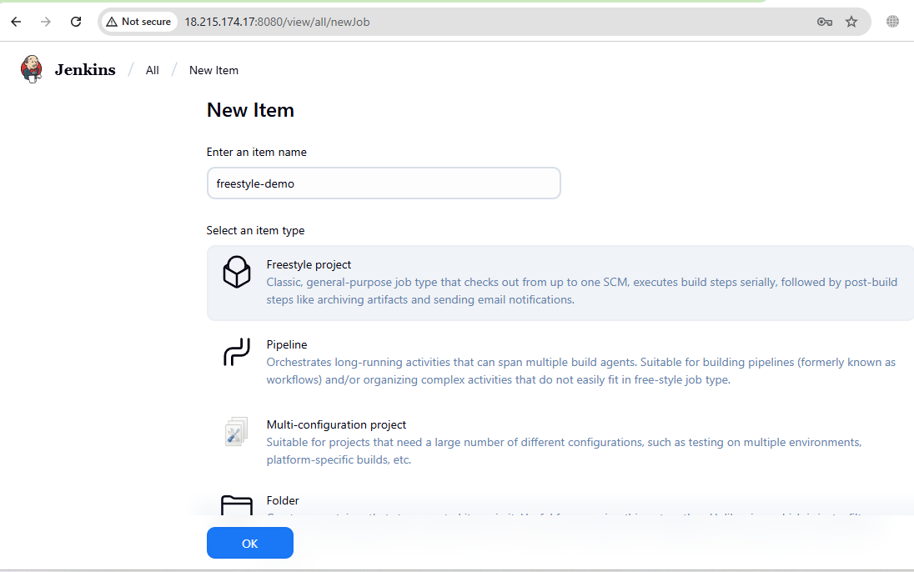
- Build Steps
  - Scroll to Build
  - Click Add build step → Execute shell
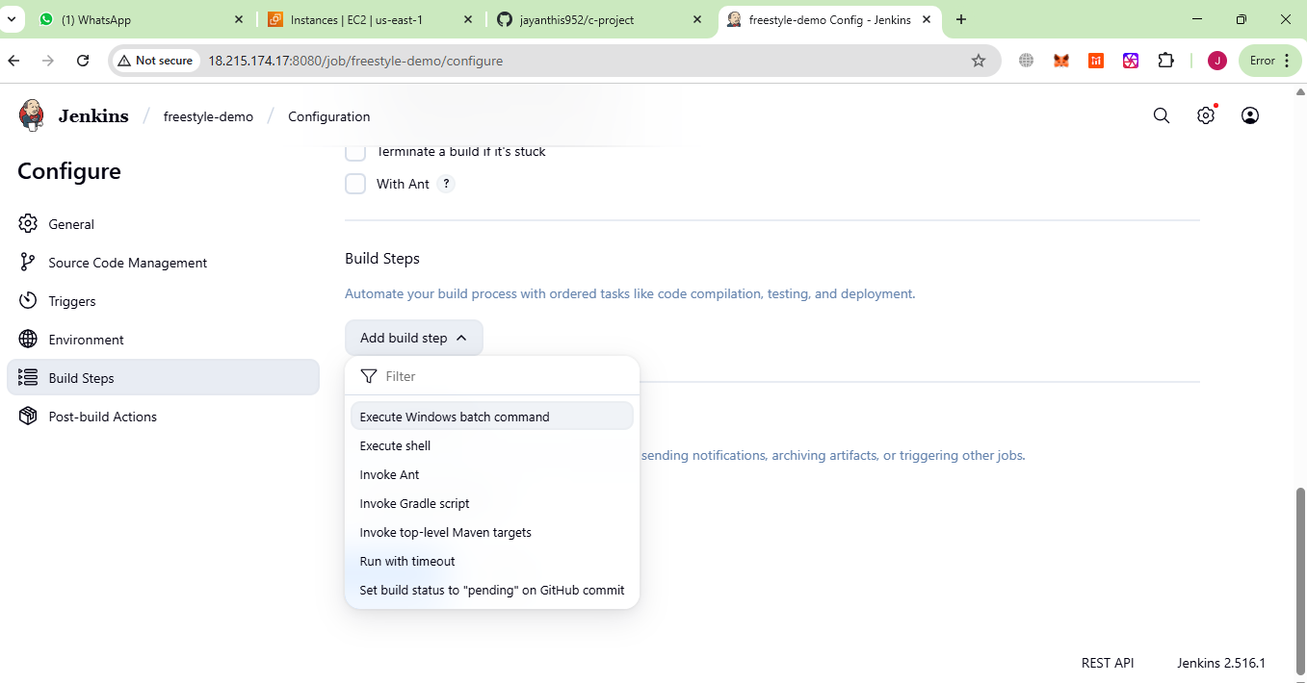
  - Add these simple commands:
  - echo "=== BUILD STEP ==="
  - mkdir -p dist
  - echo "Hello Jenkins Freestyle Build!" > dist/index.html

  - echo "=== DEPLOY STEP ==="
  - cp dist/index.html /tmp/index.html

  - echo "=== TEST STEP ==="
  - if grep -q "Hello Jenkins" /tmp/index.html; then
  - echo "Test Passed "
  - else
  - echo "Test Failed "
  - exit 1
  - fi
  - 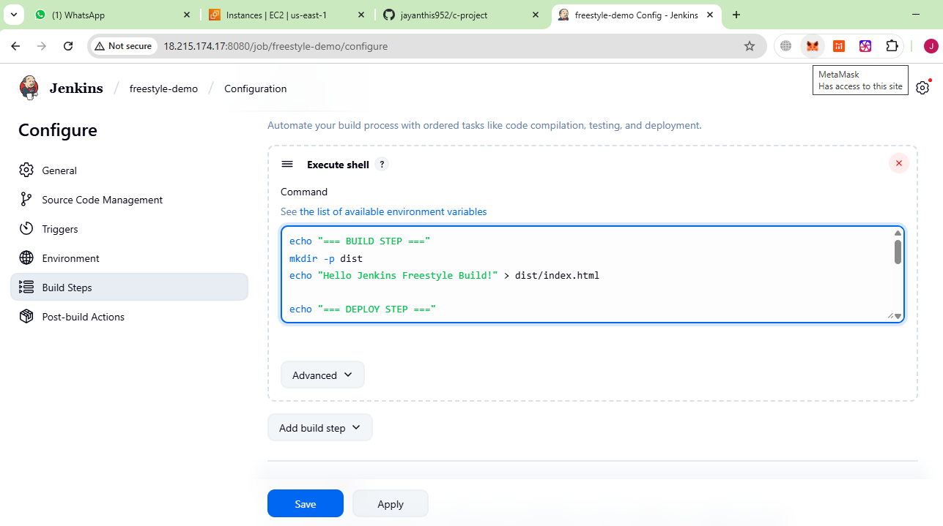
- Save and Run
  - Click Save
  - On the left, click Build Now
  - Go to Build History → Console Output
  - You’ll see logs for BUILD → DEPLOY → TEST
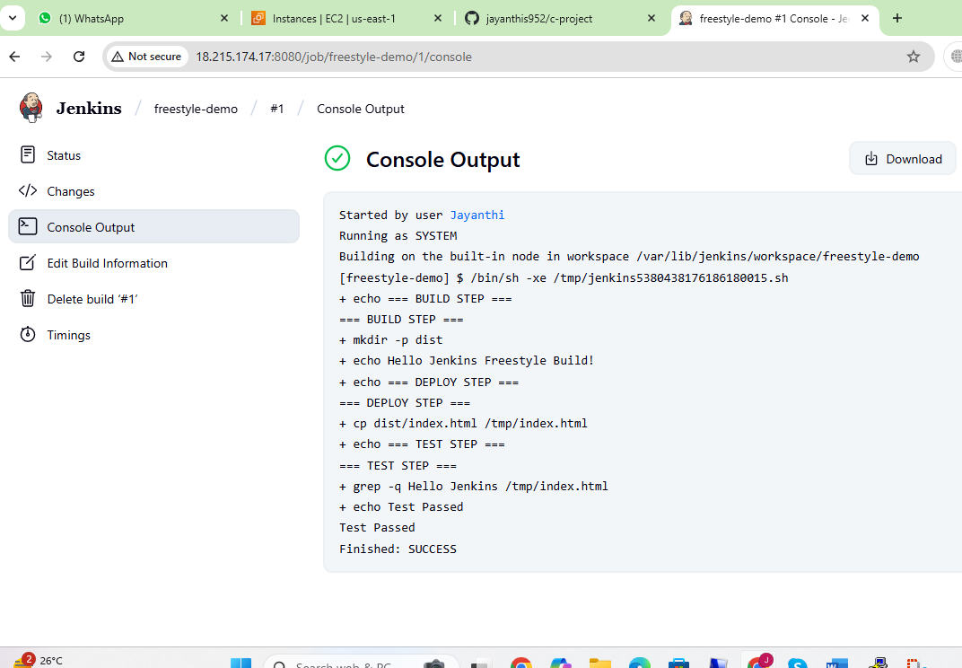

Output:
We can check the created freestyle project in below path.
/var/lib/jenkins/workspace/freestyle-demo/
After running build the dist file is created in below path
/var/lib/jenkins/workspace/freestyle-demo/dist/index.html
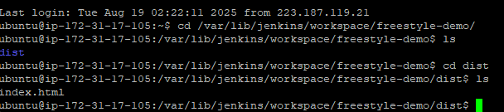

Summary
- Builds (echo file into dist/)
- Deploys (copies to /tmp/)
- Tests (checks content of file)

2) Connect Jenkins to a GitHub repository and trigger a build when code is pushed.
Steps to Connect Jenkins to GitHub & Trigger Build on Push
1. Install Needed Plugins in Jenkins (if github is not installed)
- Go to Settings → Manage Jenkins → Plugins → Available Plugins
- Install:
  - Git plugin (to clone your repo)
  - GitHub plugin (to receive webhooks)
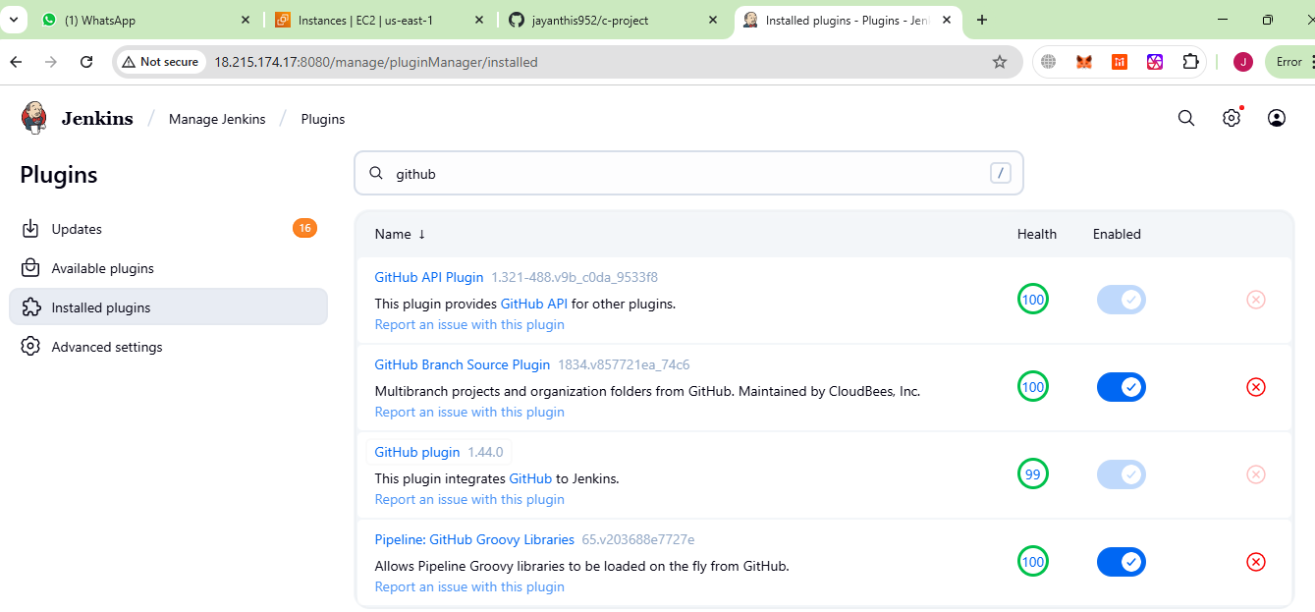

2. Add GitHub Credentials in Jenkins
Click on New item in dashboard → give project name → select freestyle project → give description → under source code management select git → provide git Repository URL → create a credentials by providing username and password → select the credentials → give branches to build (main/master) → save
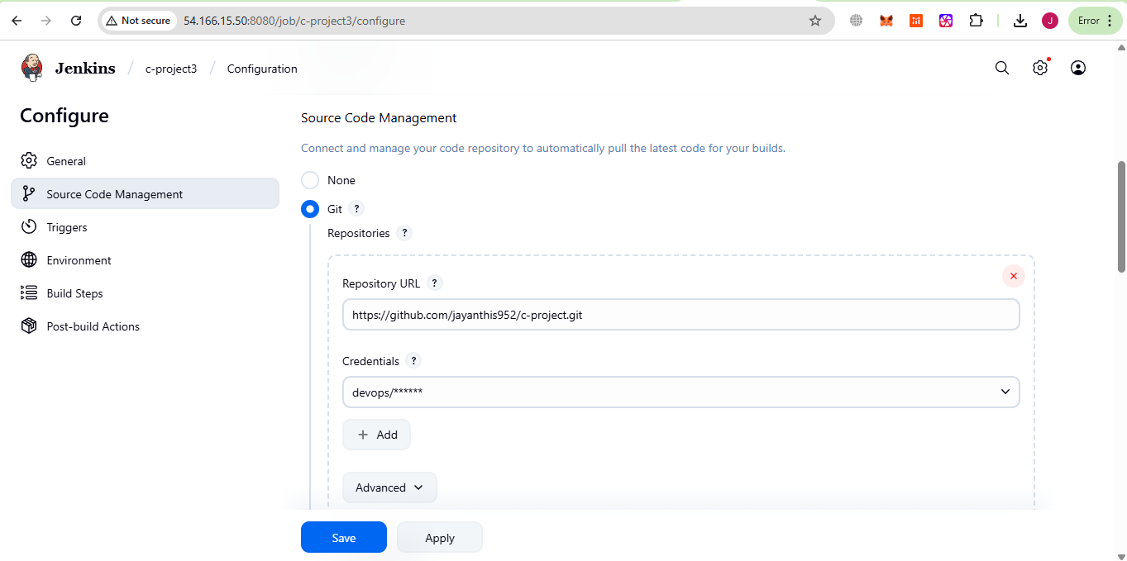
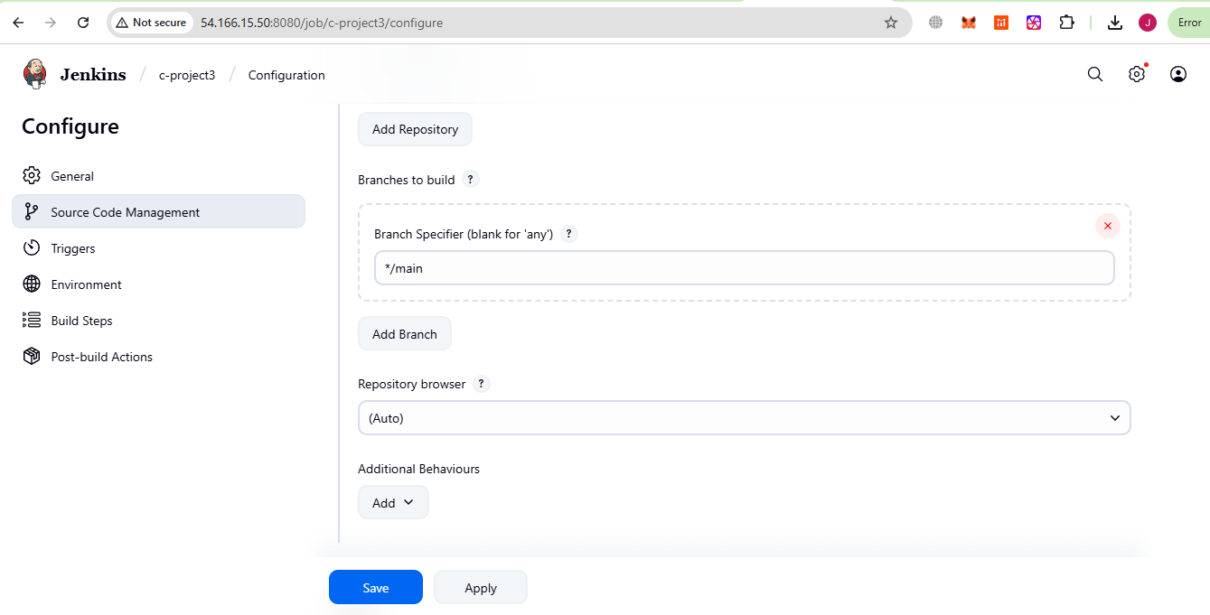

3)To create a Personal access tokens (classic)
Goto settings → developer settings → select Token(classic) → click on generate new token → give note → select scope as repo (checkbox) → click on generate token
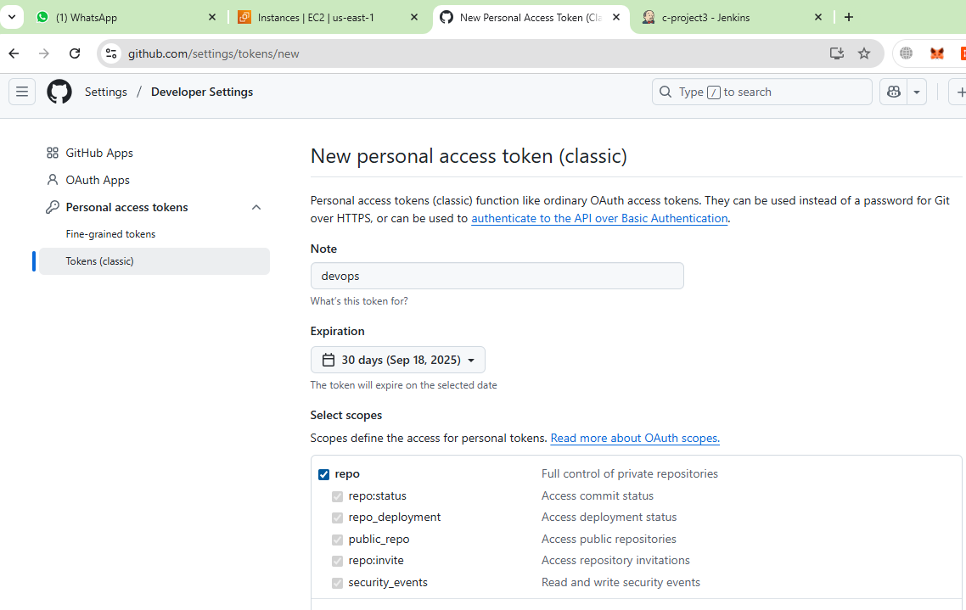

4. To See Output
- In Jenkins, click your job → Build History → Console Output
- We can see logs from pulling the repo + build/deploy/test steps.
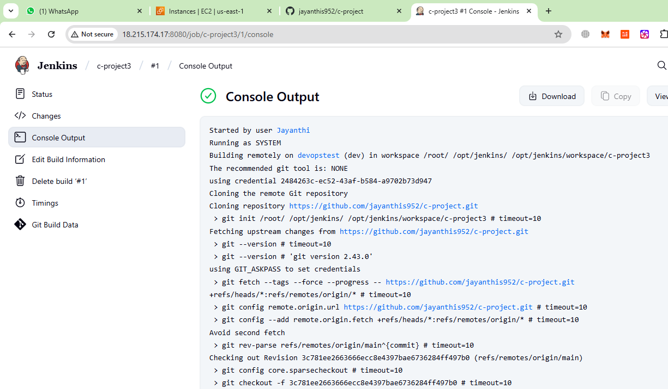

Summary:
- Jenkins job pulls GitHub repo
- Jenkins job starts automatically

