Jayanthi.M
Assignment

Assignment 06/09

Create two new instances and install Tomcat server on both. Ensure they are accessible from the outside world.

Write a Jenkins Declarative Pipeline that includes the following three stages:
Build Stage:
Clone or download an application package (WAR or RAR file), for example, calendar.war.

Deploy Stage:
Deploy the WAR file to two Tomcat servers that have been newly created.
Assume the servers are accessible (use SSH or SCP for deployment).

Test Stage:
Verify the deployment by pinging the Tomcat servers or sending an HTTP request to confirm Tomcat is running and serving the application.

Create two new instances and install Tomcat server on both. Ensure they are accessible from the outside world.

Created 2 EC2instance in aws console.

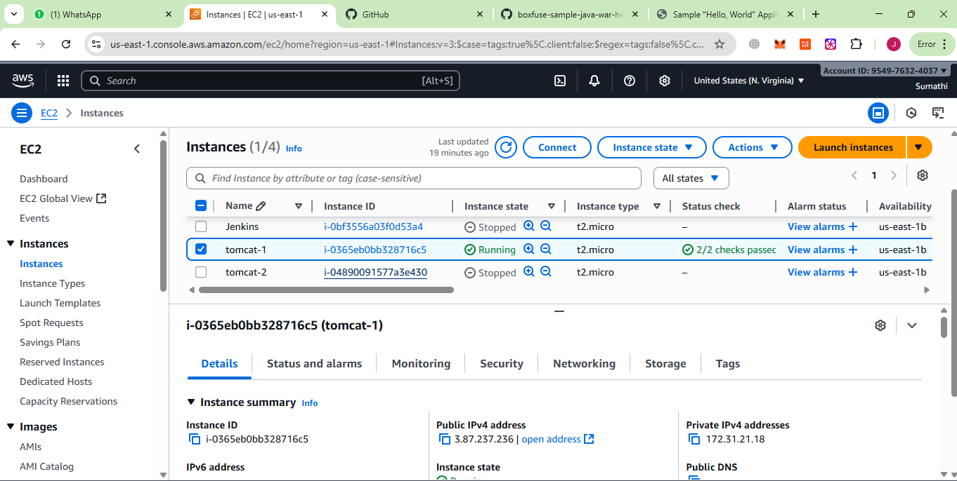
And providing security to access 8080 port as inbound traffic
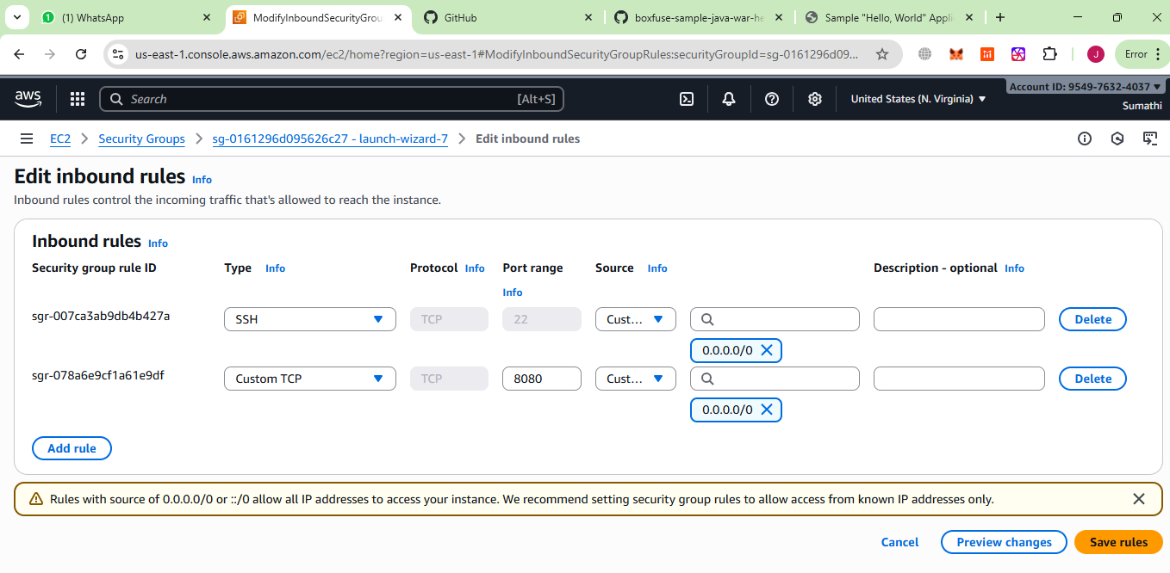

To install tomcat on tomcat1 and tomcat2

Steps to install tomcat

Step1: install java

sudo apt update
sudo apt install -y openjdk-17-jdk wget

To confirm java is installed in server
java -version

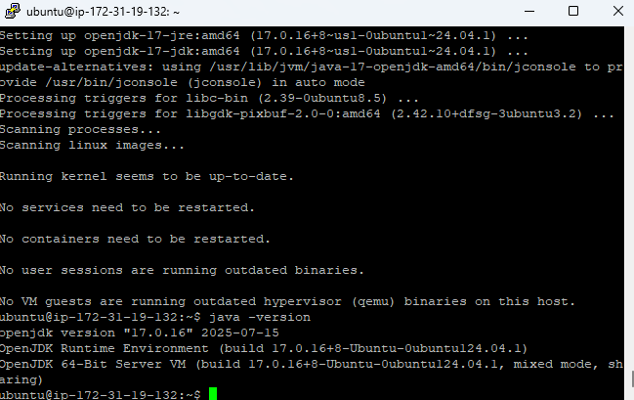

Step2: Install tomcat using below command

cd /opt
sudo wget https://archive.apache.org/dist/tomcat/tomcat-10/v10.1.29/bin/apache-tomcat-10.1.29.tar.gz
sudo tar -xvzf apache-tomcat-10.1.29.tar.gz
sudo mv apache-tomcat-10.1.29 tomcat10
sudo rm apache-tomcat-10.1.29.tar.gz

Step3: Check if the folder exists

ls -l /opt/tomcat10

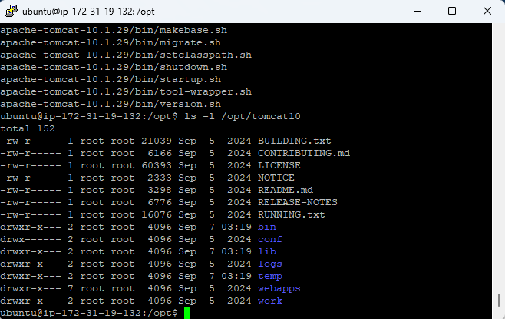

Step4: set the permission and give the current user ownership of the Tomcat directory:

sudo chown -R ubuntu:ubuntu /opt/tomcat10
sudo chmod +x /opt/tomcat10/bin/*.sh

Step 5: Create a Systemd Service
Create the service file so Tomcat starts automatically

sudo nano /etc/systemd/system/tomcat.service

[Unit]
Description=Apache Tomcat 10 Web Application Container
After=network.target

[Service]
Type=forking
User=ubuntu
Group=ubuntu
Environment="JAVA_HOME=/usr/lib/jvm/java-17-openjdk-amd64"
Environment="CATALINA_PID=/opt/tomcat10/temp/tomcat.pid"
Environment="CATALINA_HOME=/opt/tomcat10"
Environment="CATALINA_BASE=/opt/tomcat10"
ExecStart=/opt/tomcat10/bin/startup.sh
ExecStop=/opt/tomcat10/bin/shutdown.sh
Restart=on-failure

[Install]
WantedBy=multi-user.target

Step6: Reload systemd and Start Tomcat

sudo systemctl daemon-reload
sudo systemctl enable tomcat
sudo systemctl start tomcat

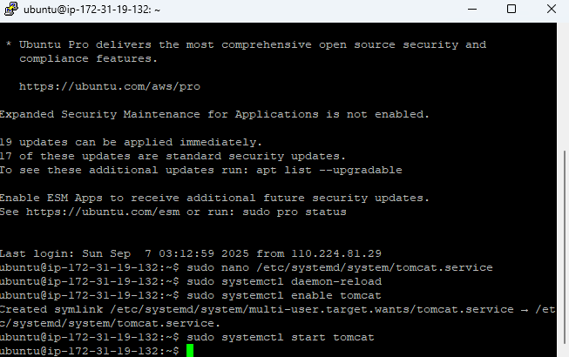

Step7: Verify Tomcat

sudo systemctl status tomcat

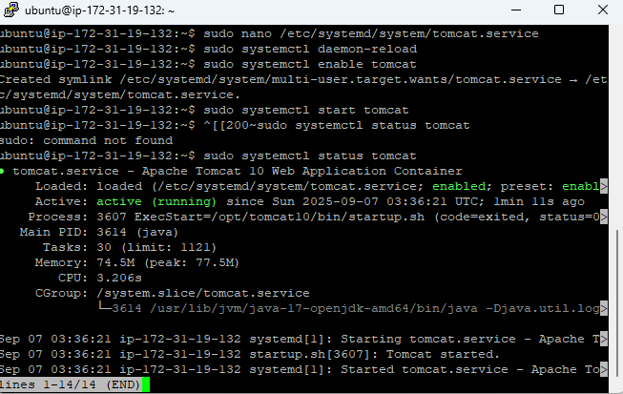

Test the port in google

http:// 18.212.210.112:8080

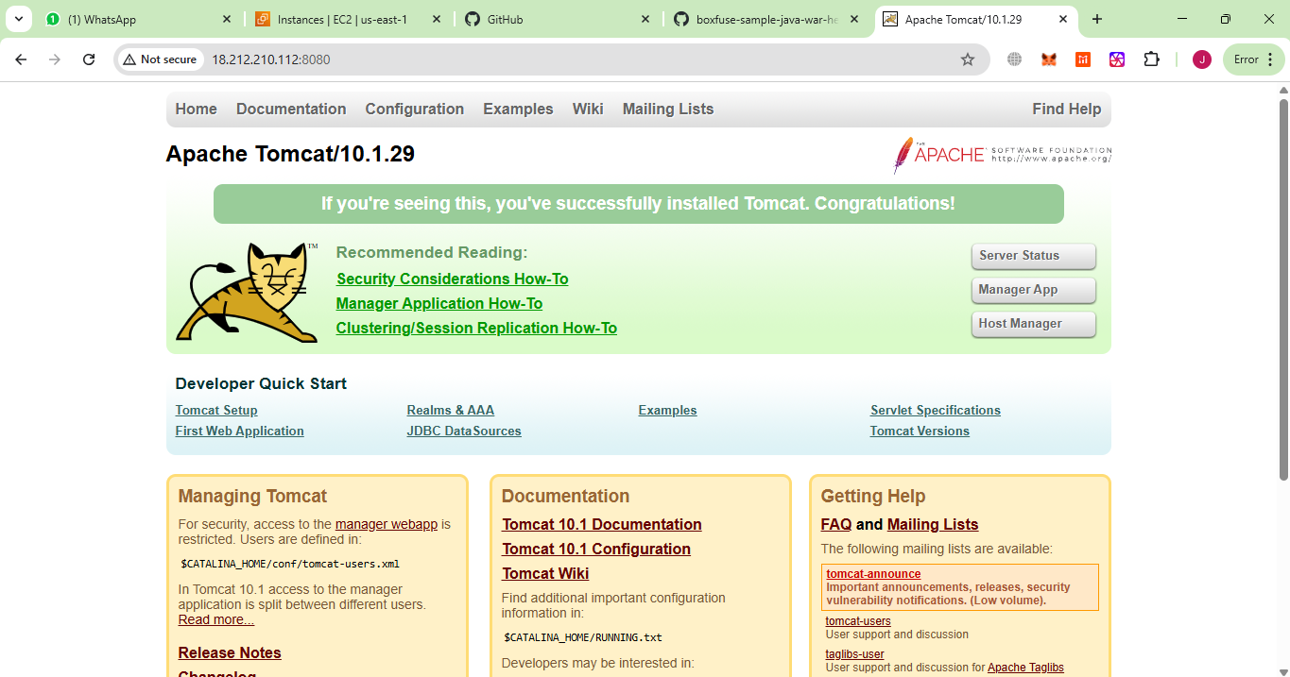

Step 8: Deploy calendar.war
Download sample WAR file and move it to webapps

cd /tmp
wget https://tomcat.apache.org/tomcat-7.0-doc/appdev/sample/sample.war -O calendar.war

check calendar.war is exist or not

ls -l /tmp/calendar.war

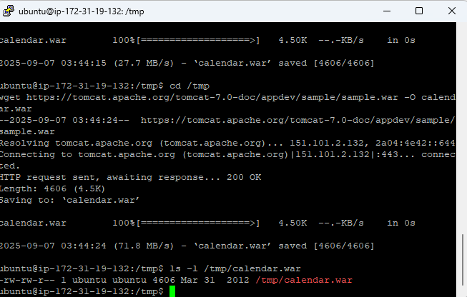

We need to move tomcat to webapps

sudo mv /tmp/calendar.war /opt/tomcat10/webapps/
sudo chown ubuntu:ubuntu /opt/tomcat10/webapps/calendar.war
sudo chmod 644 /opt/tomcat10/webapps/calendar.war

we need to restart the tomcat to deploy

sudo systemctl restart tomcat
we need to verify deployment

ls -l /opt/tomcat10/webapps/

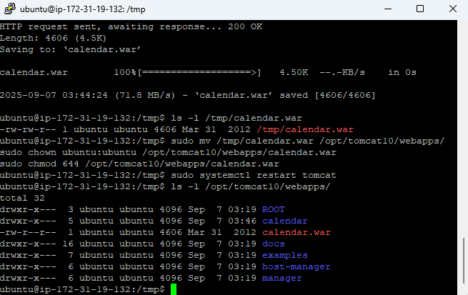

now we need to test the browser

http://18.212.210.112:8080/calendar/

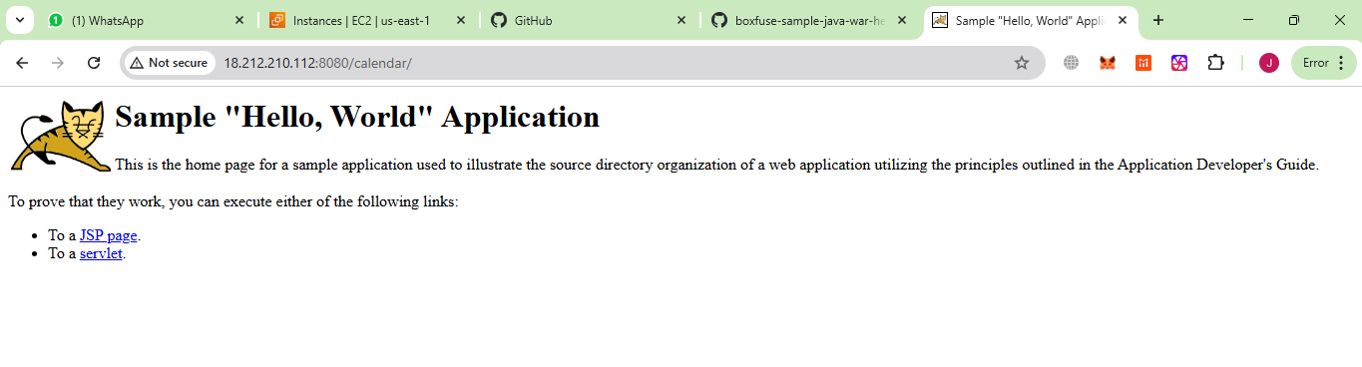
Write a Jenkins Declarative Pipeline that includes the following three stages:
Build Stage:
Clone or download an application package (WAR or RAR file), for example, calendar.war.

To do this we need to generate a ssh key from jenkin_ec2instance and we need to take the id_rsa pub key and paste this in tomcat1_ec2instace and tomcat2_ec2instance

To check id_rsa public key is already present or not
ls -l ~/.ssh/

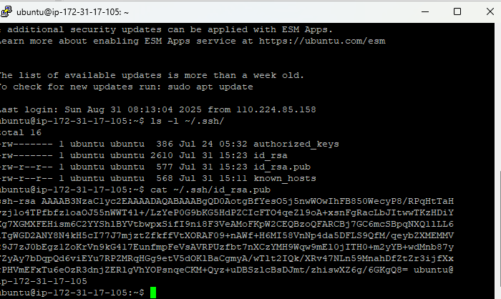

We need to take this key copy paste this id_rsa pub key to tomcatserver1 and tomcatserver2

nano ~/.ssh/authorized_keys

paste the key

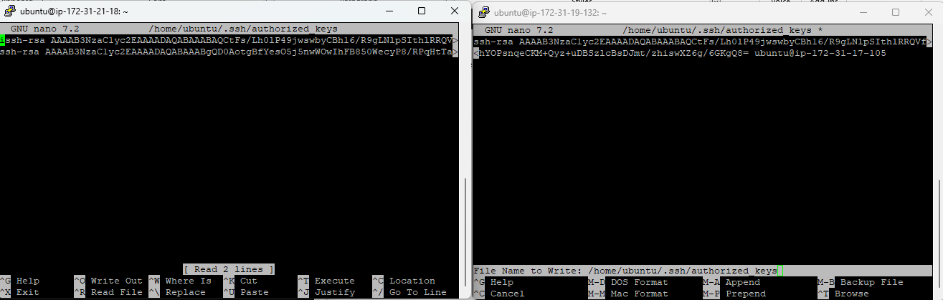

Step 9: Add SSH Key in Jenkins
- Go to Jenkins → Manage Jenkins → Credentials → System → Global → Add Credentials
- Select SSH Username with private key
  - Username: ubuntu
  - Private Key: choose “Enter directly” → paste your private key from Jenkins EC2 (~/.ssh/id_rsa)
  - ID: tomcat-key
- Save
This provides Jenkins use SSH to connect to Tomcat1 and Tomcat2.

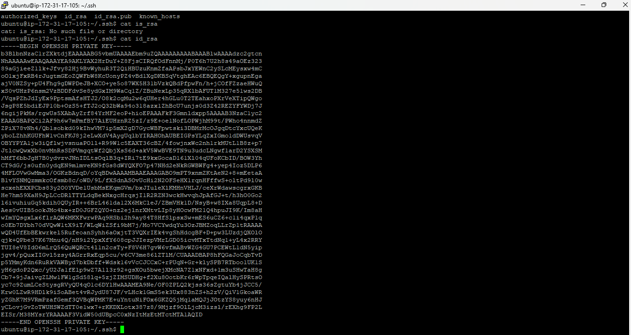

Paste this in Jenkins Credentials

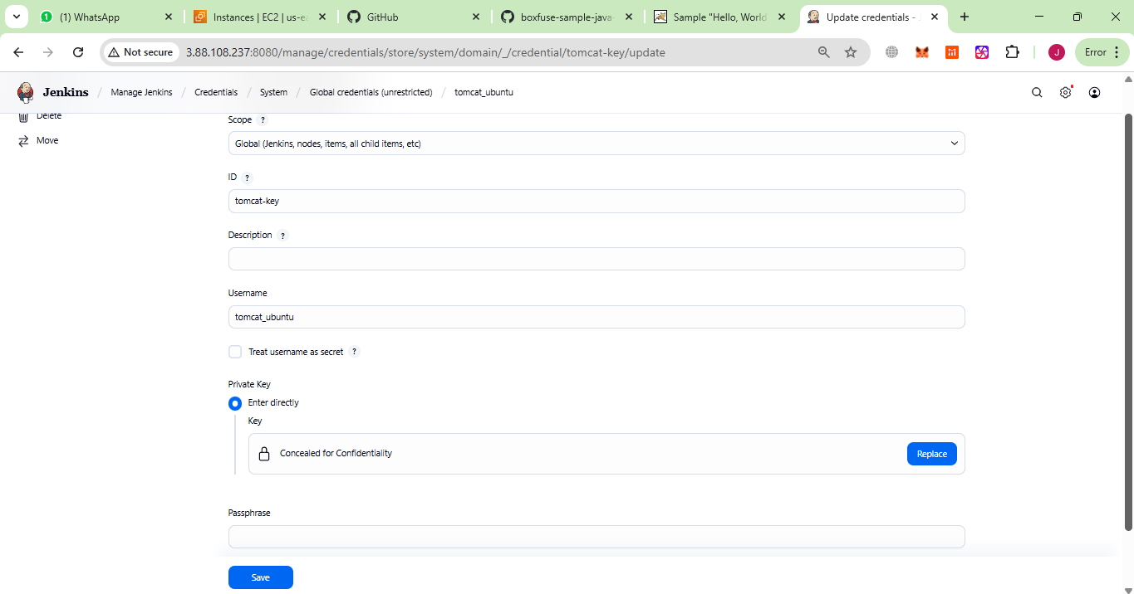

Write a Jenkins Declarative Pipeline that includes the following three stages:
Build Stage:
Clone or download an application package (WAR or RAR file), for example, calendar.war.

Deploy Stage:
Deploy the WAR file to two Tomcat servers that have been newly created.
Assume the servers are accessible (use SSH or SCP for deployment).

Test Stage:
Verify the deployment by pinging the Tomcat servers or sending an HTTP request to confirm Tomcat is running and serving the application.

Step 1: Create a GitHub Repository
- Go to https://github.com and log in.
- Click New repository → give it a name, e.g., calendar-deployment.
- Choose Public
- Click Create repository

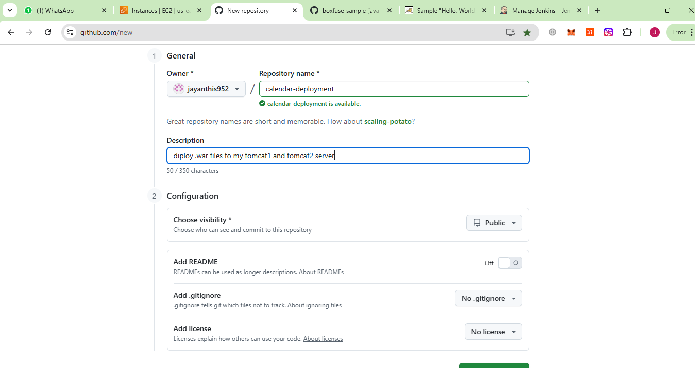

Step 2: Add Jenkinsfile to GitHub

Clone the repo to local system and create a folder and add Jenkins file to github

git clone https://github.com/jayanthis952/calendar-deployment.git

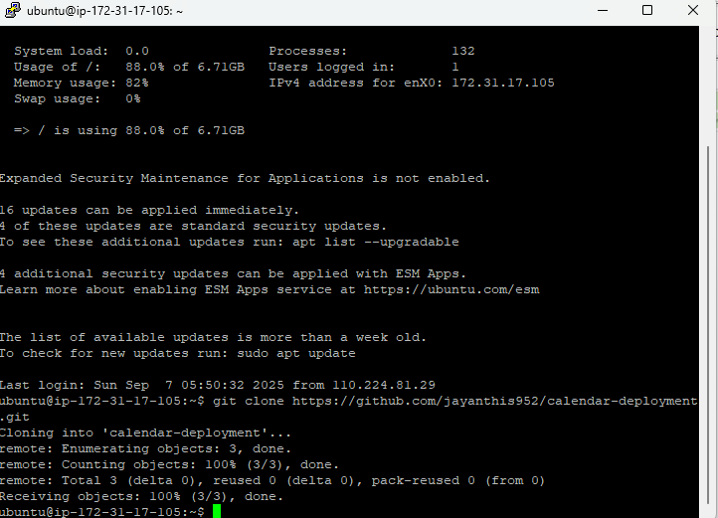

Create a folder
mkdir calendar-deployment
cd calendar-deployment

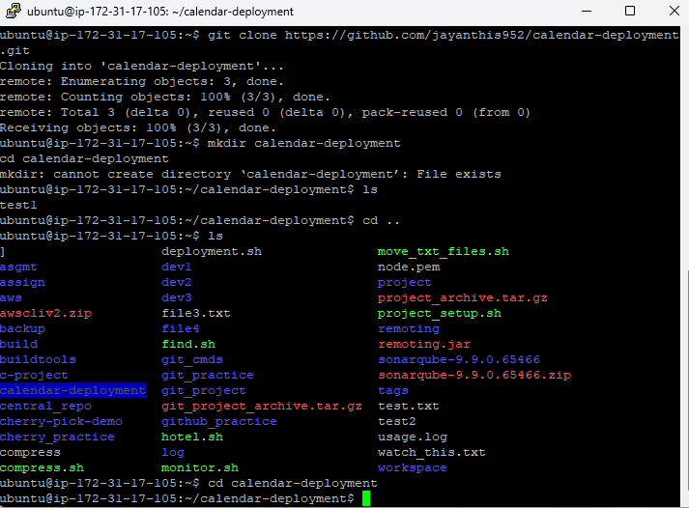

Create a Jenkinsfile

vi Jenkinsfile
pipeline {
agent any

stages {
stage('Build') {
steps {
echo "Downloading calendar.war..."
sh 'wget -O calendar.war https://tomcat.apache.org/tomcat-7.0-doc/appdev/sample/sample.war'
}
}

stage('Deploy') {
steps {
sshagent(['tomcat-key']) {
sh '''
echo "Deploying to Tomcat1 (98.84.151.139)..."
scp -o StrictHostKeyChecking=no calendar.war ubuntu@98.84.151.139:/tmp/
ssh ubuntu@98.84.151.139 "sudo mv /tmp/calendar.war /opt/tomcat10/webapps/ && sudo systemctl restart tomcat"

echo "Deploying to Tomcat2 (34.228.19.124)..."
scp -o StrictHostKeyChecking=no calendar.war ubuntu@34.228.19.124:/tmp/
ssh ubuntu@34.228.19.124 "sudo mv /tmp/calendar.war /opt/tomcat10/webapps/ && sudo systemctl restart tomcat"
'''
}
}
}

stage('Test') {
steps {
echo "Testing deployments..."
sh 'curl -I http://98.84.151.139:8080/calendar/'
sh 'curl -I http://34.228.19.124:8080/calendar/'
}
}
}
}
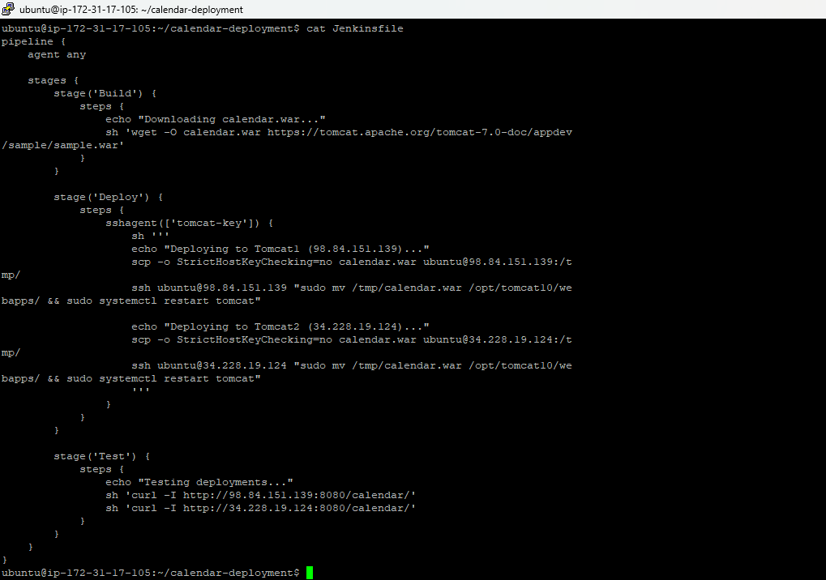

Now push the file to github git init
git add Jenkinsfile
git commit -m "Update Jenkins pipeline for Tomcat deployment"
git push origin main

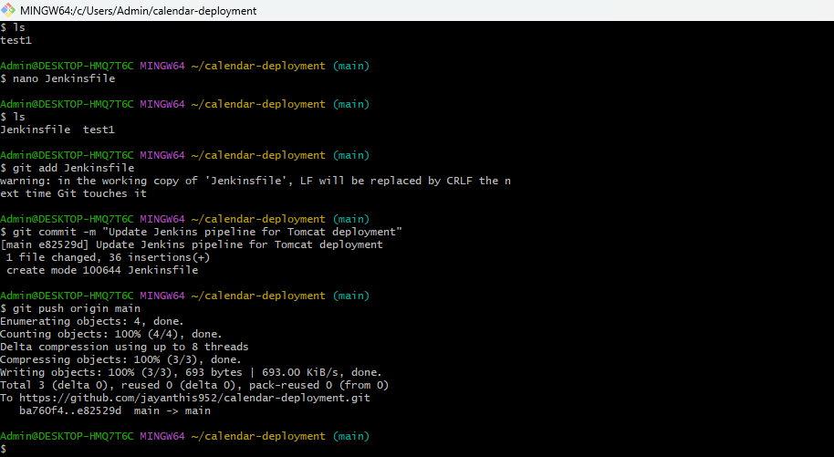

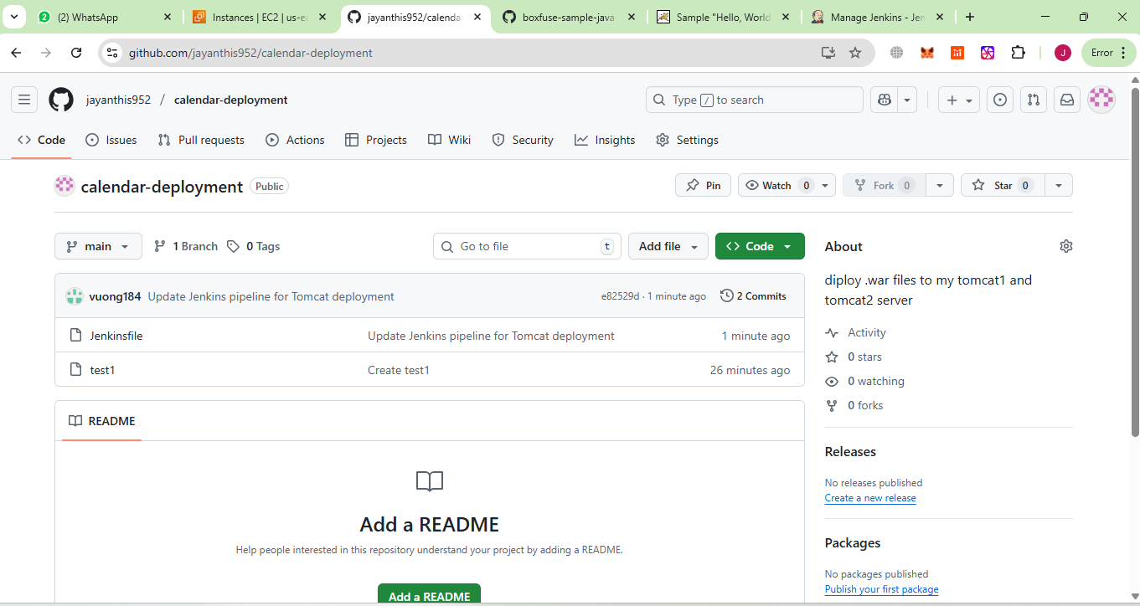

Step 2: Configure Jenkins to pull from GitHub
- Go to Jenkins → New Item → Pipeline → name it as Deploy-Calendar.
- Under Pipeline → Definition, choose Pipeline from SCM.
- SCM: Git
- Repository URL: https://github.com/jayanthis952/calendar-deployment.git
- Branch: main
- Script Path: Jenkinsfile
- Click Save

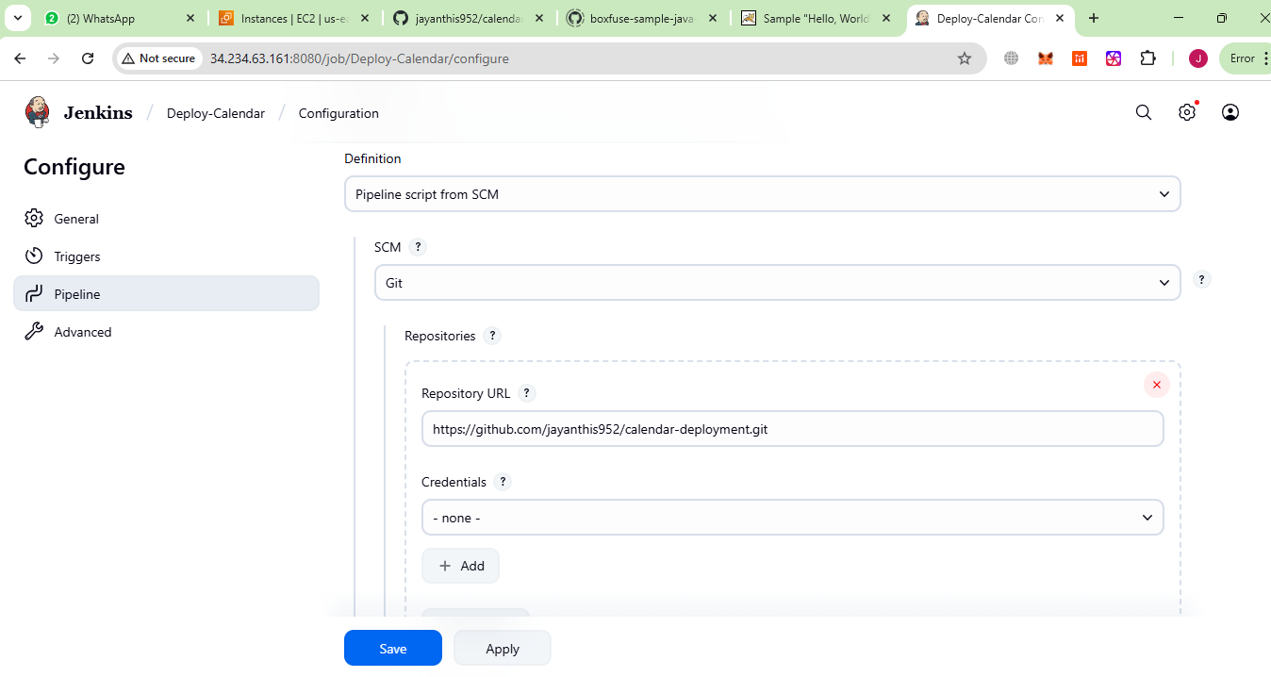

Step 3: Run the Jenkins pipeline
- Click Build Now in Jenkins.
- Jenkins will execute Build → Deploy → Test stages:
- Build stage: downloads calendar.war
- Deploy stage: copies the WAR to Tomcat1 (54.197.155.52) and Tomcat2 (100.25.217.178) and restarts Tomcat
- Test stage: sends HTTP requests to verify deployment

Step 4: Verify deployment in browser

http://54.197.155.52:8080/calendar/
http://100.25.217.178:8080/calendar/

to verify

Both tomcat1 and tomcat2 should display the Hello World sample app.
Output of tomcatserver1

