Jayanthi
Git Assignment
- Create a central repo
Git command to create a central repo
git init –bare central_repo
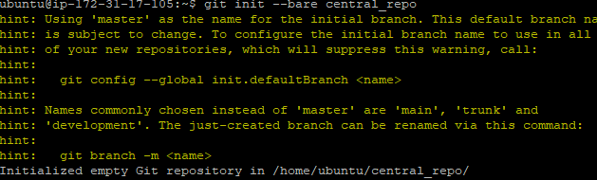

Clone this to dev1 and add big3.c and push back to central_repo
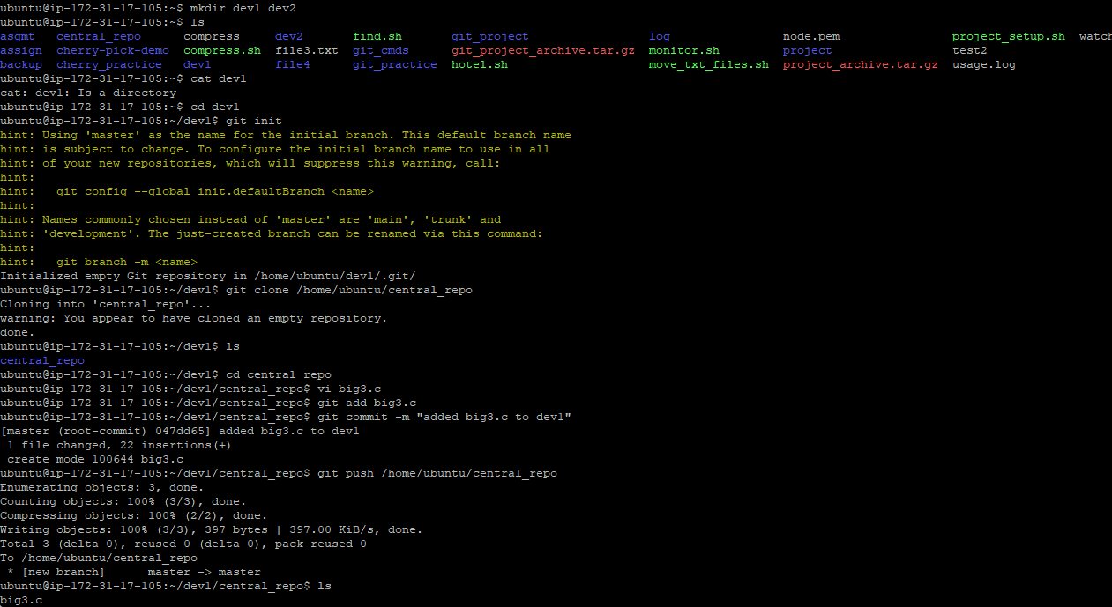
Create dev2 and clone dev1 and add fact.c and push to central_repo
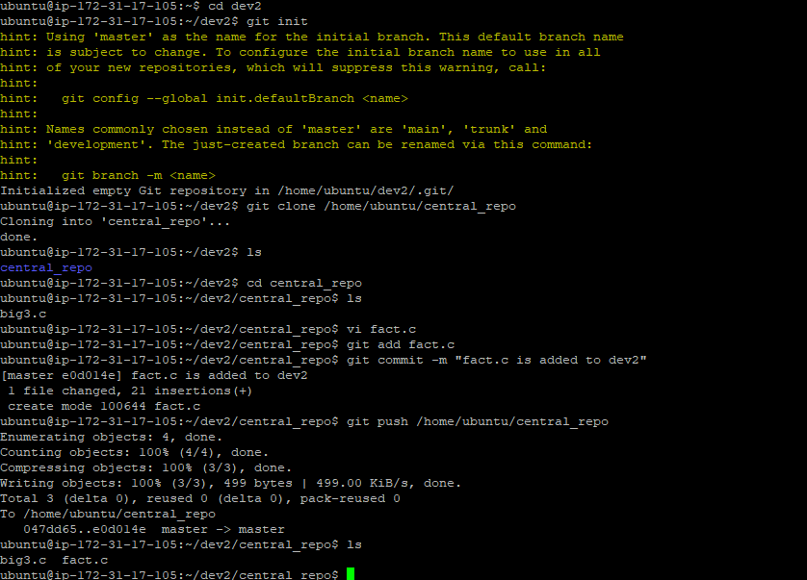

Here tag release1 and create branch1 on release1

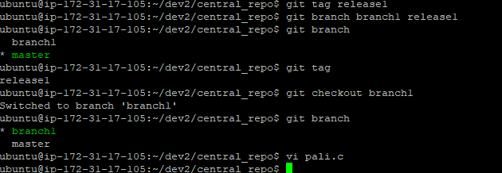

Create a pali.c and tag release1.1
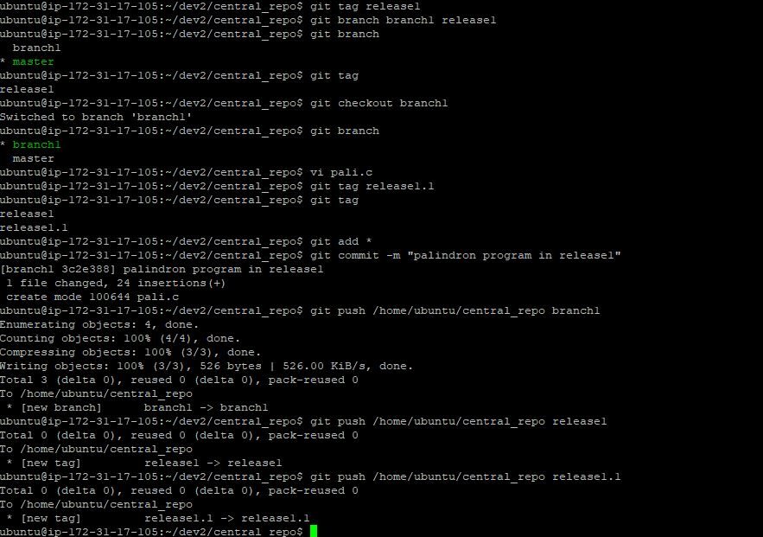

Create dev3 and clone it and add branch1 and branch3
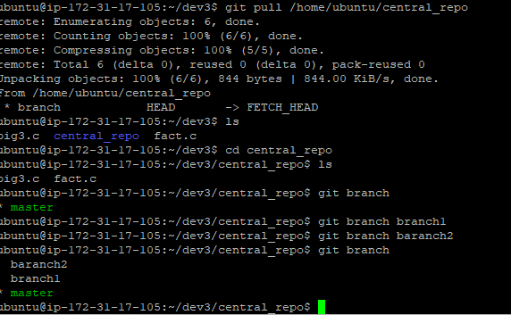

6) fetch it and review and merge in dev1

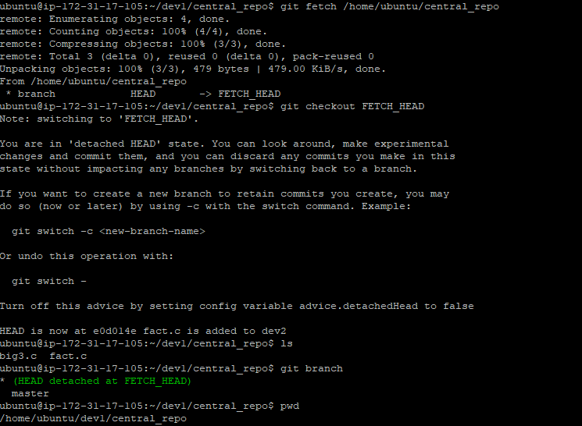

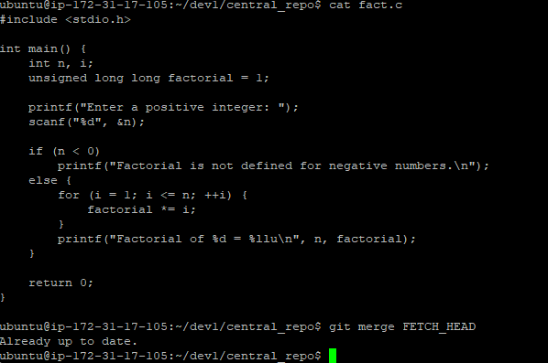

7) goto dev3 and add rev.c and tag release and push everything to centralrepo
