Jayanthi.M
Assignment

Create an S3 bucket and upload files from an EC2 instance using the AWS CLI.

Enable Cross-Region Replication (CRR) between two S3 buckets.

Create, delete, and copy files in an S3 bucket using the AWS CLI.

Enable Same-Region Replication (SRR) between two S3 buckets and verify the replication.

Create an S3 bucket and upload files from an EC2 instance using the AWS CLI.

# Create bucket (replace with unique bucket name & region)
aws s3 mb s3://my-source-bucket-1234 --region us-east-1

# Create a sample file
echo "Hello S3" > file1.txt

# Upload file to bucket
aws s3 cp file1.txt s3://my-source-bucket-123/

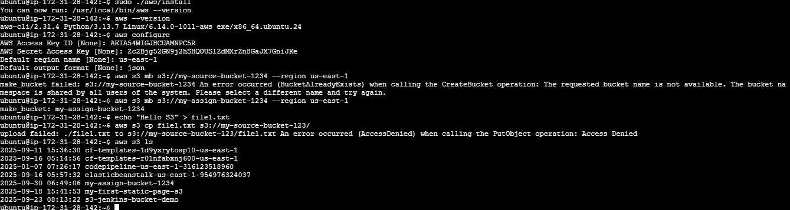

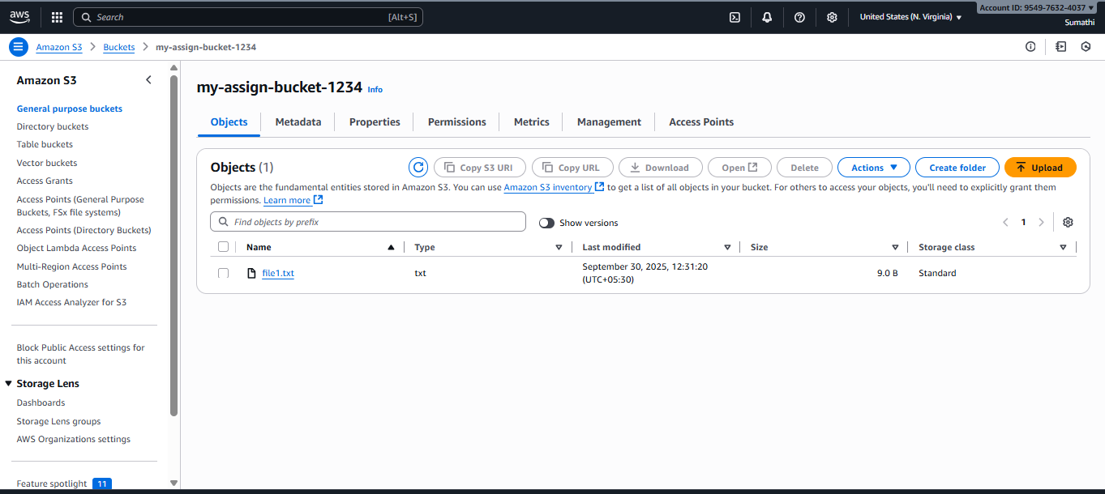

create a role for your EC2 instance so it can access S3.

Step 1: Select Trusted Entity
- Trusted entity type: AWS service ✅
- Use case / Service or use case: Select EC2 ✅
This tells AWS: “This role will be assumed by an EC2 instance.”
Click Next: Add permissions.

Step 2: Add Permissions
- In the list, search for S3
- Select AmazonS3FullAccess ✅
(This allows the EC2 instance to create, delete, copy, and replicate S3 objects.)
Click Next: Tags → (optional, we can skip) → Next: Review

Step 3: Name, Review, and Create
- Role name: EC2_S3_Access_Role (or any name you like)
- Review: Trusted entity = EC2, Permissions = AmazonS3FullAccess
Click Create role ✅

Step 4: Attach the Role to your EC2 Instance
- Go to EC2 → Instances → Select your instance → Actions → Security → Modify IAM role
- Choose EC2_S3_Access_Role
- Click Save
Step 5: Test Access from EC2 (PuTTY)
aws s3 ls

# Upload file to bucket

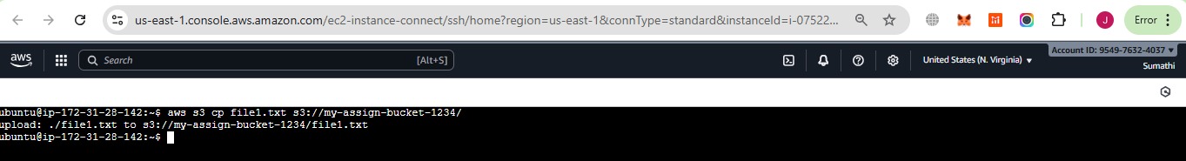

Create Destination Buckets

- Source bucket: my-assign-bucket-1234
- CRR destination bucket: my-assign-dest-crr-1234
- SRR destination bucket: my-assign-dest-srr-1234

# CRR (different region)
aws s3 mb s3://my-assign-dest-crr-1234 --region us-west-2

# SRR (same region)
aws s3 mb s3://my-assign-dest-srr-1234 --region us-east-1

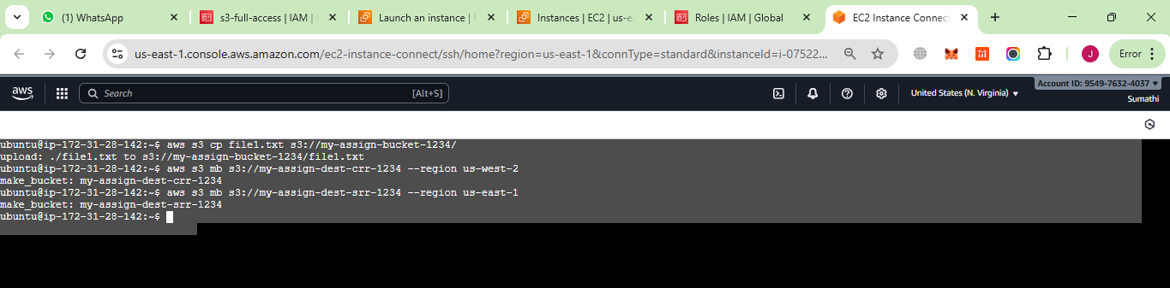

versioning and replication, which are required for CRR and SRR.

Step 1: Enable Versioning

# Source bucket
aws s3api put-bucket-versioning --bucket my-assign-bucket-1234 --versioning-configuration Status=Enabled

# CRR destination bucket
aws s3api put-bucket-versioning --bucket my-assign-dest-crr-1234 --versioning-configuration Status=Enabled

# SRR destination bucket
aws s3api put-bucket-versioning --bucket my-assign-dest-srr-1234 --versioning-configuration Status=Enabled

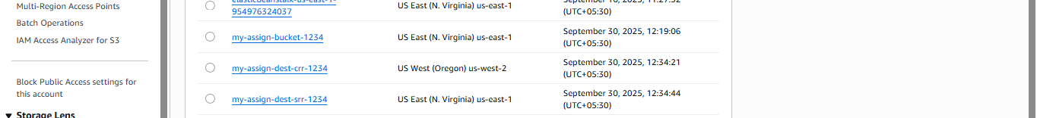

Step 1: Create CRR replication JSON

cat > crr.json <<EOF
{
"Role": "arn:aws:iam::954976324037:role/EC2_S3_Access_Role",
"Rules": [
{
"ID": "CRRRule",
"Status": "Enabled",
"Priority": 1,
"Filter": { "Prefix": "" },
"Destination": {
"Bucket": "arn:aws:s3:::my-assign-dest-crr-1234"
}
}
]
}
EOF

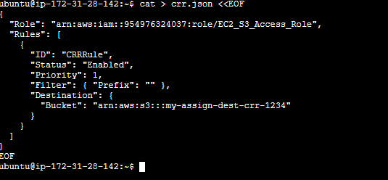

Step 2: Create SRR replication JSON

cat > srr.json <<EOF
{
"Role": "arn:aws:iam::954976324037:role/EC2_S3_Access_Role",
"Rules": [
{
"ID": "SRRRule",
"Status": "Enabled",
"Priority": 1,
"Filter": { "Prefix": "" },
"Destination": {
"Bucket": "arn:aws:s3:::my-assign-dest-srr-1234"
}
}
]
}
EOF

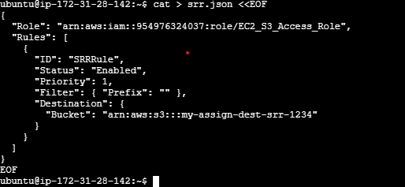

Step 3: Apply Replication Configurations

aws s3api put-bucket-replication --bucket my-assign-bucket-1234 --replication-configuration file://crr.json
aws s3api put-bucket-replication --bucket my-assign-bucket-1234 --replication-configuration file://srr.json

creating test-crr.txt and coping this to my-assign-bucket-1234

echo "CRR Test" > test-crr.txt
aws s3 cp test-crr.txt s3://my-assign-bucket-1234/
aws s3 ls s3://my-assign-dest-crr-1234/

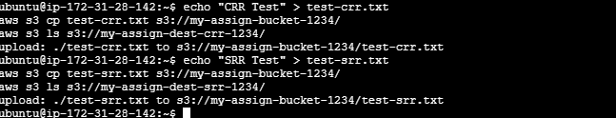

then upload a test file to verify replication:
echo "SRR Test" > test-srr.txt
aws s3 cp test-srr.txt s3://my-assign-bucket-1234/
aws s3 ls s3://my-assign-dest-srr-1234/

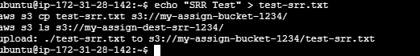

We nee to edit trust relationship

Step 1: Edit Trust Relationship
- Go to IAM → Roles → EC2_S3_Access_Role → Trust relationships → Edit trust relationship
- Replace the current policy with:
{
"Version": "2012-10-17",
"Statement": [
{
"Effect": "Allow",
"Principal": {
"Service": "s3.amazonaws.com"
},
"Action": "sts:AssumeRole"
}
]
}

Step 2: Attach a Custom Policy for Replication
- Go to IAM → Roles → EC2_S3_Access_Role → Permissions → Add permissions → Create inline policy
- Choose JSON and paste:
{
"Version": "2012-10-17",
"Statement": [
{
"Effect": "Allow",
"Action": [
"s3:GetObjectVersion",
"s3:GetObjectVersionAcl",
"s3:GetObjectVersionTagging",
"s3:ReplicateObject",
"s3:ReplicateDelete",
"s3:ReplicateTags"
],
"Resource": [
"arn:aws:s3:::my-assign-bucket-1234/*",
"arn:aws:s3:::my-assign-dest-crr-1234/*",
"arn:aws:s3:::my-assign-dest-srr-1234/*"
]
}
]
}

Click Review → Name it S3ReplicationPolicy → Create policy

Step 3: Re-upload Test Files
echo "CRR Fixed" > test-crr.txt
aws s3 cp test-crr.txt s3://my-assign-bucket-1234/

echo "SRR Fixed" > test-srr.txt
aws s3 cp test-srr.txt s3://my-assign-bucket-1234/

Step 4: Verify

aws s3 ls s3://my-assign-dest-crr-1234/
aws s3 ls s3://my-assign-dest-srr-1234/

