Jayanthi
Assignment of s3 static webpage hosting
Create and host a static webpage with Amazon S3.
step1: Create an S3 Bucket
- Sign in to the AWS Management Console.
- Navigate to S3 Service.
- Click Create bucket.
- Enter a unique bucket name (e.g., my-first-static-page-s3).
- Select a Region (e.g., us-east-1).
- Uncheck “Block all public access” → Confirm acknowledgment. Or if the data wants to shared with public then we can check the “Block all public access”
- Click Create bucket.
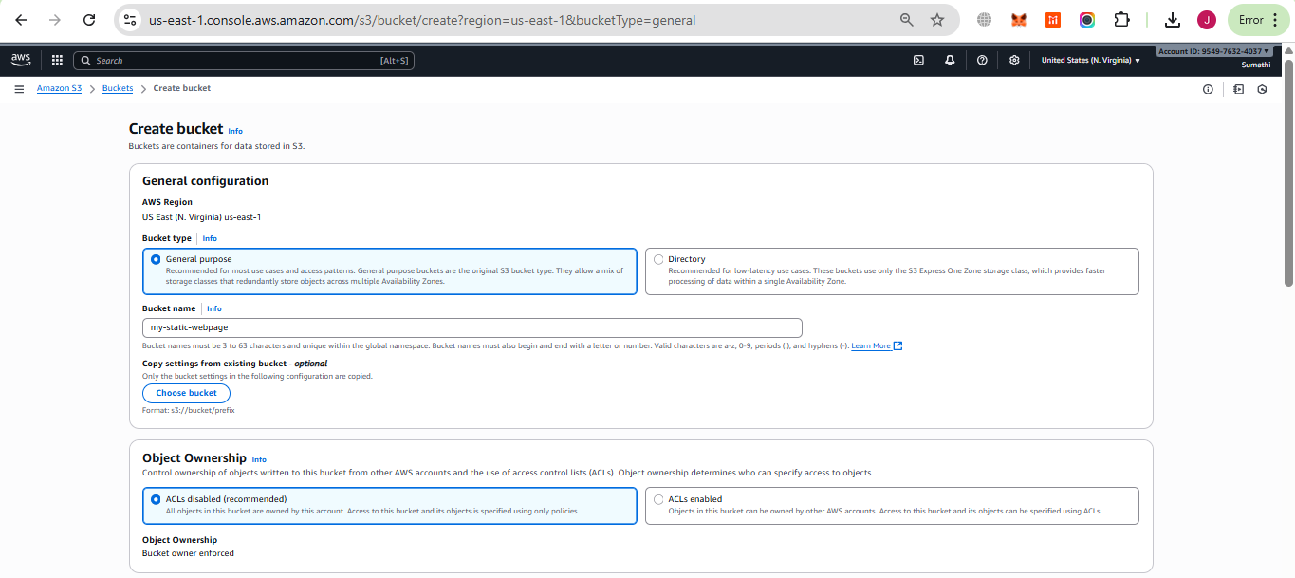

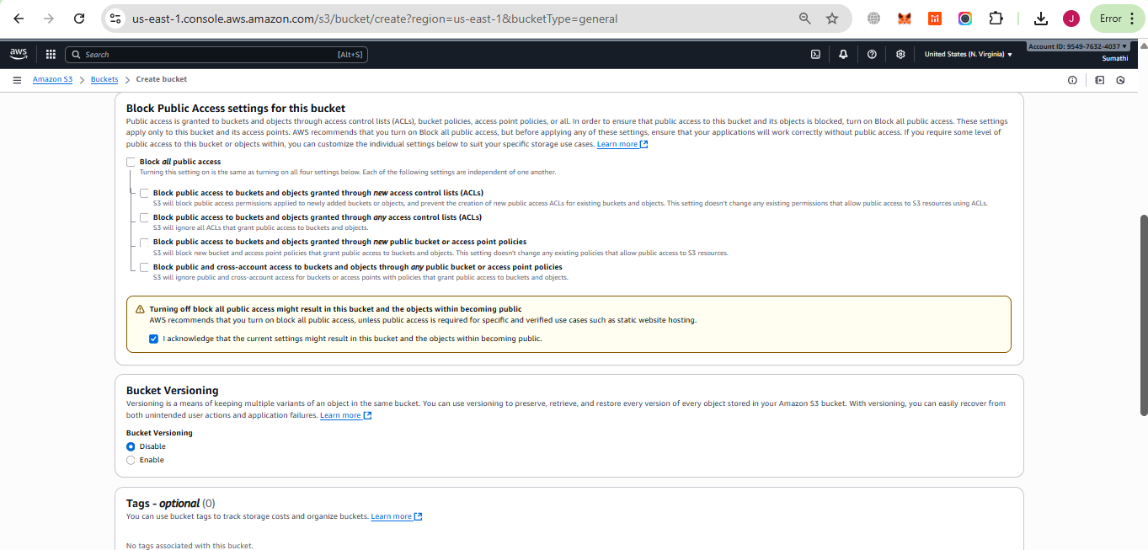

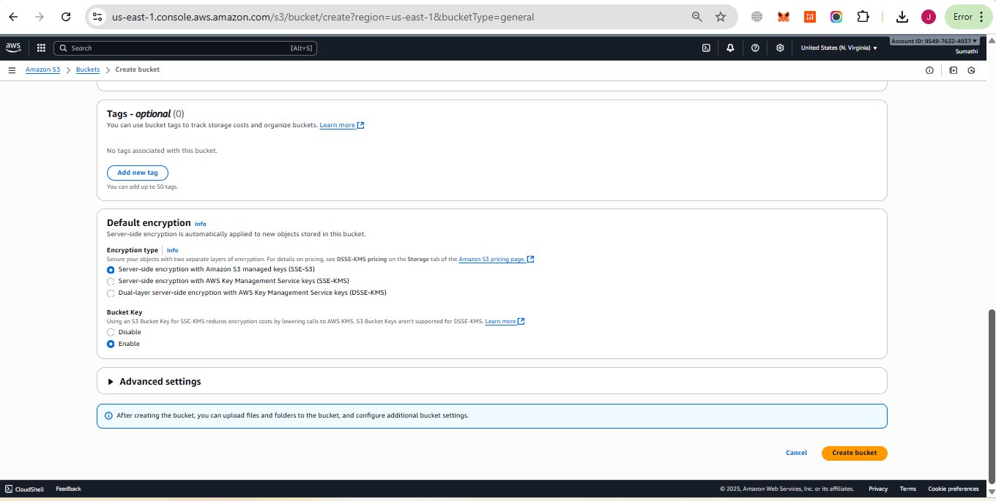

Step 2. Upload Website Files
- Open bucket.
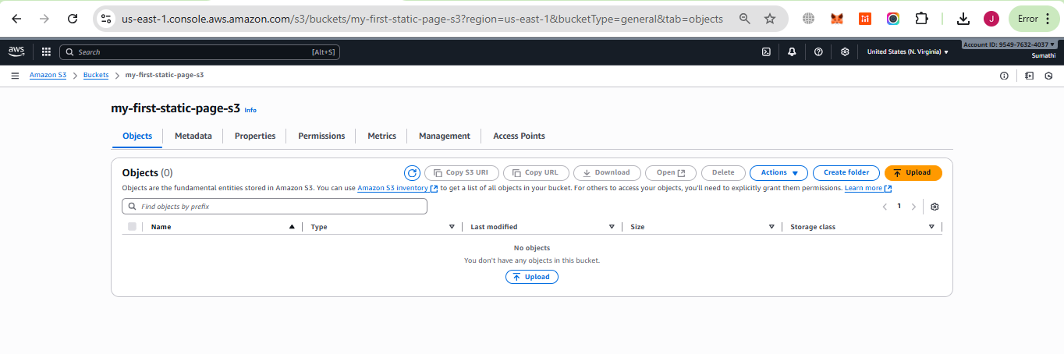
- Click Upload → Add your files:
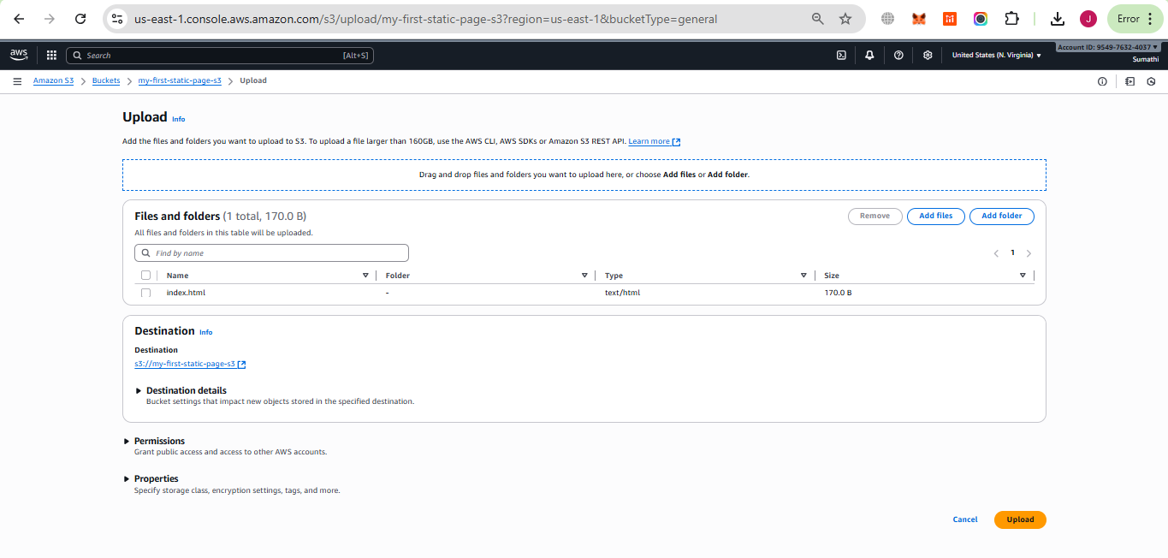
  - index.html
<!DOCTYPE html>
<html>
<head>
<title>My Static Website</title>
</head>
<body>
<h1>Hello, this is my static website hosted on Amazon S3!</h1>
</body>
</html>

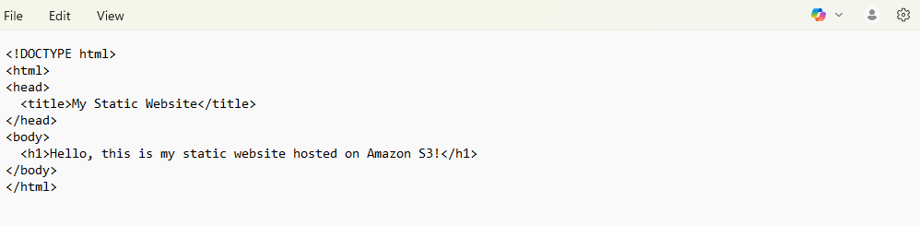
- Click Upload.
Step:3. Enable Static Website Hosting
- In our bucket, go to Properties tab.
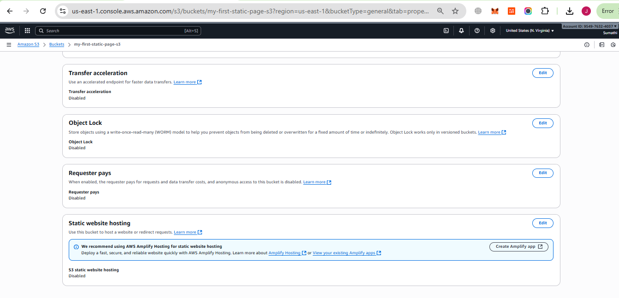
- Scroll to Static website hosting → Click Edit.
- Select Enable.
- Enter:
  - Index document: index.html
- Save changes.
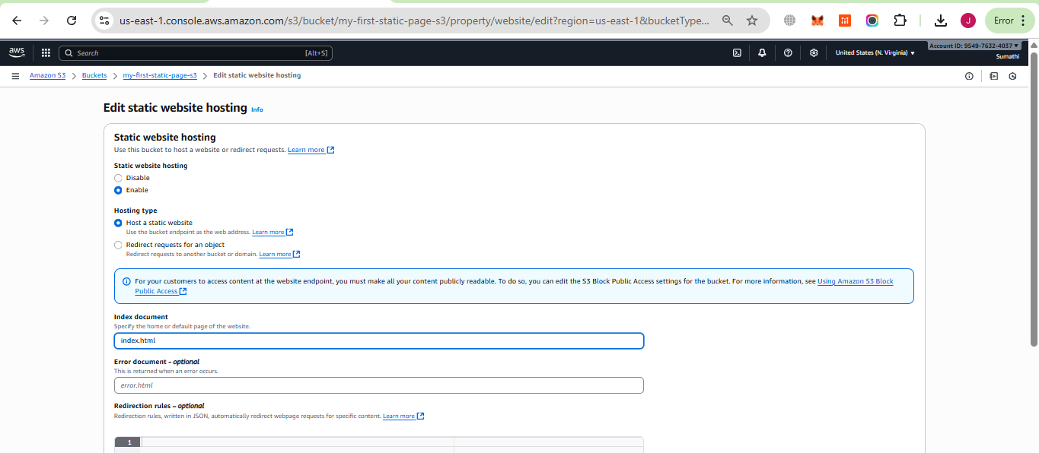
- Copy the Bucket website endpoint URL (http://my-first-static-page-s3.s3-website-us-east-1.amazonaws.com).
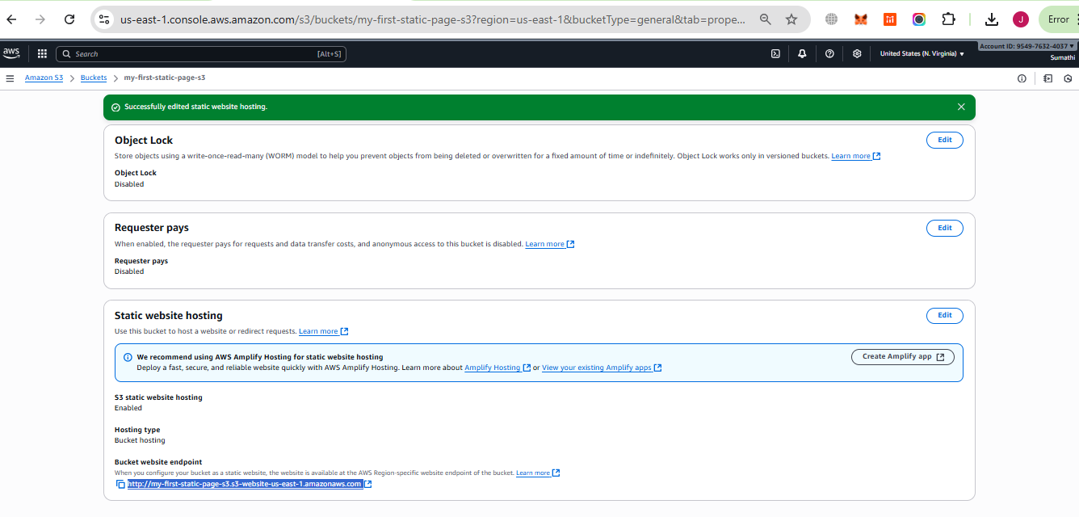

Step 4. Set Bucket Policy for Public Access
Go to Permissions tab → Bucket policy → Edit.
We need to add the json code with our s3 bucket name as shown below
{
"Version": "2012-10-17",
"Statement": [
{
"Effect": "Allow",
"Principal": "*",
"Action": "s3:GetObject",
"Resource": "arn:aws:s3:::my-first-static-page-s3/*"
}
]
}

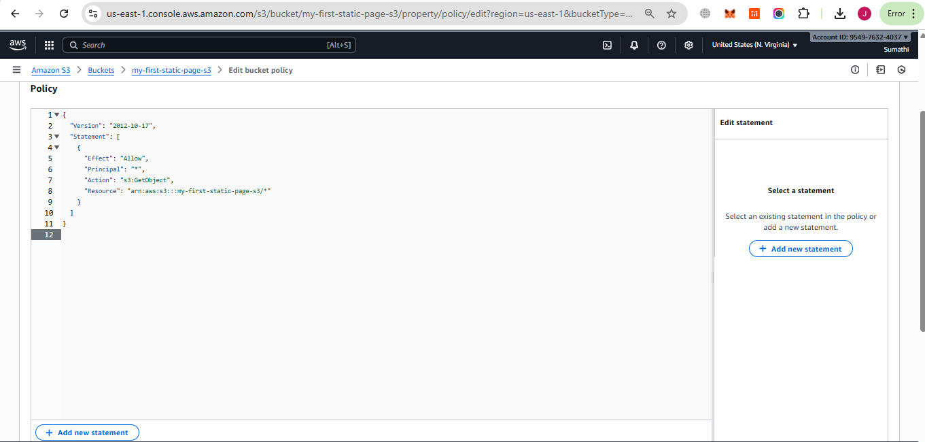
Click on save changes .
And open the url in browser
