Jayanthi M

Assignment 12/09
1. IAM User and MFA Setup:
Create a new IAM user in your cloud environment. Then, enable and configure Multi-Factor Authentication (MFA) for that user to enhance security.

2. CloudWatch Alarm Configuration:
Configure a CloudWatch alarm that sends a notification if the CPU usage of an EC2 instance exceeds 40% for more than 5 minutes.

1. IAM User and MFA Setup:
Create a new IAM user in your cloud environment. Then, enable and configure Multi-Factor Authentication (MFA) for that user to enhance security.

Step A: Create IAM User
- Login to AWS Management Console → Go to IAM.
- On the left menu, click Users → Add users.
- Enter a username (e.g., newuser).
- Select Provide user access:
  - If this user needs AWS CLI or programmatic access → Check Access key - Programmatic access.
  - If the user needs Console login → Check Password - AWS Management Console access.
  - Choose Autogenerated password or create own.
  - (Optional) Force user to reset password on first login.
- Click Next → Attach a policy (e.g., AdministratorAccess for testing, but in production use least privilege).
- Review → Click Create user.
- We can now see the login URL for the new user

In the below page click on create user
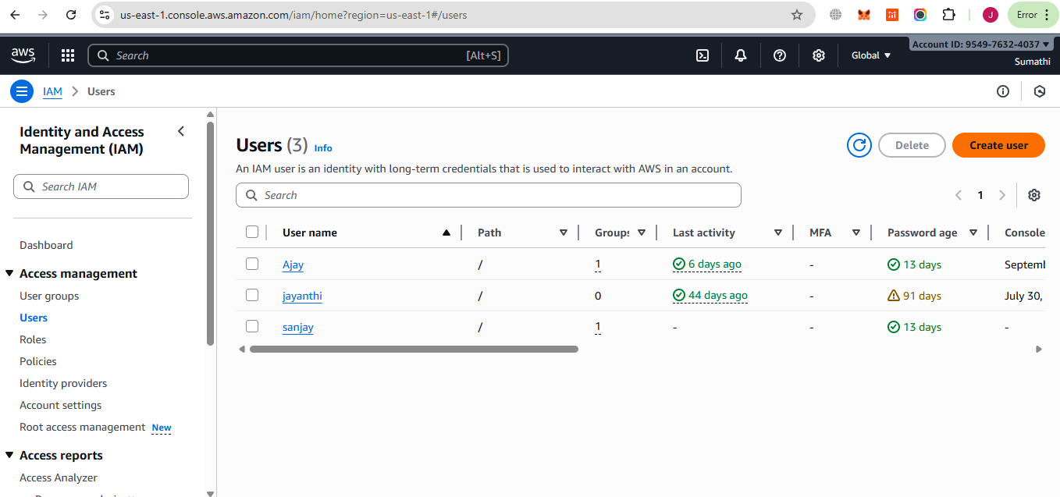

Next step in User details enter User name as iamuser
click on Provide user access to the AWS Management Console – optional checkbox
in Console password click on Autogenerated password
click next.

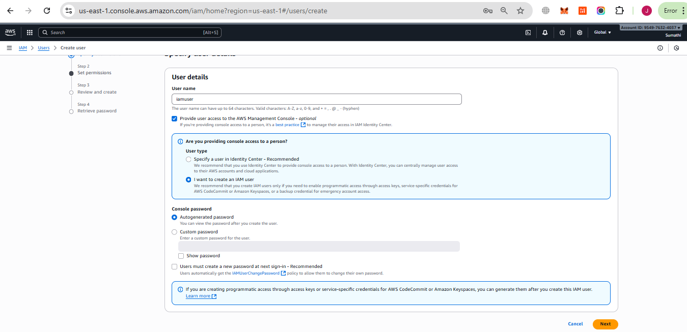

In Set permissions page select Attach policies directly.
In Permissions policies section click on checkbox required policies need to be attached
Click on next

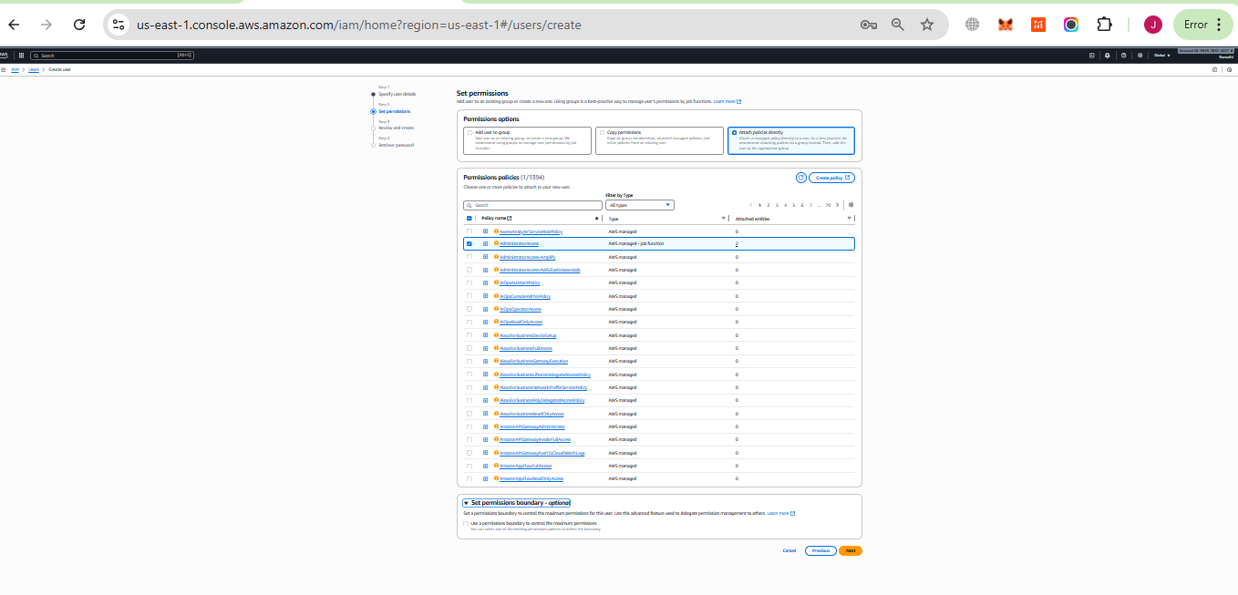

Then in Review and create page review the details before creating. Then click on create

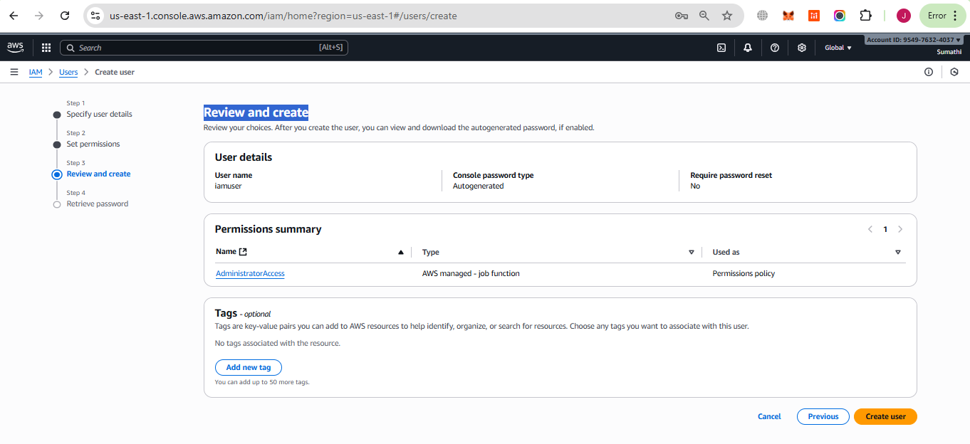
Retrieve password page download the documents which consist of username password and login url

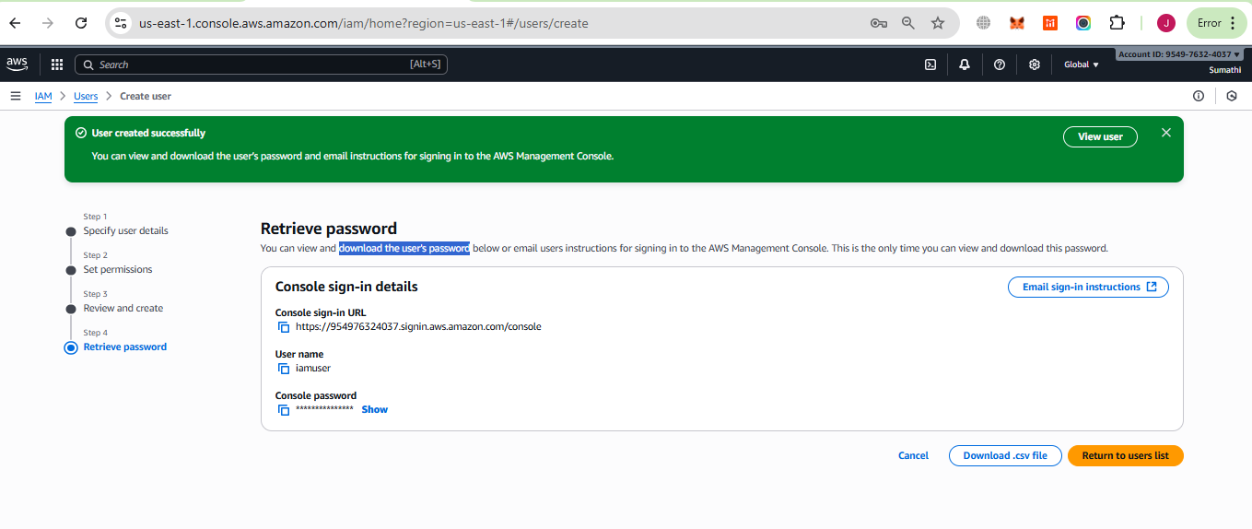

configure Multi-Factor Authentication (MFA) for that user to enhance security.

Step B: Enable MFA for IAM User
- In IAM → Users, select new user.
- Go to the Security credentials tab.
- Under Multi-Factor Authentication (MFA) → Click Assign MFA device.
- Choose Authenticator app (recommended, e.g., Google Authenticator, Authy, Microsoft Authenticator).
- Open the app on phone → scan the QR code AWS gives us.
- Enter the two consecutive codes shown in authenticator app Aunty in mobile.
- Click Assign MFA → Now MFA is enabled

Select the newly created user.
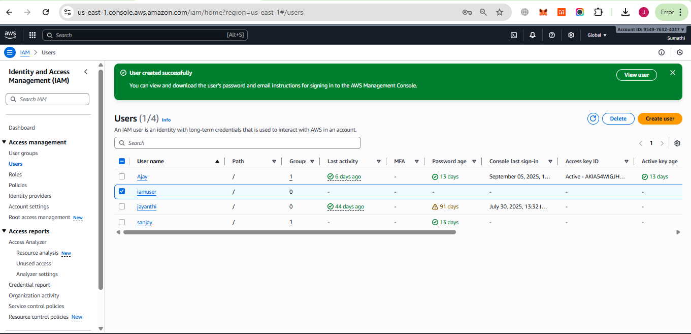
Open the created user and goto Security credentials tab click on Assign MFA device

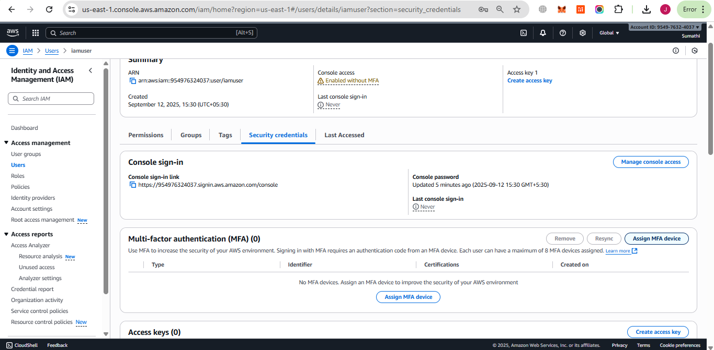

Then in Assign MFA device page give MFA device name Device name as iam-mfa and
Select a MFA device Device options as Authenticator app then click on next

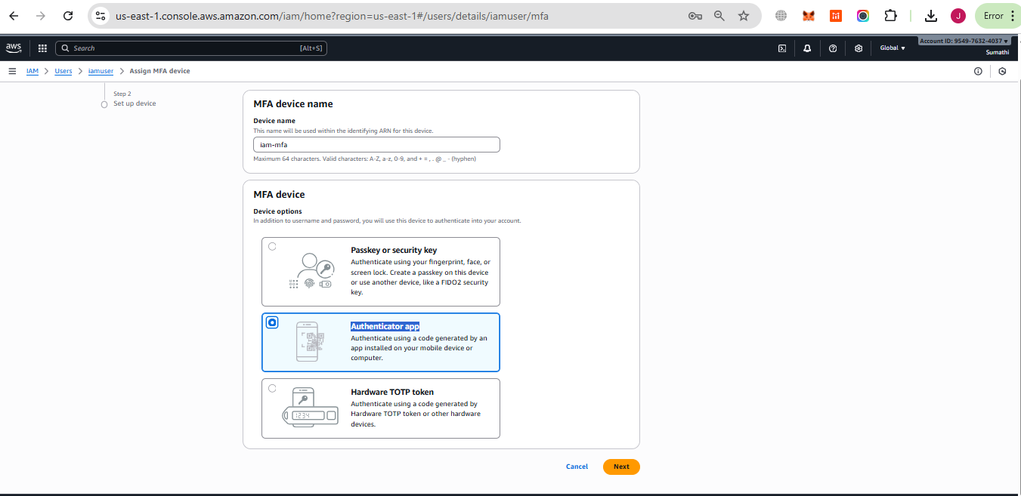

Then we need to install Authy app in our mobile and open the app the scan the qr code shown in aws Set up device page as shown below

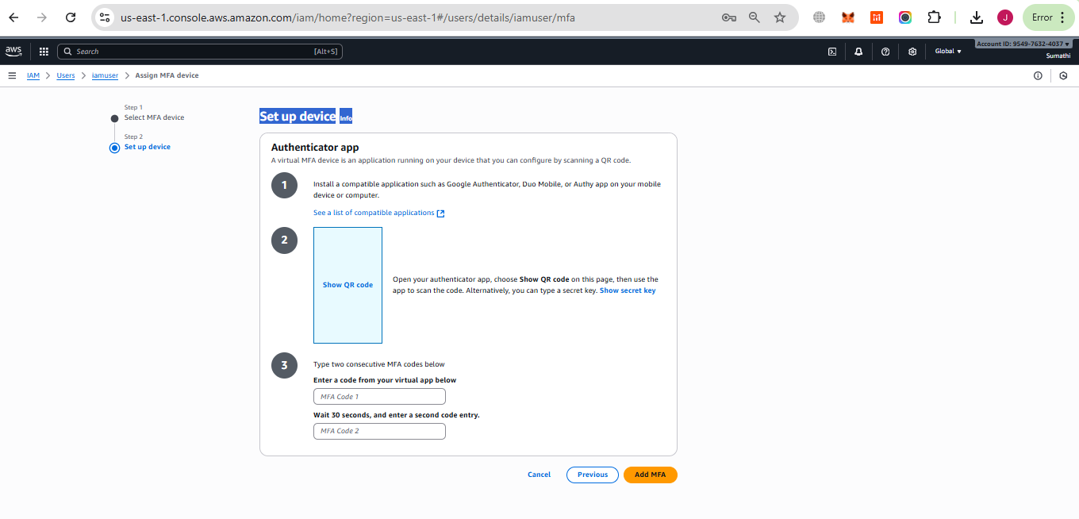

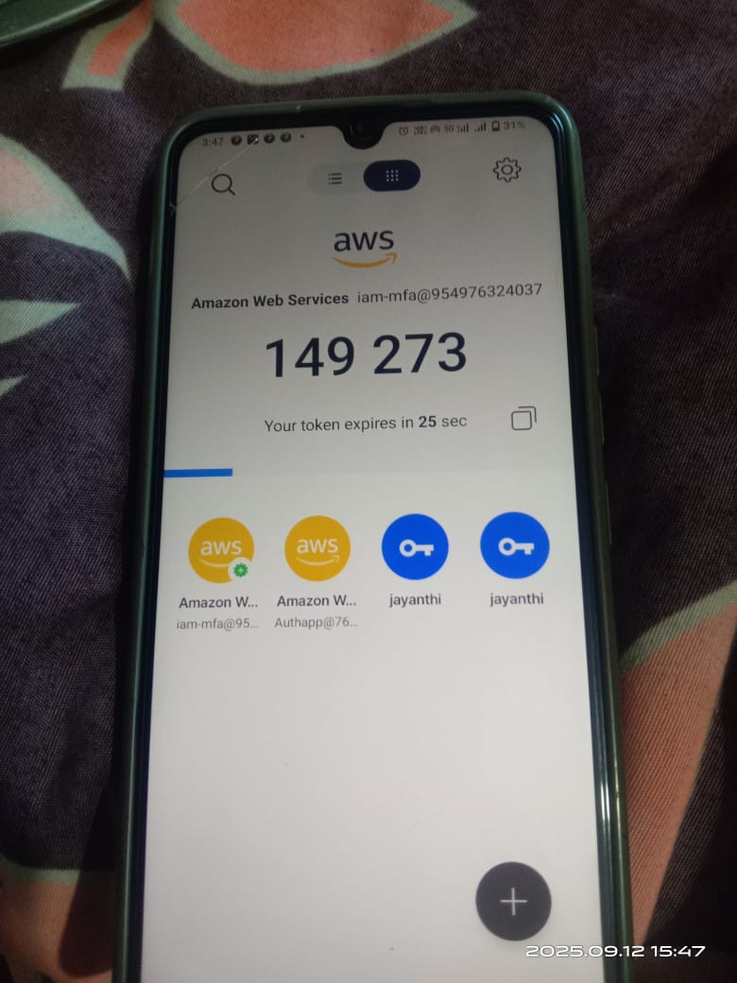

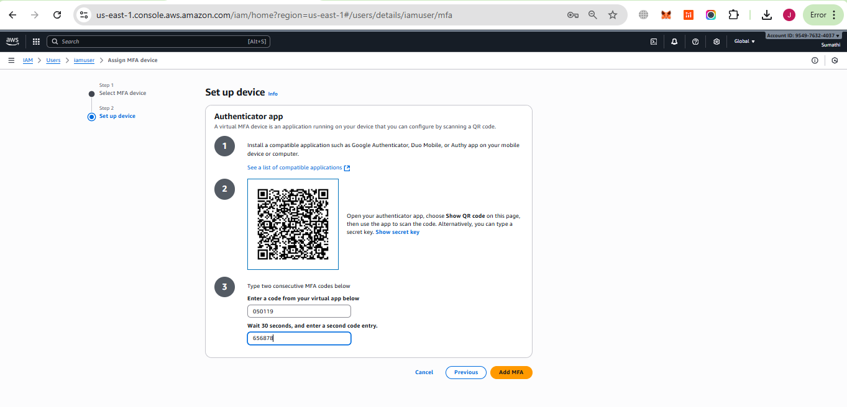
Click on add MFA

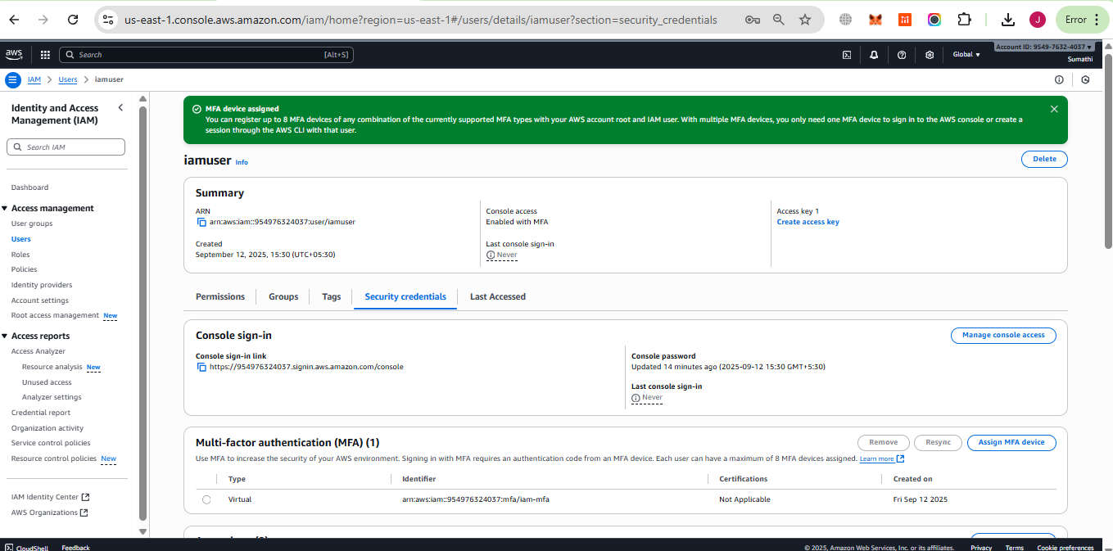

2. CloudWatch Alarm Configuration:
Configure a CloudWatch alarm that sends a notification if the CPU usage of an EC2 instance exceeds 40% for more than 5 minutes.

Step 1: Open CloudWatch
- Login to AWS Management Console.
- Navigate to CloudWatch.
- In the left panel, select All alarms.
- Click Create alarm.

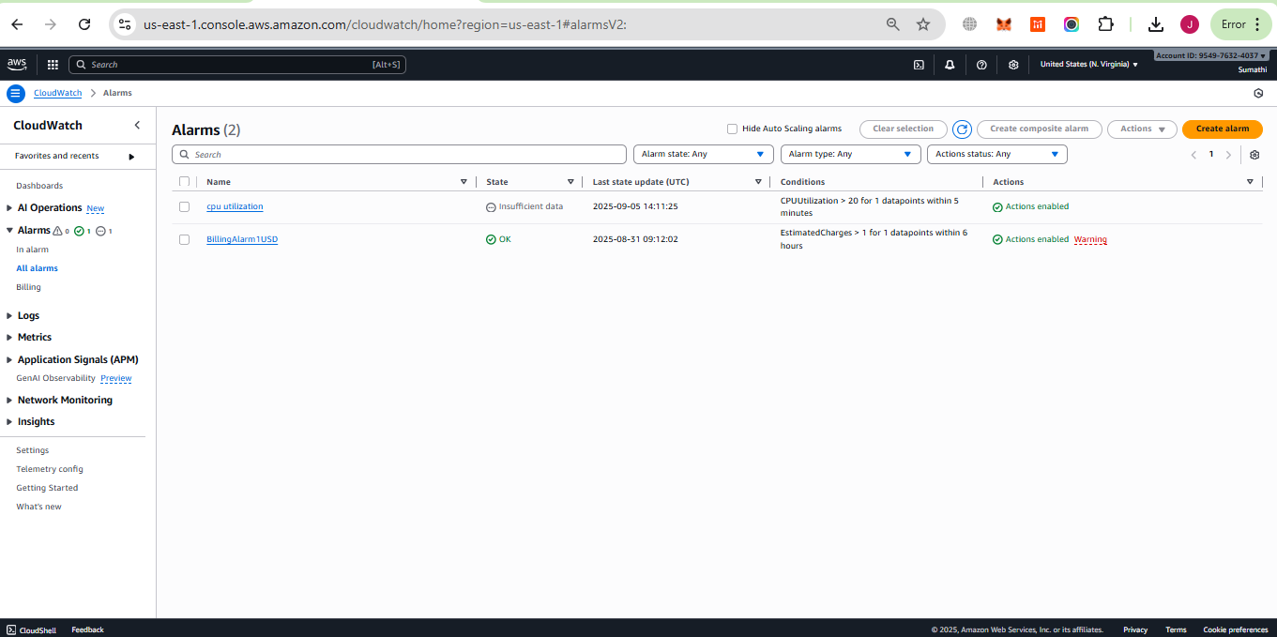

Step 2: Select Metric
- Choose Metrics.
- Select EC2 → Per-Instance Metrics.
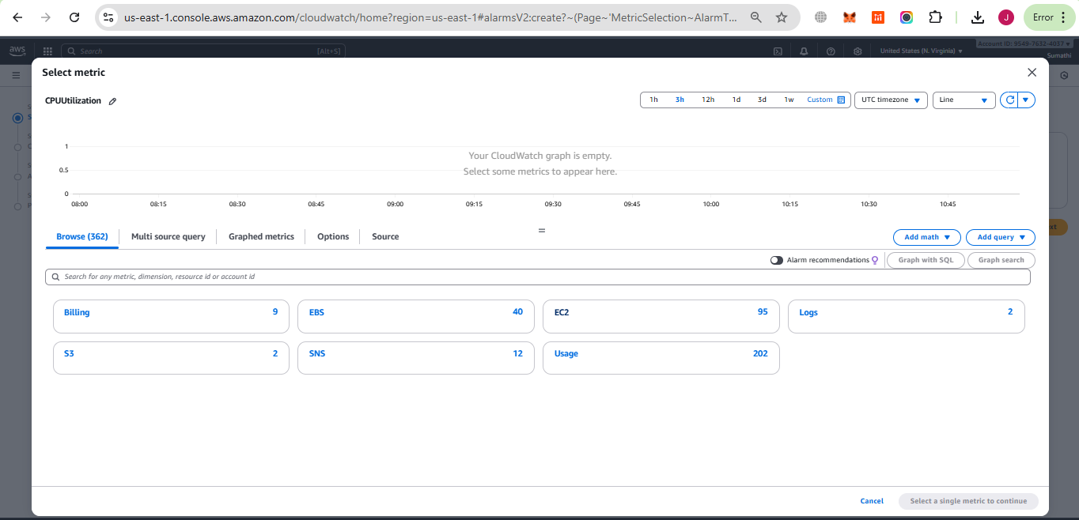

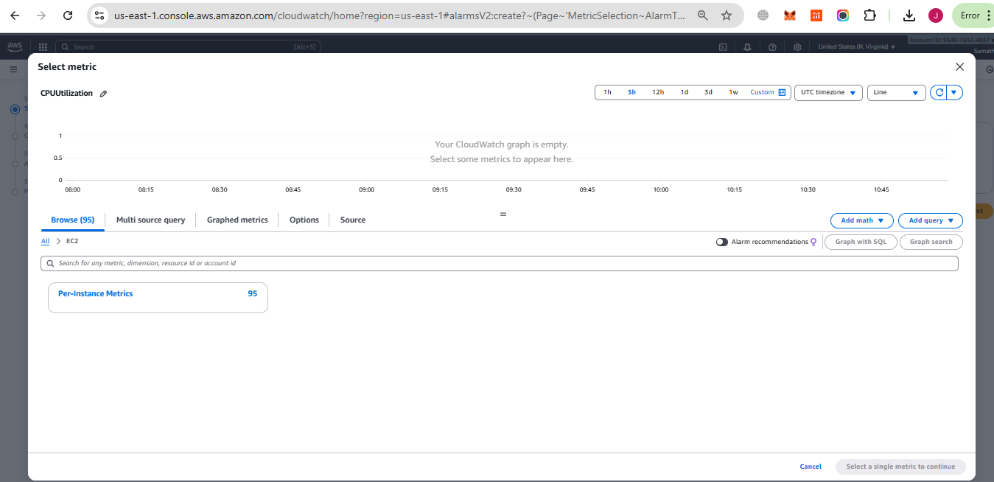

- Select the running EC2 instance you want to monitor(in search tab paste ec2instance ID eg: i-05e73c3fa6f30d9fb).
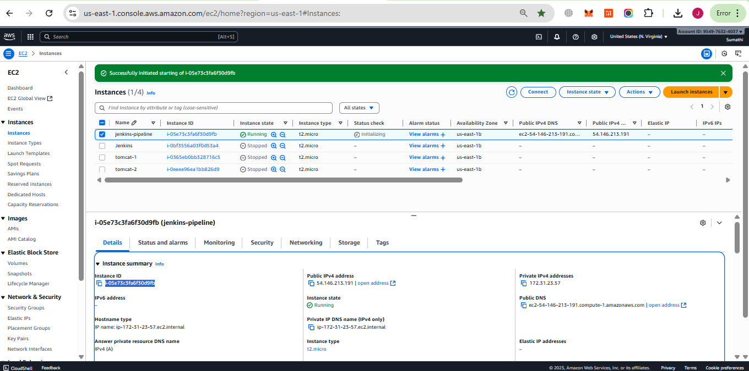

- Choose the metric CPUUtilization.
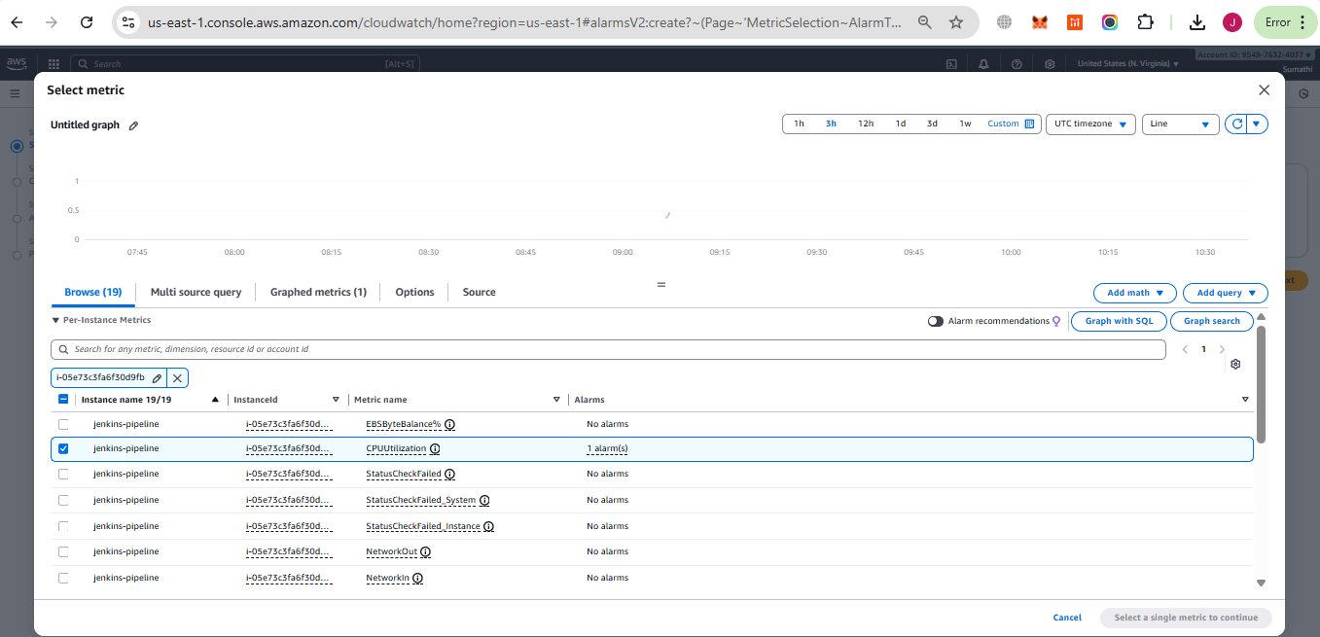
- Set threshold condition: CPU Utilization > 40%.
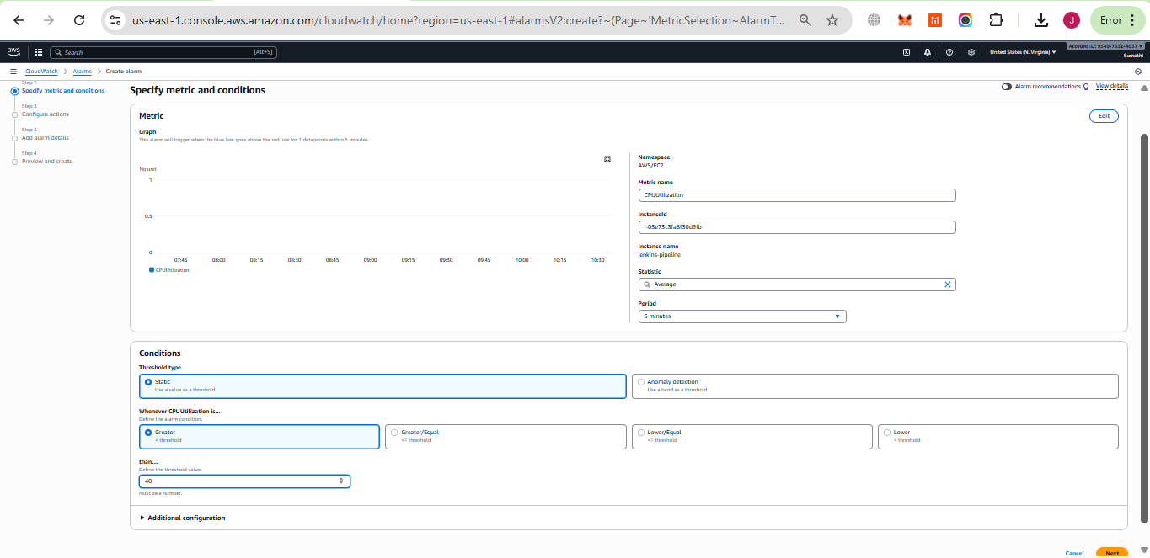
- Click Next.

Step: Configure Actions (Notifications) for Alarm
- On the Configure actions page:
  - Under Notification, go to Alarm state trigger and select In alarm.
- In Send a notification to the following SNS topic:
  - Choose Create new topic.
- Enter the following details:
  - Topic name: testcpu
  - Email endpoints that will receive the notification: jayanthi1200@gmail.com
- Click Create topic.
- Open your email inbox and confirm the subscription by clicking the link from AWS.

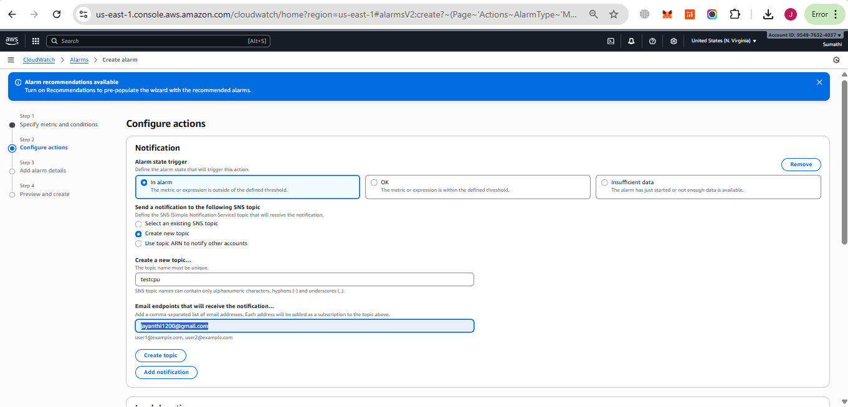

We will get email as shown below and we need to click on confirm subscription

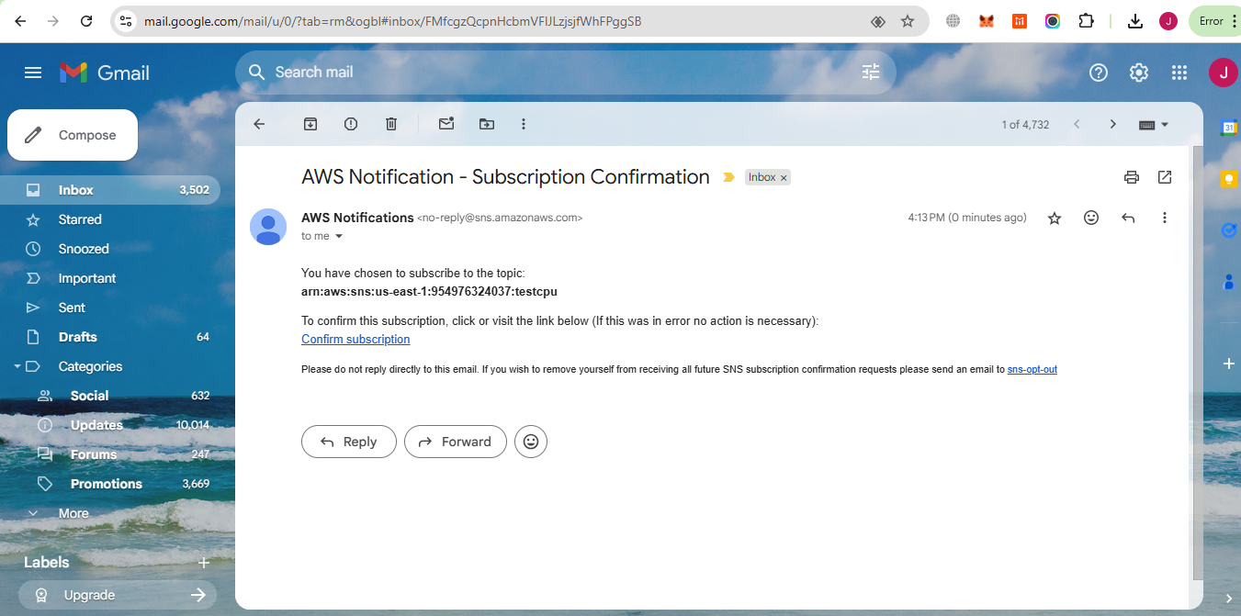

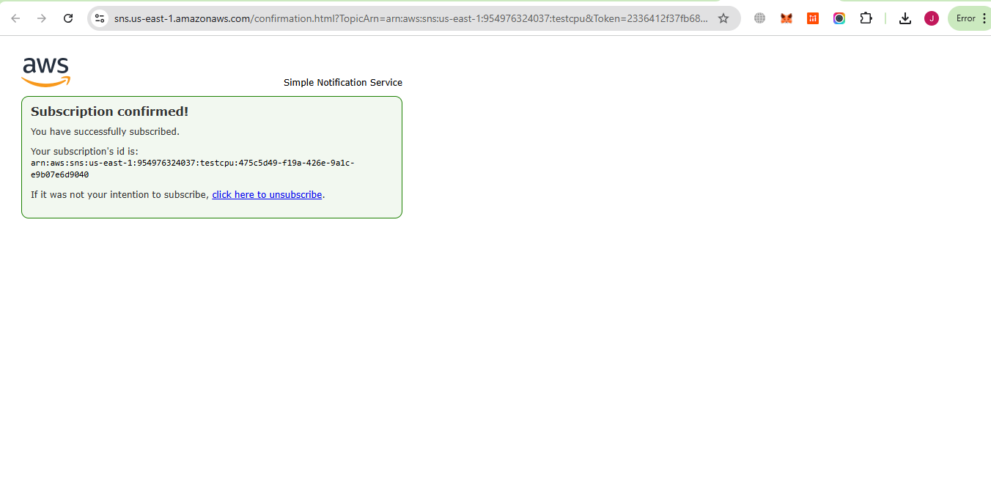

Click on next

In Add alarm details page give alarm name

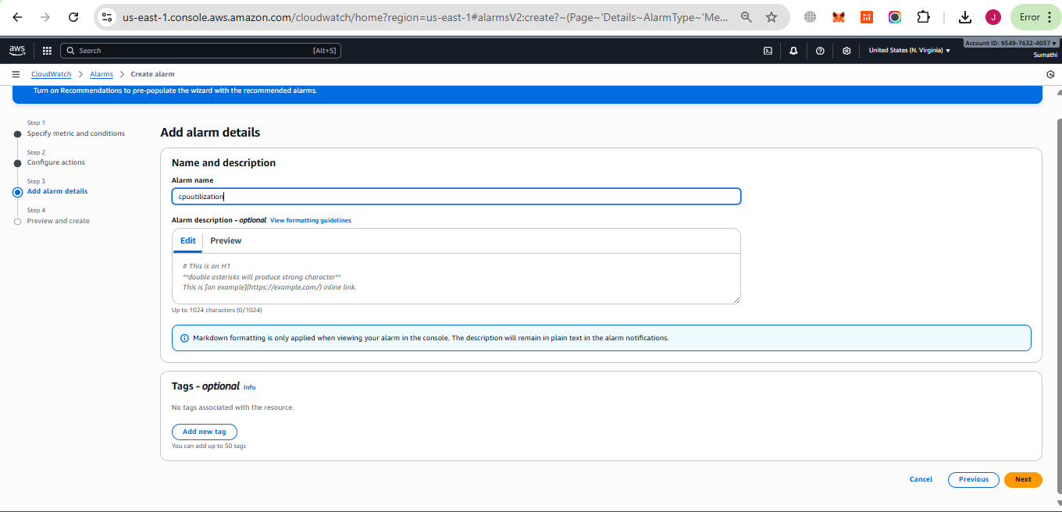

Click on next

In preview page verify all details and click on create

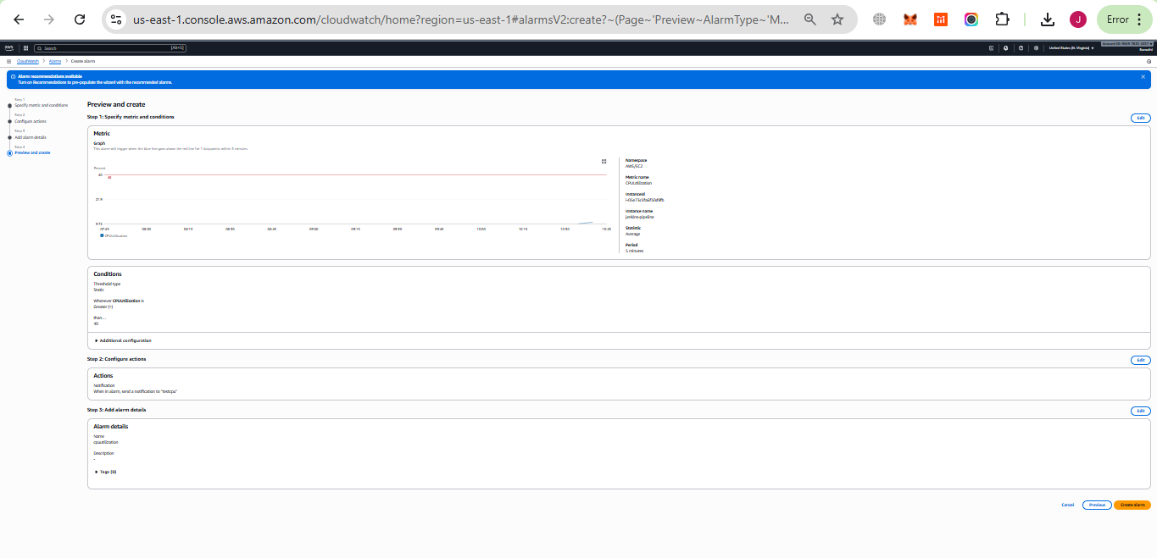

Then goto Jenkins dashboard and build the job until it reaches 40% we will get notification on my email

