Jayanthi.M

Assignment

Assignment 16/10

Write a Dockerfile that includes all major Dockerfile instructions and prints a message when the container starts.

Make the application accessible from outside the container.

Use both *bind mounts* and *Docker volumes* to store data, then verify which data remains after deleting the container.

**Write a Dockerfile that includes all major Dockerfile instructions and prints a message when the container starts.**

To create a Dockerfile we make use of below command

**vi Dockerfile**

FROM ubuntu:22.04

LABEL maintainer="jayanthi1200@gmail.com" version="1.0"

ENV APP_NAME="PersistenceDemo"

ARG GREETING="Hello from Docker!"

WORKDIR /app

COPY ./app /app

ADD ./extra /app/extra

RUN apt-get update && apt-get install -y curl && \

mkdir -p /data_volume && \

echo "Setup complete"

EXPOSE 8080

VOLUME /data_volume

RUN useradd -ms /bin/bash appuser

USER appuser

ENTRYPOINT ["bash", "-c", "echo Container started: ${GREETING} && python3 -m http.server 8080"]

**To Run the Dockerfile**

**docker build -t persistence_demo .**

**docker rm -f demo_container**

**docker run --name demo_container persistence_demo**

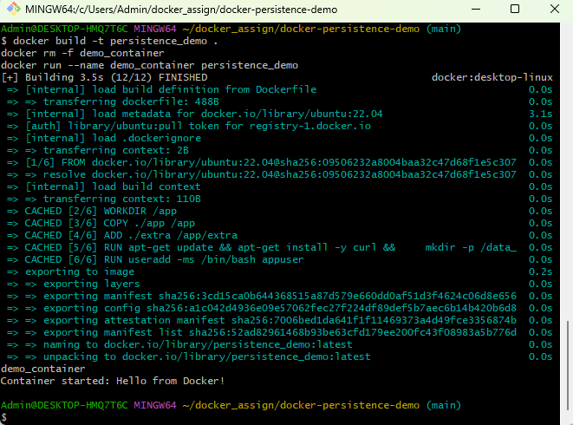

**Make the application accessible from outside the container.**

First we need to build the Dockerfile using below cmd

**docker build -t persistence_demo .**

**docker rm -f demo_container**

**docker run -d -p 8080:8080 --name demo_container persistence_demo**

**Use both *bind mounts* and *Docker volumes* to store data, then verify which data remains after deleting the container.**

We need to add some content to bind_data/bind_file.txt

**echo "Hello from bind mount" > bind_data/bind_file.txt**

To Run container with bind mount + volume

**docker build -t persistence_demo .**

**docker rm -f demo_container**

**docker run -d -p 8080:8080 \**

**-v $(pwd)/bind_data:/app/bind_data \**

**-v data_volume:/data_volume \**

**--name demo_container \**

**persistence_demo**

To go inside a container we need to use below cmd

To Run the container with bindmount and volumn

**docker rm -f demo_container**

**docker run -d -p 8080:8080 \**

**-v ~/docker-persistence-demo/bind_data:/bind_data \**

**-v data_volume:/data_volume \**

**--name demo_container \**

**--user root \**

**persistence_demo**

To access container

**docker exec -it demo_container bash**

Check Bind Mount

**ls /bind_data**

**cat /bind_data/bind_file.txt**

**# Output: Hello bind mount**

Check Docker Volume

**echo "Hello volume" > /data_volume/volume_file.txt**

**ls /data_volume**

**cat /data_volume/volume_file.txt**

**# Output: Hello volume**

**# Volume files**

**docker rm -f demo_container**

**docker volume rm data_volume # remove the named volume**

**docker run -d -p 8080:8080 \**

**-v ~/docker-persistence-demo/bind_data:/bind_data \**

**-v data_volume:/data_volume \**

**--name demo_container \**

**--user root \**

**persistence_demo**

**docker exec -it demo_container bash**

**echo "Hello volume" > /data_volume/volume_file.txt**

**ls /data_volume**

**cat /data_volume/volume_file.txt**

Verify persistence after container deletion.

To Remove Container

**docker rm -f demo_container**

To check Check Bind mount files still exist on host:

**cat ~/docker-persistence-demo/bind_data/bind_file.txt**

To check Host volume files still exist (if using data_volume/ bind mount):

**cat ~/docker-persistence-demo/data_volume/volume_file.txt**

