**ADVANCED BREAST CANCER PREDICTION WITH DEEP LEARNING**

**A PROJRCT**

*Submitted by*

**Teppala Nikhil 216C5A0125**

**Sirapurapu Jayanthi 216C5A0407**

**Adari Praveen kumar 216C5A0201**

**GROUP-3 STUDENTS**

**Team ID:LTVIP2023TMID06601**

**Project Report Format**

1. **INTRODUCTION** 
   1. Project Overview
   2. Purpose
2. **IDEATION & PROPOSED SOLUTION** 
   1. Problem Statement Definition
   2. Empathy Map Canvas
   3. Ideation & Brainstorming
   4. Proposed Solution
3. **REQUIREMENT ANALYSIS** 
   1. Functional requirement
   2. Non-Functional requirements
4. **PROJECT DESIGN** 
   1. Data Flow Diagrams
   2. Solution & Technical Architecture
   3. User Stories
5. **CODING & SOLUTIONING (Explain the features added in the project along with code)** 
   1. Feature 1
   2. Feature 2
   3. Database Schema (if Applicable)
6. **RESULTS** 
   1. Performance Metrics
7. **ADVANTAGES & DISADVANTAGES**
8. **CONCLUSION**
9. **FUTURE SCOPE 10. APPENDIX** Source Code

GitHub & Project Video Demo Link

**LEARNING ADVANCED BREAST CANCER PREDICTION WITH DEEP**

# INTRODUCTION

Deep and machine learning models aid in the detection of breast cancer. The aim of the research work is to encourage medical research and the development of technology by employing deep learning models to recognize cancer cells that are small in size

1. **IDEATION & PROPOSED SOLUTION**

2.1 Problem Statement Definition

**Customer Problem Statement Template:**

## Breast cancer is one of the main causes of cancer death worldwide. Early diagnostics significantly increases the chances of correct treatment and survival, but this process is tedious and often leads to a disagreement between pathologists

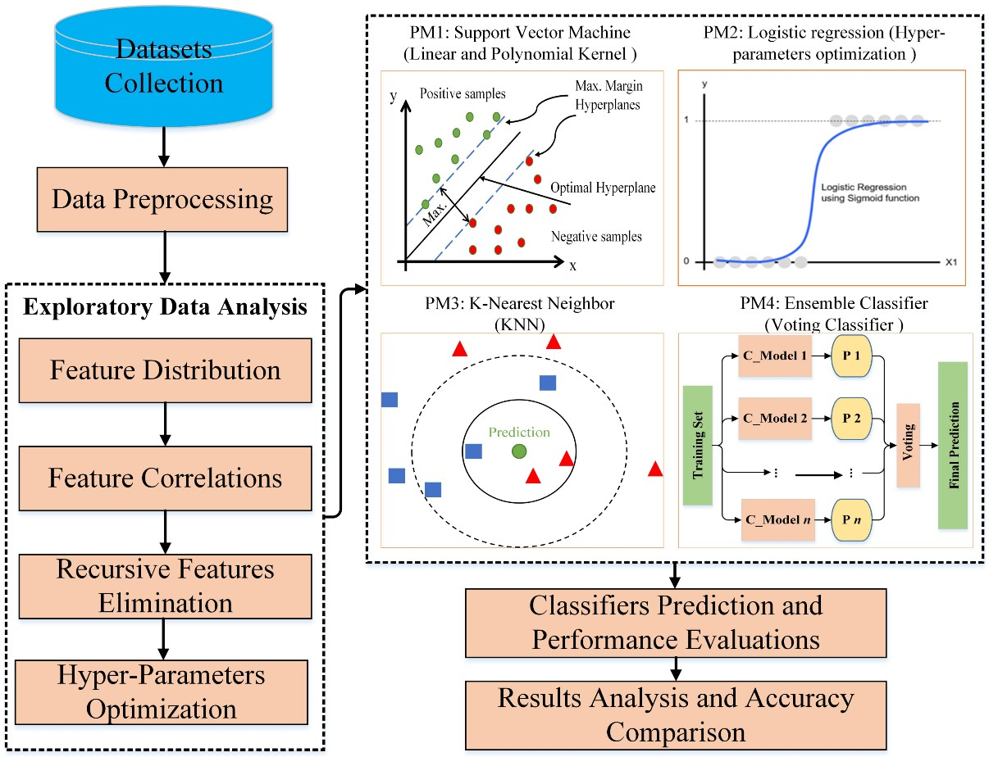

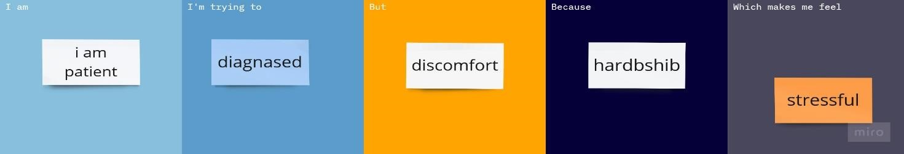

|  |  |  |  |  |  |
| --- | --- | --- | --- | --- | --- |
| **Problem**  **Statement (PS)** | **I am**  **(Customer)** | **I’m trying to** | **But** | **Because** | **Which makes me**  **feel** |
| PS-1 | Person-1 | Live like normal human | Surrounding | Inferiority complex | Disable person |
| PS-2 | Person-2 | Great racer | Vision problem | Basic need in racing | To forget my ambition |
| PS-3 | Person-3 | Police | Vision disability | Physical requirement | I cannot be a save people |
| PS-4 | Person-4 | driver | Improper vision | Can’t drive a vehicle | I not a proper driver |
| PS-5 | Person-5 | Student | Blind by birth | Gene problem | I am not fell like normal |

**Empathy Map Canvas:**

An empathy map is a simple, easy-to-digest visual that captures knowledge about a user’s behaviours and attitudes.

It is a useful tool to helps teams better understand their users.

Creating an effective solution requires understanding the true problem and the person who is experiencing it. The exercise of creating the map helps participants consider things from the user’s perspective along with his or her goals and challenges.

**Empathy Map Canvas:**

An empathy map is a simple, easy-to-digest visual that captures knowledge about a user’s behaviours and attitudes.

It is a useful tool to helps teams better understand their users.

Creating an effective solution requires understanding the true problem and the person who is experiencing it. The exercise of creating the map helps participants consider things from the user’s perspective along with his or her goals and challenges.

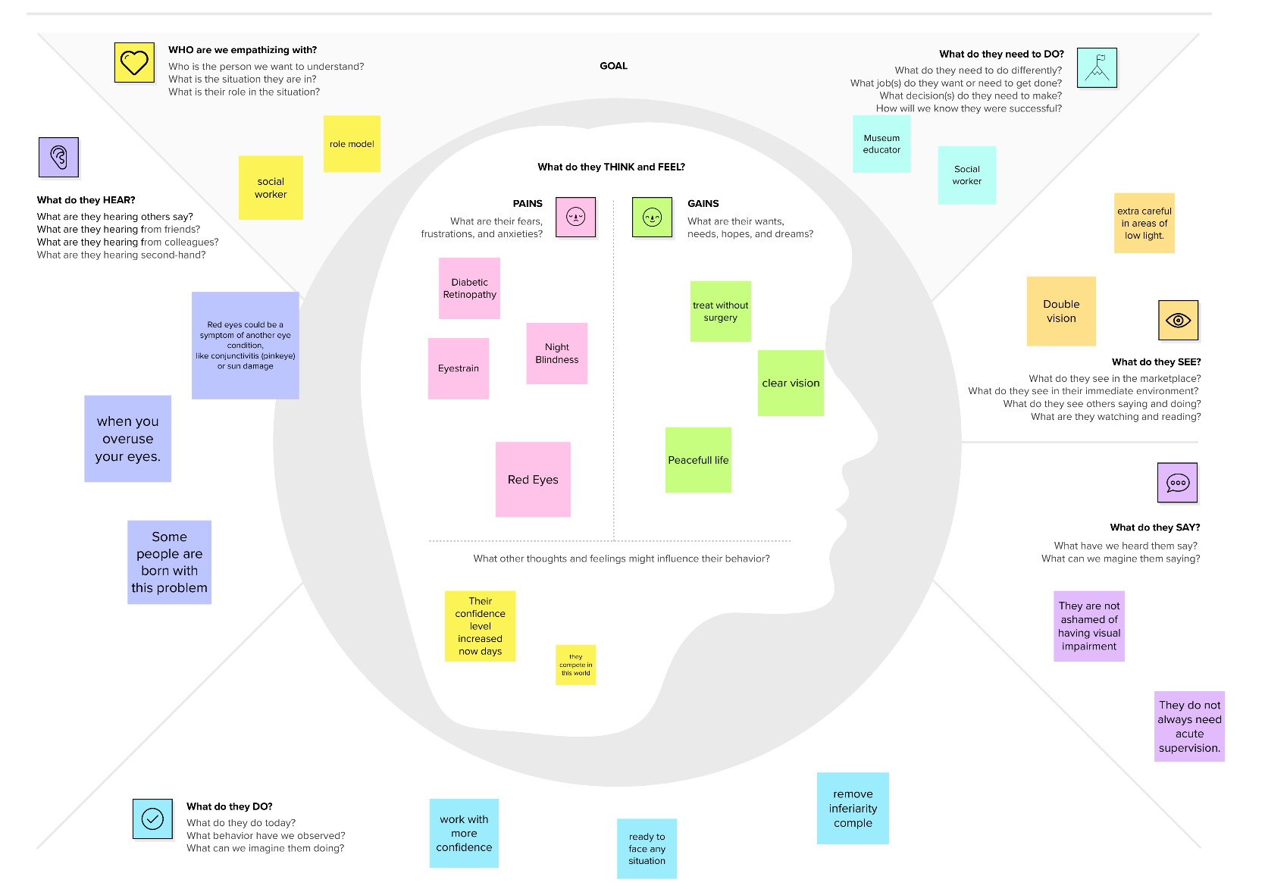

**Brainstorm & Idea Prioritization Template:**

Brainstorming provides a free and open environment that encourages everyone within a team to participate in the creative thinking process that leads to problem solving. Prioritizing volume over value, out-of-the-box ideas are welcome and built upon, and all participants are encouraged to collaborate, helping each other develop a rich amount of creative solutions.

Use this template in your own brainstorming sessions so your team can unleash their imagination and start shaping concepts even if you're not sitting in the same room.

**Step-1: Team Gathering, Collaboration and Select the Problem Statement**

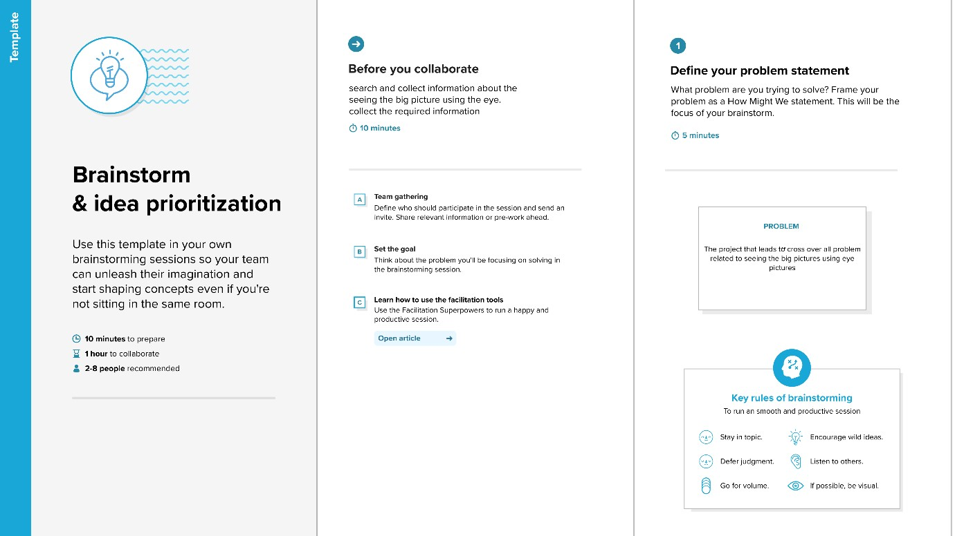

**Step-2: Brainstorm, Idea Listing and Grouping**

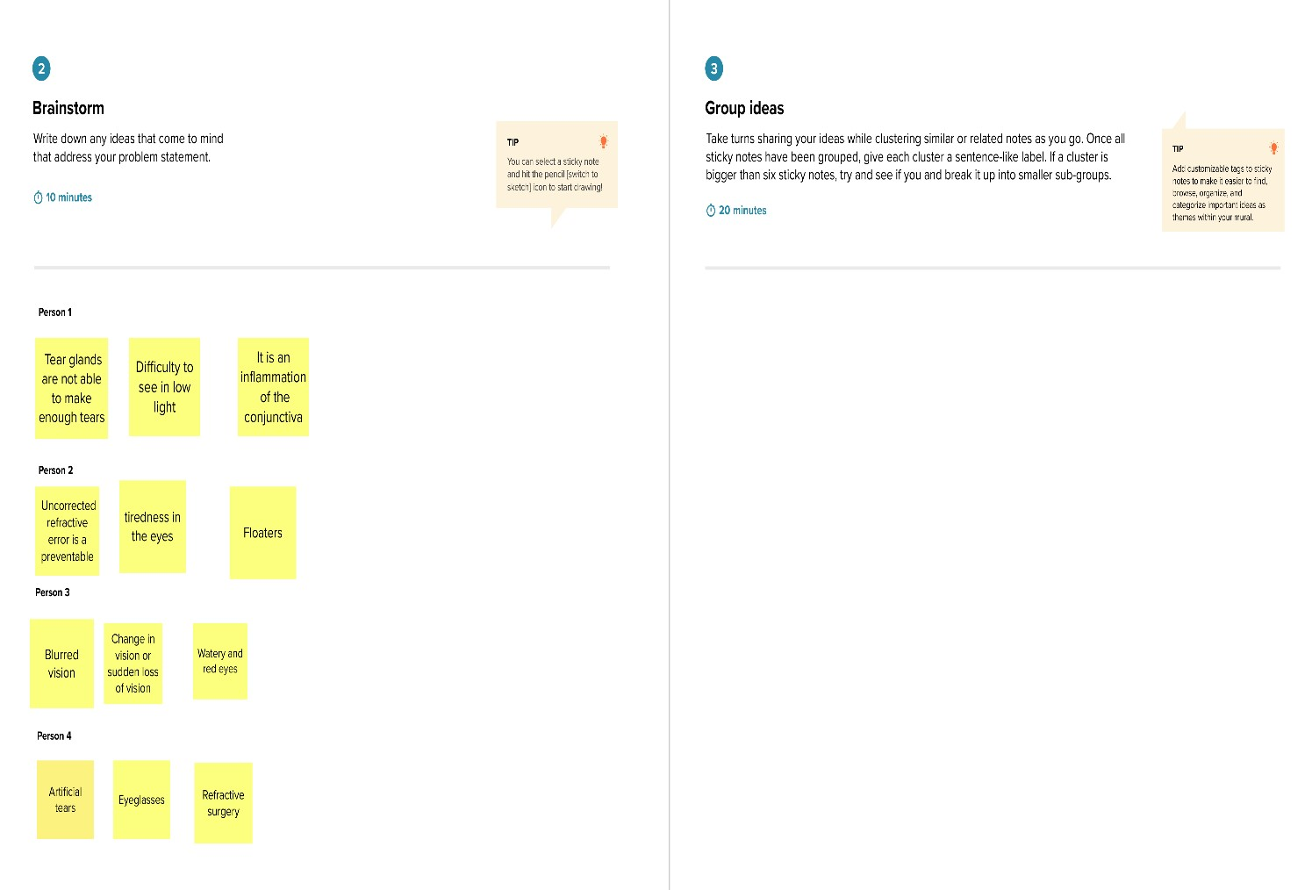

**Step-3: Idea Prioritization**

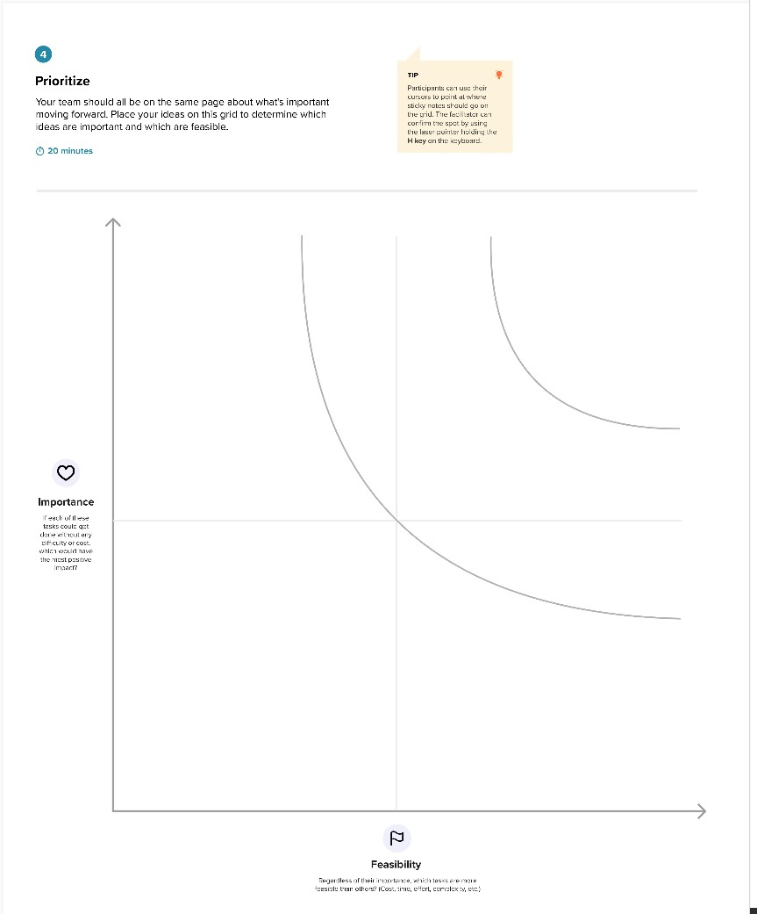

**Proposed Solution Template:**

|  |  |  |
| --- | --- | --- |
| **S.No.** | **Parameter** | **Description** |
| 1. | Problem Statement (Problem to be solved) | Breast cancer is one of the main causes of cancer death worldwide |
| 2. | Idea / Solution description | Surgery is usually the first type of treatment for breast cancer |
| 3. | Novelty / Uniqueness | The most unique quality of cancers is their tenderness of compassion |
| 4. | Social Impact / Customer Satisfaction | A sense of isolation is common after cancer  .you might find emotional support in counsilling  ,a support group or faith community |
| 5. | Business Model (Revenue Model) | The McGrath model of care naturally existing or artificially |
| 6. | Scalability of the Solution | Surgery an operation where doctors cut out cancer tissue. |

**REQUIREMENT ANALYSIS**

**Functional Requirements:**

Following are the functional requirements of the proposed solution.

|  |  |  |
| --- | --- | --- |
| **FR No.** | **Functional Requirement (Epic)** | **Sub Requirement (Story / Sub-Task)** |
| FR-1 | User Registration | Registration through Form  Registration through Gmail  Registration through LinkedIN  Registration through Facebook |
| FR-2 | User Confirmation | Confirmation via Email  Confirmation via OTP  Confirmation via Call |
| FR-3 | Completion the profile | Fill the Name  Fil the Age  Fil the Gender  Fill the Eye problem |
| FR-4 | Continue with | 10 Image Detection free trial  Continue with membership |
| FR-5 | Upload the Images of Affected Eye | Upload the affected eye images in our app |
| FR-6 | Image Processing | AI is detect and identify the eye problem wait for few minutes |
| FR-7 | Report generation | Free version of report-  Disease name  Details about disease |

**Non-functional Requirements:**

Following are the non-functional requirements of the proposed solution.

|  |  |  |
| --- | --- | --- |
| **FR No.** | **Non-Functional Requirement** | **Description** |
| NFR-1 | **Usability** | Available in all languages around in India |
| NFR-2 | **Security** | User data bases are encrypted in our own data centre |
| NFR-3 | **Reliability** | Frequently gives update to resolve the bug in our App |
| NFR-4 | **Performance** | Users can access the App whenever internet speed is low |
| NFR-5 | **Availability** | We can fulfil the requirements of user experience |
| NFR-6 | **Scalability** | Our App traffic limit must be 500000 users at a time |

**PROJECT DESIGN**

**Data Flow Diagrams:**

A Data Flow Diagram (DFD) is a traditional visual representation of the information flows within a system. A neat and clear DFD can depict the right amount of the system requirement graphically. It shows how data enters and leaves the system, what changes the information, and where data is stored.

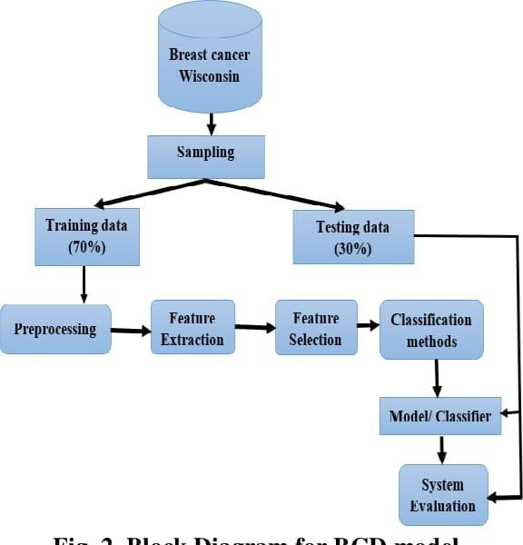

**Solution Architecture:**

Solution architecture is a complex process – with many sub-processes – that bridges the gap between business problems and technology solutions. Its goals are to:

* Find the best tech solution to solve existing business problems.
* Describe the structure, characteristics, behavior, and other aspects of the software to project stakeholders.
* Define features, development phases, and solution requirements.
* Provide specifications according to which the solution is defined, managed, and delivered.

**Solution Architecture Diagram:**

|  |  |  |  |  |
| --- | --- | --- | --- | --- |
| **User Type** | **Functional**  **Requirement**  **(Epic)** | **User Story Number** | **User Story / Task** | **Acceptance crite** |
| Customer  (Mobile user) | Registration | USN-1 | As a user, I can register for the application by entering my email, password, and confirming my password. | I can access my a dashboard |
|  |  | USN-2 | As a user, I will receive confirmation email once I have registered for the application | I can receive conf email & click con |
|  |  | USN-3 | As a user, I can register for the application through Facebook | I can register & ac dashboard with F  Login |
|  |  | USN-4 | As a user, I can register for the application through Gmail | I can register thro gmail |
|  | Login | USN-5 | As a user, I can log into the application by entering email & password | Give login using o |
|  | Dashboard | USn-6 | I cannot download result after image processed. | I need history op my dashboard |
| Customer (Web user) | login | USN-7 | As a user I login every time in browser | Give the keep me in option. |

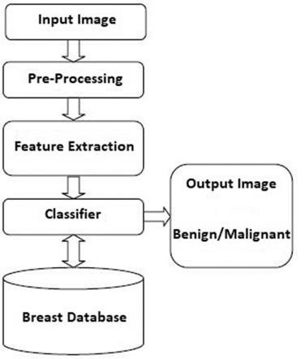

**User Stories**

Use the below template to list all the user stories for the product.

f

|  |  |  |  |  |
| --- | --- | --- | --- | --- |
| **User Type** | **Functional**  **Requirement**  **(Epic)** | **User Story Number** | **User Story / Task** | **Acceptance crite** |
|  | Multiple login | USN-8 | Need multiple device login option | I need this option download my resu |
|  | Doctor recommendation | USN-9 | Give doctor recommendation | Give perfect docto |
| Customer Care Executive | Need importance | USN-10 | Give importance for both customer | Improve in custom |
| Administrator | advertisement | USN-11 | Make advertisement | Spend in advertis |

**4. CODING & SOLUTIONING (Explain the features added in the project along with code)**

1. **RESULTS**

* 1. **PERFORMANCE METRICES**

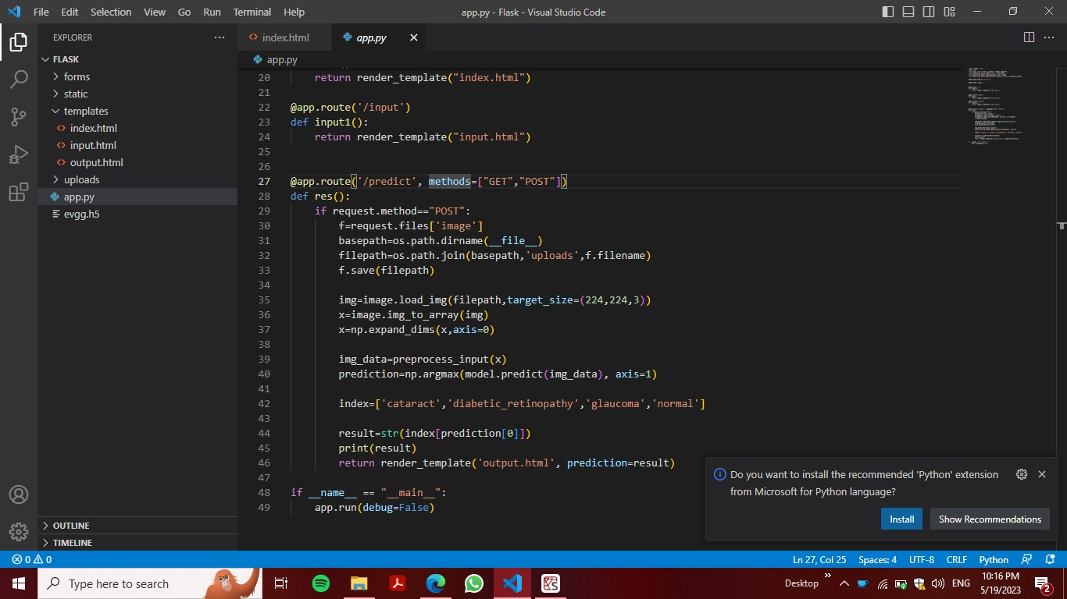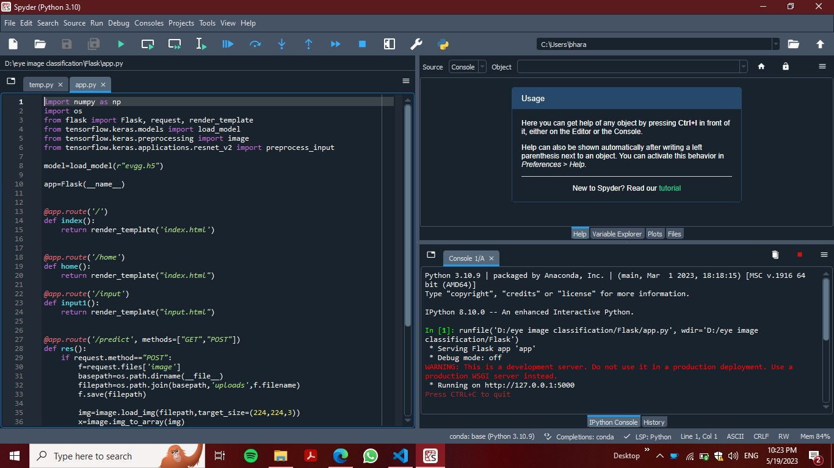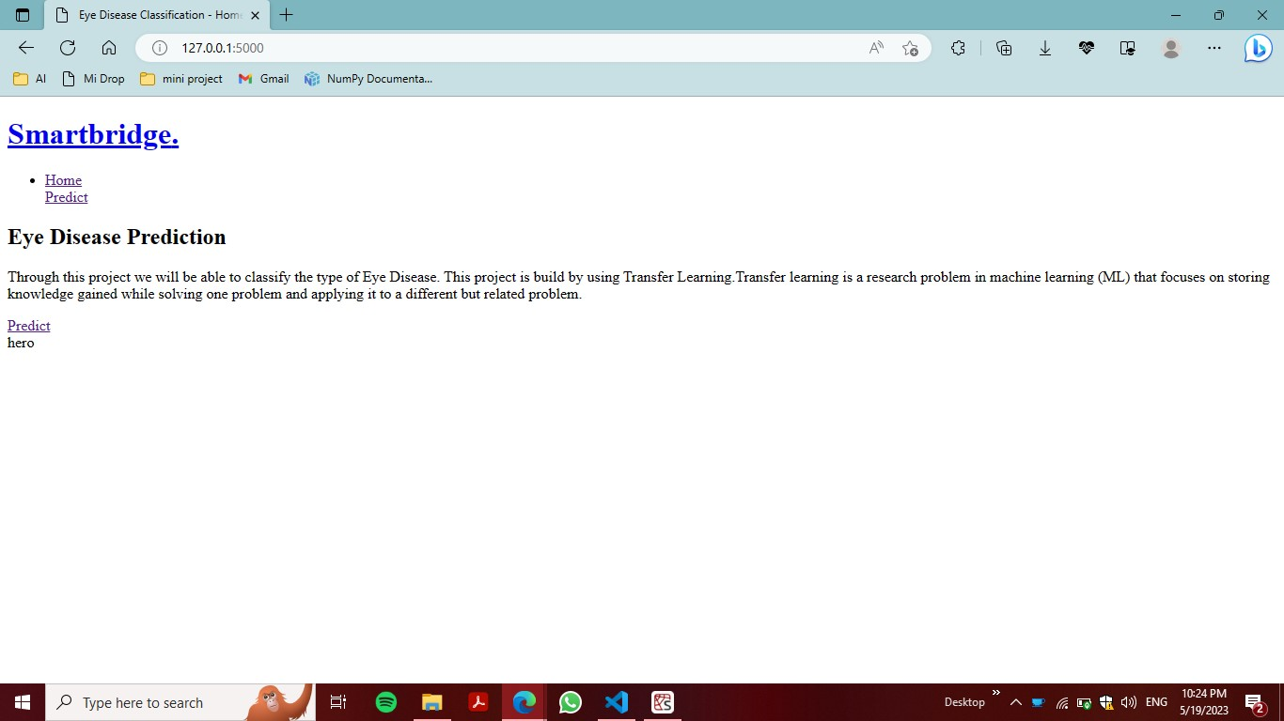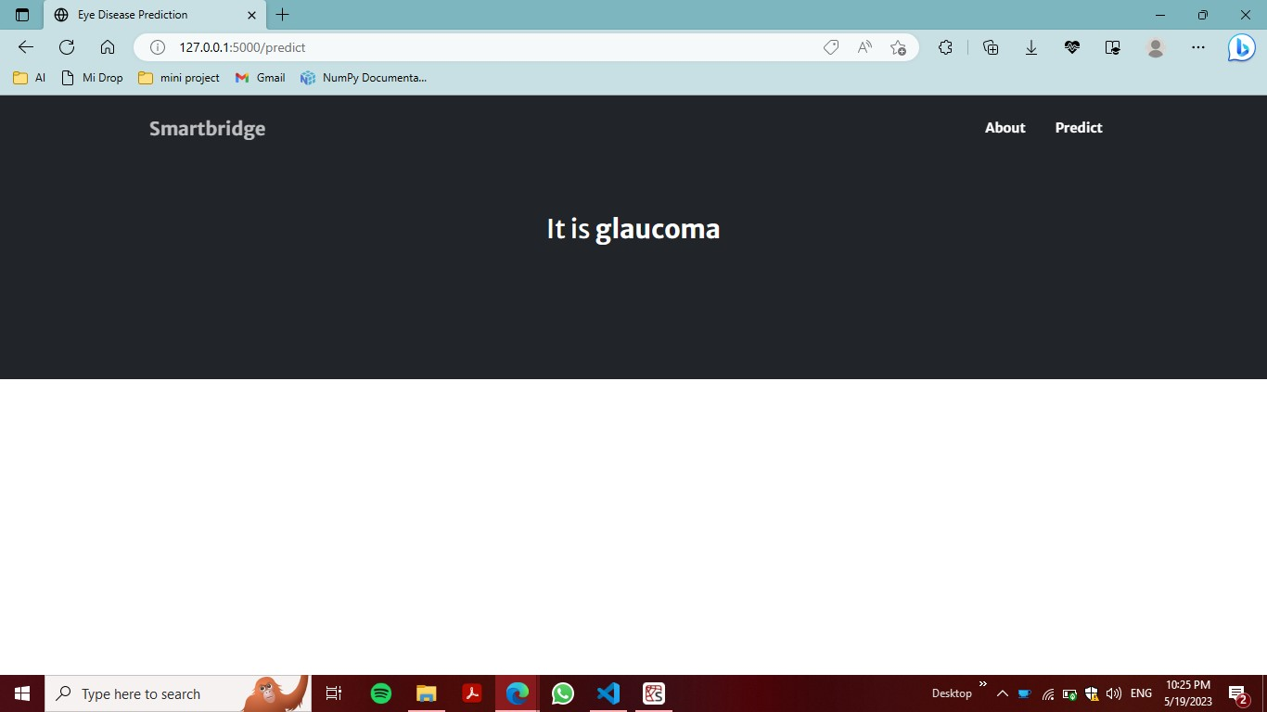

1. **ADVANTAGES AND DISADVANTAGES**

* 1. **ADVANTAGES**

### 1. Reduction in Human Error

One of the biggest advantages of Artificial Intelligence is that it can significantly reduce errors and increase accuracy and precision. The decisions taken by AI in every step is decided by information previously gathered and a certain [set of algorithms.](https://www.simplilearn.com/tutorials/data-structure-tutorial/what-is-an-algorithm) When programmed properly, these errors can be reduced to null.

***Example:***

An example of the reduction in human error through AI is the use of robotic surgery systems, which can perform complex procedures with precision and accuracy, reducing the risk of human error and improving patient safety in healthcare.

### 2. Zero Risks

Another big advantage of AI is that humans can overcome many risks by [letting AI robots](https://www.simplilearn.com/tutorials/artificial-intelligence-tutorial/humanoid-robots) do them for us. Whether it be defusing a bomb, going to space, exploring the deepest parts of oceans, machines with metal bodies are resistant in nature and can survive unfriendly atmospheres. Moreover, they can provide accurate work with greater responsibility and not wear out easily.

***Example:***

One example of zero risks is a fully automated production line in a manufacturing facility. Robots perform all tasks, eliminating the risk of human error and injury in hazardous environments.

### 3. 24x7 Availability

There are [many studies](https://www.cnbc.com/2019/11/17/67percent-of-workers-say-spending-too-much-time-in-meetings-distracts-them.html) that show humans are productive only about 3 to 4 hours in a day. Humans also need breaks and time offs to balance their work life and personal life. But AI can work endlessly without breaks. They think much faster than humans and perform multiple tasks at a time with accurate results. They can even handle tedious repetitive jobs easily with the help of AI algorithms.

***Example:***

An example of this is online customer support chatbots, which can provide instant assistance to customers anytime, anywhere. Using AI and natural language processing, chatbots can answer common questions, resolve issues, and escalate complex problems to human agents, ensuring seamless customer service around the clock.

**4. Digital Assistance**

Some of the most technologically advanced companies engage with users using digital assistants, which eliminates the need for human personnel. Many websites utilize digital assistants to deliver user-requested content. We can discuss our search with them in conversation. Some chatbots are built in a way that makes it difficult to tell whether we are conversing with a human or a chatbot.

***Example:***

We all know that businesses have a customer service crew that must address the doubts and concerns of the patrons. Businesses can create a chatbot or voice bot that can answer all of their clients' questions using AI.

### 5. New Inventions

In practically every field, AI is the driving force behind numerous innovations that will aid humans in resolving the majority of challenging issues.

For instance, recent advances in [AI-based technologies](https://www.simplilearn.com/how-ai-and-automation-are-changing-the-nature-of-work-article) have allowed doctors to detect breast cancer in a woman at an earlier stage.

***Example:***

Another example of new inventions is self-driving cars, which use a combination of cameras, sensors, and AI algorithms to navigate roads and traffic without human intervention. Self-driving cars have the potential to improve road safety, reduce traffic congestion, and increase accessibility for people with disabilities or limited mobility. They are being developed by various companies, including Tesla, Google, and Uber, and are expected to revolutionize transportation.

**7.2 DISADVANTAGES**

### 1. High Costs

The ability to create a machine that can simulate human intelligence is no small feat. It requires plenty of time and resources and can cost a huge deal of money. AI also needs to operate on the latest hardware and software to stay updated and meet the latest requirements, thus making it quite costly.

### 2. No Creativity

A big disadvantage of AI is that it cannot learn to think outside the box. AI is capable of learning over time with pre-fed data and past experiences, but cannot be creative in its approach. A classic example is the bot Quill who can write [Forbes earning reports.](https://www.forbes.com/sites/narrativescience/2015/10/12/eps-estimates-down-for-j-m-smucker-in-past-month/?sh=655a16097595) These reports only contain data and facts already provided to the bot. Although it is impressive that a bot can write an article on its own, it lacks the human touch present in other Forbes articles.

### 3. Unemployment

One application of artificial intelligence is a robot, which is displacing occupations and increasing unemployment (in a few cases). Therefore, some claim that there is always a chance of unemployment as a result of chatbots and robots replacing humans.

For instance, robots are frequently utilized to replace human resources in manufacturing businesses in some more technologically advanced nations like Japan. This is not always the case, though, as it creates additional opportunities for humans to work while also replacing humans in order to increase efficiency.

### 4. Make Humans Lazy

[AI applications](https://www.simplilearn.com/tutorials/artificial-intelligence-tutorial/artificial-intelligence-applications) automate the majority of tedious and repetitive tasks. Since we do not have to memorize things or solve puzzles to get the job done, we tend to use our brains less and less. This addiction to AI can cause problems to future generations.

### 5. No Ethics

Ethics and morality are important human features that can be difficult to incorporate into an AI. The rapid progress of AI has raised a number of concerns that one day, AI will grow uncontrollably, and eventually wipe out humanity. This moment is referred to as the AI singularity.

## **8 CONCLUSION**

Artificial intelligence has the potential to transform all organizations. The process by which this transformation happens can vary, but the steps will tend to follow the roadmap we have listed in this book. Following all the steps outlined in the previous chapters will enable your organization to implement and excel in the use of AI technology. AI holds the key to unlocking a magnificent future where, driven by data and computers that understand our world, we will all make more informed decisions. These computers of the future will understand not just *how* to turn on the switches but *why* the switches need to be turned on. Even further, they may one day ask us if we need *switches* at all.

Although AI cannot solve all your organization's problems, it has the potential to completely change how business is done. It affects every sector, from manufacturing to finance, bringing about never before seen increases in efficiency.

As more industries adopt and start experimenting with this technology, newer applications will be invented. AI will bring a change even more widespread and sweeping than the introduction of computing devices. It will change the way we transact, get diagnosed, perform surgeries, and drive our cars. It is already changing industrial processes, medical imaging, financial modeling, and computer vision. We are well on our way to tapping into this enormous potential, and as a result, the future holds better decision-making potential and faster, ...

**9 FUTURE SCOPE**

The future of [Artificial Intelligence](https://www.javatpoint.com/artificial-intelligence-tutorial) is bright in India, with many organizations opting for AI automation. It is essential to understand the recent developments in AI to find suitable job roles based on your competencies.

The scope of Artificial Intelligence is limited to domestic and commercial purposes as the medical and aviation sectors are also using AI to improve their services. If AI is outperforming human efforts, then opting for AI automation will reduce costs in the long run for a business.

Automation in operational vehicles has created a buzz in the logistics industry as it is expected that automated **trucks/vehicles** may soon be used.

Due to the bright scope of Artificial Intelligence in the future, the number of AI startups is expected to increase in the coming years. Indicating the opportunities, the number of AI start-ups in India has increased significantly.

Moreover, India's talent gap for specialist AI developers is huge, and AI experts are needed by businesses more than ever. Businesses don't want to miss out on any technology that can revolutionize their business processes.

1. **APPENDIX**

**10.1 SOURCE CODE import numpy as np import os from flask import Flask, request, render_template from tensorflow.keras.models import load_model from tensorflow.keras.preprocessing import image from tensorflow.keras.applications.resnet_v2 import preprocess_input**

**model=load_model(r"evgg.h5")**

**app=Flask(_name_)**

**@app.route('/') def index():**

**return render_template('index.html')**

**@app.route('/home') def home():**

**return render_template("index.html")**

**@app.route('/input') def input1():**

**return render_template("input.html")**

**@app.route('/predict', methods=["GET","POST"]) def res(): if request.method=="POST": f=request.files['image'] basepath=os.path.dirname(_file_) filepath=os.path.join(basepath,'uploads',f.filename) f.save(filepath)**

**img=image.load_img(filepath,target_size=(224,224,3)) x=image.img_to_array(img) x=np.expand_dims(x,axis=0)**

**img_data=preprocess_input(x) prediction=np.argmax(model.predict(img_data), axis=1)**

**index=['cataract','diabetic_retinopathy','glaucoma','normal']**

**result=str(index[prediction[0]]) print(result) return render_template('output.html', prediction=result)**

**if _name_ == "_main_": app.run(debug=False) GitHub Link**

[**https://github.com/bharathi20BM002/ODIR-Seeing-the-Big-Picture-for-EyeHealth**](https://github.com/bharathi20BM002/ODIR-Seeing-the-Big-Picture-for-Eye-Health)