Docker and Containerization in Modern DevOps Workflows
Tejith Jayanthi – c0941614
Fameeda Chundanga – c0941888

Abstract
This paper explores the fundamental concepts of software-defined elements, virtualization, hypervisors, and containerization, with a focus on Docker technology. It discusses the differences between containers and virtual machines, Linux and Windows container architectures, the Docker ecosystem, and the installation process. Furthermore, it reflects on the impact of containerization on DevOps culture and processes.
Index Terms — Docker, Containerization, Virtualization, DevOps, Hypervisor, Linux Containers, Windows Containers.

I. INTRODUCTION
The shift towards cloud-native development has accelerated the adoption of containerization technologies. Docker, a leading containerization platform, enables developers to package applications with dependencies for consistent deployment across environments [1]. This paper discusses the core technologies underlying Docker and examines its role in DevOps.

II. SOFTWARE-DEFINED ELEMENTS AND VIRTUALIZATION

A. Software-Defined Elements
Software-defined elements refer to IT resources abstracted from their underlying hardware and managed via software [2]. Examples include Software-Defined Networking (SDN), Software-Defined Storage (SDS), and Software-Defined Data Centers (SDDC).

B. Virtualization
Virtualization enables multiple operating systems to run on a single physical machine using a hypervisor [3]. This allows better resource utilization, isolation, and workload management.

III. HYPERVISORS

A. Types of Hypervisors
- Type 1 (Bare Metal) — Runs directly on physical hardware (e.g., VMware ESXi, Xen).
- Type 2 (Hosted) — Runs on top of a host OS (e.g., VirtualBox, VMware Workstation).

IV. CONTAINERIZATION AND ITS DIFFERENCES FROM VIRTUAL MACHINES
Containerization packages applications with their dependencies in isolated environments using a shared OS kernel [4].
Table I contrasts containers with virtual machines:
Aspect | Containers | Virtual Machines
OS Kernel | Shared | Separate
Size | MBs | GBs
Boot Time | Seconds | Minutes
Isolation | Process-level | Hardware-level
Performance | Near-native | Slight overhead

V. LINUX VS WINDOWS CONTAINERS
Linux containers rely on Linux kernel features (namespaces, cgroups), whereas Windows containers use Windows kernel process isolation. Containers are OS-specific and cannot natively cross host OS boundaries without virtualization layers.

VI. DOCKER TECHNOLOGY

A. Overview
Docker is an open-source platform for developing, shipping, and running applications in containers [5].

B. Popularity Factors
- Environment consistency.
- Rapid deployment.
- Microservices compatibility.
- Large community and ecosystem.

C. Docker Engine
Docker Engine consists of:
- Docker Daemon (manages containers).
- Docker CLI (user interface).
- REST API (integration point).

D. Versions
- Docker CE — Community Edition (free).
- Docker EE — Enterprise Edition (paid).

E. Ecosystem
Includes Docker Hub, Docker Compose, Docker Swarm, and Kubernetes integration.

VII. DOCKER INSTALLATION AND CONFIGURATION

A. Installation Steps (Windows/macOS)
- Download Docker Desktop from the official site.
- Install and launch Docker Desktop.
- Verify with:
- docker --version
- docker info

C. Docker Hub
Central repository for container images. Users can pull official or community images.

VIII. CONTAINERIZATION IN DEVOPS

A. Development Impact
- Eliminates environment inconsistencies.
- Speeds up onboarding and testing.
- Enables microservices architectures.

B. Operations Impact
- Easier deployments and scaling.
- Reduced infrastructure costs.
- Supports CI/CD pipelines.

C. Cultural Shift
Encourages collaboration between development and operations teams, supporting agile practices.

Application Containerization
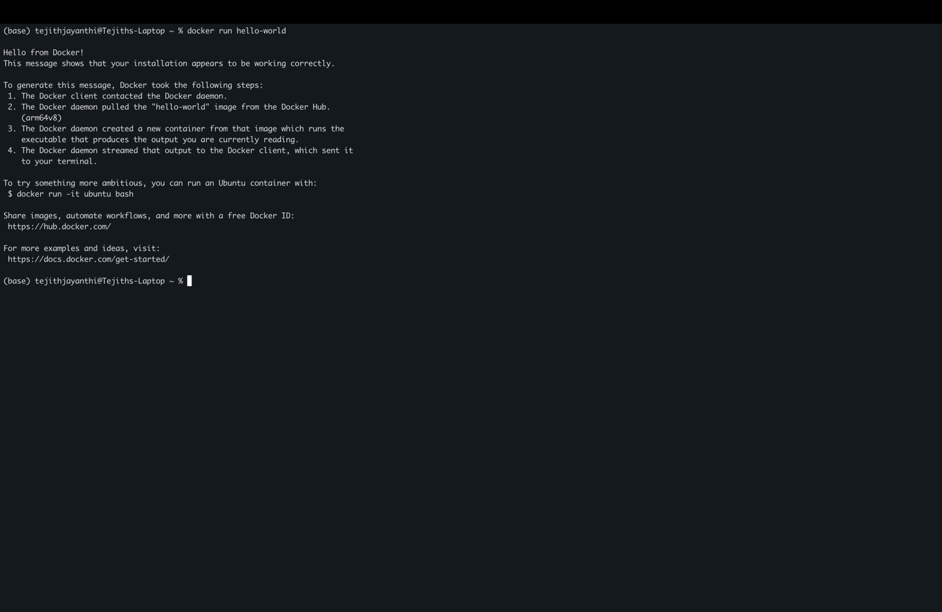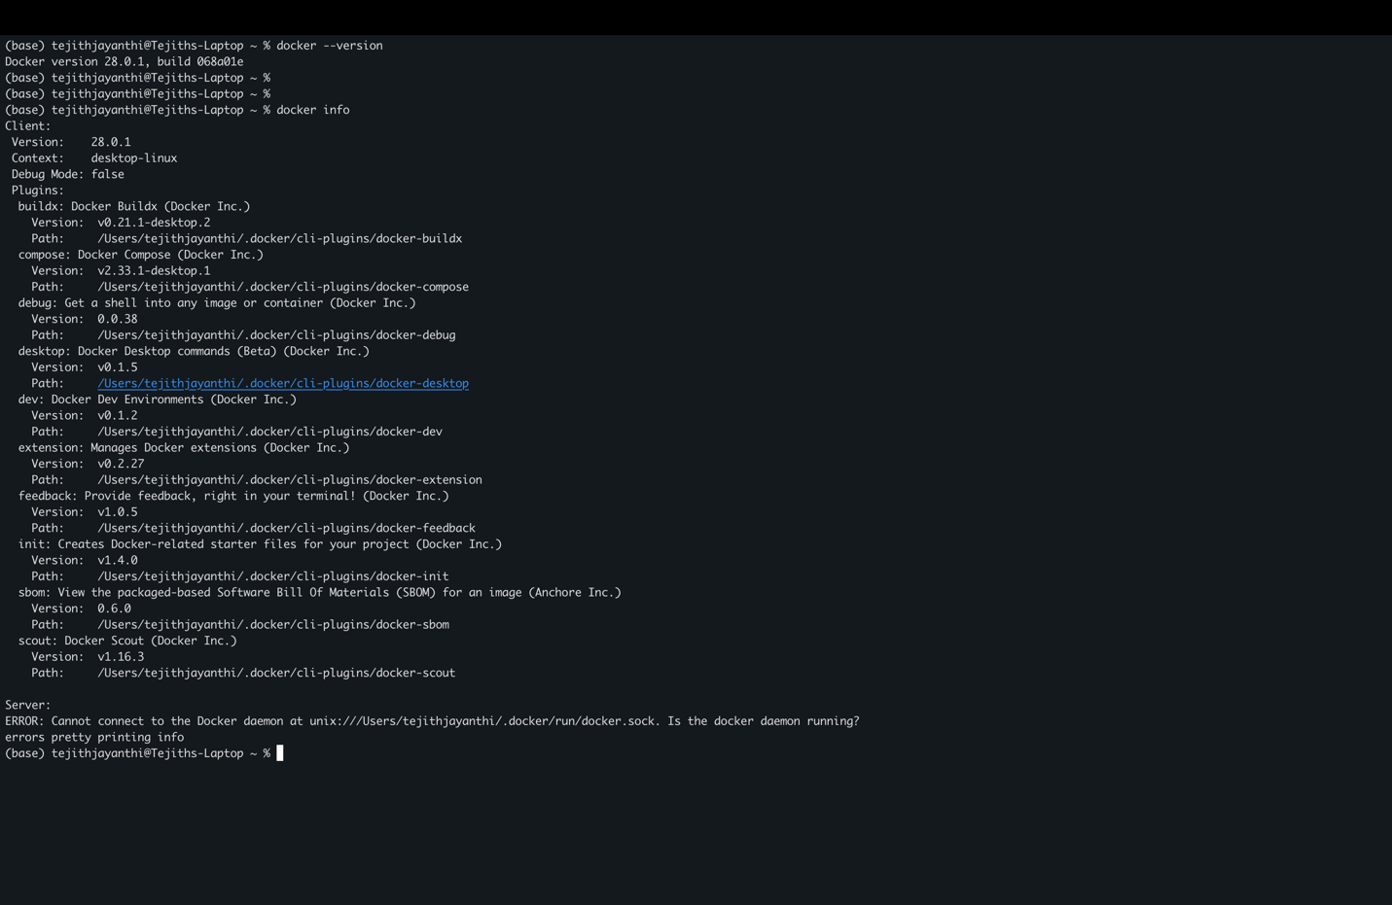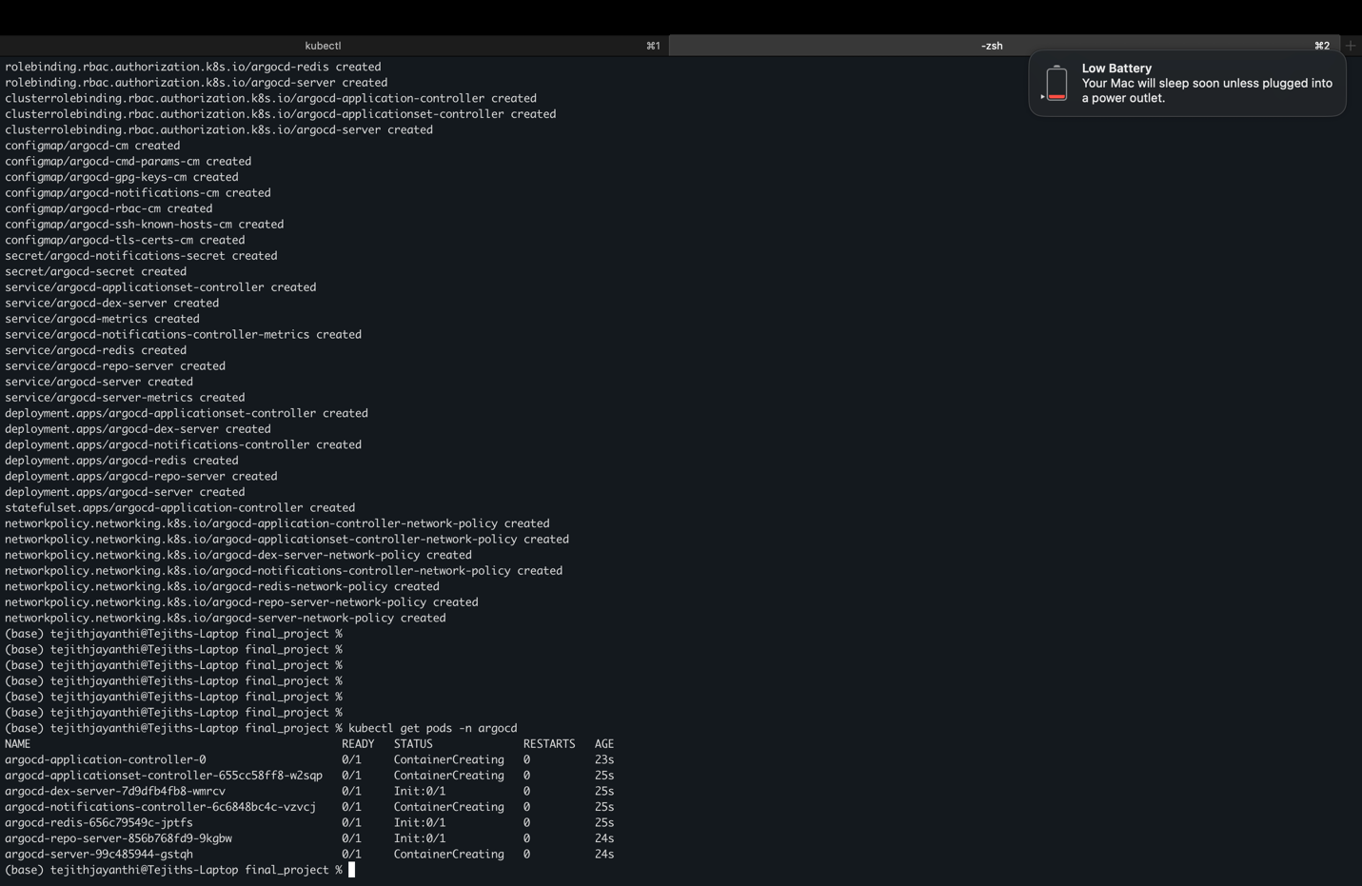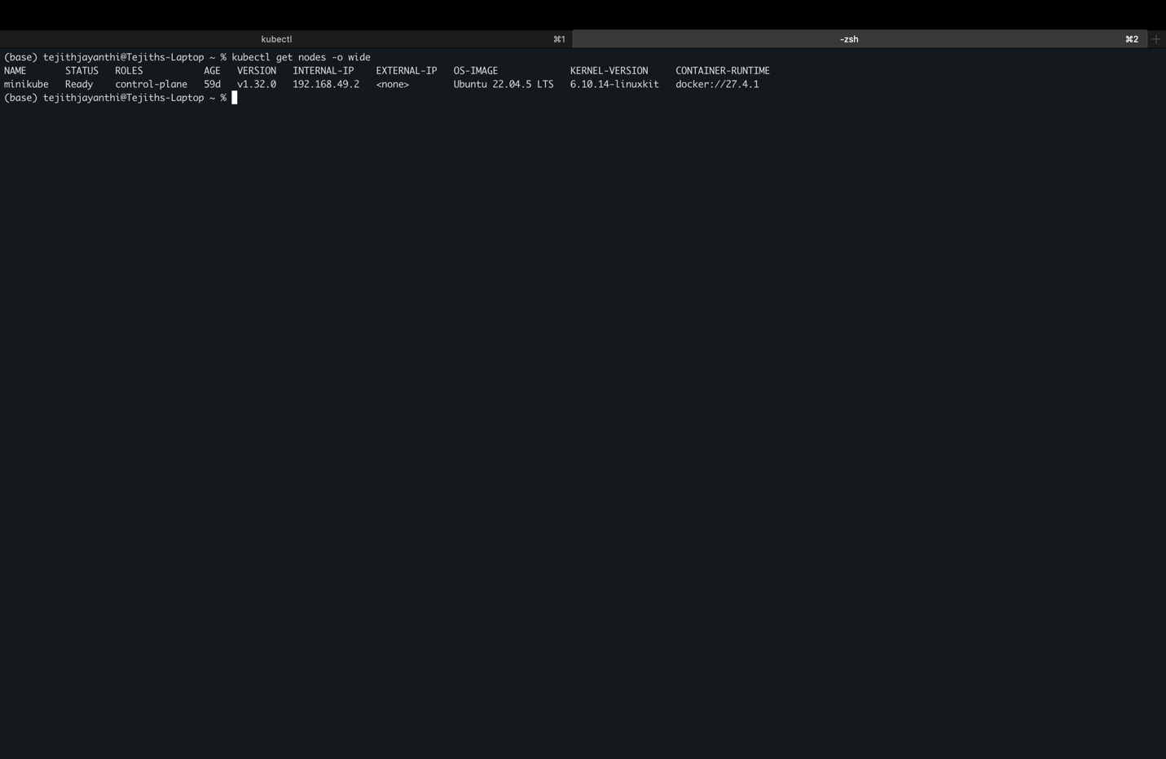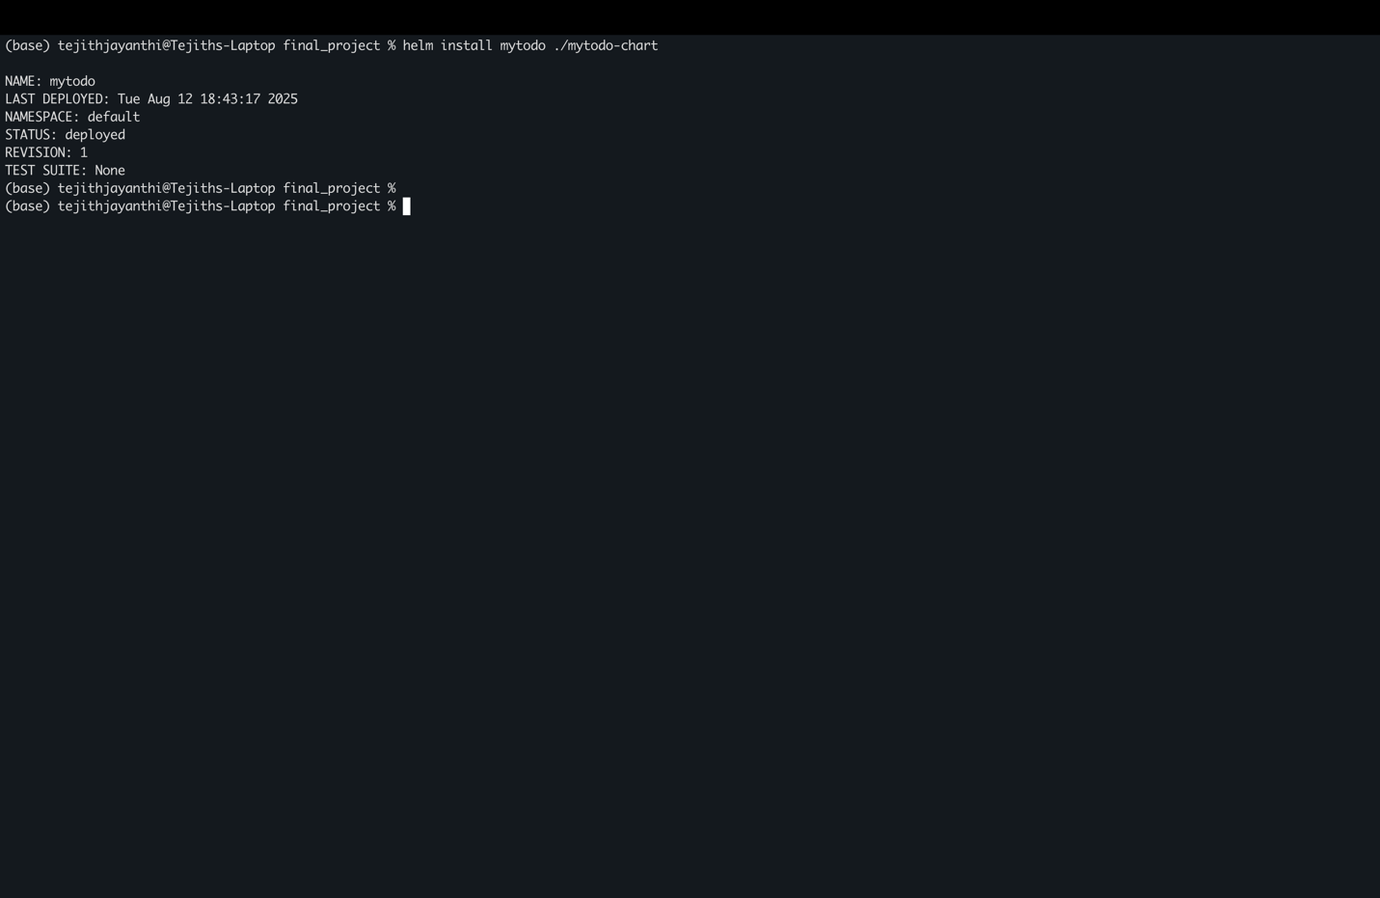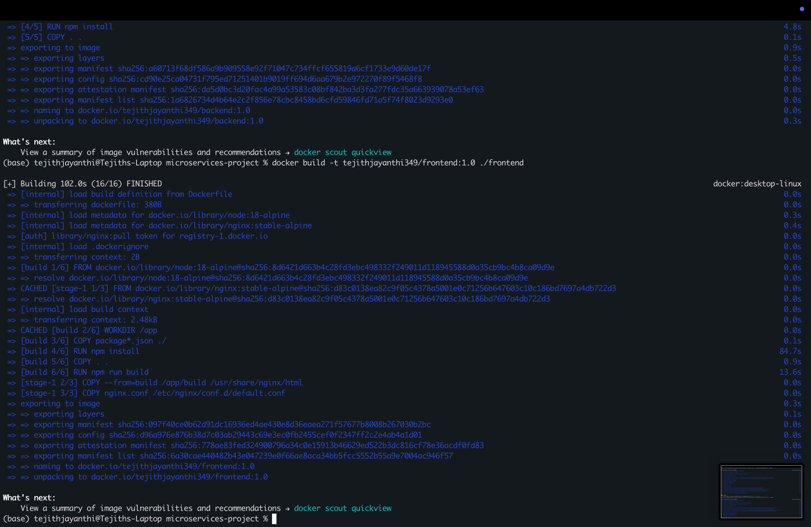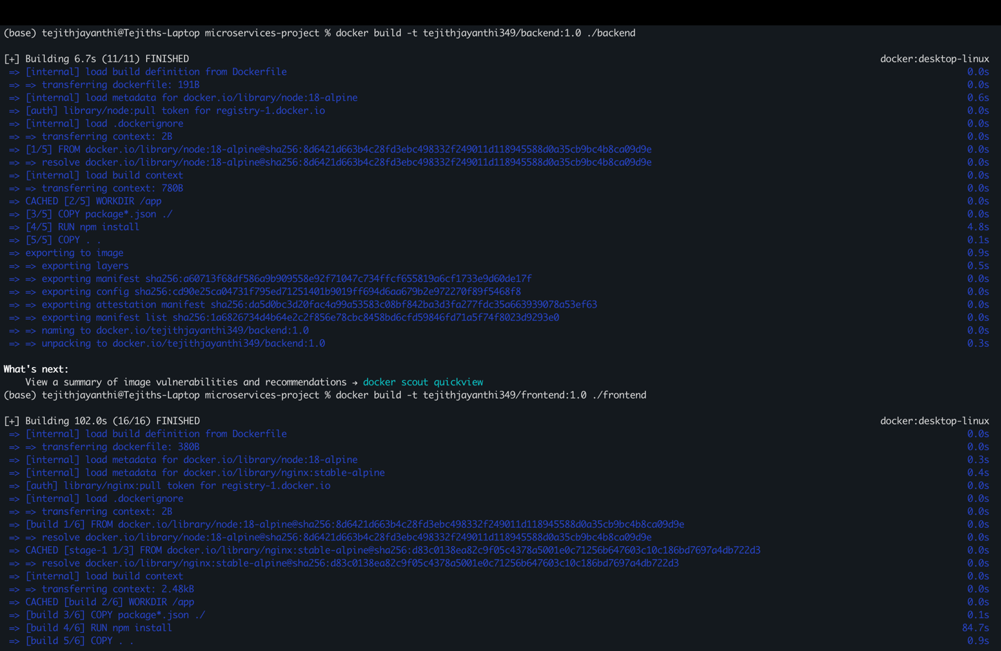
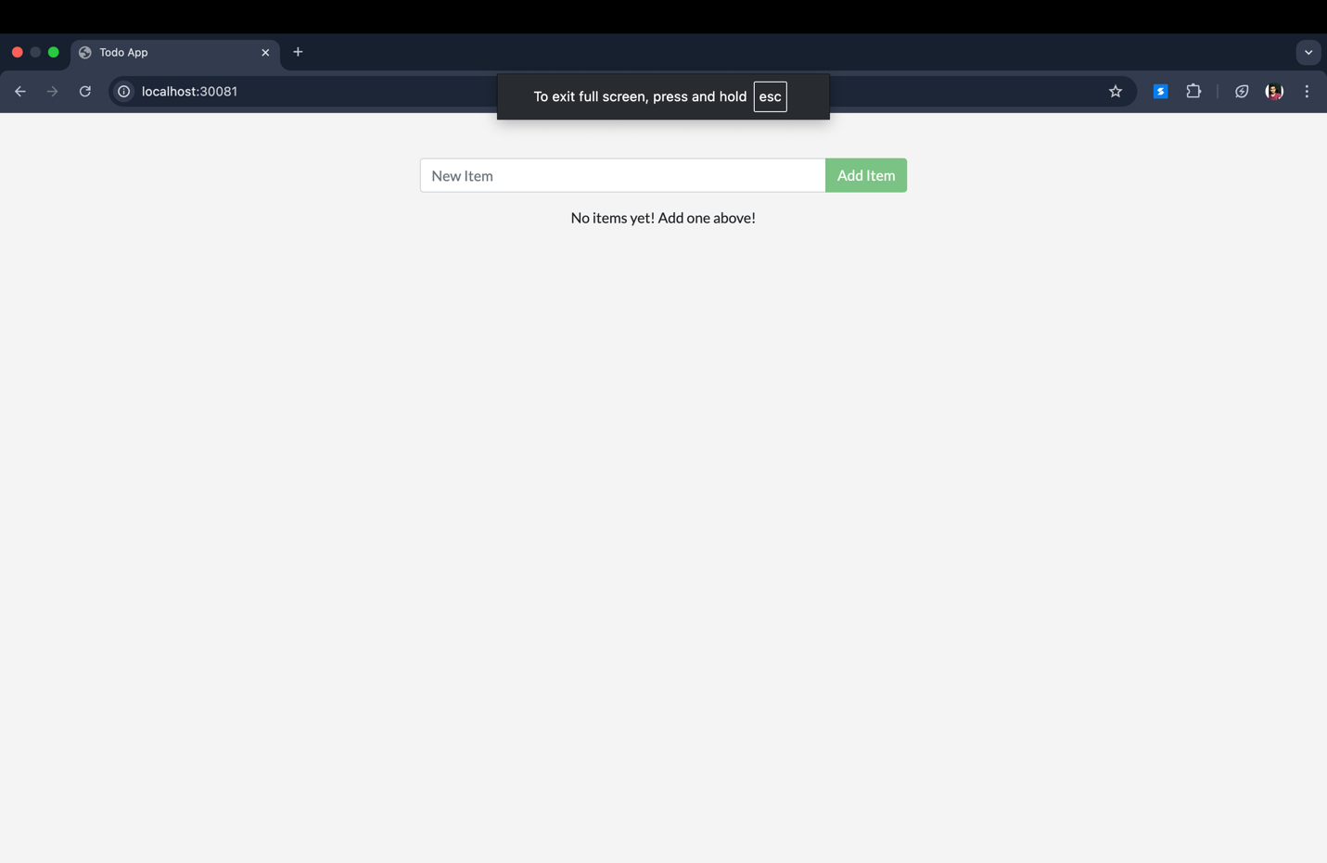

IX. CONCLUSION
Docker and containerization have reshaped the DevOps landscape by improving consistency, scalability, and efficiency. As cloud-native architectures grow, containerization will remain integral to modern software delivery.

REFERENCES
[1] D. Merkel, “Docker: Lightweight Linux Containers for Consistent Development and Deployment,” Linux Journal, vol. 2014, no. 239, pp. 2–5, 2014.
[2] P. Mell and T. Grance, “The NIST Definition of Cloud Computing,” NIST Special Publication 800-145, 2011.
[3] J. Smith and R. Nair, Virtual Machines: Versatile Platforms for Systems and Processes, Morgan Kaufmann, 2005.
[4] W. Felter et al., “An Updated Performance Comparison of Virtual Machines and Linux Containers,” IBM Research Report, 2015.
[5] Docker Inc., “What is Docker?,” [Online]. Available: https://www.docker.com

