**import** java.util.Scanner;

**public class** bucket {

**public static void** main(String[] args)

{ Scanner sc=**new** Scanner(System.*in*);

**int** bucket=0;

**int** op_rate,i,n,bsize;

System.*out*.println("Enter the number of packets"); n=sc.nextInt();

System.*out*.println("Enter the output rate of the bucket"); op_rate=sc.nextInt();

System.*out*.println("Enter the bucket size"); bsize=sc.nextInt();

System.*out*.println("Enter the arriving packets(size)");

**int** pkt[]=**new int**[n]; **for**(i=0;i<n;i++)

{ pkt[i]=sc.nextInt(); }

System.*out*.println("\nSec\tpsize\tBucket\tAccept/Reject\tpkt_send");

System.*out*.println("--------------------------------------------");

**for**(i=0;i<n;i++)

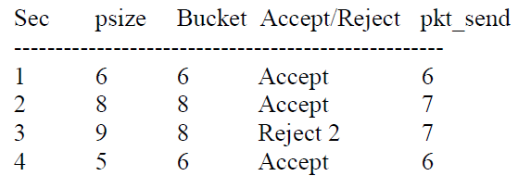{ System.*out*.print(i+1+"\t"+pkt[i]+"\t");

**if**(bucket+pkt[i]<=bsize)

{ bucket+=pkt[i];

System.out.print(bucket+"\tAccept\t\t"+min(bucket,op_rate)+"\n" +""); bucket=sub(bucket,op_rate); }

**else**

{ int reject=(bucket+pkt[i]-bsize);

bucket=bsize;

System.out.print(bucket+"\tReject "+reject+"\t"+min(bucket,op_rate)+"\n");

bucket=sub(bucket,op_rate); } }

**while**(bucket!=0)

{ System.*out*.print((++i)+"\t0\t"+bucket+"\tAccept\t\t"+*min*(bucket,op_rate)+"\t"); bucket=*sub*(bucket,op_rate); } }

**static int** min(**int** a,**int** b)

{ **return** ((a<b)?a:b); }

**static int** sub(**int** a,**int** b)

{ **return** (a-b)>0?(a-b):0; } }

**Output 1**–

Enter the number of packets 4

Enter the output rate of the bucket 7

Enter the bucket size 8

Enter the arriving packets(size) 6 8 9 5