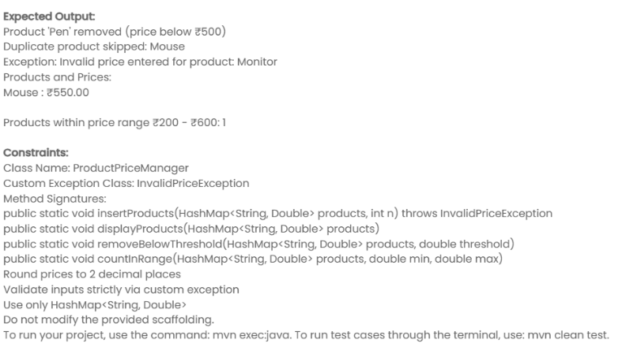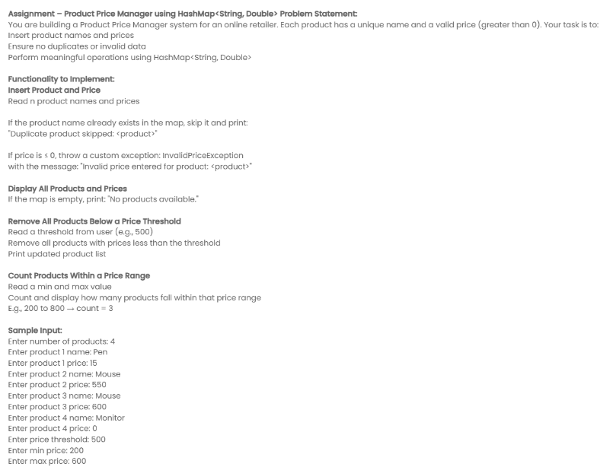

package com.examly;

import java.util.\*;

public class RatingTracker {

    public static void insertRatings(ArrayList<Integer> ratings, int n){

        Scanner sc = new Scanner(System.in);

        for(int i=0;i<n;i++){

        System.out.println("Enter rating "+i+1+": ");

            int rating =Integer.parseInt(sc.nextLine().trim());

            if(rating<1 || rating>5){

                throw new IllegalArgumentException("Invalid rating: must be between 1 and 5.");

            }

            ratings.add(rating);

        }

    }

    public static void displayRatings(ArrayList<Integer> ratings){

        if(ratings.isEmpty()){

            System.out.println("No valid ratings were entered. please try again with at least one valid rating.");

        }

        else{

            System.out.println("All Ratings: "+ratings);

        }

    }

    public static void analyzeRatings(ArrayList<Integer> ratings){

        if(ratings.isEmpty())  return;

        int count5 =0;

        for(int rate: ratings){

            if(rate == 5)   count5++;

        }

        double percentage = (count5\*100.0 )/ratings.size();

        System.out.printf("5-Star Ratings Count: %d (%.2f%%)%n",count5,percentage);

    }

    public static void findLowestRating(ArrayList<Integer> ratings){

        if(ratings.isEmpty())  return;

        int min = Collections.min(ratings);

        System.out.println("Lowest Rating: "+min);

    }

    public static void printRatingFrequency(ArrayList<Integer> ratings){

        int c1 = 0,c2 =0, c3 = 0,c4=0,c5=0;

        for(int r:ratings){

            if(r==1)  c1++;

            if(r==2)  c2++;

            if(r==3)  c3++;

            if(r==4)  c4++;

            if(r==5)  c5++;

        }

        System.out.println("1 star: "+c1);

        System.out.println("2 star: "+c2);

        System.out.println("3 star: "+c3);

        System.out.println("4 star: "+c4);

        System.out.println("5 star: "+c5);

    }

    public static void main(String[] args) {

//Write Your Code Here

    }

}