Pantry Cooking Assistant Project Documentation
  - Version 1 development report
Prepared for JAY | October 16 2026

Project overview
I built Pantry Cooking Assistant as a local application for managing kitchen ingredients and planning meals. It combines a searchable pantry, reminders, AI recipe generation, a shopping checklist, saved favorites, a meal planner, and a food matching game. The purpose is to make the path from a meal idea to a shopping list and a planned date easier to follow.
The functional Version 1 scope is implemented. On October 16, I reported completing the application checks. The remaining release work is to capture final screenshots, record the demonstration, and commit the updated documentation. The project runs locally and is not presented as a hosted multi-user service.

Completed scope
- Five main tabs: My Pantry, AI Chef, Shopping List, Favorites, and Meal Planner.
- Recipe requests can be independent of pantry contents. Cuisine, food preference and a 10 to 120 minute preferred cooking time guide generation.
- Qwen 2.5 7B runs through a local Ollama server. Streamed text makes progress visible while the response is generated.
- Pantry, shopping, favorites and meal plans use SQLite. Custom meals do not require a favorite or an AI recipe.
- The interface retains the cooking palette, top grocery row, floating decorations and a 4 by 4 memory game.

Practical limits
Recipes and nutrition are model-generated suggestions, not verified calculations or guaranteed cooking instructions. Reminder dates help organize ingredients; they are not expiry predictions. The measured local wait was about 90 seconds for a detailed recipe, and streaming changes visibility rather than guaranteeing faster generation.

Development journey

From a recipe dataset to open requests
The early implementation stored curated recipes in recipes.json and matched normalized pantry ingredients with recipe requirements. Strict matching often returned no result when the user lacked one ingredient. The approach changed to allow suggestions and, later, open recipe requests through AI Chef. The curated recipe JSON was removed while the grocery catalog and 120-minute slider remained.

Separating requests from pantry ownership
A user can search for mutton curry even without owning mutton. The recipe should keep the requested dish and list a complete ingredient set. Earlier answers incorrectly converted meat dishes into vegetarian alternatives or repeated ingredients under available and suggested sections. The interface now uses one recipe ingredient list and a shopping draft that users review themselves.

Adding persistence and planning
SQLite replaced temporary pantry storage so ingredient dates survive restarts. Favorites added saved recipes and editable labels. The meal planner then expanded beyond favorites: users can write their own meal, select the latest AI recipe, or choose a favorite. A meal can begin with just a name and receive instructions later.

Improving generation and troubleshooting
Small-model answers sometimes omitted noodles, contradicted quantities or mislabeled food types. Formatting checks also rejected readable labels. We separated presentation fixes from generation quality, normalized titles and metadata, and stopped repeatedly rewriting recipes automatically.
On the development laptop, Ollama initially used the CPU. Enabling the Intel Arc 140V integrated GPU through Vulkan allowed GPU execution but was followed by repetitive and unrelated output. A direct CPU comparison produced a relevant answer. CPU mode became the working configuration; this comparison suggests a GPU execution issue on this setup, not a general conclusion about Intel hardware.
Qwen 2.5 7B followed the tested dish request better than 3B. The larger model was slower, so streamed generation was added. Server errors now expose useful details, including repetition aborts, rather than assuming every failure means the model is missing.

What I learned
I practiced modular Python, SQLite transactions, date calculations, Streamlit reruns and callbacks, local API integration, streamed JSON events, Markdown parsing, scoped CSS and Git. The main debugging lesson was to inspect the saved file, original model response and server logs before changing unrelated code.

Architecture and project files
Streamlit renders the interface and calls separate Python modules. Requests sends a local HTTP chat request to Ollama. SQLite preserves application records; session state holds the current AI answer and game. YouTube is an external search action, not a fetched or verified video.
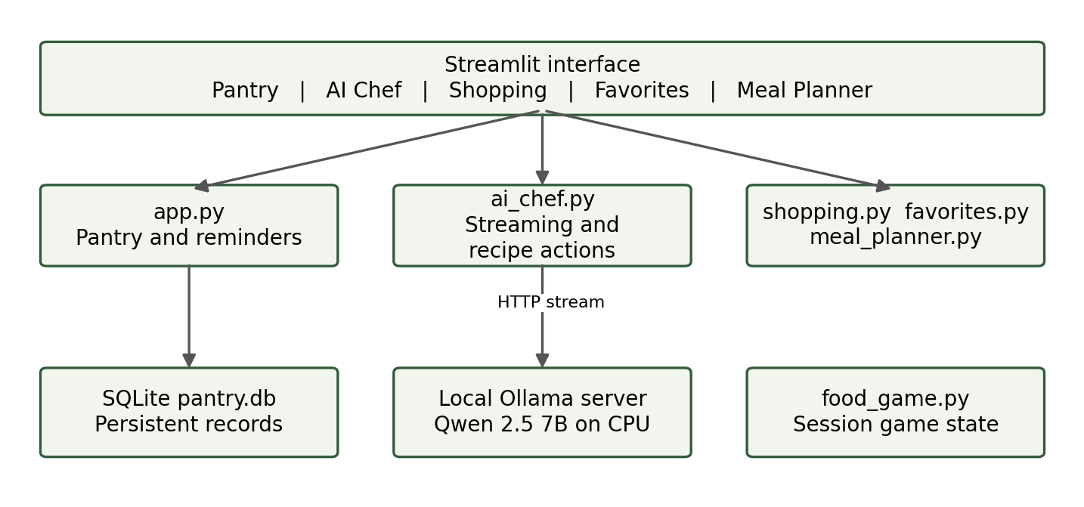
Figure 1 Main components with selected connections
Component | Responsibility
app.py | Tabs, grocery catalog, aliases, pantry CRUD, reminder popup and style.
ai_chef.py | Prompt, streamed response, title and label normalization, recipe actions.
favorites.py | Persistent recipes, search, food/cuisine/gluten filters and corrections.
meal_planner.py | Any-date custom, AI or favorite meal copies; editing and download.
shopping.py | Shopping checklist, purchase status, deletion and text download.
food_game.py | Random food pairs, names, moves, session best and celebration.
.streamlit/config.toml | Theme settings; additional CSS remains in the app.
pantry.db | Local pantry, shopping, favorite_recipes and weekly_meals tables.
Additional connections: shopping, favorites and planner modules use the same database. AI Chef supplies a reviewed shopping draft and calls the favorite save action. The planner reads favorites and the latest completed AI answer. The game appears within the pantry layout.

Pantry reminders and shopping
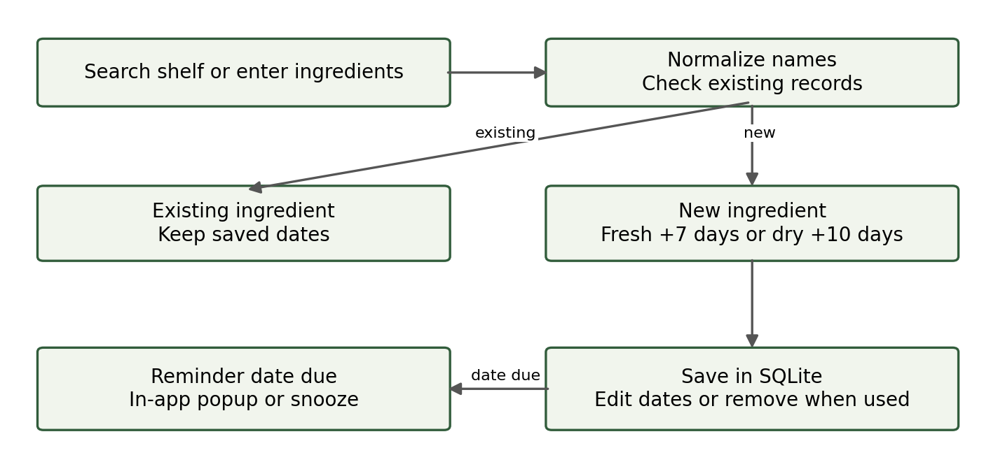
Figure 2 Ingredient persistence and reminder workflow

Ingredient entry and search
Users browse vegetables, fruits, pantry and dairy, meat and seafood, and spices, herbs and sauces. Alias normalization covers examples such as egg to eggs, green onions to spring onion and shrimp to prawns. This is a defined alias map rather than unrestricted spelling correction. Existing ingredient records keep their original dates when selected again.

Reminder behavior
Fresh ingredients default to seven days after the chosen added date; dry goods default to ten. Users can edit category and dates, and a reminder date before the added date is rejected. Dates on or before today are due. The popup appears once per date in the active session or through the reminder action; snoozing moves due reminder dates to tomorrow without resetting added dates.
Reminder dates are organizational aids only. The app does not assess freshness or send notifications while closed. Compatible due items can be prioritized through an optional AI Chef checkbox when pantry use is enabled.

Shopping checklist
Users can enter items manually or review all recipe ingredient bullets in an editable draft. They remove already-owned ingredients and unwanted optional extras before adding items. Purchase checkboxes, removal, clearing purchased records and download operate independently from the pantry. Full-text, case-insensitive deduplication can still treat different quantity wording as separate items.

AI recipes and saved favorites
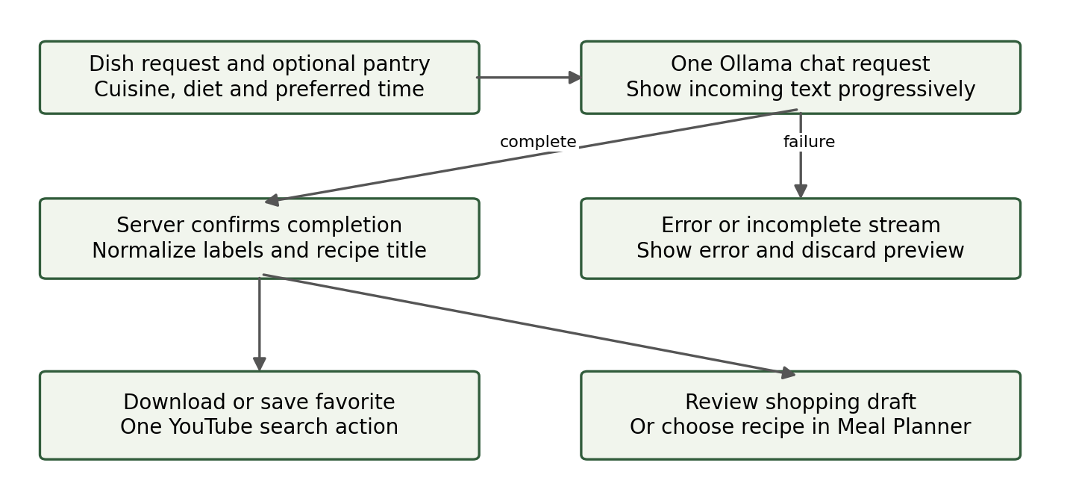
Figure 3 Streamed recipe generation and downstream actions

Generation and completion
AI Chef uses qwen2.5:7b at localhost:11434/api/chat. One request uses stream=true, temperature 0.6, repeat_last_n 128, repeat_penalty 1.1, and an output cap of 2400 tokens. The connection timeout is 10 seconds and the read timeout is 300 seconds between received data. The model is kept loaded for 30 minutes after use when possible.
The client reads newline-delimited JSON events, accumulates message.content and refreshes the preview roughly every 0.15 seconds. A successful final done event completes the answer. Stream errors, disconnection, empty content or a length-limit finish do not store a completed recipe. These are transport and completion checks, not a guarantee of recipe consistency.

Titles and recipe actions
Title handling accepts common headings, short plain titles and explicit recipe-name labels. When the model omits a title, the request provides a fallback. A title is placed at the top of the completed recipe and stored in its context, so display, download and a new favorite can use a consistent name. Earlier saved generic names require correction in Favorites.

Favorites and estimates
Favorites store a recipe copy and automatic food/cuisine suggestions. Users can search names, filter food type, cuisine and gluten status, correct labels or remove records. Gluten defaults to Not checked. Nutrition remains an approximate AI estimate per serving; no verified ingredient nutrition database is connected. The recipe offers one YouTube search action, whose results may differ from the generated method.

Meal planner workflow
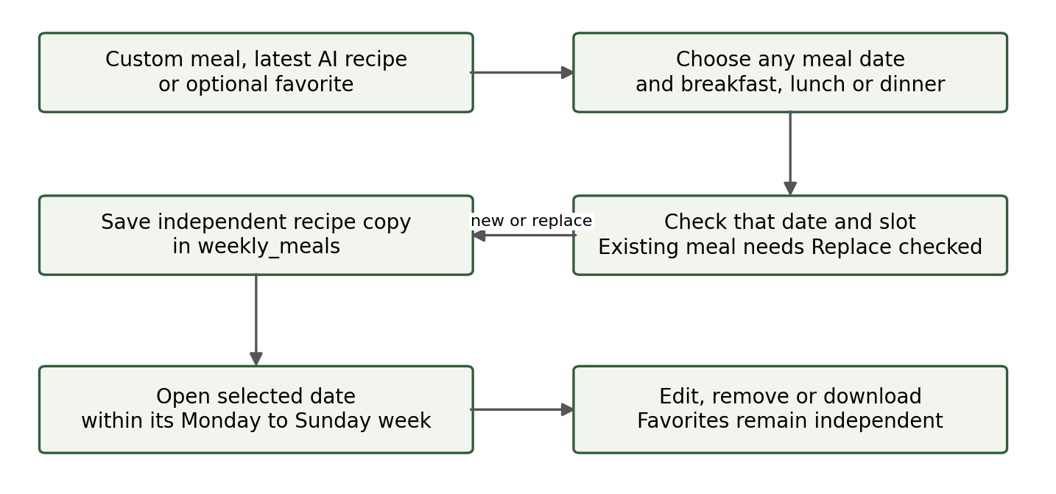
Figure 4 Custom and generated meals share the same calendar workflow

Three ways to add a meal
Custom meal accepts a name, optional ingredients and optional instructions or notes. Latest AI recipe uses the completed session answer without requiring a favorite. Favorite lets users reuse an existing saved recipe. Every path selects a calendar date and breakfast, lunch or dinner. Users can choose dates outside the currently displayed week.

Saving and navigation
The planner checks the chosen date and slot for an existing record. Replacement requires the Replace checkbox. Successful saving records a pending navigation date, then reruns the app. Before the next date widget is created, the pending value is applied so the view opens the Monday-to-Sunday week containing the saved meal. This avoids assigning a widget value after it has rendered.

Independent copies and editing
The weekly_meals table stores meal_date, meal_slot, name, recipe_text and source, with one record per date and slot. Recipe text is copied rather than linked by a favorite foreign key. Deleting or editing a favorite therefore does not alter an existing plan. Users can view instructions, edit name and notes, remove a meal, or download the visible week as Markdown. Editing a planned recipe makes it a custom meal.

Persistence
Meal plans stay in the same local database as the pantry and favorites. The latest AI answer is available only within its active session until copied into a plan or favorite. Changing the view date filters stored records; it does not regenerate or delete meals.

Food game and interface
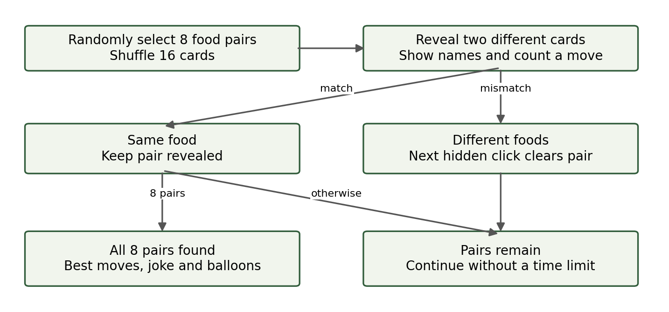
Figure 5 The game continues until all eight pairs are found

Matching and learning
The 4 by 4 board uses eight pairs selected from food groups, including vegetables, fruits, dairy and pantry foods, meat, seafood and spices. Revealed food names help children associate an ingredient with its symbol. Each two-card attempt increases the move count. Matched pairs remain visible; a wrong pair remains until another hidden card starts the next attempt. There is no timeout or loss condition.

Scores and celebration
The game tracks moves and the lowest completed move count in session state. The best possible result is eight moves for eight pairs. Completing the board selects a funny cooking message and triggers balloons once for that game. Starting again resets the board while a session best can remain. The score is not a permanent account-based leaderboard.

Readability and navigation
The interface uses a cream background with green and orange accents, a top grocery row and floating ingredient decorations. Decorative animation does not intercept clicks and is disabled for reduced-motion preferences. Bright cards and visible food names replaced faded game controls. Five main tabs separate the growing feature set; ingredient categories stay visible within My Pantry, and expanders hold less frequent editing actions.

Verification and release status

Data model
Table | Stored fields
pantry | name primary key, kind, added_on, remind_on
shopping | id, item, checked; uniqueness on full item text
favorite_recipes | id, recipe_hash, name, recipe_text, food_type, cuisine, gluten_status, saved_on
weekly_meals | id, meal_date, meal_slot, name, recipe_text, source; unique date and slot

Checks and evidence
On October 16, the developer reported completing the functional application checklist covering pantry operations, due reminders, recipe actions, favorite filters and removal, shopping, planner operations, and the food game. This is a user-reported local check, not an independently observed browser test or complete automated suite.
Development helper checks covered streamed event completion and common error paths, title extraction across common formats, planner persistence and slot replacement, blank-name rejection, removal, Markdown download, and week boundaries including a year transition. Syntax checks were run for supplied replacements. Local model trials demonstrated both poor 3B/GPU outputs and more relevant CPU/7B output. No test establishes general recipe or nutrition accuracy.

Known limitations
- Single-user local storage; no accounts, access separation or hosted deployment.
- Generation latency varies by hardware and output length. Streaming does not guarantee a shorter total wait.
- Model instructions do not reliably enforce every quantity, dietary or time constraint.
- Gluten labels and nutrition are not verified; YouTube is search only.
- Reminders require app use. Game state and best moves are session-based.

Release packaging
The accompanying README explains setup and operation. The demo guide supplies a screenshot list and a recording script. Actual final screenshots and a recorded demonstration still need to be captured from the running Windows app. Commit the final source and documentation, exclude local data and logs, push to GitHub, and confirm git status. Future improvements include verified nutrition lookup, stronger recipe consistency checks, measured speed improvements and persistent game scores.

