NAME: KVN JAYANTH
ROLL NO: 2503b09905

Q1. Write a Python function `is_prime(n)` to check if a number is prime. Use an AI coding tool to generate and justify a set of test cases before implementation. Pass all generated test cases.
PROMPT :
Generate Python code that defines an is_prime(n) function, creates AI-generated test cases, runs a regression test suite, and then prompts the user for integers to check if they are prime. All test cases must pass.
CODE:
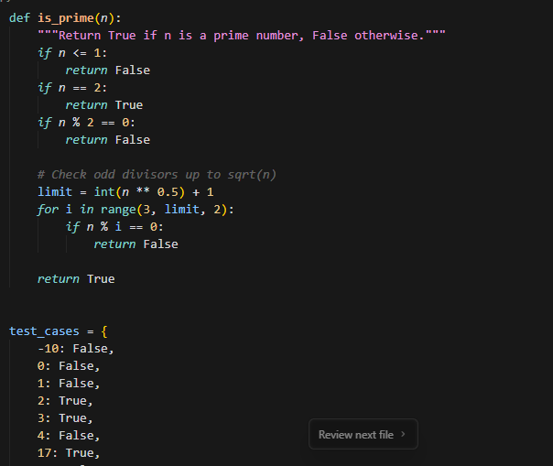
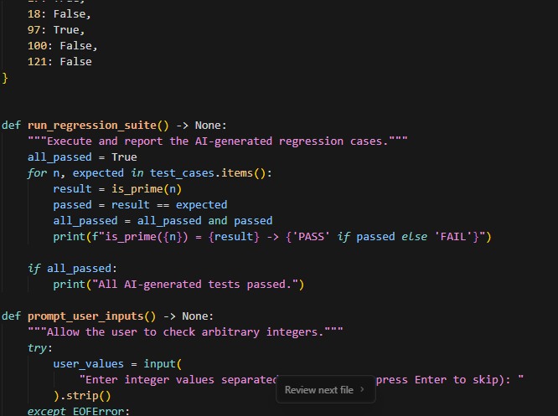
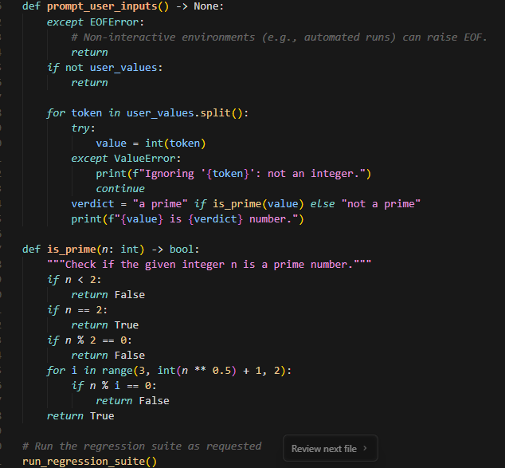
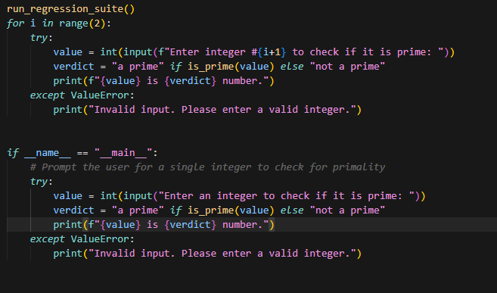
OUTPUT:
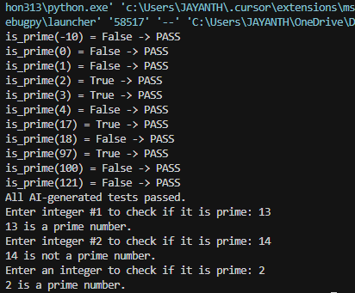

Q2. Develop a Python class `Rectangle` with methods for area and perimeter. Use an AI
assistant for auto-generating docstrings and inline comments. Compare them with your
manual documentation.
PROMPT:
Create a Python module that defines a Rectangle class with AI-generated docstrings and inline comments, and also includes manually written documentation for comparison. Add a function that prints both the AI documentation and the manual documentation side by side, and include a main block that tests the class and displays the comparison.
CODE: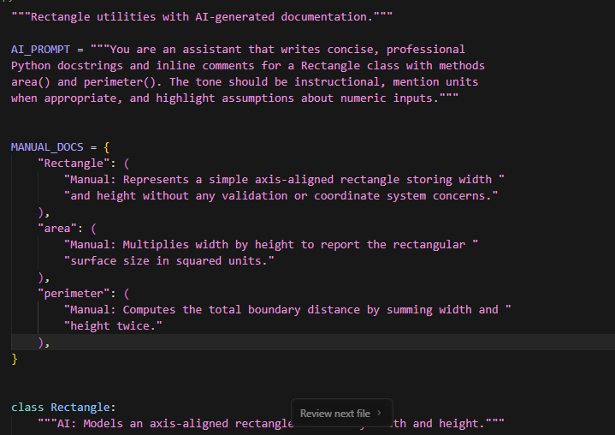
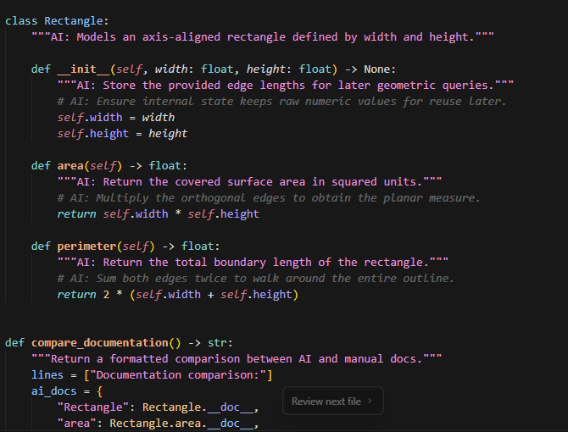
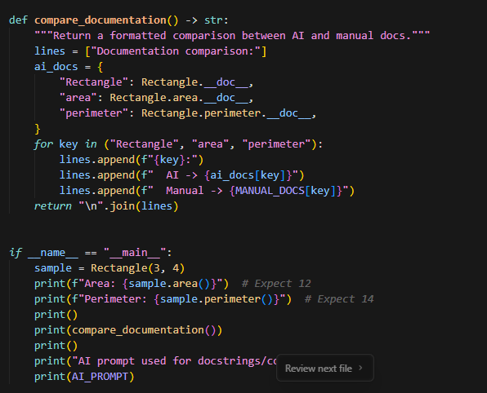
OUTPUT: