Impact of Batter-Friendly Conditions on IPL Scoring Trends (2008–2025)

A Data Analytics Project Using Python and Power BI
Prepared by: Jayanth AP
Tools Used: Python, Pandas, NumPy, Matplotlib, Seaborn, Power BI

1. Introduction
The Indian Premier League (IPL) has evolved significantly since its inception in 2008. In recent seasons, teams have regularly crossed 200 runs, and aggressive batting has become increasingly common. This project investigates whether IPL has become more batter-friendly over time by analyzing scoring patterns, run rates, boundary frequency, bowling effectiveness, and venue characteristics using historical IPL data.

2. Project Objective
To analyze whether IPL cricket has become increasingly batter-friendly between 2008 and 2025 using ball-by-ball and match-level data.

3. Research Questions
RQ1: Has the average innings score increased over time?
RQ2: Has the average run rate increased over time?
RQ3: Are more sixes being hit than before?
RQ4: Has bowling become less effective?
RQ5: Have 200+ scores become more common?
RQ6: Which venues are the most batting-friendly?

4. Dataset Description
Datasets Used:
• matches.csv – Match information, season, venue, teams, winner
• deliveries.csv – Ball-by-ball information, runs scored, boundaries, wickets
Source: IPL historical datasets from Kaggle.

5. Methodology
Data Cleaning:
• Removed unnecessary columns
• Checked missing values
• Standardized season information
Feature Engineering:
• Average innings score by season
• Run rate by season
• Sixes per season
• Economy rate by season
• Number of 200+ totals
• Venue-wise average scores

6. Batter Friendliness Index (BFI)
A custom Batter Friendliness Index (BFI) was developed by combining average innings score, run rate, six-hitting frequency, and bowling economy rate. All metrics were normalized using MinMax Scaling and combined into a single score ranging from 0 to 100.

7. Results and Visualizations
Insert Power BI dashboard screenshots here.
Average Score Trend – Observation:
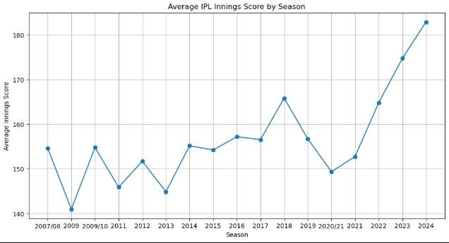
Run Rate Trend – Observation:
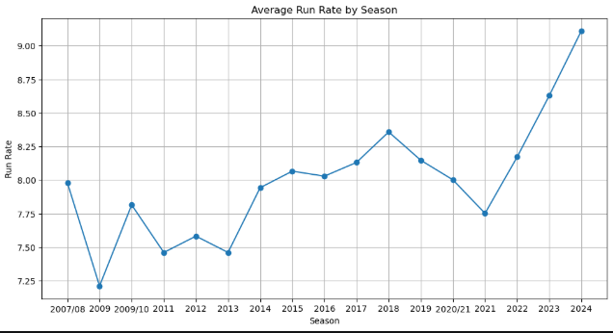

Sixes Trend – Observation:
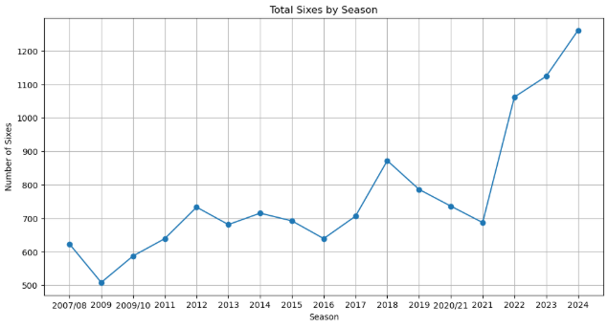
Economy Rate Trend – Observation:
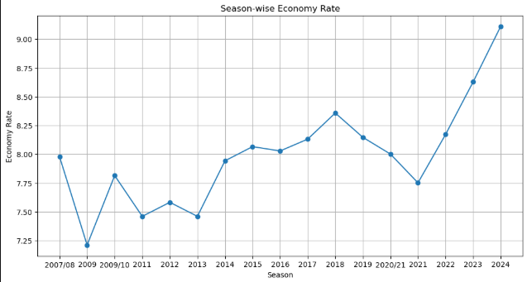

200+ Totals Trend – Observation:
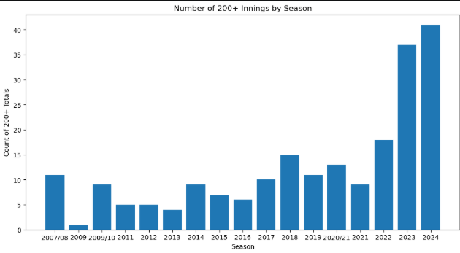
BFI Trend – Observation:
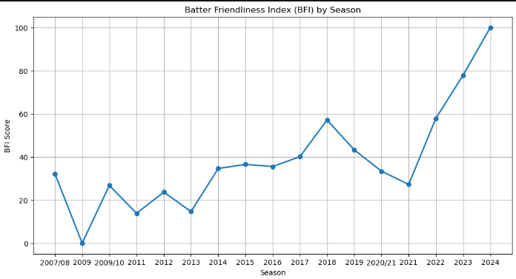

8. Statistical Validation
Correlation Analysis Result:
Correlation Value: 0.713
Interpretation:
Correlation analysis was performed to evaluate the relationship between IPL seasons and batting performance indicators.

A strong positive correlation between season progression and average innings score supports the hypothesis that IPL has become increasingly batter-friendly over time.

9. Key Findings
• Average scores increased over time.
• Run rates increased over time.
• Six-hitting frequency increased significantly.
• Bowling economy rates increased.
• 200+ totals became more frequent.
• BFI indicated a clear rise in batting-friendliness.

10. Conclusion
The analysis provides strong evidence that IPL has become increasingly batter-friendly between 2008 and 2025. Higher scores, faster run rates, increased six-hitting, and rising bowling economy rates collectively support this conclusion. The custom Batter Friendliness Index further confirms this trend.

11. Future Work
• Weather conditions
• Pitch reports
• Boundary dimensions
• Team strategy analysis
• Machine learning models for score prediction

