Issue 1:
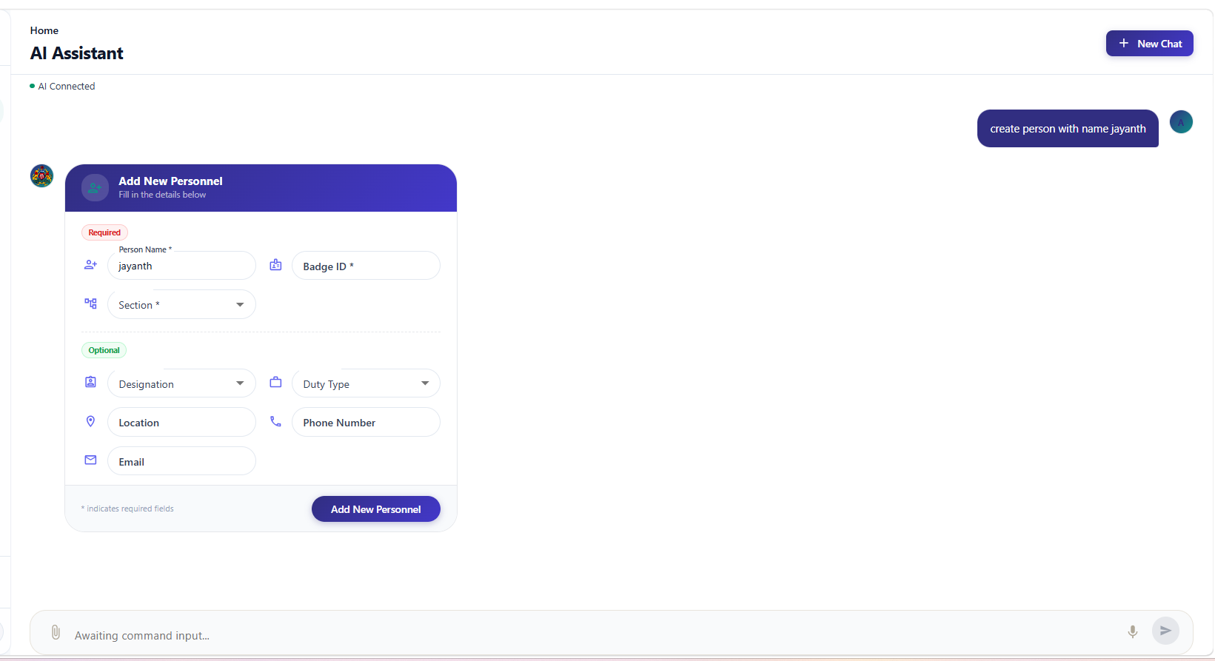
Command : create person with name jayanth
form missing all new fields , check the exisiting create person form in the personale page and include all exisiting fields here as well all fields it should support , check all necessary front end and backend changes
don’t break anything and don’t hallucinate anything
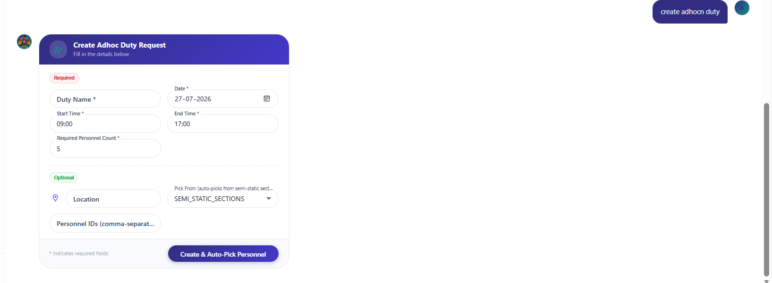
not showing pick up time widget for start and end time its asking for plain text to enter as time should show wdget
pick up from should show the section selectio just like how we do it I the adhoc create duty page and should should show the option to enter the number of designation wise people just like how we show in the adhoc duty page and based on count pick the peole from the selected sections and auto select the persons and show option to add or remove the auto picked persons
this should happen in the chat ui converstattion screen
fix appropriate fronendand backend changes

