

A Guide to Track Days

PRASANTH

Contents

Purpose of this document 2

Prepare yourself 3

Prepare the car 3

Fire extinguisher 3

Towing eye 4

Brakes 4

Fluids 4

Pad thickness 4

Seats and seat belts 5

Tyres 5

Pressure 5

Using slicks 5

# Purpose of this document

This guide is intended for drivers who have limited or no experience of on-track driving. It can also be used by intermediate track-day drivers who want to learn something new or confirm that they’re heading in the right direction with their circuit driving. To make your first track day safe and fun for everyone, it is imperative that you Prepare yourself and Prepare the car.

# Prepare yourself

You need to prepare yourself before attending a track day by ensuring that you are ready with the following things:

* A valid driving license.
* A crash helmet that complies with the standard British Kite Mark 6658-85 Type A or A/FR or SA2000 (since superseded by SA2005 and SA2005-FIA8858).
* Clothing that is overall of fire-proof type or is cotton-based; covers all body parts except the hands and face.

**Note**: Rolled-up sleeves are not allowed while on the circuit.

**Important**: Do not carry timing equipment on the track day.

# Prepare the car

Driving a car on the circuit puts a far greater strain on it and for much longer than can ever be achieved on ordinary roads; therefore, weak points are shown up quickly. You can prevent at the outset a few things that cause problems that are found to occur due to lack of use or preparation. You can prevent the problems by ensuring the efficiency of the following equipment through checks:

## Fire extinguisher

Fire extinguishers installation is a smart idea that can be implemented even if it’s not mandatory to do so. Fire suppressant systems can save your car and life in scenarios, for example, your car catching fire.

#### To Do

Mount a fire extinguisher with a quick release safety strap under the bonnet or in the boot or which is tie-wrapped to the seat adjuster. The following table details the minimum and recommended requirements for the AFFF extinguishant:

|  |  |  |
| --- | --- | --- |
| Type of extinguishant | Minimum quantity | Recommended quantity |
| AFFF | 1.75 litres | 2 litres |

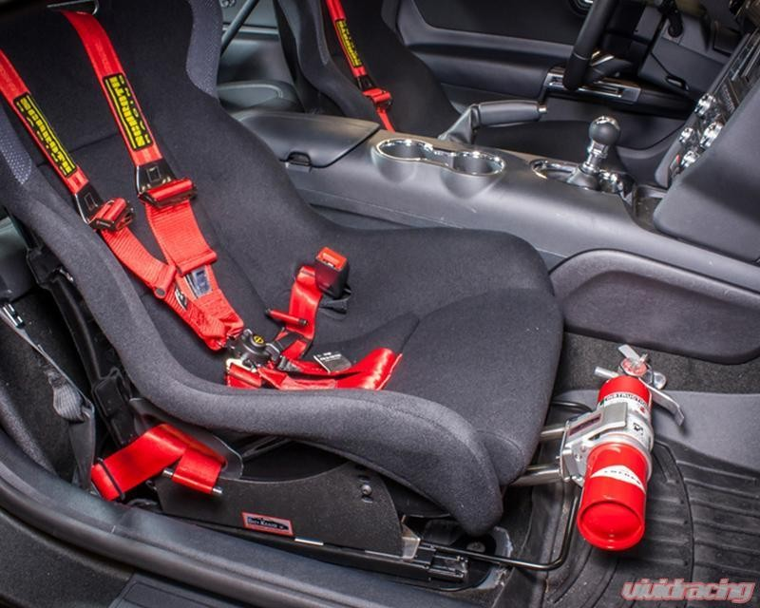

*Figure 1: Fire extinguisher mounted to seat adjuster*

## Towing eye

The towing eye is used to pull the car up onto a recovery vehicle with a flatbed platform. This pulling up is determined by the car’s position and clearance. If the slope of the recovery vehicle's ramp is too steep, or if the ground clearance under the car is inadequate, then the car may be damaged if you try to pull it up using the towing eye.

If necessary, raise the car by using the recovery vehicle's lifting device. Do not use the towing eye.

#### To Do

Install screw-in towing eye in the car (if equipped) before arrival at the circuit. Inserting towing eye is difficult if the hole is rusty (because of non-usage).

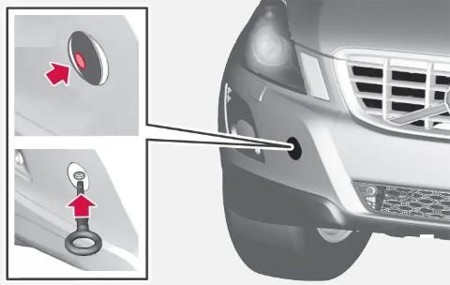

## Brakes

*Figure 2: Towing eye installation*

The brakes are a crucial part of your car which helps in avoiding accidents. The brakes’ significance is highlighted in scenarios in which you are speeding and indulge in extreme cornering. Make sure you inspect the brake fluid quality and brake pad thickness before arriving on the track day.

### Fluids

It is important to have fresh brake fluid of good quality. Competition brake fluid can be used, but some can be more hygroscopic (water absorbing) than others and need replacements more often. On the other hand, **ATE dot 4 plus** is more effective and is more easily available.

If the old fluid is left in the system over a while, the heat accumulates in the calipers due to the absorption of water. As a result, the moisture comes out of the fluid, causing it to become aerated, resulting in the brake pedal going straight to the floor. If the heat is allowed to persist for a while, the pedal returns but the fluid needs changing. The pedal may get burnt and the brakes then require bleeding after the track day. You can generally identify this only when the system is bled and the first couple of strokes produce dark-colored brake fluid. If you are anticipating a season of track days (and why not), consider the fitment of brake cooling to the front brakes. This is the single most effective modification that you can do to help prepare your car for the extra loads imposed on the circuit.

### Pad thickness

Ensure that you check the discs for wear and tear - the brake pads should have at least half their life left. A certain amount of pad thickness is required to dissipate the heat. Standard pads last about five laps before they start to fade; this threshold is less on heavy cars, for example, Boxers and Testarossas. The fitment of an improved pad designed for fast-road use is desirable. Such pads are available from Mintex, Ferodo, and many other suppliers. You should take advice from your preparer regarding these pads as new European legislation requires equivalent (to the original pad) replacement pads from non-original sources to be ‘E’ marked to conform with homologation

regulations (not all are ‘E’ marked, yet). The Ferodo DS2000 is ‘E’ marked and is advertised as suitable for track day and road use. It is important to bed in the new pads correctly; this is usually a simple process for which instructions are included with the pads.

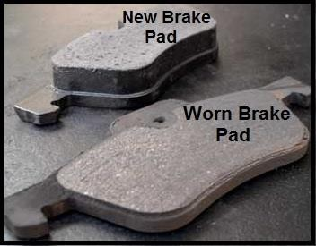

## Seats and seat belts

*Figure 3: New brake vs worn brake*

Drivers and passengers must always wear seat belts. It is the driver’s responsibility to ensure his/her passenger is strapped correctly. For serious track-day participants, the fitment of a four- or six-point safety harness is desirable, and a good racing seat provides lateral support and confidence.

## Tyres

The car’s tyres are the only point of contact with the race circuit; therefore, it is extremely important that you take care of them and prepare them properly.

### Pressure

Most circuits are clockwise and consequently, the left front tyre takes the most wear and tear because the majority of bends are right-handed. If you are running on standard road tyres and your car belongs to the pre-348 series, you should check your tyre pressures after the first session (after which, most probably, the tyres are hot).

**Note**: Pressure should not exceed 35psi.

The most modern cars, 348, 355, and later series, running on special low-profile tyres, should not require pressure adjustment. Remember that any road tyre heats up quite quickly and you may suffer a reduction in traction towards the end of a session.

### Using slicks

If you are using slicks, remember that a slick tyre works only in dry or slightly damp conditions and that treaded tyres are needed for wet weather. Slicks make the car go round the corners faster, but they are not just a bolt-on goodie, the suspension settings need to be adjusted. General road suspension is too soft to get the best out of them; hence, you also need an extra set of wheels that are to be transported to and from circuits. The biggest problem with road tyres is that a circuit tends to wear and tear the outside edge of the left front, especially in block-treaded tyres such as Michelin XWX and Pirelli P7. Good road and track tyres are Goodyear Eagle F1/F1 Fiorano, Yokohama A008, Pirelli P Zero, and Bridgestone Expedia - these have little outside tread but are road legal.