**LINE FOLLOWER ROBOT**

**A COURSE-BASED PROJECT REPORT SUBMITTED**

**IN PARTIAL FULFILMENT FOR THE LAB EVALUATION OF BASIC ELECTRICAL ENGINEERING LAB**

**FOR**

**BACHELOR OF TECHNOLOGY**

**IN**

**ELECTRONICS & INSTRUMENTATION ENGINEERING**

**Submitted by**

O. SAI TEJA 21071A1049

P. HARI KRISHNA 21071A1050

P. TEJASWI 21071A1051

P. ROHITH 21071A1052

P. VENKATESH 21071A1053

**DEPARTMENT OF ELECTRONICS & INSTRUMENTATION ENGINEERING**

**VALLURUPALLI NAGESWARA RAO VIGNANA JYOTHI**

**INSTITUTE OF ENGINEERING AND TECHNOLOGY**

AICTE Approved; UGC Autonomous; JNTUH Affiliated; UGC “College with Potential for Excellence”; NAAC “A++” Grade

ISO 9001:2015 Certified; QS I.GAUGE “Diamond” Rated; NIRF 2019: 109th Rank Engineering (151–200 Band Overall)

NBA Accredited: CE, CSE, ECE, EEE, EIE, IT, ME, AE; JNTUH-Recognised Research Centres: CE, CSE, ECE, EEE, ME

**20****21-2022**

**LINE FOLLOWER ROBOT**

# Introduction

1. **Theory**

The widespread use of liquefied petroleum gas (LPG) globally, for various purposes including heating, cooking, and vehicle fuel, highlights its importance in daily life. However, its highly flammable nature poses significant risks, with gas leakage often leading to accidents. To address this issue, this paper proposes a smart IoT-based solution for monitoring LPG leakage, alongside natural gas and butane, enhancing safety measures.

The proposed system entails the development of a smart electronic system capable of detecting the presence of LP gas, natural gas, butane, as well as monitoring temperature, humidity, and heat index. Through a web server interface, this system can promptly trigger an alarm if gas leakage is detected or if any measured parameters surpass predefined threshold values. Additionally, it can send an alerting SMS to the relevant authority, thereby mitigating potential hazards associated with gas leakage.

Integral to the system is a sensor array that effectively measures key indices related to gas presence and leakage. The Node MCU, housing an ESP8266 Wi-Fi chip, serves as the central controller unit, facilitating data collection from sensors. Data collected by the Node MCU are then transmitted to a website accessible via the internet, ensuring remote monitoring capabilities. Furthermore, an onsite 16*2 LCD display connected to the Node MCU enables real-time visualization of sensor values.

Notably, the system offers user interaction through SMS inquiries regarding gas presence, enhancing user accessibility and control. Moreover, to enhance security measures, a stepper motor is incorporated to enable automatic switch-off in emergencies, particularly when occupants are absent.

This project deviates from conventional LPG gas detectors by integrating a stepper motor and employing a sensor with superior sensitivity and rapid response capabilities. The report provides insights into the integration of 8051 microcontroller and mobile communication, detailing their interfacing and the AT command set utilized in communication protocols. Through this innovative approach, the proposed system aims to significantly enhance safety measures and minimize the risks associated with combustible gas leakage accidents. Develop an IoT-based LPG detection system aimed at enhancing safety and minimizing the risks associated with gas leakage accidents. This system will employ a network of sensors to monitor the presence of LPG, natural gas, and butane, along with environmental parameters such as temperature, humidity, and heat index. The primary objective is to promptly detect gas leaks and exceedance of predefined thresholds, triggering alarms and sending alerting SMS notifications to relevant authorities. Additionally, the system will feature a user-friendly interface for remote monitoring via a web server and onsite visualization of sensor values on an LCD display. Integration of a stepper motor will enable automatic switch-off during emergencies, further enhancing security measures. Through this initiative, the objective is to create a cost-effective and efficient solution to prevent accidents caused by LPG leakage, contributing to overall safety in domestic and industrial settings.

1. **Objective**

Objective of LPG Gas Sensor and Detection System

The primary objective of the LPG Gas Sensor and Detection System is to ensure safety and prevent accidents related to LPG gas leaks.

This system aims to achieve the following specific goals:

1. Early Detection of LPG Leaks:

- Continuously monitor the environment for the presence of LPG gas.

- Detect even small concentrations of LPG to provide early warnings.

2. Immediate Alert Mechanism:

- Trigger an audible alarm using a buzzer to alert occupants of a gas leak.

- Activate visual indicators (such as LEDs) to provide a clear visual signal of danger.

3. Automated and Reliable Operation:

- Ensure the system operates autonomously without the need for manual intervention.

- Maintain high reliability and accuracy in gas detection under various environmental conditions.

4. User-Friendly and Accessible:

- Design the system to be easy to install and use, making it accessible to a wide range of users, including households and small businesses.

- Provide clear and understandable alerts that can be easily recognized by users of all ages.

5. Cost-Effective Solution:

- Utilize affordable components to create a cost-effective safety solution.

- Offer an economical alternative to more expensive commercial gas detection systems without compromising safety and effectiveness.

6. Integration Capability:

- Enable integration with other safety systems, such as home automation systems or emergency response systems, to enhance overall safety measures.

By meeting these objectives, the LPG Gas Sensor and Detection System aims to minimize the risk of fire, explosions, and other hazards associated with LPG leaks,

thereby protecting lives and property.

1. **Implementation**
2. **Hardware Requirements**

Building a line follower robot requires several components to create a functional and effective robot. Here's a list of essential components you'll need:

1. Wooden Platform:

The wooden plank provides the structural framework for mounting all the components. You can buy a pre-made chassis or design your own using materials like acrylic, aluminum, or plastic.

1. Microcontroller or Development Board:

Arduino UNO is a microcontroller board based on the ATmega328P. It has 14 digital input/output pins (of which 6 can be used as PWM outputs),

6 analog inputs, a 16 MHz ceramic resonator, a USB connection, a power jack, an ICSP header and a reset button.

It contains everything needed to support the microcontroller; simply connect it to a computer with a USB cable or

power it with a AC-to-DC adapter or battery to get started. You can tinker with your UNO without worrying too much about doing something wrong,

worst case scenario you can replace the chip for a few dollars and start over again.

1. Servo Motor (SG90):

A servomotor is a closed-loop servomechanism that uses position feedback

(either linear or rotational position) to control its motion and final position.

The input to its control is a signal (either analog or digital)

representing the desired position of the output shaft.

1. Buzzer:

Buzzer meaning electronic component that generates sound through the transmission of electrical signals.

Its primary function is to provide an audible alert or notification and typically operates within a voltage range of 5V to 12V.

1. LPG GAS Detection Sensors:

Liquefied petroleum gas (LPG) gas sensors detect leaks in LPG gas and warn before gas levels reach dangerous levels. MQ 2 flying fish sensor can be used

When LPG leaks, gas molecules interact with the sensor's surface, changing the resistance of the sensing material.

This change is converted into an electrical signal that triggers an alarm or other indicator.

1. Power Source:

Batteries or power supplies provide the necessary electrical energy to operate the robot. Make sure to choose a power source with enough voltage and current capacity to power the motors and electronics.

1. Gas Regulator :

A gas regulator is a mechanical device that controls the pressure and flow of gas to an appliance or cylinder

1. Wires and Connectors:

Jumper wires, male-to-male and male-to-female connectors, and breadboard connectors are needed for making electrical connections between components.

1. Prototyping Breadboard (Optional):

A breadboard is useful for quickly testing and prototyping circuits before soldering components onto a permanent circuit board.

1. Screws and Hardware(Optional):

Various screws, nuts, bolts, and standoffs are needed for assembling the components securely.

1. Voltage Regulator (Optional):

A voltage regulator might be necessary if your components require different voltage levels than your power source provides.

1. Additional Sensors (Optional):

Depending on your project goals, you might incorporate additional sensors like encoders for measuring wheel rotations, ultrasonic sensors for obstacle avoidance, or light sensors for environmental awareness.

1. Wire Strippers and Cutters:

Essential tools for preparing wires and trimming components to fit your design.

1. Programming Tools:

A computer for writing and uploading code to the microcontroller. Depending on the microcontroller, you might need specific programming software or development environments.

1. Soldering Iron and Solder (Optional):

If you're creating a permanent circuit, soldering might be required for secure connections.

1. Documentation and Components List:

Keep track of the components you've used, their specifications, and wiring connections for future reference.

1. **Diagram**

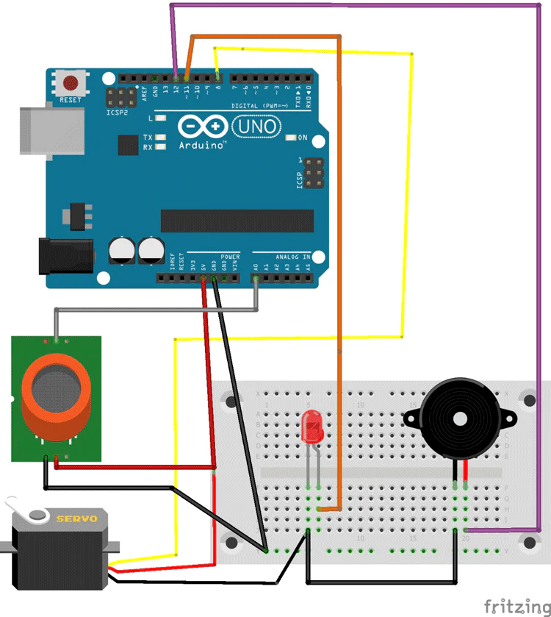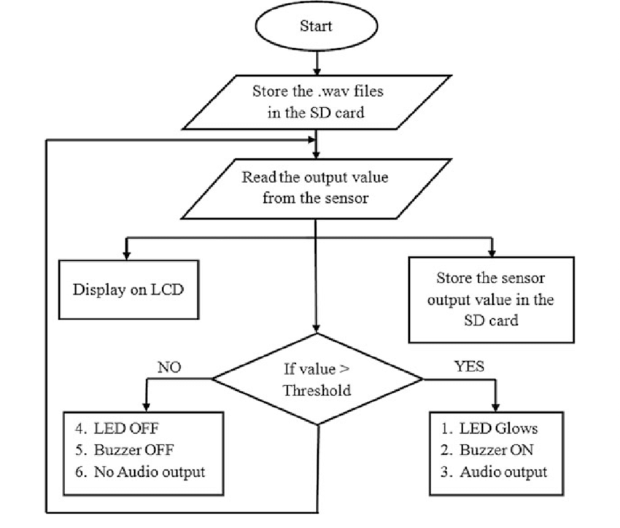

**Block Diagram Flow Chart**

1. **Working Principle**

The LPG gas detection system operates based on the following steps:

Gas Sensing:

The MQ-2 sensor continuously monitors the air for the presence of LPG gas.

The sensor output varies based on the concentration of gas detected.

Signal Processing:

The Arduino Uno reads the analog signal from the MQ-2 sensor.

It converts this analog signal to a digital value that represents the gas concentration.

Threshold Comparison:

The Arduino compares the digital value with a predefined threshold.

This threshold is set based on the safe limit of LPG concentration.

Alert Mechanism:

If the gas concentration exceeds the threshold, the Arduino activates the buzzer and LED to alert the user of a potential gas leak.

1. **Procedure**

Implementing an LPG gas detection system involves several steps from component assembly to programming and testing.

Below is a detailed procedure to set up and operate an LPG gas detection sensor using an Arduino Uno and an MQ-2 gas sensor.

Step 1:

Gather Components and Tools

Arduino Uno

MQ-2 gas sensor module

Buzzer

LED

Resistor (220 ohms)

Breadboard and jumper wires

USB cable for Arduino

Power supply (9V battery or USB from a computer)

Step 2: Assemble the Circuit

Connect the MQ-2 Gas Sensor:

Connect the VCC pin of the MQ-2 sensor to the 5V pin on the Arduino.

Connect the GND pin of the MQ-2 sensor to the GND pin on the Arduino.

Connect the Analog Output (A0) pin of the MQ-2 sensor to the Analog Input (A0) pin on the Arduino.

Connect the Buzzer

Connect one terminal of the buzzer to the Digital Pin 8 on the Arduino.

Connect the other terminal of the buzzer to the GND pin on the Arduino.

Connect the LED

Connect the anode (longer leg) of the LED to the Digital Pin 7 on the Arduino through a 220-ohm resistor.

Connect the cathode (shorter leg) of the LED to the GND pin on the Arduino.

**Step 3: Write and Upload the Arduino Code**

Open the Arduino IDE on your computer.

Copy and paste the following code into the Arduino IDE:

**cpp**

**Copy code**

**const int gasSensorPin = A0; // Analog pin connected to MQ-2 sensor**

**const int buzzerPin = 8; // Digital pin connected to buzzer**

**const int ledPin = 7; // Digital pin connected to LED**

**const int gasThreshold = 300; // Threshold value for gas detection**

**void setup() {**

**pinMode(gasSensorPin, INPUT);**

**pinMode(buzzerPin, OUTPUT);**

**pinMode(ledPin, OUTPUT);**

**Serial.begin(9600);**

**}**

**void loop() {**

**int gasLevel = analogRead(gasSensorPin); // Read gas sensor value**

**Serial.println(gasLevel); // Print gas level for debugging**

**if (gasLevel > gasThreshold) {**

**digitalWrite(buzzerPin, HIGH); // Turn on buzzer**

**digitalWrite(ledPin, HIGH); // Turn on LED**

**} else {**

**digitalWrite(buzzerPin, LOW); // Turn off buzzer**

**digitalWrite(ledPin, LOW); // Turn off LED**

**}**

**delay(1000); // Wait for a second before the next reading**

**}**

Connect the Arduino to your computer using the USB cable.

Select the correct board and port from the Tools menu in the Arduino IDE.

Upload the code to the Arduino by clicking the upload button (right arrow icon).

Step 4: Test the System

Power the Arduino using a 9V battery or the USB connection from your computer.

Open the Serial Monitor in the Arduino IDE to observe the gas sensor readings.

Introduce a small amount of LPG gas near the MQ-2 sensor. You can use a lighter (without igniting it) to release a small amount of gas.

Observe the response of the system:

The LED should light up.

The buzzer should sound an alarm.

The Serial Monitor should show increased gas level readings.

Step 5: Calibrate and Adjust the Threshold

If necessary, adjust the gasThreshold value in the code based on the environment and sensitivity requirements.

Re-upload the modified code to the Arduino.

Repeat the testing procedure to ensure the system responds correctly at the new threshold level.

1. **Results and Discussion**

An LPG gas detection system using Arduino Uno and an MQ-2 gas sensor is an effective

and affordable solution to enhance safety in environments where LPG is used.

This system provides real-time monitoring and immediate alerts, allowing for quick action to prevent dangerous situations.

The simplicity of Arduino programming and the availability of components make it accessible for both hobbyists and professionals.

1. **Conclusions**

# In conclusion, the line follower robot is a fascinating embodiment of robotics principles, control systems, and sensor technology. Through a careful integration of these components, the line follower robot demonstrates its ability to autonomously navigate a designated path by following a contrasting colored line on the ground. This technology has diverse applications, ranging from education and skill development to industrial automation and entertainment.

# The design and construction of a line follower robot encompass a range of considerations, including component selection, sensor placement, motor control, and programming. As an educational tool, it offers a hands-on approach to learning about sensors, control algorithms, and real-world applications of robotics.

# The working principle of a line follower robot showcases the importance of feedback loops, where sensors continuously provide information to the microcontroller, enabling real-time adjustments in motor speeds to maintain accurate line following. The implementation of control algorithms, such as PID controllers, underscores the role of mathematics and programming in achieving precise and stable movement.

# Overall, the line follower robot serves as a foundational project for aspiring roboticists, hobbyists, and engineers, providing a platform to experiment, innovate, and deepen understanding of robotics concepts. Its ability to follow a designated path with autonomy and accuracy underscores the vast potential of robotics technology in simplifying tasks, enhancing automation, and inspiring creativity.

# 

# Applications and Future Scope

# Line follower robots find applications in various fields due to their ability to autonomously navigate predefined paths using line detection sensors and control algorithms. Here are some common applications of line follower robots:

# Education and STEM Learning:

# Line follower robots are popular educational tools for teaching students about robotics, programming, and automation. They provide hands-on experience in designing, building, and programming robots.

# Robotics Competitions:

# Line follower robot competitions challenge participants to design robots that can follow intricate paths or compete against each other. These competitions foster innovation and encourage participants to develop advanced control algorithms.

# Industrial Automation and Material Handling:

# In manufacturing and warehousing environments, line follower robots can be used to transport materials or goods along predefined paths. This reduces the need for manual labor in repetitive tasks.

# Agricultural Applications:

# Line follower robots can be adapted for precision agriculture tasks, such as planting seeds or applying fertilizers along specific paths. They ensure accurate and efficient distribution of resources.

# Guided Transportation:

# Airports, shopping malls, and large facilities can use line follower robots to guide visitors or passengers along designated routes, providing a self-guided experience.

# Floor Cleaning and Maintenance:

# Line follower robots equipped with cleaning mechanisms can automatically clean floors in commercial spaces, reducing the need for manual labor.

# Security and Surveillance:

# Line follower robots can be used to patrol predefined routes in security-sensitive areas, enhancing surveillance and monitoring capabilities.

# Entertainment and Amusement Parks:

# Line follower robots can entertain visitors in amusement parks by guiding them through attractions or providing interactive experiences.

# Prototype Testing and Research:

# Line follower robots can serve as testing platforms for new control algorithms, sensor technologies, or navigation techniques, contributing to research in robotics.

# Indoor Navigation and Mapping:

# Line follower robots equipped with sensors can help map indoor environments by following predefined paths, aiding in navigation and localization.

# Laboratory Automation:

# Line follower robots can transport samples, reagents, or equipment within a laboratory setting, streamlining workflows and minimizing human intervention.

# Public Demonstrations and Outreach:

# Line follower robots are used in science museums, technology expos, and educational events to engage the public and showcase robotics concepts.

# Delivery Services:

# Line follower robots could be employed in controlled environments to deliver items within a building or facility, enhancing efficiency in logistics.

# Exploration and Research:

# Line follower robots can navigate predefined paths in research environments, collecting data or samples along the way.

# Art and Creativity:

# Artists and hobbyists often use line follower robots as creative platforms, generating intricate and visually appealing designs on surfaces.

# These applications highlight the versatility and adaptability of line follower robots in various domains, ranging from education and entertainment to industrial automation and research. As technology advances, line follower robots may continue to find new and innovative uses in diverse fields.

# The future scope of line follower robots holds several exciting possibilities as technology advances and new applications emerge. Here are some potential directions in which line follower robots could evolve:

# Advanced Sensor Integration:

# Line follower robots could incorporate more advanced sensors, such as computer vision cameras, LiDAR, or depth sensors, to enhance their perception capabilities and navigation accuracy.

# Machine Learning and AI:

# Integrating machine learning algorithms could enable line follower robots to adapt to dynamic environments, handle complex paths, and improve their decision-making capabilities.

# Multi-Robot Collaboration:

# Line follower robots could collaborate in teams to perform tasks that are beyond the capabilities of a single robot. They could communicate and coordinate to achieve complex objectives.

# Obstacle Avoidance and Navigation:

# Future line follower robots might incorporate advanced obstacle detection and avoidance mechanisms, allowing them to navigate safely through environments with unpredictable obstacles.

# Outdoor Navigation:

# Line follower robots could be adapted to navigate outdoor paths, such as sidewalks or trails, by using GPS and advanced localization techniques.

# Autonomous Delivery Services:

# Line follower robots could be employed for last-mile delivery services, transporting packages within controlled environments like warehouses or neighborhoods.

# Human-Robot Interaction:

# Line follower robots might be enhanced with the ability to interact with humans, answering questions, providing guidance, or offering assistance in various contexts.

# Flexible Path Following:

# Robots could follow paths that are not rigid lines but dynamically generated trajectories, allowing for more intricate and versatile movements.

# Energy Efficiency:

# Future line follower robots could focus on energy-efficient designs, integrating renewable energy sources or optimized power management systems.

# Mixed Reality Integration:

# Augmented reality (AR) or virtual reality (VR) technologies could be integrated to provide users with immersive experiences while interacting with line follower robots.

# Medical and Healthcare Applications:

# Line follower robots could find applications in medical environments, assisting with tasks such as medication delivery or equipment transportation within hospitals.

# Elderly Care and Assistance:

# Line follower robots could be designed to assist the elderly with navigation, medication reminders, and daily tasks in home environments.

# Environmental Monitoring:

# Line follower robots could be used to monitor and collect data from remote or hazardous environments, contributing to environmental research and disaster response.

# Agricultural Automation:

# In agriculture, line follower robots could evolve to handle tasks like planting, monitoring crops, and applying treatments in a more efficient and precise manner.

# Customization and Personalization:

# Line follower robots might become customizable platforms, allowing users to design and program their unique behaviors and functions.

# As technology continues to evolve, line follower robots have the potential to diversify and find new roles across various industries and applications. Their adaptability, ease of development, and educational value make them an excellent platform for innovation and exploration in the field of robotics.

# References

1. GBD 2013 Mortality and Causes of Death Collaborators. Global, regional,

and national age–sex specific all-cause and cause-specific mortality for

240 causes of death, 1990–2013: a systematic analysis for the Global

Burden of Disease Study 2013. Available at:

http://www.thelancet.com/journals/lancet/article/PIIS0140-6736(14)61682-2/abstract

[Last accessed 17 January 2016].

2. Office for national statistics. Ageing of the UK Population. Available at: http://webarchive.nationalarchives.gov.uk/20160105160709/http://w

ww.ons.gov.uk/ons/rel/pop-estimate/population-estimates-for-uk--

england-and-wales--scotland-and-northern-ireland/mid-2014/styageing-of-the-uk-population.html

[Last accessed 5 January 2016].

3. iRobot (2016), irobot.com <http://www.irobot.com/About-iRobot.aspx>

4. Saraswat, K. (2013) The ill-effects of carrying heavy schoolbags, [Online]

thehealthsite.com. Available at: http://www.thehealthsite.com/diseasesconditions/the-ill-effects-of-carrying-heavy-schoolbags/ [Last accessed 13 January 2016]

5. Office for national statistics. Ageing of the UK Population. Available at: http://www.ons.gov.uk/ons/rel/pop-estimate/population-estimates-foruk--england-and-wales--scotland-and-northern-ireland/mid-2014/styageing-of-the-uk-population.html

[Last accessed 5 January 2016].

6. Erin Sutton, Danielle Bare, Melissa Taylor, Deborah Kinor, Julia Schaeffer,

Alexander Jules, Kimberly Edginton Bigelow. MINIMIZING POSTURAL

INSTABILITY WHEN CARRYING LOAD: THE EFFECTS OF CARRYING

GROCERY BAGS ON THE ELDERLY

[https://www.udayton.edu/news/images/documents/grocery_bag_resear ch.pdf](https://www.udayton.edu/news/images/documents/grocery_bag_resear%20ch.pdf)

[Last Accessed 7 March 2016]

7. English Federation of Disability Sport. Facts and Statistics

http://www.efds.co.uk/resources/facts_and_statistics

[Last accessed 5 March 2016]

8. Internation Federation of Robotics. World Robotics 2015 Industrial

Robots http://www.ifr.org/industrial-robots/statistics/

[Last accessed 4 March 2016]