[1]

Increasing Control Dimensionality of a Closed-Loop Neural Interface

Katherine Perks, Esther Li, and Sai Jayanth Kalisi, Member, IEEE

*Abstract*— Closed-loop neural interfaces using surface electromyography (sEMG) hold promise in restoring movement and improving the quality of life for those with motor disabilities. However, currently, existing technologies are limited in their control complexity and as a result, may not provide a wide range of abilities.

To increase the usability and function of neural interfaces, we used a closed-loop system with two channels of non-invasive sEMG activity recorded from a subject’s arm to control a computer cursor in real time. The subject received simultaneous visual feedback about the cursor position. We explored ways to increase the subject’s control of the cursor from one dimension (1D) to two dimensions (2D) while performing a center-out reaching task. We found that the subject was able to control the cursor in 2D to reach a wider range of targets. These results demonstrate the feasibility of increased dimensions of control and suggest that there are more possibilities for restorative properties in those who have motor disabilities. Future studies can expand on our work to increase control to 3D as well as enable control for more complex, naturalistic tasks than the center-out task used here.

# Introduction

Developing interests and research in the development of technology like closed-loop neural interfaces using surface electromyography (sEMG) have recently grown, as they have the ability to restore daily activities requiring motor functions in individuals who suffer from disabilities such as limb paralysis. Despite the advancements made in these restorative technologies, they are still imperfect and have a limited range of abilities that provide unnatural movements. Therefore, there is a need to further understand how to effectively build neural interfaces with a wider range of abilities that provide smooth, non-erratic movements. Previous studies have progressed in research in sEMG signal processing, a promising development for more in depth prosthesis (Li)

Using electrodes on the forearm for electrical activity, muscle SpikerBox and MATLAB to stream and read data from a USB buffer, we aimed to increase the range of motion in the cursor from 1D to 2D (meaning from only left to right movements to left, right, up and down). The subject received feedback about the cursor position from a center-out task, creating a closed-loop system.

The findings from this study suggest that increasing the range of motion of a neural interface could lead to more restorative properties in those with motor disabilities. Future studies may further explore the potential of closed-loop interfaces to improve the quality of life for individuals with motor disabilities.

# Methods

# *Data collection*

# We recruited one able-bodied subject who had previous experience using an sEMG-controlled cursor. We performed sEMG recordings from the subject’s forearm muscles using surface electrodes and a Muscle SpikerBox from Backyard Brains. For 1D control, we recorded from two muscles on the same arm. For 2D control, we recorded from one muscle on the left arm and one muscle on the right arm. In both control modes, the subject’s muscle activity controlled the velocity of a cursor on a screen. We used a Kalman filter to decode cursor position and velocity in real time and update the position of the cursor on the screen. We increased the subject’s control from 1D to 2D by adding Y position and Y velocity states to the state-transition matrix and altering the observation matrix to map one sEMG channel to +X velocity and -Y velocity and the other sEMG channel to -X velocity and +Y velocity. We also changed the scaling of the sEMG inputs to enable 2D control.

# We asked the subject to use the sEMG interface to perform 20 trials of a center-out reaching task under each control mode. The task consists of initiating trials by moving the cursor into a target in the center of the screen, waiting for a peripheral target to appear (“go cue”), and moving the cursor into the peripheral target. For a trial to be considered successful, the subject had to both enter the peripheral target and hold the cursor there for a set amount of time. Correct reaches without sufficient holding were considered failed trials. In the 1D control task, there were two peripheral targets, located at 0 and 180 degrees. In the 2D control task, there were eight peripheral targets, evenly spaced between 0 and 360 degrees.

# *Data analysis*

# We performed behavioral analyses to quantify the subject’s performance in two ways - using the percent of successful trials (“percent correct”) and the time it took to reach the peripheral target (“reach time”). We performed the same analysis on both datasets to be able to compare the subject’s performance across the two control modes. All analyses were done in Matlab using custom functions.

# First, we trial-aligned the events to when the subject entered the center target to obtain trial segments consisting of events just before and after each trial was initiated. We computed the percent correct by finding the proportion of trials in which the subject successfully reached and held the peripheral target. We computed the reach time of each trial by finding the time between when the go cue occurred and the peripheral target was first entered. We then calculated the mean and standard error of the reach times. In order to explore how the subject’s performance varied across target locations, we separately computed the percent correct and mean and standard error of the reach times for each peripheral target.

# Results

We found that the subject was able to perform the center-out reaching task using both 1D and 2D control. The subject successfully acquired the peripheral target 42% of the time when both cursor movements and targets were confined to 1D and 32% of the time when cursor movements and targets were expanded to 2D (Fig. 1). The subject’s reach time was similar across the two control modes, with a mean reach time of 1.69s in 1D control and 1.71s in 2D control (Fig. 2).

When breaking down performance by target location, we found that the subject successfully acquired both targets in the 1D control task at least 50% of the time (Fig 3a). In contrast, the subject successfully acquired only a small subset of the targets in the 2D control task, with vastly different percent correct (Fig. 3b). The subject successfully acquired the target located at 0 degrees 100% of the time, but hardly acquired targets at any other location. However, the subject was able to reach targets that spanned the entire 2D control space (Fig. 4b), with greater variance in reach time to the different targets than in the 1D control task (Fig. 4a). These results demonstrate the subject’s ability to move the cursor both left/right and up/down during the center-out task.

# Discussion

*Overview of Subject Performance across the Two Control Modes*

Figures 1 and 2 show a direct comparison between the accuracy and reach times using 1D and 2D cursor control to perform the center-out task. Here, we can see that while the mean reach time for 1D and 2D control were alike, using 2D control led to lower accuracy on the task.

Why is there this difference in accuracy? We postulate that this may be because the increased dimensionality made it much more difficult to control the cursor. In addition, the control scheme was non-intuitive. As a result of our formulation of the Kalman filter’s observation matrix, activating one arm’s muscle moved the cursor right and up, while activating the other arm’s muscle moved the cursor left and down. Due to this design, by the time the cursor was in place, the trial was over, making 2D cursor control less accurate than its 1D counterpart.

As for why both control dimensionalities had similar reach times, we can note that the distance from the center to the peripheral targets was the same in both tasks. Thus, given that the velocity is the same and the subject takes the shortest route, it is reasonable that the average reach times in the two different tasks are comparable.

*Subject Performance across the Two Control Modes*

Figures 3 and 4 compare trends inaccuracy and reach time for each target across the control modes.

We observed that accuracy using 1D control was greater than 50% for each target. We expected to get similar results for accuracy in the 2D control mode. However, only targets located at 0 degrees and 225 degrees had any trials with success.

We can justify the 0-degree case because our subject had previous practice moving to the 0 degrees target in the 1D control task. The design of our observation matrix for 2D control somewhat correlated the cursor’s movements along the y=x axis. We believe the subject was able to acquire the 225-degree target with some success because it was located on this axis.

Looking at the reach time in 1D, we see that it was between 1.5 seconds and 2.0 seconds for both targets. However, with the 8 different targets in the 2D case, some trials didn’t even reach the target, while others took a significantly longer time.

This can be due to the aforementioned correlation of velocity control along the y=x axis. Quite a few times, the cursor ended up moving in a circle around a target. If the cursor was too high but was aligned with the target on the right-left axis, the correction would move the cursor too much to the left, while being aligned on the up-down axis. This repetitive micromanaging took substantially longer than correcting cursor movements in the 1D control mode, which completely separated leftward and rightward movements.

These figures suggest the subject could reach almost all targets in the 2D space but struggled to hold the cursor on the target long enough for the trial to be considered successful. This reveals that our 2D control scheme gave the subject an increased range of motion as intended, but made it difficult to hold the cursor steady. Future work should improve this aspect of 2D control, as fine control and the ability to hold still is necessary to accomplish many tasks.

*Limitations*

A limitation of this experiment is that controlling the cursor in two dimensions required using muscles on both arms. If a user is an amputee, the interface would be unable to function properly. The neural interface used in this experiment was meant as a proof of concept for multi-dimensional control, but more work would be needed to adapt such an interface for amputee patients or paralyzed patients who can no longer activate the muscles in their arms. An additional limitation is the lack of data to make a conclusive judgment. The experiment only handled one test subject, with 20 trials. Not all targets appeared during these 20 trials, making it hard to theorize on potential trends.

Finally, comes the stability issue. We observed that the cursor was quite jumpy and the subject reported that it was difficult to hold the cursor steady in one position. Even with prior experience in using an sEMG interface, the subject had a little trouble controlling the cursor well and had to learn the required muscle activations needed to move the cursor in the desired directions. Evidence of this learning curve is shown in the improved accuracy in acquiring the 0-degree target between the 1D and 2D tasks.

*Looking Forward*

Moving forward, the issue of cursor stability needs to be fixed. In addition, further studies will need to be done on how to make sure that a single arm does not control a particular direction in the x and y-axes. Additionally, more trials and experiments of the same nature as this experiment need to take place to further support our understanding of this experiment.

References

1. Lobo-Prat, J., Nizamis, K., Janssen, M. et al. “Comparison between sEMG and force as control interfaces to support planar arm movements in adults with Duchenne: a feasibility study” J NeuroEngineering Rehabil, 2017. <https://doi.org/10.1186/s12984-017-0282-6>
2. Li W, Shi P and Yu H. “Gesture Recognition Using Surface Electromyography and Deep Learning for Prostheses Hand: State-of-the-Art, Challenges, and Future” Frontiers in Neuroscience, 2021, 15:621885.https://doi.org/10.3389/fnins.2021.621885

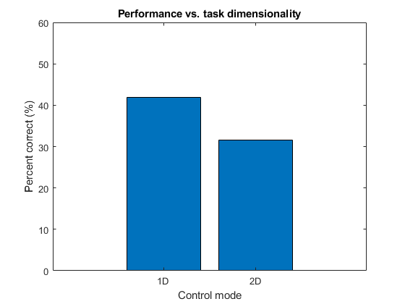

Figure 1. **The subject’s percent correct in the center-out task using 1D vs. 2D control.** Bars represent the percent correct across all peripheral targets.

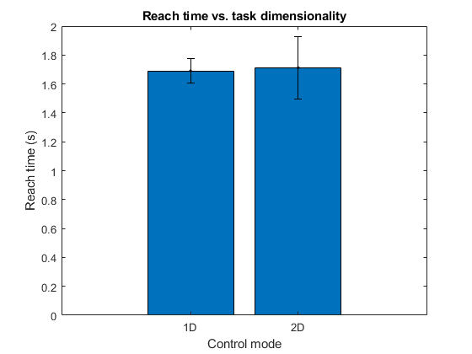

Figure 2. **The subject’s reach time in the center-out task using 1D vs. 2D control**. Bars represent the mean reach time across all peripheral targets, with error bars corresponding to the standard error.

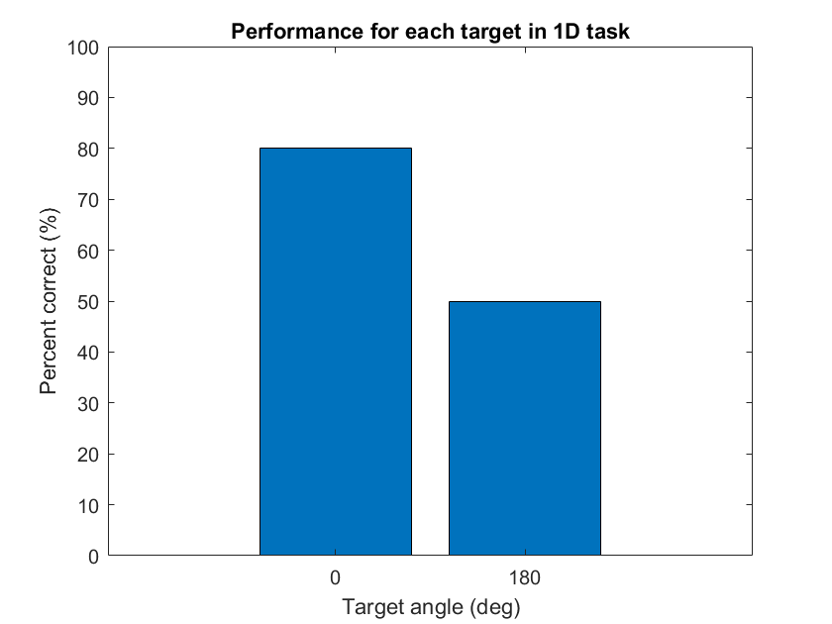

Figure 3.a **The subject’s percent correct for each target in the center-out task using 1D vs. 2D control.** Bars represent the percent correct for each of the two peripheral targets used in the 1D task.

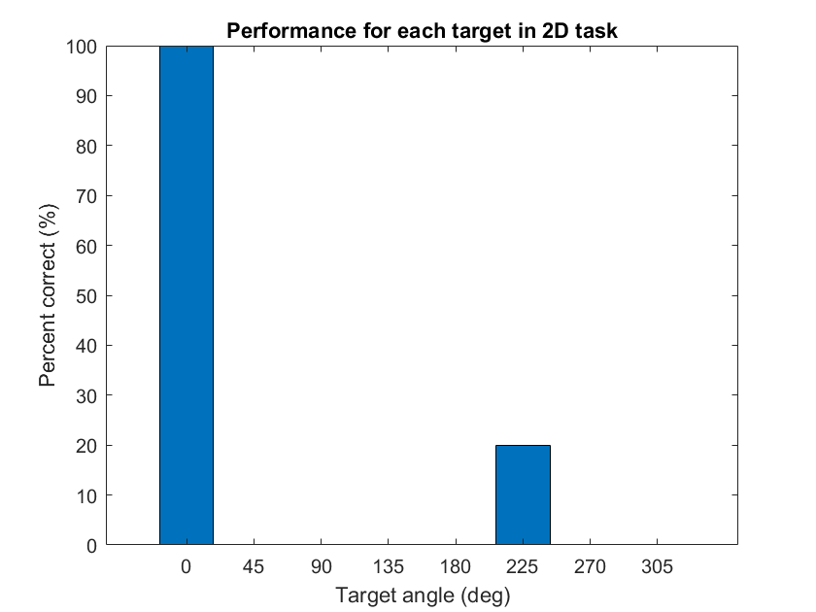

Figure 3.b **The subject’s percent correct for each target in the center-out task using 1D vs. 2D control.** Bars represent the percent correct for the eight peripheral targets used in the 2D task

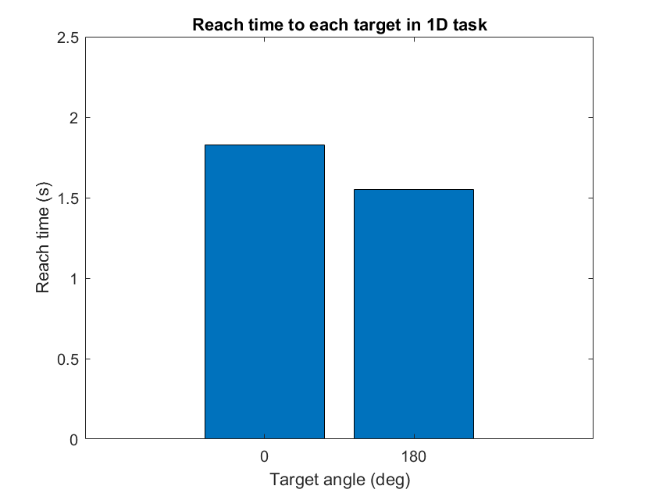

Figure 4.a **The subject’s reach time to each target in the center-out task using 1D vs. 2D control.** Bars represent the mean reach time to each of the a) two peripheral targets used in the 1D task

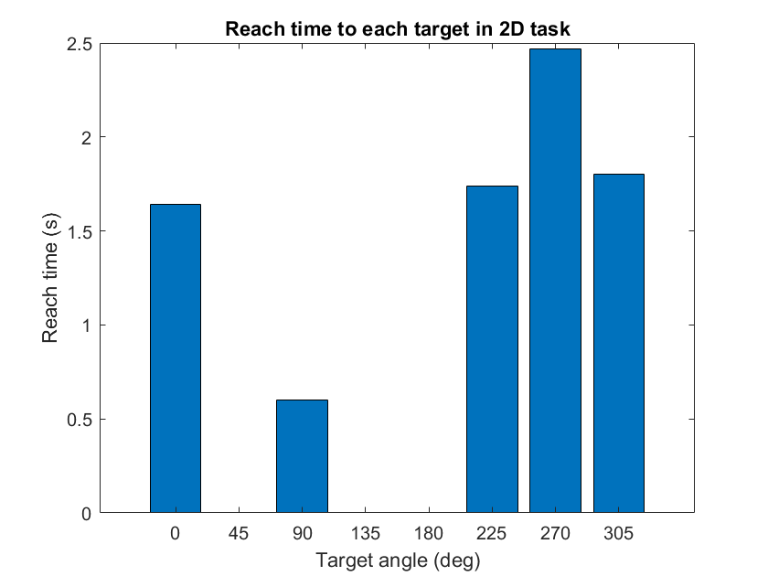

Figure 3.b **The subject’s percent correct for each target in the center-out task using 1D vs. 2D control.** Bars represent the mean reach time for the eight peripheral targets used in the 2D task

1.