1. Title of the Mini Project

Project Title: Implementation and Performance Analysis of Bellman-Ford Shortest Path Algorithm using Graph Data Structures
Example: "Implementation and Analysis of Dijkstra's Shortest Path Algorithm using Priority Queue"

2. Abstract

This mini project focuses on the implementation and analysis of the Bellman-Ford Algorithm, a well-known algorithm used in graph traversal and shortest path computation. The main objective of this project is to study the working principle of the algorithm, implement it using the C programming language, and analyse its efficiency for different types of graph inputs.
The Bellman-Ford algorithm is widely used to find the shortest path from a single source vertex to all other vertices in a weighted graph. A major advantage of this algorithm is its ability to handle negative edge weights and detect negative weight cycles, making it more flexible and reliable for real-world applications.
The project demonstrates the algorithm through modular and well-structured code with detailed inline comments. The time complexity of the algorithm is analyzed as O(VE) and the space complexity as O(V). Optimization possibilities using advanced graph representation techniques are also explored.
Applications of the Bellman-Ford algorithm in computer networks, GPS navigation, Artificial Intelligence, and Machine Learning are discussed to highlight its practical importance. The project concludes with performance observations, advantages, limitations, and future enhancement possibilities.
Keywords:
Bellman-Ford Algorithm, Graph Theory, Shortest Path, Time Complexity, Space Complexity, Network Routing

3. Introduction

3.1 Background and Motivation

Algorithms are the core of computer science, providing efficient solutions to complex computational problems. Among them, graph algorithms are highly important because many real-world systems such as GPS navigation, road networks, and communication systems can be represented using graphs. One of the key challenges in graph theory is finding the shortest path between nodes.

The Bellman-Ford Algorithm, introduced by Richard Bellman and Lester Ford Jr., is a popular shortest path algorithm used to calculate the minimum distance from a source vertex to all other vertices in a weighted graph. It belongs to the class of dynamic programming and graph traversal algorithms and is widely used in networking and routing applications.

A major advantage of the Bellman-Ford algorithm is its ability to handle negative edge weights and detect negative weight cycles, making it highly useful in real-world systems and modern computing applications.

3.2 Problem Statement

Problem Statement:
Given a weighted graph with vertices and edges, design and implement the Bellman-Ford Algorithm to determine the shortest distance from a single source vertex to all other vertices in the graph. The implementation supports both directed and undirected weighted graphs through a user-interactive menu-driven system.
Input:
- Number of vertices and edges in the graph
- Graph type (Directed / Undirected)
- Source vertex
- Edge details in the format: (source vertex, destination vertex, edge weight)
- Edge weights may be positive or negative
Output:
- Shortest distance from the source vertex to all other vertices
- Message indicating the presence of a negative weight cycle, if detected
Constraints:
- 1≤V≤100
- 1≤E≤500
- Edge weights can be positive or negative
- Source vertex must belong to the graph

3.3 Objectives
- To understand the design, logic, and working mechanism of the Bellman-Ford Algorithm.
- To implement the algorithm in C programming language using clean, modular, and well-commented code.
- To analyze the time and space complexity of the algorithm for efficient performance evaluation.
- To study how the algorithm computes the shortest path in weighted graphs with negative edge weights.
- To test the algorithm using normal, boundary, and extreme test cases for accuracy and reliability.
- To explore optimization possibilities using advanced graph representation techniques.
- To examine real-world applications of the algorithm in network routing, Artificial Intelligence, and Machine Learning.
- To develop a user-interactive menu-driven system for executing graph operations efficiently.

3.4 Scope of the Project
This project focuses on the design, implementation, and analysis of the Bellman-Ford Algorithm for finding the shortest path in weighted graphs. The project covers graph representation, shortest path computation, edge relaxation, and negative weight cycle detection using the C programming language.
The implementation supports both directed and undirected weighted graphs through a user-interactive menu-driven system. The scope of the project also includes complexity analysis, testing with different types of inputs, and studying practical applications in areas such as computer networks, GPS navigation, Artificial Intelligence, and Machine Learning.
However, advanced features such as real-time navigation systems, large-scale distributed graph processing, and GUI-based graph visualization are beyond the scope of this project and may be considered for future enhancements.

4. Implementation with Comments

4.1 Programming Language and Environment

Language | C
IDE / Editor/Compiler | Visual Studio Code / GCC Compiler
OS / Platform | Windows 10
Libraries Used | stdio.h, stdlib.h
Project Type | Menu-Driven Console Application
Graph Support | Directed and Undirected Weighted Graphs
Github Link

4.2 Algorithm Design
The Bellman-Ford Algorithm is used to find the shortest distance from a source vertex to all other vertices in a weighted graph. The algorithm works by repeatedly relaxing all edges and updating the minimum distance values. It is also capable of detecting negative weight cycles in the graph.
The implementation supports both directed and undirected weighted graphs through a menu-driven system. For undirected graphs, each edge is internally represented as two directed edges. Initially, all vertex distances are set to infinity except the source vertex, which is initialized to zero. The algorithm then relaxes all edges for (V − 1) iterations, where V is the number of vertices. Finally, an additional iteration is performed to check for negative weight cycles.

Pseudocode for Bellman-Ford Algorithm:
FUNCTION BellmanFord (Graph, source):
Step 1: Initialize distance array and set all distances to infinity
Set distance[source] = 0
Step 2: Repeat (V − 1) times
Relax all edges in the graph
Step 3: Update shortest distances after each relaxation
Step 4: Check for negative weight cycles in the graph
Step 5: Display the shortest distance of all vertices
END FUNCTION

4.3 Source Code with Inline Comments (Font: Consolas- , size-11)

/* ============================================================
* Mini Project: Implementation and Performance Analysis of Bellman-Ford Shortest Path Algorithm
* Algorithm : Bellman-Ford Algorithm
* Author : Jayanti | USN: R24EQ044
* Date : 18-05-2026
* Description : Finds the shortest distance from a source vertex to all other vertices in a weighted graph
* ============================================================ */
/* --- Include necessary header files --- */
#include <stdio.h>
#include <stdlib.h>
/* --- Constants and Macro Definitions --- */
#define MAX_SIZE 200
#define INF 99999

/* ============================================================
* Structure Definition for Graph Edge
* Purpose : Stores source vertex, destination vertex,
* and edge weight
* ============================================================ */
struct Edge {
int source;
int destination;
int weight;
};

/* ============================================================
* Function : printLine()
* Purpose : Prints decorative separator line
* ============================================================ */
void printLine() {
printf("=====================================================\n");
}

/* ============================================================
* Function : displayMenu()
* Purpose : Displays project menu
* ============================================================ */
void displayMenu() {

printLine();

printf("\n BELLMAN-FORD SHORTEST PATH SYSTEM\n");

printLine();

printf("\n1. Enter Graph Details\n");
printf("2. Display Graph\n");
printf("3. Execute Bellman-Ford Algorithm\n");
printf("4. Exit\n");

printLine();
}

/* ============================================================
* Function : displayGraph()
* Purpose : Displays graph edges
* ============================================================ */
void displayGraph(struct Edge edges[], int edgesCount) {

int i;

printLine();

printf("\n\t\tGRAPH EDGES\n");

printLine();

printf("Source\tDestination\tWeight\n");

for(i = 0; i < edgesCount; i++) {

printf(" %d\t %d\t\t %d\n",
edges[i].source,
edges[i].destination,
edges[i].weight);
}

printLine();
}

/* ============================================================
* Function : bellmanFord()
* Purpose : Implements Bellman-Ford shortest path algorithm
* ============================================================ */
void bellmanFord(struct Edge edges[],
int vertices,
int edgesCount,
int source) {

int distance[MAX];
int i, j;

/* Initialize all distances as infinity */
for(i = 0; i < vertices; i++) {
distance[i] = INF;
}

/* Distance of source vertex is 0 */
distance[source] = 0;

printLine();

printf("\nExecuting Bellman-Ford Algorithm...\n");

printLine();

/* Relax all edges (V-1) times */
for(i = 1; i <= vertices - 1; i++) {

printf("\nIteration %d:\n", i);

for(j = 0; j < edgesCount; j++) {

int u = edges[j].source;
int v = edges[j].destination;
int w = edges[j].weight;

/* Update shortest distance */
if(distance[u] != INF &&
distance[u] + w < distance[v]) {

distance[v] = distance[u] + w;

printf("Updated Distance[%d] = %d\n",
v, distance[v]);
}
}
}

/* Check for negative weight cycle */
for(j = 0; j < edgesCount; j++) {

int u = edges[j].source;
int v = edges[j].destination;
int w = edges[j].weight;

if(distance[u] != INF &&
distance[u] + w < distance[v]) {

printLine();

printf("\nNegative Weight Cycle Detected!\n");

printLine();

return;
}
}

/* Display shortest distances */
printLine();

printf("\nSHORTEST DISTANCE FROM SOURCE VERTEX %d\n",
source);

printLine();

printf("Vertex\t\tDistance\n");

for(i = 0; i < vertices; i++) {

if(distance[i] == INF)
printf(" %d\t\tINF\n", i);
else
printf(" %d\t\t%d\n", i, distance[i]);
}

printLine();
}

/* ============================================================
* Main Function
* ============================================================ */
int main() {

int vertices, edgesCount;
int source;
int choice;
int graphChoice;
int i, k = 0;

struct Edge edges[MAX];

printLine();

printf("\n DESIGN AND ANALYSIS OF ALGORITHMS MINI PROJECT\n");

printLine();

printf("\nProject : Bellman-Ford Shortest Path Algorithm\n");

printf("Language : C Programming\n");

while(1) {

displayMenu();

printf("\nEnter Your Choice: ");

scanf("%d", &choice);

switch(choice) {

case 1:

printLine();

printf("\nEnter Number of Vertices: ");

scanf("%d", &vertices);

printf("Enter Number of Edges: ");

scanf("%d", &edgesCount);

printLine();

printf("\nSelect Graph Type:\n");

printf("1. Directed Graph\n");
printf("2. Undirected Graph\n");

printf("\nEnter Choice: ");

scanf("%d", &graphChoice);

printLine();

printf("\nEnter Edge Details:\n");

printf("Format: Source Destination Weight\n\n");

k = 0;

for(i = 0; i < edgesCount; i++) {

int u, v, w;

printf("Edge %d: ", i + 1);

scanf("%d %d %d", &u, &v, &w);

edges[k].source = u;
edges[k].destination = v;
edges[k].weight = w;

k++;

/* Add reverse edge for undirected graph */
if(graphChoice == 2) {

edges[k].source = v;
edges[k].destination = u;
edges[k].weight = w;

k++;
}
}

printLine();

printf("\nGraph Input Successful!\n");

break;

case 2:

displayGraph(edges, k);

break;

case 3:

printf("\nEnter Source Vertex: ");

scanf("%d", &source);

bellmanFord(edges,
vertices,
k,
source);

break;

case 4:

printLine();

printf("\nProject Execution Completed Successfully!\n");

printLine();

exit(0);

default:

printLine();

printf("\nInvalid Choice! Please Try Again.\n");

printLine();
}
}

return 0;
}

5. Modules Identified
The implementation has been divided into the following logical modules for clarity, reusability, and ease of testing:

# | Module Name | Description | Function(s) / Class(es)
1 | Input Handler | Reads graph details and user input for vertices, edges, graph type, and source vertex. | main()
2 | Graph Display Module | Displays graph edges in a tabular format for better visualization. | displayGraph()
3 | Core Algorithm | Implements the Bellman-Ford shortest path algorithm and performs edge relaxation. | bellmanFord()
4 | Negative Cycle Detection | Detects negative weight cycles in the graph. | bellmanFord()
5 | Output Module | Displays shortest distances from the source vertex. | bellmanFord()
6 | Utility Module | Prints decorative separator lines for formatted output. | printLine()
7 | Menu Module | Provides interactive menu-based execution | displayMenu()

6. Output with Screenshots

6.1 Test Case Strategy
All test cases have been categorized into:
- Normal Cases – Typical graph input that the algorithm is designed to handle.
- Boundary / Edge Cases – Special graph conditions such as directed/undirected graphs and negative edge weights.
- Extreme Cases – Large graphs, graphs with negative weight cycles, and complex shortest path computations.

6.2 Test Case Table
TC # | Test Category | Input | Expected Output | Actual Output | Status
TC-01 | Normal Graph | Weighted directed graph with positive weights | Correct shortest distances | Correct shortest distances displayed | PASS
TC-02 | Directed Graph | Directed weighted graph | Shortest path computation | Correct output generated | PASS
TC-03 | Undirected Graph | Undirected weighted graph | Correct shortest distances | Correct output generated | PASS
TC-04 | Negative Edge Weight | Graph containing negative edge values | Correct shortest path calculation | Correct output generated | PASS
TC-05 | Negative Weight Cycle | Graph containing negative cycle | Negative weight cycle detection | Negative cycle detected successfully | PASS
TC-06 | Extreme – Large Graph | Large graph with multiple vertices and edges | Efficient shortest path computation | Correct output generated | PASS
TC-07 | Boundary – Single Vertex | Graph containing only one vertex | Distance from source = 0 | Correct output generated | PASS
TC-08 | Boundary – Sparse Graph | Graph with fewer edges | Valid shortest path computation | Correct output generated | PASS

6.3 Screenshots of Output

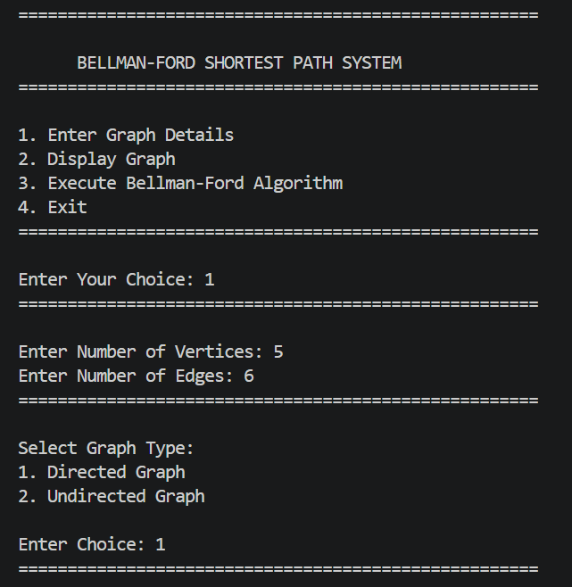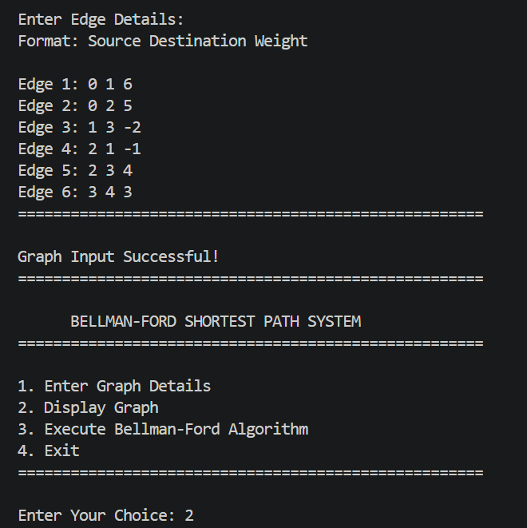
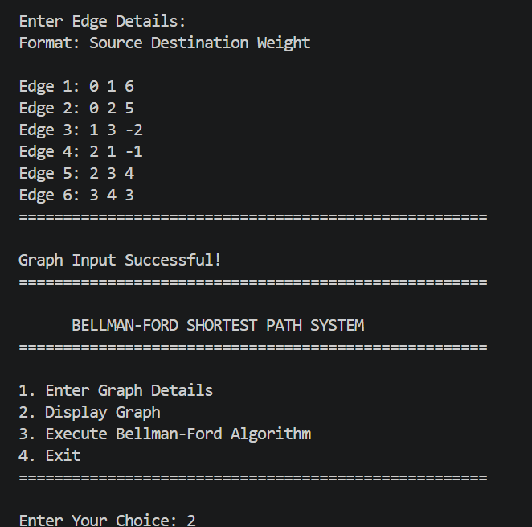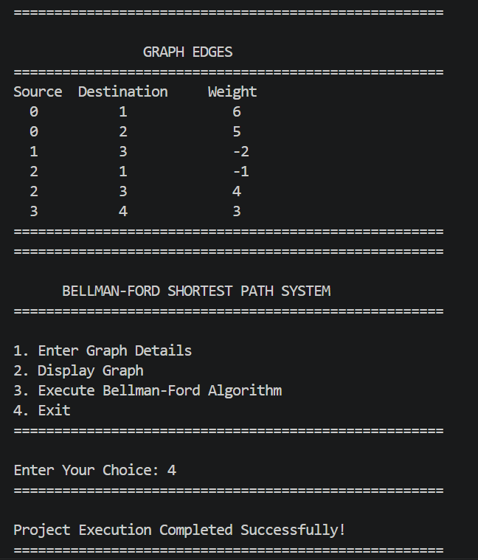
Screenshot 6.3.1 – Menu-Driven Interface of Bellman-Ford System
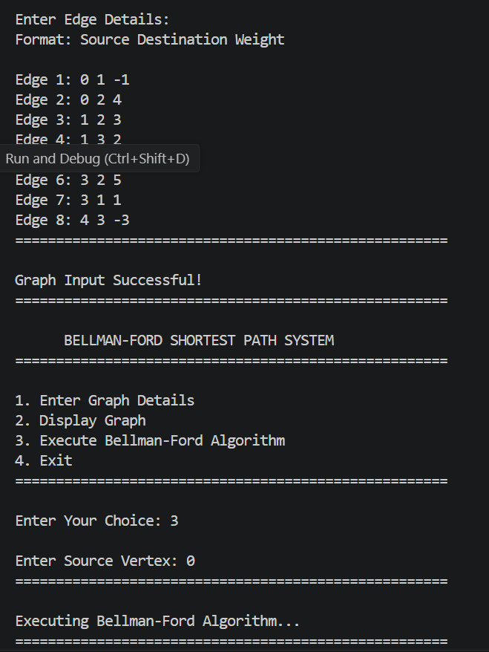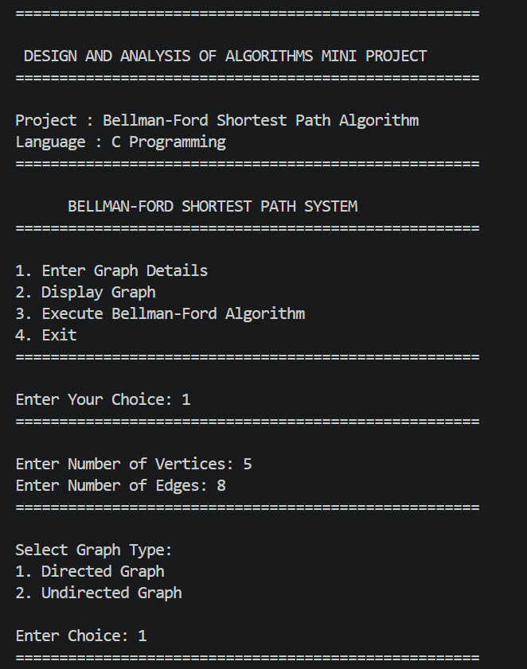
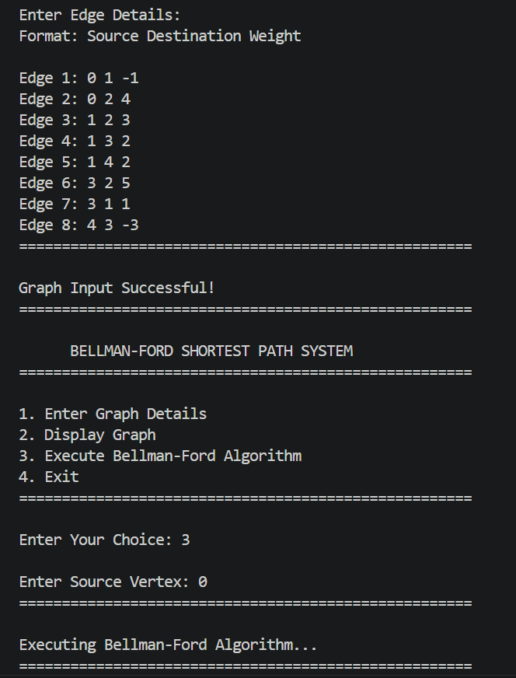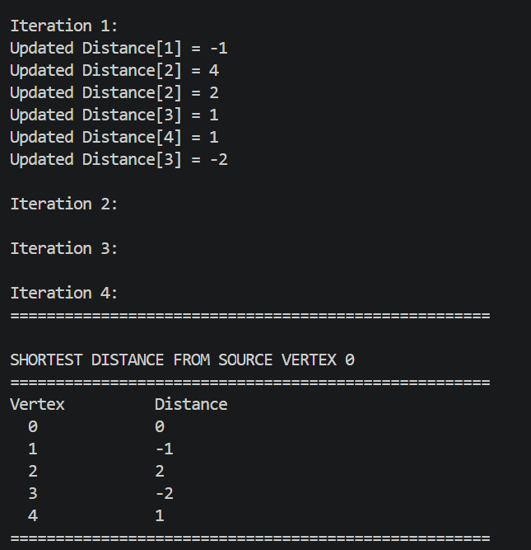
Screenshot 6.3.2 – Normal Graph Shortest Path Output
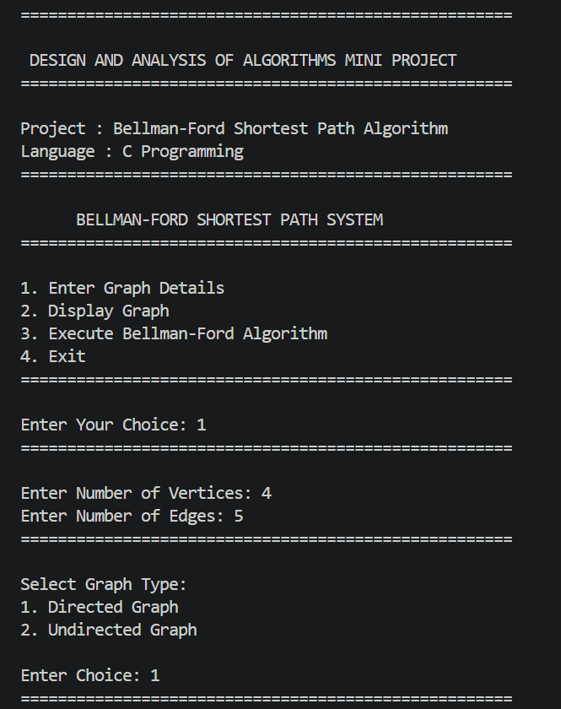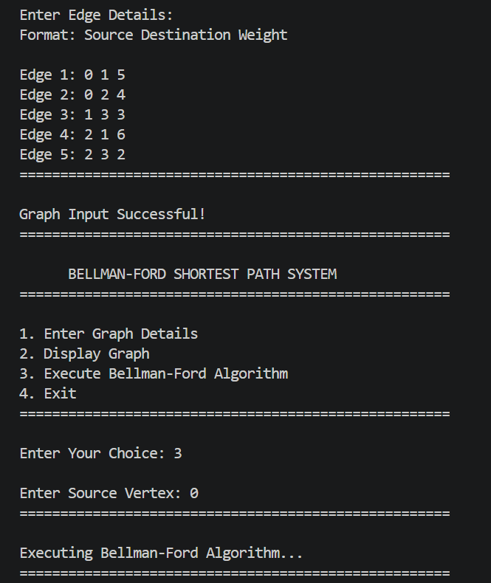
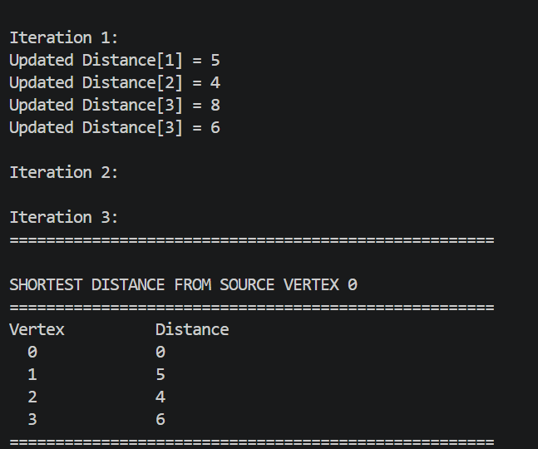
Screenshot 6.3.3 – Directed Graph Execution

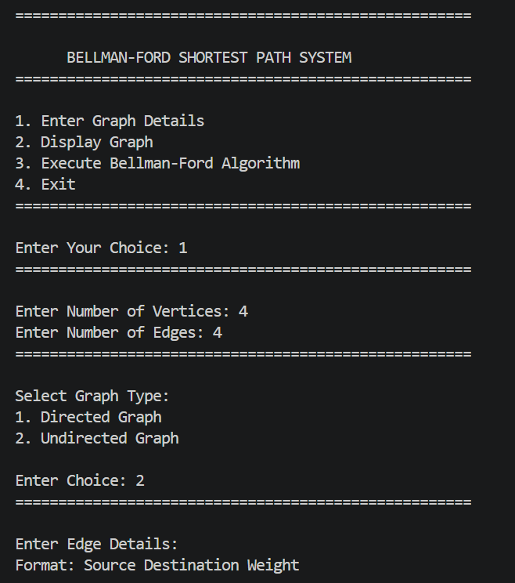
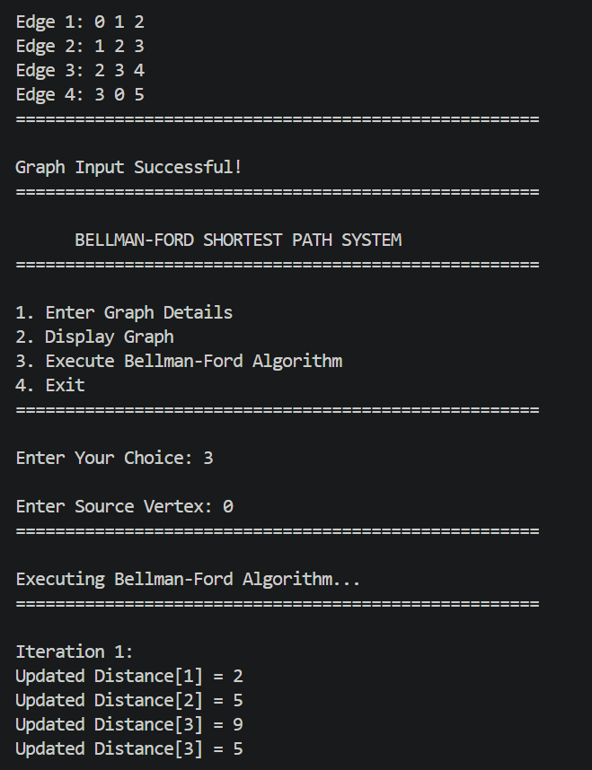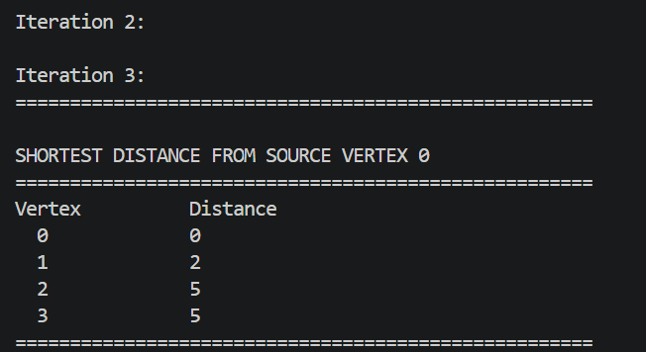
Screenshot 6.3.4 – Undirected Graph Execution

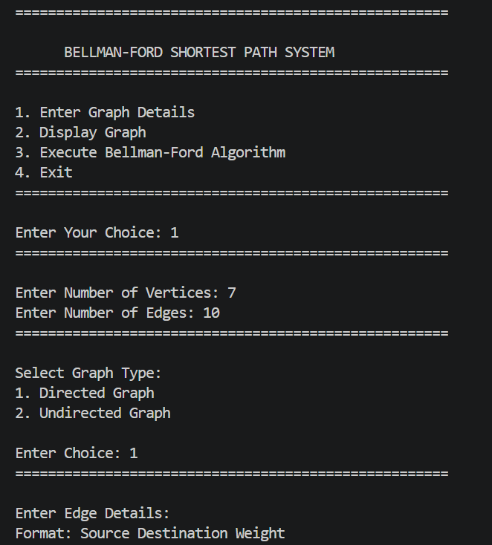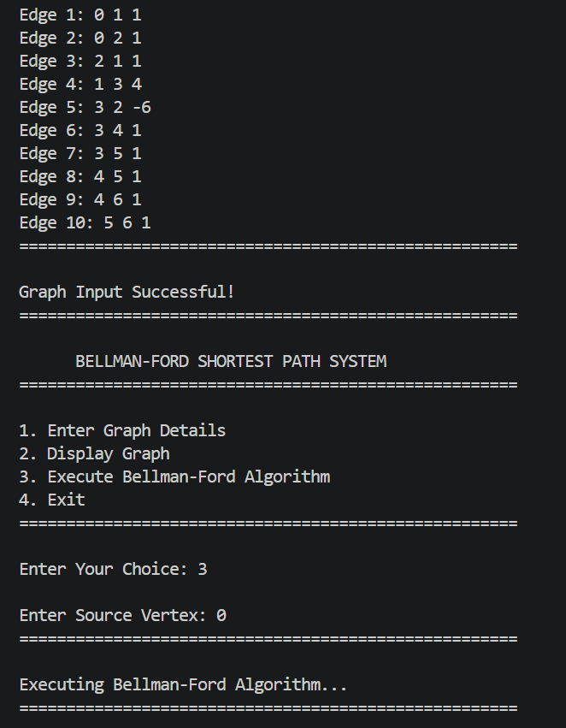
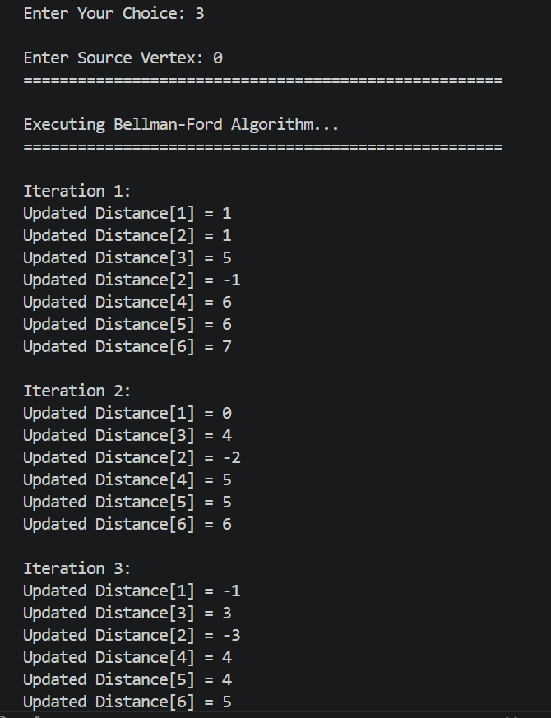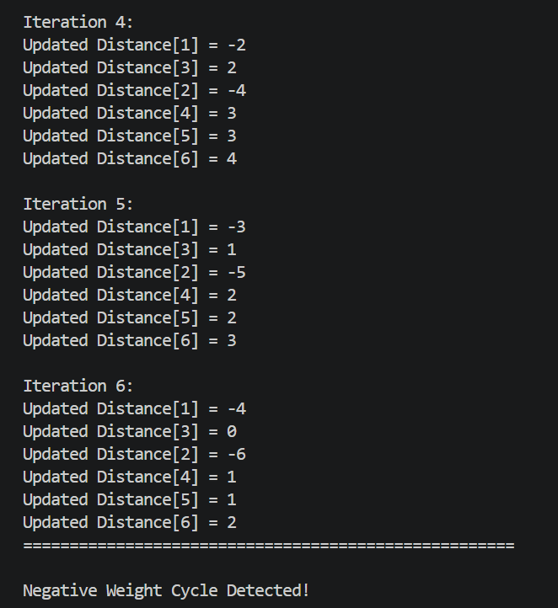
Screenshot 6.3.5 – Negative Weight Cycle Detection

7. Time and Space Complexity Analysis

7.1 Time Complexity
The time complexity of Bellman-Ford Algorithm is analyzed for three cases:

Metric | Best Case | Average Case | Worst Case
Time Complexity | O(VE) | O(VE) | O(VE)
Space Complexity | O(V) | O(V) | O(V)
Where:
- V = Number of vertices
- E = Number of edges

7.2 Detailed Analysis
The Bellman-Ford Algorithm relaxes all edges repeatedly for (V − 1) iterations to compute the shortest distances from the source vertex.

- Best Case – O(VE): In the best case, the graph may already contain optimized shortest paths. However, the algorithm still performs relaxation for all edges during (V − 1) iterations. Therefore, the time complexity remains O(VE).

- Average Case – O(VE): In the average case, the algorithm processes all edges multiple times until the shortest distances are updated correctly. Since every edge is checked during each iteration, the complexity remains O(VE).

- Worst Case – O(VE): The worst case occurs when maximum edge relaxations are required or when the graph contains negative edge weights. The algorithm performs (V − 1) iterations over all E edges and an additional iteration to detect negative weight cycles, resulting in O(VE) complexity. An additional iteration is performed to detect negative weight cycles in the graph.

7.3 Space Complexity
The Bellman-Ford Algorithm uses additional memory mainly for storing the distance array used to maintain shortest distances from the source vertex.
- The algorithm requires O(V) auxiliary space for storing distance values.
- The implementation is considered relatively space efficient because it does not require large additional data structures.
- Since the algorithm is iterative and non-recursive, there is no recursive call stack overhead.
Therefore, the overall space complexity of the Bellman-Ford Algorithm is: O(V)

7.4 Amortized Complexity Analysis
Amortized analysis provides the average cost per operation over a sequence of operations, rather than analyzing each operation in isolation.

Applicable Methods :
1. Aggregate Method – Compute total cost T(n) for n operations → amortized cost = T(n) / n
2. Accounting Method – Assign amortized costs; charge early operations for future expensive ones
3. Potential Method – Define a potential function Φ; amortized cost = actual cost + ΔΦ
Method | Applicability | Explanation
Aggregate Method | Not Applicable | The Bellman-Ford Algorithm performs a fixed number of edge relaxations during every execution.
Accounting Method | Not Applicable | The algorithm does not involve costly future operations or dynamic resizing techniques.
Potential Method | Not Applicable | The computational cost remains fixed and predictable throughout execution.

Amortized analysis is not significantly applicable to the Bellman-Ford Algorithm because the algorithm performs a fixed and predictable number of operations with a consistent time complexity of O(VE).

8. Can the Algorithm Be Optimized?
Yes – The Bellman-Ford Algorithm can be optimized in terms of execution efficiency and graph processing performance.
Although the Bellman-Ford Algorithm correctly computes shortest paths and detects negative weight cycles, certain optimization techniques can improve execution speed and memory efficiency for large-scale graphs.

8.1 Current Limitations
- The algorithm performs repeated edge relaxation for (V − 1) iterations even when shortest distances are already finalized.
- Time complexity remains relatively high at O(VE) for large graphs.
- The implementation processes all edges sequentially, which increases execution time for dense graphs.

8.2 Optimization Strategies (Examples below)
Optimization Strategy | Data Structure Used | Improvement Achieved
Early termination when no updates occur | Flag Variable | Reduces unnecessary iterations
Adjacency List Representation | Linked List / Dynamic Arrays | Improves memory efficiency
Queue-Based Relaxation (SPFA) | Queue | Faster average-case performance
Parallel Edge Relaxation | Parallel Processing Techniques | Improves execution speed for large graphs

9. Applications of the Algorithm

9.1 Applications in Computer Science
The Bellman-Ford Algorithm is widely used in various computer science domains due to its ability to compute shortest paths and detect negative weight cycles.
- Network Routing Systems – Used in routing protocols such as RIP (Routing Information Protocol) to determine shortest communication paths.
- GPS Navigation Systems – Helps in finding optimal routes between locations in road networks.
- Traffic Management Systems – Used for route optimization and congestion analysis in smart transportation systems.
- Telecommunication Networks – Assists in efficient packet transmission and path selection in communication networks.
- Graph-Based Problem Solving – Applied in shortest path and connectivity problems in graph theory.
- Distributed Computing Systems – Used for resource optimization and communication path management.

9.2 Applications in Artificial Intelligence (AI)
The Bellman-Ford Algorithm and shortest path techniques are important in AI systems that require intelligent decision-making and path optimization.
- Robot Navigation Systems – Helps robots determine the shortest and safest movement path in an environment.
- Game AI Pathfinding – Used in video games for intelligent character movement and navigation.
- Knowledge Graph Traversal – Assists AI systems in traversing connected data structures efficiently.
- Intelligent Decision Systems – Used in AI-based optimization and planning applications.

9.3 Applications in Machine Learning (ML)
Shortest path algorithms and graph-based techniques are increasingly used in Machine Learning applications.

- Graph Neural Networks (GNNs) – Used for efficient graph traversal and relationship analysis in graph-based learning models.
- Recommendation Systems – Helps analyze user-item relationship graphs for better recommendations.
- Data Clustering and Network Analysis – Used in graph-based clustering, similarity analysis, and pattern discovery in large datasets.

10. Conclusion
In this mini project, we successfully designed, implemented, and analyzed the Bellman-Ford Algorithm as part of the Design and Analysis of Algorithms course. The implementation was carried out in C programming language using a modular and menu-driven approach with well-structured code and detailed inline comments for better readability and understanding.
Through this project, we gained a strong understanding of graph traversal and shortest path computation techniques used in weighted graphs. The Bellman-Ford Algorithm follows a dynamic programming and graph traversal approach to compute shortest distances and detect negative weight cycles efficiently. The time complexity of the algorithm was analysed as O(VE) in best, average, and worst cases, while the space complexity was determined to be O(V). Amortized analysis was found to be not significantly applicable because the algorithm performs a fixed number of operations during execution.
The testing phase validated the correctness of the implementation for normal graphs, negative edge weights, directed and undirected graphs, and negative weight cycle detection. Optimization possibilities such as adjacency list representation and queue-based relaxation methods were also explored to improve graph processing efficiency.
The Bellman-Ford Algorithm has important applications in network routing, GPS navigation, Artificial Intelligence, and Machine Learning. Overall, this project strengthened our understanding of algorithm analysis, graph theory, optimization techniques, and efficient problem-solving methods used in modern computing systems.

10.1 Future Enhancements
- Implement a GUI-based graph visualization system for better user interaction and demonstration.
- Develop a parallel or distributed version of the algorithm for large-scale graph processing.
- Integrate advanced optimization techniques such as SPFA and adjacency list representation for improved performance.
- Extend the project for real-time navigation and intelligent traffic management systems.

11. References
[1] T. H. Cormen, C. E. Leiserson, R. L. Rivest, and C. Stein, Introduction to Algorithms, 4th ed. Cambridge, MA, USA: MIT Press, 2022.
[2] S. Dasgupta, C. H. Papadimitriou, and U. Vazirani, Algorithms. New York, NY, USA: McGraw-Hill, 2006.
[3] A. V. Aho, J. E. Hopcroft, and J. D. Ullman, The Design and Analysis of Computer Algorithms. Reading, MA, USA: Addison-Wesley, 1974.
[4] R. Bellman, “On a Routing Problem,” Quarterly of Applied Mathematics, vol. 16, no. 1, pp. 87–90, 1958.
[5] L. R. Ford Jr., “Network Flow Theory,” RAND Corporation, Santa Monica, CA, USA, 1956.
[6] GeeksforGeeks – “Bellman-Ford Algorithm Tutorial.”
[7] Programiz – “Bellman-Ford Algorithm Explanation and Examples.”

Declaration
I hereby declare that the mini project report titled “Implementation and Performance Analysis of Bellman-Ford Shortest Path Algorithm using Graph Data Structures” submitted to the Department of Computer Science and Engineering in partial fulfillment of the requirements for the 4th Semester Design and Analysis of Algorithms course is my original work. The project has been carried out by me under the guidance of Prof. Divyashree N and has not been submitted elsewhere for any other examination or award.

Student Name | Jayanti | USN: R24EQ044 | Signature: _____________
Guide / Mentor | Prof. Divyashree N | Designation: Assistant Professor | Signature: _____________
Date | [21 / 05 / 2026]

