# Book Catalogue API Document

Contents

Book Catalogue API Document 1

Overview 1

Workflow 1

Code Design 2

Utility 6

API Response 7

Get list of books 7

Unit test Case 12

# Overview

This document is designed to highlight the Book Catalogue Application, Its responses and unit test cases.

# Workflow

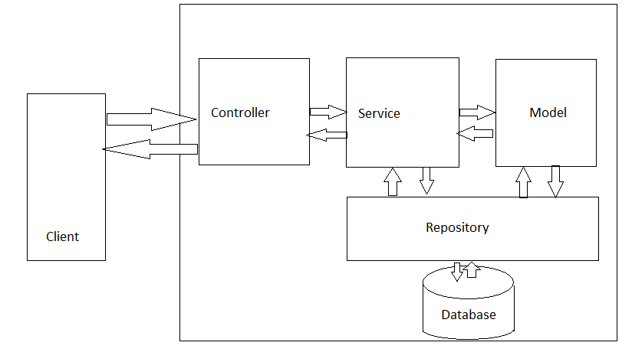

# Code Design

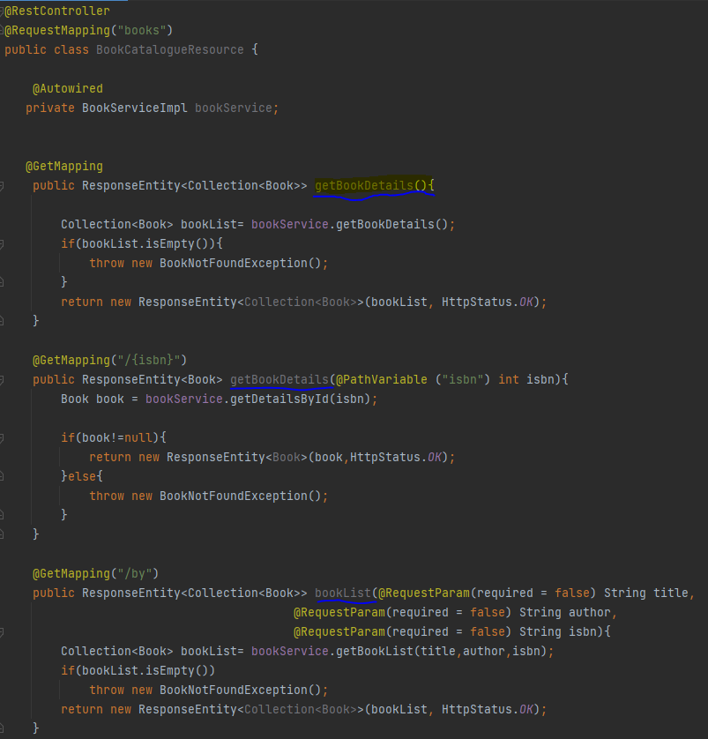

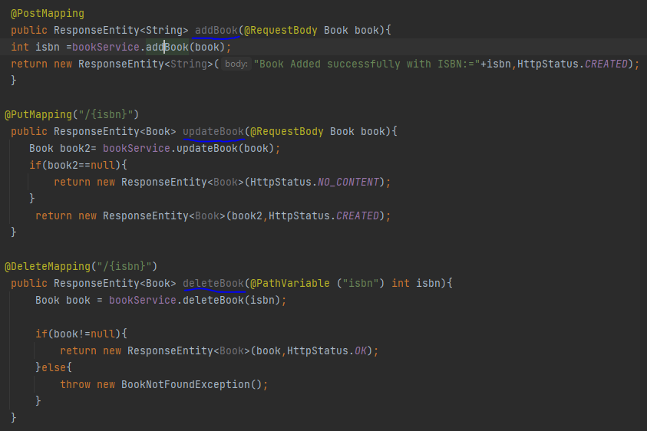

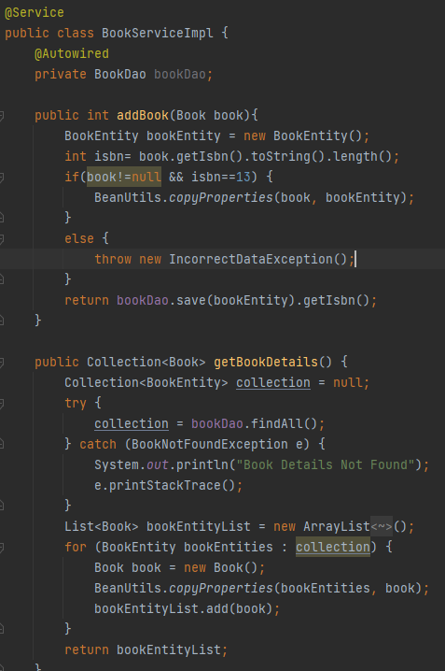

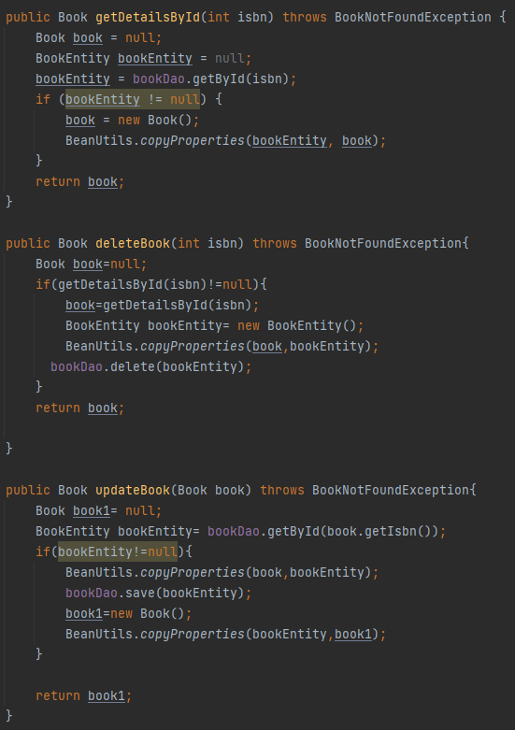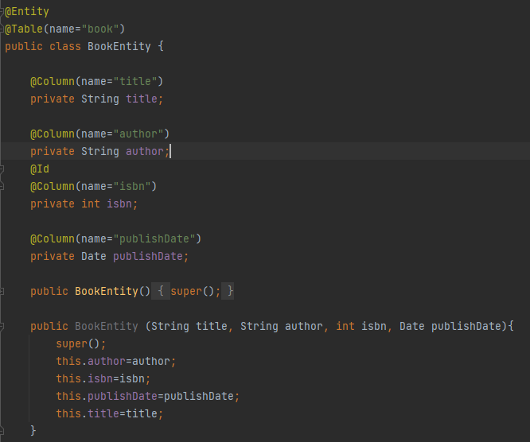

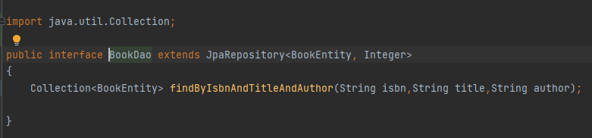

# Utility

* Exception Handling
  + BookNotFoundException.java
  + IncorrectDataException.java
  + BookConttrollerHandler.java

# API Response

Get list of books

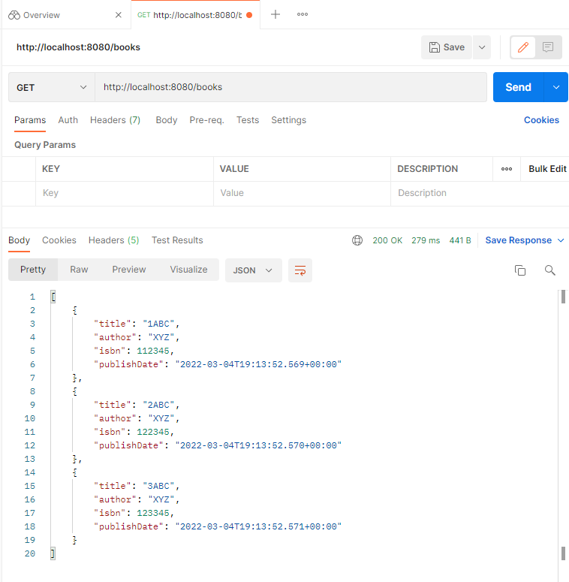

Add Book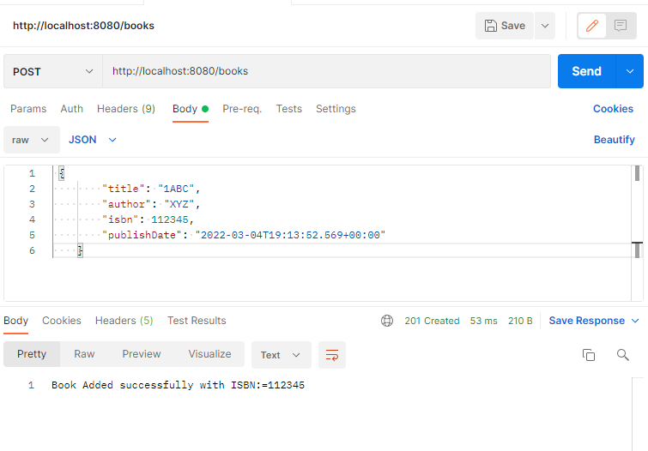

Delete Book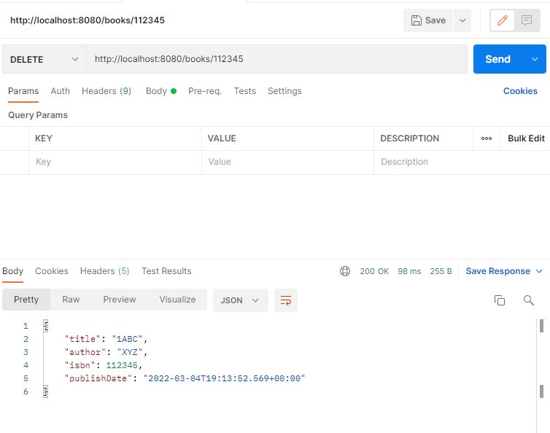

Get Book by Isbn

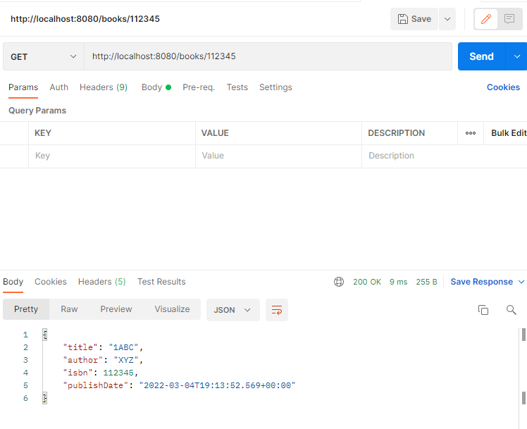

Update Book

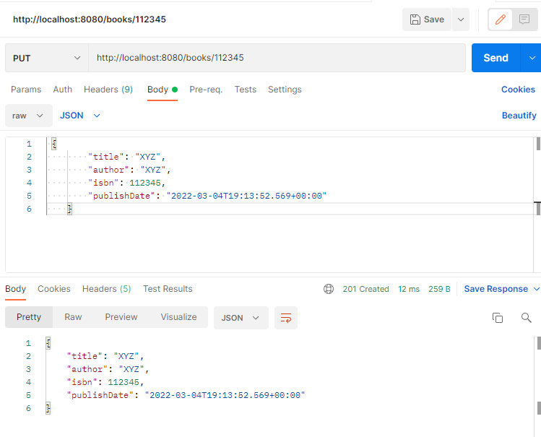

# Unit test Case

