#include <stdio.h>

int main()

{

int s,i;

printf("\n Enter number of students\n");

scanf("%d",&s);

struct students

{

char ID[20];

int age;

float marks;

} stud1[s];

for(i=0;i<s;i++)

{

printf("\n Enter student %d details:\n",i+1);

printf("Student ID - ");

scanf("%s",&stud1[i].ID);

printf("Age- ");

scanf("%d",&stud1[i].age);

printf("Marks -");

scanf("%f",&stud1[i].marks);

if(stud1[i].age > 20 && stud1[i].marks >= 0 && stud1[i].marks <= 100)

{

printf("Data is valid\n");

if(stud1[i].marks >= 65)

printf("student %d qualified\n",i+1);

else

printf("Student %d Not qualified\n",i+1);

}

else

printf("student %d data is invalid and not qualified\n",i+1);

}

}

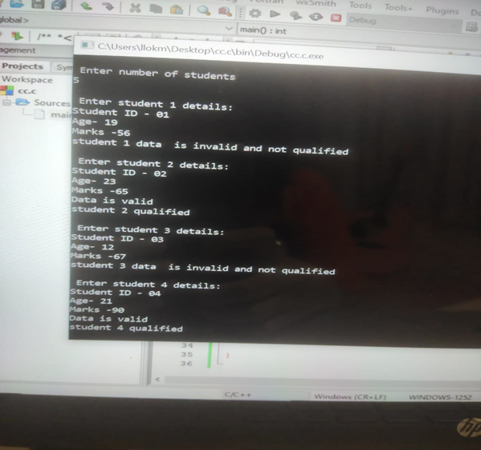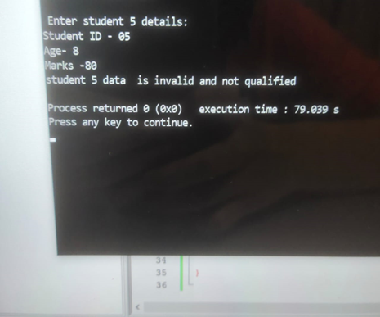k