# **Get and Set Data In LocalStorage In Ionic 2 app**

This is a demo application in Ionic 2 for setting the value into localstorage and getting the value from localstorage.

**Reference sites:**

You can find the reference for same in this site:

<http://jayantpaliwal.com/2016/11/get-and-set-data-in-localstorage-in-ionic-2-app/>

**Steps in brief:**

* Create a page with a button and input text field.
* Setting the value of input field into local storage.
* Getting the value from localstorage.
* Showing the items in list form.

**Above steps in details:**

**First,Creating page with a button and input text field:**

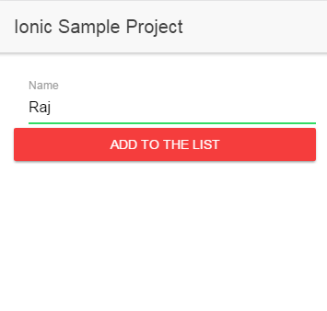

**Second,Setting the value of input field into local storage:**

**localStorage.setItem("Key",value);**

Here **setItem** will set the value into the local storage which will have ‘key’ and ‘value’ attributes. In the ‘KEY’ -> we can give any name, the ‘VALUE’ attribute contains the value that you want to set into the local storage.

**Third,Getting the value from localstorage**

**localStorage.getItem(‘key’);**

Here **getItem** will get the item value of the ‘key’ mentioned from the local storage into the page where you want it to display.

Displayed below are the images of the pages with get and set of items of localstorage:

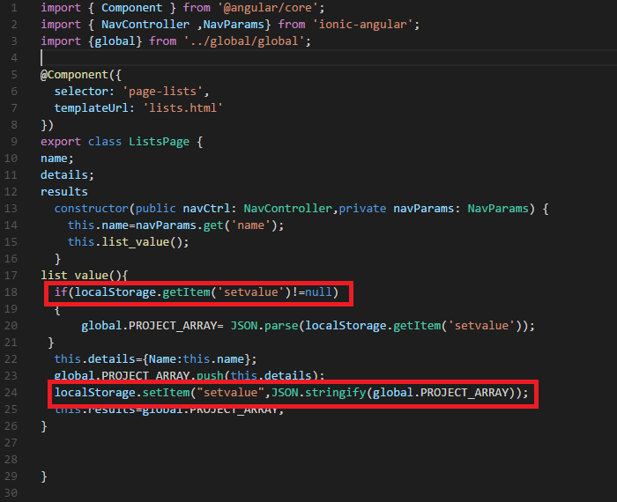

**Fourth,Showing the items in list form**

To show the items in the form of a list we will have to make changes in our HTML file:

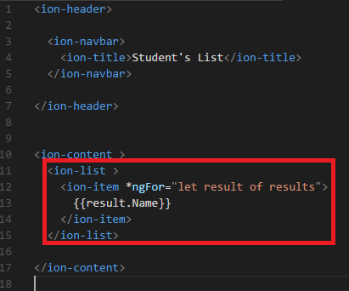

This will show the items in the list in the following way:

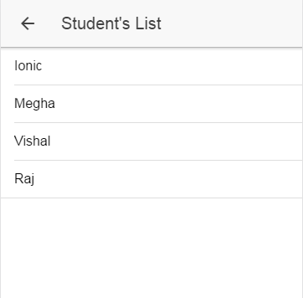

**Reference sites:**

You can find the reference for same in this site:

<http://jayantpaliwal.com/2016/11/get-and-set-data-in-localstorage-in-ionic-2-app/>

**Thank you.**