Game Design Document

Fill up the following document

1. Write the title of your project.

Plant vs Zombies

1. What is the goal of the game?

TO kill the Zombies

1. Write a brief story of your game.

This game is similar to the real plant vs zombie game in which plant

are going to save us from the zombies .

1. Which are the playing characters of this game?

* Playing characters are the ones who respond to the user based on the input from the user.
* Cars, monkeys, dinos, wizards, etc., are the playing characters in the game.

|  |  |  |
| --- | --- | --- |
| Number | Character Name | What can this character do? |
| 1 | Plants | They can kill Zombies |
| 2 |  |  |
| 3 |  |  |
| 4 |  |  |
| 5 |  |  |
| 6 |  |  |
| 7 |  |  |
| 8 |  |  |

1. Which are the Non-Playing Characters of this game?

* Non-Playing characters are the ones that don't have an action or behavior when the user interacts with the game.
* Hurdles, stones, bananas, coins, etc., are non-playing characters in the game.

|  |  |  |
| --- | --- | --- |
| Number | Character Name | What can this character do? |
| 1 | Zombies | They are coming to eat our brains |
| 2 |  |  |
| 3 |  |  |
| 4 |  |  |
| 5 |  |  |
| 6 |  |  |
| 7 |  |  |
| 8 |  |  |

Draw your imagination of this game. What does this game look like?

* Draw the game either on your computer or on paper.
* Add images of the game scenes to show each of the playing and non-playing characters at least once.

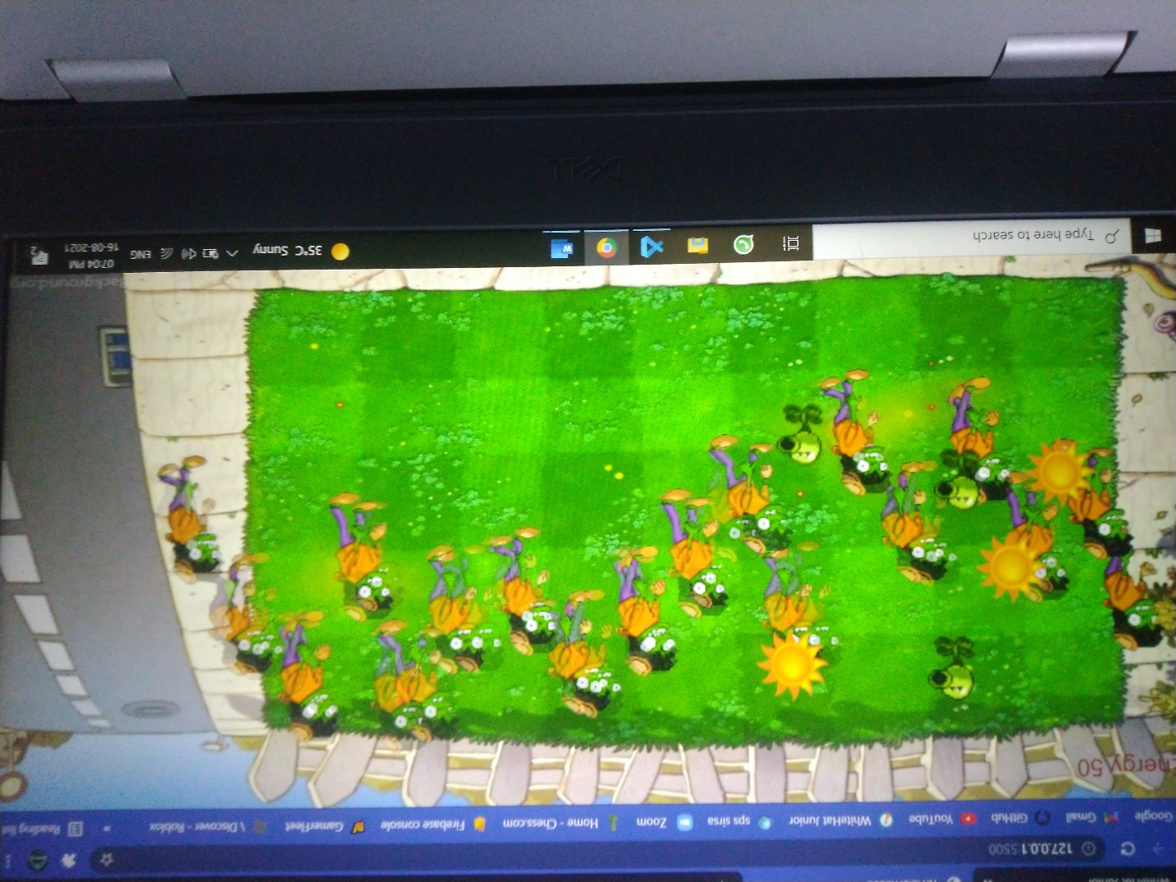

How do you plan to make your game engaging?

By adding animation of plant and zombies.

By giving the score after killing any zombie.