**CS 325 - Homework 5**

1. **(7 points) Let X and Y be two decision problems. Suppose we know that X reduces to Y in polynomial time. Which of the following statements are true? Explain**

Answer - If X $≤p$ Y, then if we have a solution to solve Y efficiently, we can use the same solution to solve X efficiently.

**a. If Y is NP-complete then so is X.**

Answer – False ,it cannot be inferred as X can be anything. X can be NP Hard or NP.

**b. If X is NP-complete then so is Y**

Answer – False as it cannot be inferred, same as above.

**c. If Y is NP-complete and X is in NP then X is NP-complete.**

Answer – False as it cannot be inferred.

**d. If X is NP-complete and Y is in NP then Y is NP-complete.**

Answer – True, as we can see from the below diagram that NP complete problems can be reduced to other NP complete ones.

NP-Hard

NP- Complete

**e. If X is in P, then Y is in P.**

Answer – False cannot be said.

**f. If Y is in P, then X is in P.**

Answer – True, it can be seen from the above diagram that a polynomial time problem can be reduced to another polynomial time problem.

**g. X and Y can't both be in NP.**

Answer – False, it cannot be inferred as if X is in NP, it can be reduced to a NP-complete problem as well.

**2. (8 points) A Hamiltonian path in a graph is a simple path that visits every vertex exactly once. Show that HAM-PATH = { (G, u, v ): there is a Hamiltonian path from u to v in G } is NP-complete. You may use the fact that HAM-CYCLE is NP-complete.**

a) We need to show that Hampath $∈$ NP

Given a Graph G(V,E) with n vertices and a path from u to v, we can verify whether there exist a simple path from u to v in polynomial time. This can be done by checking for the adjacent vertices. That is by checking the adjacency list to verify whether the vertices are adjacent and that there are n vertices.

b) We need to show that R $≤$ p Hampath for some R which is NP complete.

* Given that Ham-Cycle is NP- complete and therefore it is NP. Let R be a Ham-cycle as it is similar to Hampath.
* To prove that Ham-cycle reduces to Hampath.

Given a graph G(u-v) having a Hamiltonian cycle, where(u-v) represents set of vertices, we can construct a new graph G’(u-u’) by adding another vertex u’ which is a replica of the vertex u. Hence, u’ has an edge to all the vertex as u.

The new graph constructed G’(u,u’) has a Hamiltonian path from u to u’. This reduction from G to G’ can be done in polynomial time by adding the list of edges to u’ as in the list for u in G.

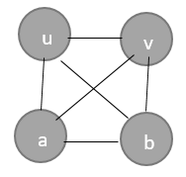 

G’(u-u’) ->

G(u-v) -> Hamiltonian Cycle

Hamiltonian Path

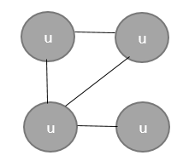 

v

b

a

v

b

a

No Hamiltonian Cycle No Hamiltonian Path

* We have proved that G’ has a Hamiltonian path from u to u’, in that case it can be said that G has a Hamiltonian cycle. On the other hand, if G has a Hamiltonian cycle then G’ has a Hamiltonian path.

With this we can also say that if G does not have a Hamiltonian cycle, then neither G’ will have a Hamiltonian path.

* Since Hamiltonian cycle is NP – complete, Hamiltonian path should be NP-Hard.

Therefore, Hamiltonian Path is NP-complete.

**3. (15 points) K-COLOR. Given a graph G = (V,E), a k-coloring is a function c: V -> {1, 2, … , k} such that c(u)  c(v) for every edge (u,v)  E. In other words the number 1, 2, .., k represent the k colors and adjacent vertices must have different colors. The decision problems K-COLOR asks if a graph can be colored with at most K colors.**

**a. The 2-COLOR decision problem is in P. Describe an efficient algorithm to determine if a graph has a 2-coloring. What is the running time of your algorithm?**

Answer – Since this is a decision problem, this can be verified by traversing the adjacency list of a vertex and comparing whether the neighboring vertex has the same color. If there are V vertices and E edges, then we would compare a vertex with all its adjacent vertex which would give the running time as a polynomial = O(V+E).

**b. The 3-COLOR decision problem is NP-complete by using a reduction from SAT. Use the fact that 3-COLOR is NP-complete to prove that 4-COLOR is NP-complete.**

Answer - We need to prove 3-COLOR $≤$ p 4-COLOR.

Given a colored graph, as mentioned above in the previous problem, we can say whether it is 3 colored one or not in O(V+E) by evaluating the adjacent nodes.

1. To prove 3-COLOR graph can be reduced to 4-COLOR in polynomial time.

Consider the Graph G in the below diagram. We can see that Graph G is a 3 colored one.

We can transform the graph G to G’ which is a 4 colored one by adding an extra vertex and constructing an edge from all other vertices to that vertex. Since it has an edge with all the vertices(adjacent to all) we need to give it a different color.

This 4-COLOR graph can only be colored correctly, if the original 3 COLOR graph is colored correctly. There by I have shown that a 3 COLOR problem can be reduced to a 4 COLOR problem.

This takes a polynomial time O(V+E) as it involves traversing through the adjacency list and verifying the color of each vertex.

1. We can verify whether the new graph G’ is 4 colored or not by traversing the vertices and checking against its adjacent vertices. This would give a polynomial running time of O(V+E).

Reduced Graph G’ – Yes to 4 COLOR

Graph G - YES to 3 COLOR

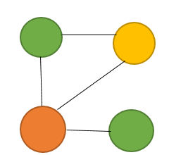 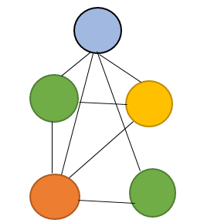

Graph G’ - Says No to 3-color as well as 4-color

Graph G -> Says No to 3- COLOR and Yes to 4-Color

Hence we could see that the 3-COLOR decision problem has a polynomial time solution from above. But since 3-COLOR decision problem is NP-complete, 4 COLOR decision problem must also be NP-complete. Therefore, there is a contradiction.

Hence, 4 colored decision problem is a NP- complete one.