**PRICE CHANGE NOTIFICATION BOT**

**PROBLEM ABSTRACT**

The Price Change Notification Bot is a Robotic Process Automation (RPA) Project. The Bot is majorly created to check the price change (drop/rise) of the various products available on e-Commerce sites like Flip-kart, Amazon, etc. The customer can add the desired product either to his Cart or Wish-list waiting for the price drop. The bot actually works on monitoring the price change whenever the product is added on the cart/wish-list. Once the price increases, the bot sends the notification to the customer with a voice message. Similarly whenever there is a decline in the price, the bot automatically notifies the customer with a voice message and an automated email invitation to purchase the product attached with the purchase link is being sent.

**PROBLEM DEFINITION**

The existing system does not provide any notification or alert to the customer on the price change be it high or low. Manually the customer has to visit the e-commerce site to check for the price drop each and every time. The customer is not sure of when there will be a drop in the price and may miss the opportunity to buy the product on that period. No notification will be sent to the customer from the e-commerce site on the price change.

The proposed system consists of 6 modules : Data-Scraping the product on the Cart/Wish-List, Excel Automation, Monitoring the price change, Comparing the price with expected price(approx.), Notification and voice message ,E-mail Automation. Automatically the bot monitors on the price change, Sends a notification message along with a voice message to make the customer aware of the price drop. Similarly we can monitor the price change based on the customer’s expected price. In case of price drop, it sends an email invitation to purchase the product with that product-purchase link. Finally, task scheduling has been done to run the robot.

**TECHNOLOGY USED**

UiPath is a free, fully-featured and extensible version of our automation tool. This platform delivers the fastest and most reliable RPA that enhances business performance at unlimited scale. It is easy to use, highly responsive, and instantly scalable to allow you to build the process.

RPA tools are defined as non-integrated, stand-alone software for laptops and workstations. UiPath is recognized worldwide for product leadership and technical excellence. RPA is the largest in the industry, the most active in the automation field.

**A UiPath feature has three main products:**

* **UiPath Studio-** It designs automation process using diagrams, which are visually appealing
* **UiPath Robot-** Executes the UiPath Studio Processes

**UiPath Orchestrator –** It is an application that deploys, manages, and monitors processes/robots

**INPUT**

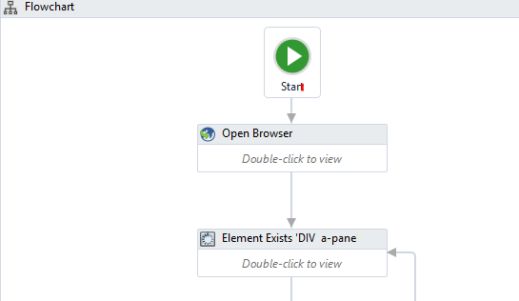

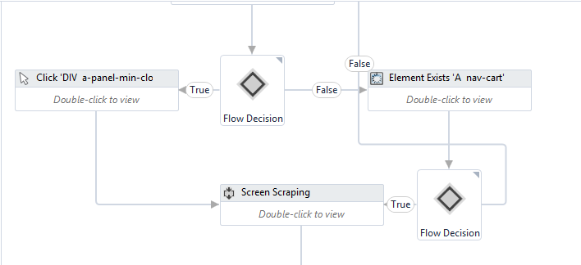

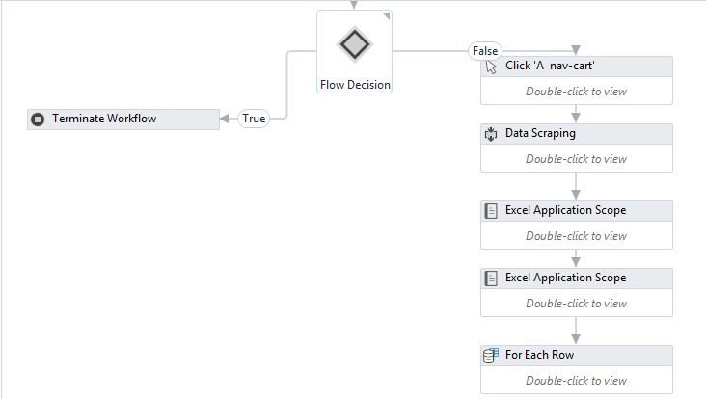

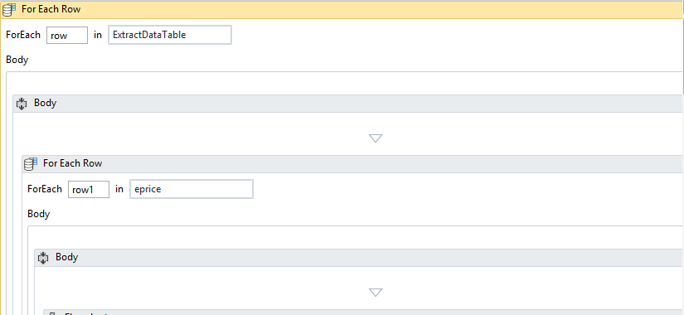

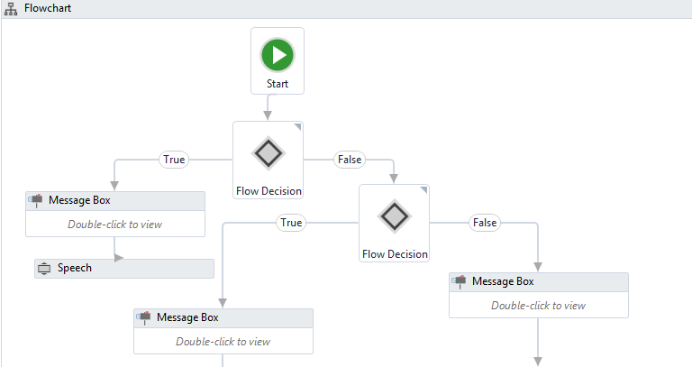

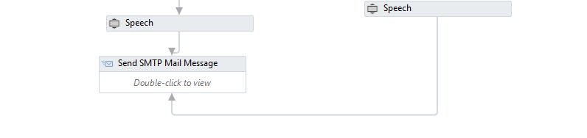

**OUTPUT**

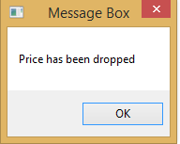

Voice message 🡪

**“Price has been dropped”**

