NM PROJECT

PUBLIC TRANSPORT OPTIMIZATION

DEVELOPMENT PHASE 3

https://wokwi.com/projects/378933068634242049

#define BLYNK_TEMPLATE_ID "TMPL26V4fGv5q"

#define BLYNK_TEMPLATE_NAME "Test"

#define BLYNK_AUTH_TOKEN "XEHxNF_Ur1Nt2p7wB5B20dNI1ZUwj34P"

#include <WiFi.h>

#include <WiFiClient.h>

#include <BlynkSimpleEsp32.h>

int duration1 = 0;

int distance1 = 0;

int duration2 = 0;

int distance2 = 0;

int dis1 = 0;

int dis2 = 0;

int dis_new1 = 0;

int dis_new2 = 0;

int entered = 0;

int left = 0;

int inside = 0;

#define LED 2

#define PIN_TRIG1 15

#define PIN_ECHO1 14

#define PIN_TRIG2 13

#define PIN_ECHO2 12

BlynkTimer timer;

char auth[] = BLYNK_AUTH_TOKEN;

char ssid[] = "Wokwi-GUEST";   // your network SSID (name)

char pass[] = "";

#define BLYNK_PRINT **Serial**

long get_distance1() {

  // Start a new measurement:

  digitalWrite(PIN_TRIG1, HIGH);

  delayMicroseconds(10);

  digitalWrite(PIN_TRIG1, LOW);

  // Read the result:

  duration1 = pulseIn(PIN_ECHO1, HIGH);

  distance1 = duration1 / 58;

  return distance1;

}

long get_distance2() {

  // Start a new measurement:

  digitalWrite(PIN_TRIG2, HIGH);

  delayMicroseconds(10);

  digitalWrite(PIN_TRIG2, LOW);

  // Read the result:

  duration2 = pulseIn(PIN_ECHO2, HIGH);

  distance2 = duration2 / 58;

  return distance2;

}

void myTimer() {

**Serial**.println("100");

  dis_new1 = get_distance1();

  dis_new2 = get_distance2();

  if (dis1 != dis_new1 || dis2 != dis_new2){

**Serial**.println("200");

    if (dis1 < dis2){

**Serial**.println("Enter loop");

      entered = entered + 1;

      inside = inside + 1;

      digitalWrite(LED, HIGH);

      Blynk.virtualWrite(V0, entered);

      Blynk.virtualWrite(V2, inside);

      dis1 = dis_new1;

      delay(1000);

      digitalWrite(LED, LOW);

    }

    if (dis1 > dis2){

**Serial**.println("Leave loop");

      left = left + 1;

      inside = inside - 1;

      Blynk.virtualWrite(V1, left);

      Blynk.virtualWrite(V2, inside);

      dis2 = dis_new2;

      delay(1000);

    }

  }

}

 void setup() {

**Serial**.begin(115200);

  pinMode(LED, OUTPUT);

  pinMode(PIN_TRIG1, OUTPUT);

  pinMode(PIN_ECHO1, INPUT);

  pinMode(PIN_TRIG2, OUTPUT);

  pinMode(PIN_ECHO2, INPUT);

  Blynk.begin(auth, ssid, pass, "blynk.cloud", 8080);

  timer.setInterval(1000L, myTimer);

}

void loop() {

  Blynk.run();

  timer.run();

}

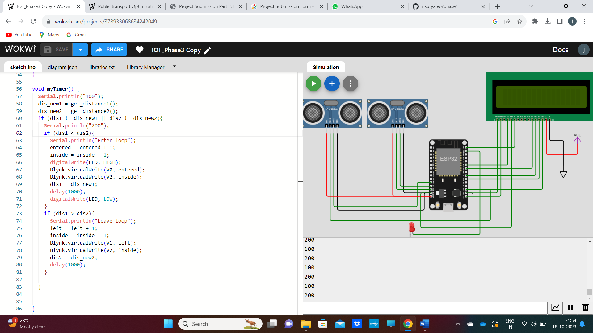

OUTPUT

1 VSS VDD V0 RS RW E D0 D1 D2 D3 D4 D5 D6 D7 A K 16

ets Jul 29 2019 12:21:46

rst:0x1 (POWERON_RESET),boot:0x13 (SPI_FAST_FLASH_BOOT)

configsip: 0, SPIWP:0xee

clk_drv:0x00,q_drv:0x00,d_drv:0x00,cs0_drv:0x00,hd_drv:0x00,wp_drv:0x00

mode:DIO, clock div:2

load:0x3fff0030,len:1156

load:0x40078000,len:11456

ho 0 tail 12 room 4

load:0x40080400,len:2972

entry 0x400805dc

100

200

100

200

100

200

100

200

100

200

100

200

100

200

100

200

100

200

100

200