**PUBLIC TRANSPORT OPTIMIZATION**

**PHASE 2**

After thorough research and analysis, we arrived at an innovative solution to solve the above problem as detailed in phase 1 of our project.

**DESIGN**

The block diagram below is a general design of our solution.

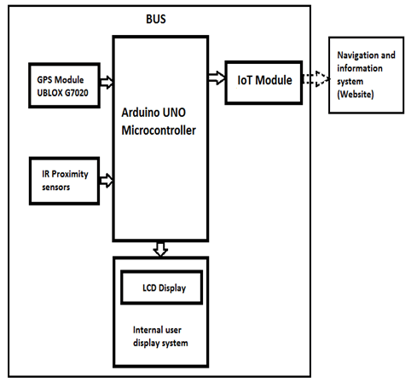

**MICROCONTROLLER:**

* We will be using the ESP32 micro controller, Arduino UNO microcontroller, or Raspberry Pi because these suit the best for our project.
* As an Android App for tracking buses and calculating distances to stations along their routes, the tracking system includes placement of GPS, RTC, and Arduino UNO in a bus, and an Android App installed on any smartphone to track the bus location

**SENSOR UNIT**

Passengers can track the bus’s real-time location at any time using GPS (Sim808), Arduino UNO, ESP8266, and RFID. There are many innovative technologies, that promoted the development and implementation of smart public transport systems, such as Geographical Information Systems (GIS), Automatic Vehicle Location Systems (AVLS), and Traveler Information Systems (TIS)

**1. GPS Sensor**

GPS (Global Position System) is used for positioning and tracking buses based on satellite communication. GPS satellites cover the entire earth at all times. To get accurate GPS location data, there should be a minimum of three satellites. The NEO-6M GPS module used in the proposed system is small and works on very low power, making it ideal for tracking applications. They receive signals from GPS satellites to calculate the vehicle's latitude, longitude, and altitude. This information is crucial for tracking the vehicle's position in real-time and optimizing routes.

**2. RFID Sensors**:

Radio Frequency Identification (RFID) sensors are employed for identifying and tracking specific buses. RFID tags or cards may be issued to each bus, and RFID sensors at bus stations or on board can read these tags, helping to keep track of which bus is at a particular location and aiding in fare calculation and passenger data management.

**3. Ultrasonic Sensors:**

Ultrasonic sensors can measure the distance between the bus and nearby objects. They are used for collision avoidance and parking assistance. This data can improve safety and prevent accidents.

**4. Gas Sensors:**

Gas sensors can detect the presence of harmful gases, such as carbon monoxide or volatile organic compounds. They are crucial for monitoring air quality on public transport vehicles, ensuring the safety and comfort of passengers and drivers.

**5. Infrared Sensors:**

Infrared sensors can detect the presence of passengers on board. They are used to determine occupancy levels and control various systems, such as heating, ventilation, and air conditioning (HVAC), to optimize energy consumption based on the number of passengers.

**6. Temperature Sensors**:

Temperature sensors are used to monitor and control the interior climate of the vehicle. They ensure that the temperature remains comfortable for passengers and can also contribute to energy efficiency by adjusting HVAC systems accordingly.

Based on the project requirements, it is highly likely that we will solely utilize a GPS sensor.

3.Write Code: Write Python or C++ code to identify the location of the vehicle. Use MQTT, HTTP, or AMQP to send data to your IoT platform and receive remote commands.

4.Set Up IoT Platform: Create an account on your chosen IoT platform, configure device settings, and obtain the necessary authentication keys and credentials.

5.Integrate IoT Platform: Modify your Python code to send and receive data from the IoT platform using MQTT.

6.Optional Web Interface: If you want remote control, set up a web server on the Raspberry Pi. Create a web interface that allows you to check the location of the vehicle.

Database (optional): If you want to store and analyze historical data, set up a database and modify your code to log relevant information.

7.Testing and Debugging: Test your system thoroughly, and ensure the sensor readings and that communication with the IoT platform is reliable.

8.Finalize and Secure: Deploy the IoT system in public transport vehicles and infrastructure, ensuring all components are functioning as expected. Integrate the hardware into the existing transport network.

9.Continuous Monitoring and Maintenance: Implement a robust system for continuous monitoring and maintenance of the IoT components. Regularly check and update the hardware, software, and communication protocols to keep the public transport optimization system running smoothly and efficiently.

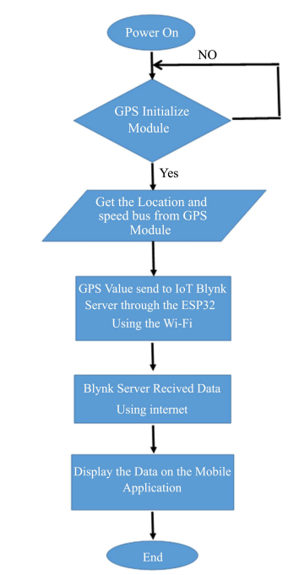

**ALGORITHM**

**Distance calculation**

The Haversine formula was adopted to calculate the distance that will appear in the Android app. It calculates the distance between the passenger and the bus location using the latitude and longitude of the bus and the passenger who is at home, work, or the bus stop. The following equations can be used to calculate the distance

a = sin 2(∆φ/2)+ cosφ1* cosφ2* sin2(∆λ )

c=2*atan2($a*\sqrt{1-a})$

d=R*c

where: (“φ”) = latitude;

(“λ”) = longitude;

(“∆φ”) = latitude 2 − latitude 1;

(“∆λ”) = longitude 2 − longitude 1; R = earth radius (6371 meters);

d = distance between the two locations.

**Arrival time calculation**

The arrival time of each bus, which will appear in the Android app, is calculated based on the following equation.

t =ds ∗60

where: t = arrival time of the bus, d = distance between the passenger and bus location that get from Equation,s = average speed of bus along the route.

To convert the arrival time (t) that will be obtained from Equation (3) from an hour into a minute, it is multiplied by 60 (one hour into a minute).

**FEATURES:**

A public transport optimization project aims to improve the efficiency, accessibility, and sustainability of public transportation systems. To achieve these goals, the project may incorporate various features and strategies. Here are some key features of a public transport optimization project:

1. Route Optimization:
   * Analyzing existing routes and schedules to identify inefficiencies.
   * Adjusting routes to reduce overlap and improve coverage in underserved areas.
   * Implementing real-time data and GPS tracking to adjust routes dynamically based on traffic and demand.
2. Schedule Optimization:
   * Optimizing timetables to reduce waiting times and ensure better synchronization between different modes of transportation.
   * Using predictive analytics to adjust schedules based on historical data and current trends.
3. Integration of Modes:
   * Integrating various modes of public transportation (buses, trams, subways, ferries, etc.) to create a seamless, multi-modal system.
   * Developing unified fare structures and ticketing systems for easier transfers between modes.
4. Passenger Information Systems:
   * Providing real-time information to passengers regarding arrival times, delays, and service disruptions through apps, signage, and announcements.
   * Implementing electronic payment systems and mobile apps for ticketing and route planning.
5. Accessibility and Inclusivity:
   * Ensuring that public transport is accessible to all, including individuals with disabilities.
   * Designing stations and vehicles with ramps, elevators, and other features to accommodate passengers of all abilities.
6. Sustainable Practices:
   * Promoting the use of eco-friendly vehicles, such as electric buses and hybrid trains, to reduce emissions and energy consumption.
   * Encouraging the use of public transport to reduce the number of private vehicles on the road and alleviate congestion.
7. Safety and Security:
   * Enhancing security through the installation of surveillance cameras and the presence of personnel at key locations.
   * Implementing emergency response systems to handle accidents or medical emergencies.
8. Data Analytics:
   * Collecting and analyzing data on passenger flows, usage patterns, and customer feedback to make informed decisions and adjustments.
   * Employing predictive analytics to anticipate future demand and adjust services accordingly.
9. Public Engagement:
   * Conducting surveys and seeking feedback from passengers to understand their needs and preferences.
   * Involving the public in decision-making processes, such as route changes and service improvements.
10. Cost Efficiency:
    * Implementing cost-effective strategies to reduce operational expenses while maintaining service quality.
    * Exploring partnerships with the private sector for funding and service provision.
11. Public-Private Partnerships:
    * Collaborating with private companies to improve and expand public transport services, especially in regions with budget constraints.

