

**Department of Information Technology**

**A.Jayapradap**

**3yr b-tech IT**

**JP Player**

**Software Requirement Specification**

**CONTENTS**

**1. Introduction**

1. Introduction

**2. Modules**

2.1. Graphical Interface

2.2. Protability

2.3. Facilities

2.4. Add Multiple Files

2.5. Feasible To Access

2.6. Playlist History

**3. Functional Requirements**

3.1 User Interface

3.2 Hardware Interface

**4. Design**

**5. System Description**

5.1 Limitations

5.2 Advantages of Proposed System

5.3 Disadvantages of Existing System

**6.Conclusion**

**1.INTRODUCTION**

**Introduction**

Media player is a software for playing different

types of media files. This media player will play the different typed of video audio files as well as image. The main feature of this software is to play the mp4 type of video files and mp3 type of audio file and jpge type of image files.The requirement of this software is given below. This Software will be run only in windows operating system. Any Person who use the windows OS they can be able to access this software.

**2. MODULES**

**2.1 GRAPHICAL INTERFACE:**

**1. MENUBAR:**

**DESCRIPTION**: The menu bar will be displayed at the upper position of the media player where all the option regarding the software and the files will be given. For a particular task the user have to choose the proper option only.

**INPUT :** User need to click the option button as displayed in the software.

**OUTPUT :** The specific task will be performed.

**2. STATUS BAR:**

**DESCRIPTION :** The status bar use for displaying the duration of the running file. User can also seek in different position of the file during run time through

this status bar.

**INPUT:** The mouse click on any position on the status bar.

OUTPUT: The running file will be seek to that time duration

**3 .INTERMEDIATE FRAME:**

**DESCRIPTION :** This is required for displaying the fame of the video file and the picture contain by the audio file.

**INPUT:** The audio or video file will be the input.

**OUTPUT :** The content of that input file.

**4. VOLUME CONTROL**

**DESCRIPTION :** It gives the facility to the user to control the volume of the video or audio file when it running.

**2.2 PROTABILITY:**

**2.1 MEMORY REQUIREMENT:**

**DESCRIPTION :** Memory required for this software is very low. The code of this software is made by java and it very logical.

**OUTPUT** : very flexible to use.

**2.2 DIFFERENT MODE:**

**DESCRIPTION** : This software is able to work in three different mode.

1>Video

2>Audio

3>Photo viewer;

According to the file type it will automatically run in its suitable mode.

**INPUT :** The file name is the input.

**OUTPUT :** It will show the Content of the supportive file. Otherwise an error message will be shown to the user .

**2.3-FACILITIES :**

**2.3.1 - PLAYLIST :**

**INPUT :** Any media file.

**OUTPUT :** Next time when users will play the same media file , it is not require them to select the file from the specific folder. Because this software is given the facility of playlist of the earlier played media file.

**3.2.2 – RESOLUTION CONTROL ::**

**INPUT :** Any media file.

**OUTPUT :** The users can change the colour , contrast & brightness when require.

**3.3 – FAST FORWARD** ::

**INPUT :** Any media file.

**OUTPUT :** They can forward the media file with respect to the time when they want.

**2.4: ADD MULTIPLE FILES**

**2.4.1: ADD FILES BY BROWSING**

**DESCRIPTION:** User will input the file by browsing the different directory or path of the file where it is located. The software automatically fetch the file from the given path.

**2.5: FEASIBLE TO ACCESS**

**2.5.1: Open File**

**DESCRIPTION** **:** User will select the media file which he/she want to play by opening their computer directory.

**INPUT :** user will add one or more file by mouse as interface with the media player.

**OUTPUT:** The selected file will be add to the player library and shows the chosen file into the list.

**2.5.2: Start Option**

**DESCRIPTION :** The selected or the added media files will be played one by one after the user press the start button by mouse click. So, there will be a start button.

**INPUT :** User can play the current music selected in the play list by clicking the start button.

**OUTPUT :** The played media file will run and shows video along with it’s sound if it is video file , if it is audio file it will play that particular music, song or sounds. If the file is not supported then a error message will be displayed.

**2.5.3: Pause/Resume Option**

**DESCRIPTION** : There will a button which will pause and resume the running file, by clicking that button user can pause/resume the running media file.

**INPUT :** A mouse click is needed for pause the running audio or video file.

**OUTPUT :** After the clicking of pause button the running audio or video file will be paused and if the user again clicks then the audio or video file will be resumed.

**2.5.4: Jump Option**

**DESCRIPTION :** The running media file can be jump from the one duration to other duration. It can be both the forward and backward direction.

**INPUT:** A status bar will show the current duration of the running media file, the user can move to any duration of the running media file by clicking on the status/progress bar on the media player.

**OUTPUT :** The audio or video running file will be moved to it’s current position to the clicked position.

**2.2.6: Playlist History**

**2.6.1: Show the History**

**DESCRIPTION :** Show history will show the list of files which are recently played

or played within that weekend.

**INPUT :** A option named history will be there to see the recently played file.

**OUTPUT :** The list of the file which was played recently will be shown.

**2.6.2: Remove the history**

**DESCRIPTION :** User can be able to remove the list of the history file which was played recently.

**INPUT :** A remove option will be there; by clicking on that option the user will be able to remove the recent played list.

**OUTPUT :** The entire history play list will be remove and again count those file which are now playing as a history.

**3. FUNCTIONAL REQUIREMENTS**

**3.1 USER INTERFACES**

1. Window media player

**3.1 HARDWARE INTERFACES**

* Hard Disk: 40 GB
* Ram : 512Mb
* OS : Windows 7 or Higher.

**3.2 SOFTWARE INTERFACES**

* Technologies : Visual basic .
* Tools :.net.

**4. DESIGN**

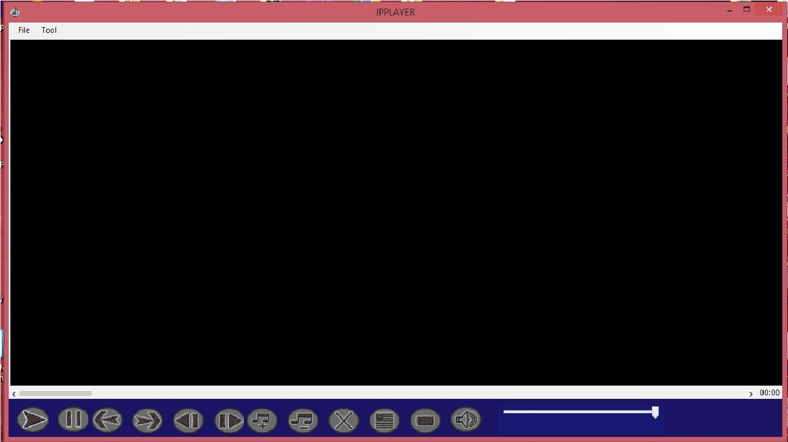FIG:1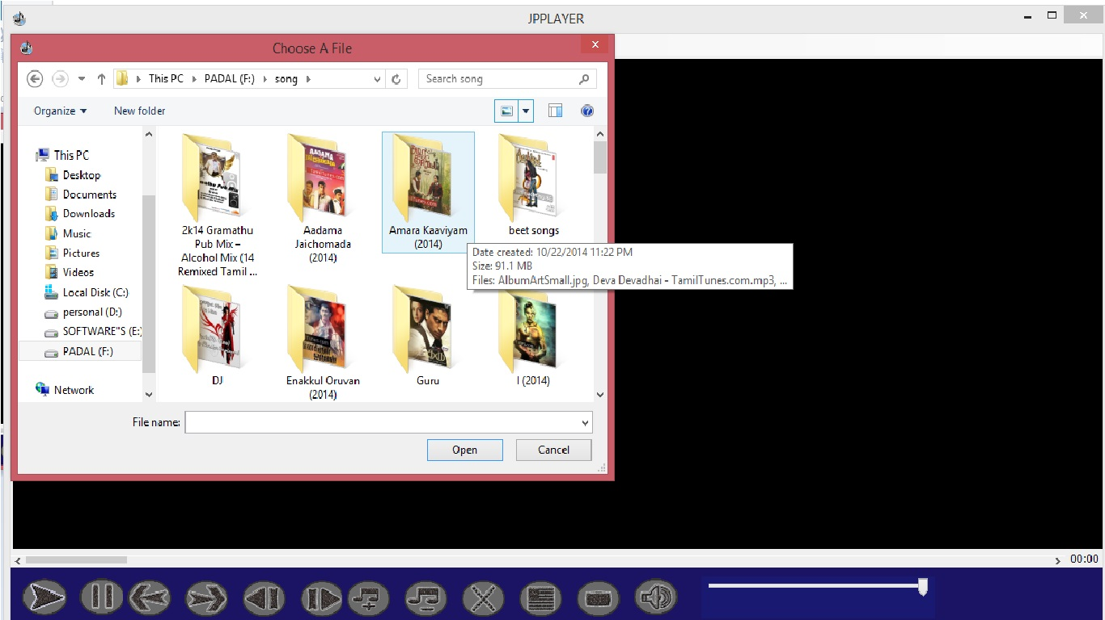

FIG:2

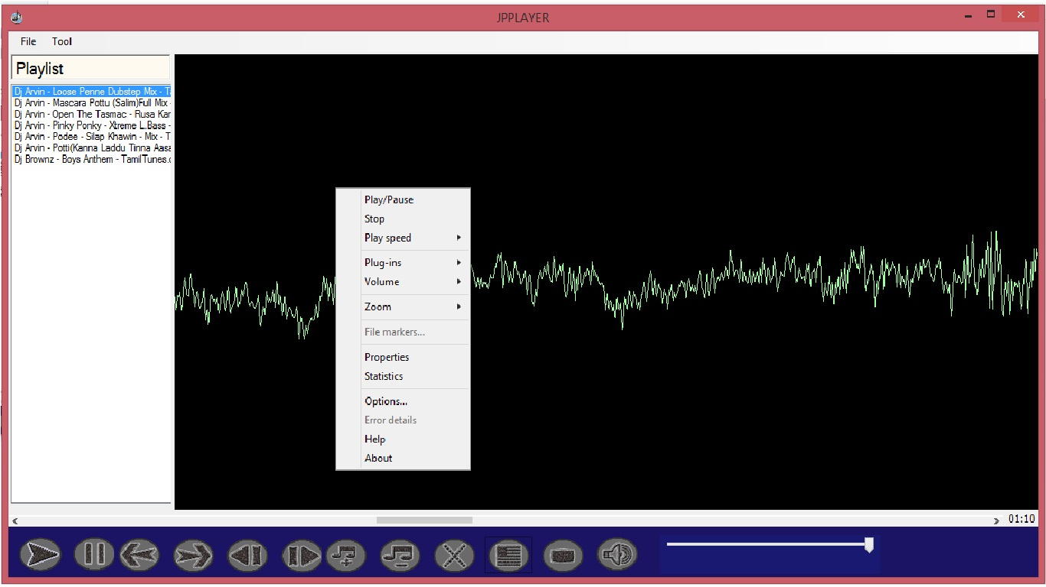

FIG:3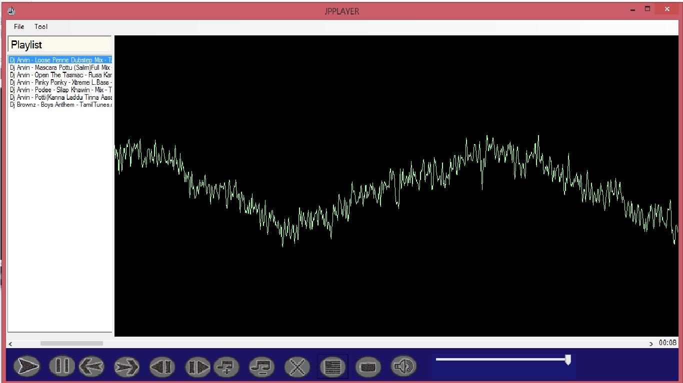

FIG:4

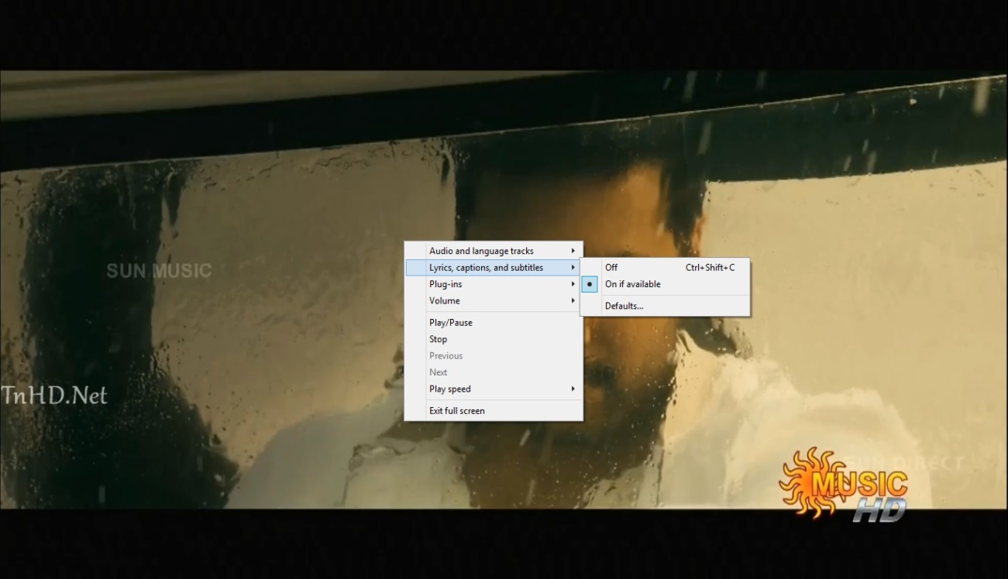

FIG:5

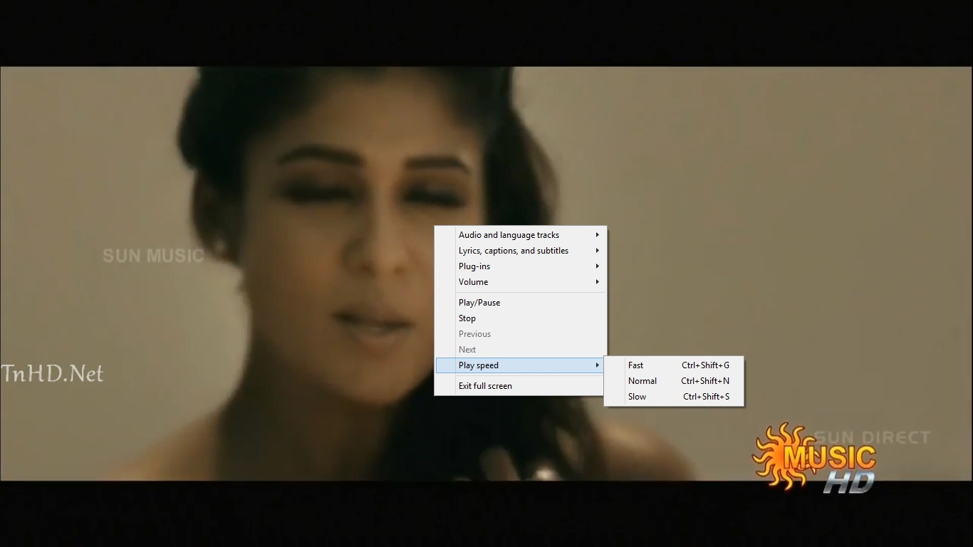FIG:6



FIG:7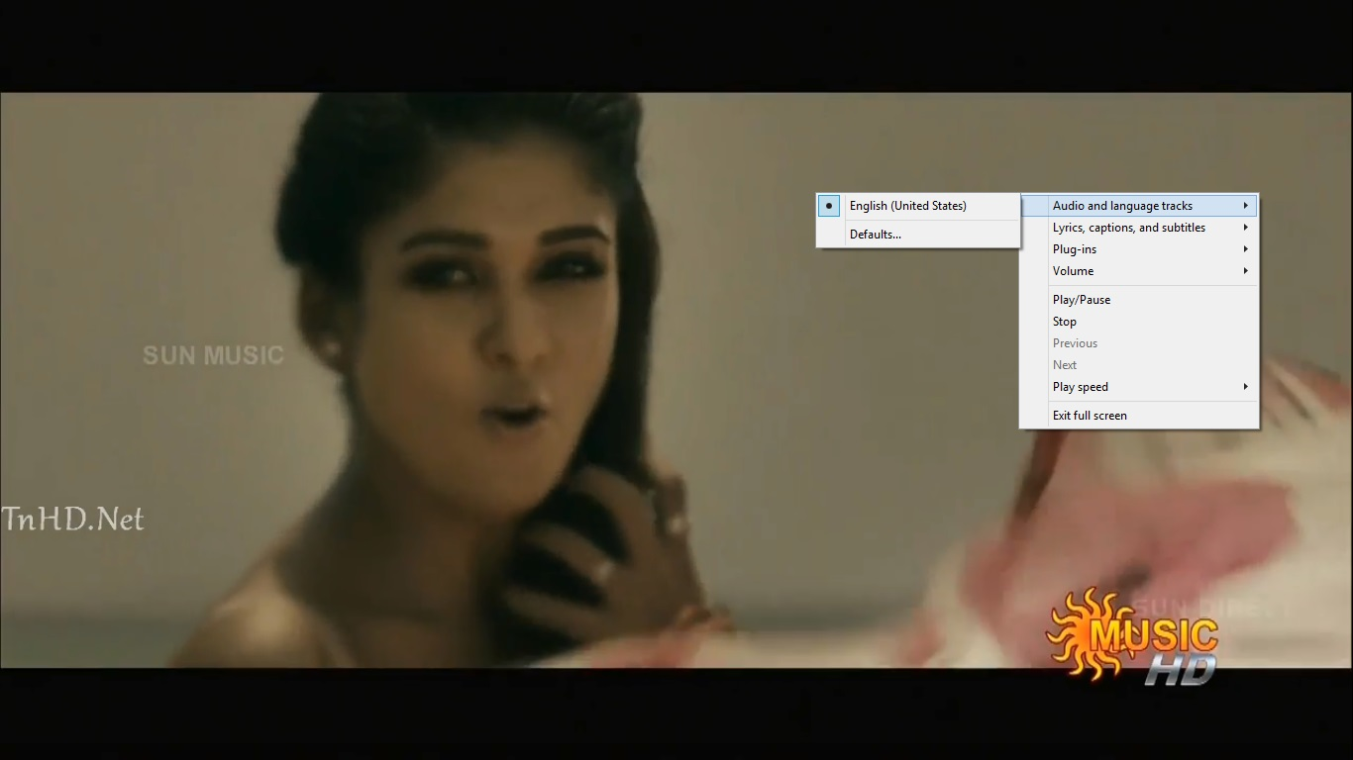FIG:8FIG:9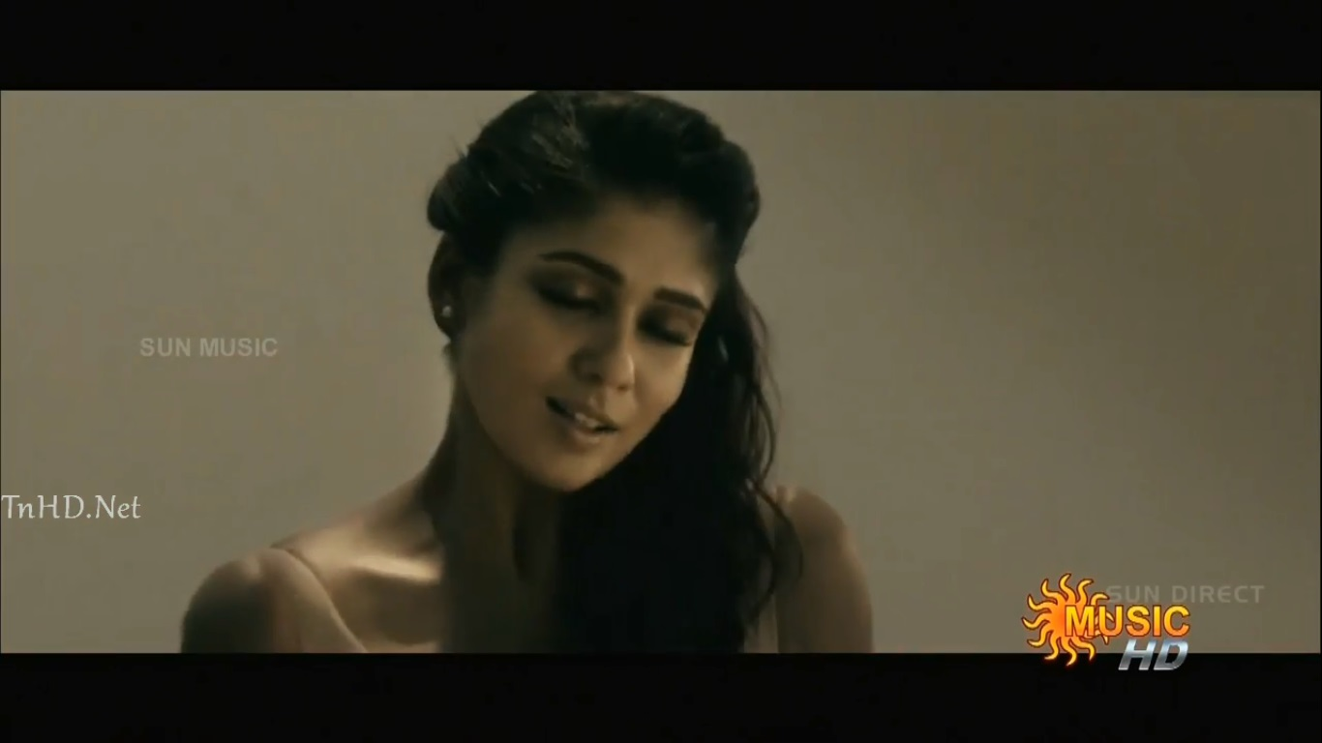

FIG:10

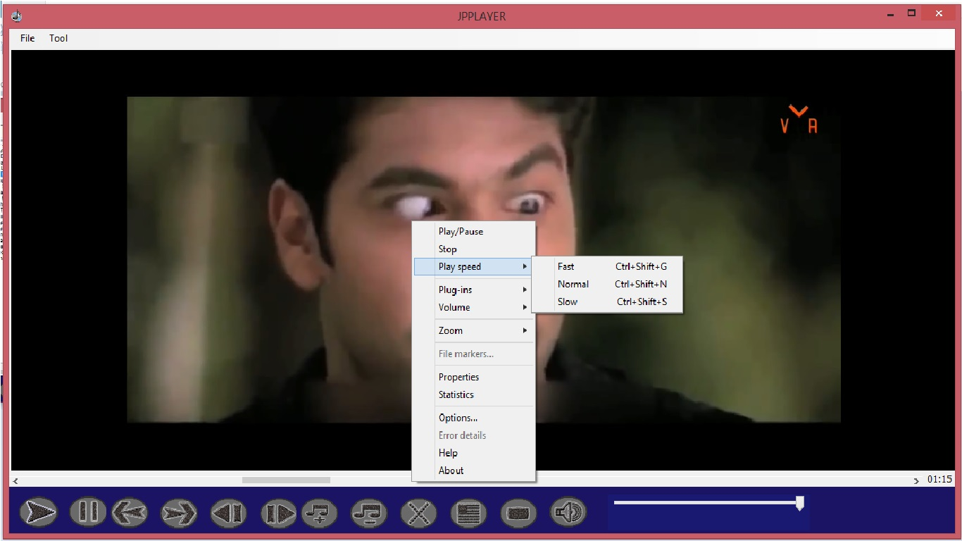

FIG:11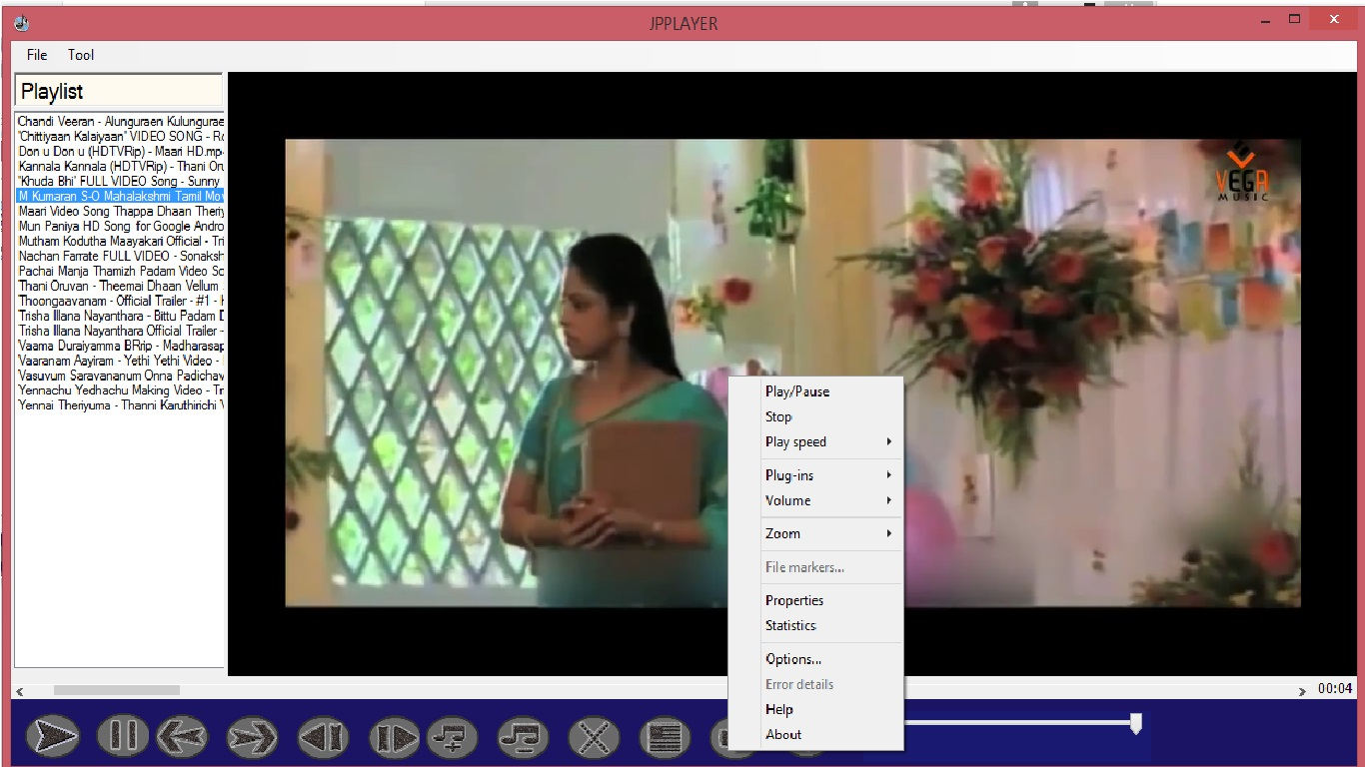

FIG:12

**5. SYSTEM DESCRIPTION**

**5.1 Limitations of the project**

   Not supports web based operations Multiprocessing not allowed. Extensive help is not provided. Not support in the OS lower than windows.

**5.2Advantages of Proposed system**

* It is very simple in nature & doesn’t provide much functionality, thus reducing complexity of the system.
* This media player will play the different typed of video audio files as well as image.

**5.3 Disadvantages of existing system**

This Software will be run only in windows operating system. Any Person who use the windows OS they can be able to access this software.

**6. CONCLUSION**

JP player is a windows-based application that can be accessed from anywhere within an Operating System by the authorized users. The system would be centrally managed and controlled which is designed to run on the departmental server. Different control have been assigned to different features.

