# **E-Commerce Application on IBM Cloud Foundry**

**Definition:**

An e-commerce application on IBM Cloud Foundry refers to a digital platform designed to facilitate online buying and selling of products or services, hosted and operated using IBM's Cloud Foundry service. Cloud Foundry is a cloud computing platform that simplifies the deployment and management of web applications, providing a scalable and reliable infrastructure for hosting e-commerce solutions.

This e-commerce application typically includes a user-friendly front-end for customers to browse products, add items to their shopping cart, and make secure transactions. It also encompasses a back-end that manages inventory, order processing, and customer data. IBM Cloud Foundry's features ensure high availability, fault tolerance, and auto-scaling, enabling the application to handle fluctuating customer loads seamlessly.

**What is E-Commerce:**

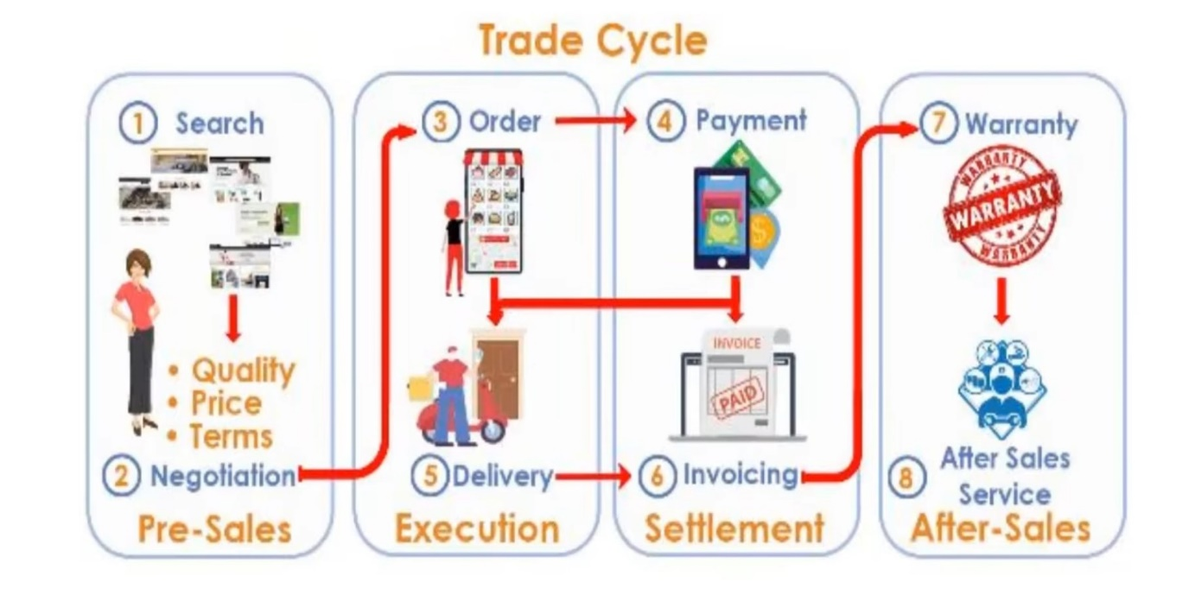

E-commerce, short for electronic commerce, refers to the buying and selling of goods and services over the internet. It involves a wide range of online transactions, including purchasing products from online stores, conducting online auctions, electronic banking, digital payments, and more. E-commerce has become a significant part of the global economy and has transformed the way businesses operate and consumers shop.

**Buying and Selling:**

Process of buying and selling of goods or services using an electronic medium such as Internet.



* Sale happens online.
* You can potentially sell

across the world.

* There is limited personal interaction.
* Delivery of goods and services

might take some time.

* It is available 24/7 and can be done day or night.

**Commerce is buying and selling of goods:**

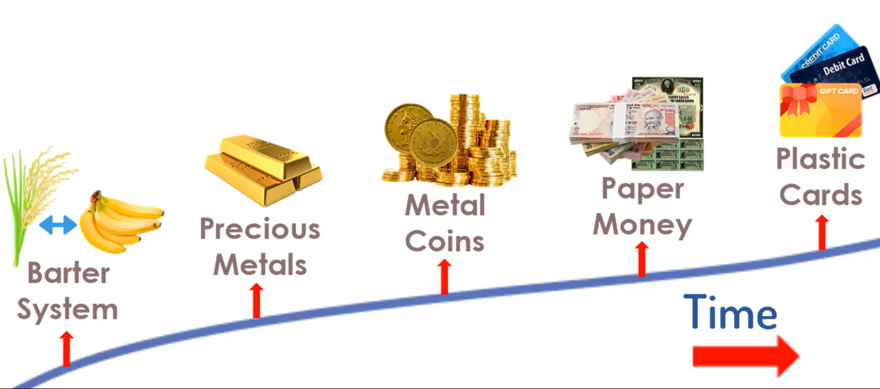

**The buying and selling process:**

The buying and selling process on an e-commerce website involves several steps to facilitate transactions between customers and businesses in the digital realm.

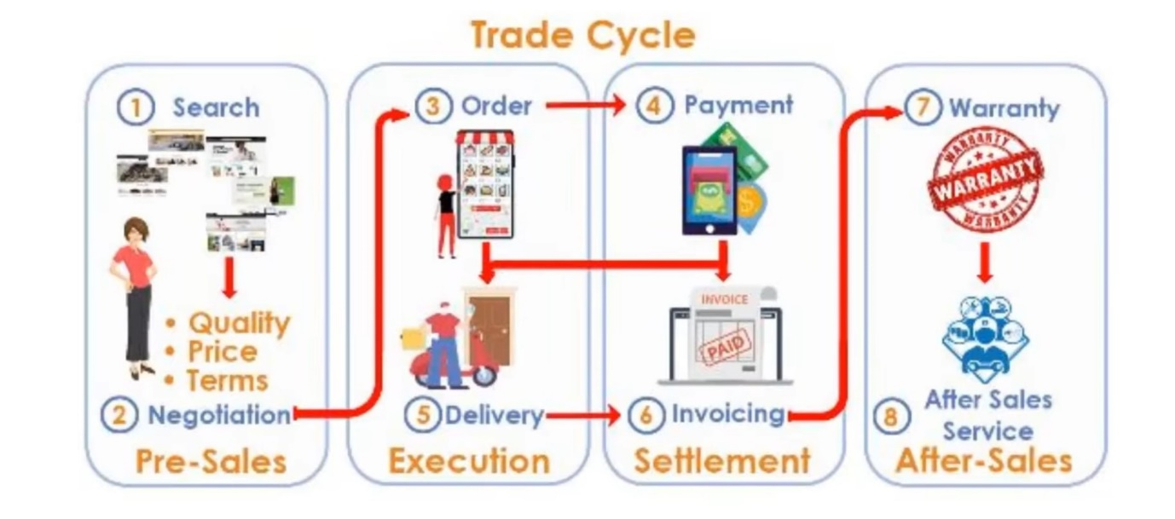

1. Browsing and Product Selection: Customers visit the e-commerce website, browse through product listings, and select items they want to purchase. They can filter and search for products based on their preferences.

2. Adding to Cart: After choosing products, customers add them to their virtual shopping cart, where they can review the selected items and make changes if needed.

3. Checkout: To proceed with the purchase, customers go to the checkout page. Here, they provide shipping and payment information, including billing details and shipping address.

4. Payment: Customers choose a payment method, such as credit card, digital wallets, or other online payment systems, and securely enter their payment details.

5. Order Confirmation: Once the payment is processed successfully, customers receive an order confirmation with details of their purchase, including an order number and estimated delivery date.

6. Fulfilment: The e-commerce business processes the order, including picking, packing, and preparing the product for shipping.

7. Shipping and Delivery: The chosen shipping method determines how the product reaches the customer. Customers can track their orders in real-time and receive updates.

8. Receiving the Product: When the product arrives, customers inspect it to ensure it meets their expectations.

***“THE ABOVE STEPS ARE GOING TO IMPLEMENT TO OUR OWN E-COMMERCE APPLICATION WEBSITE”***

**Conclusion:**

In conclusion, e-commerce applications are the backbone of modern online retail, enabling businesses to reach a vast global customer base while providing consumers with convenient, accessible, and secure shopping experiences. These websites facilitate the entire buying process, from product selection to payment and delivery, often enhancing customer satisfaction through personalized recommendations and user-friendly interfaces. E-commerce applications have not only transformed the retail landscape but have also diversified into various models, including B2C, B2B, C2C, and M-commerce. Their significance in the digital economy continues to grow, making them essential tools for businesses and consumers alike in the digital age.