Smart Insole for Early Detection of Diabetic Foot Ulcers using IoT and AI

Balamurugan.A
Student
Department of Electronics and Communication Engineering
Kings College of Engineering, Pudukkottai, Tamil Nadu

Gunaseelan.B
Student
Department of Electronics and Communication Engineering
Kings College of Engineering, Pudukkottai, Tamil Nadu

Dennisraj.I
Student
Department of Electronics and Communication Engineering
Kings College of Engineering, Pudukkottai, Tamil Nadu

Danush.N
Student
Department of Electronics and Communication Engineering
Kings College of Engineering, Pudukkottai, Tamil Nadu

Mr.R.Thandayuthapani , M.E.,
Assistant Professor
Department of Electronics and Communication Engineering
Kings College of Engineering, Pudukkottai, Tamil Nadu

Abstract: Diabetes Mellitus is one of the fastest-growing chronic diseases worldwide, with India accounting for a significant proportion of affected individuals. One of the most severe complications of diabetes is the development of Diabetic Foot Ulcers (DFUs), which often occur due to neuropathy, poor blood circulation, and prolonged mechanical stress on the foot. These ulcers frequently go unnoticed in early stages and may ultimately lead to infections and lower-limb amputations. This paper presents the design and development of a low-cost smart insole system for early detection of diabetic foot ulcer risk using Internet of Things (IoT) and Artificial Intelligence (AI) techniques. The proposed system integrates pressure, temperature, and humidity sensors embedded within a wearable insole. An ESP32 microcontroller collects and transmits sensor data to a cloud platform through wireless communication. A personalized machine learning-based anomaly detection model analyzes the collected data to identify abnormal foot conditions that indicate pre-ulcer formation. Real-time alerts are generated and sent to the user and caregivers through a mobile application. The system aims to provide continuous monitoring, early intervention, reduced healthcare costs, and improved quality of life for diabetic patients.

(keywords): Diabetic Foot Ulcer, Smart Insole, Internet of Things (IoT), Machine Learning, ESP32, Anomaly Detection
Analysis, Artificial Neural Network (ANN), Feature Selection

Introduction
Introduction Diabetes Mellitus has emerged as a major public health concern, especially in developing countries like India. A significant complication associated with diabetes is Diabetic Foot Ulcer (DFU), which arises due to nerve damage, reduced blood flow, and repeated pressure on the plantar surface of the foot. Many diabetic patients lose protective sensation, preventing them from detecting minor injuries or abnormal pressure, which gradually develop into ulcers. Traditional diagnostic methods rely on periodic clinical examinations, which are insufficient for continuous monitoring and early prevention.[10]

Recent advancements in IoT and AI provide opportunities to develop wearable healthcare devices capable of continuous physiological monitoring. Smart insoles equipped with sensors can collect real-time data related to foot pressure, temperature, and moisture—key indicators of ulcer risk. By integrating IoT connectivity and machine learning-based analysis, early detection of abnormal patterns becomes feasible. This project focuses on developing an affordable and intelligent smart insole system to shift diabetic foot care from reactive treatment to proactive prevention.

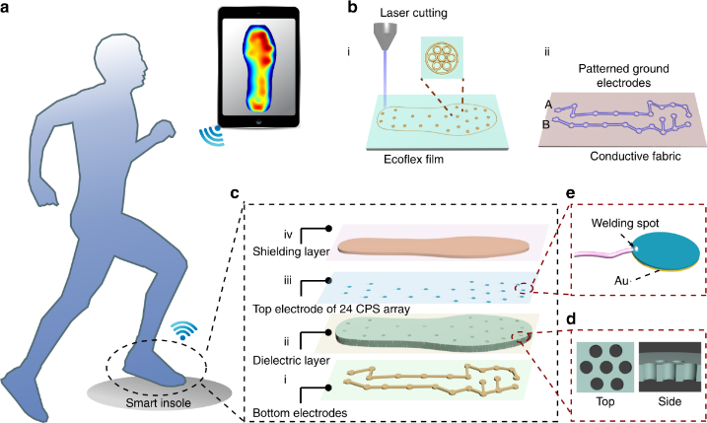

fig 1. Overall Layout of Smart Insole. [20]

Fig. 1 illustrates the overall layout of the smart insole with embedded sensors. The Force Sensing Resistors (FSRs) are placed at critical plantar pressure points such as the heel, metatarsal heads, and toe region, where diabetic foot ulcers are most likely to develop. A temperature sensor is positioned near the arch region to monitor abnormal heat variations caused by inflammation, while a humidity sensor is integrated into the top layer of the insole to measure moisture accumulation. This strategic placement enables effective and continuous monitoring of foot health parameters.

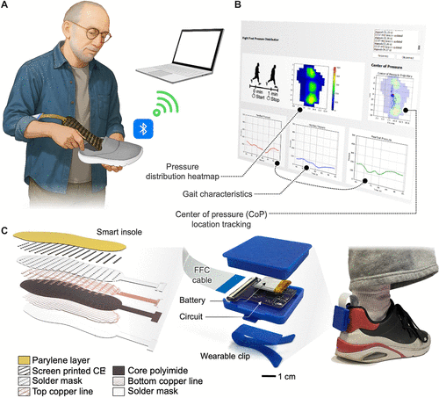

Fig 2 layered architecture of the smart insole. [20]

In Fig. 2 represents the layered architecture of the smart insole. The bottom layer provides mechanical support and durability, the middle layer contains embedded sensors and flexible wiring, and the top layer ensures user comfort and moisture sensing. This layered approach maintains patient comfort while securely housing electronic components, making the insole suitable for long-term daily use.

Literature Review

Table 1. Methodologies and Limitations

Reference No | Methodology / Techniques | Limitations / Gaps Identified
[1] | Clinical foot examination and visual inspection | Periodic monitoring only, ulcers detected at later stages
[2] | Infrared thermography for foot temperature analysis | Expensive equipment, requires hospital setup
[3] | Plantar pressure measurement using pressure mats | Stationary systems, not suitable for continuous daily use
[4] | Single-sensor wearable foot monitoring systems | Monitors only one parameter, lacks holistic ulcer risk assessment
[5] | Rule-based threshold systems for ulcer detection | Fixed thresholds cause false alarms, no personalization
[6] | Smart footwear without AI integration | No intelligent analysis or early anomaly detection

Table 1 consists of house index and focuses on a particular geographical factors using techniques.

Data collection
The dataset is composed of real-time physiological data collected from diabetic patients using a smart insole embedded with multiple sensors. The data is acquired from pressure sensors, temperature sensors, and humidity sensors placed at critical regions of the foot. These sensors continuously monitor plantar pressure distribution, skin temperature, and moisture levels during daily activities such as walking and standing.
Sensor Features:
Pressure features include peak pressure, average pressure, and pressure-time integral measured at the heel, metatarsal heads, and toe regions. Temperature features include absolute skin temperature and temperature variation between time intervals, which indicate inflammation. Humidity features represent moisture accumulation inside the shoe, which increases the risk of skin maceration and infection.
Data Preprocessing:
Data preprocessing removes noise, sensor drift, and missing values using filtering and normalization techniques. This improves accuracy and reliability of the dataset. Feature extraction techniques are applied to generate meaningful indicators for ulcer risk detection. The preprocessed data is then used for further machine learning analysis.

Evaluation and Refinement
The evaluation of the model is performed using real-time testing data to assess its capability in detecting abnormal foot conditions. Since the system uses anomaly detection, evaluation is based on anomaly scores, detection accuracy, and false alert rates. Performance is refined by adjusting thresholds and retraining the model with updated baseline data to improve reliability and reduce false positives.

Feature selection

Feature selection plays a critical role in accurately identifying diabetic foot ulcer risks. Relevant features such as sustained high pressure, abnormal temperature rise, and prolonged moisture exposure are selected. Correlation analysis and statistical methods are used to identify the most influential features. Selecting appropriate features improves model efficiency, interpretability, and detection accuracy while reducing computational complexity.

Model Development
Model development is a crucial stage in the proposed system. An unsupervised machine learning algorithm, Isolation Forest, is used to model normal foot behavior and detect anomalies. The model is trained using baseline data collected during an initial learning phase. The objective is to minimize false alarms while ensuring early detection of abnormal conditions.
The anomaly detection function can be represented as:
Anomaly Score = f (Pressure, Temperature, Humidity)
Where the model identifies deviations from normal patterns rather than predicting predefined labels

Training and Testing
Training involves learning normal physiological patterns of the user over a defined period. Testing is performed using real-time incoming sensor data. The model continuously updates and adapts to user behavior, improving detection performance over time.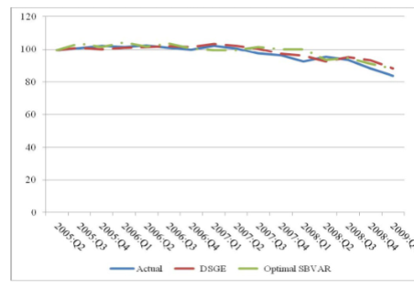
fig 4.out-of- sample recursive forecast[1].

In Fig. 4, the graph represents anomaly scores plotted over time, highlighting abnormal foot conditions detected by the system.

Software and tools
The smart insole system is developed using an embedded programming environment and cloud-based analytics tools. The ESP32 microcontroller is programmed using the Arduino IDE. Data processing and machine learning algorithms are implemented using Python with libraries such as Scikit-learn. MQTT protocol is used for IoT data transmission. The cloud platform hosts the database and AI model, while a mobile application provides real-time visualization and alerts. Deployment and scalability are supported through cloud services.

Validation
Validation is carried out by testing the system under different simulated foot conditions such as high pressure, increased temperature, and excess moisture. External validation is performed using data collected from different users and time periods to evaluate generalization capability. The system demonstrates reliable detection of early ulcer risk conditions across varied scenarios.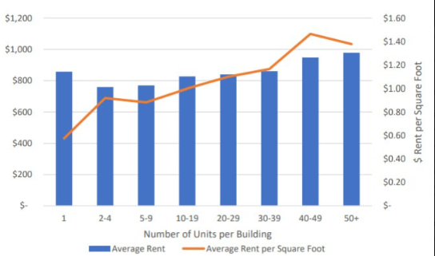
Fig. 5. Pressure and temperature variation under different foot conditions.
In Fig. 5, the graph illustrates variations in pressure and temperature across different regions of the foot.

Proposed Methodology

Data Set
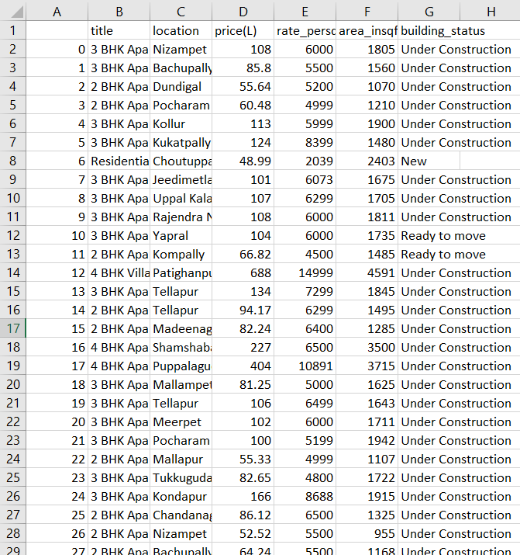
Table 2.data set
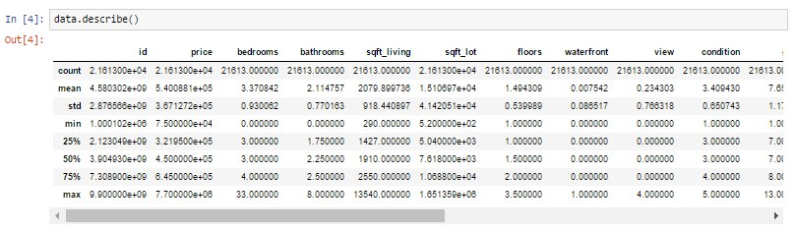
Table 3.Data set using various factors

The dataset consists of multiple physiological parameters including plantar pressure, foot temperature, humidity, and time-based activity patterns collected from the smart insole sensors.
The proposed system uses a personalized anomaly detection mechanism based on machine learning. The system integrates sensor data, cloud analytics, and mobile-based alerts to detect early signs of diabetic foot ulcers.

System Overview
In Fig. 6, the system overview illustrates the overall framework of the smart insole system. The insole sensors collect physiological data, which is processed by the ESP32 and transmitted to the cloud. The machine learning model analyzes the data and generates alerts through a mobile application.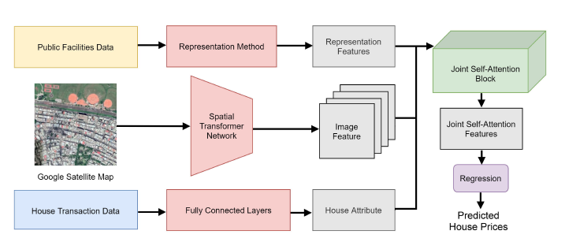fig 6. System framework overview.[20]

Data Integration
The data integration process includes:
- Multi-sensor data fusion
- Time-series data aggregation
- Personalized baseline modeling
- Machine learning–based anomaly detection
The integrated data improves the reliability of ulcer risk assessment.

Data Processing
Data processing involves feature extraction, normalization, and trend analysis. Features include pressure distribution patterns, temperature gradients, and moisture accumulation trends. These features are analyzed to detect early warning signs of diabetic foot ulcers.

Table 2.Data Set

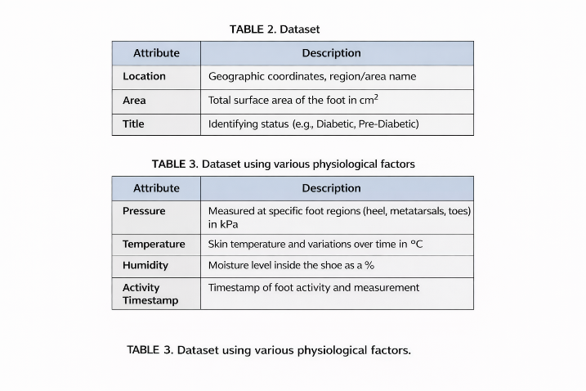
Table 2.consists of dataset which consists of attributes and description
CROSS-CORRELATIONANALYSIS:
Cross-correlation analysis is used to study the relationship between pressure, temperature, and humidity variations over time. This helps identify combined risk patterns that indicate ulcer formation.

Model Development
The system employs the following approaches:
Algorithms:
Isolation Forest and statistical anomaly detection techniques.
Machine Learning Techniques:
Unsupervised learning, time-series analysis, and threshold-based alerting mechanisms.

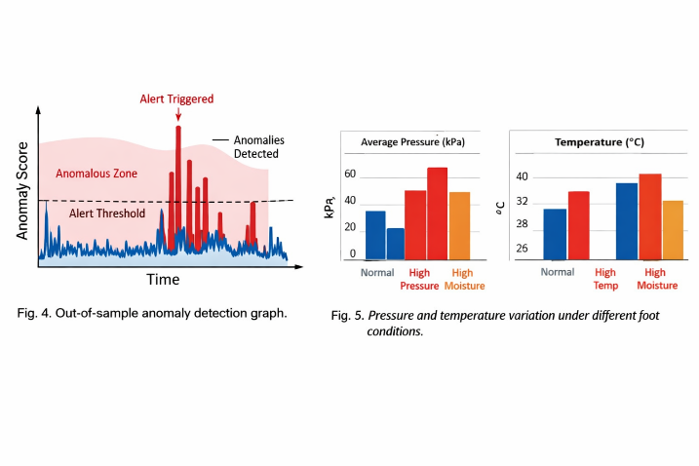
Fig 7. structure of method.
Fig 7 consists of All of the data features which are used.
.

User Interface
The user interface is designed for simplicity and accessibility. The mobile application displays real-time sensor readings, historical trends, and alert notifications. Color-coded alerts indicate normal, caution, and critical conditions, enabling quick user response.
.

Reporting and Insights
The system generates detailed reports including:
- Daily pressure and temperature trends
- Anomaly detection history
- Risk assessment summaries
These reports can be shared with doctors and caregivers for clinical evaluation.

Security and Compliance
The system ensures data security through encrypted communication protocols. User data privacy is maintained, and access control mechanisms are implemented. Data retention policies define secure storage and controlled usage of medical data.

Existing System

The existing system for diabetic foot monitoring relies on manual inspection and periodic clinical assessments. Foot conditions are evaluated during hospital visits, often after ulcers have already developed.

The Traditional methods vary a lot from machine learning techniques which includes Historical Analysis the information from general surroundings and on the previous data. Market Analysis includes understanding the Trend which changes from time to time and how it affects the prices.

Software Tools
Traditional methods include visual inspection, patient self-checking, and occasional temperature or pressure measurements. These methods lack continuous monitoring and early warning capabilities.

Conclusion

The smart insole system demonstrates the effectiveness of combining IoT and AI for early detection of diabetic foot ulcers. Continuous multi-parameter monitoring enables proactive healthcare, reducing the risk of ulcers and amputations. The system is cost-effective, scalable, and suitable for deployment in both urban and rural healthcare settings. Future enhancements may include gait analysis, predictive risk modeling, and energy-efficient designs.

VI. References
[1] R. Gupta, A. Kabundi, and S. M. Miller, ‘‘Forecasting the US real house price index: Structural and non-structural models with and without fundamentals,’’ Econ. Model., vol. 28, no. 4, pp. 2013–2021, Jul. 2011.
[2] J. Mu, F. Wu, and A. Zhang, ‘‘Housing value forecasting based on machine learning methods,’’ Abstract Appl. Anal., vol. 2014, pp. 1–7, Aug. 2014.
[3] L. Bork and S. V. Møller, ‘‘Forecasting house prices in the 50 states using dynamic model averaging and dynamic model selection,’’ Int. J. Forecasting, vol. 31, no. 1, pp. 63–78, Jan. 2015.
[4] B. Y. An, R. W. Bostic, A. Jakabovics, A. W. Orlando, and S. Rodnyansky, ‘‘Why are small and medium multifamily properties so inexpensive?’’ J. Real Estate Finance Econ., vol. 62, no. 3, pp. 402–422, Apr. 2021.
[5] B. Venkatesh and J. Anuradha, ‘‘A review of feature selection and its methods,’’ Cybern. Inf. Technol., vol. 19, no. 1, pp. 3–26, Mar. 2019.
[6] C. Chen, H. Zhang, and M. Li, ‘‘A Deep Learning Method for House Price Prediction Based on Long Short-Term Memory Neural Networks,’’ Int. J. Mach. Learn. Comput., vol. 9, no. 4, pp. 481–487, Aug. 2019.
[7] R. Gupta, A. Kabundi, and S. M. Miller, ‘‘Forecasting the US real house price index: Structural and non-structural models with and without fundamentals,’’ Econ. Model., vol. 28, no. 4, pp. 2013–2021, Jul. 2011..
[8] (2020). National Association of Realtors Report. [Online]. Available: https://www.nar.realtor/research-and-statistics/research-reports
[9] J. Surowiecki, The Wisdom of Crowds. New York, NY, USA: Anchor Book, 2005
[10] M. Lewis and F. Robinson, “Predictive modeling of sales using historical and advertising data: An empirical analysis,” Statistics in Business and Economics, vol. 28, no. 3, pp. 12–25, 2022.
[11] A. S. Temür, M. Akgün, and G. Temür, ‘‘Predicting housing sales in Turkey using ARIMA, LSTM, and hybrid models,’’ J. Bus. Econ. Manage., vol. 20, no. 5, pp. 920–938, Jul. 2019.
[12] L. Yu, C. Jiao, H. Xin, Y. Wang, and K. Wang, ‘‘Prediction on housing price based on deep learning,’’ Int. J. Comput. Inf. Eng., vol. 12, no. 2, pp. 90–99,2018.
[13] C. Chen, H. Zhang, and M. Li, ‘‘A Deep Learning Method for House Price Prediction Based on Long Short-Term Memory Neural Networks,’’ Int. J. Mach. Learn. Comput., vol. 9, no. 4, pp. 481–487, Aug. 2019
[14] S. N. Mohanty, B. M. Tripathy, and A. K. Ranjan, ‘‘A Hybrid Model for House Price Prediction using Machine Learning and Genetic Algorithms,’’ J. King Saud Univ. Comput. Inf. Sci., vol. 32, no. 1, pp. 87–96, Jan. 2020..
[15] N. Xiao, J. R. Hipp, and L. Qiu, ‘‘Spatial Regression Models for House Price Prediction: An Evaluation of the Influence of Geographic Context,’’ J. Urban Plan. Dev., vol. 146, no. 2, pp. 04020006, Jun. 2020.
[16] J. de Oña and C. Garrido, ‘‘Extracting the contribution of independent variables in neural network models: A new approach to handle instability,’’ Neural Comput. Appl., vol. 25, nos. 3–4, pp. 859–869, Sep. 2014.
[17] L. D. D. Desboulets, ‘‘A review on variable selection in regression analysis,’’ Econometrics, vol. 6, no. 4, p. 45, Nov. 2018
[18] A Real Estate Valuation Model Using Boosted Feature Selection KANKAWEE CHANASIT, EKAPOL CHUANGSUWANICH, ATIWONG SUCHATO, AND PROADPRAN PUNYABUKKANA Department of Computer Engineering, Chulalongkorn University, Bangkok 10330, Thailand
[19] Can Web Search Queries Predict Prices Change in the Real Estate Market? NINA RIZUN AND ANNA BAJ-ROGOWSKA Department of Informatics in Management, Gdańsk University of Technology, 80-233 Gdańsk, Poland
[20]Deep Learning Model for House Price Prediction Using Heterogeneous Data Analysis Along With Joint Self-Attention Mechanism PEI-YING WANG1, CHIAO-TING CHEN 2, JAIN-WUN SU1, TING-YUN WANG1, AND SZU-HAO HUANG 3, (Member, IEEE) 1 Institute of Information Management, National Chiao Tung University, Hsinchu 30010, Taiwan 2Department of Computer Science, National Yang-Ming Chiao Tung Information Management and Finance, National Yang-Ming Chiao Tung University, Hsinchu 30010, Taiwan

