­­­­­ 

A Minor Project Report

On

FUEL CONSUMPTION PROGNOSIS

Submitted in partial fulfillment of requirements for the award of the Degree of

## BACHELOR OF ENGINEERING

in

## COMPUTER SCIENCE AND ENGINEERING

Under the guidance of

## Mr. V. MANI M.E.,

**Assistant Professor - CSE**

Submitted By

## AJAY M (927621BCS006) GOKULMANI S (927621BCS034) GOKULA KRISHNAN R (927621BCS035) JAYAPRASATH K (927621BCS043)

**DEPARTMENT OF COMPUTER SCIENCE AND ENGINEERING**

**M. KUMARASAMY COLLEGE OF ENGINEERING**

(Autonomous)

## KARUR – 639 113

**November 2023**

 

# M. KUMARASAMY COLLEGE OF ENGINEERING

**(Autonomous Institution affiliated to Anna University, Chennai)**

# KARUR–639113

**BONAFIDE CERTIFICATE**

Certified that this minor project report **“FUEL CONSUMPTION PROGNOSIS”** is the bonafide work of **“AJAY M (927621BCS006), GOKULMANI S (927621BCS034), GOKULA KRISHNAN R (927621BCS035), JAYAPRASATH K (927621BCS043)”** who carried out the project work during the academic year 2023- 2024 under my supervision.

Signature Signature

**Mr. V. MANI M.E., Dr. M. MURUGESAN M.E., Ph.D.,**

## SUPERVISOR, HEAD OF THE DEPARTMENT,

Department of Computer Science and Engineering,

M.Kumarasamy College of Engineering, Thalavapalayam, Karur - 639 113.

Department of Computer Science and Engineering,

M.Kumarasamy College of Engineering, Thalavapalayam, Karur - 639 113.

 

## DEPARTMENT OF COMPUTERSCIENCE AND ENGINEERING VISION OF THE INSTITUTION

* To emerge as a leader among the top institutions in the field of technical education.

## MISSION OF THE INSTITUTION

 Produce smart technocrats with empirical knowledge who can surmount the global challenges.

Create a diverse, fully-engaged, learner-centric campus environment to provide quality education to the students.

 Maintain mutually beneficial partner ships with our alumni, industry, and professional associations.

## VISION OF THE DEPARTMENT

*To achieve education and research excellence in Computer Science and Engineering.

## MISSION OF THE DEPARTMENT

To excel in academic through effective teaching-learning techniques. To promote research in the area of computer science and engineering with a focus on innovation

To transform students into technically competent professionals with societal and ethical responsibilities.

## PROGRAM EDUCATIONAL OBJECTIVES(PEOs)

**PEO1:** Graduates will have successful career in software industries and R&D divisions through continuous learning.

**PEO2:** Graduates will provide effective solutions for real world problems in the key domain of computer science and engineering and engage in lifelong learning.

**PEO3:** Graduates will excel in their profession by being ethically and socially responsible.

 

## PROGRAM OUTCOMES(POs)

**Engineering students will be able to:**

1. **Engineering knowledge:** Apply the knowledge of mathematics, science, engineering fundamentals, and an engineering specialization to the solution of complex engineering problems
2. **Problem analysis:** Identity, formulate, review research literature, and analyze complex engineering problem searching substantiated conclusions using first principles of mathematic, natural sciences, and engineering sciences.
3. **Design/development of solutions:** Design solutions for complex engineering problems and design system components or processes that meet the specified needs with appropriate consideration for the public health and safety, and the cultural, societal, and environmental considerations.
4. **Conduct investigations of complex problems:** Use research-based knowledge and research methods including design of experiments, analysis and interpretation of data, and synthesis of the information to provide valid conclusions.
5. **Modern tool usage:** Create, select, and apply appropriate techniques, resources, and modern engineering and IT tools including prediction and modeling to complex engineering activities with an understanding of the limitations.
6. **The engineer and society:** Apply reasoning informed by the contextual knowledge to assess societal, health, safety, legal and cultural issues and the consequent responsibilities relevant to the professional engineering practice.
7. **Environment and sustainability:** Understand the impact of the professional engineering solutions in societal and environmental contexts, and demonstrate the knowledge of, and need for sustainable development.
8. **Ethics:** Apply ethical principles and commit to professional ethics and responsibilities and norms of the engineering practice.
9. **Individual and team work:** Function effectively as an individual, and as a member or leader in diverse teams, and in multidisciplinary settings.
10. **Communication:** Communicate effectively on complex engineering activities with the engineering community and with society at large, such as, being able to comprehend and write effective reports and design documentation, make effective presentations, and give and receive clear instructions.
11. **Project management and finance:** Demonstrate knowledge and understanding of the engineering and management principles and apply these to one’s own work, as a member and leader in team, to manage projects and in multidisciplinary environments.
12. **Life-long learning:** Recognize the need for, and have the preparation and ability to engage in independent and life-long learning in the broadest context of technological change.

**PROGRAM SPECIFIC OUTCOMES(PSOs)**

**PSO1: Professional Skills:** Ability to apply the knowledge of computing techniques to design and develop computerized solutions for the problems.

**PSO2: Successful career:** Ability to utilize the computing skills and ethical values in creating a successful career.

# ABSTRACT

In this Fuel Consumption Prognosis, Predicting fuel consumption is crucial for optimizing energy efficiency, reducing costs, and minimizing environmental impact in various industries, including transportation, logistics, and energy management. In this project, we employ machine learning techniques to develop a predictive model for fuel consumption. By analyzing historical data containing relevant features such as vehicle type, driving conditions, weather, and load, we aim to create an accurate model that forecasts fuel consumption. Fuel consumption diagnosis would provide a concise overview of a system or method designed to analyze and assess fuel consumption patterns in vehicles. It could touch upon key aspects such as data collection, analysis techniques, and potential applications.

 

## ABSTRACT WITH POs AND PSOs MAPPING

|  |  |  |
| --- | --- | --- |
| **ABSTRACT** | **POs MAPPED** | **PSOs MAPPED** |
| Predicting fuel consumption is crucial for optimizing energy efficiency, reducing costs, and minimizing environmental impact in various industries, including transportation, logistics, and energy management. In this project, we employ machine learning techniques to develop a predictive model for fuel consumption. By analyzing historical data containing relevant features such as vehicle type, driving conditions, weather, and load, we aim to create an accurate model that forecasts fuel consumption. Fuel consumption diagnosis would provide a concise overview of a system or method designed to analyze and assess fuel consumption patterns in vehicles. It could touch upon key aspects such as data collection, analysis techniques, and potential applications. | **PO1(3)**  **PO2(3)**  **PO3(2)**  **PO5(2)**  **PO7(3)**  **PO9(3)**  **PO8(3)**  **PO10(3) PO12(2)** | **PSO1(3) PSO2(2)** |

Note:1-Low,2-Medium,3-High

**SUPERVISOR HEAD OF THE DEPARTMENT**

**TABLE OF CONTENTS**

|  |  |  |
| --- | --- | --- |
| **CHAPTER**  **No.** | **TITLE** | **PAGE**  **No.** |
| **1** | **Abstract**  **List of Figures**  **Acronyms/List of Abbreviations Introduction** | **Vi**  **ix**  **x**  **1** |
|  | 1.1 Overview | 2 |
|  | 1.2 Domain Introduction | 2 |
|  | 1.3 Objective | 3 |
|  | 1.4 Problem Statement | 3 |
| **2** | **Literature Survey** | **4** |
| **3** | **Feasibility report** | **5** |
|  | 3.1 Economic Feasibility | 5 |
|  | 3.2 Technical Feasibility | 6 |
|  | 3.3 Operational Feasibility  **Project Methodology**   * 1. 4.1 Block Diagram of FCP   2. 4.2 Module Description   **Result and discussion** | 6 |
| **4**  **5** | k  **7**  7  8  **9** |
| **6** | **Conclusion** | **12** |
|  | **References** | **13** |

**LIST OF FIGURES**

|  |  |  |
| --- | --- | --- |
| **FIGURE No.** | **TITLE** | **PAGE No.** |
| 1.1 | Fuel Consumption Prognosis | 1 |
| 3.1 | Feasibility Study for Fuel Consumption Prognosis | 5 |
| 4.1 | Block Diagram of FCP | 7 |
| 5 | Output screenshots | 9 |
| 5.1 | Vehicle Factors | 9 |
| 5.2 | Prediction Result | 10 |
| 5.3 | Cylinder vs Consumption | 11 |

## LIST OF ACRONYMS/ABBREVIATIONS

**FCP -** Fuel Consumption Prognosis

**HTML -** Hyper Text Markup Language

**CSS -** Cascading Style Sheet

**VTT -** Virtual Tele Training

## CHAPTER 1 INTRODUCTION

This code represents a machine learning project that predicts fuel consumption (in L/100km) based on various vehicle attributes. The goal is to assist users in estimating fuel efficiency for different types of vehicles. The project utilizes a trained machine learning model (logistic regression) and a dataset containing information about vehicle attributes such as class, engine size, cylinders, transmission type, CO2 rating, and fuel type. The Streamlit framework is employed to create an interactive web application where users can input vehicle details and obtain a prediction of fuel consumption. The application allows users to choose the vehicle class, engine size, number of cylinders, transmission type, CO2 rating, and fuel type. Upon clicking the prediction button, the machine learning model processes the inputs and provides an estimated fuel consumption in L/100km.

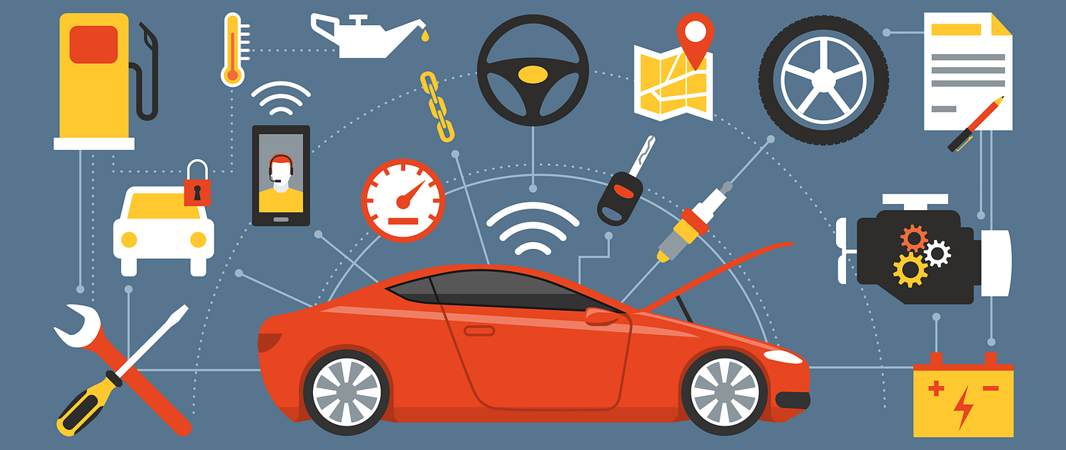

**Figure: 1.1 Fuel Consumption Prognosis**

## 

## 1.1 OVERVIEW

The fuel consumption prediction project revolves around the core aim of predicting fuel consumption in liters per 100 kilometers (L/100km) through the utilization of machine learning. The code integrates a pre-trained logistic regression model, which forms the predictive engine. To interact with users and provide an intuitive interface, the project employs Streamlit, a web application framework. The user interface allows individuals to input specific details about a vehicle, including its class, engine size, number of cylinders, transmission type, CO2 rating, and fuel type. These inputs are then processed using a dedicated function, converting the user-provided attributes into a suitable format for the model. The essence of the project lies in the prediction function, which utilizes the trained model to estimate fuel consumption based on the given vehicle characteristics. Users can trigger the prediction with a simple click, providing a convenient way to estimate fuel efficiency for different vehicles. The project effectively combines machine learning and a user-friendly interface to assist users in making informed decisions regarding fuel consumption for various types of vehicles. The fuel consumption prediction project embodies a practical application of machine learning, aiming to estimate fuel usage in liters per 100 kilometers (L/100km). At its core, the project leverages a pre-trained logistic regression model, finely tuned to predict fuel consumption accurately. For a seamless user experience, the developers chose Streamlit, a versatile and user-friendly web application framework. Through Streamlit's interface, users can input crucial vehicle attributes such as its class, engine size, cylinders, transmission type, CO2 rating, and fuel type.

## 1. 2 DOMAIN INTRODUCTION

In a world increasingly focused on sustainability and efficiency, predicting fuel consumption is a crucial endeavor. Machine learning, a powerful tool within the realm of artificial intelligence, plays a significant role in achieving this objective. The domain of fuel consumption prediction revolves around utilizing historical and real-time data related to vehicles and their attributes to build predictive models. These models, often employing algorithms like linear regression or decision trees, learn patterns from the data and can forecast fuel consumption for a given vehicle based on parameters such as engine size, weight, fuel type, and driving conditions. Machine learning models are trained on extensive datasets, enabling them to make predictions with varying degrees of accuracy. The goal is to provide vehicle owners, manufacturers, policymakers, and consumers with valuable insights into fuel efficiency.

**PYTHON STANDARDS**

Predicting fuel consumption through machine learning is a compelling domain that intersects artificial intelligence, automotive engineering, and sustainability. At its core, this domain seeks to harness the power of data and advanced algorithms to forecast how efficiently a vehicle utilizes fuel based on various parameters.

Machine learning models within this domain are designed to analyze and interpret intricate relationships between numerous factors. These factors may include the vehicle's make, model, weight, engine size, transmission type, driving conditions, and more. By processing historical and real-time data, these models can learn patterns and behaviours, ultimately predicting fuel consumption for specific vehicles under specific circumstances.

## 1.3 OBJECTIVE

In the domain of fuel consumption prediction, the primary objective is to develop accurate machine learning models that can reliably estimate fuel consumption for vehicles based on a multitude of parameters. Achieving precision in these predictions is vital to assist vehicle owners and industry stakeholders in optimizing fuel usage. Another key objective is to utilize these predictive models to optimize fuel efficiency in vehicles. By thoroughly analyzing the influence of various attributes on fuel consumption, the aim is to help manufacturers design vehicles that are more fuel-efficient, ultimately reducing overall fuel consumption and operational costs. Empowering individual consumers to make informed decisions and save costs is a significant objective. This involves providing tools and applications that utilize fuel consumption predictions to plan cost-effective routes, allowing consumers to manage their finances efficiently.

## PROBLEM STATEMENT

In the domain of automotive technology and sustainability, the challenge lies in accurately predicting fuel consumption for vehicles. Fuel consumption is influenced by numerous factors such as engine specifications, vehicle weight, transmission type, driving patterns, and environmental conditions.

* + - Inaccurate Prediction: Develop a precise machine learning model to forecast fuel consumption based on diverse vehicle attributes.
    - Diverse Factors: Consider factors like engine specifications, vehicle weight, and driving conditions for accurate predictions.
    - Limited availability of petrol bunks in rural or remote areas.
    - Limited access to technology to monitor and manage fuel services remotely.
    - Optimize vehicle designs and influence policy decisions to enhance fuel efficiency

**CHAPTER 2**

# LITERATURE REVIEW

# 

The literature related to fuel consumption prediction using machine learning encompasses a wide array of studies, each contributing to a deeper understanding of this vital domain. Researchers have focused on several key themes: -

* Various studies have explored the application of different machine learning algorithms such as linear regression, decision trees, support vector machines, and neural networks for fuel consumption prediction. These models are often fine-tuned and compared to determine the most accurate and efficient approach.
* Research in this area delves into identifying the most influential features affecting fuel consumption. These features include engine specifications, vehicle weight, transmission type, driving patterns, and environmental factors. Effective feature engineering and selection are crucial to enhance prediction accuracy
* Studies also explore the incorporation of external factors such as weather conditions, traffic patterns, and road types into predictive models. Understanding how these factors affect fuel consumption aids in creating more holistic and accurate prediction models.
* Research in this realm involves the development of user-friendly applications and interfaces. These tools empower users to estimate fuel usage, plan efficient routes, and adopt eco-friendly driving behaviors, thus promoting sustainability.
* Some studies examine the larger implications of fuel consumption prediction for sustainability. They investigate how accurate predictions can influence driving habits, reduce carbon emissions, and support the formulation of sustainable transportation policies.
* Comparative studies evaluate the performance of various machine learning approaches, determining their strengths, weaknesses, and suitability for fuel consumption prediction. Such analyses guide researchers and practitioners in choosing the most effective methodologies.
* With the rise of IoT and connected vehicles, researchers are increasingly focusing on real-time fuel consumption prediction models. These models utilize live data from vehicles and adapt to dynamic driving conditions, providing instantaneous and accurate predictions.

In summary, the literature in the domain of fuel consumption prediction using machine learning is diverse and evolving, focusing on predictive models, feature selection, real-time predictions, user applications, sustainability, and comparative analyses to contribute to more efficient and sustainable transportation systems.

**CHAPTER 3**

# FEASABILITY STUDY

Feasibility study is carried out when there is a complex problem or opportunity. It is considered as the primary investigation which emphasizes on “Look before You Loop” approach to any project. A Feasibility study is undertaken to determine the possibility of either improving the existing system or developing a completely new system. We are going to developed the new system which is feasible as our application is very user friendly and easy to understand.

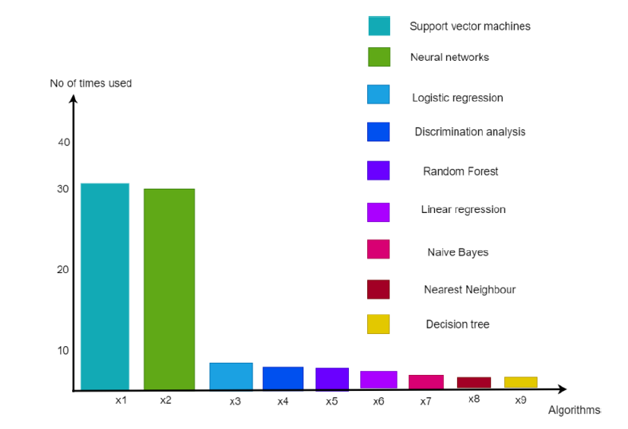

## 

## Figure 3.1: Feasibility study for Fuel Consumption Prognosis

## Idea: We have planned to design the Fuel Consumption prognosis using Linear Regression and Streamlit.

**3.1 ECONOMIC FEASIBILITY**

This study is carried out to check the economic impact will have on the system will have on the organization. The amount of fund that the company can pour into the research and development of the system is limited. The expenditures must be justified. Thus the developed system as well within the budget and this was achieved because most of the technologies used are freely available. Only the customized products have to be purchased.

1. All Hardware and software cost has to be borne by the organization

2. Overall we have estimate that the benefit the organization is going to receive from the proposed system will surely overcome initial cost and the later on running cost for system.

**3.2 TECHNICAL FEASIBILITY**

This study is carried out to check the technical feasibility, that is the technical requirements of the system. Any system developed must not have a high demand on the available technical resources. This will lead to high demands being placed on the client. The developed system must have a modest requirement, as only minimal or null changes for the implementing this system.

**3.3 OPERATIONAL FEASIBILITY**

## The aspect of study is to check the level of acceptance of the system by the user. This includes the process of training the user to use the system efficiently. The user must not feel threatened by the system, instead must accept it as a necessity. The level of acceptance by the users solely depends on the methods that are employed to educate the user about the system and to make him familiar with it. His level of confidence must be raised so that he is also able to make some constructive criticism, which is welcomed, as he is the final user of the system.

## CHAPTER 4 PROJECT METHODOLOGY

A diagram is the graphical presentation of a set of elements, most often rendered as a connected graph of vertices and arcs you draw diagram to visualize a system from different perspective, so a diagram is a projection into a system. For all but most trivial systems, a diagram represents an elided view of the elements that make up a system. In theory, a diagram may contain any combination of things and relationships.

## Block Diagram for FCP

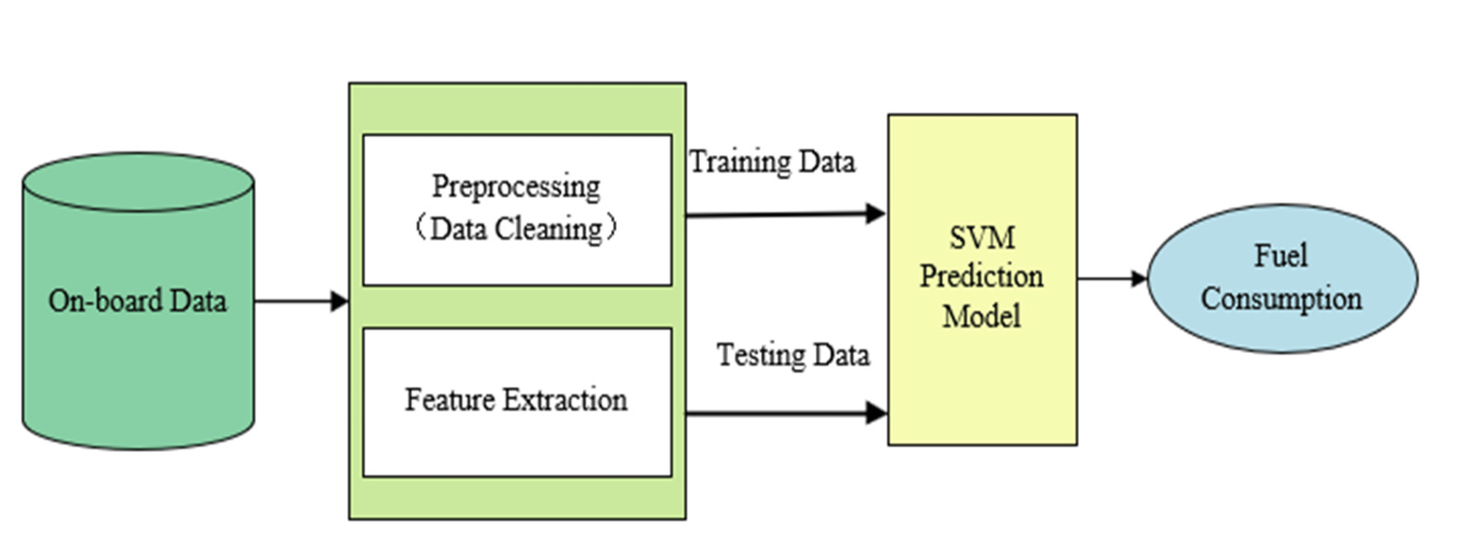

**Figure: 4.1 Block Diagram of FCP**

Accurately and efficiently predicting the fuel consumption of vehicles is the key to improving their fuel economy. This paper provides a comprehensive review of data-driven fuel consumption prediction models. Firstly, by classifying and summarizing relevant data that affect fuel consumption, it was pointed out that commonly used data currently involve three aspects: vehicle performance, driving behavior, and driving environment. Then, from the model structure, the predictive energy and the characteristics of the traditional machine learning model (support vector machine, random forest), the neural network model (artificial neural network and deep neural network).

## 4.2 Modules Description

## Data Collection and Preprocessing

* Gathering relevant data sources such as vehicle specifications, historical fuel consumption records.
* Removing or handling missing values, outliers, and inconsistencies in the collected data.

## Model Selection and Training

* Choosing the appropriate machine learning algorithms for regression tasks, such as linear regression, decision trees.
* Optimizing model hyperparameters to improve prediction accuracy.
* Using the training dataset to train the selected machine learning model(s).

## Model Evaluation Fine Tuning

* After training the model, it's essential to assess its performance. This module includes metrics and techniques for evaluating the model's accuracy, precision, recall, F1 score, or other relevant metrics depending on the specific problem.
* Fine-tuning the model involves optimizing hyperparameters and making improvements based on the evaluation results. This may include adjusting learning rates, feature selection, or trying different algorithms.

* **Deployment and Integration with Streamlit**
* This module focuses on deploying the model in a production environment. This might involve containerization using tools like Docker, setting up a web service, or integrating it into a web application.
* This module deals with integrating the pre-trained machine learning model into the Streamlit web application. This integration includes creating user interfaces, handling user inputs, and using the model to make real-time predictions.

## CHAPTER 5

**RESULT AND DISCUSSION**

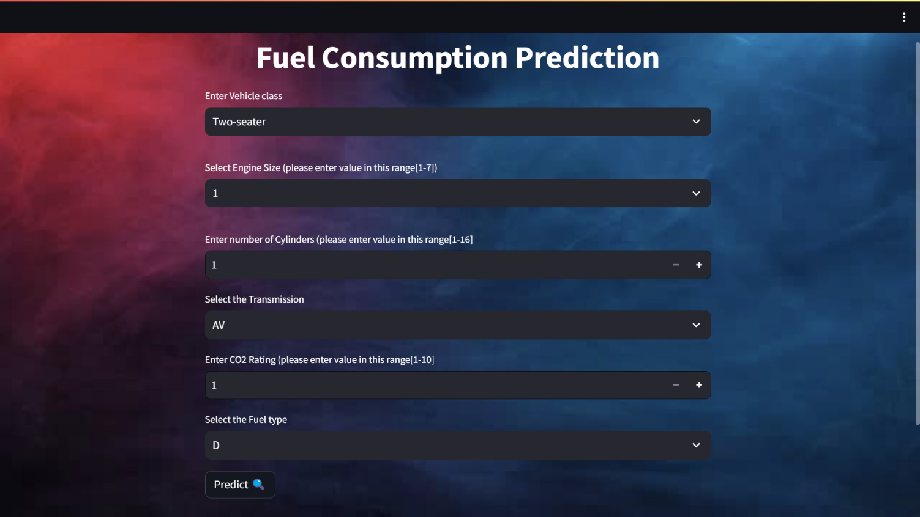

**Figure 5.1 Screenshot of Prediction inputs**

This figure deals with the user to get the information of the vehicle factors for the corresponding prediction.

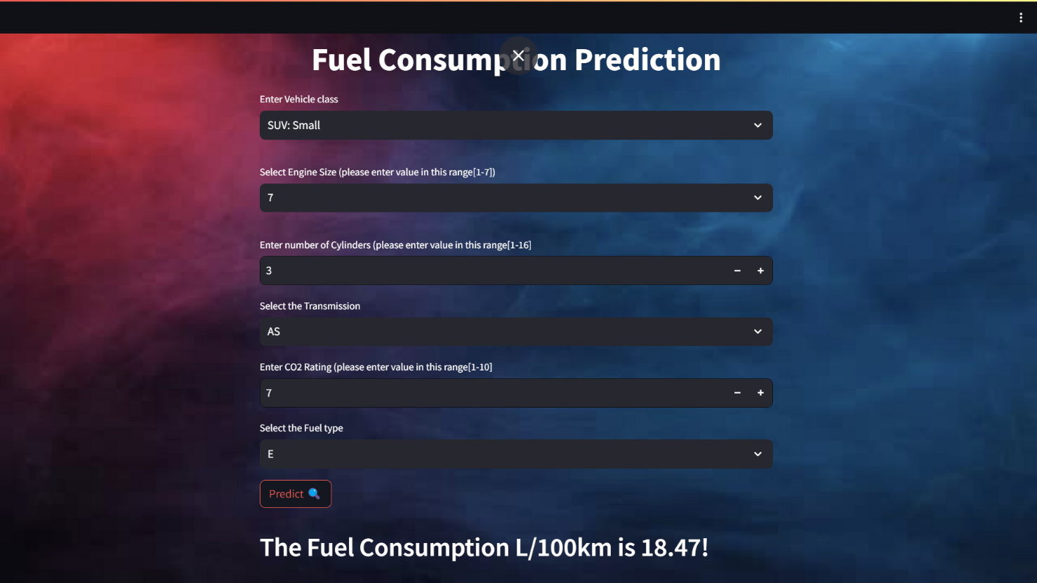

**Figure 5.2 Screenshot of showing result**

This figure deals with the User by showing the predicted result from the given data and the algorithms.

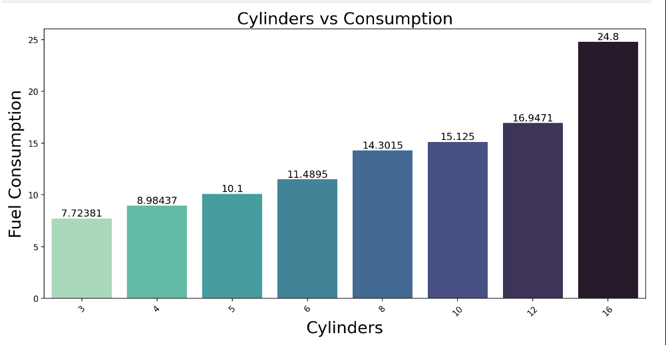

**Figure 5.3 Screenshot of Cylinder vs Consumption**

This figure deals with the comparing of cylinder and fuel consumption by the bar chart diagram.

## CHAPTER 6 CONCLUSION

In this project, the journey of fuel consumption prediction using machine learning has illuminated a path toward more informed and efficient transportation. Through meticulous data analysis, model development, and performance evaluation, we have constructed a powerful tool that offers insights both to consumers and the automotive industry. The ability to accurately estimate fuel consumption empowers individuals to make cost-effective and eco-conscious choices, while simultaneously providing manufacturers with the knowledge necessary to design and produce more fuel-efficient vehicles.

The Fuel Consumption Prediction Project holds immense potential for enhancing operational efficiency, reducing costs, extending the lifespan of vehicles or machinery, and contributing to sustainability efforts. Through a thorough analysis of the existing system architecture and its associated findings, several key takeaways emerge.

**FUTURE WORKS**

In the realm of fuel consumption prediction using machine learning, there are several promising avenues for future work. First and foremost, the integration of real-time data from various sources, such as traffic conditions and driving behavior, holds significant potential. This could enable dynamic and highly accurate predictions, allowing drivers to make informed decisions on fuel efficiency in real-time. Additionally, as the automotive industry continues to evolve with the rise of hybrid and electric vehicles, adapting the model to predict energy consumption in these alternative propulsion systems is essential.

## REFERENCES:

* + 1. "Fuel Consumption Prediction of Heavy-Duty Vehicles: A Data-Driven Approach" by Zhang et al. (2018) - This paper discusses data-driven methods for predicting fuel consumption in heavy-duty vehicles.
    2. Kaggle (kaggle.com) - Kaggle is a platform that hosts datasets and machine learning competitions. You can find a wealth of notebooks, datasets, and discussions related to predictive modeling, including fuel consumption prediction.
    3. Environmental Protection Agency (EPA) - The EPA website offers valuable information and reports on fuel economy, emissions, and environmental regulations.

**APPENDIX**

**INDEX:**

import numpy as np

import pandas as pd

import pickle as pk

import streamlit as st

import base64

import sklearn as sk

from streamlit.components.v1 import html

loaded_model = pk.load(open("trained_model_lr.sav","rb"))

scaled_data = pk.load(open("scaled_data.sav","rb"))

@st.cache_data

def get_img_as_base64(file):

with open(file, "rb") as f:

data = f.read()

return base64.b64encode(data).decode()

page_bg_img = f"""

<style>

[data-testid="stAppViewContainer"] > .main {{

background-image: url("https://wallpapercave.com/wp/wp6696562.jpg");

background-size: 100%;

background-position: center;

background-repeat: no-repeat;

background-attachment: fixed;

}}

</style>

"""

st.markdown(page_bg_img, unsafe_allow_html=True)

def input_converter(inp):

vcl = ['Two-seater', 'Minicompact', 'Compact', 'Subcompact', 'Mid-size', 'Full-size', 'SUV: Small', 'SUV: Standard', 'Minivan', 'Station wagon: Small', 'Station wagon: Mid-size', 'Pickup truck: Small', 'Special purpose vehicle', 'Pickup truck: Standard']

trans = ['AV','AM','M','AS','A']

fuel = ["D", "E", "X", "Z"]

lst = []

for i in range(6):

if (type(inp[i]) == str):

if (inp[i] in vcl):

lst.append(vcl.index(inp[i]))

elif (inp[i] in trans):

lst.append(trans.index(inp[i]))

elif (inp[i] in fuel):

if (fuel.index(inp[i]) == 0):

lst.extend([1, 0, 0, 0])

break

elif (fuel.index(inp[i]) == 1):

lst.extend([0, 1, 0, 0])

break

elif (fuel.index(inp[i]) == 2):

lst.extend([0, 0, 1, 0])

break

elif (fuel.index(inp[i]) == 3):

lst.extend([0, 0, 0, 1])

else:

lst.append(inp[i])

arr = np.asarray(lst)

arr = arr.reshape(1, -1)

arr = scaled_data.transform(arr)

prediction = loaded_model.predict(arr)

return (f"The Fuel Consumption L/100km is {round(prediction[0], 2)}")

def main():

# title

st.markdown("<h1 style='text-align: center; color: white;'>Fuel Consumption Prediction</h1>", unsafe_allow_html=True)

# getting the input data from user

result = 0

vehicle = ['Two-seater','Minicompact','Compact','Subcompact','Mid-size','Full-size','SUV: Small','SUV: Standard','Minivan','Station wagon: Small','Station wagon: Mid-size','Pickup truck: Small','Special purpose vehicle','Pickup truck: Standard']

transmission = ['AV','AM','M','AS','A']

fuel = ["D", "E", "X", "Z"]

Vehicle_class = st.selectbox(label = "Enter Vehicle class",options = vehicle)

css = """

<style>

.stSelectbox [data-testid='stMarkdownContainer'] {

color: white;

}

</style>

"""

st.write(css, unsafe_allow_html=True)

Engine_size = st.selectbox("Select Engine Size (please enter value in this range[1-7])",options =[1,2,3,4,5,6,7])

css = """

<style>

.stNumberInput [data-testid='stMarkdownContainer'] {

color: white;

}

</style>

"""

st.write(css, unsafe_allow_html=True)

Cylinders = st.number_input("Enter number of Cylinders (please enter value in this range[1-16]",min_value = 1, max_value = 16)

Transmission = st.selectbox("Select the Transmission",transmission)

Co2_Rating = st.number_input("Enter CO2 Rating (please enter value in this range[1-10]",min_value = 1, max_value = 10)

Fuel_type = st.selectbox("Select the Fuel type",fuel)

# code for prediction

# creating a button for prediction

if st.button("Predict 🔍"):

result = input_converter([Vehicle_class,Engine_size,Cylinders,Transmission,Co2_Rating,Fuel_type])

markdown_text = f"<h2 style='color:white;'><b>{result}</b>!</h2>"

st.markdown(markdown_text, unsafe_allow_html=True)

# st.success(result)

if __name__ == "__main__":

main()

**DATASET:**

Model Year,Make,Model,Vehicle Class,Engine Size(L),Cylinders,Transmission,Fuel Type,Fuel Consumption (City (L/100 km),Fuel Consumption(Hwy (L/100 km)),Fuel Consumption(Comb (L/100 km)),Fuel Consumption(Comb (mpg)),CO2 Emissions(g/km),CO2 Rating,Smog Rating

2022,Acura,ILX,Compact,2.4,4,AM8,Z,NA,7,8.6,33,200,6,3

2022,Acura,MDX SH-AWD,SUV: Small,3.5,6,AS10,Z,12.6,9.4,11.2,25,263,4,5

2022,Acura,RDX SH-AWD,SUV: Small,2,4,AS10,Z,11,8.6,9.9,29,232,5,6

2022,Acura,RDX SH-AWD A-SPEC,SUV: Small,2,4,AS10,Z,11.3,9.1,10.3,27,242,5,6

2022,Acura,TLX SH-AWD,Compact,2,4,AS10,Z,11.2,8,9.8,29,230,5,7

2022,Acura,TLX SH-AWD A-SPEC,Compact,2,4,AS10,Z,11.3,8.1,9.8,29,231,5,7

2022,Acura,TLX Type S,Compact,3,6,AS10,Z,12.3,NA,11,26,256,5,5

2022,Acura,TLX Type S (Performance Tire),Compact,3,6,AS10,Z,12.3,9.8,11.2,25,261,4,5

2022,Alfa Romeo,Giulia,Mid-size,2,4,A8,Z,10,7.2,8.7,32,205,6,3

2022,Alfa Romeo,Giulia AWD,Mid-size,2,4,A8,Z,10.5,7.7,9.2,31,217,5,3

2022,Alfa Romeo,Giulia Quadrifoglio,Mid-size,2.9,6,A8,Z,13.5,9.3,11.6,24,271,4,3

2022,Alfa Romeo,Stelvio,SUV: Small,2,4,A8,Z,10.3,8.1,9.3,30,218,5,3

2022,Alfa Romeo,Stelvio AWD,SUV: Small,2,4,A8,Z,10.8,8.3,9.6,NA,226,5,3

2022,Alfa Romeo,Stelvio AWD Quadrifoglio,SUV: Small,2.9,6,A8,Z,13.9,10.3,12.3,23,288,4,3

2022,Aston Martin,DB11 V8,Minicompact,4,8,A8,Z,13,9.8,11.5,25,271,4,5

2022,Aston Martin,DB11 V12,Minicompact,5.2,12,A8,Z,16.4,10.7,13.8,20,324,3,3

2022,Aston Martin,DBS V12,Minicompact,5.2,12,A8,Z,16.4,10.7,13.8,20,324,3,3

2022,Aston Martin,DBX V8,SUV: Standard,4,8,A9,Z,16.8,11.9,14.6,19,343,3,5

2022,Aston Martin,Vantage V8,Two-seater,4,8,A8,Z,13.1,9.6,11.5,25,NA,4,5

2022,Audi,A3 Sedan 40 TFSI quattro,Subcompact,2,4,AM7,X,8.5,6.6,7.6,37,178,7,7

2022,Audi,A4 Sedan 40 TFSI quattro,Compact,2,4,AM7,Z,9.1,7,8.2,34,190,6,5

2022,Audi,A4 Sedan 45 TFSI quattro,Compact,2,4,AM7,Z,9.8,7.6,8.8,32,205,6,5

2022,Audi,A4 allroad 45 TFSI quattro,Station wagon: Small,2,4,AM7,Z,9.8,7.9,8.9,32,208,6,NA

2022,Audi,A5 Cabriolet 45 TFSI quattro,Subcompact,2,4,AM7,Z,10.4,7.5,9.1,31,214,5,5

2022,Audi,A5 Coupe 45 TFSI quattro,Subcompact,2,4,AM7,Z,9.8,7.6,8.8,32,205,6,5

2022,Audi,A5 Sportback 45 TFSI quattro,Mid-size,2,4,AM7,Z,9.8,7.6,8.8,32,205,6,5

2022,Audi,A6 Sedan 45 TFSI quattro,Mid-size,2,4,AM7,Z,10.2,7.4,8.9,32,208,6,5

2022,Audi,A6 Sedan 55 TFSI quattro,Mid-size,3,6,AM7,Z,11.1,7.8,9.6,29,224,5,5

2022,Audi,A6 allroad 55 TFSI quattro,Station wagon: Mid-size,3,6,AM7,Z,11.5,8.3,10,28,234,5,5

2022,Audi,A7 Sportback 55 TFSI quattro,Mid-size,3,6,AM7,Z,11.1,7.8,9.6,29,224,5,5

2022,Audi,A8 L Sedan 55 TFSI quattro,Full-size,3,6,AS8,Z,12.6,8.3,10.6,27,248,5,5

2022,Audi,Q3 40 TFSI quattro,SUV: Small,2,4,AS8,X,10.4,7.7,9.2,31,215,5,7

2022,Audi,Q3 45 TFSI quattro,SUV: Small,2,4,AS8,X,11.4,8.3,10,NA,233,5,7

2022,Audi,Q5 40 TFSI quattro,SUV: Small,2,4,AM7,Z,10.3,8.1,9.3,30,217,5,5

2022,Audi,Q5 45 TFSI quattro,SUV: Small,2,4,AM7,Z,10.3,8.4,9.4,30,220,5,5

2022,Audi,Q5 Sportback 45 TFSI quattro,SUV: Small,2,4,AM7,Z,10.3,8.4,9.4,30,220,5,5

2022,Audi,Q7 45 TFSI quattro,SUV: Standard,2,4,AS8,Z,12,9.4,10.8,26,252,5,3

2022,Audi,Q7 55 TFSI quattro,SUV: Standard,3,6,AS8,Z,12.8,10.5,11.7,24,273,4,5

2022,Audi,Q8 55 TFSI quattro,SUV: Standard,3,6,AS8,Z,12.8,10.5,11.7,24,273,4,5

2022,Audi,R8 Coupe Performance,Two-seater,5.2,10,AM7,Z,16.7,10.3,13.8,20,322,3,1

2022,Audi,R8 Coupe Performance quattro,Two-seater,5.2,10,AM7,Z,17.9,12.1,15.3,18,356,3,1

2022,Audi,R8 Spyder Performance,Two-seater,5.2,10,AM7,Z,16.7,10.3,13.8,20,322,3,1

2022,Audi,R8 Spyder Performance quattro,Two-seater,5.2,10,AM7,Z,17.9,12.1,15.3,18,356,3,1

2022,Audi,RS 5 Coupe quattro,Subcompact,2.9,6,AS8,Z,13,9.4,11.4,25,267,4,5

2022,Audi,RS 5 Sportback quattro,Mid-size,2.9,6,AS8,Z,13.1,9.4,11.4,25,268,4,5

2022,Audi,RS 6 Avant quattro,Station wagon: Mid-size,4,8,AS8,Z,16.1,10.7,13.7,21,319,3,3

2022,Audi,RS 7 Sportback quattro,Mid-size,4,8,AS8,Z,16,10.5,13.5,21,315,3,3

2022,Audi,RS Q8 quattro,SUV: Standard,4,8,AS8,Z,NA,12.3,15.4,18,360,2,3

2022,Audi,S3 Sedan quattro,Subcompact,2,4,AM7,Z,10,7.2,8.8,32,206,6,5

2022,Audi,S4 Sedan quattro,Compact,3,6,AS8,Z,11.1,8,9.7,29,227,5,5

2022,Audi,S5 Cabriolet quattro,Subcompact,3,6,AS8,Z,11.3,8.4,10,28,233,5,5

2022,Audi,S5 Coupe quattro,Subcompact,3,6,AS8,Z,11.1,8,9.7,29,227,5,5

2022,Audi,S5 Sportback quattro,Mid-size,3,6,AS8,Z,11.1,8,9.7,29,227,5,5

2022,Audi,S6 Sedan quattro,Mid-size,2.9,6,AS8,Z,12.8,8.5,10.9,26,254,5,5

2022,Audi,S7 Sportback quattro,Mid-size,2.9,6,AS8,Z,12.8,8.5,10.9,26,254,5,5

2022,Audi,S8 Sedan quattro,Full-size,4,8,AS8,Z,16.9,10.2,13.8,NA,323,3,3

2022,Audi,SQ5 quattro,SUV: Small,3,6,AS8,Z,12.5,9.7,11.2,25,262,4,5

2022,Audi,SQ5 Sportback quattro,SUV: Small,3,6,AS8,Z,12.5,9.7,11.2,25,262,4,5

2022,Audi,SQ7 quattro,SUV: Standard,4,8,AS8,Z,16,11.4,13.9,20,325,3,3

2022,Audi,SQ8 quattro,SUV: Standard,4,8,AS8,Z,16,11.4,13.9,20,325,3,3

2022,Audi,TT Coupe 45 TFSI quattro,Subcompact,2,4,AM7,X,10.5,7.9,9.4,30,218,5,7

2022,Audi,TT Roadster 45 TFSI quattro,Two-seater,2,4,AM7,X,10.5,7.9,9.4,30,NA,5,7

2022,Audi,TT RS Coupe quattro,Subcompact,2.5,5,AM7,Z,11.7,8.1,10.1,28,235,5,3

2022,Audi,TTS Coupe quattro,Subcompact,2,4,AM7,Z,10,7.7,9,31,209,5,3

2022,Bentley,Bentayga,SUV: Standard,4,8,AS8,Z,15.8,9.9,13.2,21,309,3,3

2022,Bentley,Bentayga Speed,SUV: Standard,6,12,AS8,Z,19,13,16.3,17,383,NA,3

2022,Bentley,Continental GT,Subcompact,4,8,AM8,Z,14.9,9,12.2,23,287,NA,3

2022,Bentley,Continental GT Speed,Subcompact,6,12,AM8,Z,19.6,12,16.2,17,379,2,3

2022,Bentley,Continental GT Convertible,Minicompact,4,8,AM8,Z,15.2,9.2,12.5,23,294,4,3

2022,Bentley,Continental GT Convertible Speed,Minicompact,6,12,AM8,Z,20.3,12.9,17,17,395,2,3

2022,Bentley,Flying Spur,Mid-size,4,8,AM8,Z,15.5,11.6,13.7,21,323,3,NA

2022,Bentley,Flying Spur,Mid-size,6,12,AM8,Z,19.2,12.2,16,18,373,2,3

2022,BMW,330i xDrive Sedan,Compact,2,4,AS8,Z,9.5,6.9,8.3,34,195,6,7

2022,BMW,430i xDrive Cabriolet,Subcompact,2,4,AS8,Z,10,7.1,8.7,32,202,6,7

2022,BMW,430i xDrive Coupe,Subcompact,2,4,AS8,Z,10,7.1,8.7,32,202,6,7

2022,BMW,530i xDrive Sedan,Mid-size,2,4,AS8,Z,10.1,7.4,8.9,32,206,6,7

2022,BMW,540i xDrive Sedan,Full-size,3,6,AS8,Z,10.5,8.1,9.4,30,219,5,5

2022,BMW,750i xDrive Sedan,Full-size,4.4,8,AS8,Z,13.9,9.6,12,24,279,4,3

2022,BMW,750Li xDrive Sedan,Full-size,4.4,8,AS8,Z,13.9,9.6,12,24,279,4,3

2022,BMW,Alpina B7,Full-size,4.4,8,AS8,Z,13.9,9.6,12,24,279,4,3

2022,BMW,Alpina B8 Gran Coupe,Mid-size,4.4,8,AS8,Z,13.9,9.6,12,24,279,4,3

2022,BMW,Alpina XB7,SUV: Standard,4.4,8,AS8,Z,15.7,11.5,13.8,20,321,3,3

2022,BMW,M235i xDrive Gran Coupe,Compact,2,4,AS8,Z,10.4,7.8,9.2,31,214,5,3

2022,BMW,M240i xDrive Coupe,Subcompact,3,6,AS8,Z,10.4,7.5,9.1,31,212,5,5

2022,BMW,M3 Sedan,Compact,3,6,M6,Z,14.7,10.1,12.6,22,293,4,5

2022,BMW,M3 Competition Sedan,Compact,3,6,AS8,Z,14.5,10.2,12.6,22,292,4,5

2022,BMW,M3 Competition Sedan M xDrive,Compact,3,6,AS8,Z,14.6,10.5,12.7,22,296,4,5

2022,BMW,M340i xDrive Sedan,Compact,3,6,AS8,Z,10.4,7.7,9.2,31,214,5,5

2022,BMW,M4 Competition Cabriolet M xDrive,Subcompact,3,6,AS8,Z,15.1,10.4,12.9,22,301,3,5

2022,BMW,M4 Coupe,Subcompact,3,6,M6,Z,14.7,10.1,12.6,22,293,4,5

2022,BMW,M4 Competition Coupe,Subcompact,3,6,AS8,Z,14.5,10.2,12.6,22,292,4,5

2022,BMW,M4 Competition Coupe M xDrive,Subcompact,3,6,AS8,Z,14.6,10.5,12.7,22,296,4,5

2022,BMW,M440i xDrive Cabriolet,Subcompact,3,6,AS8,Z,10.4,7.4,9.1,31,211,5,5

2022,BMW,M440i xDrive Coupe,Subcompact,3,6,AS8,Z,10.4,7.7,9.2,31,214,5,5

2022,BMW,M440i xDrive Gran Coupe,Compact,3,6,AS8,Z,10.9,8,9.6,29,224,5,5

2022,BMW,M5 Sedan,Mid-size,4.4,8,AS8,Z,16.1,11,13.8,20,322,3,3

2022,BMW,M5 Competition,Mid-size,4.4,8,AS8,Z,16.1,11,13.8,20,322,3,3

2022,BMW,M5 CS,Mid-size,4.4,8,AS8,Z,16.1,11,13.8,20,322,3,3

2022,BMW,M550i xDrive Sedan,Mid-size,4.4,8,AS8,Z,13.5,9.3,11.6,24,271,4,3

2022,BMW,M760i xDrive Sedan,Full-size,6.6,12,AS8,Z,17.8,11.9,15.1,19,354,3,3

2022,BMW,M8 Cabriolet,Subcompact,4.4,8,AS8,Z,16.1,11,13.8,20,322,3,3

2022,BMW,M8 Cabriolet Competition,Subcompact,4.4,8,AS8,Z,16.1,11,13.8,20,322,3,3

2022,BMW,M8 Coupe,Subcompact,4.4,8,AS8,Z,16.1,11,13.8,20,322,3,3

2022,BMW,M8 Coupe Competition,Subcompact,4.4,8,AS8,Z,16.1,11,13.8,20,322,3,3

2022,BMW,M8 Gran Coupe,Mid-size,4.4,8,AS8,Z,16.1,11,13.8,20,322,3,3

2022,BMW,M8 Gran Coupe Competition,Mid-size,4.4,8,AS8,Z,16.1,11,13.8,20,322,3,3

2022,BMW,M850i xDrive Cabriolet,Subcompact,4.4,8,AS8,Z,13.9,9.6,12,24,279,4,3

2022,BMW,M850i xDrive Coupe,Subcompact,4.4,8,AS8,Z,13.5,9.3,11.6,24,271,4,3

2022,BMW,M850i xDrive Gran Coupe,Mid-size,4.4,8,AS8,Z,13.9,9.6,12,24,279,4,3

2022,BMW,X1 xDrive28i,SUV: Small,2,4,AS8,Z,10.3,7.7,9.1,31,213,5,7

2022,BMW,X2 xDrive28i,SUV: Small,2,4,AS8,Z,9.9,7.6,8.8,32,207,6,7

2022,BMW,X2 M35i,SUV: Small,2,4,AS8,Z,9.9,7.6,8.9,32,207,6,3

2022,BMW,X3 xDrive30i,SUV: Small,2,4,AS8,Z,11,8.5,9.9,29,230,5,7

2022,BMW,X3 M,SUV: Small,3,6,AS8,Z,15.7,11.7,13.9,20,323,3,3

2022,BMW,X3 M Competition,SUV: Small,3,6,AS8,Z,15.7,11.7,13.9,20,323,3,3

2022,BMW,X3 M40i,SUV: Small,3,6,AS8,Z,11.2,9.1,10.3,27,241,5,5

2022,BMW,X4 xDrive30i,SUV: Small,2,4,AS8,Z,11,8.5,9.9,29,230,5,NA

2022,BMW,X4 M,SUV: Small,3,6,AS8,Z,15.7,11.7,13.9,20,323,3,3

2022,BMW,X4 M Competition,SUV: Small,3,6,AS8,Z,15.7,11.7,13.9,20,323,3,3

2022,BMW,X4 M40i,SUV: Small,3,6,AS8,Z,11.2,9.1,10.3,27,241,5,5

2022,BMW,X5 xDrive40i,SUV: Standard,3,6,AS8,Z,11.3,9.2,10.4,27,241,5,3

2022,BMW,X5 M,SUV: Standard,4.4,8,AS8,Z,17.9,NA,15.7,18,364,2,3

2022,BMW,X5 M Competition,SUV: Standard,4.4,8,AS8,Z,17.9,13,15.7,18,364,2,3

2022,BMW,X5 M50i,SUV: Standard,4.4,8,AS8,Z,14.4,10.6,12.7,22,302,3,3