**Project**: **FoodBox**

Developer Details : Jayapratha kajapathi

E-mail: [jpratha96@gmail.com](mailto:jpratha96@gmail.com)

**Tools Used:** Mysql, eclipse, visual studio code, Jenkins, GitHub, JIRA

**REQUIREMENTS:**

Admin portal able to add remove food items able to view details and can disable the item, User portal able to purchase items and delete the items from the cart also view the details of the purchase items.

In this implementation I use MySQL for in order to maintain a data (for backend purpose). Using sql queries for creating table.

Create a spring boot application with rest controller, jpa for crud operation. With cross origin annotation binding backend with frontend.

Using a visual studio code create service layers and components for login and crud operation purpose. Here I have used Httpclient module to communicate with backend HTTP server. For backend testing using Junit for frontend using selenium testing ,finally deploy the application in GitHub to docker and Jenkins.

Use spring boot application, 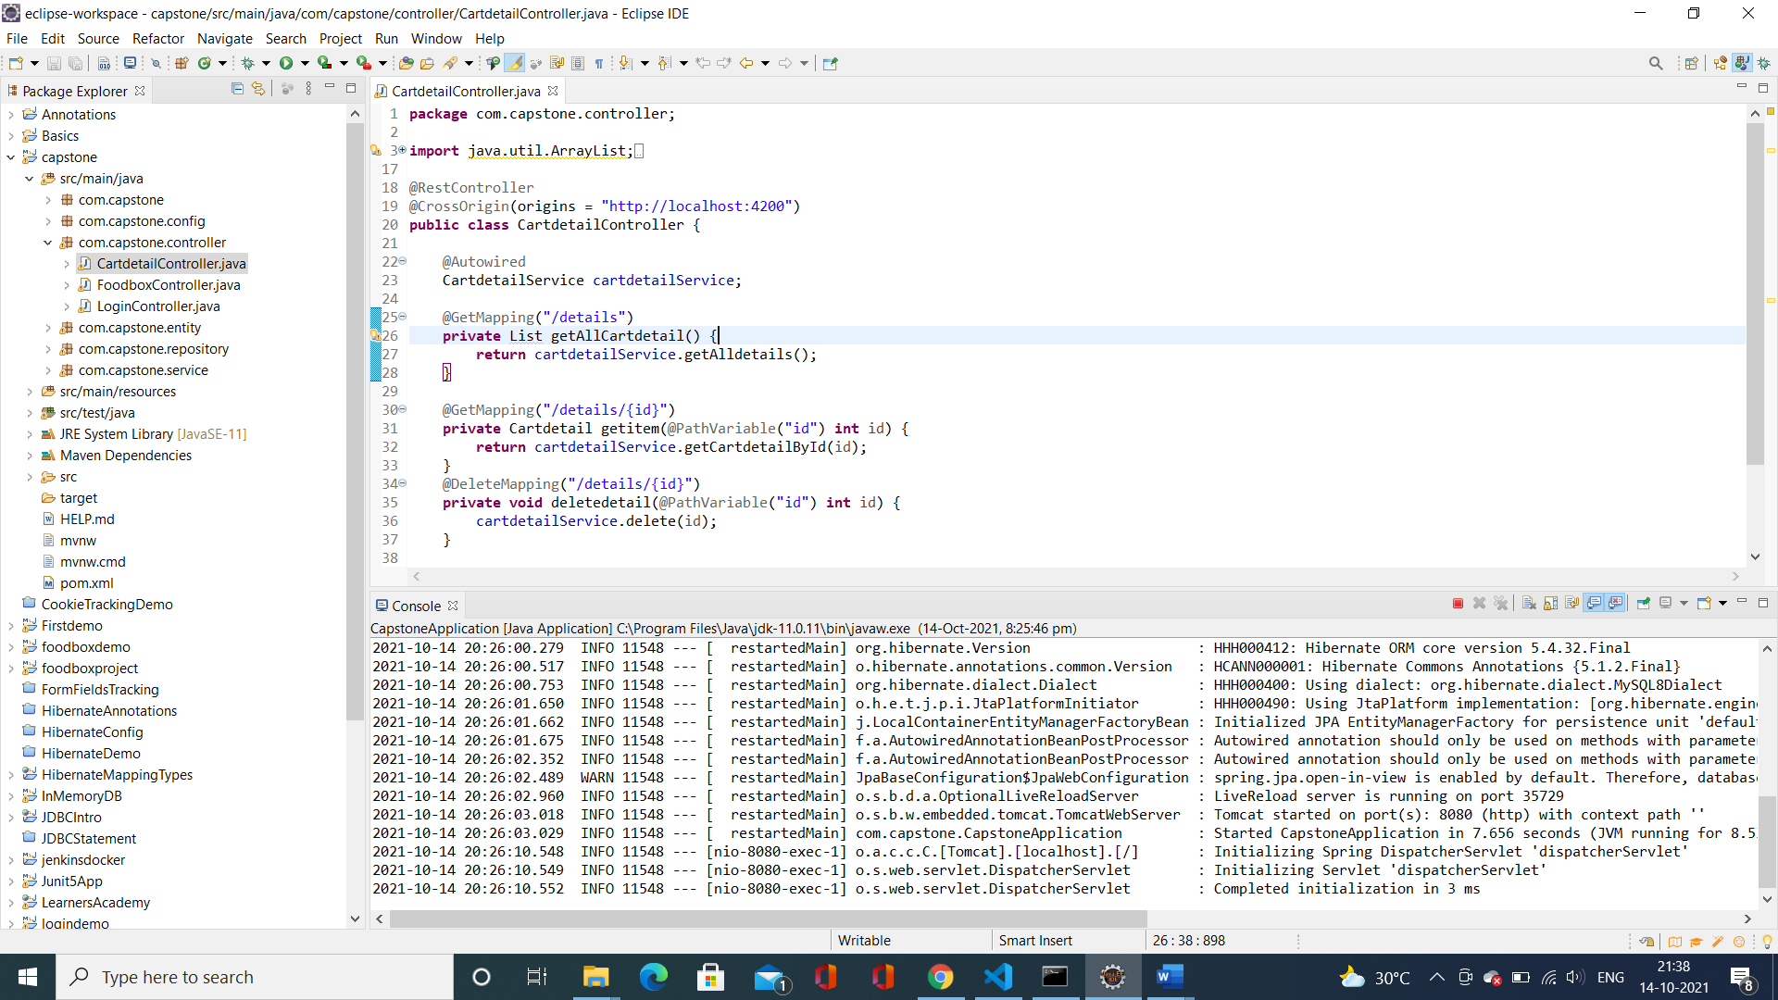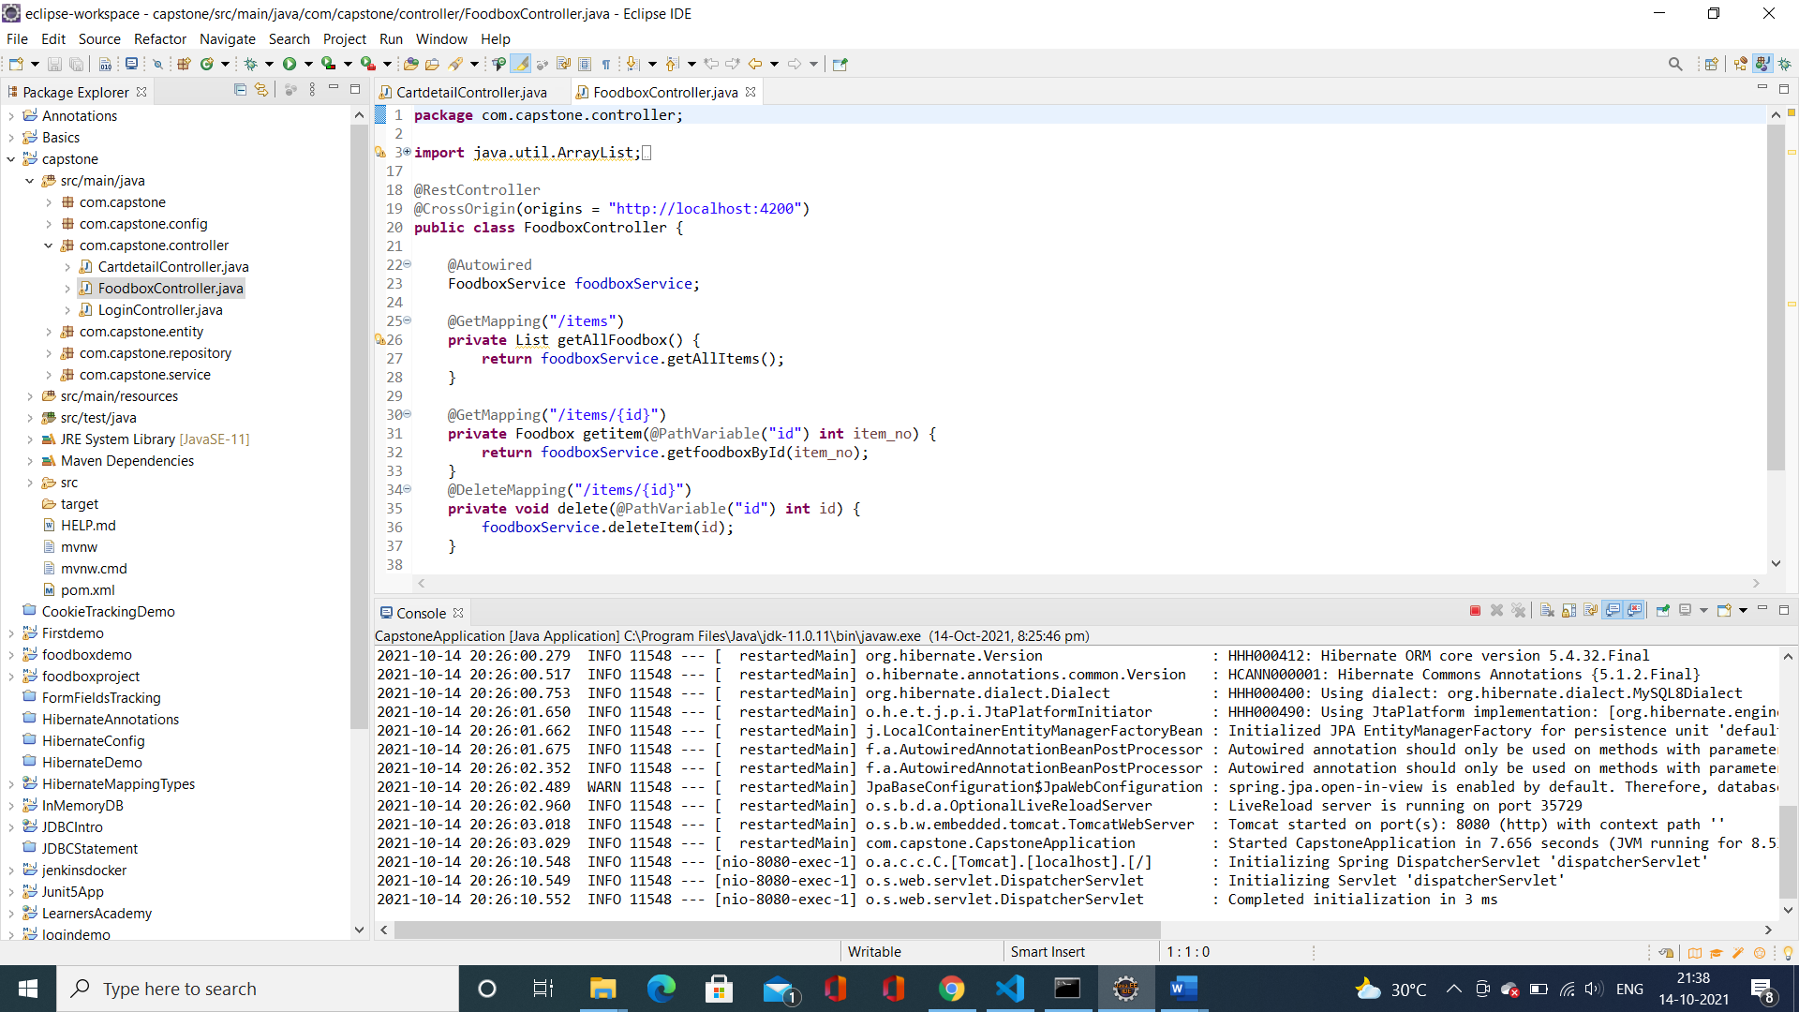

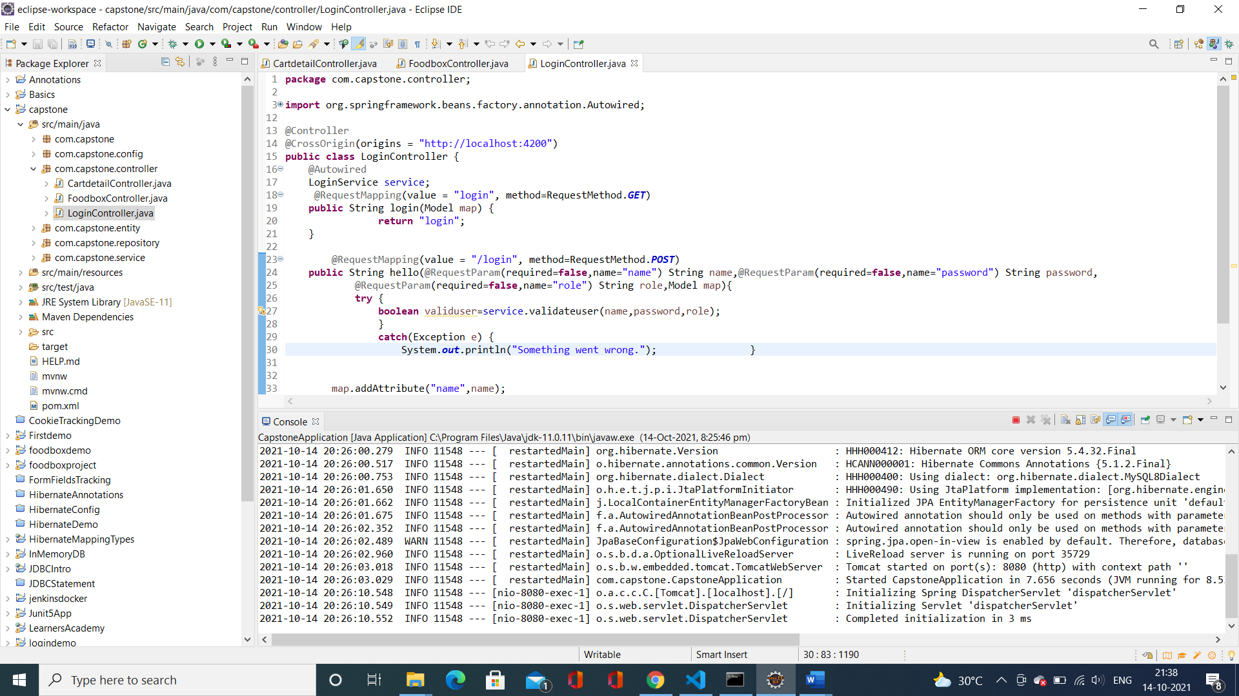

For frontend coding using angular

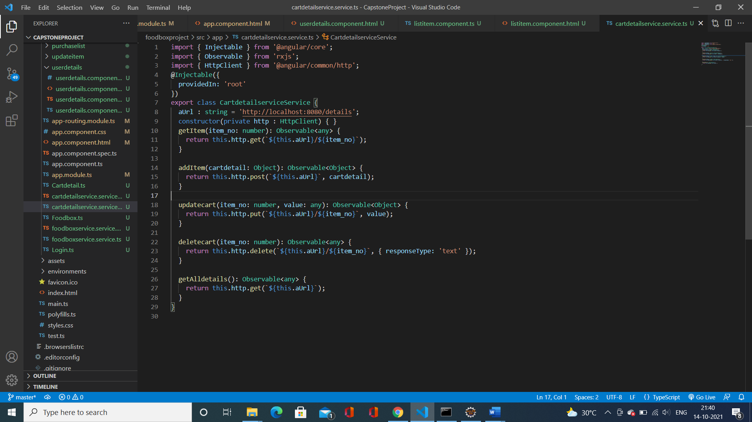

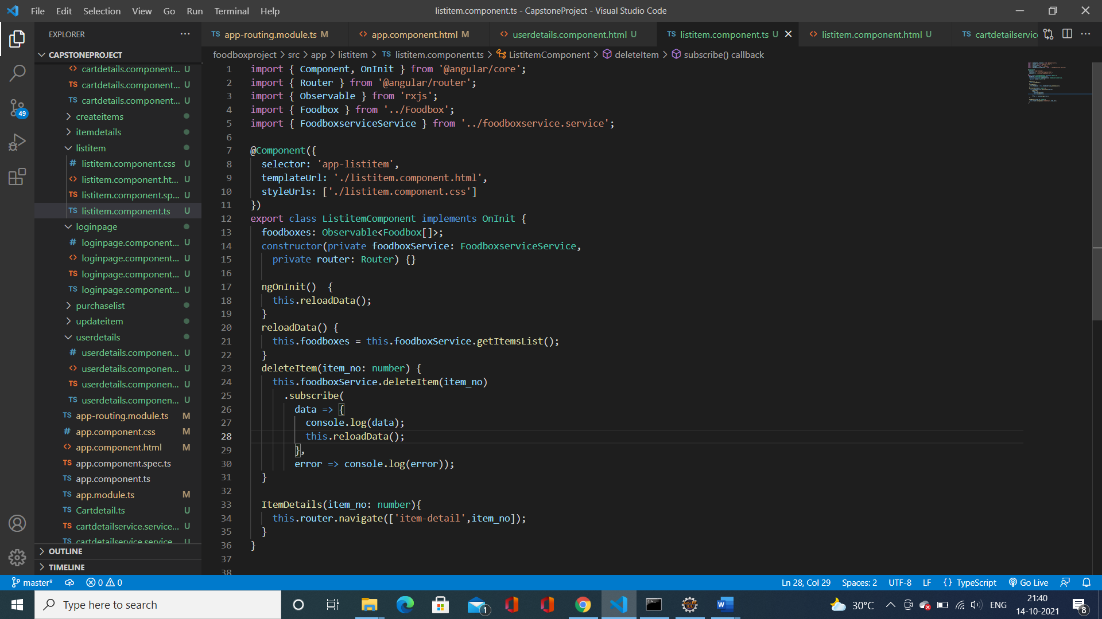

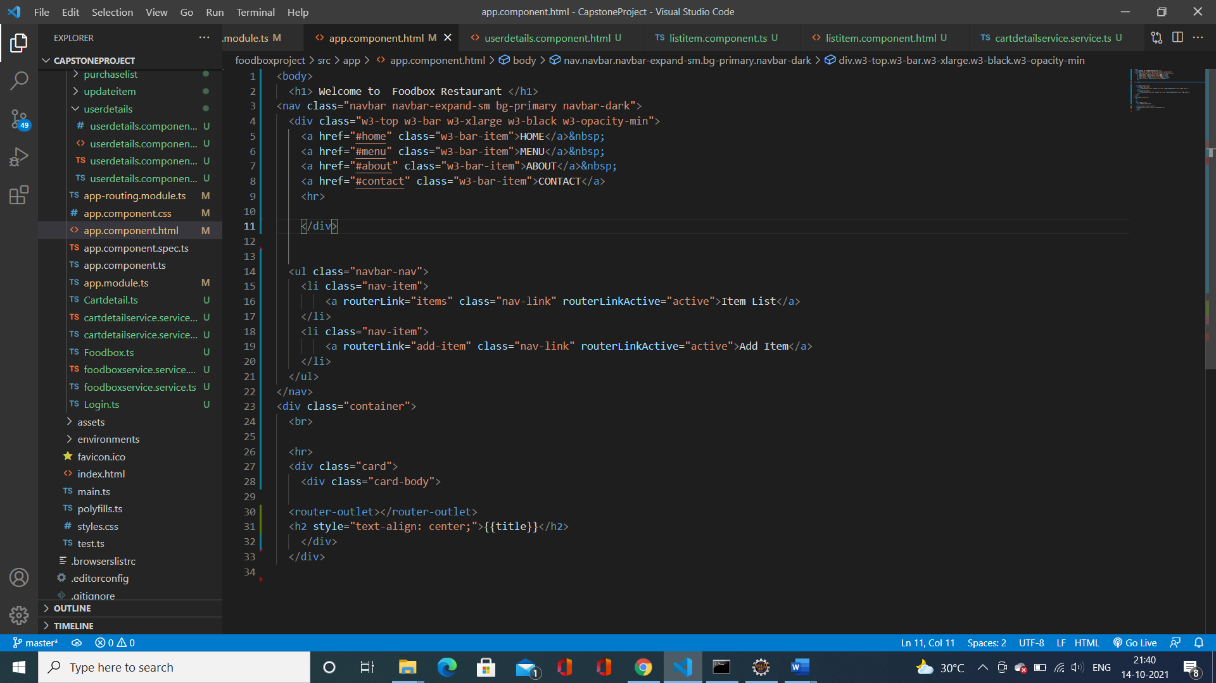

Testing frontend application using selenium testing

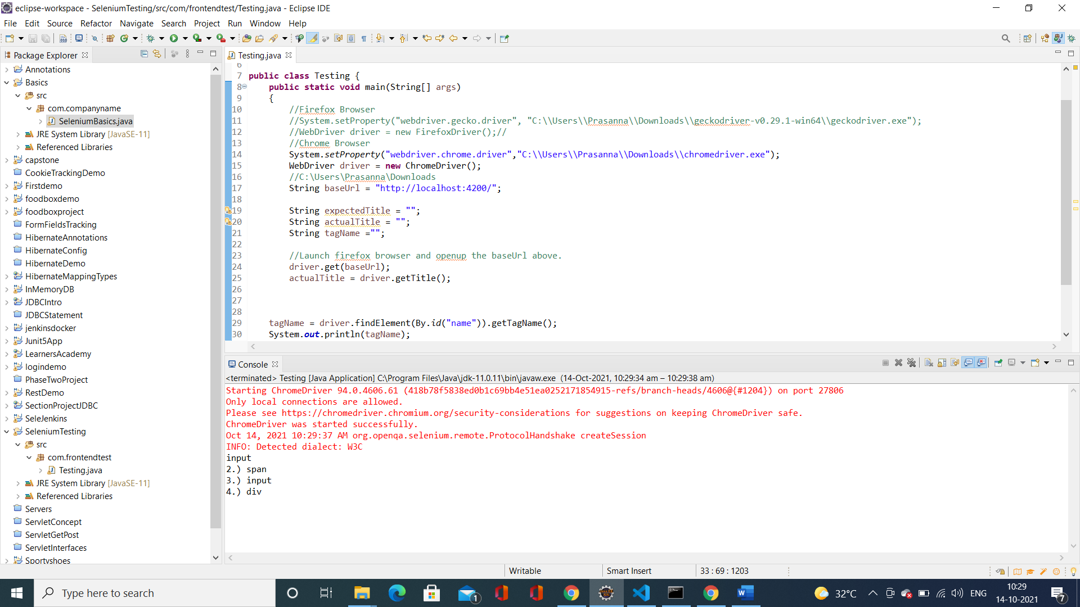

Deploy the application from GitHub to Jenkins and docker.

