High-Level Architecture
Two independently deployable Spring Boot services, each owning its own H2 instance, talking over synchronous REST with trace propagation and a circuit breaker guarding the internal hop.
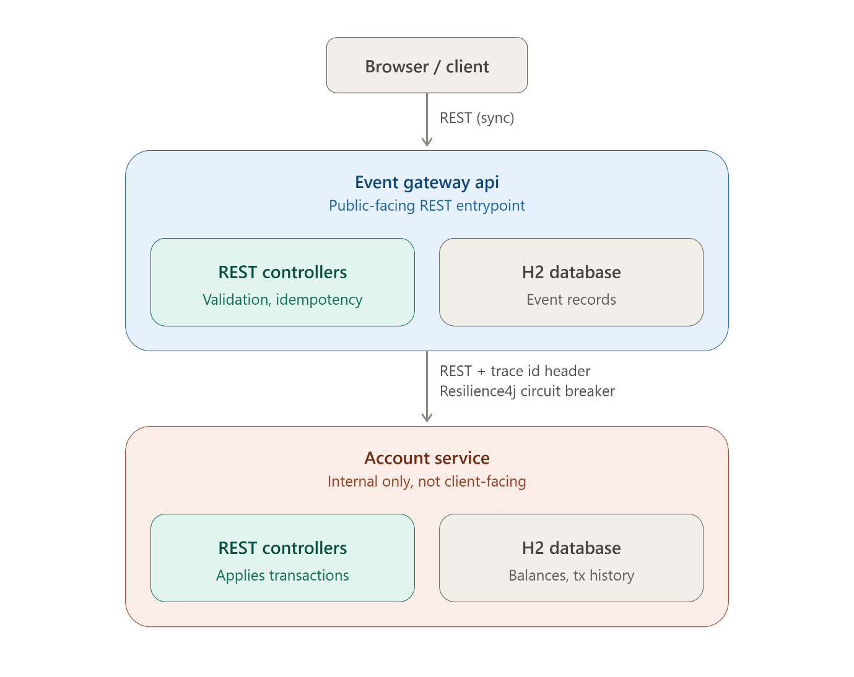
Architected microservice decomposition with structural boundaries and layering

Artifact 1 — Microservice decomposition

Service 1: Event Gateway (public-facing)
Bounded context: Event intake and idempotency ledger. It owns the question "did we ever receive this event, and what does it currently say?" — nothing about account balances.
Responsibilities:
- Accept, validate, and structurally persist incoming events (the event as submitted, independent of whether it was ever successfully applied downstream).
- Enforce idempotency by eventId — the source of truth for "have we seen this before."
- Own chronological ordering/listing of events per account (by eventTimestamp, not arrival order).
- Orchestrate the call to the Account Service and track the application status of each event (e.g. PENDING, APPLIED, FAILED_DOWNSTREAM) so it can answer GET /events/{id} even when the Account Service is unreachable.
- Own resiliency (circuit breaker), tracing origination, and structured logging for the public edge.
Explicitly NOT responsible for: account balances, transaction math, or any notion of "current state of money." It only knows "I told the Account Service about this event," not the result of applying it, beyond success/failure.
Internal layers (all within one Spring Boot process):
- controller — REST endpoints, request/response DTOs, HTTP-level concerns.
- service — orchestration: idempotency check → persist → call Account Service → update status.
- client — typed HTTP client to Account Service (RestClient/WebClient wrapped with Resilience4j).
- repository — Spring Data JPA over the Gateway's own H2 schema.
- domain/entity — EventRecord (its own concept, not shared with Account Service's Transaction).
- tracing — trace ID generation/propagation filter + MDC logging config.
- config — Resilience4j, OpenTelemetry, Jackson, DB config.

Service 2: Account Service (internal)
Bounded context: Account state. It owns the question "given the transactions I've been told about, what does this account currently look like?"
Responsibilities:
- Apply transactions to an account, recomputing balance from CREDIT/DEBIT.
- Own out-of-order correctness for balance math (a transaction with an earlier eventTimestamp arriving after a later one must not corrupt the running balance — balance is a fold over all transactions ordered by eventTimestamp, not by arrival/insertion order).
- Serve current balance and account detail/history queries.
- Its own idempotency safety net: even though the Gateway is expected to de-dupe by eventId, the Account Service should not assume a perfectly-behaved caller — I'd give it a unique constraint on eventId too, so a retried/duplicate downstream call (e.g. Gateway retrying after a timeout that actually succeeded) can't double-apply. This is a deliberate defense-in-depth decision — two idempotency checks, one per bounded context — rather than trusting the Gateway's check alone across a network boundary.
Internal layers:
- controller — REST endpoints receiving Gateway calls only.
- service — transaction application logic, balance computation.
- repository — Spring Data JPA over the Account Service's own H2 schema.
- domain/entity — Account, Transaction (distinct from the Gateway's EventRecord).
- tracing — trace ID extraction from incoming header + MDC logging config.
- config — DB config, OpenTelemetry, Jackson.

Why Circuit Breaker Pattern

Bulkhead isolates one dependency's resource pool from another's — but the Gateway has only one downstream dependency (the Account Service), so there's nothing to isolate it from. It becomes useful the moment a second downstream service gets added, but it doesn't solve a real problem in this architecture as-is.

Timeout + retry handles transient slowness — a call that'll likely succeed if you wait or try again. It doesn't help when the service is genuinely down: retrying against a dead dependency just makes every request take 3x longer to fail, and keeps hammering a service that needs room to recover.

Circuit breaker is the pattern that specifically answers that question: stop trying once it's clear the dependency is down, until there's a reason to believe it's back. A pure retry-with-backoff strategy, even bounded, still means each request hangs for the duration of all it retries before finally failing — that's slower degradation, not fast failure. The circuit breaker is what makes the failure fast and honest once the pattern of failures is established

Artifact 2 — Database design
Both services use H2, in-memory, embedded per-process. No shared schema, no shared connection.

Event Gateway — schema
Table: event_record
Column | Type | Notes
id | BIGINT, PK, auto-increment | Internal surrogate key
event_id | VARCHAR(100), UNIQUE NOT NULL | Client-supplied idempotency key
account_id | VARCHAR(100), NOT NULL, indexed | For GET /events?account=
type | VARCHAR(10), NOT NULL | CREDIT / DEBIT
amount | DECIMAL(19,4), NOT NULL | Never use float/double for money
currency | VARCHAR(3), NOT NULL
event_timestamp | TIMESTAMP, NOT NULL, indexed | Original occurrence time — used for chronological ordering
metadata | VARCHAR(2000) / JSON-as-text | Optional, stored as serialized JSON string (H2 has no native JSON type in older versions — I'll store as CLOB/VARCHAR and (de)serialize in the entity)
status | VARCHAR(20), NOT NULL | PENDING, APPLIED, FAILED_DOWNSTREAM, VALIDATION_FAILED
failure_reason | VARCHAR(500), nullable | Populated when status is a failure state
received_at | TIMESTAMP, NOT NULL | Server-side arrival time (distinct from event_timestamp — this is what lets us detect/measure out-of-order arrival)
updated_at | TIMESTAMP, NOT NULL | Last status transition

Account Service — schema
Table: account
Column | Type | Notes
account_id | VARCHAR(100), PK | Natural key — accounts aren't created by an explicit API in this spec, they're implicitly established on first transaction
balance | DECIMAL(19,4), NOT NULL, default 0 | Denormalized running balance — see below for why this is safe
currency | VARCHAR(3), NOT NULL | Assumes single-currency per account for this exercise; I'll note the multi-currency limitation in the README rather than over-engineer it
created_at | TIMESTAMP, NOT NULL
updated_at | TIMESTAMP, NOT NULL
Table: account_transaction
Column | Type | Notes
id | BIGINT, PK, auto-increment
event_id | VARCHAR(100), UNIQUE NOT NULL | Same value the Gateway sent — Account Service's own idempotency guard (defense-in-depth, per Artifact 2)
account_id | VARCHAR(100), NOT NULL, FK → account.account_id, indexed
type | VARCHAR(10), NOT NULL | CREDIT / DEBIT
amount | DECIMAL(19,4), NOT NULL
event_timestamp | TIMESTAMP, NOT NULL, indexed
applied_at | TIMESTAMP, NOT NULL | Server-side application time
Indexes:
- Unique index on event_id.
- Composite index on (account_id, event_timestamp) — supports account detail/history queries in chronological order.

Artifact 3 — Event flows
This artifact walks through the four core scenarios end-to-end at the logic level — request/response sequencing comes next in Artifact 6. Here I'm focused on what each service actually decides and why.

Flow 1: Happy path — new event, Account Service healthy
- Client POST /events with a new eventId.
- Gateway validates payload (required fields, positive amount, valid type, parseable timestamp). Fails fast with 400 if invalid — nothing persisted.
- Gateway checks event_record for existing event_id. Not found → proceeds.
- Gateway inserts event_record with status: PENDING, received_at: now().
- Gateway calls Account Service POST /accounts/{accountId}/transactions, passing eventId, type, amount, eventTimestamp, and the trace ID header. Call goes through the circuit breaker (currently closed) with a timeout.
- Account Service checks its own account_transaction for the eventId. Not found → proceeds.
- Account Service, in one DB transaction: inserts account_transaction, updates account.balance (+amount for CREDIT, -amount for DEBIT), commits.
- Account Service returns 201 with updated balance.
- Gateway updates event_record.status = APPLIED, updated_at = now().
- Gateway returns 201 to client with the event record + balance.

Flow 2: Duplicate submission
- Client POST /events with an eventId that already exists (client retried after a timeout, or an upstream system double-sent).
- Gateway's uniqueness check on event_id finds the existing row.
- Gateway does not call the Account Service at all — this is the key correctness point: a duplicate must not even attempt a second downstream call under normal conditions, because that's wasted work and (without the Account Service's own defense-in-depth check) a theoretical second point of risk.
- Gateway returns 200 OK with the original stored event record, exactly as first persisted (original status, original balance-at-the-time if it was captured).
Race condition case: two duplicate requests arrive near-simultaneously, both pass the Gateway's "not found" check before either commits. The DB's unique constraint on event_id causes the second insert to fail with a constraint violation; the Gateway catches that specific exception and treats it as "duplicate detected late," re-reads the now-existing row, and returns 200 — never a 500. This is why the constraint lives at the DB level, not just as an app-level pre-check.
Defense-in-depth case: if the Gateway's own record was somehow lost/reset but the Account Service already applied that eventId (unlikely in this exercise since there's one Gateway instance, but worth designing for), the Account Service's own unique constraint on event_id prevents a second balance mutation — it returns 200 with unchanged state, and the Gateway just passes that through.

Flow 3: Out-of-order arrival
Example: event A (eventTimestamp: 14:00) and event B (eventTimestamp: 14:05) both belong to acct-123. B arrives at the Gateway first (server clock 14:10), A arrives second (server clock 14:12).
- B is processed via the happy path — inserted, applied, balance updated by B's amount.
- A arrives later, is processed via the happy path too — inserted, applied, balance updated by A's amount.
- Balance correctness: since balance is Σcredits − Σdebits, the final balance is identical whether A or B was applied first — order of application doesn't change the sum. No special-casing needed in the balance mutation itself.
- Listing correctness: GET /events?account=acct-123 sorts by event_timestamp ascending, so the response correctly shows A (14:00) before B (14:05) — even though B was inserted first (lower internal id, earlier received_at). This is purely a query-time ORDER BY event_timestamp, not a data-fixup process.
- Same logic applies to the Account Service's transaction history endpoint (GET /accounts/{accountId}) — ordered by event_timestamp, not insertion order.

Flow 4: Account Service unavailable
Two sub-cases, both under requirement 6:
4a — POST /events while Account Service is down:
- Gateway validates and persists event_record with status: PENDING, same as always.
- Gateway's call to the Account Service times out, connection-refuses, or the circuit breaker is already open (skips the call entirely).
- Gateway updates event_record.status = PENDING (left as-is — it was never applied, not marked as "failed" unless it was a definitive downstream error vs. unreachability, which I'll distinguish: PENDING = "not yet applied, may still succeed," FAILED_DOWNSTREAM = "Account Service explicitly rejected it").
- Gateway returns 503 to the client with a clear message that the transaction was received but not yet applied, not silently dropped.
4b — GET /events/{id} and GET /events?account= while Account Service is down:
- These queries never touch the Account Service — pure Gateway-local reads. They return 200 normally, unaffected. This is the direct payoff of Artifact 2's decomposition decision (event storage lives outside the Account Service).
4c — balance queries while Account Service is down:
- If the client only interacts via the Gateway (per this architecture, it must — the Account Service isn't exposed), the only way it learns about balance is via the POST /events response. If that 201's balance field is missing (because the call was PENDING), that itself communicates "balance currently unknown, Account Service unavailable" — I'll make the error/response explicit about this rather than making the client infer it from a missing field. If you want a dedicated Gateway-side proxy endpoint like GET /events/{id} that also surfaces "current known balance," that's not in the spec's endpoint list, so I'm not adding it unless you want it.

Artifact 4 — Resources (Properties)

DB_CLOSE_DELAY=-1 Keeps the db alive even if the one connection is closed and a new connection is opened.

Artifact 5 — Sequence diagrams
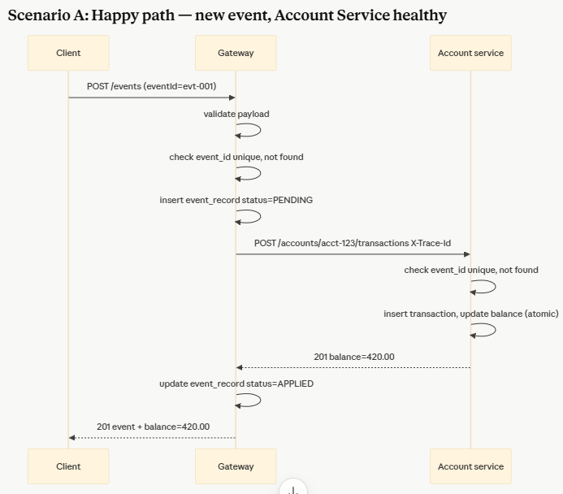

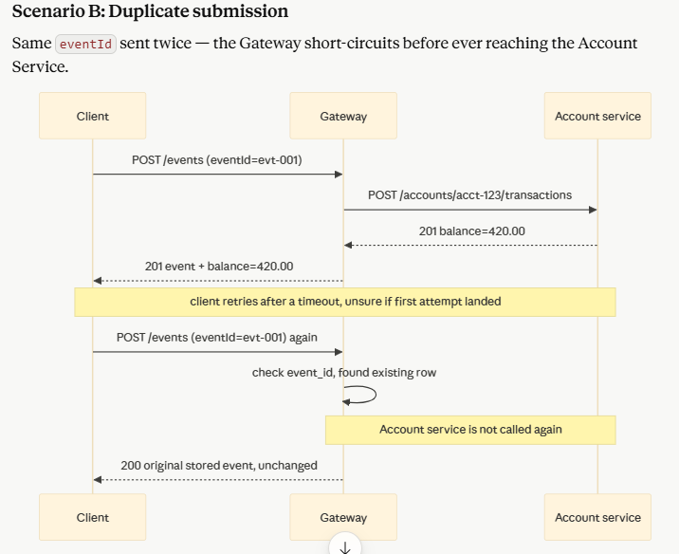
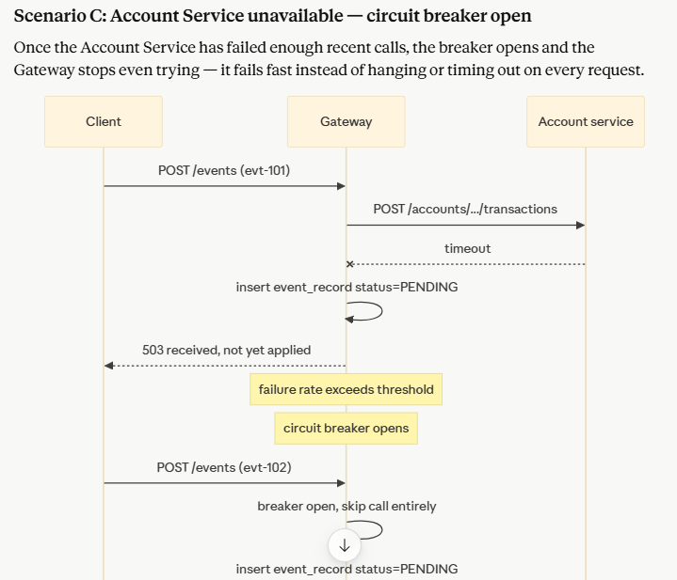
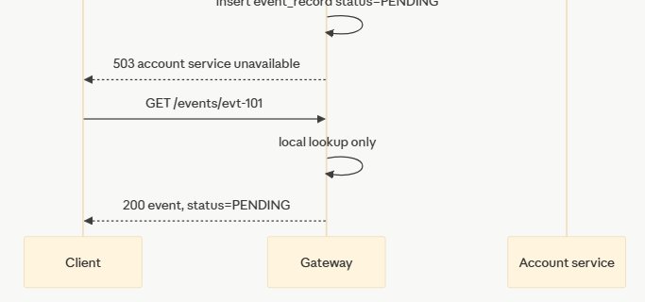

Artifact 6 — Folder Structure
event-ledger/
├── README.md
├── docker-compose.yml
├── pom.xml # parent/reactor pom — build convenience only, NOT shared runtime
│
├── event-gateway/
│ ├── pom.xml
│ ├── Dockerfile
│ └── src/
│ ├── main/
│ │ ├── java/com/eventledger/gateway/
│ │ │ ├── EventGatewayApplication.java
│ │ │ ├── controller/
│ │ │ │ └── EventController.java
│ │ │ ├── service/
│ │ │ │ └── EventService.java
│ │ │ ├── client/
│ │ │ │ ├── AccountServiceClient.java
│ │ │ │ └── AccountServiceClientConfig.java
│ │ │ ├── repository/
│ │ │ │ └── EventRecordRepository.java
│ │ │ ├── domain/
│ │ │ │ ├── EventRecord.java
│ │ │ │ └── EventStatus.java
│ │ │ ├── dto/
│ │ │ │ ├── request/
│ │ │ │ │ └── EventSubmissionRequest.java
│ │ │ │ ├── response/
│ │ │ │ │ ├── EventResponse.java
│ │ │ │ │ └── ErrorResponse.java
│ │ │ │ └── internal/
│ │ │ │ ├── ApplyTransactionRequest.java
│ │ │ │ └── ApplyTransactionResponse.java
│ │ │ ├── exception/
│ │ │ │ ├── GlobalExceptionHandler.java
│ │ │ │ ├── ValidationException.java
│ │ │ │ ├── DuplicateEventException.java
│ │ │ │ └── AccountServiceUnavailableException.java
│ │ │ ├── tracing/
│ │ │ │ ├── TraceIdFilter.java
│ │ │ │ └── TraceContext.java
│ │ │ ├── metrics/
│ │ │ │ └── EventMetrics.java
│ │ │ └── config/
│ │ │ ├── ResilienceConfig.java
│ │ │ ├── OpenTelemetryConfig.java
│ │ │ └── RestClientConfig.java
│ │ └── resources/
│ │ ├── application.yml
│ │ ├── application-docker.yml
│ │ └── logback-spring.xml # JSON structured logging config
│ └── test/
│ ├── java/com/eventledger/gateway/
│ │ ├── controller/
│ │ │ └── EventControllerTest.java
│ │ ├── service/
│ │ │ └── EventServiceTest.java
│ │ ├── resiliency/
│ │ │ └── CircuitBreakerTest.java
│ │ ├── tracing/
│ │ │ └── TracePropagationTest.java
│ │ └── integration/
│ │ └── GatewayAccountServiceIntegrationTest.java
│ └── resources/
│ └── application-test.yml
│
├── account-service/
│ ├── pom.xml
│ ├── Dockerfile
│ └── src/
│ ├── main/
│ │ ├── java/com/eventledger/account/
│ │ │ ├── AccountServiceApplication.java
│ │ │ ├── controller/
│ │ │ │ └── AccountController.java
│ │ │ ├── service/
│ │ │ │ └── AccountTransactionService.java
│ │ │ ├── repository/
│ │ │ │ ├── AccountRepository.java
│ │ │ │ └── AccountTransactionRepository.java
│ │ │ ├── domain/
│ │ │ │ ├── Account.java
│ │ │ │ ├── AccountTransaction.java
│ │ │ │ └── TransactionType.java
│ │ │ ├── dto/
│ │ │ │ ├── request/
│ │ │ │ │ └── ApplyTransactionRequest.java
│ │ │ │ ├── response/
│ │ │ │ │ ├── TransactionResponse.java
│ │ │ │ │ ├── BalanceResponse.java
│ │ │ │ │ └── ErrorResponse.java
│ │ │ ├── exception/
│ │ │ │ ├── GlobalExceptionHandler.java
│ │ │ │ ├── AccountNotFoundException.java
│ │ │ │ └── DuplicateTransactionException.java
│ │ │ ├── tracing/
│ │ │ │ └── TraceIdFilter.java
│ │ │ ├── metrics/
│ │ │ │ └── TransactionMetrics.java
│ │ │ └── config/
│ │ │ └── OpenTelemetryConfig.java
│ │ └── resources/
│ │ ├── application.yml
│ │ ├── application-docker.yml
│ │ └── logback-spring.xml
│ └── test/
│ ├── java/com/eventledger/account/
│ │ ├── controller/
│ │ │ └── AccountControllerTest.java
│ │ ├── service/
│ │ │ ├── AccountTransactionServiceTest.java
│ │ │ └── OutOfOrderBalanceTest.java
│ │ └── tracing/
│ │ └── TraceIdExtractionTest.java
│ └── resources/
│ └── application-test.yml
│
└── docs/
└── architecture-notes.md # optional: rationale captured during this design process

Artifact 7 — Maven modules
Reactor structure: one parent POM at the repo root (build/dependency management only — not a runtime artifact itself), aggregating two independently buildable/runnable modules.

event-gateway/pom.xml — key dependencies
Dependency | Purpose
spring-boot-starter-web | REST controllers, embedded Tomcat
spring-boot-starter-data-jpa | Repository layer over H2
com.h2database:h2 | Embedded DB, runtime scope
spring-boot-starter-validation | @Valid/Bean Validation on request DTOs
io.github.resilience4j:resilience4j-spring-boot3 | Circuit breaker, timeout on the Account Service client
spring-boot-starter-actuator | /actuator/health base, and the substrate I'll extend for the custom /health shape
io.opentelemetry:opentelemetry-api + -sdk + Spring instrumentation | Tracing spans, propagation
net.logstash.logback:logstash-logback-encoder | JSON structured log encoding for Logback
spring-boot-starter-test + io.github.resilience4j:resilience4j-test (test scope) | Unit/integration tests, breaker-state testing
org.springframework.cloud:spring-cloud-starter-contract-stub-runner (optional, only if we do contract tests as a bonus) | Skipped unless you want the bonus contract-test item

account-service/pom.xml — key dependencies
Dependency | Purpose
spring-boot-starter-web | REST controllers
spring-boot-starter-data-jpa | Repository layer
com.h2database:h2 | Embedded DB (separate in-memory instance from the Gateway's)
spring-boot-starter-validation | Defensive validation on incoming transaction requests
spring-boot-starter-actuator | Health endpoint base
io.opentelemetry:opentelemetry-api + -sdk | Trace ID extraction/logging (no outbound calls to instrument, since it calls nothing downstream)
net.logstash.logback:logstash-logback-encoder | JSON structured logs
spring-boot-starter-test | Unit tests

Artifact 9 — Entity classes

@Enumerated This is a JPA/Hibernate mapping that tells Hibernate how to persist an enum field into a database column.

Account uses @Version for optimistic locking. Even though the atomic-transaction insert + balance update happens in one @Transactional service method (Artifact 3), concurrent requests for the same accountId could still race at the row level without this — two threads reading the same balance, both computing a new value, one silently overwriting the other's update. @Version makes JPA detect that and throw OptimisticLockException, which the service layer will translate into a retry or a 409/503-style response rather than silently losing a credit/debit. This is a detail the earlier database artifact didn't need to surface, but it matters once we write the service layer.

Artifact 10 — Repository interfaces

Artifact 11 — DTOs

The Record structure is used to carry immutable data

Artifact 12 — Service layer

Artifact 13 — Controller layer

Artifact 14 — Exception handling

Artifact 15 — Configuration classes
Artifact 16 — Docker Compose
Artifact 17 — Testing strategy

Test pyramid mapped to Maven lifecycle (per Artifact 8)
Layer | Tool | Bound to | Scope
Unit tests | JUnit 5 + Mockito | mvn test (Surefire) | Service logic, entity behavior, exception mapping — no Spring context
Slice tests | @WebMvcTest, @DataJpaTest | mvn test (Surefire) | Controller request/response shape, repository queries against real H2
Resiliency tests | @SpringBootTest + WireMock/MockServer | mvn test (Surefire) | Circuit breaker open/close behavior, retry/backoff
Trace propagation test | @SpringBootTest + MockServer | mvn test (Surefire) | Header flows from Gateway to a stubbed downstream call
Cross-service integration | @SpringBootTest + MockServer | mvn verify (Failsafe) | Full Gateway request → simulated Account Service → response, per Artifact 8's MockServer decision
Manual/Compose smoke test | curl / Postman collection | Documented in README, not automated | Real two-process verification, the outage-simulation

Coverage checklist
Required | Covered by
Idempotency | EventServiceTest, EventRecordRepositoryTest, AccountTransactionServiceTest
Out-of-order tolerance | OutOfOrderBalanceTest, EventRecordRepositoryTest
Balance computation | OutOfOrderBalanceTest
Validation | AccountControllerTest (+ equivalent EventControllerTest on the Gateway side, same pattern)
Resiliency (circuit breaker opens, proper errors) | CircuitBreakerTest
Trace propagation | TracePropagationTest
Full Gateway → Account Service integration | GatewayAccountServiceIntegrationTest (MockServer, mvn verify)

