IBM – Anti-Money Laundering Dashboard

Submitted by:
Name: M. Jaya Prathiba
Roll No: E25FA064
Department: B.Com FinTech with AI
Year of Study: 2nd Year

Introduction
For this project, I used the IBM Anti-Money Laundering dataset in Microsoft Power BI to prepare an interactive AML Transaction and Fraud Analysis dashboard. The report brings together transaction counts, transaction amounts, fraud status, time-based trends and alert categories. It helps present large transaction data in a clear visual format and highlights patterns that may require further investigation.

Objectives
- Summarise the total number and monetary value of transactions.
- Identify the proportion of transactions marked as fraudulent.
- Study transaction and fraudulent-transaction activity across timestamps.
- Compare total transaction amounts by fraud status.
- Examine alerts by alert type and apply interactive filters.
- Use a custom tooltip to display additional information without overcrowding the dashboard.

Dataset Description
The Power BI model displays two data tables, Transactions and Alerts. Visible fields include TX_ID, TX_AMOUNT, TIMESTAMP, IS_FRAUD, TX_TYPE, sender and receiver account fields, ALERT_ID and ALERT_TYPE. Measures in the report summarise Total Transactions, Total Transaction Amount, Fraudulent Transactions and Total Accounts.

Data Preparation
The dashboard uses transaction and alert fields from the existing Power BI model. For reliable interpretation, timestamp ordering, numeric transaction amounts, fraud-status values and the relationships between tables should be checked. The supplied images show the completed visuals, but do not independently establish every transformation performed during data cleaning.

Measures and KPIs
The main dashboard displays approximately 1M total transactions, 10K accounts, 2K fraudulent transactions and a total transaction amount of about $153.5 billion. The transaction amount is truncated in the card, so the rounded value is used here.
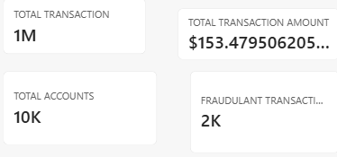

Dashboard Components

1. Overall AML Dashboard
The main dashboard combines the transaction trend, fraud-status donut chart, summary cards, alert chart, fraud trend, transaction-value comparison and slicers in one report page.
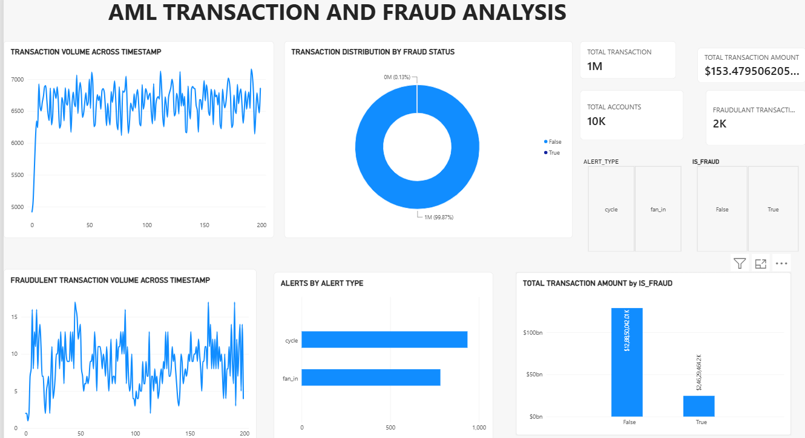

2. Transaction Distribution by Fraud Status
The donut chart shows that False accounts for approximately 99.87% of the transactions and True accounts for approximately 0.13%. This means the flagged fraud category represents a very small share of total transaction volume, although it still deserves attention.
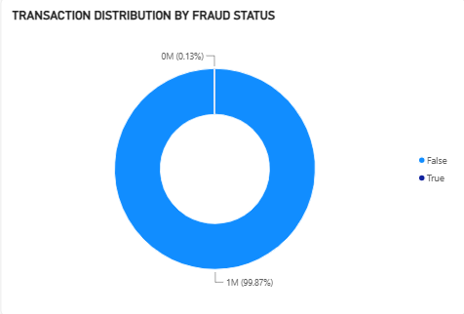

3. Transaction Volume Across Timestamp
The line chart plots transaction volume across the timestamp axis. After an initial increase, the series fluctuates mostly between about 6,200 and 7,100 transactions, with repeated short-term peaks and dips. These movements can help identify periods worth closer examination.
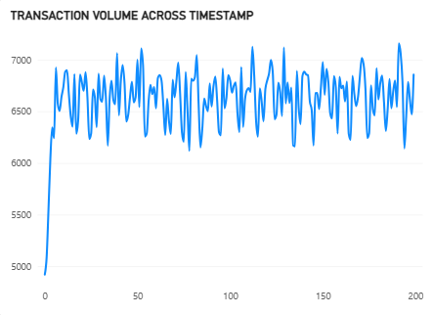

4. Fraudulent Transaction Volume Across Timestamp
This chart focuses on transactions classified as fraudulent. Values vary across the displayed timestamps, with occasional spikes above 15 and lower periods near 2–5. The pattern suggests fraud-related activity is uneven rather than constant throughout the displayed sequence.
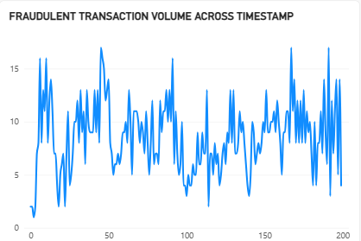

5. Total Transaction Amount by IS_FRAUD
The column chart compares monetary values for False and True fraud-status categories. The False category represents the overwhelming majority of total transaction value. The True category is visibly smaller. This comparison adds financial context to the fraud-count distribution, but does not by itself establish the loss caused by fraud.
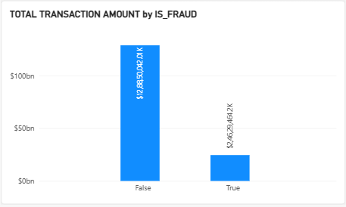

6. Alerts by Alert Type
The horizontal bar chart shows two alert categories: cycle and fan_in. The cycle category has the larger count, at roughly 900–950, while fan_in is around 750–800. Alerts indicate activity selected for review; an alert alone does not prove fraudulent behaviour.
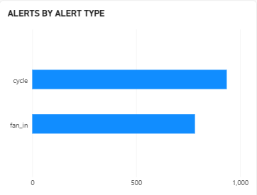

7. Slicers Used
Two slicers are visible: ALERT_TYPE, with cycle and fan_in, and IS_FRAUD, with False and True. These selections allow the dashboard user to narrow the displayed results to a particular alert category or fraud status.
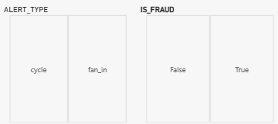

8. AML Tooltip
The Power BI report also includes an AML Tooltip page. In the screenshot, a tooltip-style panel shows additional filtered KPI values, including approximately 6K transactions, a transaction amount beginning with $288.3, and 8 fraudulent transactions. The monetary figure is cut off in the screenshot, so its full value cannot be confirmed. The tooltip helps users inspect more detail while keeping the main report uncluttered.
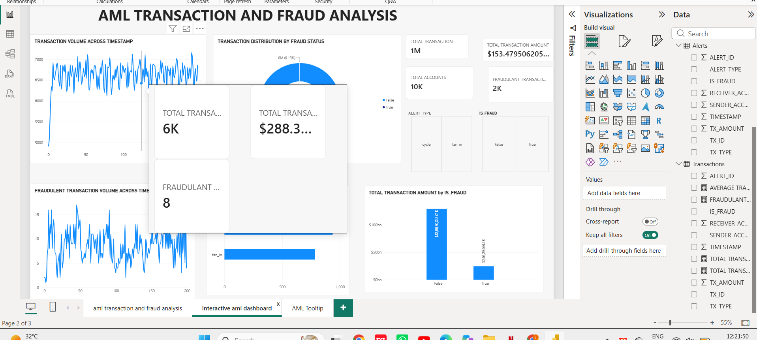

Key Findings
- The dashboard summarises about 1M transactions, 10K accounts and 2K fraudulent transactions.
- The donut chart reports 99.87% False and 0.13% True in the fraud-status distribution.
- The overall transaction volume fluctuates across timestamps, while the fraudulent-transaction series shows several distinct peaks.
- The non-fraud category dominates total transaction value in the displayed column chart.
- cycle alerts outnumber fan_in alerts in the alert-type comparison.
- The fraud-status and alert-type slicers, together with the AML Tooltip page, support interactive exploration.

Conclusion
This Power BI project demonstrates how transaction data, fraud classifications and alert information can be presented in a single AML monitoring dashboard. KPI cards provide a quick summary, while line, donut, column and bar charts help compare trends and categories. Slicers and tooltips make the analysis more interactive. The dashboard is useful for identifying patterns for further review, but a flagged transaction or alert must be investigated before any final conclusion about fraud or money laundering is reached.

References
- IBM – Anti-Money Laundering dataset (Dataset 5).
- Microsoft Power BI Desktop.
- Microsoft Power BI documentation.

