FINANCIAL AND SALES PERFORMANCE
DASHBOARD
Mini Project using Microsoft Power BI
PROJECT REPORT

Submitted By:
Name: M. Jaya Prathiba
Roll Number: E25FA064
Programme: B.Com FinTech with AI
Tool Used: Microsoft Power BI Desktop

1. Introduction
For this mini project, I used Microsoft Power BI to study the sales and financial performance of a distribution business. The dashboard covers products from Personal Care, Stationery, Food & Grocery, Household, Apparel and Electronics. It brings together sales, profit, customer payments, returns, branches and salesperson performance for 2024 and 2025.
I arranged the report into eight dashboard pages so that the main figures can be understood first and the details can be checked separately. The visuals make it easier to notice changes in monthly sales, identify profitable categories and see where the business needs improvement.

Objectives
- To present important sales and profit figures through KPI cards and charts.
- To compare product categories, subcategories and discounts.
- To study customers, overdue amounts and collection patterns.
- To understand the reasons for sales returns.
- To compare branch and salesperson performance.
- To use filters and a drill-through page to explore details.

2. Data Model
The project is organised around transaction information and descriptive tables. The following tables and roles follow the structure described in the reference mini-project. The screenshots show the report pages rather than the model view, so the exact relationships should be checked in Power BI Desktop.
Table | Purpose
FactInvoices | Invoice amounts, invoice count, status and ageing
FactInvoiceLines | Product-level sales, discount, cost and gross profit
FactPayments | Collections and payment methods
FactSalesReturns | Returned amounts and return reasons
DimProduct | Product, category and subcategory
DimCustomer | Customer and customer type
DimSalesperson | Salesperson names
DimBranch / DimCity / DimState / DimRegion | Branch and geographic details
DimDate | Year, month and date fields

3. Main Measures Used
The KPI cards display the following overall values when the dashboards are not filtered. “M” means million and “K” means thousand.
Measure | Value | Meaning
Total Sales | 136.40M | Sales after discount
Cost of Goods Sold | About 110M | Cost of products sold
Gross Profit | 26.16M | Sales less cost of goods sold
Gross Profit Margin | 19.18% | Gross profit as a share of sales
Total Collection | 102.72M | Payments received
Total Invoices | About 2K | Number of invoices
Overdue Amount | 33.02M | Amount displayed as overdue
Sales Returns | 1.47M | Value of returned products
Total Branches / Regions | 10 / 4 | Business coverage
Total Salespersons | 35 | Sales team size

4. Dashboard Structure
Page | Dashboard | Main purpose
1 | Executive Sales Overview | Sales KPIs and monthly trend
2 | Product & Discount Analysis | Categories, products and discounts
3 | Customer & Receivables | Invoices and overdue payments
4 | Collections & Sales Returns | Payment methods and return reasons
5 | Branch & Regional Performance | Branch invoices and region visuals
6 | Salesperson Performance & Profitability | Individual sales and profit
7 | Overall Performance & Dashboard | Combined financial summary
8 | Product Category Details | Stationery drill-through view

5. Dashboard Pages

5.1 Page 1: Executive Sales Overview
The first page gives a quick summary of the business. It has five cards for Total Collection, Total Invoices, Gross Profit Margin, Gross Profit and Total Sales. A line chart shows sales month by month, while the Region, Year and Branch filters help narrow down the view.
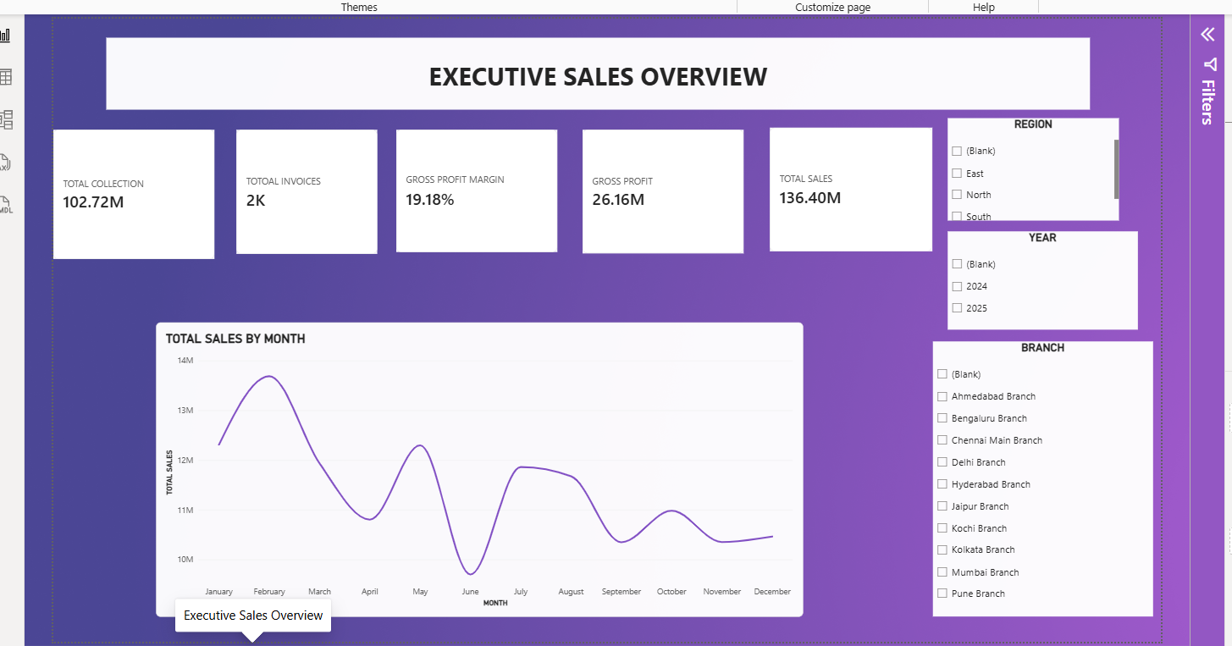
Executive Sales Overview dashboard
Visual | Type | What it shows
KPI cards | Card | Total Sales, Gross Profit, Margin, Invoices, Collection
Total Sales by Month | Line chart | Month and Total Sales
Region, Year, Branch | Slicers | Region, date and branch

Key observations:
- Total sales are 136.40M, with gross profit of 26.16M and a margin of 19.18%.
- February has the highest monthly sales, around 13.7M, while June falls to roughly 9.7M.
- The drop in June is followed by a recovery in July. This is useful when planning sales targets and stock.

5.2 Page 2: Product & Discount Analysis
This page helped me understand which categories sell more, which products contribute to profit and how discounts are distributed. The treemap is especially useful because the larger boxes show the bigger subcategory sales values.
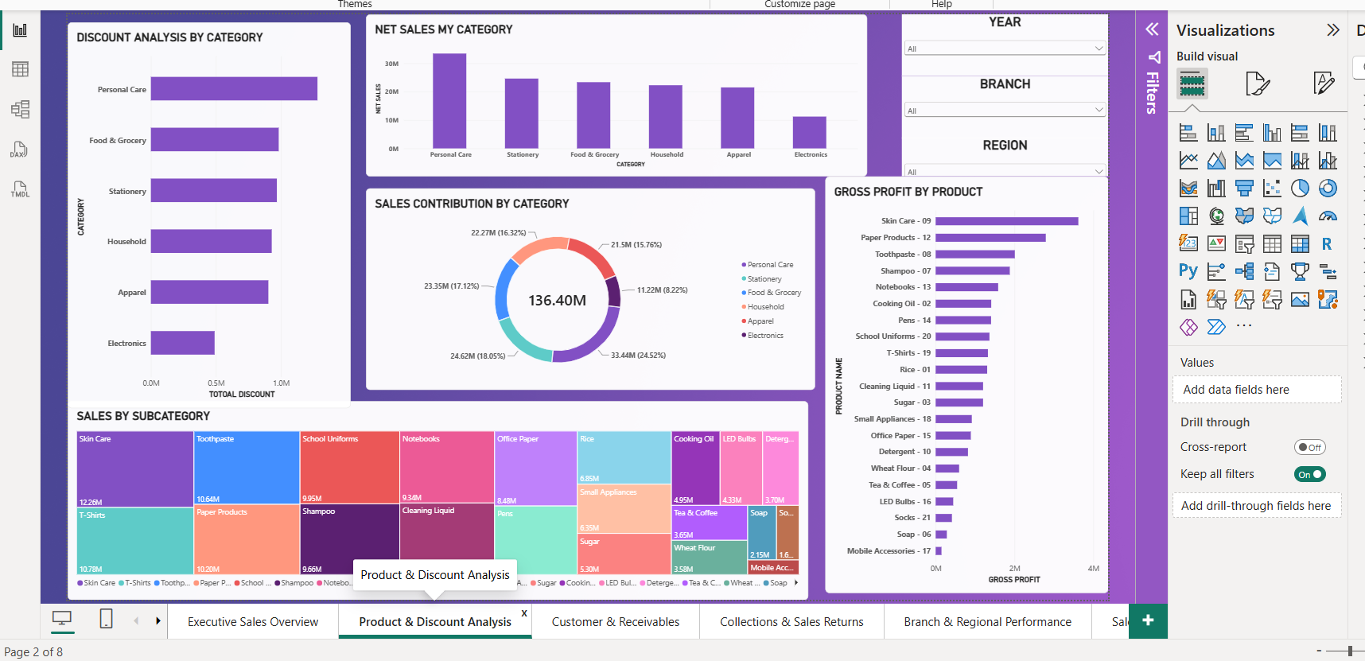
Product & Discount Analysis dashboard
Visual | Type | What it shows
Discount Analysis by Category | Bar chart | Category and discount
Net Sales by Category | Column chart | Category and net sales
Sales Contribution by Category | Donut chart | Category and total sales
Gross Profit by Product | Bar chart | Product and gross profit
Sales by Subcategory | Treemap | Subcategory and sales

Key observations:
- Personal Care contributes the most sales at 33.44M (24.52%).
- Stationery contributes 24.62M (18.05%), and Electronics is the smallest category at 11.22M (8.22%).
- Skin Care, T-Shirts and Toothpaste are among the largest subcategories.
- Personal Care also has the highest discount amount, so its discounts should be reviewed along with profit.

5.3 Page 3: Customer & Receivables
This page focuses on customer invoices, payments and money still to be collected. The customer table shows invoice amount, ageing bucket and collection, while the other visuals show overdue balances and top customers.
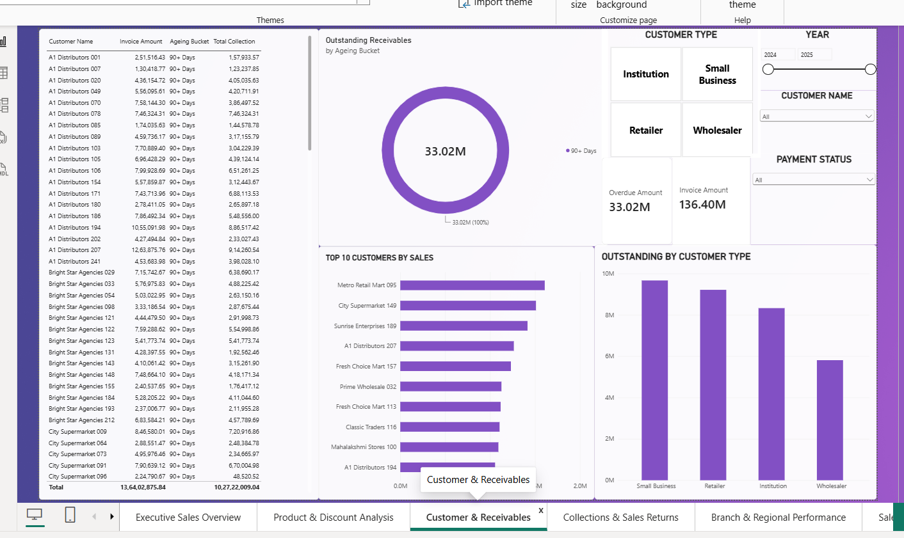
Customer & Receivables dashboard
Visual | Type | What it shows
Customer details | Table | Customer, invoice, ageing, collection
Outstanding by Ageing Bucket | Donut chart | Ageing bucket and outstanding amount
Outstanding by Customer Type | Column chart | Customer type and amount
Top 10 Customers by Sales | Bar chart | Customer and sales
Customer Type, Year, Status, Name | Slicers | Customer and invoice filters

Key observations:
- The invoice amount is 136.40M and collections are 102.72M.
- The dashboard shows an overdue amount of 33.02M, entirely in the 90+ Days ageing bucket.
- Small Business has the largest overdue share, followed by Retailers.
- Older pending invoices need attention because they can affect the cash available to the business.

5.4 Page 4: Collections & Sales Returns
This page shows how the business receives payments and why products are returned. It combines total collection, payment count, sales returns, a payment-method chart and a monthly collections trend.
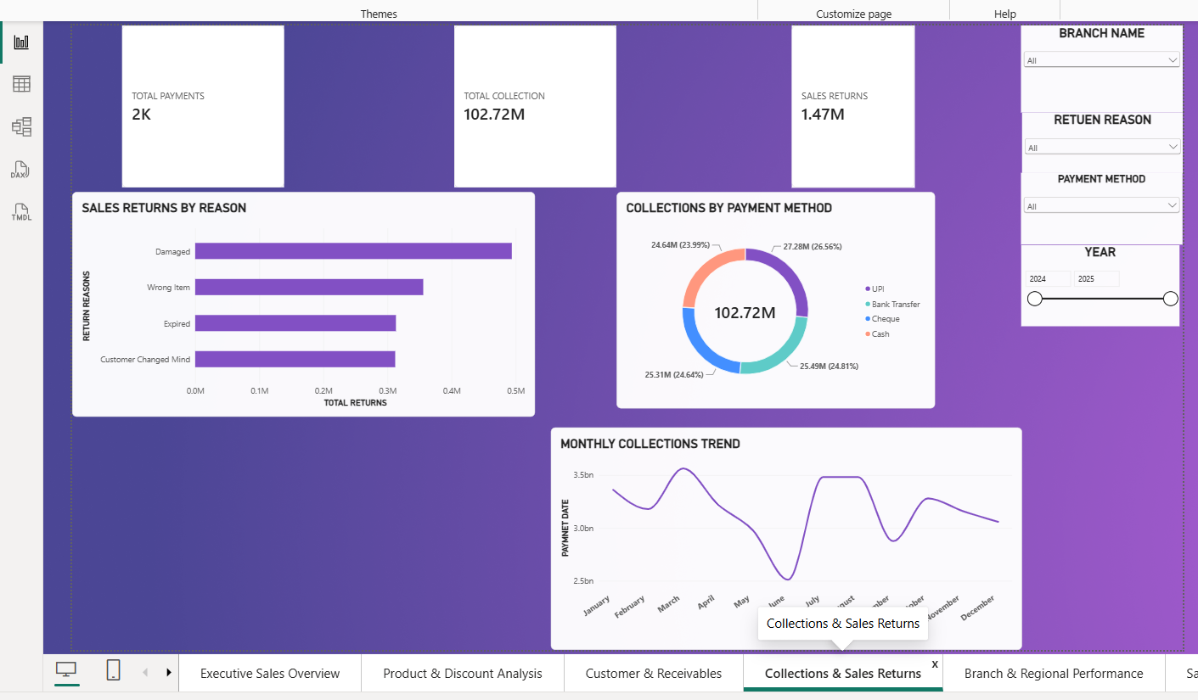
Collections & Sales Returns dashboard
Visual | Type | What it shows
Collection, Payments, Returns | Cards | Key collection and return measures
Collections by Payment Method | Donut chart | Payment method and collection
Sales Returns by Reason | Bar chart | Return reason and value
Monthly Collections Trend | Line chart | Month and collection

Key observations:
- The business collected 102.72M and recorded 1.47M in returns.
- UPI accounts for about 27.28M (26.56%) of collections, followed closely by bank transfers, cheques and cash.
- Damaged goods are the biggest reason for returns. Wrong items, expired goods and changed customer decisions are other reasons.
- Collections drop in June and then improve, which makes monthly follow-up important.

5.5 Page 5: Branch & Regional Performance
The branch page compares invoice activity and attempts to compare regions. It shows 10 branches and four regions, with filters for city, region, year and branch.
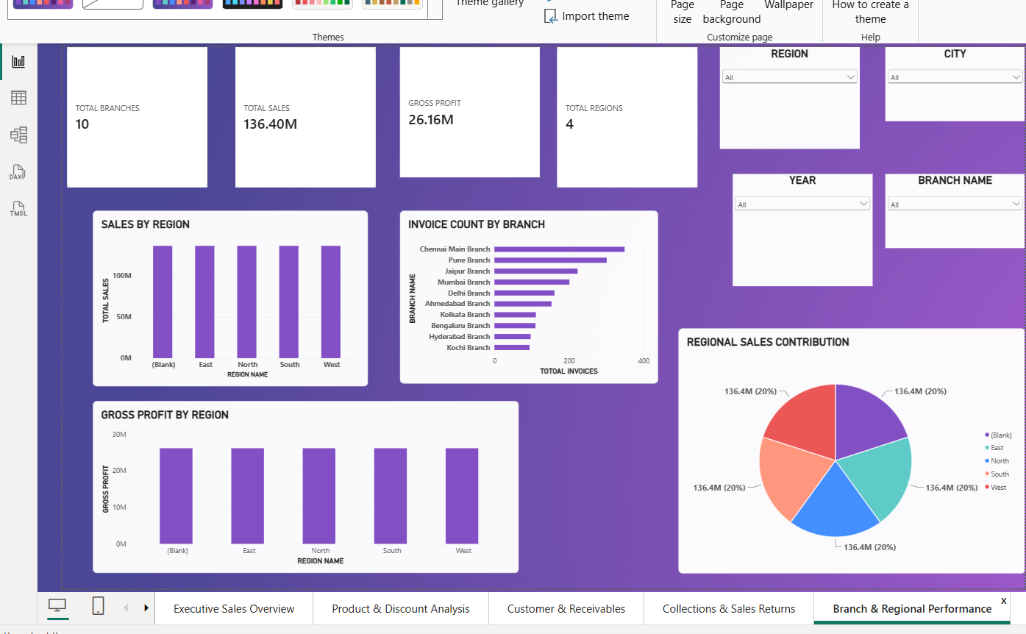
Branch & Regional Performance dashboard
Visual | Type | What it shows
Total Branches, Sales, Profit, Regions | Cards | Overall branch measures
Invoice Count by Branch | Bar chart | Branch and invoice count
Sales and Gross Profit by Region | Column charts | Region and sales/profit
Regional Sales Contribution | Pie chart | Region and total sales

Key observations:
- Chennai Main Branch has the largest invoice count, followed by Pune and Jaipur.
- The region charts repeat 136.40M sales and 26.16M gross profit across the regions and include a blank category.
- These repeated values appear to be a filtering or relationship issue, so they should not be treated as actual region-wise results until corrected.

5.6 Page 6: Salesperson Performance & Profitability
This page helps compare the sales team. The table brings together total sales, gross profit, invoice count and collections for each person. The charts make the stronger contributors easier to identify.
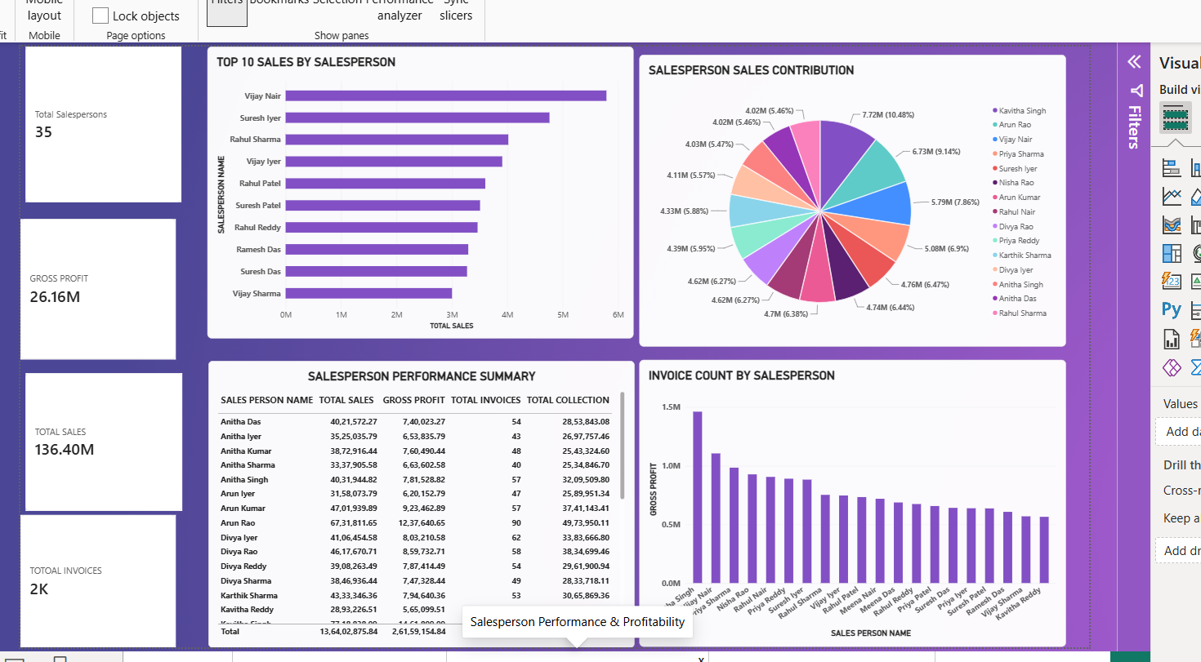
Salesperson Performance & Profitability dashboard
Visual | Type | What it shows
Salespersons, Sales, Profit, Invoices | Cards | Overall team measures
Top 10 Sales by Salesperson | Bar chart | Salesperson and total sales
Salesperson Sales Contribution | Pie chart | Salesperson and sales
Performance Summary | Table | Sales, profit, invoices, collection
Invoice Count by Salesperson | Column chart | Displayed gross profit by person

Key observations:
- The business has 35 salespersons.
- Vijay Nair leads the displayed Top 10 sales bar chart, while the pie chart shows Kavitha Singh with the largest labelled contribution.
- The difference between the two charts suggests that the Top 10 filter should be checked.
- The chart titled “Invoice Count by Salesperson” has a Gross Profit axis, so its title should be updated.

5.7 Page 7: Overall Performance & Dashboard
The financial summary combines the most important business measures. It includes a category table, collections trend, return reasons, regional profit chart and category contribution chart.
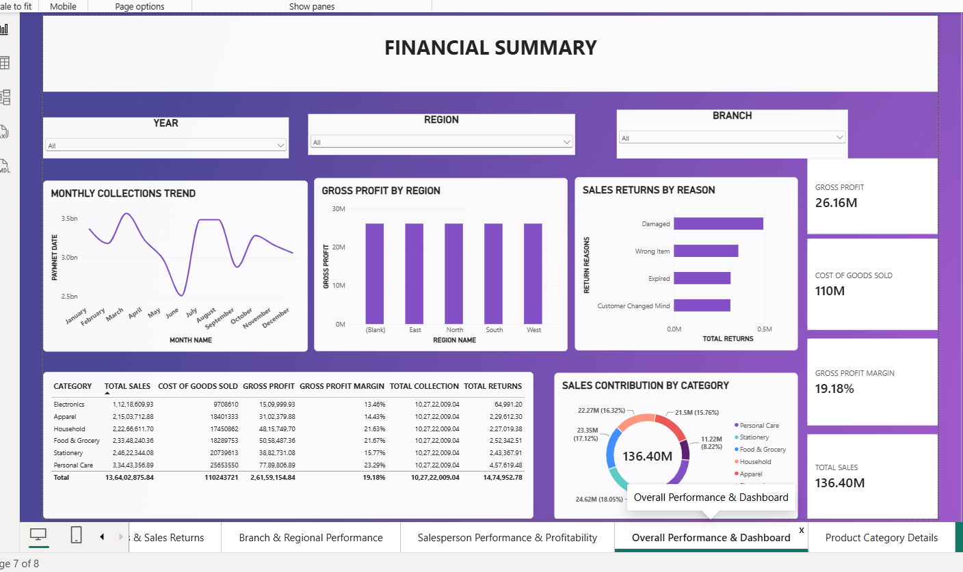
Overall Performance & Financial Summary dashboard
Visual | Type | What it shows
Sales, Cost, Profit, Margin | Cards | Main financial measures
Category Summary | Table | Sales, cost, profit, margin, collection, returns
Collections Trend | Line chart | Month and collection
Returns by Reason | Bar chart | Reason and return value
Sales Contribution by Category | Donut chart | Category and sales

Key observations:
- Sales are 136.40M and cost of goods sold is about 110.24M, leaving 26.16M gross profit.
- Personal Care has the highest gross profit margin at 23.29%, while Electronics has the lowest at 13.46%.
- The category table repeats the total collection figure for each category, which should not be interpreted as category-specific collection.

5.8 Page 8: Product Category Details (Drill-through)
The final page is a drill-through view for Stationery. It allows a category selected on another page to be studied in more detail. The back button takes the user to the previous report page.
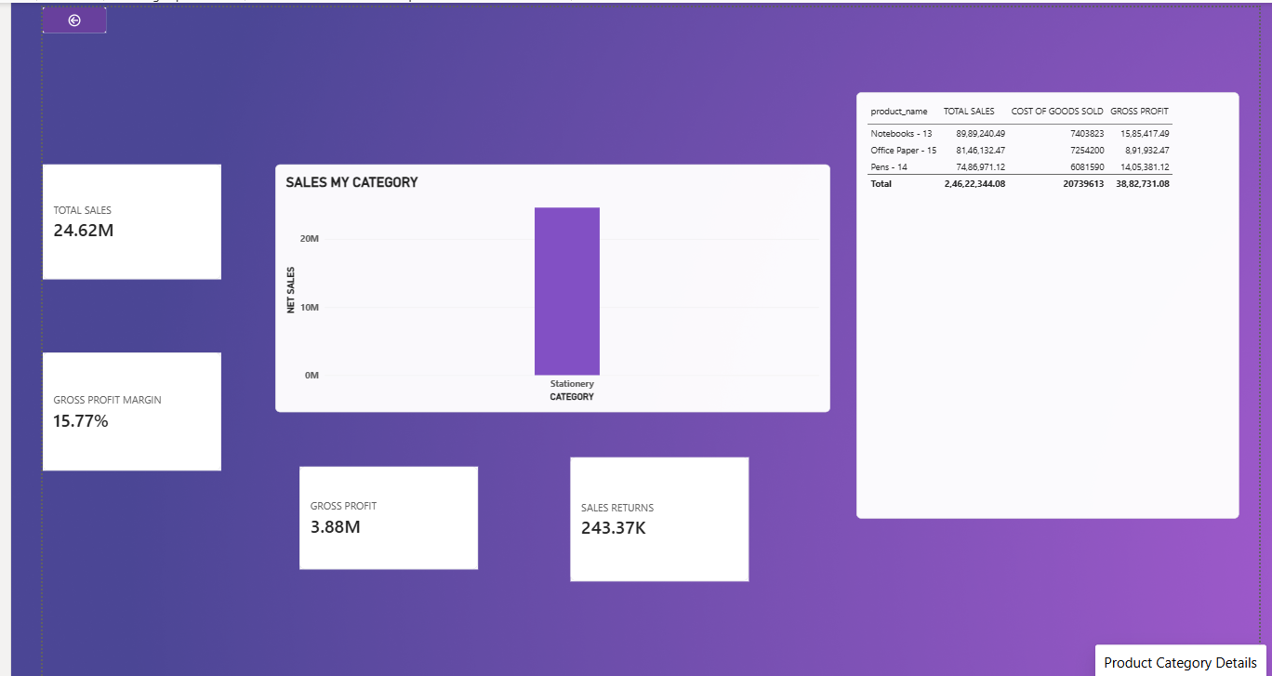
Stationery Product Category Details dashboard
Visual | Type | What it shows
Sales, Margin, Profit, Returns | Cards | Stationery measures
Sales by Category | Column chart | Filtered category and sales
Product Details | Table | Product, sales, cost and gross profit
Back Button | Navigation | Return to previous page

Key observations:
- Stationery sales are 24.62M with gross profit of 3.88M and a margin of 15.77%.
- The page shows sales returns of about 243.37K.
- Notebooks, Office Paper and Pens are the three products in the table.
- This page is useful for comparing individual product sales with the profit they actually earn.

6. Key Findings
- The business achieved 136.40M in sales and 26.16M in gross profit, with a margin of 19.18%.
- Personal Care is the largest sales category and also has the highest gross profit margin.
- Sales peak around February and fall to their lowest level in June.
- The 33.02M overdue balance is shown entirely in the 90+ Days bucket.
- UPI is the leading collection method, although collections are distributed across four methods.
- Damaged goods are the main reason for sales returns.
- The region visuals and some salesperson labels need checking before the dashboard is used for detailed comparisons.

7. Suggestions
- Follow up regularly with customers whose invoices have been pending for more than 90 days.
- Improve packaging, product checks and dispatch processes to reduce avoidable returns.
- Compare category discounts with gross profit before increasing promotions.
- Review the region relationships in the Power BI data model and remove or resolve blank region entries.
- Check Top N filters and chart titles so the salesperson visuals display consistent information.

8. Conclusion
By completing this mini project, I understood how Power BI can turn sales and financial data into clear visual reports. Instead of checking every transaction separately, I can use the dashboards to see overall sales, profit, pending collections, returns and performance by product or employee. The main result is that the business is earning a positive gross profit, but it also needs to focus on overdue payments and avoidable returns. I also learned that visuals must be checked carefully, because incorrect relationships or labels can lead to misleading conclusions.
Note: This report is based on the eight supplied dashboard screenshots. Values displayed in millions and thousands are rounded. The original Power BI data model was not provided for independent verification.

