POWER BI – RETAIL SALES & PROFIT DASHBOARD
Dashboard Analysis Report
Submitted by: M. Jaya Prathiba
Roll No: E25FA064
Department: II B.Com (FinTech with AI)
Year of Study: Second Year
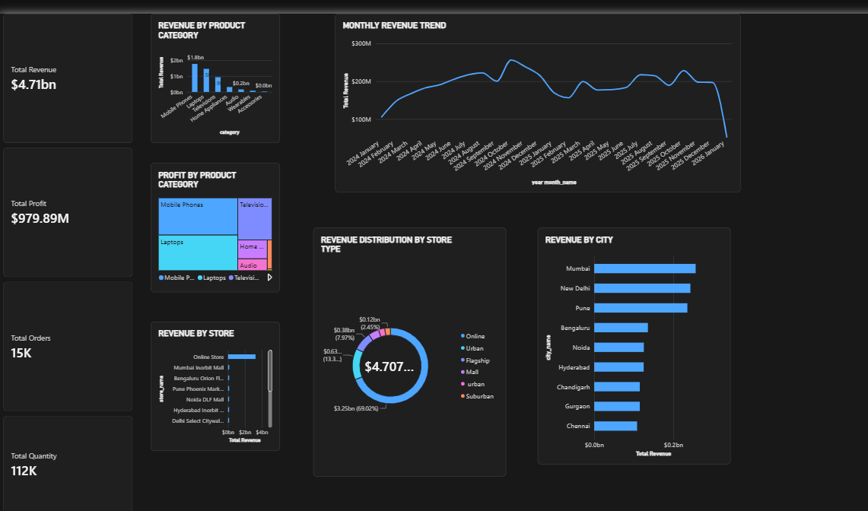

Introduction
For this project, I used Power BI to study retail sales performance through an interactive dashboard. The dashboard combines key performance indicators and visualisations of revenue, profit, product categories, stores, store types, cities and monthly trends. It makes the sales information easier to understand and helps identify which areas contribute most to overall business performance.

Objectives
- Summarise total revenue, profit, orders and quantity sold.
- Compare revenue and profit across product categories.
- Analyse monthly changes in revenue.
- Examine revenue contribution by individual stores and store types.
- Compare sales performance across cities and identify major contributors.

Dataset Description
The retail sales dashboard presents aggregated sales and profitability information. The visible measures include Total Revenue, Total Profit, Total Orders and Total Quantity. The displayed dimensions include product category, month, store, store type and city. The underlying raw dataset and calculation formulas were not provided, so this report focuses on the information visible in the dashboard.

Data Preparation
- Ensure revenue and profit are numeric measures and formatted consistently.
- Check order identifiers and quantity values before aggregation.
- Confirm that the month field is sorted chronologically.
- Review product category, store, store type and city labels for consistency.
- Check for missing values and duplicate transactions before finalising totals.

Measures and KPIs
The four KPI cards give an immediate summary of the retail business: Total Revenue is $4.71bn, Total Profit is $979.89M, Total Orders are 15K, and Total Quantity is 112K. These figures provide context for the more detailed charts.
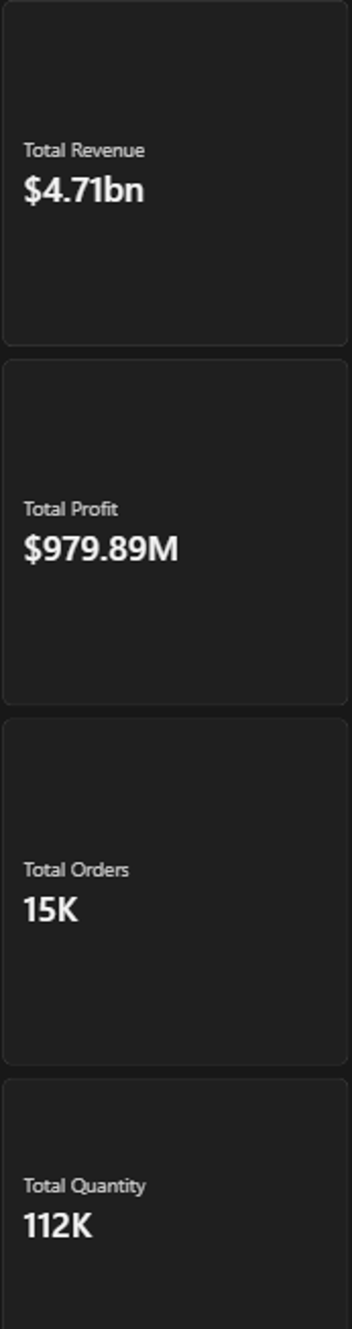
Figure 1. Key performance indicator cards

Dashboard Components

Revenue by Product Category
The column chart compares sales across product categories. Mobile Phones is the largest category at approximately $1.8bn, followed by Laptops. The smaller categories contribute substantially less revenue. This helps identify the product groups driving sales.
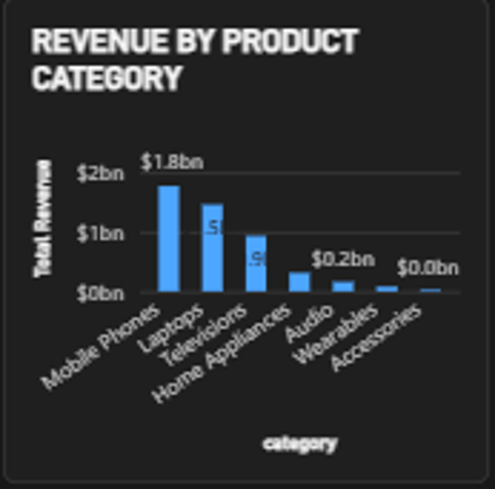
Figure 2. Revenue by product category

Profit by Product Category
The treemap shows the relative profit contribution of product categories. Mobile Phones and Laptops occupy the largest areas, indicating their important contribution to profit. The smaller rectangles represent categories with lower profit contributions.
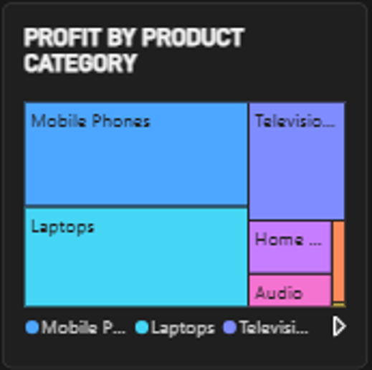
Figure 3. Profit by product category

Monthly Revenue Trend
The line chart tracks monthly revenue from 2024 through early 2026. Revenue generally rises through much of 2024, then fluctuates across 2025 with several peaks and dips. The sharp fall at the far right may reflect an incomplete final month and should not be interpreted as a confirmed collapse without checking the reporting period.
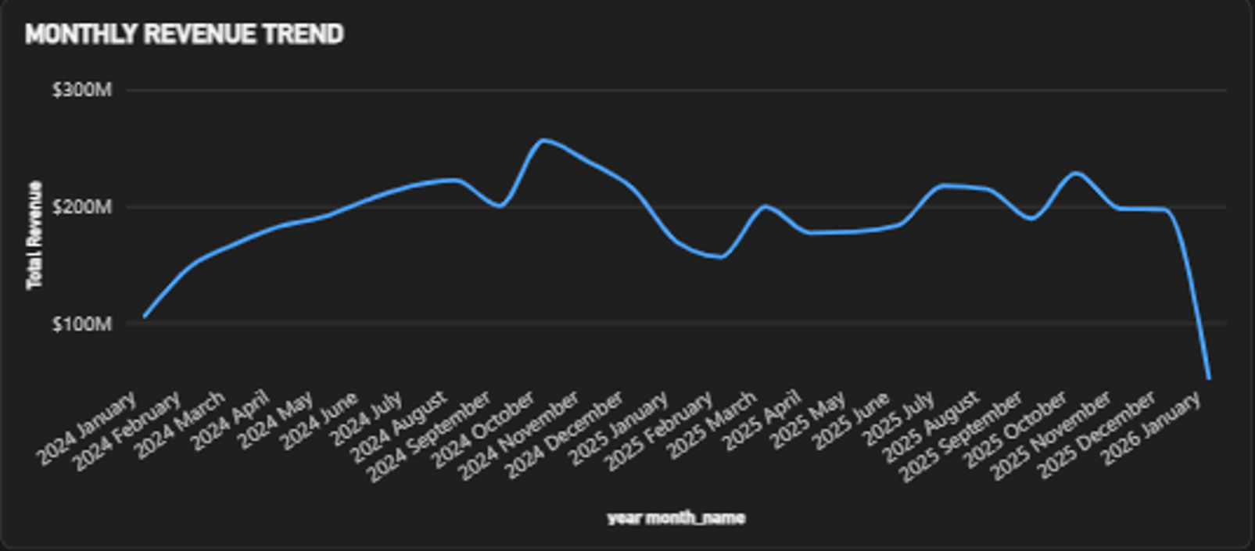
Figure 4. Monthly revenue trend

Revenue by Store
The horizontal bar chart compares individual stores. The Online Store clearly leads the displayed stores, while individual physical outlets contribute smaller amounts. This view helps evaluate store-level performance and channel concentration.
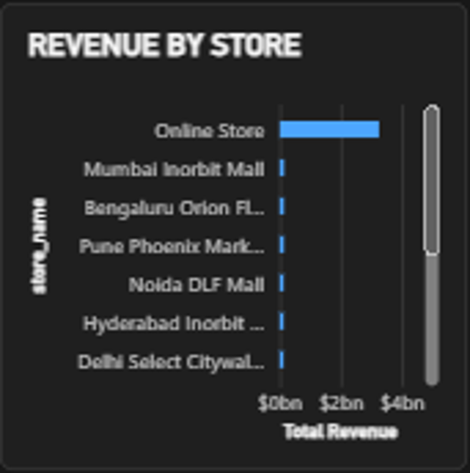
Figure 5. Revenue by store

Revenue Distribution by Store Type
The doughnut chart breaks total revenue down by store type. Online accounts for the largest share, approximately $3.25bn (69.02%). Other formats such as Urban, Flagship, Mall, urban and Suburban account for the remaining revenue. This indicates a strong dependence on online sales.
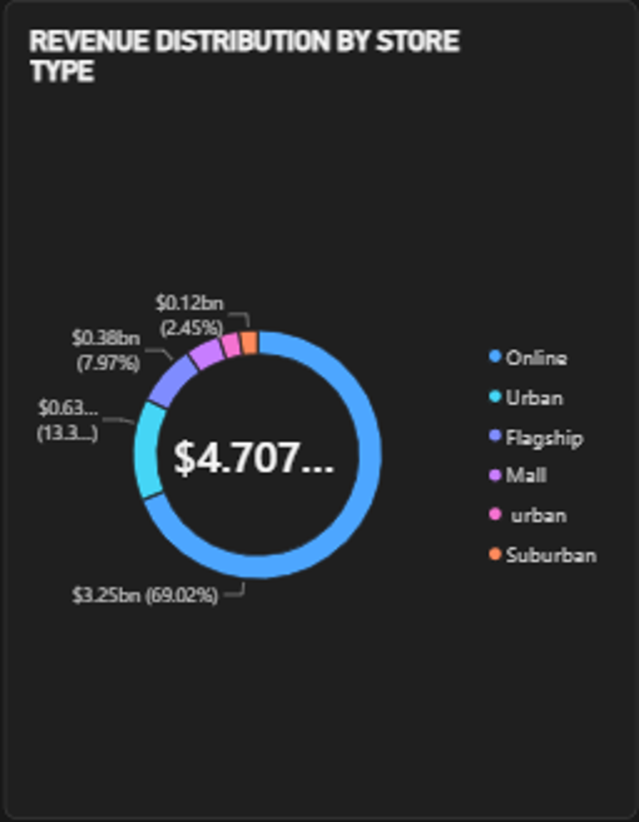
Figure 6. Revenue distribution by store type

Revenue by City
The horizontal bar chart compares revenue across Mumbai, New Delhi, Pune, Bengaluru, Noida, Hyderabad, Chandigarh, Gurgaon and Chennai. Mumbai appears highest among the cities shown, followed closely by New Delhi and Pune. The comparison helps identify stronger and weaker geographical markets.
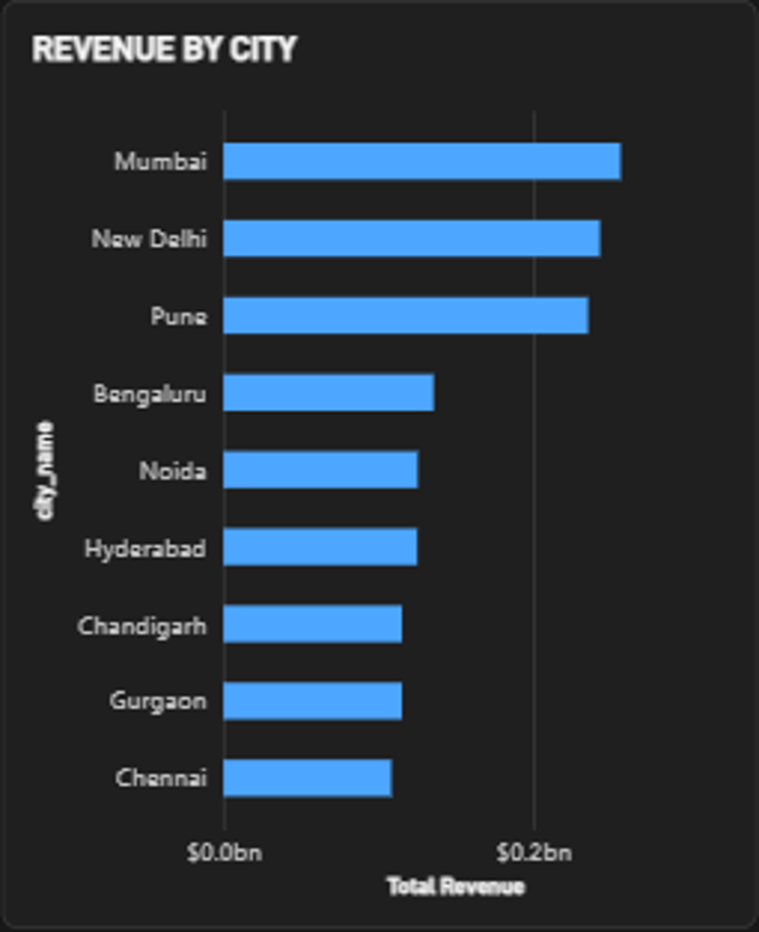
Figure 7. Revenue by city

Key Findings
- The dashboard records approximately $4.71bn in revenue and $979.89M in profit.
- Mobile Phones is the largest revenue-generating product category.
- The Online Store is the leading individual store and the online store type contributes about 69% of revenue.
- Monthly revenue changes noticeably over time; the final-period decline needs validation against month completeness.
- Mumbai, New Delhi and Pune are among the highest-revenue cities shown.
- Revenue and profit charts together give a more balanced understanding of product performance.

Conclusion
This Power BI dashboard provides a clear overview of retail performance using KPI cards, a line chart, column charts, a treemap, a doughnut chart and horizontal bar charts. It highlights leading product categories, the importance of online sales, geographical differences and changes in monthly revenue. Overall, the dashboard supports performance monitoring and can guide further investigation into sales growth and profitability.

References
- Retail Sales Power BI dashboard screenshot supplied for this report.
- Microsoft Power BI Desktop.

