STATIONERY INVENTORY MANAGEMENT SYSTEM
A PROJECT REPORT
Submitted by
JAYARAMAN S
(2116240701210)
in partial fulfilment of the End Semester Examination for the course
CB23F35 –
LOW-CODE APPLICATION DEVELOPMENT USING ZOHO CREATOR
in
BACHELOR OF ENGINEERING
COMPUTER SCIENCE AND ENGINEERING

RAJALAKSHMI ENGINEERING COLLEGE
(An Autonomous Institution, Affiliated to Anna University, Chennai)
Rajalakshmi Nagar, Thandalam, Tamil Nadu – 602 105
NOVEMBER 2026

RAJALAKSHMI ENGINEERING COLLEGE
(An Autonomous Institution, Affiliated to Anna University, Chennai)
BONAFIDE CERTIFICATE
Certified that this project report titled “Stationery Inventory Management System” is the bonafide work of JAYARAMAN S (2116240701210), who carried out the individual project work on the Zoho Creator low-code platform for the course CB23F35 – Low-Code Application Development using Zoho Creator, during the academic year 2026–2027, Semester V, under my supervision.
SIGNATURE  Dr. Manoranjini J  HEAD OF THE DEPARTMENT  Department of Computer Science and Engineering  Rajalakshmi Engineering College  Thandalam – 602 105 | SIGNATURE  Dr. J. Jinu Sophia  COURSE FACULTY  Associate Professor  Department of Computer Science and Engineering  Rajalakshmi Engineering College

Submitted for the End Semester Examination (Individual Project) held on ____________________.
INTERNAL EXAMINER | EXTERNAL EXAMINER

DECLARATION
I, JAYARAMAN S (2116240701210), hereby declare that the project report titled “Stationery Inventory Management System”, submitted for the End Semester Examination of the course CB23F35 – Low-Code Application Development using Zoho Creator, is a record of original work carried out by me individually. The Zoho Creator application described in this report — including its data model, forms, reports, pages, Deluge scripts, workflows and integrations — was designed and developed by me.
I further declare that this work has not been submitted, in part or in full, for the award of any other degree or course credit. The application was built from scratch on Zoho Creator and no Zia AI feature or AI application builder was used. Every template, sample application, code snippet or external resource used in this work has been duly acknowledged in the report.
Place: Chennai SIGNATURE OF THE STUDENT
Date: ____________________ JAYARAMAN S
2116240701210

ACKNOWLEDGEMENT
I express my sincere gratitude to our Chairman Dr. Thangam Meganathan and Vice-Chairman Mr. Abhay Meghanathan for providing the infrastructure and facilities that made this work possible.
I am grateful to our Principal, Dr. S. N. Murugesan, Rajalakshmi Engineering College, for the constant encouragement extended to students to take up industry-relevant learning.
I thank Dr. Manoranjini J, Head of the Department, Department of Computer Science and Engineering, for the guidance and support provided throughout the course.
I owe my sincere thanks to my course faculty, Dr. J. Jinu Sophia, Associate Professor, for the valuable guidance, reviews and feedback that shaped this application and report.
I also acknowledge Zoho Corporation for providing access to the Zoho Creator platform and learning resources, and I thank my family and friends for their unwavering support.

JAYARAMAN S

ABSTRACT
Stationery and office supplies in colleges and small offices are commonly tracked in registers or spreadsheets. Such manual records invite calculation and data-entry errors, allow more stock to be issued than is available, delay the discovery of items that have reached their reorder level, and make it hard to follow a purchase order from request to receipt. These weaknesses lead to shortages, last-minute purchases and unclear accountability.
This project presents the Stationery Inventory Management System, a low-code application built from scratch on Zoho Creator without Zia AI. It has three forms (Items, Stock Transaction and Purchase Orders), four regular reports, two approval task views and an Inventory Dashboard with summary panels, an item-wise stock chart and low-stock and transaction lists. Deluge scripts update current stock for every Stock In and Stock Out entry, reject a Stock Out that exceeds the available quantity, and fetch the unit price of the selected item into a purchase order. A Blueprint moves each order through the Pending, Ordered, Received and Cancelled stages, and receiving an order adds the ordered quantity to stock. Orders of ₹1,000 or more are routed to an approver, and a daily scheduled workflow emails the items that have reached their reorder level. Access is controlled through a Super Admin account and a CEO role with Write permission.
The application was verified through functional tests of stock updates, the insufficient-stock validation, price auto-fill, Blueprint transitions, approval and rejection actions and the daily alert email. It was promoted from the Development environment through Stage to Production as version 3.2. The work shows that a complete inventory process covering data capture, automation, approval and reporting can be delivered on a low-code platform using only built-in features, without third-party integration. Future work includes a weekly digest, a monthly valuation report and an approval-status column in the purchase order report.
Keywords: Low-Code Development; Zoho Creator; Inventory Management; Deluge Scripting; Blueprint; Approval Workflow

PROJECT AT A GLANCE
Attribute | Details
Project Title | Stationery Inventory Management System
Application Domain | Stationery / office-supplies inventory management
Student Name & Register No. | Jayaraman S – 2116240701210
Zoho Creator Edition | Free Plan
Application Name (Link Name) | stationery-inventory-management-system
Published / Live URL | https://creatorapp.zoho.in/jayaraman.s.2024.cse_raja676/stationery-inventory-management-system#Form:Items
Demo Credentials (per role) | Super Admin: jayaraman.s.2024.cse@rajalakshmi.edu.in  CEO (Write): s.jayaraman4321@gmail.com  Password: to be added by the student
Number of Forms / Subforms | 3 forms / 0 subforms
Number of Reports (by type) | List: 4 (All Items, Low Stock Items, All Stock Transactions, All Purchase Orders)  Kanban: 0 Calendar: 0 Pivot/Chart: 0  Others: 2 approval task views (Pending Tasks, Completed Tasks)
Number of Pages / Dashboards | 1 dashboard (Inventory Dashboard)
Number of Workflows | Form: 3 Schedule: 1 Approval: 1 Blueprint: 1 Batch: 0
Deluge Functions / Custom Actions | 0 separately created custom functions; 5 Deluge scripts (DS-01 to DS-05) used in workflows, Blueprint and schedule
Integrations | None (no third-party integration). Zoho Creator built-in email (sendmail) and approval notifications only
Roles & Profiles Defined | Super Admin; CEO (Write permission)
Environments Used | Development → Stage → Production (Stage and Production at version 3.2)
Date of Production Deployment | 31 October 2026

TABLE OF CONTENTS
ABSTRACT iv
PROJECT AT A GLANCE v
LIST OF TABLES viii
LIST OF FIGURES ix
LIST OF ABBREVIATIONS xi
INTRODUCTION 1
1.1 Background 1
1.2 Problem Statement 1
1.3 Objectives 2
1.4 Scope of the Project 2
1.5 Justification for a Low-Code Approach 3
1.6 Organisation of the Report 3
LITERATURE SURVEY AND SYSTEM STUDY 4
2.1 Study of the Existing System 4
2.2 Limitations of the Existing System 5
2.3 Low-Code versus Traditional Development 6
2.4 Literature Survey 7
2.5 Emerging Trends in Low-Code Development 8
2.6 Proposed System 8
REQUIREMENT ANALYSIS 10
3.1 Stakeholders and User Roles 10
3.2 Functional Requirements 10
3.3 Non-Functional Requirements 12
3.4 Hardware and Software Requirements 12
3.5 Use Case Model 13
SYSTEM DESIGN 15
4.1 System Architecture 15
4.2 Data Model 16
4.3 Form Design 17
4.4 Process and Workflow Design 19
4.5 User Interface and Navigation Design 20
4.6 Access Control Design 22
IMPLEMENTATION 23
5.1 Application Setup 23
5.2 Forms and Data Capture 24
5.3 Reports 27
5.4 Pages and Dashboards 30
5.5 Deluge Scripting 32
5.6 Workflows and Automation 34
5.7 Integrations 36
5.8 User Management and Role-Based Access 37
5.9 AI and Analytics Features 37
5.10 Pro-Code Extension 38
5.11 Mobile and Portal Access 38
TESTING AND DEBUGGING 39
6.1 Testing Strategy 39
6.2 Test Cases 39
6.3 Debugging Deluge Scripts 41
6.4 Defect Log 42
6.5 User Acceptance Testing 42
DEPLOYMENT, SECURITY AND GOVERNANCE 44
7.1 Environments and Deployment Strategy 44
7.2 Performance Optimisation 45
7.3 Security Features 46
7.4 Governance and Administration 47
RESULTS AND DISCUSSION 48
8.1 Application Output 48
8.2 Achievement of Objectives 53
8.3 Comparison with the Existing System 54
8.4 Limitations of the Low-Code Approach 54
8.5 Reflection on the No-Code → Low-Code → Pro-Code Spectrum 55
CONCLUSION AND FUTURE ENHANCEMENTS 56
9.1 Conclusion 56
9.2 Future Enhancements 56
9.3 Learning Outcomes and Career Relevance 57
REFERENCES 58
APPENDIX A – ZOHO CREATOR FEATURE COVERAGE CHECKLIST 59
APPENDIX B – COURSE OUTCOME MAPPING 62
APPENDIX C – COMPLETE DELUGE SOURCE CODE 63
APPENDIX D – USER MANUAL 65
D.1 Accessing the Application 65
D.2 Instructions for the Super Admin 65
D.3 Instructions for the CEO (Write permission) 65
APPENDIX E – EVALUATION RUBRIC 66
APPENDIX F – VIVA-VOCE RECORD SHEET 68

LIST OF TABLES
Table 2.1: Comparison of Low-Code and Traditional Development for the Proposed Application 6
Table 2.2: Summary of Literature Survey 7
Table 3.1: Stakeholders and User Roles 10
Table 3.2: Functional Requirements 10
Table 3.3: Non-Functional Requirements 12
Table 3.4: Hardware and Software Requirements 12
Table 3.5: Use Case Description – Record a Stock Out Transaction 13
Table 3.6: Use Case Description – Create and Approve a Purchase Order 14
Table 3.7: Use Case Description – Receive Ordered Items 14
Table 4.1: Entities and Relationships 17
Table 4.2: Field Specification – Items Form 17
Table 4.3: Field Specification – Stock Transaction Form 18
Table 4.4: Field Specification – Purchase Orders Form 18
Table 4.5: Role–Permission Matrix 22
Table 5.1: Reports and Approval Task Views Implemented 28
Table 5.2: Deluge Scripts Implemented 32
Table 5.3: Workflows Implemented 34
Table 6.1: Test Cases 39
Table 6.2: Defect Log 42
Table 6.3: User Acceptance Feedback 43
Table 7.1: Version History of the Application 44
Table 7.2: Deployment Checklist 45
Table 7.3: Performance Optimisation Results 46
Table 7.4: Security Controls Implemented 46
Table 8.1: Mapping of Objectives to Outcomes 53
Table 8.2: Existing System versus Proposed Application 54
Table 8.3: Parts of the Application on the No-Code to Pro-Code Spectrum 55
Table A.1: Feature Coverage Checklist 59
Table B.1: Mapping of Course Outcomes to Report Chapters 62
Table E.1: Evaluation Rubric for the Individual Project 66
Table E.2: Performance Level Descriptors 67
Table F.1: Viva-Voce Questions and Responses 68
Table F.2: Marks Summary 68

LIST OF FIGURES
Figure 2.1: As-Is Process Flow of the Existing System 5
Figure 3.1: Use Case Diagram of the Application 13
Figure 4.1: System Architecture of the Application 15
Figure 4.2: Entity–Relationship Diagram 16
Figure 4.3: Workflow / Process Flow of the Stock Transaction, Purchase Order and Daily Alert Processes 20
Figure 4.4: Navigation Structure of the Application 21
Figure 4.5: Wireframe of the Inventory Dashboard 21
Figure 5.1(a): Items Menu Group – Items, All Items and Low Stock Items 23
Figure 5.1(b): Approvals Menu Group – Pending Tasks and Completed Tasks 24
Figure 5.1(c): Stock Transactions Menu Group – Stock Transaction and All Stock Transactions 24
Figure 5.1(d): Purchase Orders Menu Group – Purchase Orders and All Purchase Orders 24
Figure 5.2(a): Items Form in the Form Builder 25
Figure 5.2(b): Stock Transaction Form in the Form Builder 26
Figure 5.2(c): Purchase Orders Form in the Form Builder 26
Figure 5.3(a): Items Form in Live Mode 26
Figure 5.3(b): Stock Transaction Form in Live Mode 27
Figure 5.3(c): Purchase Orders Form in Live Mode 27
Figure 5.4(a): All Items Report 29
Figure 5.4(b): Low Stock Items Report 29
Figure 5.4(c): All Stock Transactions Report 29
Figure 5.4(d): All Purchase Orders Report 30
Figure 5.4(e): Pending Tasks Approval View 30
Figure 5.4(f): Completed Tasks Approval View 30
Figure 5.5(a): Inventory Dashboard – Summary Panels and Current Stock Chart 31
Figure 5.5(b): Inventory Dashboard – Low Stock Items and All Stock Transactions 31
Figure 5.6(a): Form Workflows List – Purchase Orders Unit Price Autofill 35
Figure 5.6(b): Purchase_Order_Lifecycle Blueprint 35
Figure 5.6(c): Purchase_Order_Approval Process 36
Figure 5.6(d): Daily Low Stock Alert Schedule 36
Figure 5.6(e): Daily Low Stock Alert Email Received 36
Figure 5.8(a): Users in the Organisation – Super Admin and the CEO User 37
Figure 5.8(b): CEO Role with Write Permission for the Application 37
Figure 7.1(a): Environments – Stage and Production at Version 3.2 44
Figure 7.1(b): Version History of the Application 45
Figure 8.1: Scenario Step 1 – All Items report with the Parker pen 48
Figure 8.2: Scenario Step 2 – Stock Out of 100 rejected for insufficient stock 48
Figure 8.3: Scenario Step 3 – Valid Stock Out of 21 pens 49
Figure 8.4: Scenario Step 4 – Low Stock Items report shows the Parker pen 49
Figure 8.5: Scenario Step 5 – Purchase order for 10 Parker pens 50
Figure 8.6: Scenario Step 6 – Approval request for the ₹1,500 order 50
Figure 8.7: Scenario Step 7 – Completed Tasks view after the approver acts 51
Figure 8.8: Scenario Step 8 – Blueprint stage Pending with the Place Order transition 51
Figure 8.9: Scenario Step 9 – Blueprint stage Ordered with the Receive Items transition 52
Figure 8.10: Scenario Step 10 – All Purchase Orders report with order 6 received 52
Figure 8.11: Scenario Step 11 – All Items report with updated stock 52
Figure 8.12: Scenario Step 12 – Inventory Dashboard after the scenario 53

LIST OF ABBREVIATIONS
Abbreviation | Expansion
API | Application Programming Interface
CEO | Chief Executive Officer (application role)
CRUD | Create, Read, Update, Delete
DS | Deluge Script (script identifier prefix)
ER | Entity–Relationship
FR | Functional Requirement
HoD | Head of the Department
IST | Indian Standard Time
NFR | Non-Functional Requirement
PO | Purchase Order
RBAC | Role-Based Access Control
UAT | User Acceptance Testing
UI | User Interface
URL | Uniform Resource Locator
Zia | Zoho’s AI assistant

CHAPTER 1

INTRODUCTION

1.1 Background
Stationery and office supplies — pens, pencils, notebooks, files, paper and similar consumables — are used every day in colleges, offices and shops. Each item is inexpensive, but running out of a commonly used item interrupts work, while buying more than is needed ties up money and storage space. Keeping an accurate record of what is in stock is therefore a routine but important administrative task.
In a small store or a departmental stationery room, the stock position is usually kept in a register or a spreadsheet. The person in charge records the opening stock of every item, notes each receipt from a supplier as stock added, notes each issue to a student, staff member or department as stock removed, and works out the balance by hand. When an item appears to be running low, a purchase order is prepared, usually on paper or by email, and its approval and delivery are followed up informally.
This project takes that stationery inventory process as its domain. The Stationery Inventory Management System is developed on the Zoho Creator low-code platform to keep item details, stock transactions and purchase orders in one place, to update stock balances automatically, and to bring low-stock items and purchase-order approvals to the notice of the responsible person without manual checking.

1.2 Problem Statement
A manual or spreadsheet-based stationery inventory process depends entirely on the care of the person who maintains it. Stock balances are calculated by hand, so arithmetic and data-entry errors build up; nothing prevents more stock from being issued than is actually available; items that have reached their reorder level are noticed late; and purchase orders are hard to follow from request to receipt, particularly when a higher-value order needs approval. The problem addressed by this project is the absence of a single, automated system that keeps these activities consistent. The main pain points are:
- Inaccurate stock balances caused by manual calculation and data-entry errors.
- Stock can be issued even when the requested quantity is more than the quantity available.
- Items that have reached their reorder level are identified late.
- Purchase orders are difficult to track from placement to receipt or cancellation.
- There is no structured approval step for higher-value purchase orders.

1.3 Objectives
- To design a data model and forms for items, stock transactions and purchase orders in Zoho Creator, linked to one another through lookup fields.
- To automate stock updates for Stock In and Stock Out transactions and to block a Stock Out that exceeds the available stock, using Deluge scripts and form workflows.
- To identify low-stock items using the condition Current Stock ≤ Reorder Level and to send a daily low-stock alert by email.
- To create purchase orders with the unit price fetched automatically from the item, and to manage the order lifecycle (Pending, Ordered, Received, Cancelled) through Blueprint transitions.
- To route purchase orders of ₹1,000 or above through an approval process.
- To present dashboard panels, an item-wise stock chart and inventory lists, and to deploy the application through Development, Stage and Production environments with role-based access.

1.4 Scope of the Project
In scope. The project covers the Items, Stock Transaction and Purchase Orders forms; the All Items, Low Stock Items, All Stock Transactions and All Purchase Orders reports; the Pending Tasks and Completed Tasks approval views; the Inventory Dashboard; Deluge-based form workflows; the Purchase_Order_Lifecycle Blueprint; the purchase order approval process; the daily low-stock email alert; and user access through a Super Admin account and a CEO role with Write permission. The application is used on the web through Zoho Creator and was deployed from Development through Stage to Production.
Out of scope. A weekly inventory digest, a monthly stock valuation report, integration with external services or APIs, separately created custom functions, an approval-status column in the Purchase Orders report, and the configuration or evaluation of the mobile app and customer portal are not part of this work. Only the two access configurations named above were set up; no other staff roles, record-level restrictions or field-level permissions were defined.

1.5 Justification for a Low-Code Approach
Low-code platforms let an application be assembled mainly through visual configuration, with hand-written code needed only where the business logic requires it. Bock and Frank discuss low-code platforms in connection with citizen developers, organisational agility and software development productivity [1]. A study of practitioner discussions by Luo et al. reports that visual interfaces and prebuilt components make such platforms easy to learn and speed up development, and that they are especially favoured where processes and workflows have to be automated [2]. Both observations match this project: a small inventory process, built by one student, that depends mainly on forms, reports and workflows.
Zoho Creator supplies the required building blocks directly. Forms and lookup fields hold the data, reports and a dashboard present it, a Blueprint manages the stages of a purchase order [3], an approval process routes higher-value orders to an approver [4], and the Deluge scripting language adds the custom logic for stock updates, validation and email [5]. The platform also provides hosting, role-based access and a Development–Stage–Production release path, so no separate server, database or deployment pipeline had to be set up. The application was built from scratch without Zia AI assistance. Low-code does not remove every constraint; the limitations met in this project are discussed in Chapter 8.

1.6 Organisation of the Report
Chapter 2 reviews the existing system and related low-code literature. Chapter 3 presents the requirement analysis. Chapter 4 describes the system design. Chapter 5 details the implementation on Zoho Creator. Chapter 6 covers testing and debugging. Chapter 7 discusses deployment, performance optimisation, security and governance. Chapter 8 presents results and discussion, and Chapter 9 concludes the report with future enhancements.
CHAPTER 2

LITERATURE SURVEY AND SYSTEM STUDY

2.1 Study of the Existing System
The existing system is the manual or spreadsheet-based process normally followed for stationery stock. It is described here as a baseline for comparison; it is not a measured deployment. The steps are:
- Item details and opening stock are written in a register or entered in a spreadsheet.
- When stock is received from a supplier, the quantity is added to the item’s balance by hand.
- When stock is issued, the quantity is subtracted by hand; the balance is not checked automatically against the stock available.
- The person in charge reviews the register or sheet from time to time to see which items are running low.
- A purchase order is prepared on paper or by email, and its approval, supply and receipt are followed up informally.
- When the goods arrive, the receipt is noted and the item balance is updated manually.

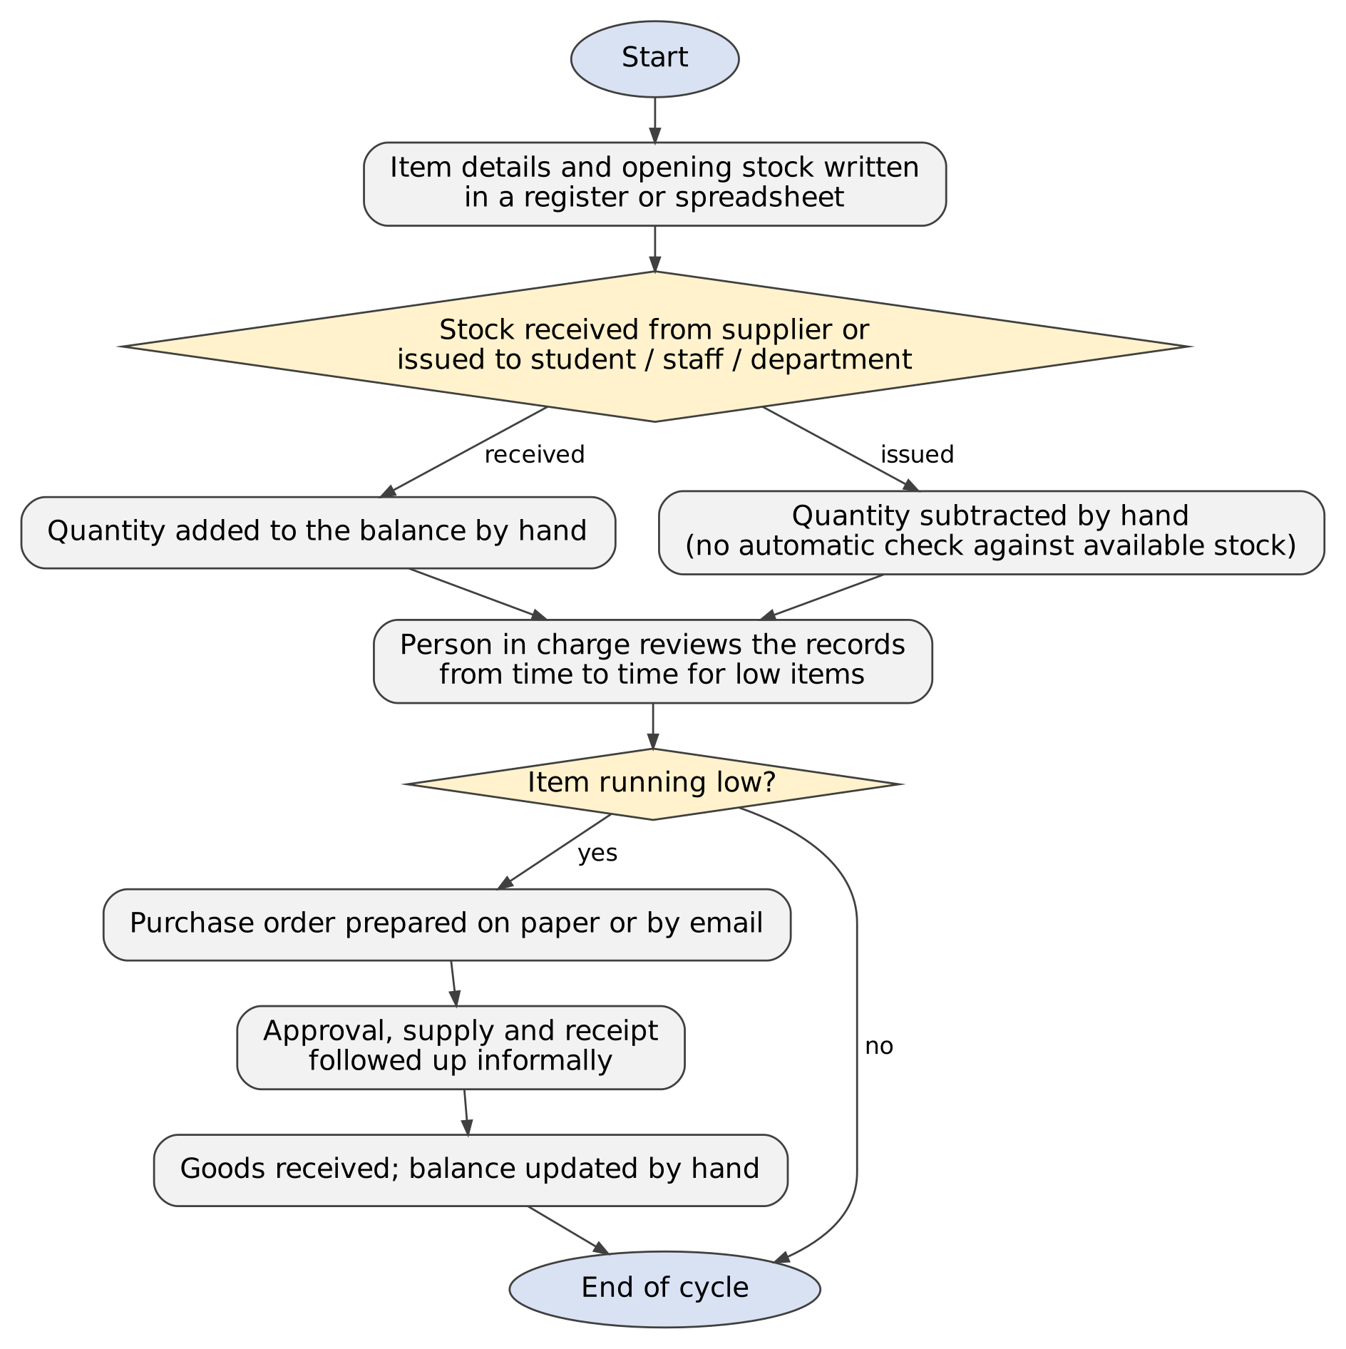
Figure 2.1: As-Is Process Flow of the Existing System

2.2 Limitations of the Existing System
- Stock balances depend on manual calculation, so arithmetic and data-entry errors can go unnoticed.
- Nothing prevents a Stock Out larger than the stock actually available.
- Items that have reached their reorder level are found only when someone reviews the records, so purchases are delayed.
- Purchase order status and approvals are tracked separately from stock records, so it is hard to see which orders are pending, ordered, received or cancelled.
- Item, transaction and order information is scattered, with no dashboard or filtered list showing the current position at a glance.

2.3 Low-Code versus Traditional Development
Table 2.1: Comparison of Low-Code and Traditional Development for the Proposed Application
Criterion | Traditional (Pro-Code) Development | Low-Code on Zoho Creator
Development time | Database design, server-side coding and a user interface have to be built and tested before the first usable version. | Forms, reports and the dashboard were configured visually; Deluge was written only for five scripts (Appendix C).
Skills required | A programming language, a web framework, database design and server administration. | Understanding of forms, lookups, reports and workflows, plus basic Deluge scripting.
Hosting & infrastructure | A server or cloud host, a database and a domain have to be arranged and maintained. | Hosted by Zoho Creator; the application is published at a URL with no server set-up.
Mobile application | A separate mobile app or a responsive web design has to be built and tested. | Mobile access is provided by the platform; it was not configured or evaluated in this project.
Security & access control | Login, roles and permissions have to be coded and secured by the developer. | Platform user management and roles were used (Super Admin; CEO with Write); validation and approval were added through workflows.
Maintenance & change | A change needs code modification, retesting and redeployment. | Fields, reports and workflows are changed in the builder and promoted from Development to Stage to Production (versions V1.0 to V3.2 so far).
Customisation limits | Practically unlimited, subject to developer effort. | Bound by platform features and Deluge; anything beyond them would need an integration or pro-code extension, which this project did not require.
Cost | Developer time, hosting and licences for the whole technology stack. | Platform plan charges instead of hosting and infrastructure; no separate server cost was incurred in this project.
Note: the comparison is qualitative. No measured development time or cost of a traditional implementation was available, so none is claimed. The low-code column describes what was done in this project; the traditional column describes the general approach [2].

2.4 Literature Survey
Six sources were reviewed: two scholarly articles on low-code development, three pages of official Zoho documentation for the features used in this project, and one analyst market evaluation. They are summarised in Table 2.2 and listed in the References.
Table 2.2: Summary of Literature Survey
S.No. | Author(s) / Source & Year | Title / Product | Key Findings | Relevance to this Project
1 | A. Bock and U. Frank, 2021 [1] | Low-Code Platform, Business & Information Systems Engineering, vol. 63, no. 6 | Discusses low-code platforms in relation to citizen developers, organisational agility and software development productivity. | Supports choosing a low-code platform for a small business process that one developer can build and maintain.
2 | Y. Luo et al., 2021 [2] | Characteristics and Challenges of Low-Code Development: The Practitioners’ Perspective (ESEM 2021) | From 73 Stack Overflow and 228 Reddit posts: visual interfaces and prebuilt components make platforms easy to learn and speed up development; practitioners disagree about benefits and drawbacks. | Explains the speed and workflow-automation advantages seen here and the need to judge platform limits (Section 8.4).
3 | Zoho Corporation, Zoho Creator Help [3] | Understanding Blueprint | Describes how a process is modelled as stages joined by transitions. | Used for the Purchase_Order_Lifecycle Blueprint (Pending, Ordered, Received, Cancelled).
4 | Zoho Corporation, Zoho Creator Help [4] | Approval Workflows | Describes approval workflows, in which records added to a form are sent to approvers who approve or reject them. | Basis for the approval process for purchase orders of ₹1,000 or more.
5 | Zoho Corporation, Deluge documentation [5] | Deluge Scripting – Overview | Describes Deluge, the scripting language used to write business logic in Zoho applications. | Used for the stock update, validation, price fetch, receive-items and daily alert scripts.
6 | Gartner, Inc., 2025 [6] | Magic Quadrant for Enterprise Low-Code Application Platforms | Evaluates vendors of enterprise low-code application platforms. | Shows that low-code application platforms are an established market category (Section 2.5).

2.5 Emerging Trends in Low-Code Development
Low-code and no-code platforms keep spreading because they let people close to the business build the applications they need. Bock and Frank link low-code with citizen developers, organisational agility and productivity [1], and Gartner publishes regular evaluations of enterprise low-code application platforms as a recognised market category [6]. This project follows the same pattern: a single student, working mostly through visual configuration, delivered a complete inventory application with only five Deluge scripts.
Other trends, such as AI-assisted application building, hyper-automation and the composition of services through APIs, were considered but not applied. The application was built manually without Zia AI, and no external API was used. The automation that was used — approval routing, Blueprint-controlled stages and a scheduled alert — is a small-scale example of the workflow-centred use for which practitioners favour low-code [2].

2.6 Proposed System
The proposed system is the Zoho Creator application described in the remaining chapters. It addresses each limitation listed in Section 2.2 as follows:
- Manual calculation errors: the Stock Transaction form and script DS-01 add or subtract the quantity from Current Stock automatically for every Stock In and Stock Out entry.
- Issuing more than is available: script DS-02 shows an alert and cancels the submission when a Stock Out quantity exceeds the available stock.
- Late identification of low stock: the Low Stock Items report, the dashboard list and a daily email alert show every item where Current Stock ≤ Reorder Level.
- Purchase order tracking: the Purchase Orders form and the Purchase_Order_Lifecycle Blueprint move each order through Pending, Ordered, Received and Cancelled, and receiving an order adds its quantity to stock.
- Approval of higher-value orders: an approval process sends orders with a Total Amount of ₹1,000 or more to an approver, who can approve or reject them.
- Scattered information: the three forms are linked by lookups, and four reports, two approval task views and the Inventory Dashboard show the current position in one place.
CHAPTER 3

REQUIREMENT ANALYSIS

3.1 Stakeholders and User Roles
The application is used by authorised users who sign in to Zoho Creator. Two user accounts and one approver are configured, and no other roles were created. Table 3.1 lists them.
Table 3.1: Stakeholders and User Roles
Role | Description | Key Responsibilities in the Application
Super Admin | Owner and administrator of the Zoho Creator account in which the application was built and published. | Builds and configures the application; manages users and permissions; publishes it through the Development, Stage and Production environments; enters and views all records.
CEO (Write permission) | A second application user who has been given the CEO role with the Write permission. | Works with the application data: enters and views item, stock transaction and purchase order records and reviews the reports and the dashboard. Confirm exact rights of the CEO role
Approver (Level 1) | The single approver selected in the Purchase_Order_Approval process; this is the Super Admin account. | Approves or rejects a purchase order whose Total Amount is ₹1,000 or more, from the Pending Tasks approval view or the email notification.
No portal users, customers, suppliers or other staff roles are configured. Suppliers appear only as text in the Supplier Name field and do not sign in to the application.

3.2 Functional Requirements
Each functional requirement below is testable. The FR identifiers are used again in the test cases of Chapter 6.
Table 3.2: Functional Requirements
FR ID | Requirement | Role(s) | Priority
FR-01 | The system shall allow an item to be registered in the Items form with Item Name, Item Code, Category, Unit Price, Opening Stock, Current Stock and Reorder Level as mandatory fields and Supplier Name as an optional field. | Super Admin, CEO | High
FR-02 | The system shall record every stock movement in the Stock Transaction form with the transaction date, the item (lookup to Items), the transaction type (Stock In or Stock Out), the quantity and optional remarks. | Super Admin, CEO | High
FR-03 | The system shall reject a Stock Out whose quantity is greater than the item’s Current Stock, show the available quantity in an alert and cancel the submission. | Super Admin, CEO | High
FR-04 | The system shall automatically add the quantity to Current Stock for a Stock In and subtract it for a Stock Out after a transaction is submitted successfully. | Super Admin, CEO | High
FR-05 | The system shall list the items whose Current Stock is less than or equal to the Reorder Level in the Low Stock Items report. | Super Admin, CEO | High
FR-06 | The system shall send one daily email listing the items whose Current Stock is less than or equal to the Reorder Level. | Super Admin (recipient) | Medium
FR-07 | The system shall fill the Unit Price of a purchase order automatically when an item is selected and calculate Total Amount as Quantity Ordered × Unit Price. | Super Admin, CEO | High
FR-08 | The system shall move a purchase order through the Pending, Ordered, Received and Cancelled stages using Blueprint transitions, and shall add the Quantity Ordered to the item’s Current Stock when the order is received. | Super Admin, CEO | High
FR-09 | The system shall route a purchase order whose Total Amount is ₹1,000 or more to an approver, who can approve or reject it. | Approver (Super Admin) | High
FR-10 | The system shall provide the reports All Items, Low Stock Items, All Stock Transactions and All Purchase Orders, and the approval task views Pending Tasks and Completed Tasks. | Super Admin, CEO | Medium
FR-11 | The system shall display an Inventory Dashboard with summary panels, an item-wise current-stock chart and the low-stock and stock-transaction lists. | Super Admin, CEO | Medium
FR-12 | The system shall allow access only to users who are signed in to Zoho Creator and have been given a role in the application. | Super Admin | Medium

3.3 Non-Functional Requirements
Table 3.3: Non-Functional Requirements
NFR ID | Category | Requirement
NFR-01 | Performance | Reports, forms and the dashboard shall respond without noticeable delay for the number of items, transactions and orders of a small stationery store. This is a design intent; response times were not measured.
NFR-02 | Security | Only signed-in Zoho users with an assigned role shall use the application, and administration (users, publishing) shall rest with the Super Admin.
NFR-03 | Usability | Functions shall be reached from a top menu of four groups plus the Inventory Dashboard, in a web browser. Mobile use was not configured or evaluated.
NFR-04 | Availability | The application is hosted by Zoho Creator, so its availability depends on the platform; no separate server is maintained.
NFR-05 | Maintainability | Fields, reports and workflows shall be changed in the Creator builder, with changes promoted through Development, Stage and Production; the five Deluge scripts are documented in Appendix C.
NFR-06 | Data integrity | A Stock Out larger than the available stock shall be rejected so that stock is not issued beyond what is held, and stock shall change only through transactions and received orders.

3.4 Hardware and Software Requirements
Table 3.4: Hardware and Software Requirements
Category | Specification
Platform | Zoho Creator, Free Plan – confirm
Scripting language | Deluge (Data Enriched Language for the Universal Grid Environment)
Browser | A current web browser such as Google Chrome, Microsoft Edge or Mozilla Firefox state the browser used
API testing tool | Not used; the application has no external API or third-party integration
Other Zoho services | None; e-mail is sent through Zoho Creator’s built-in sendmail and approval notifications
Mobile | Not configured or evaluated in this project
Client hardware | Any computer able to run a current browser, with an internet connection add the specification of your computer if required

3.5 Use Case Model
Figure 3.1 shows the two actors and the functions of the application. Recording a stock transaction includes the validation of stock availability. Three key use cases are described in Tables 3.5 to 3.7.

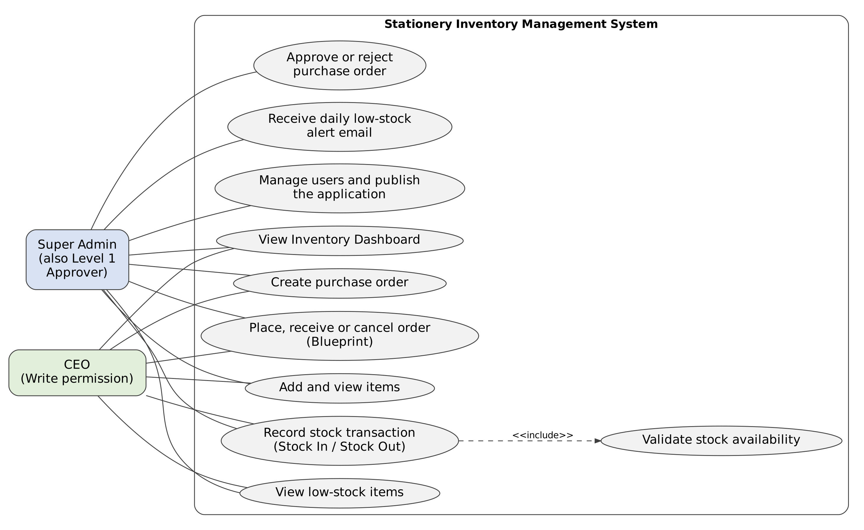
Figure 3.1: Use Case Diagram of the Application
Table 3.5: Use Case Description – Record a Stock Out Transaction
Use Case ID | UC-01
Use Case Name | Record a Stock Out Transaction
Actor(s) | Super Admin, CEO
Pre-condition | The user is signed in and the item exists in the Items form with a Current Stock value.
Main Flow | 1. Open the Stock Transactions group and select the Stock Transaction form.  2. Enter the Transaction Date, select the Item, choose Transaction Type “Stock Out”, enter the Quantity and, if needed, Remarks.  3. Submit the form; script DS-02 compares the Quantity with the item’s Current Stock.  4. When the stock is sufficient the record is saved and script DS-01 subtracts the Quantity from Current Stock.
Alternate Flow | If the Quantity is greater than Current Stock, an alert “Insufficient stock! Available quantity: X” is shown, the submission is cancelled and the user corrects the Quantity.
Post-condition | The transaction appears in All Stock Transactions and the item’s Current Stock is reduced; the item appears in Low Stock Items if it is now at or below its Reorder Level.
Related FR | FR-02, FR-03, FR-04, FR-05

Table 3.6: Use Case Description – Create and Approve a Purchase Order
Use Case ID | UC-02
Use Case Name | Create and Approve a Purchase Order
Actor(s) | Super Admin, CEO (create); Approver
Pre-condition | The user is signed in and the item exists in the Items form.
Main Flow | 1. Open the Purchase Orders group and select the Purchase Orders form.  2. Enter the Order Date and Supplier Name and select the Item; script DS-03 fills the Unit Price.  3. Enter the Quantity Ordered; Total Amount is calculated and Order Status is Pending.  4. Submit the form. When Total Amount is ₹1,000 or more, an approval request is sent to the approver.  5. The approver approves or rejects the request from the Pending Tasks view or the notification email.
Alternate Flow | When Total Amount is below ₹1,000 the approval process is not triggered. If the approver rejects the request, the default rejection notification is sent.
Post-condition | The order is stored and listed in All Purchase Orders; the approval decision is shown in the approval task views (Completed Tasks).
Related FR | FR-07, FR-09, FR-10

Table 3.7: Use Case Description – Receive Ordered Items
Use Case ID | UC-03
Use Case Name | Receive Ordered Items
Actor(s) | Super Admin, CEO
Pre-condition | A purchase order exists with Order Status “Ordered” (moved from Pending by the Place Order transition).
Main Flow | 1. Open the order from the All Purchase Orders report.  2. Select the Receive Items transition of the Purchase_Order_Lifecycle Blueprint.  3. The order moves from Ordered to Received; script DS-04 adds the Quantity Ordered to the item’s Current Stock.
Alternate Flow | The Cancel Order transition moves a Pending or Ordered order to Cancelled; stock is not changed.
Post-condition | Order Status is Received and Current Stock of the item has increased by the Quantity Ordered.
Related FR | FR-08
CHAPTER 4

SYSTEM DESIGN

4.1 System Architecture

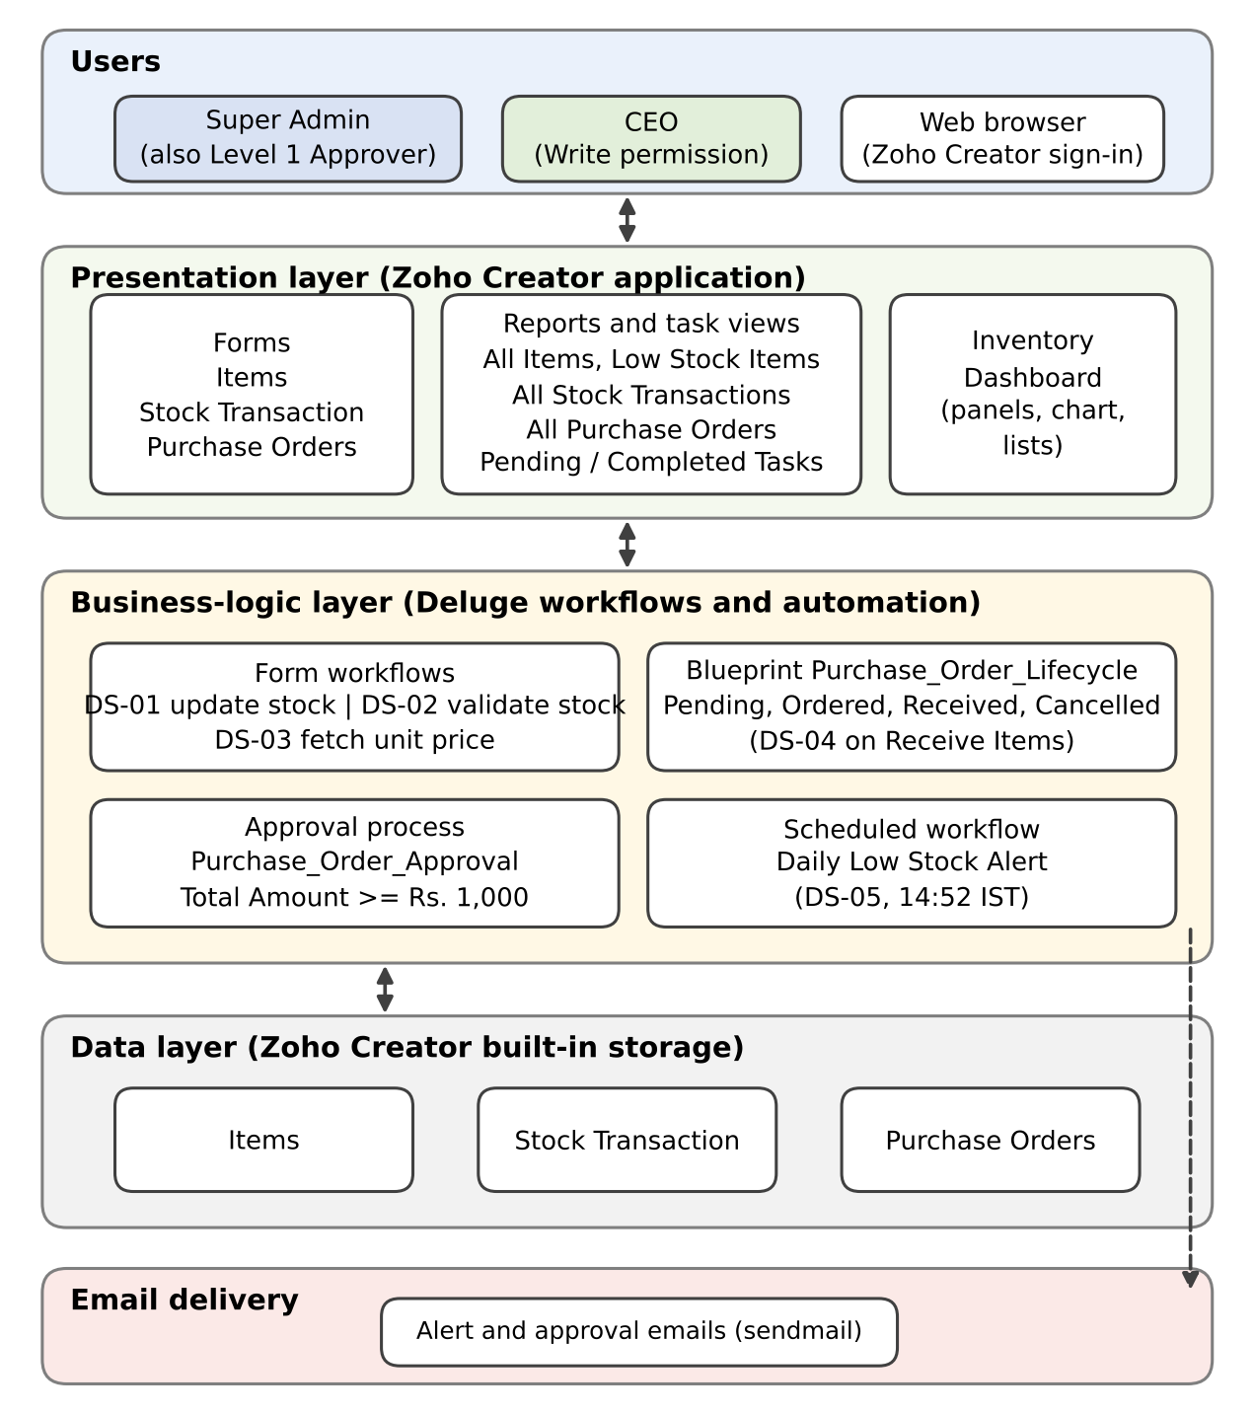
Figure 4.1: System Architecture of the Application
The application follows the layered structure of a Zoho Creator solution, shown in Figure 4.1. Everything runs inside Zoho Creator; there is no external API, third-party integration or separately created custom function.
Users and access channel. The Super Admin and the CEO sign in to Zoho Creator through a web browser. The Super Admin account is also the configured approver.
Presentation layer. The three forms (Items, Stock Transaction and Purchase Orders) capture data. Four reports (All Items, Low Stock Items, All Stock Transactions and All Purchase Orders), two approval task views (Pending Tasks and Completed Tasks) and the Inventory Dashboard present it.
Business-logic layer. Deluge form workflows update and validate stock and fetch the unit price (DS-01 to DS-03). The Purchase_Order_Lifecycle Blueprint controls the order stages and runs DS-04 when items are received. The Purchase_Order_Approval process handles orders of ₹1,000 or more, and the Daily Low Stock Alert scheduled workflow runs DS-05.
Data layer. Records are held in Zoho Creator’s built-in storage as three forms; Stock Transaction and Purchase Orders refer to Items through lookup fields.
Email delivery. The scheduled alert uses the built-in sendmail task and the approval process uses its default notification emails.

4.2 Data Model
The data model has three entities. Items is the master form; every Stock Transaction and every Purchase Order refers to one item through a lookup field, so one item can have many transactions and many purchase orders. Formula fields are shown in italics in Figure 4.2.

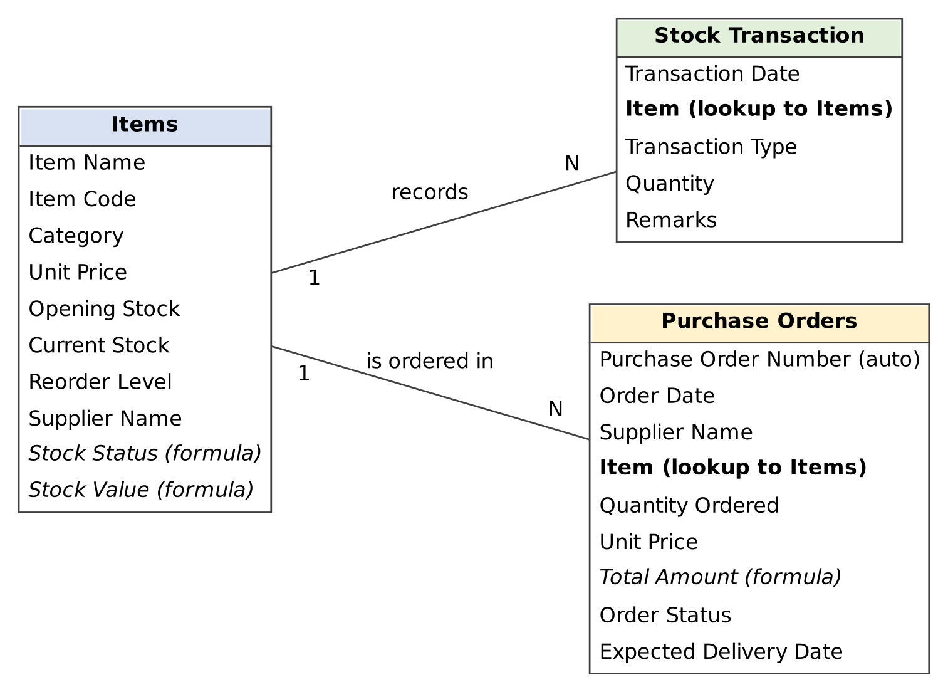
Figure 4.2: Entity–Relationship Diagram
Table 4.1: Entities and Relationships
Entity (Form) | Key Fields | Related To | Relationship Type | Implemented Using
Items | Item Name, Item Code, Category, Unit Price, Opening Stock, Current Stock, Reorder Level, Supplier Name | Stock Transaction; Purchase Orders | One-to-Many (for each) | Parent form; target of the Item lookups
Stock Transaction | Transaction Date, Item, Transaction Type, Quantity, Remarks | Items | Many-to-One | Lookup field Item → Items
Purchase Orders | Purchase Order Number, Order Date, Supplier Name, Item, Quantity Ordered, Unit Price, Total Amount, Order Status, Expected Delivery Date | Items | Many-to-One | Lookup field Item → Items
No subform is used. Supplier Name is stored as text in the Items and Purchase Orders forms, so there is no separate supplier form. Stock quantities are not calculated from the transactions on demand; Current Stock is a stored field that the workflows update (DS-01 and DS-04).

4.3 Form Design
One field specification table is given for each form. Field types are named as on the Zoho Creator platform. Link names that are used in the Deluge scripts are confirmed; the other link names are highlighted for confirmation against the live builder.
Table 4.2: Field Specification – Items Form
Field Label | Link Name | Field Type | Mandatory | Validation / Default | Remarks
Item Name | Item_Name | Single Line | Yes | — | Listed in the DS-05 alert email
Item Code | Item_Code | Single Line | Yes | — | Example code: P0013
Category | Category | Drop Down | Yes | — | Example: Pens and Pencils
Unit Price | Unit_Price | Currency | Yes | — | Read by DS-03
Opening Stock | Opening_Stock | Number | Yes | — | Stock when the item was created
Current Stock | Current_Stock | Number | Yes | — | Updated by DS-01 and DS-04; used by DS-02 and DS-05
Reorder Level | Reorder_Level | Number | Yes | Default: 5 | Low-stock threshold
Supplier Name | Supplier_Name | Single Line | No | — | Optional
Stock Status | Stock_Status | Formula | — | if(Current_Stock <= Reorder_Level, "Low Stock", "In Stock") | Formula field in the builder
Stock Value | Stock_Value | Formula | — | Current_Stock * Unit_Price | Formula field in the builder

Table 4.3: Field Specification – Stock Transaction Form
Field Label | Link Name | Field Type | Mandatory | Validation / Default | Remarks
Transaction Date | Transaction_Date | Date | Yes | — | Date of the stock movement
Item | Item | Lookup | Yes | Lookup to Items; shows Item Name | Used in DS-01 and DS-02
Transaction Type | Transaction_Type | Drop Down | Yes | Stock In / Stock Out | Decides add or subtract
Quantity | Quantity | Number | Yes | Stock Out checked against Current Stock by DS-02 | Used in DS-01 and DS-02
Remarks | Remarks | Multi Line | No | — | Optional note

Table 4.4: Field Specification – Purchase Orders Form
Field Label | Link Name | Field Type | Mandatory | Validation / Default | Remarks
Purchase Order Number | Purchase_Order_Number | Auto Number | — | System generated | Numbered 1, 2, 3 … in the reports
Order Date | Order_Date | Date | Yes | —
Supplier Name | Supplier_Name | Single Line | Yes | — | Text, no supplier form
Item | Item | Lookup | Yes | Lookup to Items; shows Item Name | Triggers DS-03 on user input
Quantity Ordered | Quantity_Ordered | Number | Yes | — | Added to stock by DS-04
Unit Price | Unit_Price | Currency | Yes | Auto-filled from Items by DS-03
Total Amount | Total_Amount | Formula | — | Quantity_Ordered * Unit_Price | Approval criterion: ≥ ₹1,000
Order Status | Order_Status | Drop Down | Yes | Default: Pending | Pending / Ordered / Received / Cancelled; changed through the Blueprint
Expected Delivery Date | Expected_Delivery_Date | Date | No | — | Optional

Screenshots of the three forms in the builder and in live mode are given in Chapter 5.

4.4 Process and Workflow Design
Figure 4.3 shows the three automated processes of the application and marks where each Deluge script runs: the stock transaction (DS-02 and DS-01), the purchase order with its approval and Blueprint stages (DS-03 and DS-04) and the daily low-stock alert (DS-05).

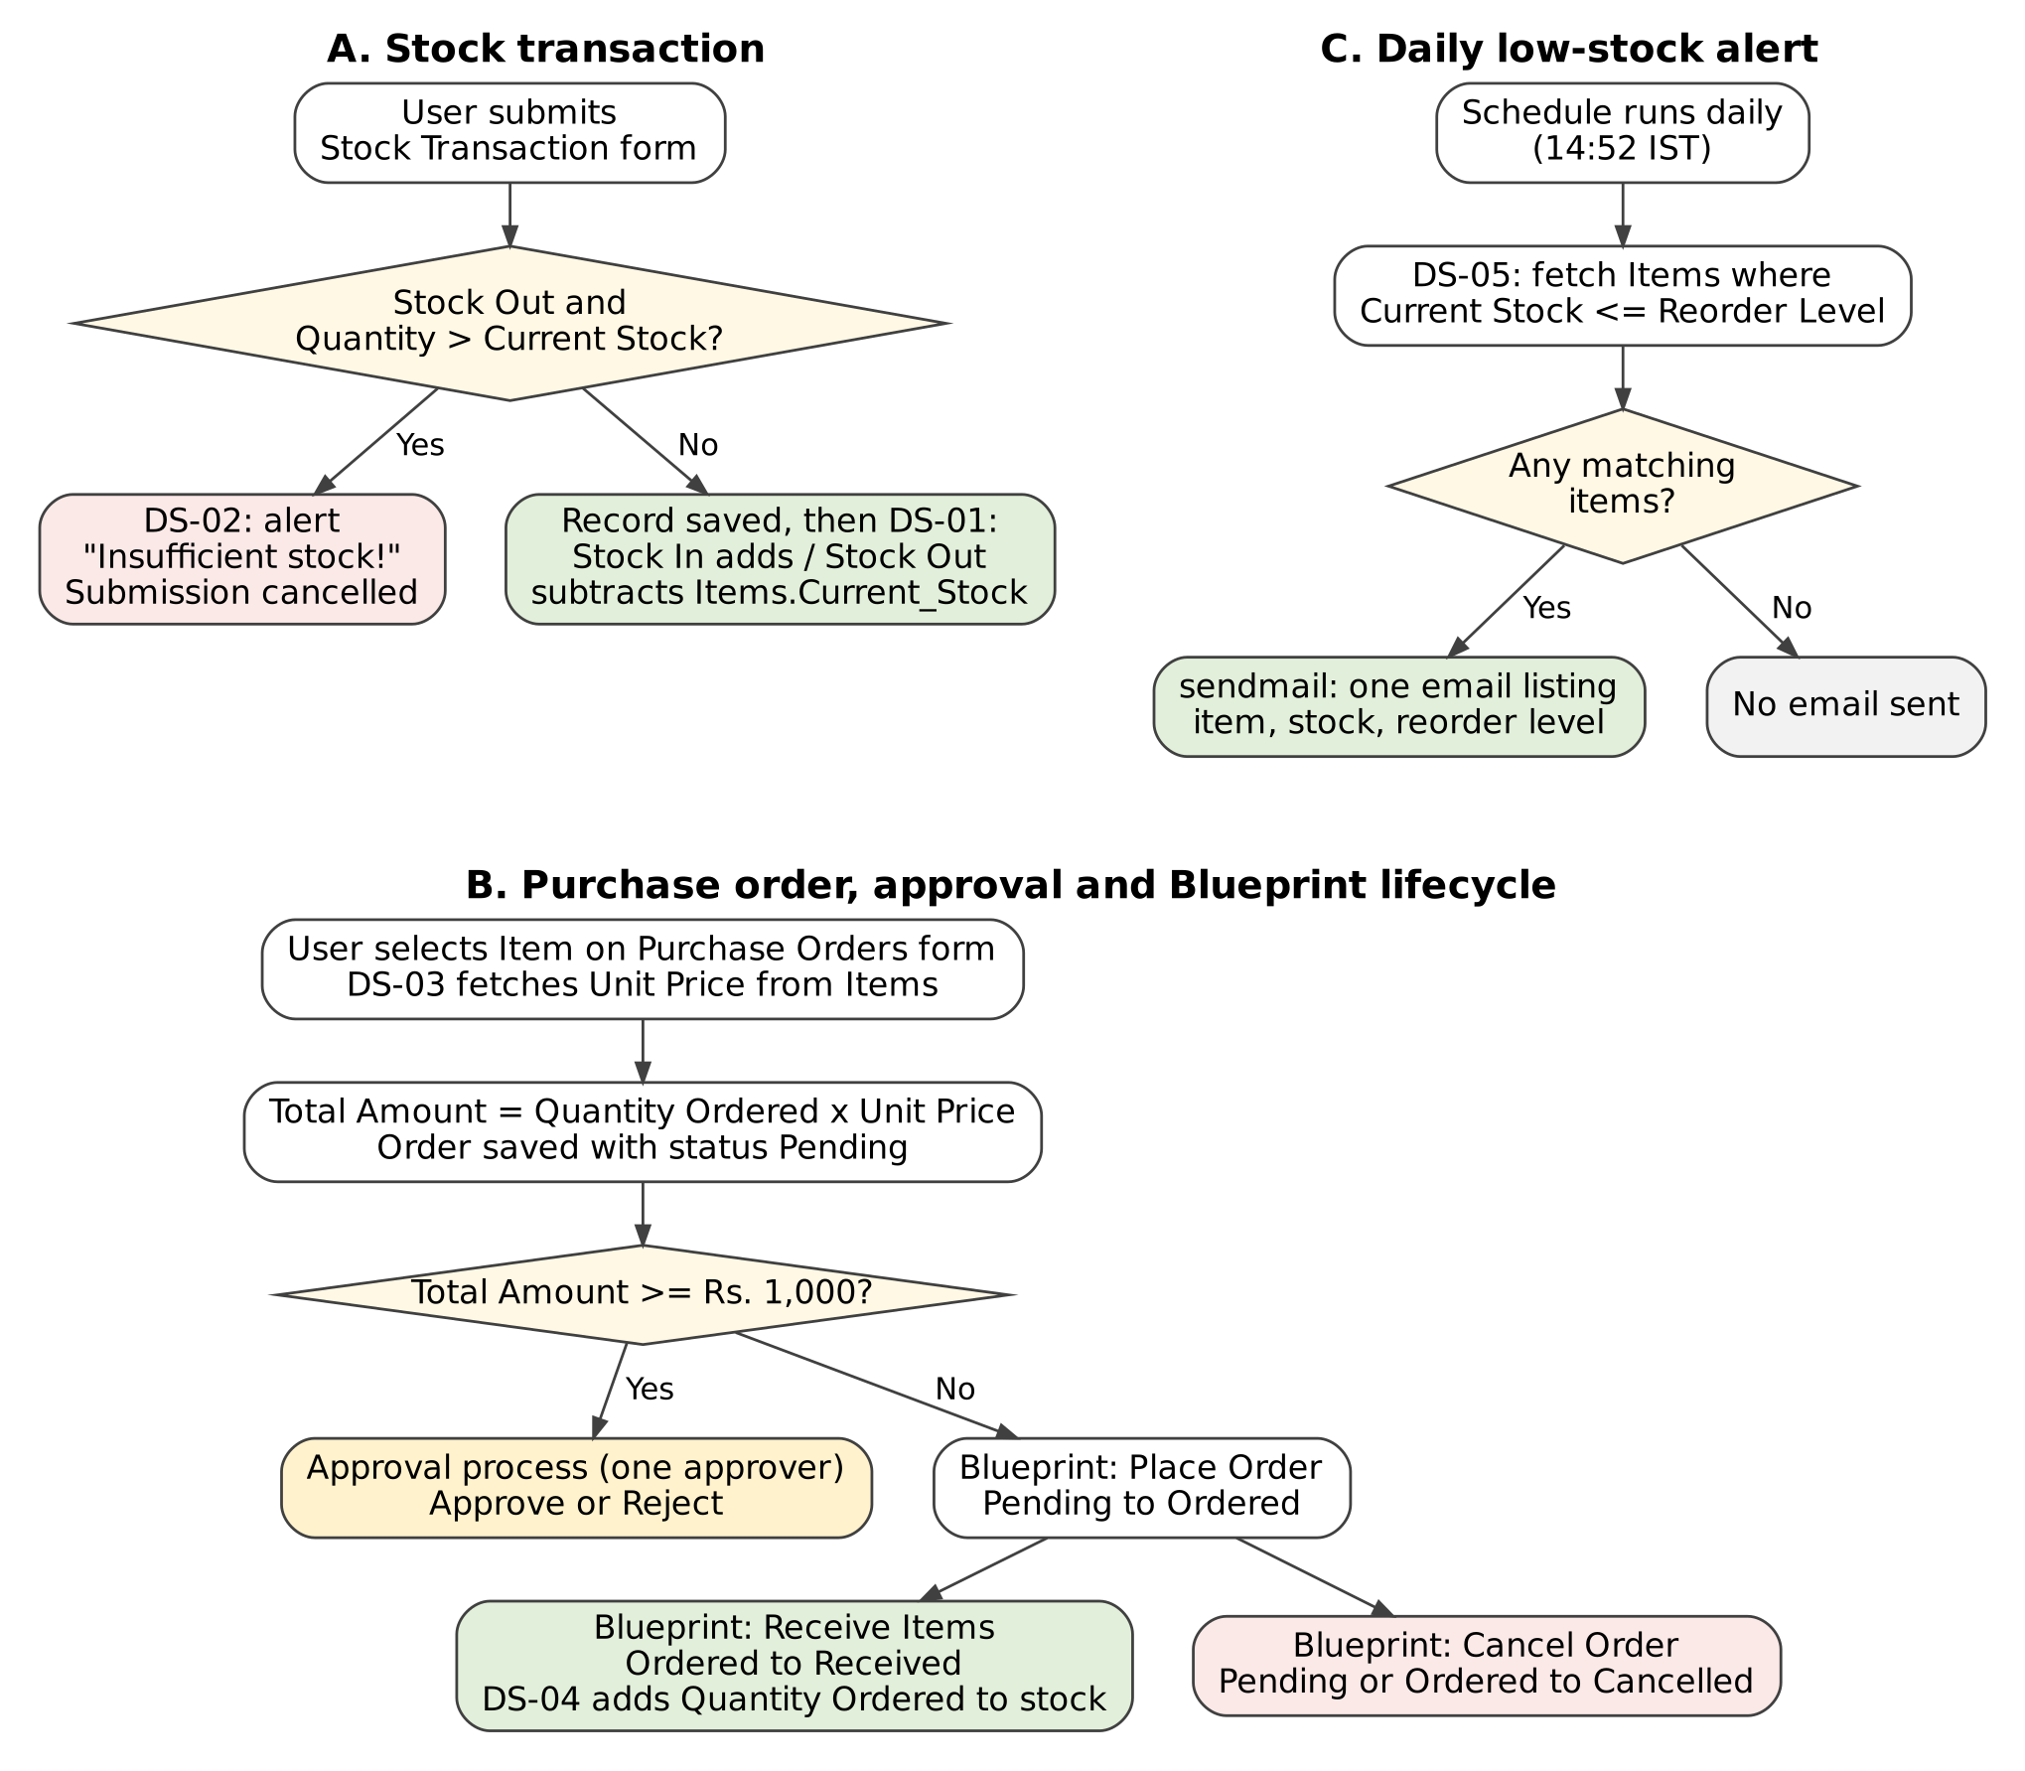
Figure 4.3: Workflow / Process Flow of the Stock Transaction, Purchase Order and Daily Alert Processes
In process A, validation runs before the record is saved and can cancel the submission; the stock update runs only after a successful submission. In process B, the unit price is fetched when the item is selected, the approval process applies when Total Amount is ₹1,000 or more, and the Blueprint controls the Order Status; stock increases only at the Receive Items transition. In process C, the scheduled workflow sends an email only when at least one item has reached its reorder level.

4.5 User Interface and Navigation Design
The application uses a top menu. Four groups open the forms and reports, and the Inventory Dashboard is a separate menu item (Figure 4.4). Pending Tasks and Completed Tasks are approval task views, not ordinary reports.

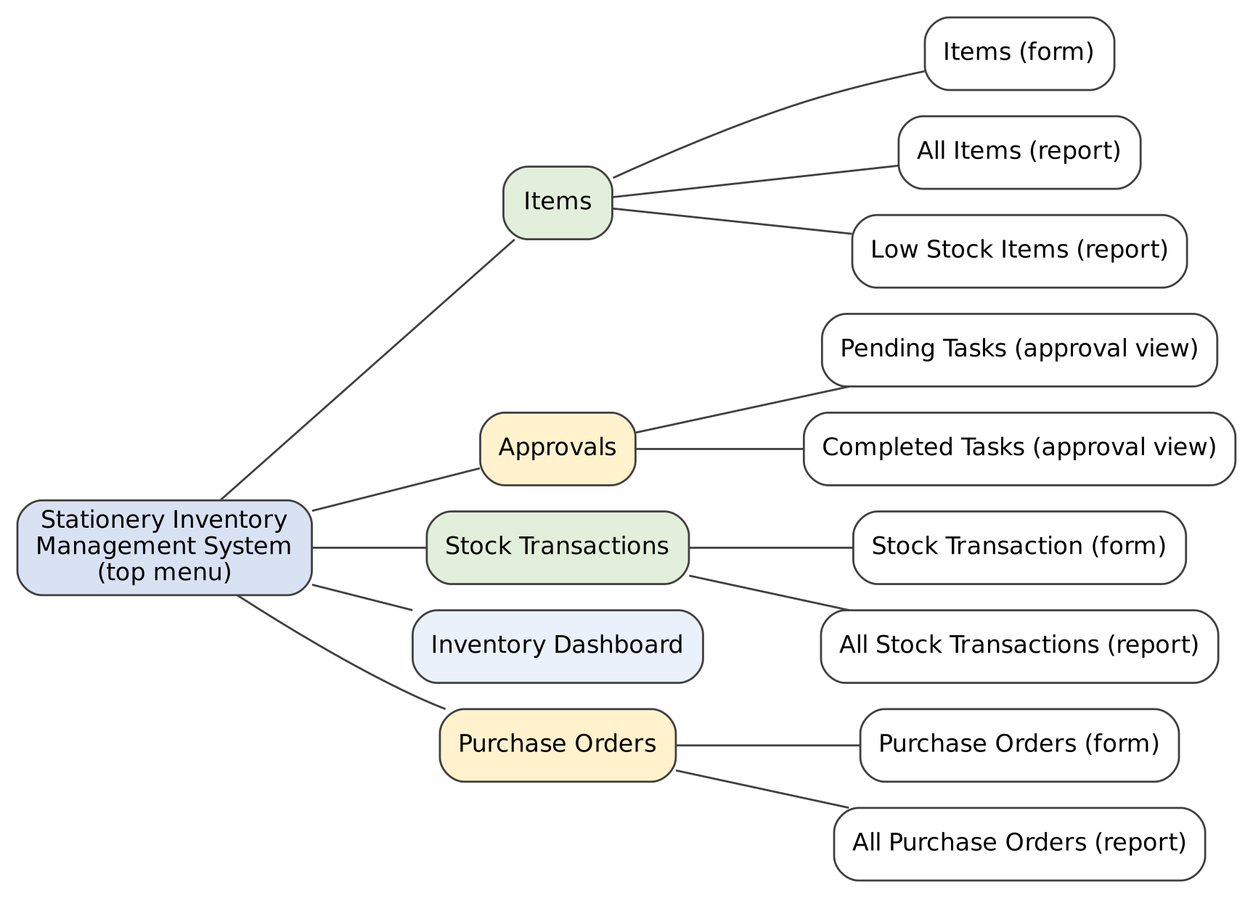
Figure 4.4: Navigation Structure of the Application
The planned layout of the Inventory Dashboard is shown in Figure 4.5: summary panels at the top, the item-wise current-stock bar chart below them, and the low-stock and stock-transaction lists at the bottom.
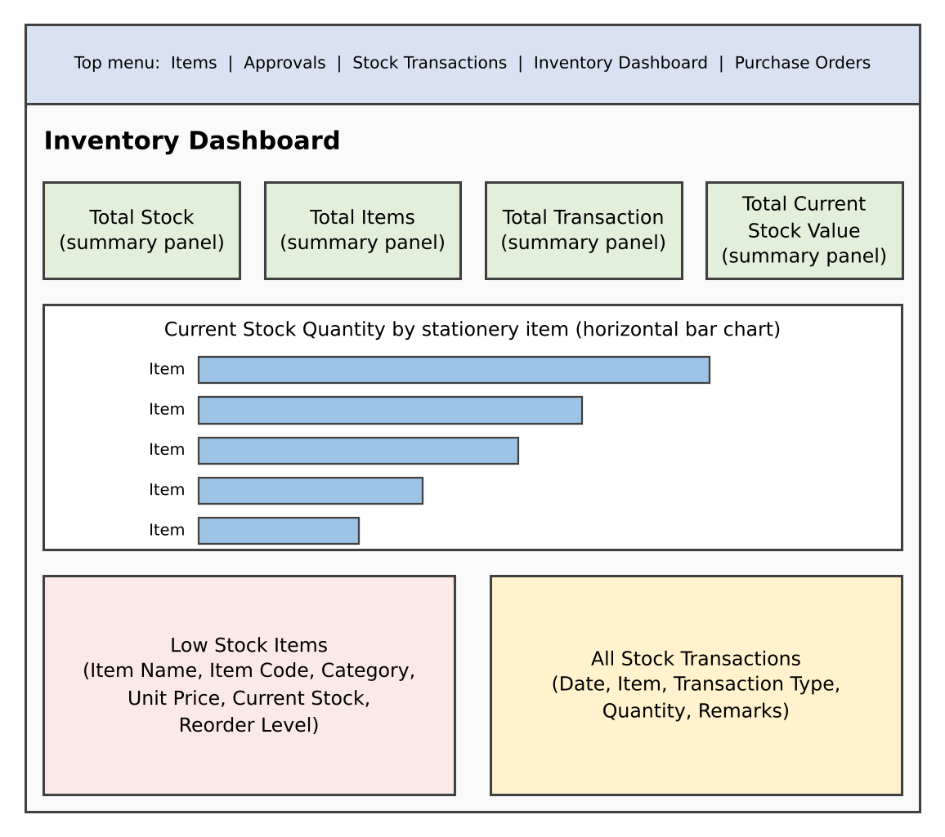
Figure 4.5: Wireframe of the Inventory Dashboard

4.6 Access Control Design
Access is based on two roles. The Super Admin has full access and administers the application. The CEO has the Write permission. Table 4.5 shows the permissions; A = Add, E = Edit, V = View, D = Delete, — = no access. No record-level or field-level restrictions, portal users or other roles are configured.
Table 4.5: Role–Permission Matrix
Component | Super Admin | CEO (Write)
Form: Items | A E V D | Write*
Form: Stock Transaction | A E V D | Write*
Form: Purchase Orders | A E V D | Write*
Reports: All Items, Low Stock Items, All Stock Transactions, All Purchase Orders | V | Write*
Approval views: Pending Tasks, Completed Tasks | V | Write*
Dashboard: Inventory Dashboard | V | Write*
Blueprint: Place Order, Receive Items, Cancel Order | Perform | Write*
Approval: approve or reject a purchase order | Perform (configured approver) | —
Application administration: users, publishing, environments | Perform | —
* The CEO holds the Write permission assigned in user management. The exact add, edit, view and delete rights for each component were not recorded, so this column is highlighted for confirmation. Security features such as audit trail and record sharing were not configured or confirmed.
CHAPTER 5

IMPLEMENTATION

5.1 Application Setup
The application was created from scratch in Zoho Creator under the Super Admin account and named Stationery Inventory Management System; no template, import or Zia AI-assisted builder was used. It is built on Free Plan – confirm. Its link name is stationery-inventory-management-system. The application opens with a dark top menu bar that shows the application name and the signed-in user.
Navigation is by a top menu. Pointing at a group opens a drop-down with its options (Figure 5.1). The menu has five entries in this order:
- Items – Items form, All Items report and Low Stock Items report.
- Approvals – Pending Tasks and Completed Tasks approval views.
- Stock Transactions – Stock Transaction form and All Stock Transactions report.
- Inventory Dashboard – opens the dashboard directly.
- Purchase Orders – Purchase Orders form and All Purchase Orders report.
The Development, Stage and Production environments used to publish the application are described in Chapter 7.
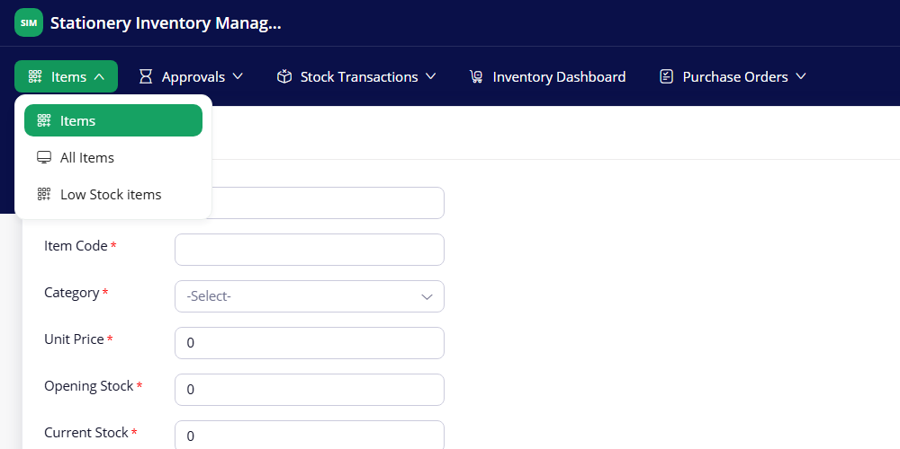
Figure 5.1(a): Items Menu Group – Items, All Items and Low Stock Items
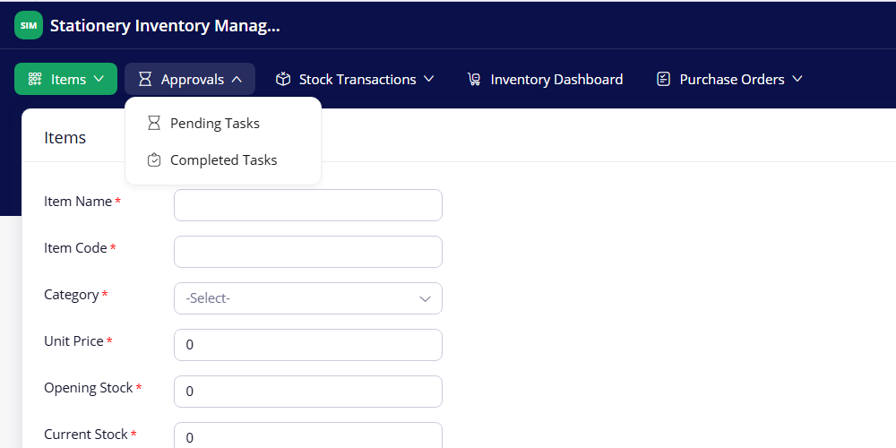
Figure 5.1(b): Approvals Menu Group – Pending Tasks and Completed Tasks
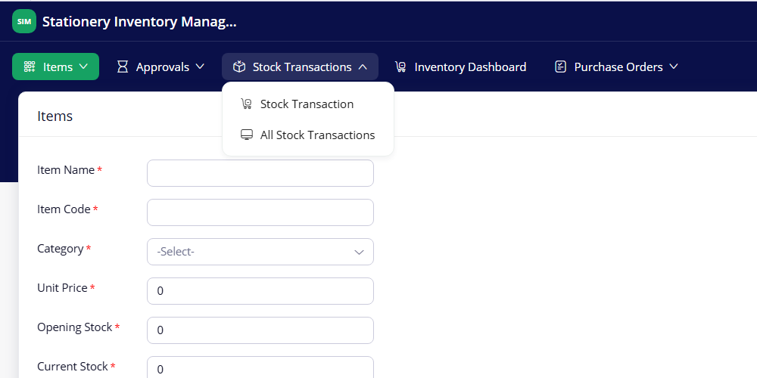
Figure 5.1(c): Stock Transactions Menu Group – Stock Transaction and All Stock Transactions
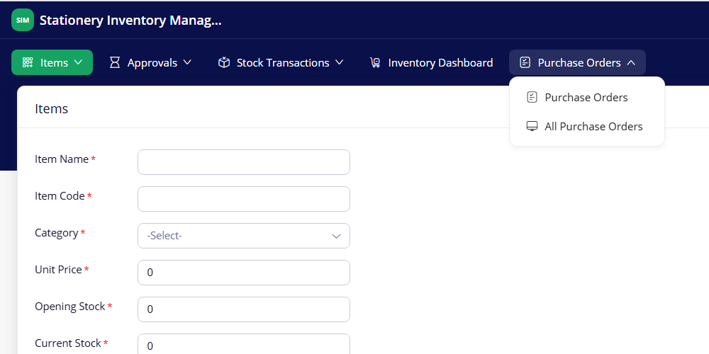
Figure 5.1(d): Purchase Orders Menu Group – Purchase Orders and All Purchase Orders

5.2 Forms and Data Capture
Three forms were built in the Zoho Creator form builder. Field types, mandatory settings and link names are listed in Tables 4.2 to 4.4; this section describes how they were configured.
Items form. Eight fields store the item master data: Item Name, Item Code, Category (Drop Down), Unit Price (Currency), Opening Stock, Current Stock, Reorder Level and the optional Supplier Name. All except Supplier Name are mandatory. In live mode the numeric fields start at 0 and Reorder Level starts at 5. Two formula fields, Stock Status and Stock Value, appear at the end of the form in the builder. The Item Name field has a 255-character limit and the “No duplicate values” option was left unchecked.
Stock Transaction form. It records each movement with Transaction Date, Item, Transaction Type, Quantity and Remarks. Item is a Lookup field to the Items form, so a user selects an existing item instead of typing its name. Transaction Type is a Drop Down with the values Stock In and Stock Out. Transaction Date, Item, Transaction Type and Quantity are mandatory; Remarks is a Multi Line field. Validation and stock update are done by Deluge workflows (Section 5.5).
Purchase Orders form. Purchase Order Number is an Auto Number field. The form also has Order Date, Supplier Name, Item (Lookup to Items), Quantity Ordered, Unit Price, Total Amount (formula), Order Status (Drop Down) and Expected Delivery Date. Unit Price is filled automatically when an item is selected, and Order Status is moved through the Blueprint described in Section 5.6.
Each form has a single Submit button. Figures 5.2 and 5.3 show the forms in the builder and in live mode.
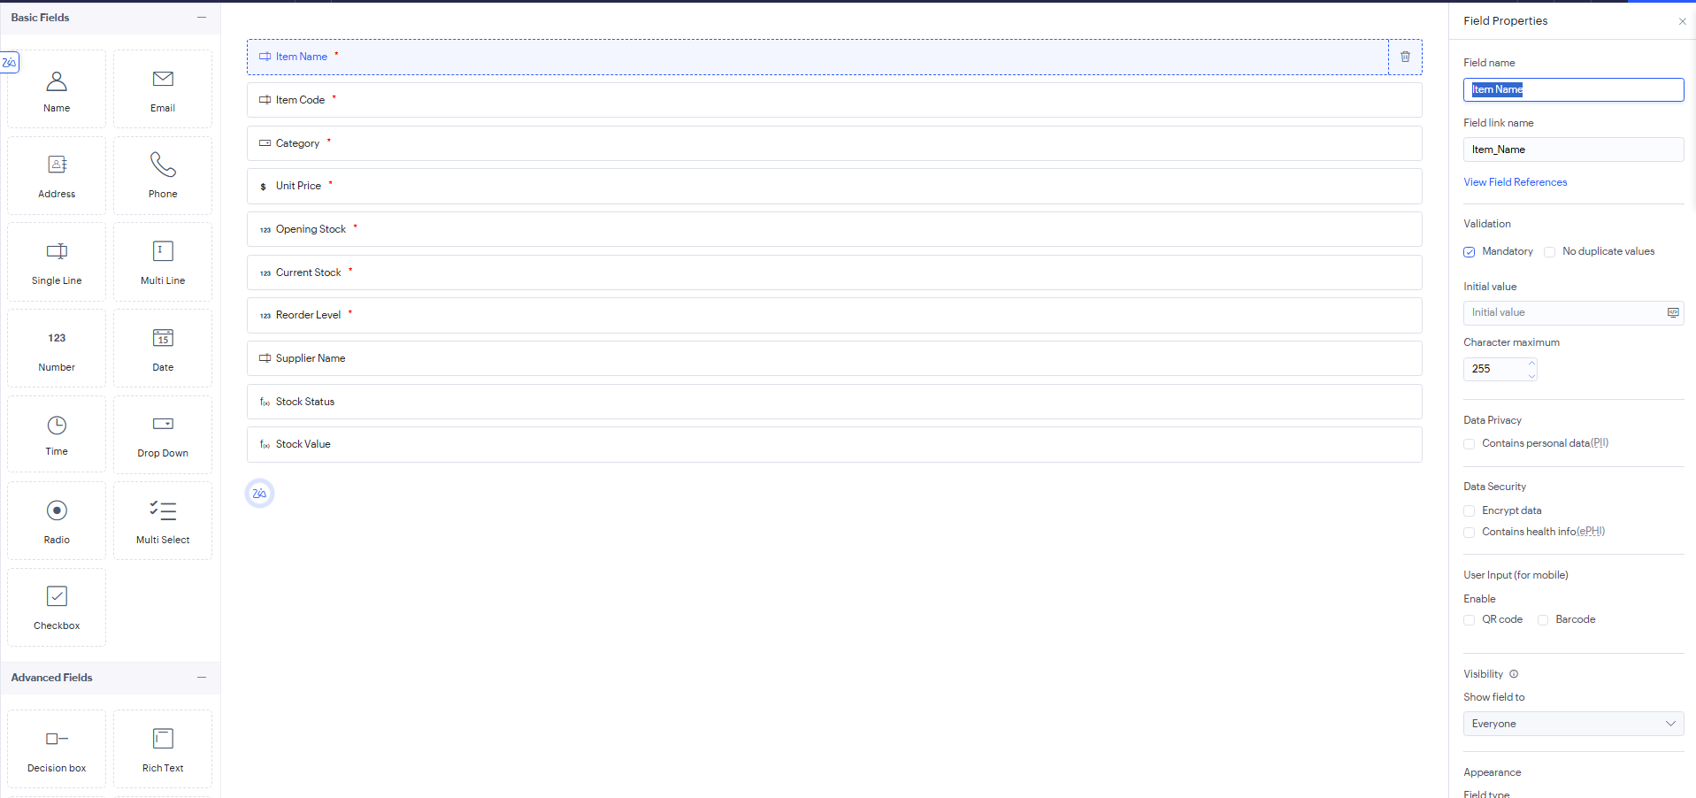
Figure 5.2(a): Items Form in the Form Builder
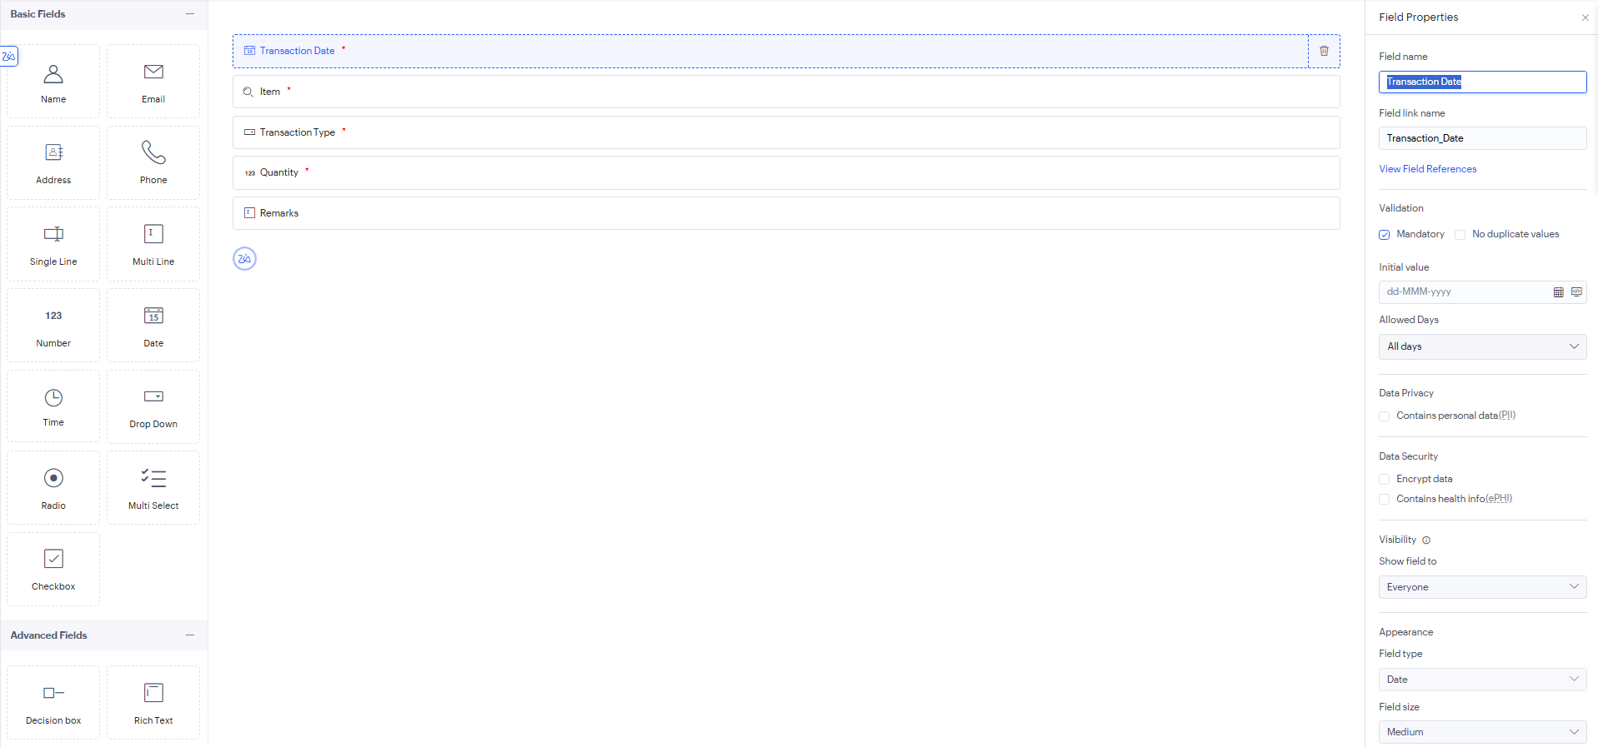
Figure 5.2(b): Stock Transaction Form in the Form Builder
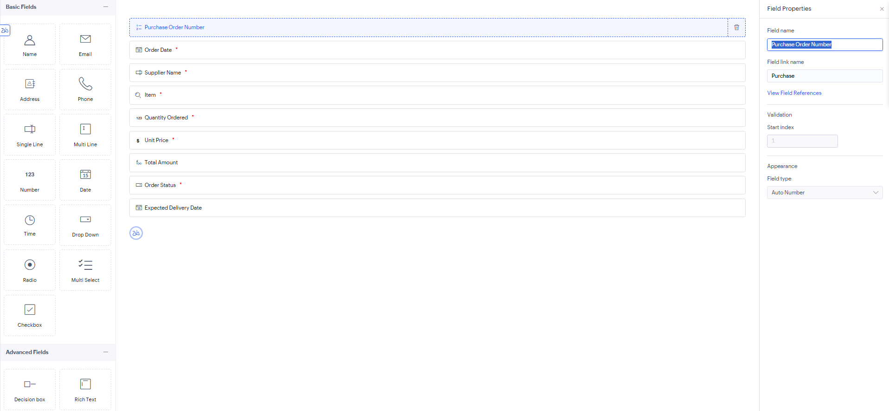
Figure 5.2(c): Purchase Orders Form in the Form Builder
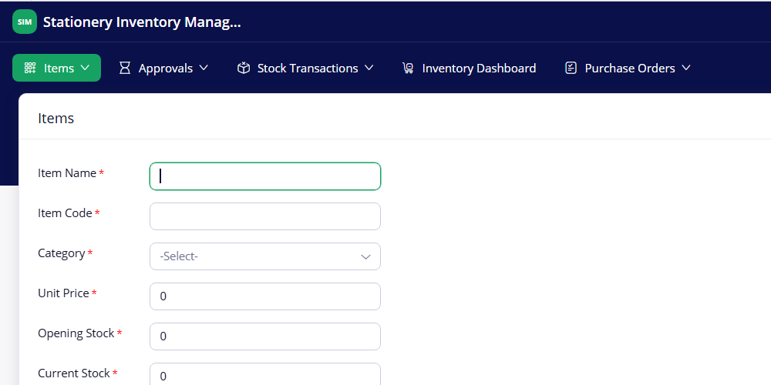
Figure 5.3(a): Items Form in Live Mode
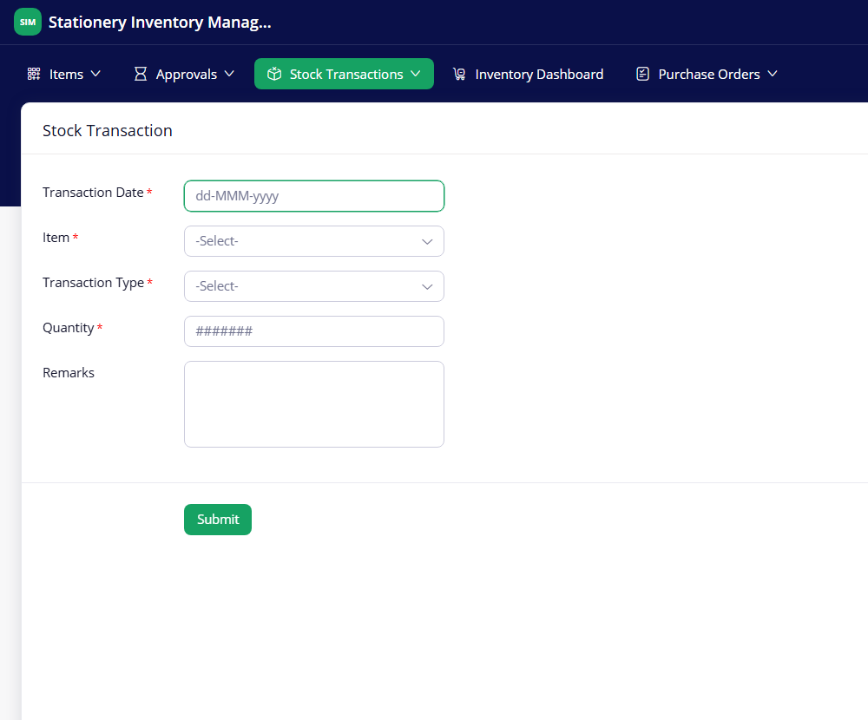
Figure 5.3(b): Stock Transaction Form in Live Mode
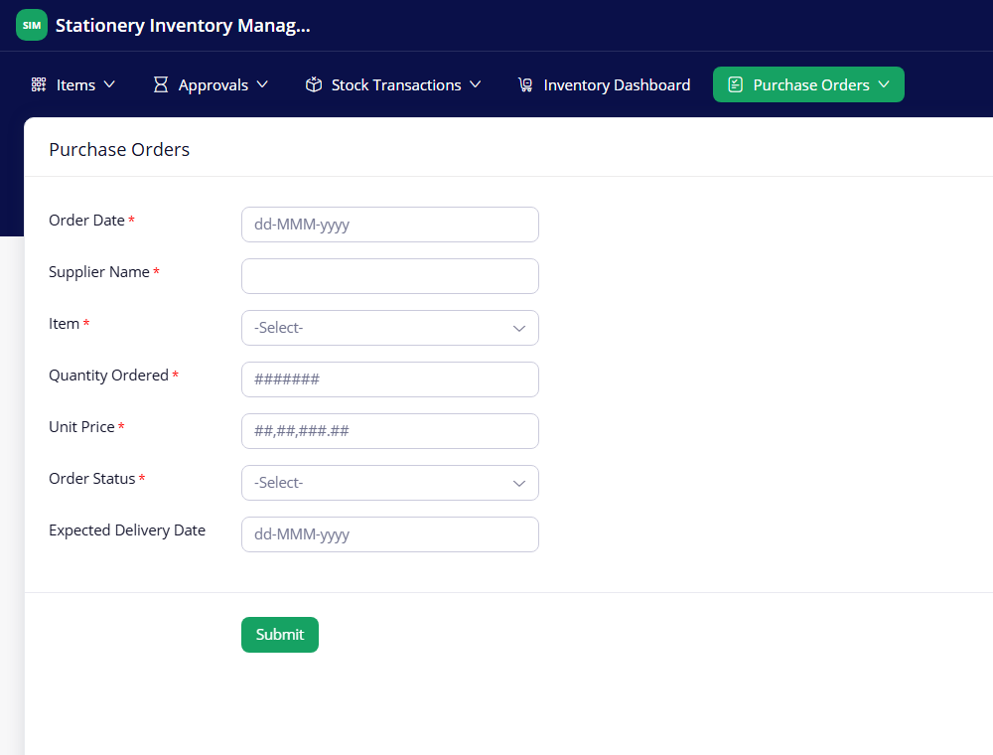
Figure 5.3(c): Purchase Orders Form in Live Mode

5.3 Reports
Four regular list reports and two approval task views present the stored data. Table 5.1 summarises them; Pending Tasks and Completed Tasks belong to the approval process and are not ordinary form reports.
Table 5.1: Reports and Approval Task Views Implemented
Report Name | Type | Source Form | Filter / Grouping / Sorting | Custom Actions | Roles
All Items | List | Items | All records shown (10 of 10 in Figure 5.4(a)); columns include Opening Stock, Current Stock, Reorder Level and Stock Value | Default report toolbar (search, add record, more) | Super Admin, CEO
Low Stock Items | List (filtered) | Items | Current Stock <= Reorder Level; shows Item Name, Item Code, Category, Unit Price, Current Stock, Reorder Level (4 of 4 in Figure 5.4(b)) | Default report toolbar | Super Admin, CEO
All Stock Transactions | List | Stock Transaction | All records shown (15 of 15 in Figure 5.4(c)); Transaction Date, Item, Transaction Type, Quantity, Remarks | Default report toolbar | Super Admin, CEO
All Purchase Orders | List | Purchase Orders | All records shown (5 of 5 in Figure 5.4(d)); Order Status column; the Blueprint transition buttons appear in the record detail view | Blueprint buttons: Place Order, Receive Items, Cancel Order | Super Admin, CEO
Pending Tasks | Approval task view | Purchase Orders (approval) | Requests waiting for the approver; “Recent Tasks” selector | Approve and Reject in the Approval Summary | Approver (Super Admin)
Completed Tasks | Approval task view | Purchase Orders (approval) | Requests already reviewed; “Recent Tasks” selector | None | Approver (Super Admin)

The All Purchase Orders report shows the Order Status column, but no separate Approval Status column was added, so the approval decision is seen only in the Pending Tasks and Completed Tasks views. Figure 5.4 shows each report.
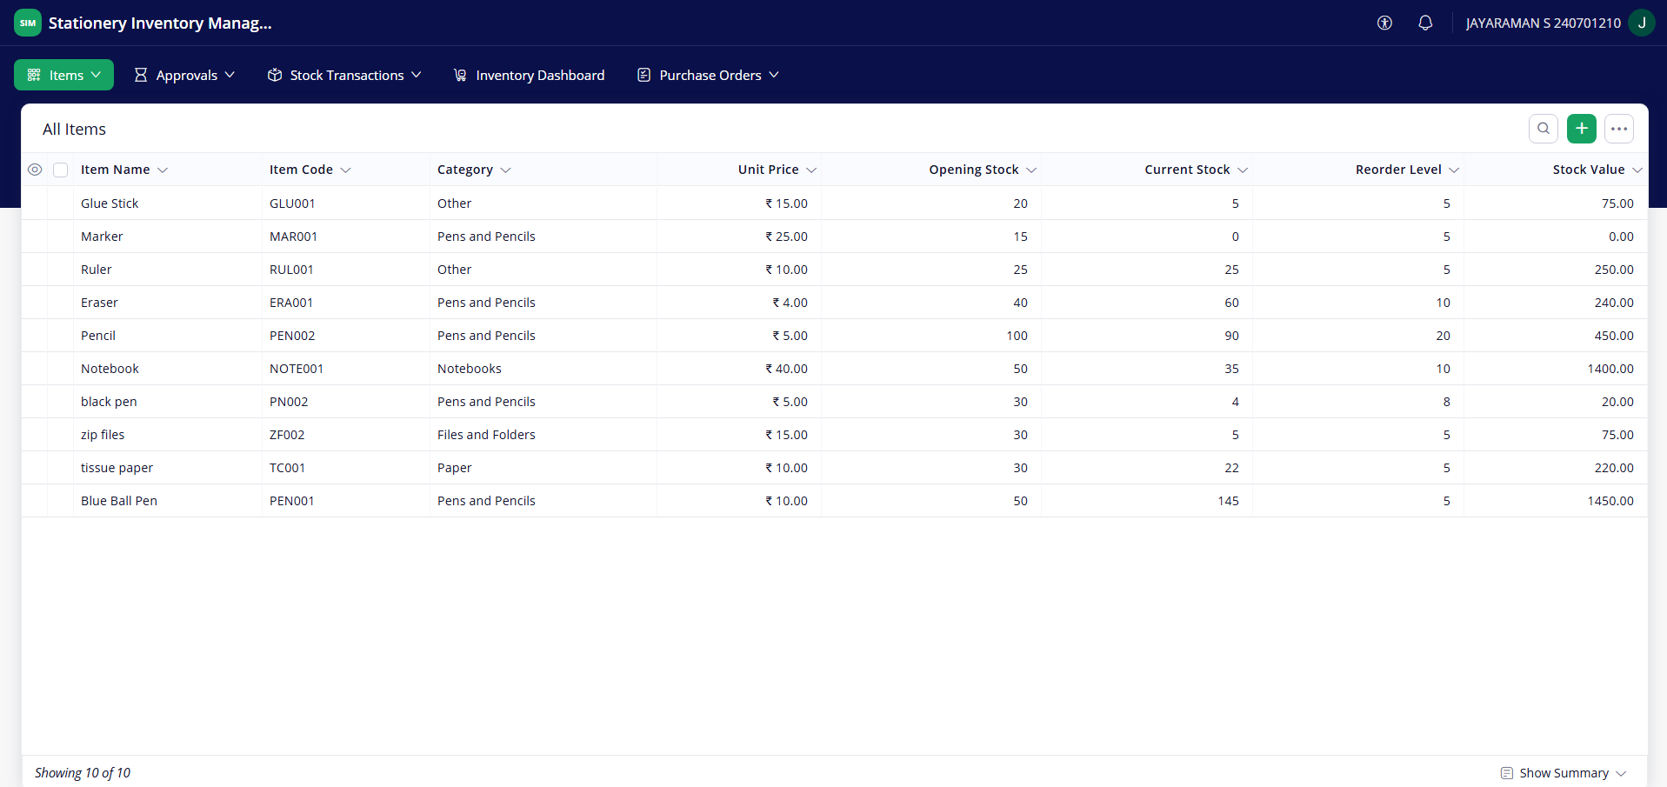
Figure 5.4(a): All Items Report
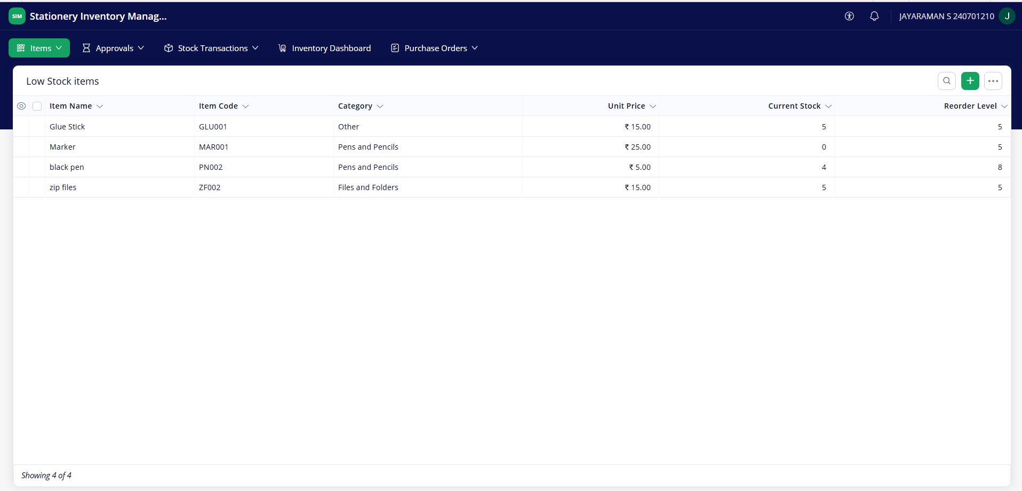
Figure 5.4(b): Low Stock Items Report
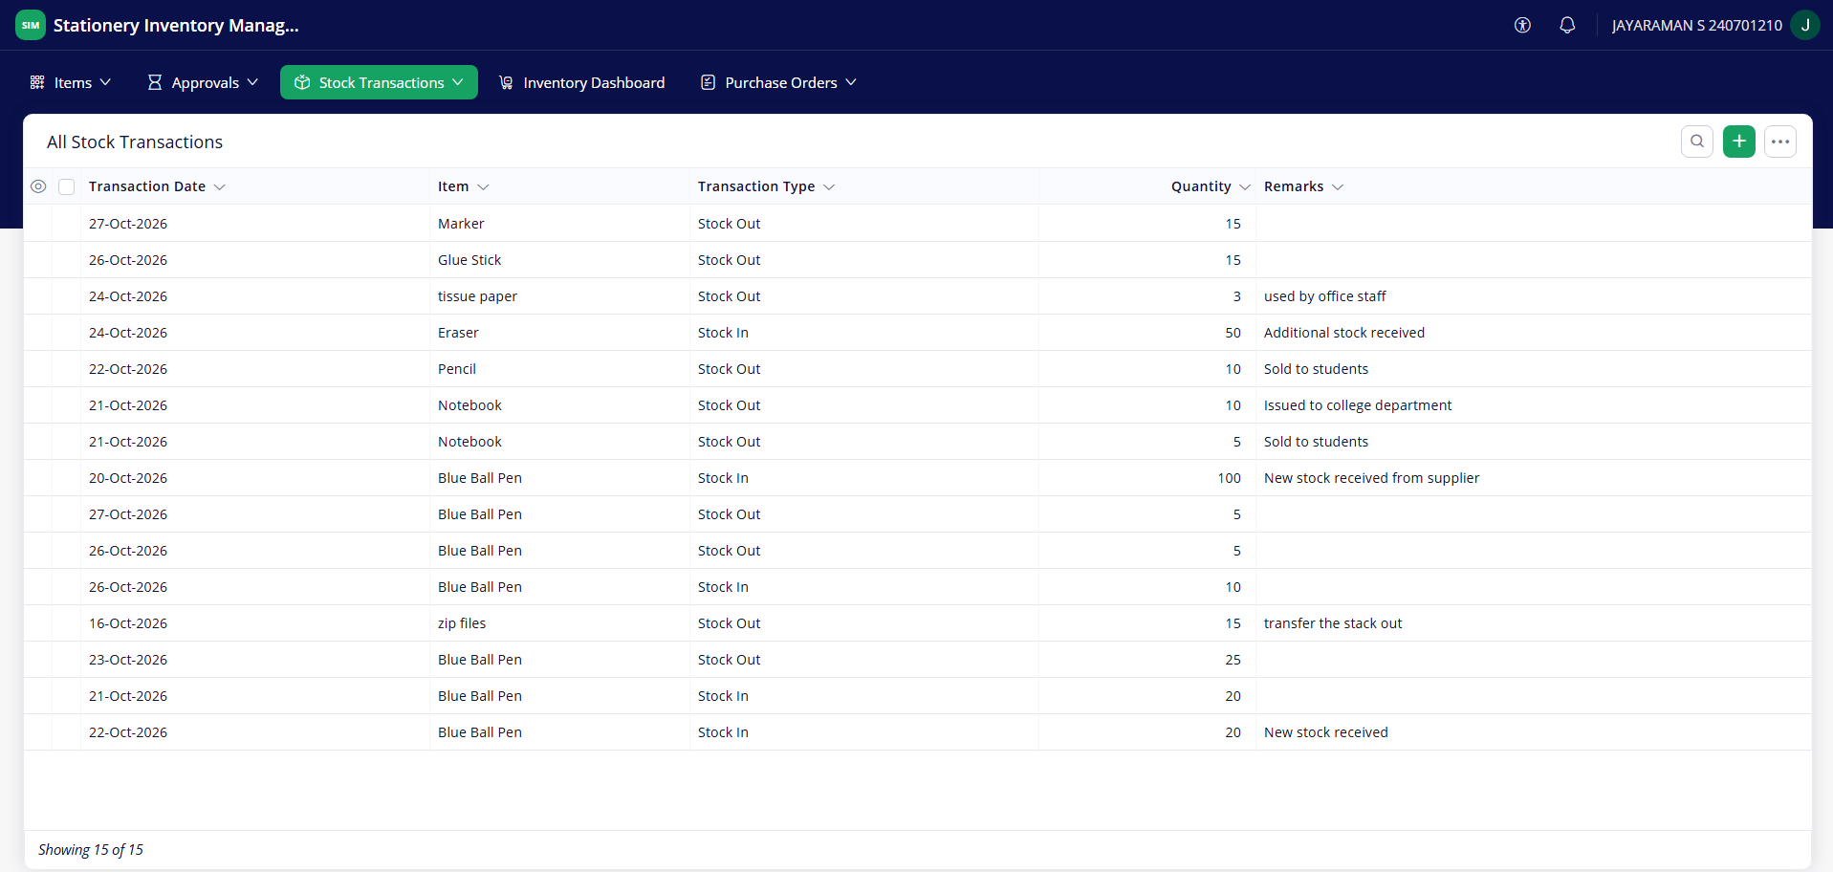
Figure 5.4(c): All Stock Transactions Report
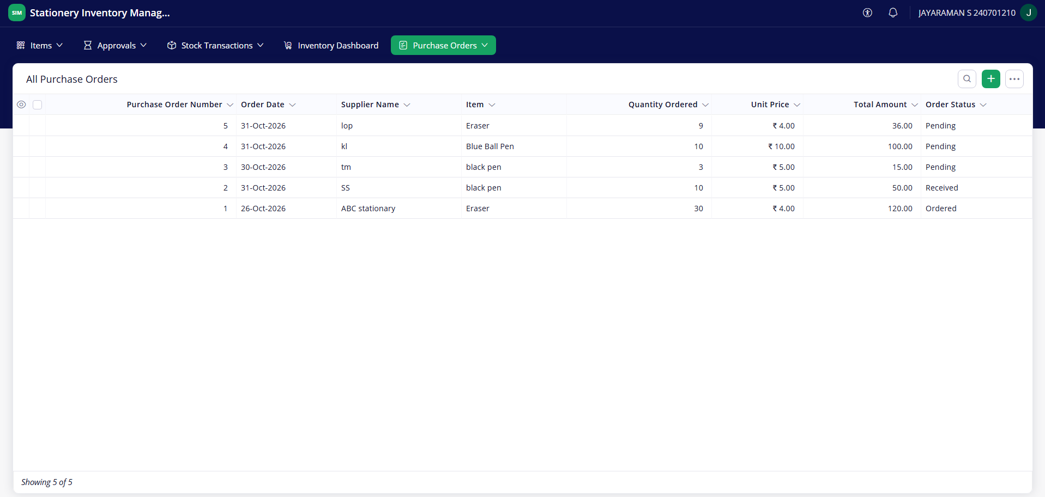
Figure 5.4(d): All Purchase Orders Report
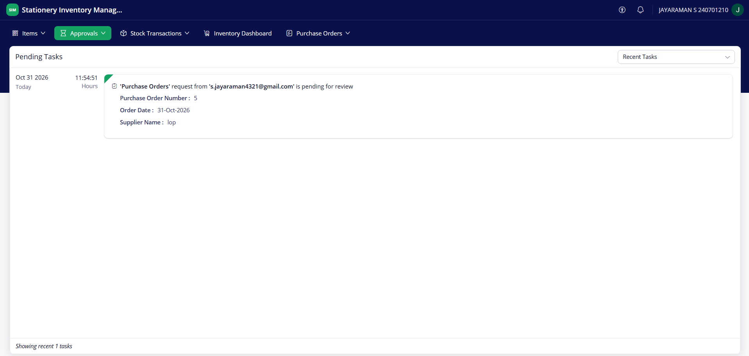
Figure 5.4(e): Pending Tasks Approval View
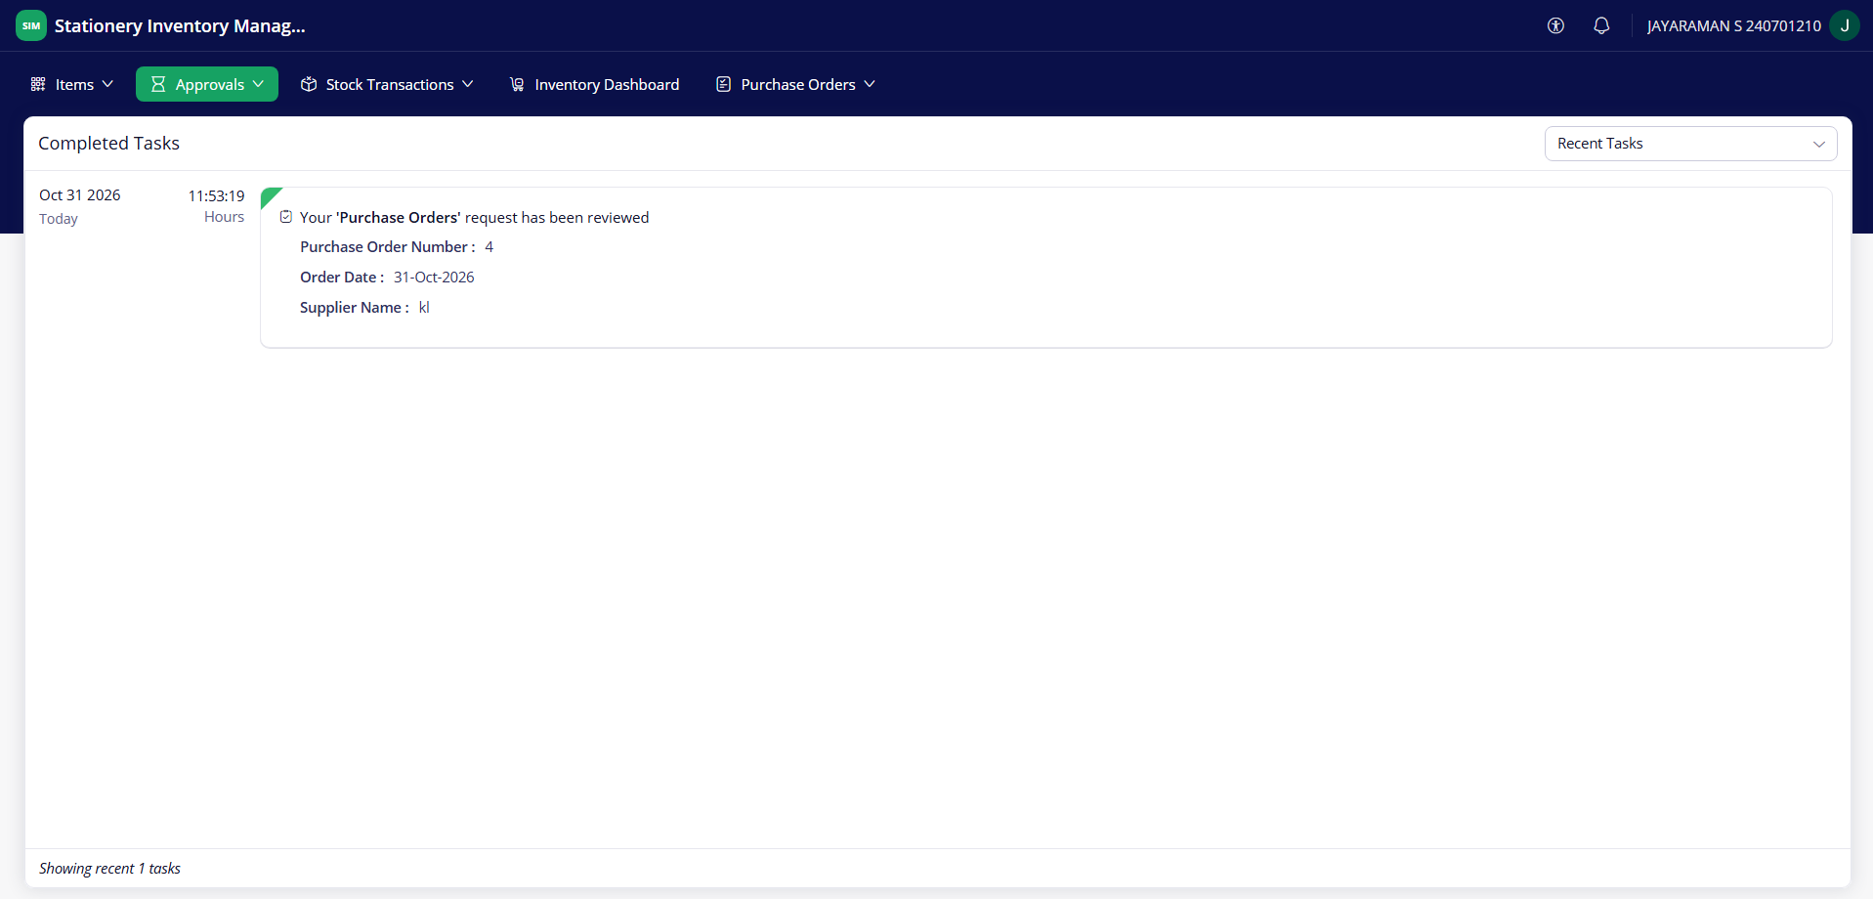
Figure 5.4(f): Completed Tasks Approval View

5.4 Pages and Dashboards
The Inventory Dashboard is the only dashboard in the application and is opened directly from the top menu. It gives the user a quick view of the stock position without opening the individual reports. It contains four summary panels, one chart and two embedded lists:
- Summary panels: Total Stock, Total Items, Total Transaction and Total Current Stock Value.
- Bar chart: a horizontal bar chart of Current Stock Quantity for each stationery item.
- Low Stock items: a list of the items at or below their reorder level, with Item Name, Item Code, Category, Unit Price, Current Stock and Reorder Level.
- All Stock Transactions: a list of transaction date, item, transaction type, quantity and remarks.
The values in Figure 5.5 (Total Stock 391, Total Items 10, Total Transaction 15 and Total Current Stock Value ₹4,180.00) are the figures at the time the screenshot was taken and change as records are added.
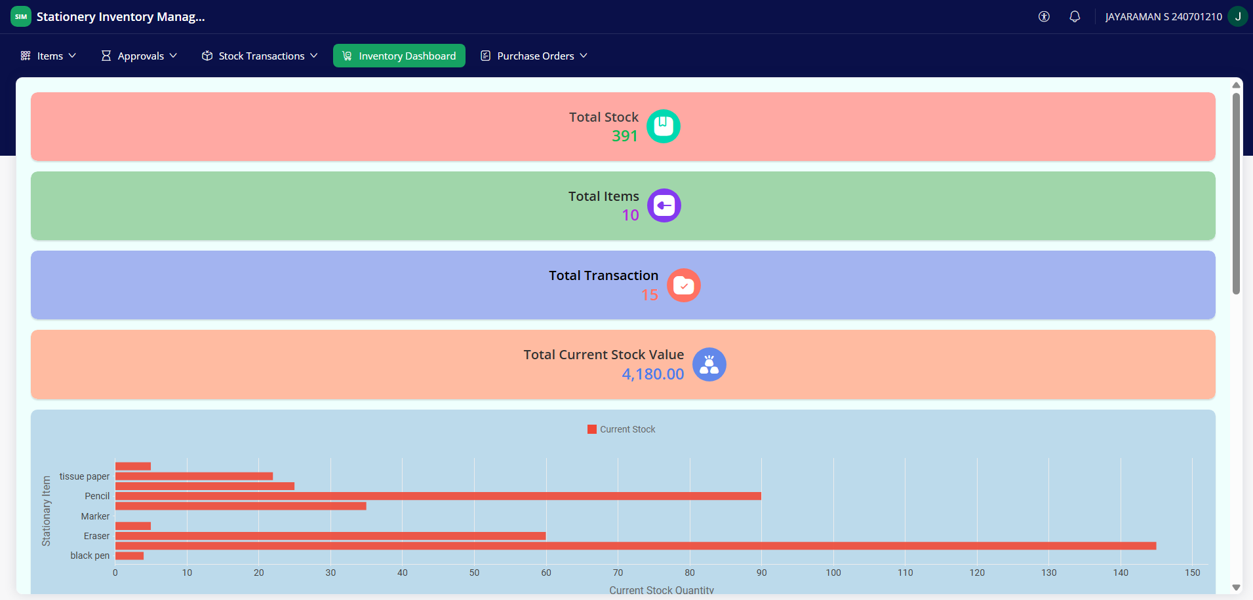
Figure 5.5(a): Inventory Dashboard – Summary Panels and Current Stock Chart
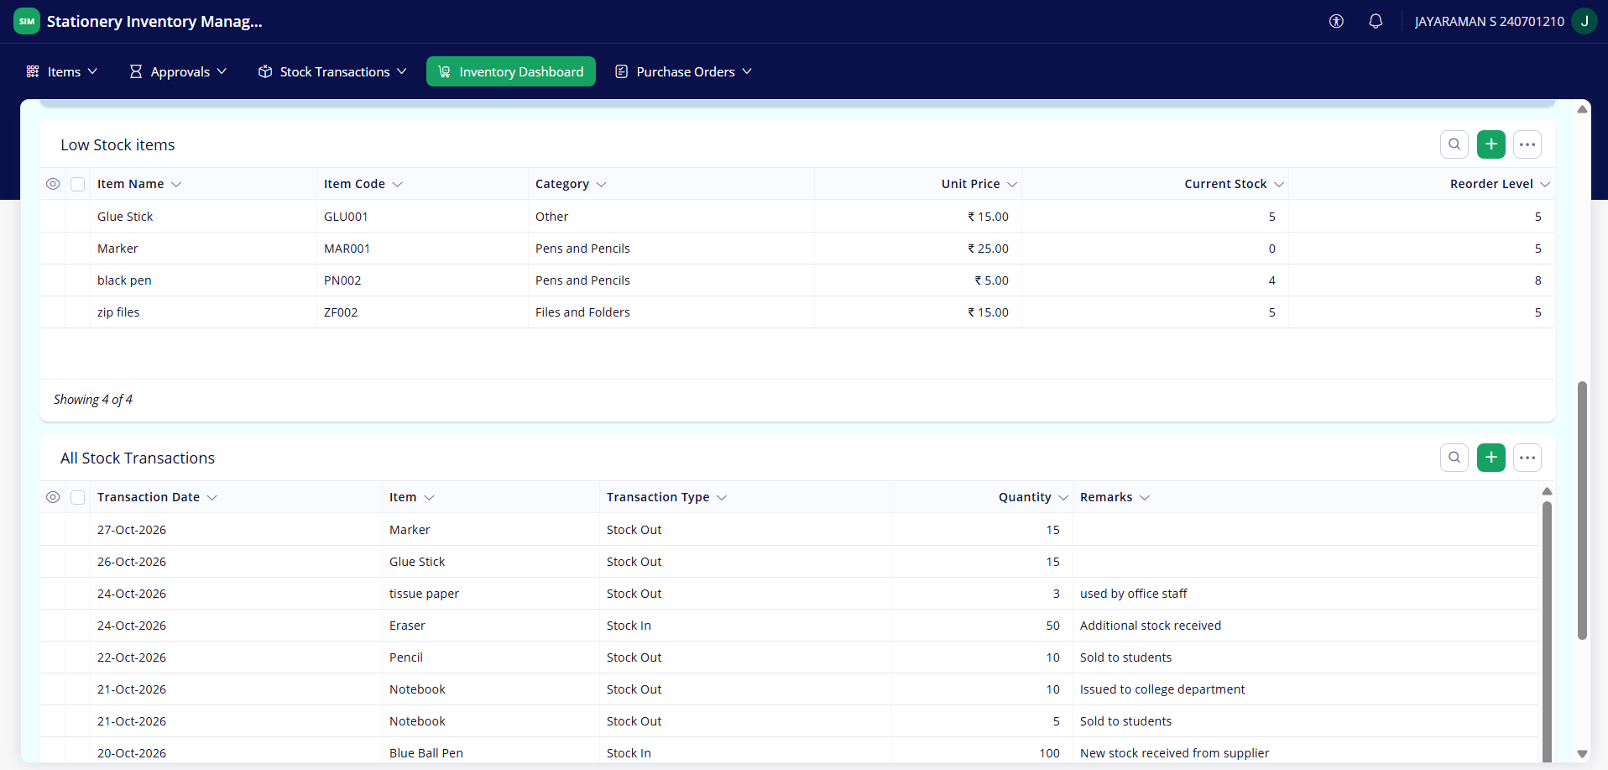
Figure 5.5(b): Inventory Dashboard – Low Stock Items and All Stock Transactions

5.5 Deluge Scripting
Table 5.2: Deluge Scripts Implemented
Script ID | Location / Trigger | Purpose | Deluge Concepts Used
DS-01 | Stock Transaction → Created → After Form Submission (Successful Submission) | Add the quantity to Current Stock for Stock In and subtract it for Stock Out | record fetch by ID, if / else if, field update
DS-02 | Stock Transaction → Created → On Form Submission (Validations) | Stop a Stock Out larger than the available stock | record fetch, nested if, alert, cancel submit
DS-03 | Purchase Orders → On User Input of Item | Fill Unit Price from the selected item | record fetch, assignment to an input field
DS-04 | Purchase Orders Blueprint → Receive Items → After Action | Add Quantity Ordered to the item’s Current Stock | record fetch, field update
DS-05 | Scheduled workflow: Daily Low Stock Alert | Email the items that have reached their reorder level | criteria fetch, count(), for each, string concatenation, sendmail

Code 5.1: Validation script – DS-02 Validate Stock Availability
// DS-02 | Form: Stock Transaction | Event: On Form Submission (Validations)
// Purpose: block a Stock Out larger than the available stock
itemRecord = Items[ID == input.Item];
if(itemRecord.ID != null)
{
if(input.Transaction_Type == "Stock Out")
{
if(input.Quantity > itemRecord.Current_Stock)
{
alert "Insufficient stock! Available quantity: " +
itemRecord.Current_Stock;
cancel submit;
}
}
}

Code 5.2: Stock update script – DS-01 Update Current Stock
// DS-01 | Form: Stock Transaction | Event: After Form Submission (Successful
Submission)
// Purpose: update the item's Current Stock
itemRecord = Items[ID == input.Item];
if(itemRecord.ID != null)
{
if(input.Transaction_Type == "Stock In")
{
itemRecord.Current_Stock = itemRecord.Current_Stock + input.Quantity;
}
else if(input.Transaction_Type == "Stock Out")
{
itemRecord.Current_Stock = itemRecord.Current_Stock - input.Quantity;
}
}

Code 5.3: Scheduled alert script – DS-05 Daily Low Stock Alert
// DS-05 | Scheduled workflow: Daily Low Stock Alert
// Purpose: email the items that have reached their reorder level
lowStockItems = Items[Current_Stock <= Reorder_Level];
if(lowStockItems.count() > 0)
{
message = "The following stationery items have reached their reorder
level:\n\n";
for each item in lowStockItems
{
message = message + "Item: " + item.Item_Name + "\nCurrent Stock: " +
item.Current_Stock + "\nReorder Level: " +
item.Reorder_Level + "\n\n";
}
sendmail
[
from :zoho.adminuserid
to :"jayaraman.s.2024.cse@rajalakshmi.edu.in"
subject :"Daily Low Stock Alert - Stationery Inventory"
message :message
]
}

The five scripts were written in Deluge. The three most important are shown above; the complete listing of DS-01 to DS-05 is in Appendix C. Results are those confirmed by the student while testing the application.
DS-02 Validate Stock Availability. Runs before the record is saved. It fetches the selected item and, for a Stock Out, compares the Quantity with Current Stock. If the Quantity is greater, an alert shows the available quantity and the submission is cancelled. Result: the insufficient-stock alert appears and no record is saved (Figure 8.2).
DS-01 Update Current Stock. Runs after a successful submission. A Stock In adds the Quantity to Current Stock and a Stock Out subtracts it. Result: Current Stock increases and decreases as expected after valid transactions.
DS-03 Fetch Item Unit Price. Runs when the Item field of the Purchase Orders form changes. It copies the item’s Unit Price into the form, so the Total Amount formula can be calculated. Result: the unit price is filled automatically once an item is selected.
DS-04 Receive Items stock update. Runs after the Receive Items Blueprint transition and adds the Quantity Ordered to the item’s Current Stock. Result: stock increases by the ordered quantity (Section 8.1).
DS-05 Daily Low Stock Alert. Runs on the daily schedule. It fetches the items whose Current Stock is less than or equal to Reorder Level; if there are any, it builds one message with the name, current stock and reorder level of each item and sends it with the built-in sendmail task. Result: the alert email is received (Figure 5.6(e)).
No separate input checks such as a zero or negative Quantity are present in the scripts supplied.

5.6 Workflows and Automation
The application uses form workflows, one Blueprint, one approval process and one scheduled workflow, listed in Table 5.3. Only the Daily Low Stock Alert is implemented among the scheduled tasks.
Table 5.3: Workflows Implemented
Workflow Name | Type | Trigger / Event | Condition | Action(s) | Script Ref.
Update Current Stock | Form Workflow | Stock Transaction: Created → After Form Submission (Successful Submission) | None (runs for every new record) | Add or subtract Current Stock | DS-01
Validate Stock Availability | Form Workflow | Stock Transaction: Created → On Form Submission (Validations) | Stock Out and Quantity > Current Stock | Show alert; cancel submit | DS-02
Purchase Orders – Unit Price autofill | Form Workflow | Purchase Orders: On User Input of Item | Item selected | Populate Unit Price | DS-03
Purchase_Order_Lifecycle | Blueprint | Order Status transitions | Pending → Ordered → Received; Pending or Ordered → Cancelled | Place Order, Receive Items, Cancel Order (two); Receive Items adds stock | DS-04
Purchase_Order_Approval | Approval process | Purchase Orders record submitted | Total_Amount >= 1000 | Mail to the approver on start; Level 1 approver approves or rejects; mail to the submitter | —
Daily Low Stock Alert | Schedule | Daily at 14:52 (India Standard Time), from 30-Oct-2026 | Items where Current Stock <= Reorder Level | Send one email listing those items | DS-05

Blueprint. Purchase_Order_Lifecycle works on the Order Status field of the Purchase Orders form. A new order starts at Pending. Place Order moves it to Ordered, and Receive Items moves it to Received and runs DS-04. Cancel Order is defined twice, from Pending and from Ordered, and both lead to Cancelled (Figure 5.6(b)). The transitions are used from the record detail view of All Purchase Orders (Figures 8.8 and 8.9).
Approval process. Purchase_Order_Approval is configured on the Purchase Orders form with the condition Total_Amount >= 1000. When it applies, a mail is sent to the configured address and the request goes to the Level 1 approver, who can Approve or Reject; the default notification mails are sent to the submitter (Figure 5.6(c)). The condition was added in version V3.2 (Section 7.1). Approval Status is separate from the Blueprint’s Order Status.
Scheduled workflow. Daily Low Stock Alert runs once a day at 14:52 India Standard Time and runs DS-05 (Figure 5.6(d)). The email it sends is shown in Figure 5.6(e). The Weekly Inventory Digest and Monthly Stock Valuation Report that were considered were not implemented.
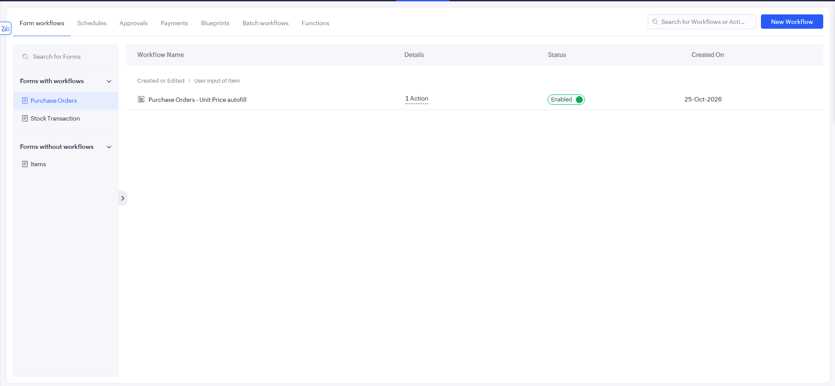
Figure 5.6(a): Form Workflows List – Purchase Orders Unit Price Autofill
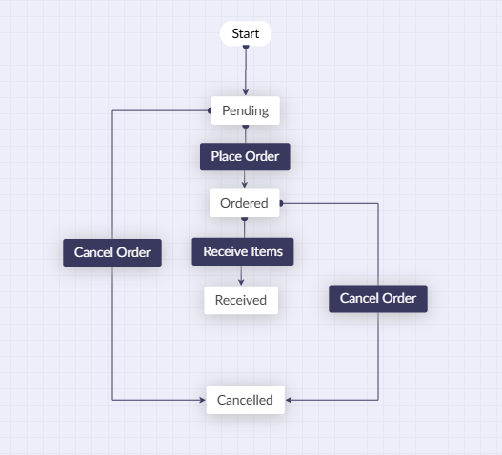
Figure 5.6(b): Purchase_Order_Lifecycle Blueprint
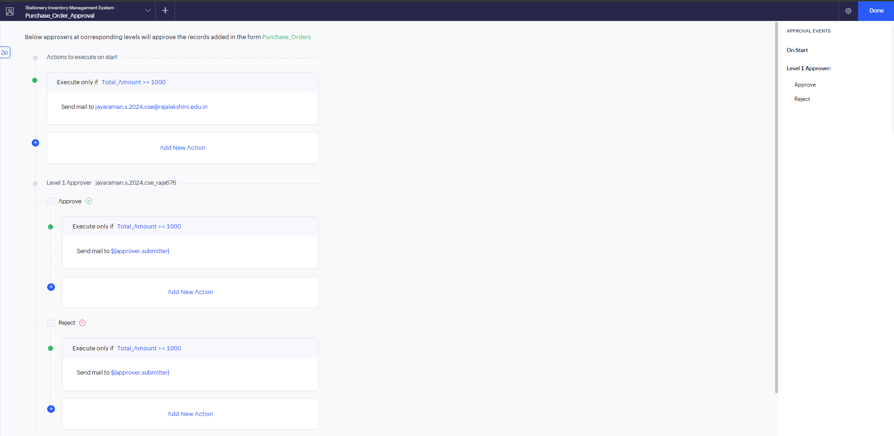
Figure 5.6(c): Purchase_Order_Approval Process
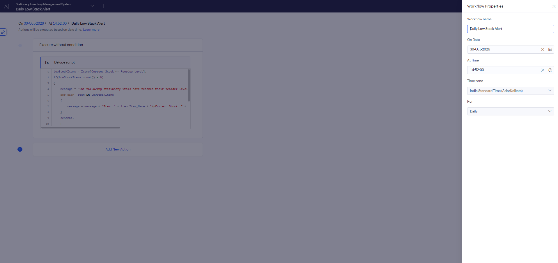
Figure 5.6(d): Daily Low Stock Alert Schedule
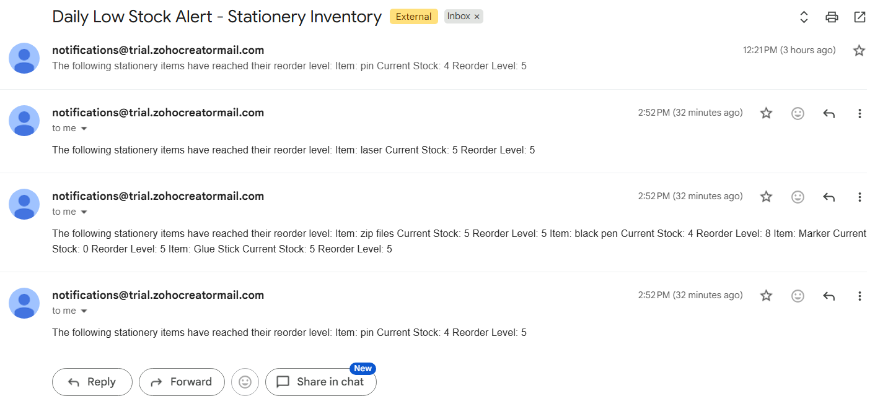
Figure 5.6(e): Daily Low Stock Alert Email Received

5.7 Integrations
No external integration was implemented. The application does not use Zoho CRM or any other Zoho service, an external REST API, a webhook, a connection with OAuth or an API key, or Postman testing, so there is no integration table or code in this report. The email in the Daily Low Stock Alert uses Zoho Creator’s built-in sendmail task, and the approval process uses the platform’s own notification mails; neither is a third-party integration.

5.8 User Management and Role-Based Access
Access is based on two accounts in the Zoho Creator organisation. The Super Admin owns the application and manages users. A second user has the CEO role with the Write permission for the Stationery Inventory Management System (Figure 5.8). The Create Application Privilege is switched off for this user. The approver of the Purchase_Order_Approval process is the Super Admin account. No other roles, permission profiles, record-level criteria or portal configuration were created; the matrix in Table 4.5 therefore has only these two columns.
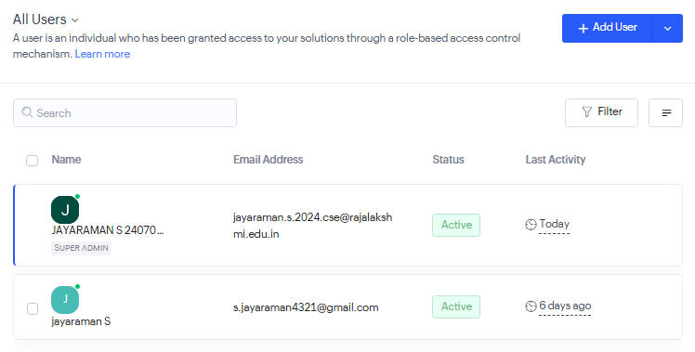
Figure 5.8(a): Users in the Organisation – Super Admin and the CEO User
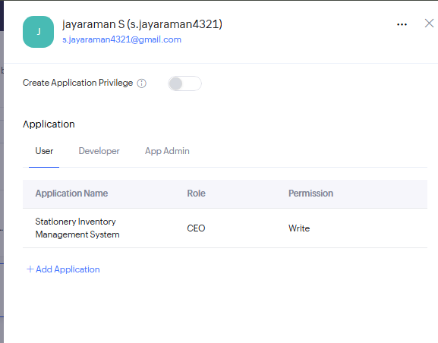
Figure 5.8(b): CEO Role with Write Permission for the Application

5.9 AI and Analytics Features
No Zia AI or other AI feature was used; the application was built manually. Analytics are limited to what the dashboard shows: the summary panels, the item-wise current-stock bar chart and the filtered Low Stock Items list. They report current figures only and do not predict demand or recommend orders.

5.10 Pro-Code Extension
No pro-code extension was used. There is no Zoho Catalyst function, JavaScript widget, separately created custom function or Creator REST API call; the requirements were met with forms, reports, the dashboard, Deluge scripts and the platform’s workflow tools. If the application grows, a custom function or an API call could be added for tasks that these tools cannot do, such as sending stock data to another system.

5.11 Mobile and Portal Access
No mobile-specific layout, offline setting or customer portal was configured, and the application was not evaluated on the Zoho Creator mobile app. It was used in a web browser.
CHAPTER 6

TESTING AND DEBUGGING

6.1 Testing Strategy
Testing was done in the Zoho Creator Development environment by the student, using sample items, transactions and purchase orders. It was functional testing at three levels:
- Form and script testing: each form was submitted with valid and invalid data, and each Deluge script (DS-01 to DS-05) was run through the form, Blueprint or schedule that triggers it.
- Workflow testing: the Blueprint transitions, the approval process (approve and reject) and the daily scheduled alert were tested end to end, including the change of stock after Receive Items.
- Report and dashboard checks: the reports, approval task views and the dashboard were opened to confirm that records and totals changed after each operation.
Test results in this chapter are those confirmed by the student while using the application; the walk-through in Chapter 8 supplies screenshot evidence for several of them. No formal test log was kept, no automated tests were used and no formal user acceptance sign-off exists. Tests that have not been run yet are marked in yellow in Table 6.1.

6.2 Test Cases
Table 6.1: Test Cases
TC ID | FR Ref. | Test Description | Input / Steps | Expected Result | Actual Result | Status
TC-01 | FR-01 | Add an item with all mandatory fields | Items form: item name, code, category, unit price, opening and current stock, reorder level | Record is saved and listed in All Items | Item saved and shown in All Items (Figure 8.1) | Pass
TC-02 | FR-01 | Submit the Items form with a mandatory field empty | Leave Item Name or Item Code blank and submit | Form is not submitted; mandatory-field message | Not run | Not run
TC-03 | FR-02, FR-04 | Stock In transaction | Stock Transaction: Item, Stock In, valid quantity | Record saved; item’s Current Stock increases by the quantity | Current Stock increased | Pass
TC-04 | FR-02, FR-04 | Valid Stock Out transaction | Stock Transaction: Parker, Stock Out, quantity 21 (stock 25) | Record saved; Current Stock decreases by 21 | Current Stock changed from 25 to 4 (Figures 8.3, 8.4) | Pass
TC-05 | FR-03 | Stock Out larger than available stock (negative test) | Stock Transaction: Parker, Stock Out, quantity 100 (stock 25) | Alert with available quantity; submission cancelled | Alert “Insufficient stock! Available quantity: 25”; no record saved (Figure 8.2) | Pass
TC-06 | FR-05 | Item at or below reorder level appears in Low Stock Items | Open Low Stock Items after TC-04 | Parker is listed (stock 4, reorder level 5) | Parker listed with 4 and 5 (Figure 8.4) | Pass
TC-07 | FR-06 | Daily low-stock alert email | Let the daily schedule run | One email listing the low-stock items with stock and reorder level | Email received (Figure 5.6(e)); it first failed to arrive and was fixed (BUG-01) | Pass
TC-08 | FR-07 | Unit price auto-fill and total | Purchase Orders: select Parker, quantity 10 | Unit Price 150.00 filled; Total Amount 1500.00 | Unit Price filled; total 1500.00 (Figures 8.5, 8.6) | Pass
TC-09 | FR-08 | Place Order transition | Open the Pending order; select Place Order | Order Status changes from Pending to Ordered | Status became Ordered (Figures 8.8, 8.9) | Pass
TC-10 | FR-08 | Receive Items transition and stock update | Open the Ordered order; select Receive Items | Status Received; Current Stock increases by the Quantity Ordered | Status Received; Parker stock 4 → 14 (Figures 8.10, 8.11) | Pass
TC-11 | FR-08 | Cancel Order transition | Open a Pending order; select Cancel Order | Order Status changes to Cancelled; stock unchanged | Student confirmed the transition works | Pass
TC-12 | FR-09 | Order of ₹1,000 or more is sent for approval | Purchase order of 10 × ₹150 = ₹1,500 | Approval request appears in Pending Tasks | Request shown with Approve and Reject (Figure 8.6) | Pass
TC-13 | FR-09 | Approve a purchase order | Select Approve in the Approval Summary | Task moves to Completed Tasks | Task shown in Completed Tasks (Figure 8.7) | Pass
TC-14 | FR-09 | Reject a purchase order | Select Reject in the Approval Summary | Rejection is recorded and notification sent | Student confirmed the Reject action works; the outcome is not shown in All Purchase Orders | Pass
TC-15 | FR-09 | Order below ₹1,000 does not need approval (negative test) | Purchase order with Total Amount below 1000 after version V3.2 | No approval request is created | Not run | Not run
TC-16 | FR-10 | Reports and approval views open with data | Open All Items, Low Stock Items, All Stock Transactions, All Purchase Orders, Pending Tasks, Completed Tasks | Each lists its records | All six open and list records (Figure 5.4) | Pass
TC-17 | FR-11 | Dashboard reflects the data | Open Inventory Dashboard before and after the walk-through | Panels, chart and lists show current values | Panels changed from 391/10/15/₹4,180 to 405/11/16/₹6,280 (Figures 5.5, 8.12) | Pass
TC-18 | FR-12 | CEO user signs in and uses the application (access test) | Sign in as the CEO user and open the forms and reports | Access follows the Write permission; no administration | Not run | Not run
TC-02, TC-15 and TC-18 are yet to be run and are highlighted. Every functional requirement FR-01 to FR-12 is covered by at least one test case.

6.3 Debugging Deluge Scripts
Bugs were found by using the application and checking the result against the expected one, then changing the Deluge script or the workflow setting and testing again. Three problems arose:
Daily alert not sent. The Daily Low Stock Alert first ran without an email arriving. The schedule and DS-05 were checked and delivery was tried again, and after troubleshooting the alert was received (Figure 5.6(e)). A short test email script was suggested for checking delivery; it is a temporary diagnostic and not part of the application. Add the exact cause if you remember it
Approval triggered for small orders. Early on, an order of only ₹36 (order number 5) reached the Pending Tasks view because the approval process had no amount condition. The condition Total_Amount >= 1000 was added in version V3.2 (Table 7.1), and the ₹1,500 order in Chapter 8 was correctly sent for approval.
Order Status out of step with the Blueprint. When Cancelled was chosen directly in the form instead of using the Cancel Order transition, the stage shown by the Blueprint did not match. Order Status is therefore changed only through the Blueprint transitions.
No exact Deluge error messages or debug logs were saved, so none are reproduced here.

6.4 Defect Log
Table 6.2: Defect Log
Bug ID | Description | Root Cause | Fix Applied | Status
BUG-01 | Daily Low Stock Alert did not send the email at first | Not recorded | Troubleshot the schedule and email sending; alert confirmed working | Closed
BUG-02 | A purchase order of ₹36 was sent for approval | Approval process had no Total Amount condition | Condition Total_Amount >= 1000 added in version V3.2; re-test with an order below ₹1,000 pending (TC-15) | Closed
BUG-03 | Order Status and Blueprint stage differed when Cancelled was set manually in the form | The Blueprint transition was bypassed | Use the Cancel Order transition from the record view | Closed
Known limitations that are not defects of the supplied design: the scripts do not reject a zero or negative Quantity, and the approval decision is not shown as a column in All Purchase Orders.

6.5 User Acceptance Testing
Feedback from end users who tried the application in their assigned roles is recorded in Table 6.3. Add at least two users, the role each tested, their feedback and the action you took.
Table 6.3: User Acceptance Feedback
User | Role Tested | Feedback | Action Taken
User 1 – name | Super Admin / CEO | Feedback | Action taken
User 2 – name | Super Admin / CEO | Feedback | Action taken
CHAPTER 7

DEPLOYMENT, SECURITY AND GOVERNANCE

7.1 Environments and Deployment Strategy
The application was built and tested in the Development environment and then published through Stage to Production. Each publish creates a numbered version with a description, and the version history keeps the list (Figure 7.1(b)). Stage and Production both hold version 3.2, published on 31 October 2026 (Figure 7.1(a)), and the Development environment shows “Changes available”. Table 7.1 lists the six versions so far.
Table 7.1: Version History of the Application
Version | Date and time | Type | Version title | Description
V1.0 | 25-Oct-2026, 11:48:32 | Major | Default Package 1.0 | Package published by default
V2.0 | 25-Oct-2026, 13:09:05 | Major | SIMS | Purchase order added to the system
V2.1 | 25-Oct-2026, 14:04:08 | Minor | SIMS | Order status added to the purchase report
V3.0 | 30-Oct-2026, 21:01:25 | Major | approval_blueprint | Approval and Blueprint added
V3.1 | 31-Oct-2026, 12:24:30 | Minor | email_change | Email address changed
V3.2 | 31-Oct-2026, 13:45:38 | Minor | conditon_approval | Approval condition changed: purchase orders of ₹1,000 or more trigger approval
The deployment was done by the Super Admin account. No rollback was needed; the earlier versions remain listed in the version history.
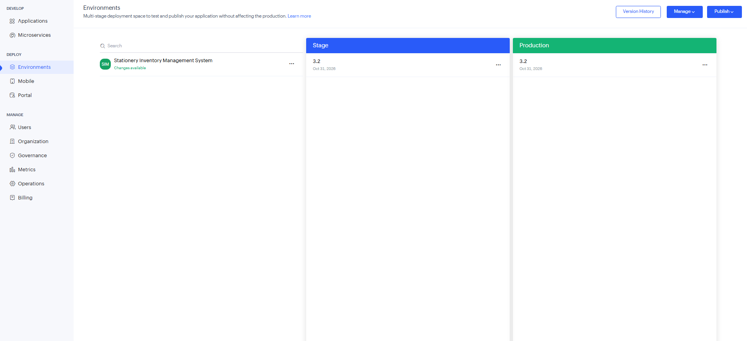
Figure 7.1(a): Environments – Stage and Production at Version 3.2
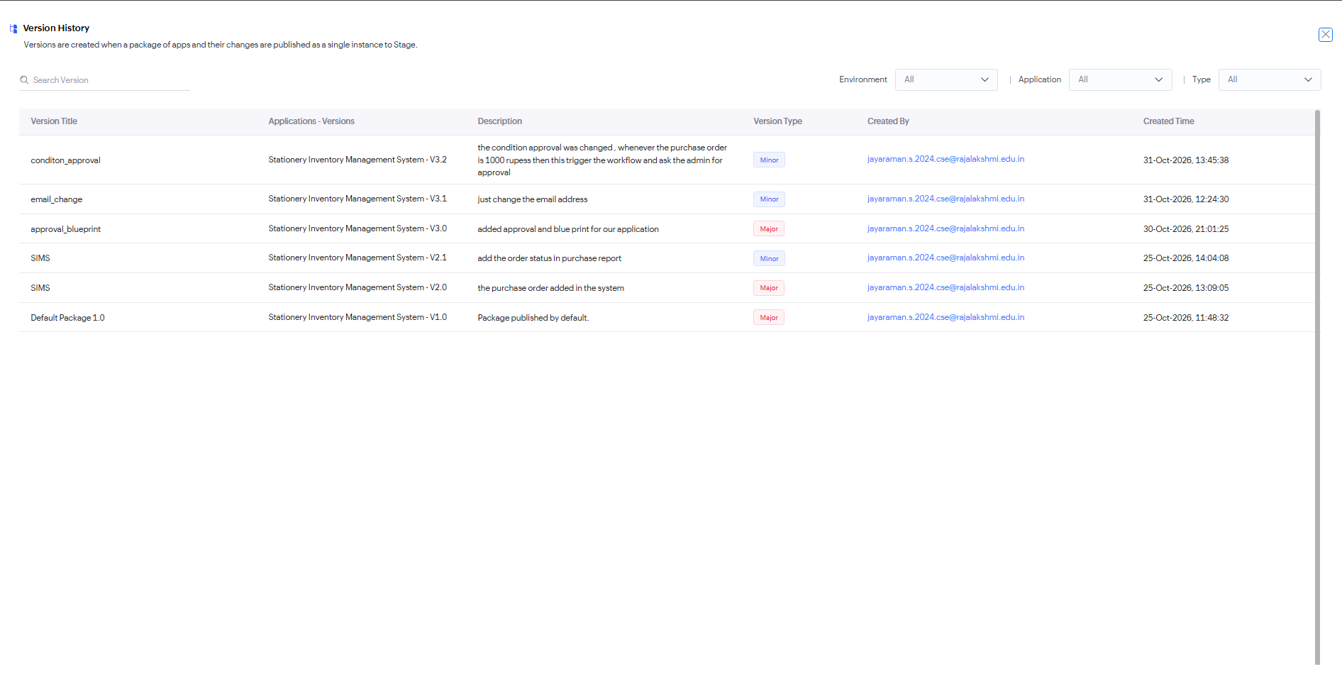
Figure 7.1(b): Version History of the Application
Table 7.2: Deployment Checklist
S.No. | Checklist Item | Done (✓)
1 | All test cases executed in Development / Stage | ✓ after the pending tests in Table 6.1
2 | Sample/test data removed or isolated | Pending – sample data is still in the application
3 | Roles, permissions and users configured in Production | ✓ (Super Admin; CEO with Write)
4 | Connections authorised in Production | Not applicable – no connections used
5 | Schedules and workflows enabled | ✓ (workflows enabled; Daily Low Stock Alert working)
6 | Application published and URL verified | ✓ (published to Production as V3.2) confirm the URL opens
7 | Version / release notes recorded | ✓ (version history, Table 7.1)

7.2 Performance Optimisation
The application holds a small data set (11 items, 16 transactions and 6 purchase orders at the last check), and no response times were measured, so no improvement figures are claimed. The scripts were written to keep the work small, as listed in Table 7.3.
Table 7.3: Performance Optimisation Results
Optimisation Applied | Component | Before | After | Improvement
One criteria fetch for all low-stock items, with no fetch inside the loop | DS-05 | Not measured | Not measured | Not claimed
Fetch only the one item record needed, by its ID | DS-01 to DS-04 | Not measured | Not measured | Not claimed
Report filtered by criteria (Current Stock <= Reorder Level) | Low Stock Items report | Not measured | Not measured | Not claimed

7.3 Security Features
Security rests on the platform’s sign-in and role settings together with the application’s own checks. Table 7.4 lists the controls that were configured.
Table 7.4: Security Controls Implemented
Security Control | Where Applied | Threat Mitigated
Role-based access (Super Admin; CEO with Write permission) | User management (Figure 5.8) | Use of the application by people without a role
Create Application Privilege switched off for the CEO user | User management (Figure 5.8(b)) | Creation of other applications by that user
Stock Out quantity validation (DS-02) | Stock Transaction form | Issue of more stock than is held
Mandatory fields | Items, Stock Transaction and Purchase Orders forms | Incomplete records
Lookup fields for Item | Stock Transaction and Purchase Orders forms | Wrong or misspelt item names
Approval process for Total Amount of ₹1,000 or more | Purchase Orders form | High-value purchases without approval
Blueprint-controlled Order Status | Purchase Orders form | Uncontrolled change of order stage
Not configured or not confirmed: record-level permission criteria, field-level hiding, encrypted fields, OAuth connections, IP or domain restrictions, two-factor authentication and portal security. The “Encrypt data” and personal-data options of the Item Name field were left unchecked (Figure 5.2(a)).

7.4 Governance and Administration
The Super Admin administers the application: it manages the two users, builds and changes forms, reports and workflows, and publishes versions. Names follow one pattern, with link names such as Item_Name and Current_Stock and the workflow names Purchase_Order_Lifecycle and Purchase_Order_Approval. Changes are traceable through the version history (Table 7.1), with a description for each version. Backup or export routines, an audit trail setting and user licence management were not configured or confirmed confirm.
CHAPTER 8

RESULTS AND DISCUSSION

8.1 Application Output
This section follows one realistic scenario through the application using a new item, the Parker pen (item code P0013, category Pens and Pencils, unit price ₹150, reorder level 5). The steps were carried out with the Super Admin account, which is also the configured approver. The values in the screenshots are those at the time they were taken.
Step 1 – All Items report with the Parker pen. The Parker pen has an opening and current stock of 25 and a reorder level of 5. All Items now lists 11 items.
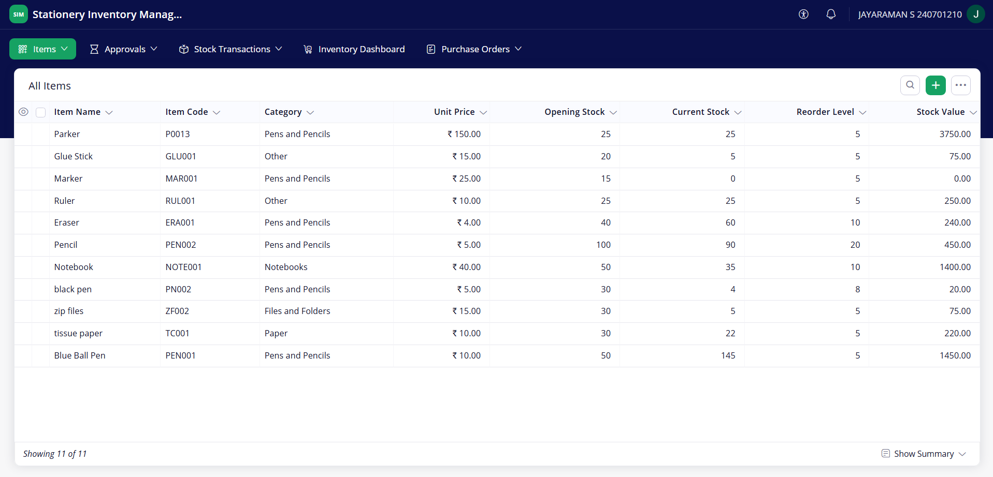
Figure 8.1: Scenario Step 1 – All Items report with the Parker pen
Step 2 – Stock Out of 100 rejected for insufficient stock. A Stock Out of 100 Parker pens is entered on 01-Nov-2026. DS-02 compares it with the 25 in stock, shows “Insufficient stock! Available quantity: 25” and cancels the submission, so no record is saved.
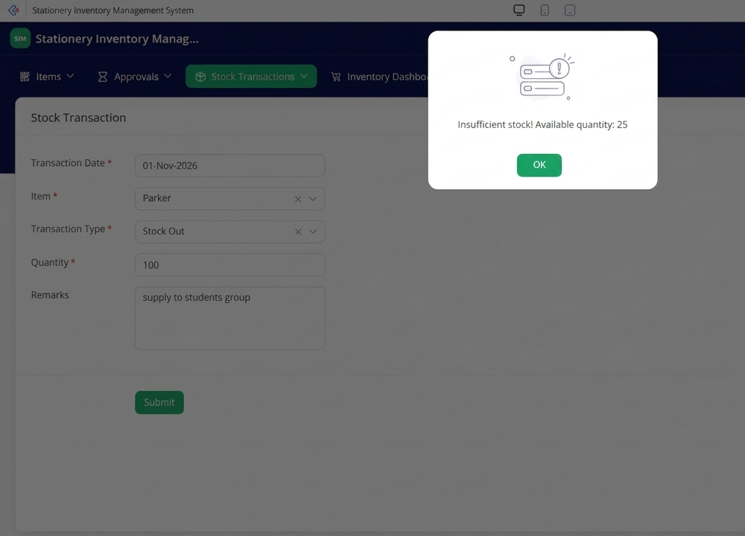
Figure 8.2: Scenario Step 2 – Stock Out of 100 rejected for insufficient stock
Step 3 – Valid Stock Out of 21 pens. A Stock Out of 21 pens with the remark “large delivery for school students” passes the validation. DS-01 subtracts 21, and Current Stock becomes 4.
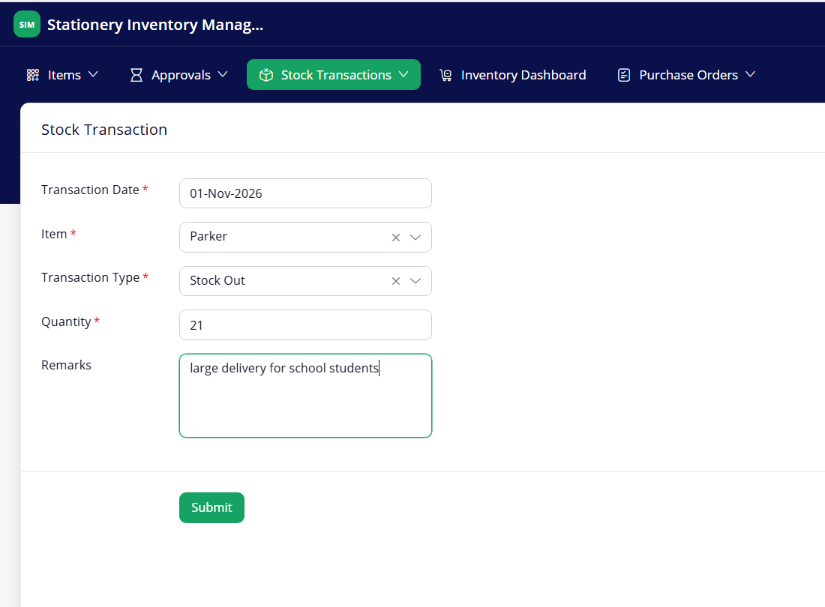
Figure 8.3: Scenario Step 3 – Valid Stock Out of 21 pens
Step 4 – Low Stock Items report shows the Parker pen. Current Stock (4) is now below the Reorder Level (5), so Parker joins the Low Stock Items report, which lists five items.
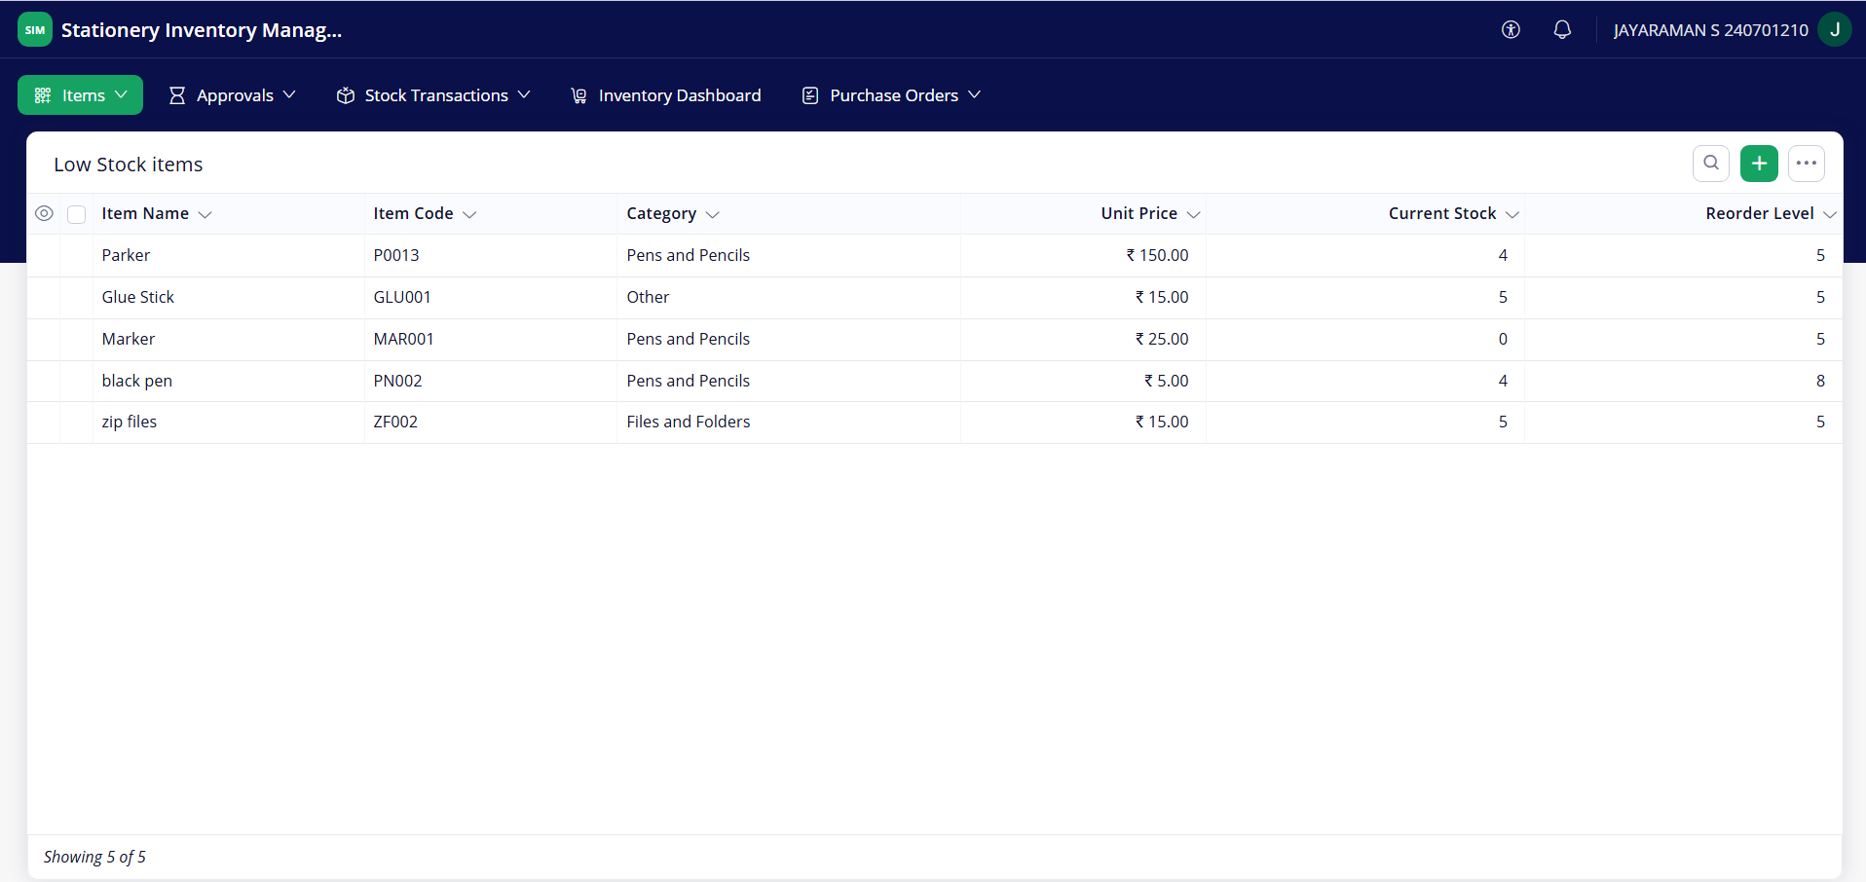
Figure 8.4: Scenario Step 4 – Low Stock Items report shows the Parker pen
Step 5 – Purchase order for 10 Parker pens. A purchase order is created for supplier HIK Stationary with quantity 10. Selecting the item makes DS-03 fill the Unit Price as 150.00, and the order starts with the status Pending.
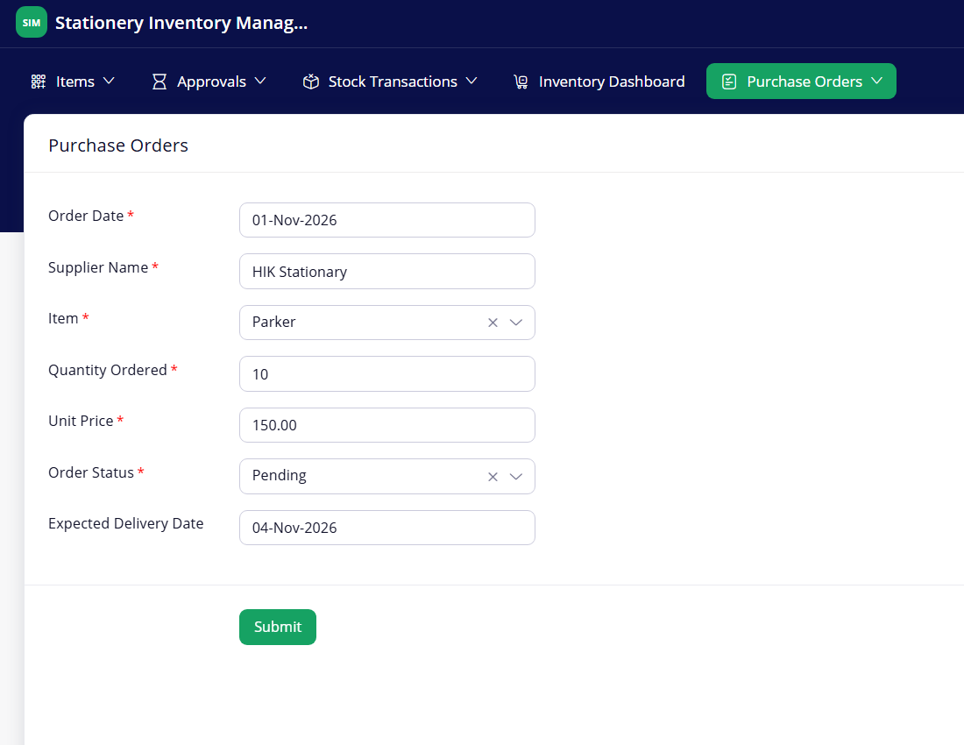
Figure 8.5: Scenario Step 5 – Purchase order for 10 Parker pens
Step 6 – Approval request for the ₹1,500 order. Total Amount is 1,500.00 (10 × ₹150), which is above ₹1,000, so the order appears in the Pending Tasks view. The Approval Summary shows its details with the Approve and Reject buttons.
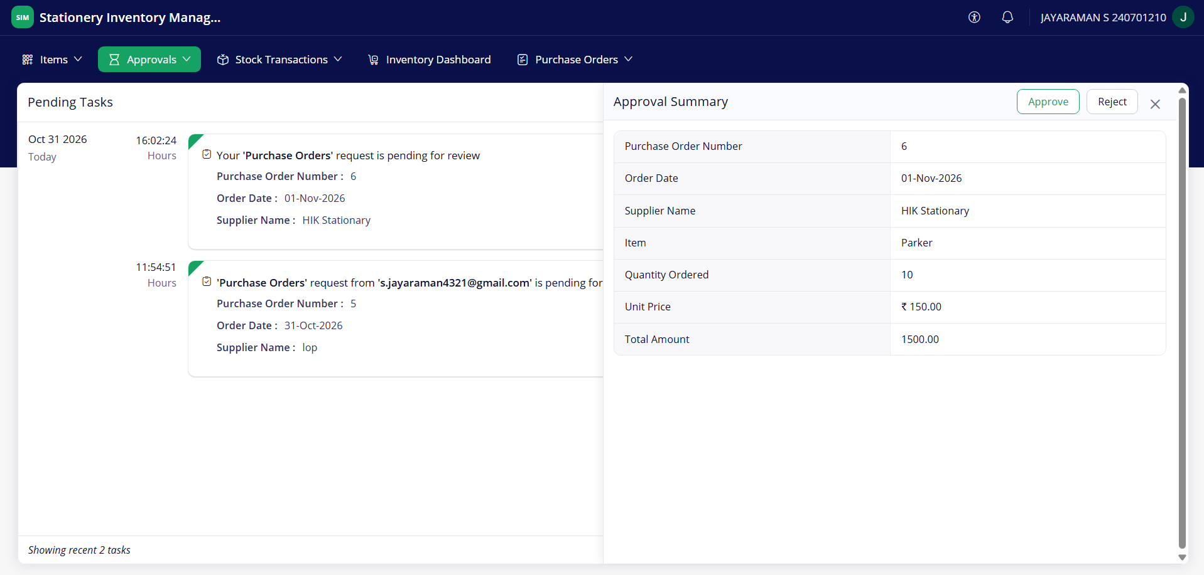
Figure 8.6: Scenario Step 6 – Approval request for the ₹1,500 order
Step 7 – Completed Tasks view after the approver acts. The approver approves the request. It moves to the Completed Tasks view as a reviewed purchase order (order number 6).
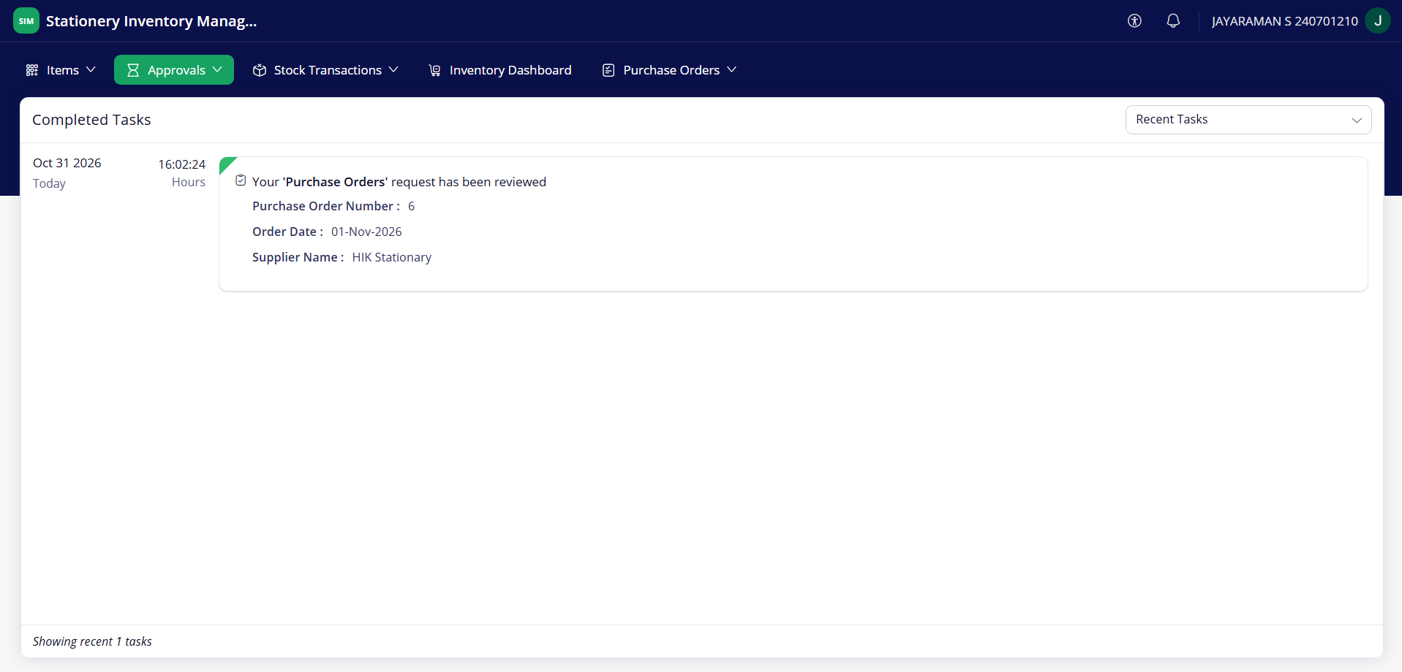
Figure 8.7: Scenario Step 7 – Completed Tasks view after the approver acts
Step 8 – Blueprint stage Pending with the Place Order transition. In All Purchase Orders, the order record shows the Blueprint stage Pending with the transitions Cancel Order and Place Order.
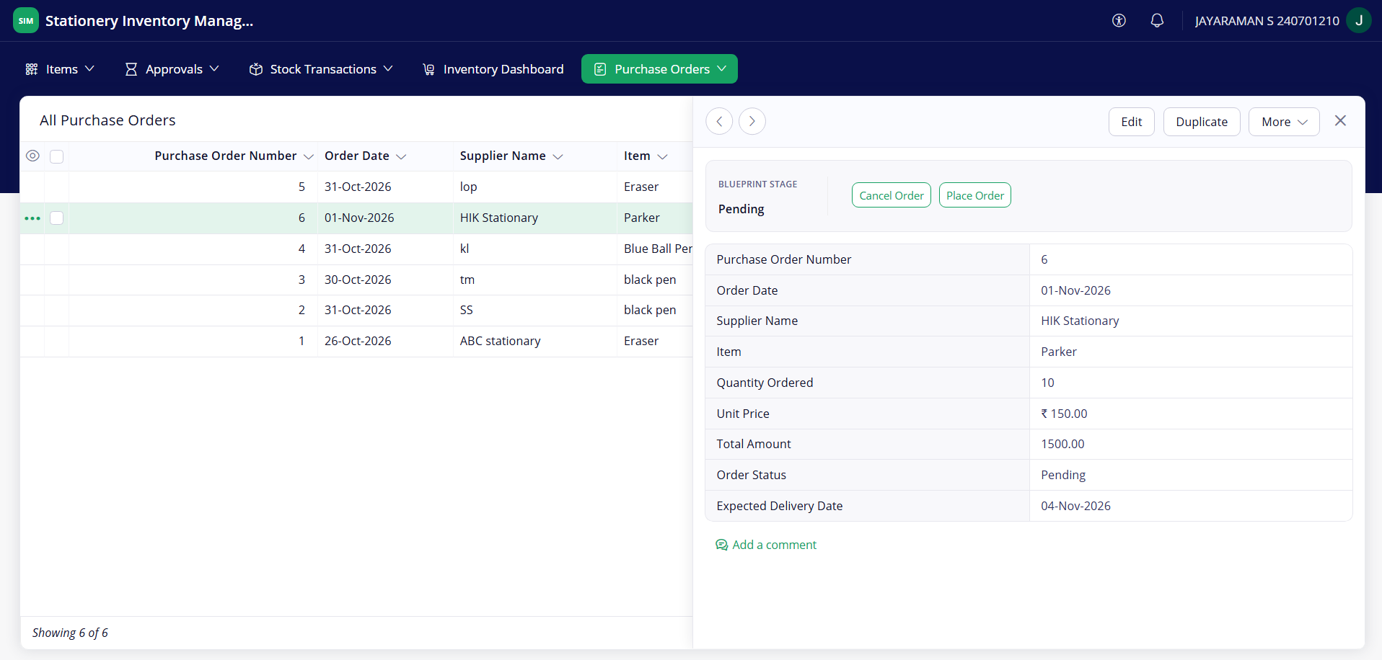
Figure 8.8: Scenario Step 8 – Blueprint stage Pending with the Place Order transition
Step 9 – Blueprint stage Ordered with the Receive Items transition. After Place Order, the stage is Ordered and the available transitions are Cancel Order and Receive Items.
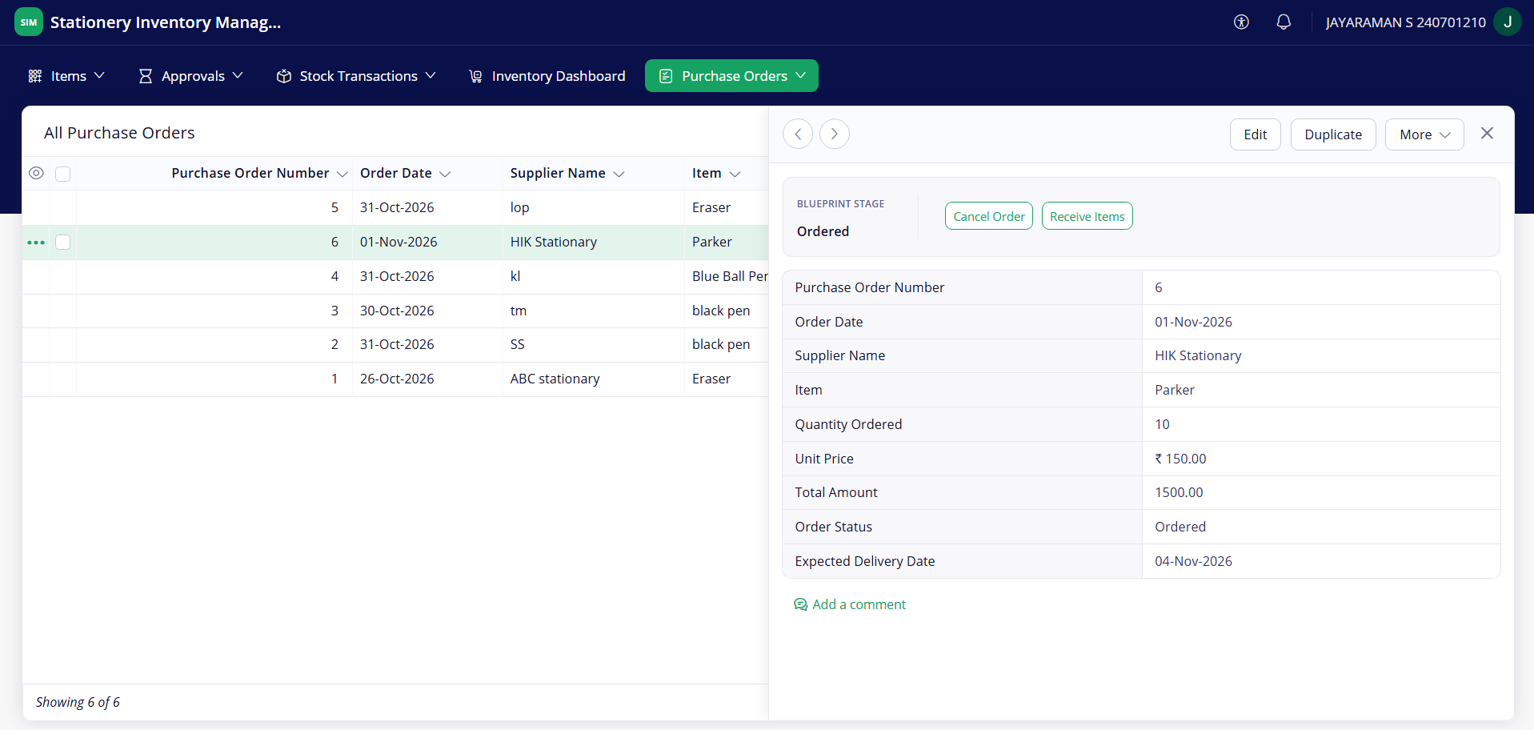
Figure 8.9: Scenario Step 9 – Blueprint stage Ordered with the Receive Items transition
Step 10 – All Purchase Orders report with order 6 received. After Receive Items, order 6 shows the status Received with a Total Amount of 1500.00.
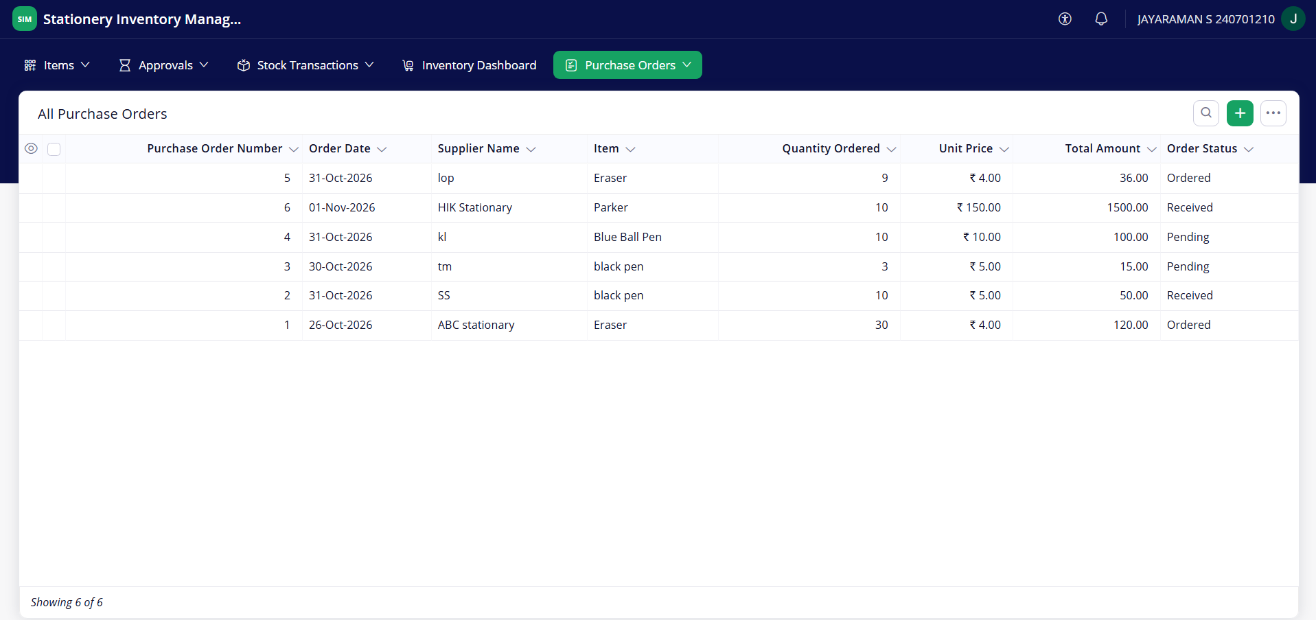
Figure 8.10: Scenario Step 10 – All Purchase Orders report with order 6 received
Step 11 – All Items report with updated stock. DS-04 added the ordered quantity, so the Parker pen’s Current Stock is 14 and its Stock Value is 2100.00. This agrees with 25 − 21 + 10 = 14.
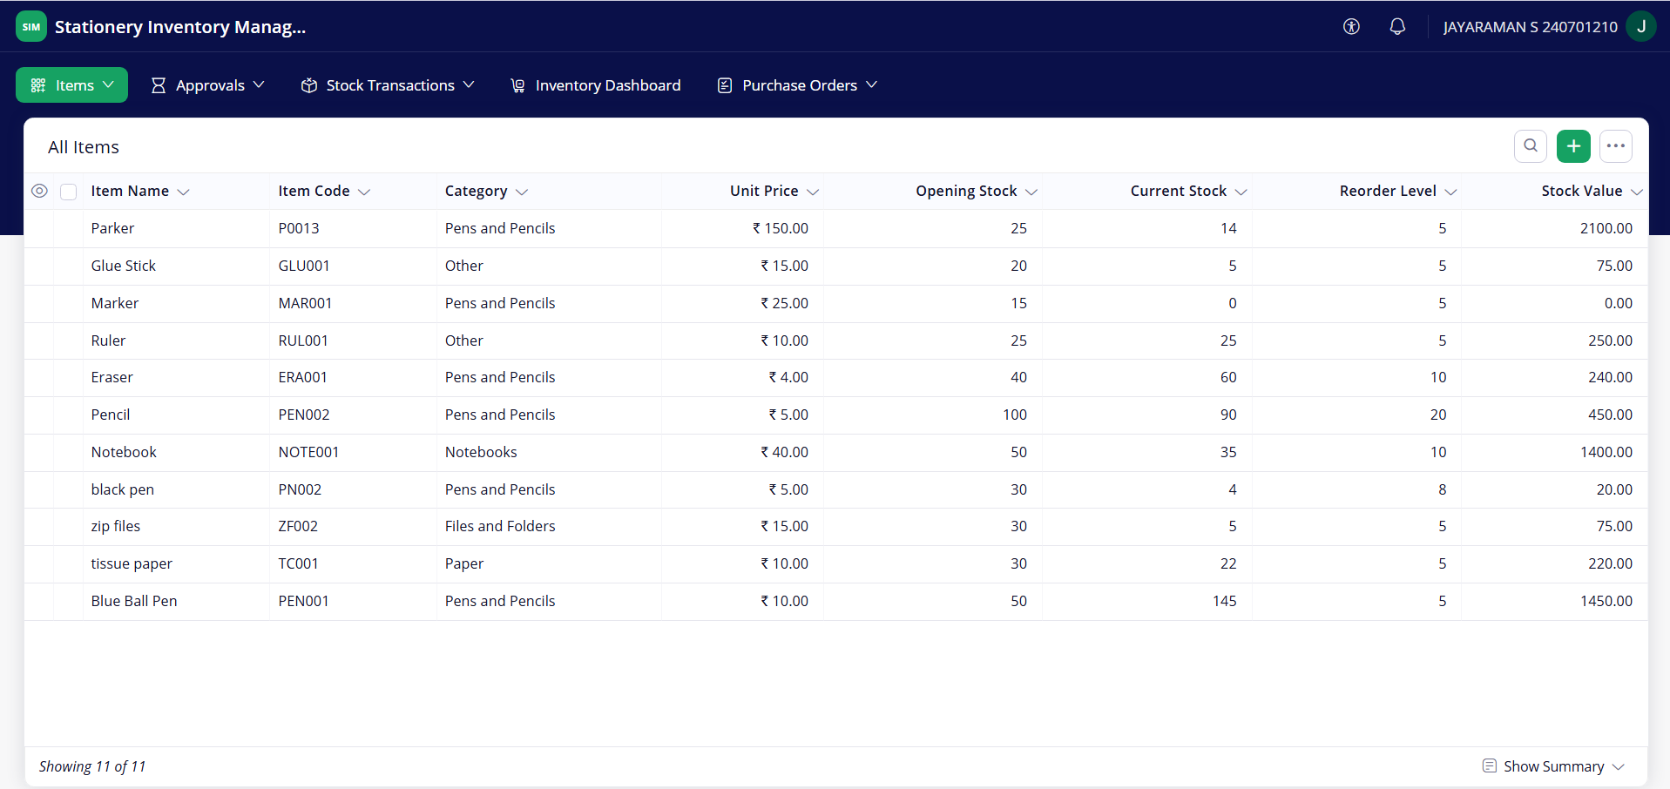
Figure 8.11: Scenario Step 11 – All Items report with updated stock
Step 12 – Inventory Dashboard after the scenario. The dashboard shows Total Stock 405, Total Items 11, Total Transaction 16 and Total Current Stock Value ₹6,280.00.
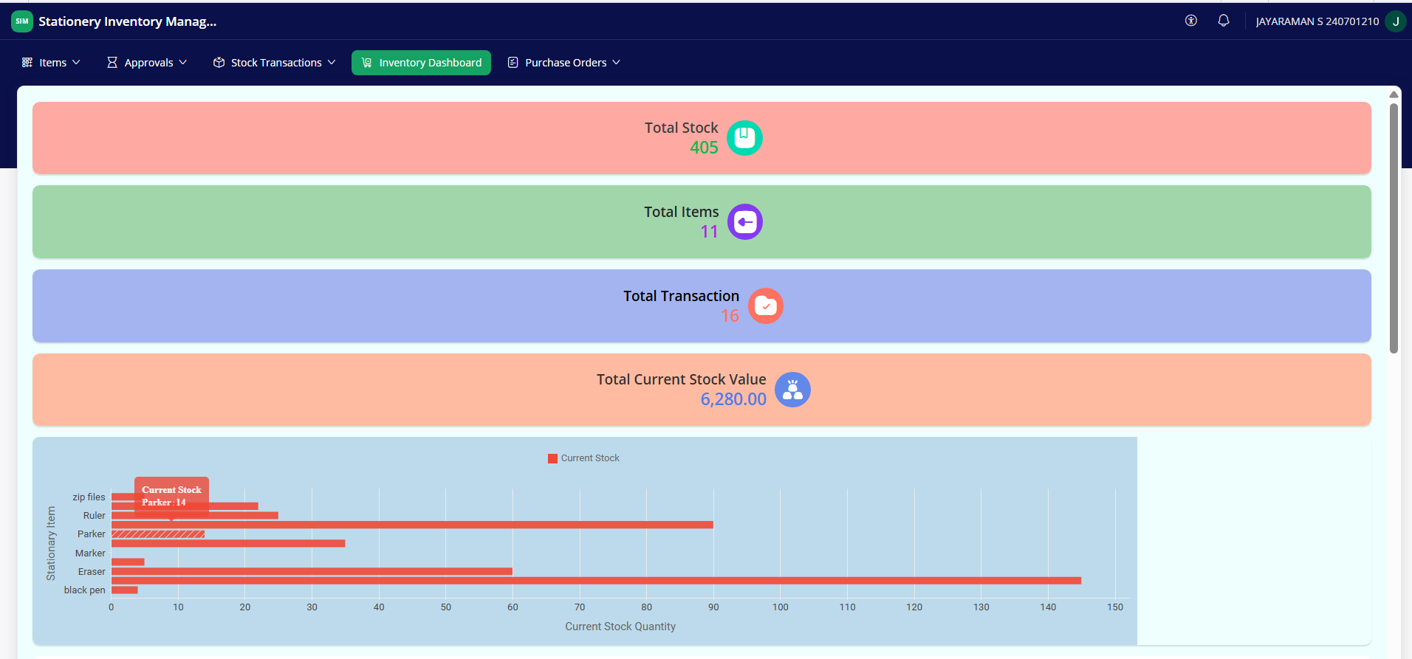
Figure 8.12: Scenario Step 12 – Inventory Dashboard after the scenario
In the end the scenario shows the whole chain working together: validation protects the stock, the transaction updates it, the low-stock report and dashboard reflect it, and the purchase order passes through approval and the Blueprint to restore the stock.

8.2 Achievement of Objectives
Table 8.1: Mapping of Objectives to Outcomes
Objective (Sec. 1.3) | Implemented Through | Outcome / Evidence
1. Data model and forms linked by lookups | Sections 4.2, 4.3, 5.2 | Three forms; the Item lookup links Stock Transaction and Purchase Orders to Items (Figures 5.2, 5.3).
2. Automatic stock update and blocking of excess Stock Out | Sections 5.5, 5.6 (DS-01, DS-02) | Stock changed correctly and the excess Stock Out was rejected (TC-03 to TC-05; Figures 8.2, 8.3).
3. Low-stock identification and daily alert | Sections 5.3, 5.5, 5.6 (DS-05) | Low Stock Items report and the daily email work (TC-06, TC-07; Figures 5.6(e), 8.4).
4. Purchase orders with unit price auto-fill and Blueprint lifecycle | Sections 5.5, 5.6 (DS-03, DS-04) | Unit Price filled automatically; Place Order, Receive Items and Cancel Order work; stock rises on receipt (TC-08 to TC-11; Figures 8.5, 8.8 to 8.11).
5. Approval for orders of ₹1,000 or more | Section 5.6 | The ₹1,500 order was routed for approval; approve and reject work (TC-12 to TC-14; Figures 8.6, 8.7). The re-test for orders below ₹1,000 (TC-15) is pending.
6. Dashboard, stock chart and lists; deployment and role-based access | Sections 5.4, 5.8, 7.1 | Dashboard shows panels, chart and lists (Figures 5.5, 8.12); versions up to V3.2 are in Stage and Production (Figure 7.1); two roles are configured. The CEO access test (TC-18) is pending.

8.3 Comparison with the Existing System
The comparison is qualitative. No time, cost or accuracy figures were measured for the existing process or for the application, so none are claimed.
Table 8.2: Existing System versus Proposed Application
Parameter | Existing System | Proposed Application | Improvement
Stock balance | Calculated by hand in a register or sheet | Updated by DS-01 and DS-04 from each transaction and received order | Fewer manual calculations
Issue beyond available stock | Nothing prevents it | DS-02 rejects a Stock Out larger than the stock | Over-issue is blocked at entry
Finding low-stock items | When someone reviews the records | Low Stock Items report, dashboard list and daily email | Items are flagged without a manual check
Purchase order tracking | Followed up informally | Blueprint stages and the All Purchase Orders report | The stage of every order is visible
Approval of larger orders | Informal, outside the stock records | Approval process for ₹1,000 or more, with task views | A recorded approve or reject step
Data accessibility | Scattered files or books | One web application with reports and a dashboard | Records are available in one place

8.4 Limitations of the Low-Code Approach
Zoho Creator allowed the whole application to be built quickly, but some limits were met or are expected. Practitioners report both the speed of low-code platforms and their limits [2].
- Approval outcome not visible in the report. The approval process is separate from the Blueprint’s Order Status, and no Approval Status column was added to All Purchase Orders, so a rejected order is not marked there. A field and a script would be needed.
- Stored stock value. Current Stock is a stored field changed by workflows. If records are edited or deleted, or the field is changed directly in the Items form, it can differ from opening stock plus the transactions.
- Input checks. The scripts do not reject a zero or negative quantity, and duplicate item codes are not blocked; further Deluge code would be required.
- No external integration. Nothing was connected to other systems, so the platform’s integration and API limits were not tested.
- Platform dependence. The application runs only on Zoho Creator, and its features, plan limits and pricing are decided by the vendor. Mobile and portal use were not evaluated.
The workarounds were to keep each script short and tied to one event, to use the Blueprint for the order stages instead of free editing of the status, and to leave unneeded features out of scope (Section 1.4).

8.5 Reflection on the No-Code → Low-Code → Pro-Code Spectrum
The application sits mostly at the low-code end of the spectrum. Table 8.3 places each part on it.
Table 8.3: Parts of the Application on the No-Code to Pro-Code Spectrum
Level | Parts of the application | Remark
No-code configuration | Forms, fields and lookups; reports; dashboard; users and roles; Blueprint; approval process; scheduled workflow settings; environments | Configured in the builder without code
Low-code (Deluge) | DS-01 to DS-05 and the formulas for Stock Status, Stock Value and Total Amount | Short scripts of a few lines each
Pro-code | None used | No custom function, widget, Catalyst service or REST API call
Pro-code would be considered if the application had to exchange data with another system, such as a supplier’s ordering service, to process large volumes of data, or to give a custom interface that the platform cannot provide. For a single store with three forms, the low-code approach was enough and avoided the cost of building and hosting a conventional system.
CHAPTER 9

CONCLUSION AND FUTURE ENHANCEMENTS

9.1 Conclusion
The Stationery Inventory Management System brings item records, stock movements and purchase orders into one Zoho Creator application. Three forms linked by lookups hold the data; Deluge scripts update stock after every transaction, reject a Stock Out larger than the available stock, fetch the unit price into a purchase order and add received quantities to stock. Reports, approval task views and an Inventory Dashboard show the position, and a daily scheduled email lists the items that have reached their reorder level.
A Blueprint controls the Pending, Ordered, Received and Cancelled stages of each purchase order, and an approval process routes orders of ₹1,000 or more to an approver. The application was tested functionally, followed through a complete scenario with the Parker pen, and published through Development and Stage to Production as version 3.2. It was built without Zia AI or external integrations, and its limits are listed in Section 8.4.

9.2 Future Enhancements
- Weekly Inventory Digest and Monthly Stock Valuation Report as scheduled workflows; both were considered but not built.
- Approval Status field and report column so that approved and rejected orders can be seen in All Purchase Orders.
- More input checks, such as rejecting a zero or negative quantity and duplicate item codes.
- Additional roles, for example a store keeper and a manager, with record-level permissions.
- A supplier form to replace the Supplier Name text field, and a mobile or portal evaluation.
- Audit and analytics improvements, such as an audit trail review, and, if required, predictive analytics using Zia.

9.3 Learning Outcomes and Career Relevance
The project gave practical experience of the main parts of a low-code build: designing forms and lookups, writing reports and a dashboard, scripting in Deluge, and configuring workflows, a Blueprint, an approval process and a schedule. It also covered user roles and deployment through Development, Stage and Production.
These skills relate to roles such as citizen developer, low-code developer and automation engineer, where business processes are turned into working applications quickly [1], [2]. The work also showed where a low-code platform stops and pro-code would be needed (Section 8.5).

REFERENCES
[1] A. Bock and U. Frank, “Low-code platform,” Bus. Inf. Syst. Eng., vol. 63, no. 6, pp. 733–740, 2021. [Online]. Available: https://aisel.aisnet.org/bise/vol63/iss6/8 (Accessed: 2 November 2026).
[2] Y. Luo, P. Liang, C. Wang, M. Shahin, and J. Zhan, “Characteristics and challenges of low-code development: The practitioners’ perspective,” in Proc. 15th ACM/IEEE Int. Symp. Empirical Softw. Eng. Meas. (ESEM), 2021, doi: 10.1145/3475716.3475782.
[3] Zoho Corporation, “Understanding Blueprint,” Zoho Creator Help. [Online]. Available: https://help.zoho.com/portal/en/kb/creator/developer-guide/workflows/blueprints/articles/understand-blueprint (Accessed: 2 November 2026).
[4] Zoho Corporation, “Approval Workflows,” Zoho Creator Help. [Online]. Available: https://help.zoho.com/portal/en/kb/creator/developer-guide/workflows/approval-workflows (Accessed: 2 November 2026).
[5] Zoho Corporation, “Deluge Scripting – Overview,” Zoho Developer Help. [Online]. Available: https://www.zoho.com/developer/help/scripting/ (Accessed: 2 November 2026).
[6] Gartner, Inc., “Magic Quadrant for Enterprise Low-Code Application Platforms,” Gartner Research, 2025. [Online]. Available: https://www.gartner.com/en/documents/6773234 (Accessed: 2 November 2026).

APPENDIX A – ZOHO CREATOR FEATURE COVERAGE CHECKLIST
Table A.1: Feature Coverage Checklist
Unit | Zoho Creator Feature | Done | Where in the Application | Report Section | Figure / Code No.
I | Application created and sections / menu organised | Y | Top menu: Items, Approvals, Stock Transactions, Inventory Dashboard, Purchase Orders | 5.1 | Figure 5.1(a)–(d)
II | Forms with ≥ 8 distinct field types | Y | Items, Stock Transaction, Purchase Orders: Single Line, Drop Down, Currency, Number, Date, Lookup, Multi Line, Auto Number, Formula (9 types) | 5.2 | Figures 5.2(a)–(c), 5.3(a)–(c); Tables 4.2–4.4
II | Lookup field (relationship between forms) | Y | Item in Stock Transaction and Purchase Orders | 4.2, 5.2 | Figures 4.2, 5.2(b), 5.2(c)
II | Subform (parent–child data) | N | Not used | 4.2 | —
II | Field validations / layout rules | Y | Mandatory fields; stock validation in the Stock Transaction form (DS-02) | 5.2, 5.5 | Figure 8.2; Code 5.1
II | List report with filter, grouping, custom action | Partial | Low Stock Items is filtered; no grouping; Blueprint buttons act on All Purchase Orders records | 5.3 | Figures 5.4(b), 8.8
II | Kanban / Calendar / Timeline / Map report | N | Not used | 5.3 | —
II | Pivot table / chart report | N | Chart is on the dashboard only; no chart report | 5.3 | —
II | Page / dashboard built with UI Builder | Y | Inventory Dashboard (summary panels, bar chart, two lists) confirm it is built as a Page | 5.4 | Figure 5.5(a), (b)
II | Deluge – form events (validate / success / field actions) | Y | DS-01, DS-02 (Stock Transaction), DS-03 (Purchase Orders) | 5.5 | Codes 5.1, 5.2; Appendix C
II | Deluge – functions, fetch, loops, collections | Y | Record fetch and criteria fetch, for each over a collection (DS-05); no custom function | 5.5 | Code 5.3
II | Email / in-app notifications | Y | sendmail in DS-05; approval notification mails | 5.5, 5.6 | Figure 5.6(e)
II | Form workflow | Y | DS-01, DS-02, DS-03 | 5.6 | Figure 5.6(a)
II | Scheduled workflow | Y | Daily Low Stock Alert, 14:52 IST | 5.6 | Figure 5.6(d)
II | Approval process | Y | Purchase_Order_Approval (Total_Amount >= 1000) | 5.6 | Figure 5.6(c)
II | Blueprint | Y | Purchase_Order_Lifecycle | 5.6 | Figure 5.6(b)
II | Batch / report workflow | N | Not used | 5.6 | —
II | Testing and debugging evidence | Y | Test cases, debugging notes, defect log | 6 | Tables 6.1, 6.2
III | Integration with a Zoho service | N | Not used | 5.7 | —
III | Connection / REST API call (invokeurl) | N | Not used | 5.7 | —
III | Webhook or Creator REST API | N | Not used | 5.7 | —
III | Users, roles and permission profiles | Y | Super Admin; CEO role with Write permission | 5.8 | Figure 5.8(a), (b)
III | Record-level access criteria / customer portal | N | Not configured | 5.8 | —
III | Zia / AI feature | N | Not used | 5.9 | —
III | Analytics (charts / Zoho Analytics) | Y | Bar chart and summary panels on the dashboard | 5.9 | Figure 5.5(a)
IV | Performance optimisation applied and measured | Partial | Single-fetch and criteria scripts applied; not measured | 7.2 | Table 7.3
IV | Deployment across environments | Y | Development → Stage → Production, version 3.2 | 7.1 | Figure 7.1(a)
IV | Security controls (encryption, OAuth, permissions) | Y | Role permissions, validation, approval, Blueprint; no encryption or OAuth | 7.3 | Table 7.4
IV | Governance (audit trail, administration) | Partial | Version history and Super Admin administration; audit trail not confirmed | 7.4 | Figure 7.1(b)
V | Pro-code extension (Catalyst / widgets / custom functions) | N | Not used | 5.10 | —
V | Low-code limitations and spectrum analysis | Y | Written analysis | 8.4, 8.5 | Table 8.3
— | Mobile app / portal access | N | Not configured | 5.11 | —

Total features implemented: 18 / 32 (a further 3 are implemented in part)

APPENDIX B – COURSE OUTCOME MAPPING
Table B.1: Mapping of Course Outcomes to Report Chapters
CO | Course Outcome Statement | Evidenced In | Self-Assessed Level | Examiner Level
CO1 | Explain the principles, architecture, and business value of low-code application development using Zoho Creator. | Ch. 1, 2 | 3
CO2 | Develop business applications using Zoho Creator forms, reports, workflows, and Deluge scripting. | Ch. 4, 5 (5.1–5.6), 6, 8.1 | 3
CO3 | Integrate Zoho Creator applications with Zoho services and external systems using APIs, connections, and role-based security. | Ch. 4.6, 5.8 (roles and security); no integration or API was used (5.7) | 1
CO4 | Deploy, secure, and manage Zoho Creator applications across development and production environments following governance best practices. | Ch. 7 | 2
CO5 | Evaluate low-code development strategies, AI-assisted application development, and the transition from citizen developer to professional developer. | Ch. 8.4, 8.5, 9.3; no AI-assisted development was used (5.9) | 2
The self-assessed levels (1 – Low, 2 – Medium, 3 – High) are suggestions for you to review; the examiner may revise them.

APPENDIX C – COMPLETE DELUGE SOURCE CODE
C.1 Stock Transaction form – Update Current Stock
// Script ID : DS-01
// Location : Stock Transaction form, Created, After Form Submission
// (Successful Submission)
// Purpose : Add Stock In or subtract Stock Out quantity in Current Stock

itemRecord = Items[ID == input.Item];
if(itemRecord.ID != null)
{
if(input.Transaction_Type == "Stock In")
{
itemRecord.Current_Stock = itemRecord.Current_Stock + input.Quantity;
}
else if(input.Transaction_Type == "Stock Out")
{
itemRecord.Current_Stock = itemRecord.Current_Stock - input.Quantity;
}
}

C.2 Stock Transaction form – Validate Stock Availability
// Script ID : DS-02
// Location : Stock Transaction form, Created, On Form Submission
(Validations)
// Purpose : Cancel a Stock Out larger than the available stock

itemRecord = Items[ID == input.Item];
if(itemRecord.ID != null)
{
if(input.Transaction_Type == "Stock Out")
{
if(input.Quantity > itemRecord.Current_Stock)
{
alert "Insufficient stock! Available quantity: " +
itemRecord.Current_Stock;
cancel submit;
}
}
}

C.3 Purchase Orders form – Fetch Item Unit Price
// Script ID : DS-03
// Location : Purchase Orders form, On User Input of the Item field
// Purpose : Fill Unit Price from the selected item

itemRecord = Items[ID == input.Item];
if(itemRecord.ID != null)
{
input.Unit_Price = itemRecord.Unit_Price;
}

C.4 Purchase Orders Blueprint – Receive Items stock update
// Script ID : DS-04
// Location : Purchase_Order_Lifecycle Blueprint, Receive Items transition,
// After Action
// Purpose : Add the Quantity Ordered to the item's Current Stock

itemRecord = Items[ID == input.Item];
if(itemRecord.ID != null)
{
itemRecord.Current_Stock = itemRecord.Current_Stock +
input.Quantity_Ordered;
}

C.5 Scheduled workflow – Daily Low Stock Alert
// Script ID : DS-05
// Location : Scheduled workflow "Daily Low Stock Alert", daily at 14:52 IST
// Purpose : Email the items that have reached their reorder level

lowStockItems = Items[Current_Stock <= Reorder_Level];
if(lowStockItems.count() > 0)
{
message = "The following stationery items have reached their reorder
level:\n\n";
for each item in lowStockItems
{
message = message + "Item: " + item.Item_Name + "\nCurrent Stock: " +
item.Current_Stock + "\nReorder Level: " + item.Reorder_Level +
"\n\n";
}
sendmail
[
from :zoho.adminuserid
to :"jayaraman.s.2024.cse@rajalakshmi.edu.in"
subject :"Daily Low Stock Alert - Stationery Inventory"
message :message
]
}

C.6 Formula expressions
// Items form – Stock Status (formula field)
if(Current_Stock <= Reorder_Level, "Low Stock", "In Stock")

// Items form – Stock Value (formula field)
Current_Stock * Unit_Price

// Purchase Orders form – Total Amount (formula field)
Quantity_Ordered * Unit_Price

Long lines are wrapped for printing. Formula expressions in C.6 are as discussed during development; confirm them against the live builder. The temporary email-test script is not part of the application and is not listed.

APPENDIX D – USER MANUAL

D.1 Accessing the Application
Sign in to Zoho Creator in a web browser with the account given to you and open the Stationery Inventory Management System. The top menu shows Items, Approvals, Stock Transactions, Inventory Dashboard and Purchase Orders (Figure 5.1).

D.2 Instructions for the Super Admin
- Add an item: open Items → Items, fill in the item name, code, category, unit price, opening stock, current stock and reorder level, and click Submit (Figure 5.3(a)).
- Record stock: open Stock Transactions → Stock Transaction, choose the date, the item, Stock In or Stock Out and the quantity, and click Submit. If the alert “Insufficient stock!” appears, enter a smaller quantity (Figure 8.2).
- Check stock: open All Items, Low Stock Items or the Inventory Dashboard (Figures 5.4(b), 5.5(a)).
- Create a purchase order: open Purchase Orders → Purchase Orders, enter the date and supplier, select the item (the unit price fills in), enter the quantity and click Submit (Figure 8.5).
- Approve an order of ₹1,000 or more: open Approvals → Pending Tasks, select the request and click Approve or Reject; processed requests move to Completed Tasks (Figures 8.6, 8.7).
- Move an order: in All Purchase Orders, use Place Order, Receive Items or Cancel Order (Figures 8.8 to 8.10).
- Read the daily low-stock email (Figure 5.6(e)). Administer the application: manage users in the Zoho Creator user settings and publish versions from Environments (Chapter 7).

D.3 Instructions for the CEO (Write permission)
- Sign in with the CEO account and open the application. Confirm which of the following the CEO role can do.
- Add and view records, reports and the Inventory Dashboard as described in D.2. Approvals, user management and publishing are done by the Super Admin account.

APPENDIX E – EVALUATION RUBRIC
(For Examiner Use Only)
Student Name | JAYARAMAN S | Register No. | 2116240701210
Project Title | Stationery Inventory Management System | Date

Table E.1: Evaluation Rubric for the Individual Project
S.No. | Criterion | Indicators | Max. Marks | Marks Awarded
1 | Problem Definition & Requirement Analysis | Clarity of problem, measurable objectives, complete FR/NFR, use cases | 10
2 | System Design | Architecture, ER/data model, form specifications, workflow design, permission matrix | 10
3 | Forms, Reports & Pages | Variety of field types, lookups/subforms, report types, UI Builder dashboards | 15
4 | Deluge Scripting & Workflows | Correctness and depth of scripts; form, schedule, approval, Blueprint, batch workflows | 15
5 | Integration, RBAC & AI | Zoho/external integrations, connections, roles & permissions, Zia/analytics | 10
6 | Testing, Deployment, Security & Governance | Test coverage, environments, optimisation, security controls, audit | 10
7 | Live Demonstration | End-to-end working of the application across roles; feature checklist verified | 15
8 | Project Report | Adherence to template and format, clarity, figures, references | 5
9 | Viva-Voce | Understanding of the platform, design decisions and low-code concepts | 10
 | TOTAL |  | 100

Table E.2: Performance Level Descriptors
Level | % of Max. Marks | Descriptor
Excellent | 90–100 | Feature implemented completely, correctly and beyond the basic requirement; student explains design choices confidently.
Good | 70–89 | Feature implemented correctly with minor gaps; explanation adequate.
Satisfactory | 50–69 | Feature partially implemented or works only for the main path; limited explanation.
Needs Improvement | < 50 | Feature missing, non-functional or not understood by the student.

Signature of Internal Examiner  Name: ____________________ | Signature of External Examiner  Name: ____________________

APPENDIX F – VIVA-VOCE RECORD SHEET
(For Examiner Use Only)
Student Name | JAYARAMAN S | Register No. | 2116240701210
Department / Section | Computer Science and Engineering | Date of Viva
Application URL Verified | Yes / No | Demo Duration | ______ min
Table F.1: Viva-Voce Questions and Responses
Q.No. | Question / Topic Asked | Unit | Response (E / G / S / NI) | Remarks
1
2
3
4
5
6
7
8
E – Excellent G – Good S – Satisfactory NI – Needs Improvement
Table F.2: Marks Summary
Component | Max. Marks | Marks Awarded
Criteria 1–8 (Appendix E) | 90
Viva-Voce | 10
TOTAL | 100

Examiners’ Remarks:
____________________________________________________________________
____________________________________________________________________
INTERNAL EXAMINER  Name: ____________________ | EXTERNAL EXAMINER  Name: ____________________

