Maintenance Task Matrix and Service Execution Design
Developer implementation guide for the .NET backend and Angular frontend
Montra Fleet Maintenance | Version 1.0 | 22 September 2026
Purpose: explain how a maintenance program and its task matrix are configured, how the matrix is converted into executable service tasks, and how technicians record and complete those tasks. This document is intended for the .NET API, EF Core, database, Angular UI, QA, and deployment teams.
Document control | Value
Document owner | Montra Fleet Maintenance product team
Primary audience | .NET developers, Angular developers, QA and DevOps
Configuration source | Maintenance Program, Service Levels and Maintenance Task Matrix
Execution target | Service Execution workspace and technician checklist
Authoritative rule | Blank action means the task is excluded from that service level
Reference screens | PM Program Task Matrix and Service Execution workspace

1 Design conclusion
The Maintenance Task Matrix is a configuration layer. It must not be copied manually into Service Execution. When a service event is created or its applicable service level is determined, the backend reads the active maintenance program, selects the task rows whose action is not blank for that service level, and creates an execution snapshot. The technician works on that snapshot, not directly on the live matrix.
This separation is important. Administrators can revise a future maintenance program without changing an in-progress job, while the service record retains exactly which checks were required, which action was selected, what specification applied, and which program revision generated the work.

2 Reference screens and terminology
The first screen is the configuration view. It shows a program for the EVIATOR model, service levels such as PM-10K, PM-20K, PM-40K and PM-80K, task rows, default actions, specification or limits, severity, and an action value per service level.
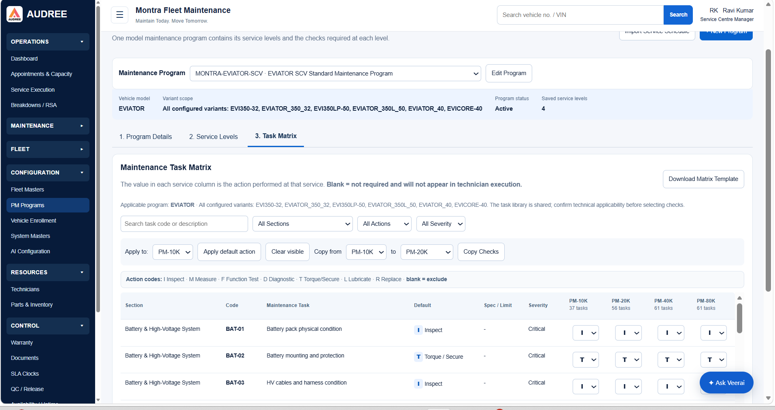
Figure 1. Maintenance Task Matrix configuration screen
The second screen is the execution view. It shows sections such as General Diagnosis, technician assignment, progress, individual checks, action, specification or limit, result or reading, remarks, evidence and section completion.
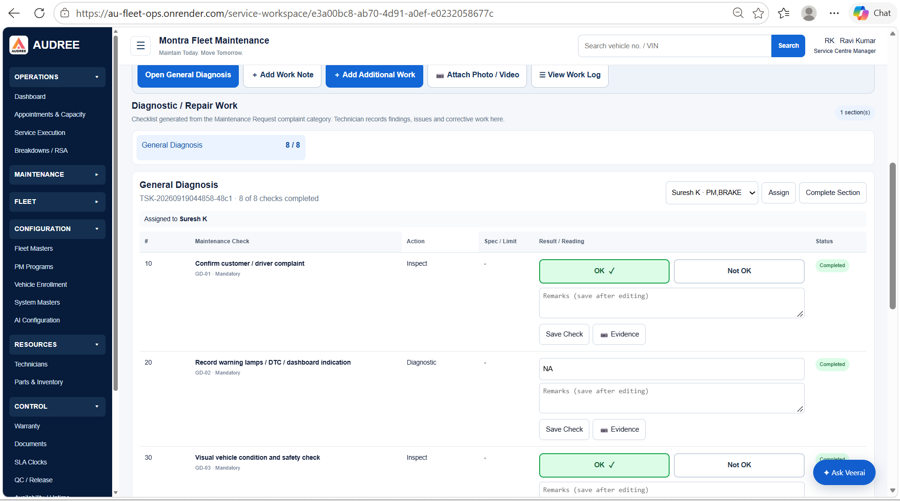
Figure 2. Service Execution checklist generated for a service event
Term | Meaning
Maintenance Program | Versioned PM definition for one vehicle model and defined variant scope.
Service Level | Interval or maintenance package, for example PM-10K or PM-20K.
Task Library Task | Reusable maintenance check with code, section, action, limit and severity.
Matrix Cell | Action selected for one task at one service level. Blank means excluded.
Service Task Snapshot | Immutable execution row created from the matrix for a service event.
Section | Logical grouping of tasks such as Battery & High-Voltage System or General Diagnosis.
Service Event | Vehicle-specific appointment, PM, breakdown or job-card work context.
Execution Result | Technician outcome such as OK, Not OK, NA, numeric reading or text reading.

3 End to end process
1. Administrator creates or imports a maintenance program for a vehicle model.
2. Administrator defines service levels and their intervals or trigger rules.
3. Administrator selects task rows from the shared task library and assigns an action in each service-level column.
4. System validates that the program, service levels, task codes and action codes are valid.
5. Program is published as an active revision. Only published revisions can generate service tasks.
6. A PM or service event is created for a vehicle. The system resolves vehicle model, variant and applicable service level.
7. Backend selects the active program revision and matrix rows applicable to that service level.
8. Backend creates service sections and task snapshots in one transaction.
9. Supervisor assigns sections or tasks to technicians.
10. Technician records result, reading, remarks and evidence. Each check is saved independently.
11. When mandatory checks are complete, the section can be completed. The service event progresses according to its completion rules.

4 Configuration model

4.1 Maintenance program
Field | Type | Rule
Id | Guid | Primary key.
ProgramCode | string | Unique business code, for example MONTRA-EVIATOR-SCV.
Name | string | Display name.
VehicleModelMasterId | Guid | Required model reference.
VariantScope | relationship | One or more allowed variants.
Status | enum | Draft, Active, Suspended, Retired.
Version | int | Increment on publish; never overwrite a published revision.
EffectiveFrom / EffectiveTo | datetime? | Used for date-based selection.
CreatedBy / CreatedAt | audit | Mandatory audit metadata.
PublishedBy / PublishedAt | audit | Required when status becomes Active.

4.2 Service level
Field | Type | Rule
Id | Guid | Primary key.
MaintenanceProgramId | Guid | Parent program.
Code | string | Unique inside program, e.g. PM-10K.
Name | string | Human-readable label.
IntervalKm | decimal? | Distance trigger where applicable.
IntervalDays | int? | Time trigger where applicable.
Sequence | int | Display and evaluation order.
IsActive | bool | Inactive levels cannot be selected for new work.
RequiredCompletionMode | enum | All mandatory tasks, all tasks, or supervisor override.

4.3 Matrix task row
Field | Type | Rule
TaskId | Guid | Reference to shared task library.
SectionCode / SectionName | string | Stable grouping key and display label.
TaskCode | string | Unique code such as BAT-01 or GD-01.
TaskDescription | string | Technician-readable check statement.
DefaultActionCode | enum | Suggested action from the library.
SpecificationOrLimit | string | Expected value, range, torque, voltage, visual standard or “-”.
Severity | enum | Critical, Major, Minor or configured severity.
ServiceLevelAction | enum? | I, M, F, D, T, L, R or null. Null means excluded.
SortOrder | int | Order inside section.
ApplicabilityRule | json? | Optional variant or equipment condition rule.

5 Action code contract
The action code is the operation expected from the technician. It is not the result. The result is captured later in Service Execution.
Code | Meaning | Expected input
I | Inspect | OK/Not OK, observation and optional evidence.
M | Measure | Numeric or text reading, unit, tolerance and evidence where required.
F | Function Test | Pass/Fail or supported result and remarks.
D | Diagnostic | Finding, code, reading or diagnostic conclusion.
T | Torque/Secure | Applied value or confirmation, tool/reference and remarks.
L | Lubricate | Confirmation, material and quantity where applicable.
R | Replace | Part used, quantity, old/new identification and remarks.
Blank | Exclude | No execution row is generated for that service level.

Do not store action labels such as “Inspect” as the only value. Persist the stable code and resolve the display label through an action master so labels can be translated without changing historical execution records.

6 Matrix to Service Execution transformation

6.1 Selection algorithm
The following algorithm should be implemented in a domain service, not in the Angular component and not as ad hoc controller logic.
1. Load the vehicle and resolve VehicleModelMasterId and VehicleVariantMasterId.
2. Resolve the requested service level from the PM plan, appointment, breakdown category or explicit user selection.
3. Find the active, effective maintenance program for the vehicle model and variant. Reject ambiguous matches; do not silently choose the newest row.
4. Load the service level and all matrix rows for the program revision.
5. Apply variant applicability rules. A task is eligible only when the vehicle variant satisfies the rule.
6. Read the matrix cell for the selected service level. If the action is null or blank, skip the row.
7. Create an execution section for each section that has at least one selected task.
8. Create one ServiceTaskSnapshot per selected row, copying description, action code, specification, severity and sequence.
9. Persist the program revision and matrix row identifiers on every snapshot for traceability.
10. Return the generated service workspace with progress counts and assignment state.

6.2 Pseudocode
GenerateExecution(serviceEventId, serviceLevelCode)
event = serviceEventRepository.GetForGeneration(serviceEventId)
model = vehicleRepository.ResolveModelAndVariant(event.VehicleId)
program = programResolver.ResolveActive(model, serviceLevelCode, event.OpenedAt)
level = program.RequireServiceLevel(serviceLevelCode)
rows = matrixRepository.GetRows(program.Id, level.Id)
eligible = rows.Where(r => r.ActionCode != null && AppliesToVariant(r, model.VariantId))
snapshot = executionFactory.Create(event, program.Version, level.Code, eligible)
executionRepository.SaveSnapshot(snapshot) // one transaction
return executionQuery.GetWorkspace(event.Id)

6.3 Snapshot rule
Once execution has started, matrix changes must not mutate the existing checklist. If an administrator changes BAT-01 from Inspect to Measure after a job has started, the open job continues using its original snapshot. A new service event may use the new program revision. Controlled regeneration before work starts must create a new execution version and record the reason.

7 Recommended database model
Table / aggregate | Purpose | Important columns
MaintenancePrograms | Program header and lifecycle | Id, Code, ModelId, Version, Status, Effective dates
MaintenanceProgramVariants | Variant scope | ProgramId, VariantId, ApplicabilityMode
MaintenanceServiceLevels | PM-10K etc. | Id, ProgramId, Code, interval fields, Sequence
MaintenanceTasks | Reusable task library | Id, SectionId, Code, Description, DefaultActionCode, Limit, Severity
MaintenanceMatrixEntries | Task × service-level action | ProgramId, ServiceLevelId, TaskId, ActionCode, SortOrder
ServiceEvents | Vehicle-specific execution context | Id, VehicleId, JobCardId, Type, Status, ServiceLevelCode
ServiceExecutionVersions | Generated checklist header | Id, ServiceEventId, ProgramId, ProgramVersion, GeneratedAt, State
ServiceExecutionSections | Execution grouping | Id, ExecutionVersionId, SectionCode, AssignedTechnicianId, Status
ServiceTaskSnapshots | Immutable task definition for job | Id, SectionId, SourceTaskId, SourceMatrixEntryId, ActionCode, Description, Limit, Severity, Sequence
ServiceTaskResults | Technician result | Id, SnapshotId, ResultCode, ReadingValue, ReadingUnit, Remarks, CompletedAt, CompletedBy
ServiceTaskEvidence | Photos, videos and files | Id, ResultId, StorageKey, FileName, MimeType, Hash, UploadedBy
ServiceExecutionAudit | Traceability | Id, AggregateId, EventType, BeforeJson, AfterJson, UserId, Timestamp

Recommended EF Core approach: keep configuration entities separate from execution entities. Use foreign keys to source records, but copy operational fields into ServiceTaskSnapshots. Configure unique indexes for ProgramCode + Version, ProgramId + ServiceLevelCode, ProgramId + ServiceLevelId + TaskId, and ServiceEventId + ExecutionVersion.

8 Service Execution behaviour
Area | Required behaviour
Workspace header | Show vehicle, service event, job card, service level, program revision, current status and last saved time.
Sections | Create sections only when they contain selected tasks; display completion count such as 8 of 8.
Assignment | Allow supervisor to assign a section or task to an active technician; record assignment history.
Result capture | Render controls based on action code and task result configuration.
Remarks | Save independently from result where practical; show unsaved changes clearly.
Evidence | Upload evidence against the result/check, validate size/type, store metadata and object key.
Completion | Do not allow section completion when mandatory tasks lack a valid result.
Critical failure | If a critical task is Not OK, require finding/remarks and show escalation state.
Concurrency | Prevent silent overwrites; use row version or ETag and return 409 on conflict.
Offline/mobile future | Keep commands idempotent and use client-generated request IDs for later offline support.

9 Result rules by action
Action | Minimum result fields | Validation
Inspect | ResultCode, Remarks when Not OK | ResultCode required. Evidence required if configured.
Measure | ReadingValue, Unit, ResultCode | Numeric/range validation where limit is numeric.
Function Test | ResultCode, Remarks when failed | Pass/Fail/NA only unless configured.
Diagnostic | Finding or diagnostic code, Remarks | Finding required; no empty diagnosis.
Torque/Secure | ResultCode, AppliedValue, Unit | Applied value required if torque limit exists.
Lubricate | ResultCode, Material/Quantity if configured | Material required when configured.
Replace | ResultCode, PartId, Quantity | Part must exist in approved parts catalogue.

10 API design for .NET
Use resource-oriented endpoints. Controllers should validate input and authorize the request, then call application services. They should not contain matrix selection rules.
HTTP | Endpoint | Purpose
GET | /api/maintenance-programs?modelId=... | List programs visible to the user.
GET | /api/maintenance-programs/{id} | Return program header, variants and revision.
GET | /api/maintenance-programs/{id}/service-levels | Return levels and counts.
GET | /api/maintenance-programs/{id}/matrix | Return paged/filterable matrix entries.
PUT | /api/maintenance-programs/{id}/matrix | Bulk save matrix cells with validation and version check.
POST | /api/maintenance-programs/{id}/publish | Validate and publish a revision.
POST | /api/service-events/{id}/execution/generate | Generate snapshot idempotently.
GET | /api/service-events/{id}/execution | Return execution workspace.
PATCH | /api/execution-tasks/{id}/result | Save result/reading/remarks with ETag.
POST | /api/execution-tasks/{id}/evidence | Upload evidence.
POST | /api/execution-sections/{id}/assign | Assign technician.
POST | /api/execution-sections/{id}/complete | Validate and complete section.
GET | /api/service-events/{id}/work-log | Return audit and execution history.

10.1 Example generation request and response
POST /api/service-events/7f.../execution/generate
{ "serviceLevelCode": "PM-20K", "requestId": "client-generated-guid" }
200 OK
{ "executionVersionId": "...", "programVersion": 3, "serviceLevel": "PM-20K", "sections": 4, "tasks": 56, "status": "NotStarted" }
If execution already exists for the same service event and service level, return the existing version unless the caller explicitly requests controlled regeneration. This prevents duplicate checklists when the user refreshes or presses the button twice.

10.2 Example result request
PATCH /api/execution-tasks/{id}/result
If-Match: "task-version-4"
{ "resultCode": "NOT_OK", "remarks": "Compressor belt shows visible damage" }

11 Backend code ownership and source locations
The exact repository names should be confirmed from the checked-out solution. Based on the current Montra application structure and the screens provided, the implementation should be organized as follows. Search the repository for the class, route or component names listed below before creating a duplicate implementation.
Layer | Expected source location / search key | Responsibility
API controllers | backend/src/MontraFleet.Api/Controllers/; search MaintenanceProgram, ServiceEvent, Execution | HTTP routes, DTO binding, authorization and status codes.
Application services | backend/src/MontraFleet.Application/ or feature folders; search GenerateExecution, Matrix, ServiceExecution | Use cases, transaction, idempotency and orchestration.
Domain model | backend/src/MontraFleet.Domain/Entities and /Enums | Program, level, task, matrix and execution rules.
EF Core | backend/src/MontraFleet.Infrastructure/Persistence or Data; search DbContext and MaintenanceMatrixEntries | Mappings, indexes, migrations and queries.
Repositories/queries | backend/src/MontraFleet.Infrastructure or Application/Queries | Paged matrix reads, program resolver and workspace read model.
Evidence storage | backend/src/MontraFleet.Api/Data or Storage; search Upload, Evidence, Document | Evidence upload, validation, object storage and download permissions.
Angular PM configuration | frontend/src/app/features/maintenance or pm-programs; search Task Matrix, PM Programs | Matrix grid, filters, bulk actions, save and publish.
Angular service execution | frontend/src/app/features/service-execution or service-workspace; search General Diagnosis, Save Check | Execution workspace, results, assignment, evidence and completion.
Shared contracts | frontend/src/app/core/api or generated client | Keep request/response names aligned and versioned.
Tests | backend/tests and frontend test folders; search maintenance, execution, matrix | Unit, integration, API and UI regression coverage.

Do not place the transformation in a front-end mapper only. The backend must generate the snapshot because it is the authority for permissions, program version, vehicle applicability, audit and transactional consistency.

12 Validation and business rules
- A program cannot be published without at least one service level.
- A matrix entry must reference a valid task and service level belonging to the same program.
- A task code must be unique within the task library or controlled scope.
- A service-level action must be one of the configured action codes or null.
- Critical tasks must have a defined severity and cannot be hidden by a blank action if program policy marks them mandatory.
- The same task may appear in multiple service levels with different actions, but the generated snapshot must preserve the selected action.
- A vehicle must not receive a program for a different model or incompatible variant.
- Only active technicians with the required role can be assigned.
- Section completion must be server-side validated even if the UI disables the button.
- Every configuration and execution change must be auditable with user, time, old value and new value.

13 UI implementation notes
Screen | Frontend behaviour
Task Matrix | Use server-side paging or virtual scrolling for large task libraries. Filters must be query parameters or clearly scoped to loaded rows.
Apply default action | Apply the task default only to visible eligible rows and confirm before applying. Mark grid dirty.
Clear visible | Set selected visible cells to blank; do not delete task library rows.
Copy checks | Copy action cells from source level to target level after confirmation.
Save | Send a bulk command with program version/ETag. Show per-cell validation errors without losing valid edits.
Publish | Run server validations and show a summary. Published revisions become immutable.
Service workspace | Load execution snapshot, not live matrix. Show source program and revision.
Save Check | Save result and remarks with task ETag. Update progress only after API success.
Evidence | Show upload progress, accepted types, failure and retry.
Retry | Use idempotency key; never duplicate generation or result commands.

14 Error handling and diagnostics
Scenario | HTTP / UI response
No active program | 409/422: No active maintenance program is configured for this model and service level.
Multiple active programs | 409: block generation and identify configuration conflict.
Program changed after UI load | 412: reload the program revision.
Duplicate generation | 200 with existing execution; never create duplicate sections.
Concurrent task edit | 409: This check was updated by another user.
Evidence upload failure | Retryable error with preserved result; do not lose remarks.
Database failure | 500 with correlation ID; no partial execution rows.
Unknown action code | 422; configuration cannot be published.

Log correlation ID, service event ID, execution version ID, program revision and user ID. Do not log uploaded file contents or sensitive customer information.

15 Testing strategy
Test level | Mandatory tests
Domain unit | Blank cell excluded; action mapping; variant applicability; severity; completion rules.
Application integration | Generation creates correct sections/tasks; transaction rollback; idempotency; revision snapshot.
API | Authorization, ETag conflicts, paging/filtering, validation and upload security.
Database | Unique indexes, foreign keys, migration and query performance.
Frontend | Filters, bulk actions, dirty state, save errors, result controls and progress refresh.
End to end | Configure PM-10K, generate event, assign technician, save result, attach evidence and complete section.
Regression | Existing breakdown and service execution flows continue when no PM matrix is present.

15.1 Acceptance scenario
1. Create EVIATOR program revision 1 with PM-10K and PM-20K.
2. Configure BAT-01 as Inspect for both levels and BAT-02 as Torque/Secure only for PM-20K.
3. Publish revision 1.
4. Create a PM-20K event for a compatible EVIATOR variant.
5. Generate execution and confirm BAT-01 and BAT-02 appear with correct actions and source revision.
6. Record BAT-01 = OK and BAT-02 = Not OK with remarks.
7. Confirm progress changes only after successful save.
8. Attach evidence to BAT-02 and confirm authorized users can open it.
9. Complete the section only after all mandatory checks have valid results.
10. Change the matrix for future revision 2 and confirm the open event still shows revision 1.

16 Security and audit requirements
- Configuration editing and publishing must be restricted to authorized maintenance administrators.
- Technicians can execute assigned work but cannot edit the source matrix.
- All endpoints must enforce tenant or service-centre scope where applicable.
- Uploads must validate extension, MIME type, size, malware scanning status and storage key.
- Never accept a vehicle ID from the client without rechecking access scope.
- Audit program edits, publish, generation, assignment, result, evidence and completion.
- Use soft delete or retirement for configuration; do not delete tasks referenced by history.
- Use optimistic concurrency for program and execution records.

17 Implementation sequence
Phase | Deliverable | Exit condition
1. Confirm current code | Locate existing PM Program, matrix and Service Execution controllers, entities, Angular components and routes. | Source map updated; no duplicate endpoints.
2. Stabilize model | Entities, migrations, enums, indexes and DTOs. | Migration applies and unit tests pass.
3. Implement configuration | Matrix read, bulk save, validation, publish and revisioning. | Admin can publish a valid program.
4. Implement generation | Program resolver, snapshot factory, transaction and idempotency. | Event generates correct tasks once.
5. Implement execution | Workspace query, assignment, result save, evidence and completion. | Technician completes test event.
6. Integrate UI | Bind screens to APIs, errors, ETags and progress. | No dummy/local-only state remains.
7. QA and deploy | Automated tests, regression, migration and observability. | Production smoke test passes.

18 Developer checklist before coding
- Confirm the real repository path and branch for backend and frontend.
- Search for existing maintenance-program, service-event and document routes before adding endpoints.
- Check whether the current Service Execution screen already creates checklist rows from breakdown complaint categories; preserve that path and add PM matrix generation as a controlled source.
- Confirm how vehicle model, variant, job card, service event and PM plan are related.
- Confirm storage provider and download authorization for evidence.
- Confirm current authentication and service-centre or tenant authorization claims.
- Add API contract tests before changing the UI.
- Add a production correlation ID to generation and result-save logs.
- Document final file paths and migration number in the project README or handover note.

19 Final design decision
The Maintenance Task Matrix is the controlled configuration source. Service Execution is the operational snapshot and technician work surface. The backend owns the transformation between them. This design provides traceability, protects in-progress work from later configuration changes, supports different actions by service level, prevents duplicate generation, and gives developers a clear place to implement validation, persistence, audit and concurrency control.

