OpenShift Virtualization – Simple Overview Document
1. Introduction
OpenShift Virtualization is a feature of Red Hat OpenShift that allows you to run and manage virtual machines (VMs) alongside containerized workloads on the same OpenShift cluster. It is based on KubeVirt technology and helps organizations modernize infrastructure by moving VMs closer to cloud-native applications.

2. Key Components
2.1 KubeVirt
- Enables running virtual machines on Kubernetes
- Integrates VMs as native Kubernetes resources
2.2 OpenShift Container Platform (OCP)
- Provides the Kubernetes foundation
- Manages compute, storage, and networking
2.3 Virtual Machine (VM)
- Runs traditional workloads (Linux/Windows)
- Managed using OpenShift web console or CLI
2.4 Data Volumes
- Used to manage VM disks
- Supports importing disks from:
  - URL
  - Container registry
  - Existing PVC

3. Architecture Overview
- OpenShift Nodes act as compute hosts
- VMs run inside pods using KVM
- Storage provided by:
  - Ceph (ODF)
  - NFS
  - iSCSI
  - Other CSI-based storage
- Networking via OpenShift SDN / OVN-Kubernetes

4. Features
- Run VMs and containers together
- Live migration of VMs
- High Availability (HA)
- Snapshots and cloning
- Windows and Linux VM support
- Role-based access control (RBAC)

5. Installation (High Level)
- Install OpenShift Container Platform
- Login to OpenShift Web Console
- Go to Operators → OperatorHub
- Search and install OpenShift Virtualization Operator
- Verify installation under Virtualization → Overview

6. VM Lifecycle Management
6.1 Create VM
- From Web Console (GUI)
- From YAML
- From CLI (virtctl)
6.2 Start / Stop / Restart VM
- Using OpenShift Console
- Using CLI commands
6.3 VM Migration
- Supports live migration
- Requires shared storage

7. CLI Tools
oc (OpenShift CLI)
Used to manage cluster resources
virtctl
Used to manage VMs
Common commands:
virtctl start vm-name
virtctl stop vm-name
virtctl migrate vm-name
virtctl console vm-name

8. Use Cases
- Lift and shift legacy VMs
- Gradual modernization
- Run VMs close to microservices
- Dev/Test environments

9. Benefits
- Unified platform for VMs and containers
- Reduced infrastructure complexity
- Easier migration to cloud-native
- Enterprise-grade security and support

10. Limitations
- Requires hardware virtualization (Intel VT-x / AMD-V)
- Performance depends on storage and network
- Not a full replacement for all hypervisors in some edge cases
11. Conclusion
OpenShift Virtualization helps organizations modernize IT infrastructure by enabling virtual machines and containers to coexist on the same platform. It is ideal for customers planning a gradual transition from traditional virtualization to Kubernetes-based platforms.

For Creating New VM in OpenShift
Login to console
https://console-openshift-console.apps.u0bpov02clss01.myl.com/
Click on OCP-Login to login.
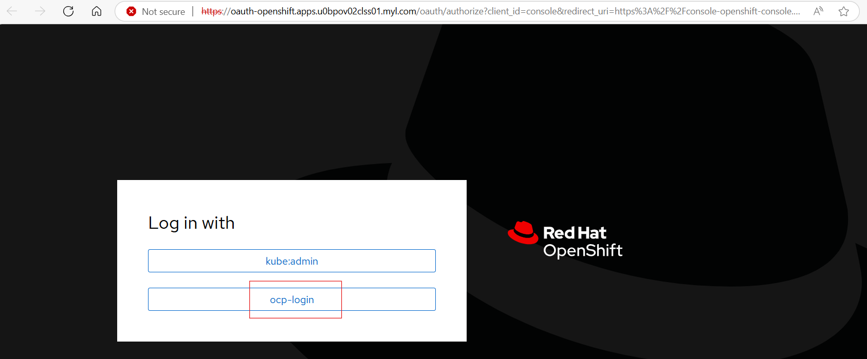

Provide the credentials which are shared.

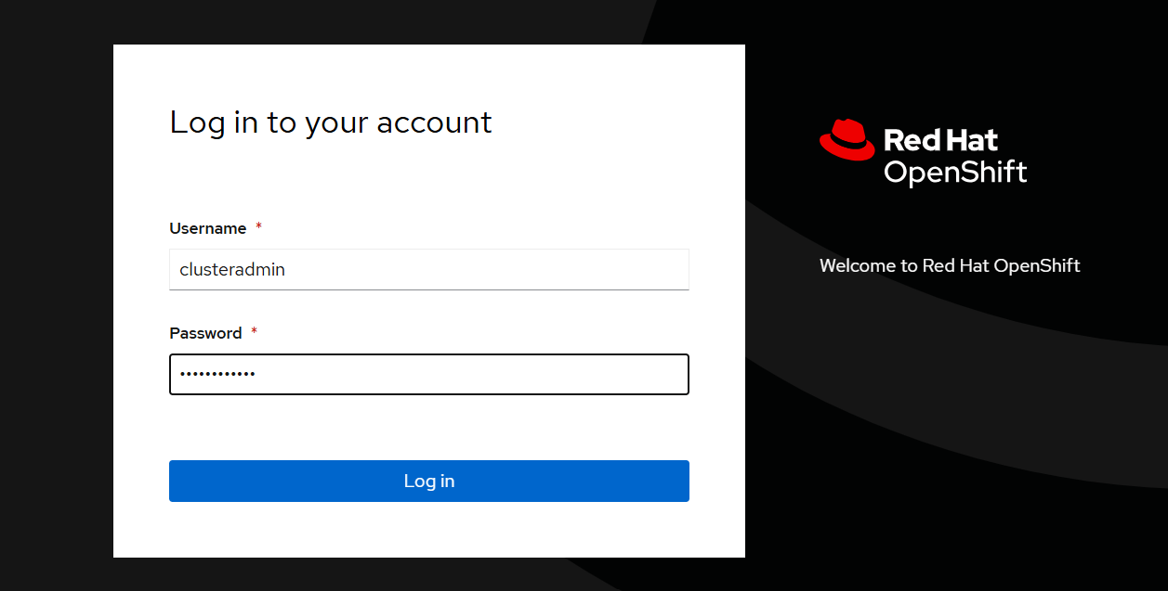

To Create a New VM:
Click Virtualization go to Virtual Machines.

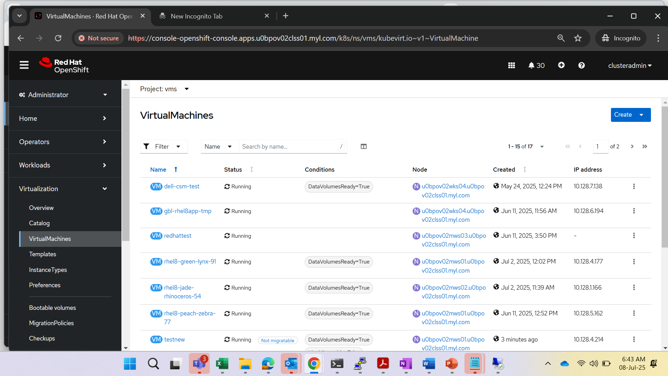
Click Create and select from Template

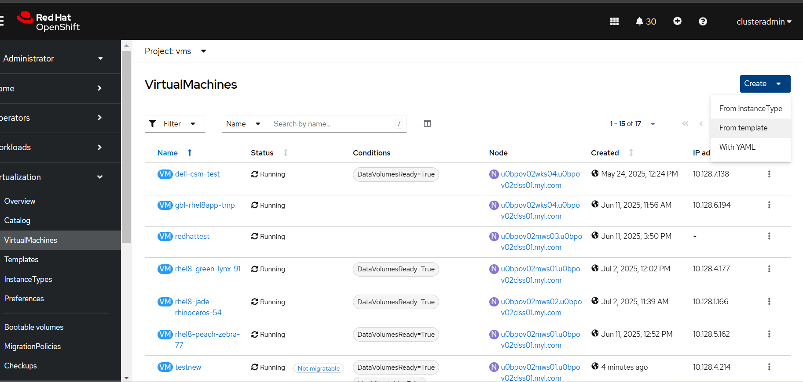

Select user Template

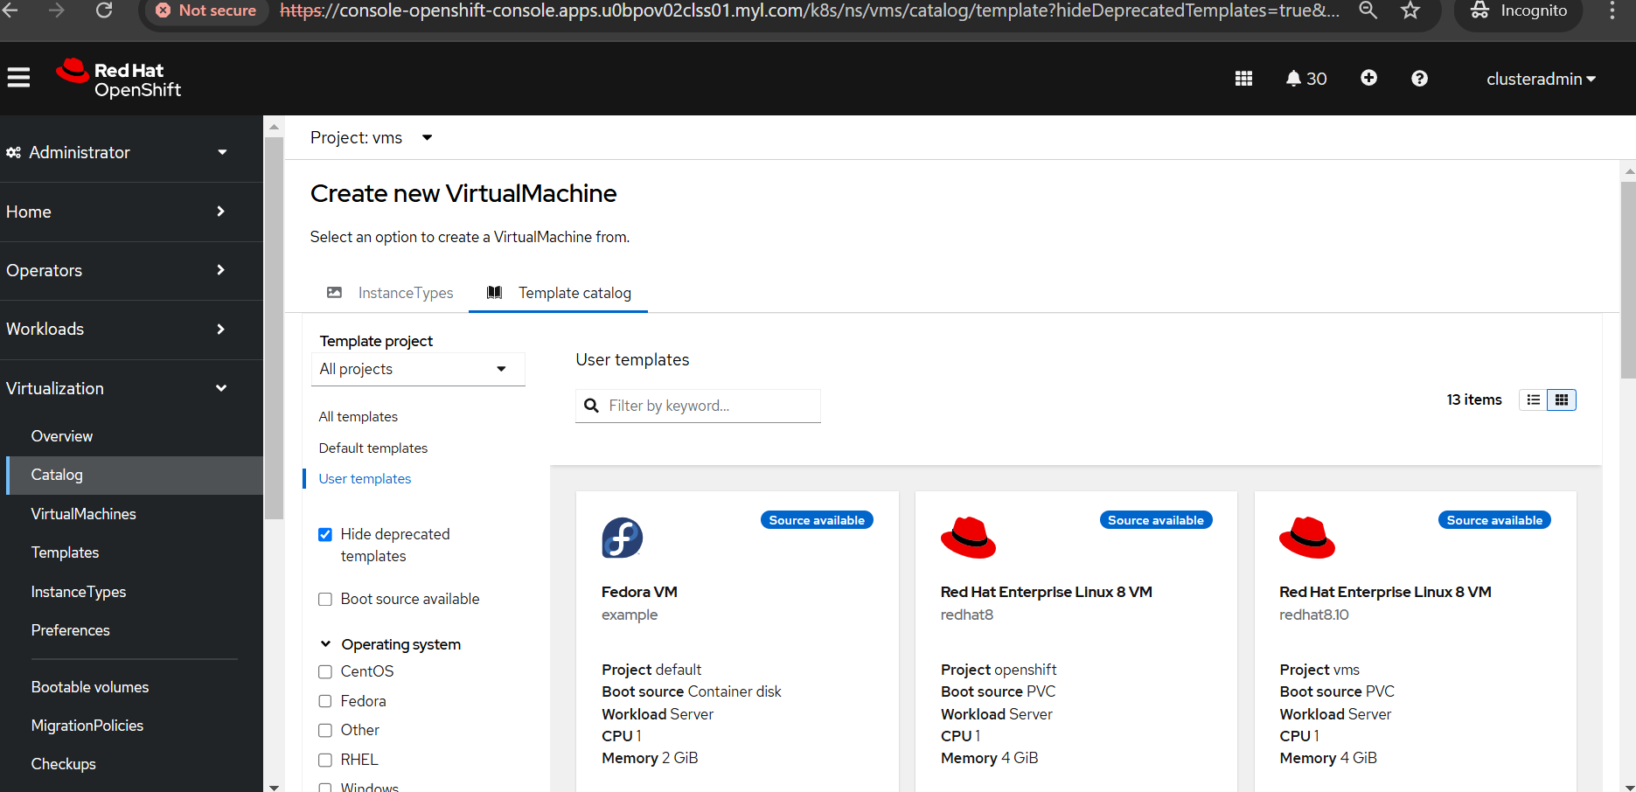

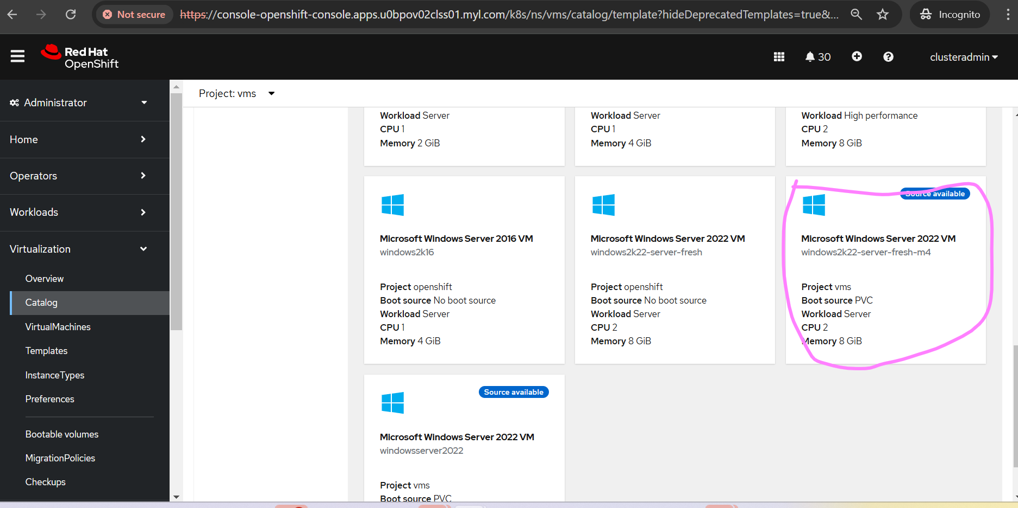

Click on Microsoft Windows Server 2022 VM and click customize Virtual Machine

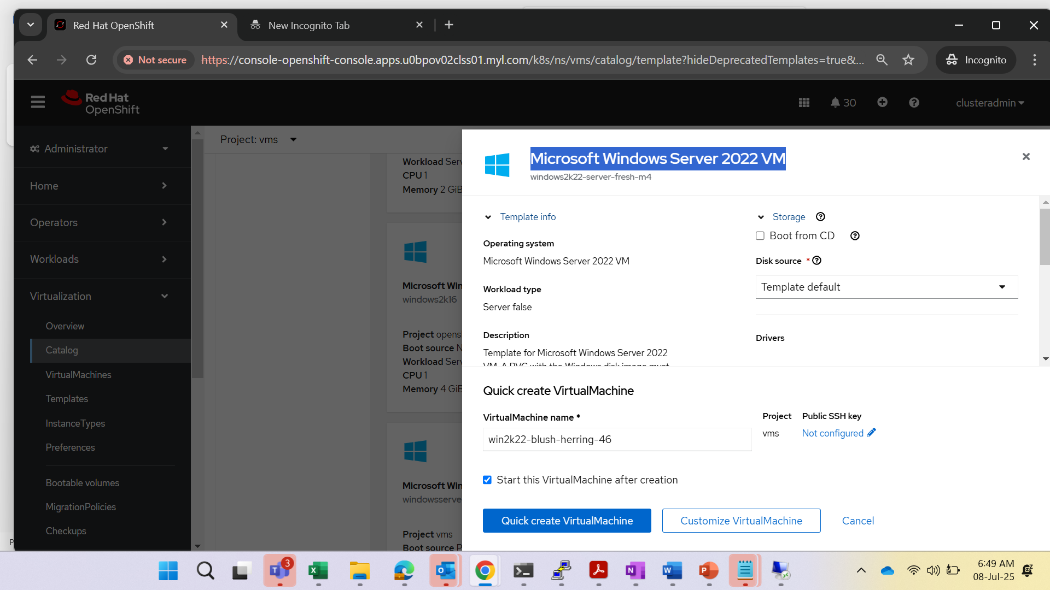

Now Click on Create Virtual Machine
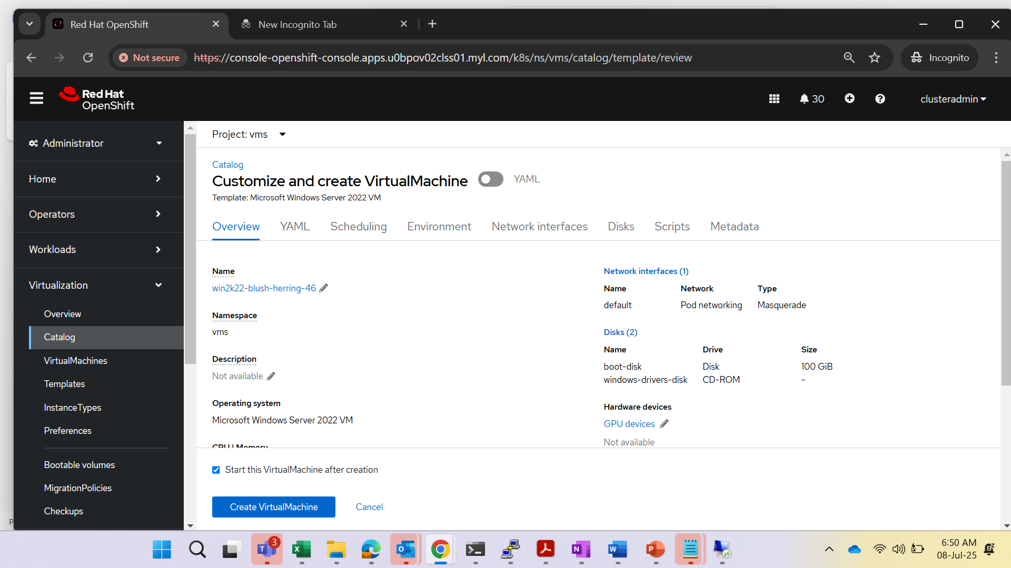
New VM Created
